**Supplementary material**

**Biophysical modelling and graph theory identify key connectivity hubs in the Mediterranean marine reserve network**

David Abecasis, Eliza ﻿Fragkopoulou, Bruno Claro and Jorge Assis

*Correspondence: David Abecasis: davidbecas@gmail.com

Supplementary Table S1. Comprehensive list of Mediterranean marine reserves.

|  |  |  |  |  |
| --- | --- | --- | --- | --- |
| Id | Marine Reserve | No-take area (km2) | Country | Marine Ecoregion |
| 1 | Parque Nacional de Archipielago de Cabrera | 7.834 | Spain | Western Mediterranean |
| 2 | Area marina protetta Cinque Terre | 1.192 | Italy | Western Mediterranean |
| 3 | Area marina protetta Costa degli Infreschi e della Masseta | 0.257 | Italy | Western Mediterranean |
| 4 | Area marina protetta Isola di Bergeggi | 0.049 | Italy | Western Mediterranean |
| 5 | Area marina protetta Isola di Ustica | 0.596 | Italy | Western Mediterranean |
| 6 | Area marina protetta Isole Ciclopi | 0.277 | Italy | Ionian Sea |
| 7 | Area marina protetta Penisola del Sinis - Isola Mal di Ventre | 5.353 | Italy | Western Mediterranean |
| 8 | Area marina protetta Plemmirio | 0.81 | Italy | Ionian Sea |
| 9 | Area marina protetta Regno di Nettuno | 3.001 | Italy | Western Mediterranean |
| 10 | Area marina protetta Santa Maria di Castellabate | 0.974 | Italy | Western Mediterranean |
| 11 | Area marina protetta Secche della Meloria | 5.047 | Italy | Western Mediterranean |
| 12 | Area naturale marina protetta Capo Caccia Isola Piana | 0.345 | Italy | Western Mediterranean |
| 13 | Area naturale marina protetta Capo Carbonara | 1.231 | Italy | Western Mediterranean |
| 14 | Area naturale marina protetta Capo Gallo - Isola delle Femmine | 0.486 | Italy | Western Mediterranean |
| 15 | Area naturale marina protetta Capo Rizzuto | 4.249 | Italy | Ionian Sea |
| 16 | Area naturale marina protetta Isole di Ventotene e Santo Stefano | 4.152 | Italy | Western Mediterranean |
| 17 | Area naturale marina protetta Porto Cesareo | 2.52 | Italy | Ionian Sea |
| 18 | Area naturale marina protetta Portofino | 0.564 | Italy | Western Mediterranean |
| 19 | Area naturale marina protetta Punta Campanella | 1.632 | Italy | Western Mediterranean |
| 20 | Area naturale marina protetta Tavolara - Punta Coda Cavallo | 5.43 | Italy | Western Mediterranean |
| 21 | Banc Des Kabyles Marine Reserve | 1.661 | Algeria | Western Mediterranean |
| 22 | Nacionalni park Brijuni | 1.193 | Croatia | Adriatic Sea |
| 23 | Reserva Marina de Cabo de Gata | 13.749 | Spain | Alboran Sea |
| 24 | Reserva Marina de Cabo de Palos - Islas Hormigas | 2.107 | Spain | Western Mediterranean |
| 25 | Parc National des Calanques | 46.757 | France | Western Mediterranean |
| 26 | Parc Natural de Cap De Creus | 0.155 | Spain | Western Mediterranean |
| 27 | Reserva marina Cap Enderrocat - Cap Blanc | 2.546 | Spain | Western Mediterranean |
| 28 | Réserve marine Cap Roux | 14.941 | France | Western Mediterranean |
| 29 | Réserve Naturelle de Cerbère - Banyuls no take-zone | 0.735 | France | Western Mediterranean |
| 30 | Parc Marin de la Côte Bleue Cap Courome | 3.302 | France | Western Mediterranean |
| 31 | Parc Marin de la Côte Bleue Reserve de Carry-le-Rouet | 1.184 | France | Western Mediterranean |
| 32 | Eastern Marine Conservation Zone | 0.109 | Gibraltar | Alboran Sea |
| 33 | Fanar Ibn Hani | 7.383 | Syria | Levantine Sea |
| 34 | Gökçeada Marine Park | 3.282 | Turkey | Aegean Sea |
| 35 | Gokova Bay | 19.049 | Turkey | Aegean Sea |
| 36 | Reserva marina de l'Illa de Tabarca | 0.298 | Spain | Western Mediterranean |
| 37 | Reserva marina de Isla De Alboran | 16.258 | Spain | Alboran Sea |
| 38 | Kas-Kekova | 6.237 | Turkey | Aegean Sea |
| 39 | Kornati, KolobuÄar islet | 9.916 | Croatia | Adriatic Sea |
| 40 | Krajinski park Strunjan | 0.113 | Slovenia | Adriatic Sea |
| 41 | Réserve Naturelle Marine des les Îles Habibas | 26.535 | Algeria | Alboran Sea |
| 42 | Reserva marina de las Islas Medas | 1.236 | Spain | Western Mediterranean |
| 43 | National Park of Gouraya | 27.927 | Algeria | Western Mediterranean |
| 44 | Palm Islands Nature Reserve | 4.174 | Lebanon | Levantine Sea |
| 45 | Parco nazionale dell' Arcipelago Toscano - Isola di Capraia | 3.957 | Italy | Western Mediterranean |
| 46 | Parco nazionale dell' Arcipelago Toscano Isla Pianosa | 48.198 | Italy | Western Mediterranean |
| 47 | Parco nazionale dell' Arcipelago Toscano- Isla Elba | 2.715 | Italy | Western Mediterranean |
| 48 | Parco nazionale dell'Arcipelago di La Maddalena | 17.915 | Italy | Western Mediterranean |
| 49 | Parco sommerso di Baia | 0.131 | Italy | Western Mediterranean |
| 50 | Parco sommerso di Gaiola | 0.032 | Italy | Western Mediterranean |
| 51 | Port-Cros National Park | 46.136 | France | Western Mediterranean |
| 52 | Reserva Marina de las Islas Columbretes no-take zone | 27.999 | Spain | Western Mediterranean |
| 53 | Reserva Marina de Masía Blanca no-take zone | 0.555 | Spain | Western Mediterranean |
| 54 | Reserva Marina del Norte de Menorca no-take zone | 8.779 | Spain | Western Mediterranean |
| 55 | Reserve Du Larvotto | 0.272 | Monaco | Western Mediterranean |
| 56 | Reserve naturelle des Bouches de Bonifacio, no-take zone | 10.159 | France | Western Mediterranean |
| 57 | Riserva naturale marina di Miramare nel Golfo di Trieste | 0.288 | Italy | Adriatic Sea |
| 58 | Riserva naturale marina Isole Egadi | 8.182 | Italy | Western Mediterranean |
| 59 | Riserva naturale marina Isole Tremiti | 1.945 | Italy | Adriatic Sea |
| 60 | Riserva naturale marina Torre Guaceto | 1.897 | Italy | Adriatic Sea |
| 61 | Rosia Marine Conservation Zone | 0.006 | Gibraltar | Alboran Sea |
| 62 | Parc Natural de s'Albufera des Grau | 1.215 | Spain | Western Mediterranean |
| 63 | Réserve Naturelle de Scandola | 3.2 | France | Western Mediterranean |
| 64 | Ses Salines d Eivissa i Formentera | 5.068 | Spain | Western Mediterranean |
| 65 | Tombant à corail des Spélugues | 0.013 | Monaco | Western Mediterranean |
| 66 | Zembra and Zembretta Iles National Park | 23.162 | Tunisia | Western Mediterranean |
| 67 | Ethniko Thalassio Parko Alonnisou Voreion Sporadon | 161.619 | Greece | Aegean Sea |
| 68 | Ethniko Parko Schinia - Marathona | 10.84 | Greece | Aegean Sea |
| 69 | Ethniko Parko limnothalasson Mesolongiou | 3.059 | Greece | Ionian Sea |
| 70 | Ethniko Thalassio Parko Zakynthou | 0.288 | Greece | Ionian Sea |

Figure S1. Representation of the surface oceanographic circulation of the Mediterranean Sea (adapted from Poulain et al 2012).

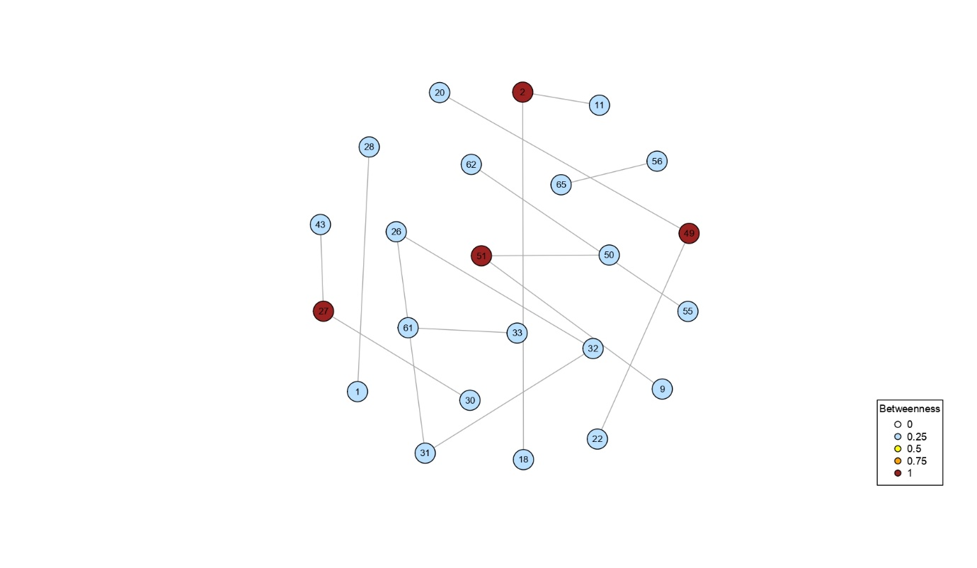

Figure S2. Graph with a Fruchterman-Reingold layout representing betweenness centrality between marine reserves (nodes matching the id of Table 1) for group 1 (G1) as representative of Cnidaria, Tunicata and Porifera (mean PD of 2 days).

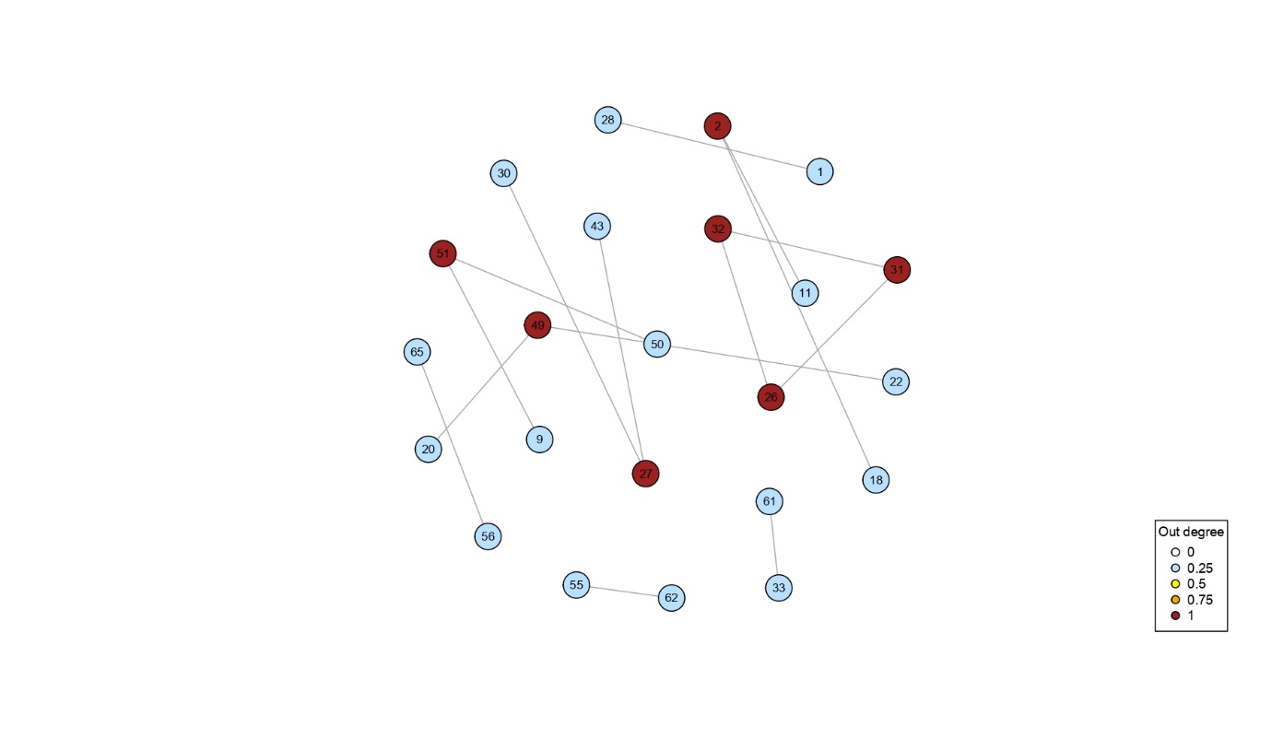

Figure S3. Graph with a Fruchterman-Reingold layout representing out-strength centrality between marine reserves (nodes matching the id of Table 1) for group 1 (G1) as representative of Cnidaria, Tunicata and Porifera (mean PD of 2 days).

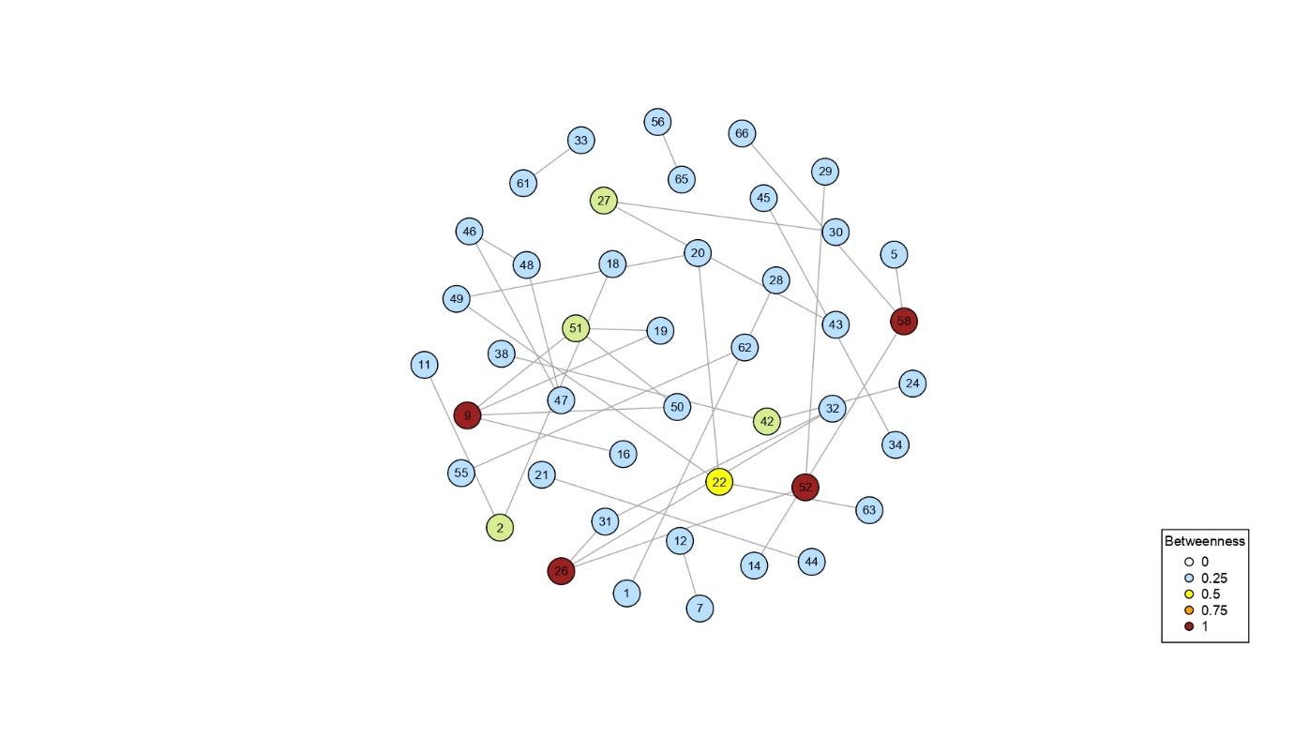

Figure S4. Graph with a Fruchterman-Reingold layout representing betweenness centrality between marine reserves (nodes matching the id of Table 1) for group 2 (G2) representing Macroalgae and Seagrass (mean PD of 6 days).

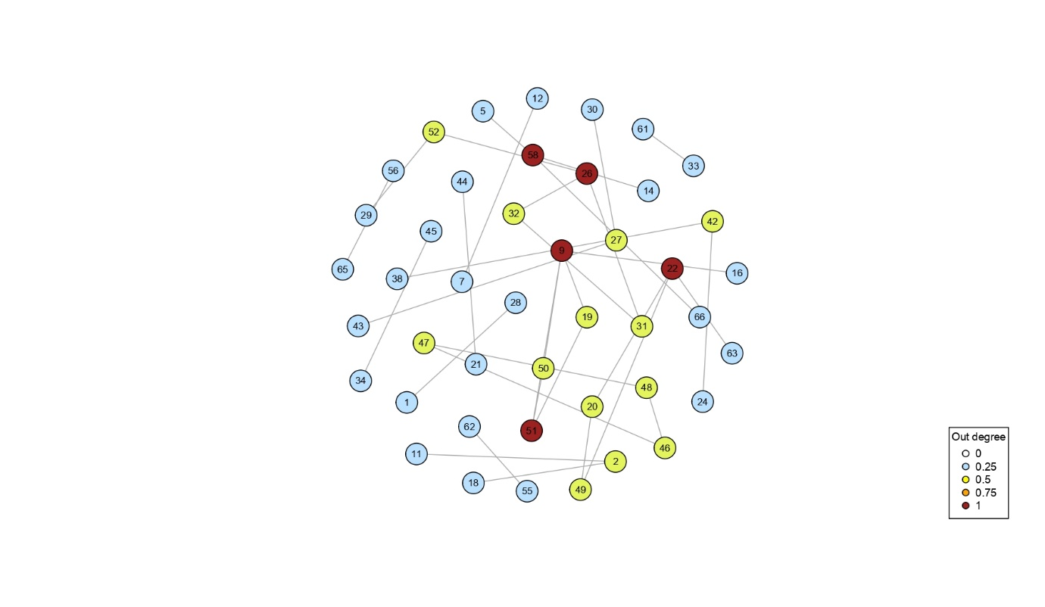

Figure S5. Graph with a Fruchterman-Reingold layout representing out-strength centrality between marine reserves (nodes matching the id of Table 1) for group 2 (G2) representing Macroalgae and Seagrass (mean PD of 6 days).

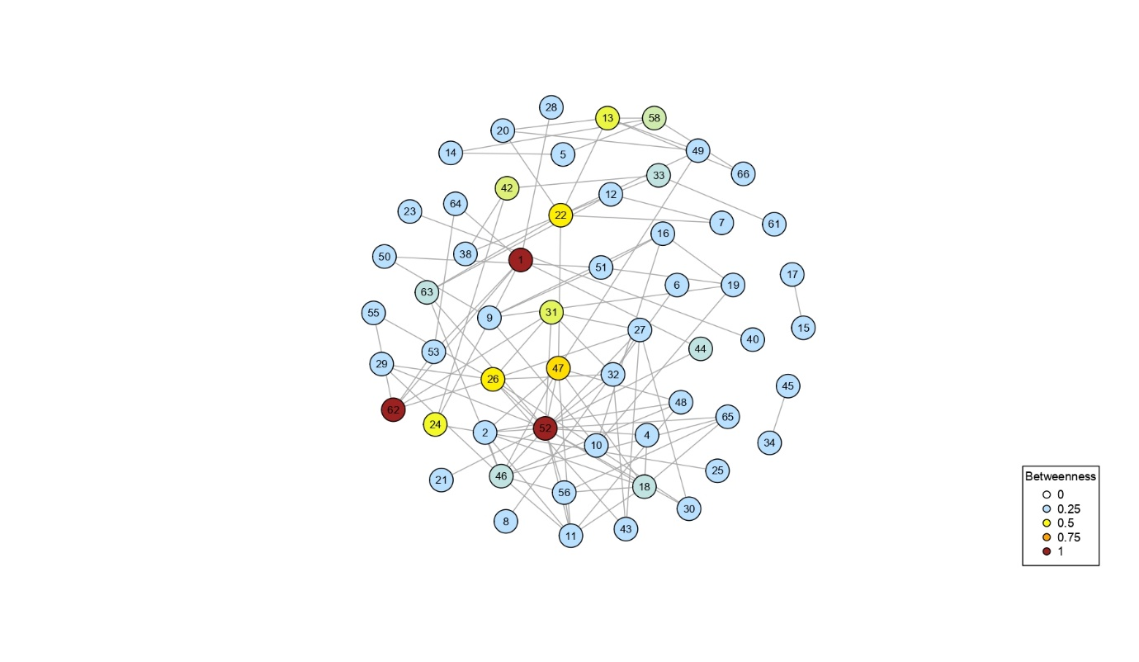

Figure S6. Graph with a Fruchterman-Reingold layout representing betweenness centrality between marine reserves (nodes matching the id of Table 1) for group 3 (G3) representing Bryozoa, Mollusca and Polychaeta (mean PD of 17 days).

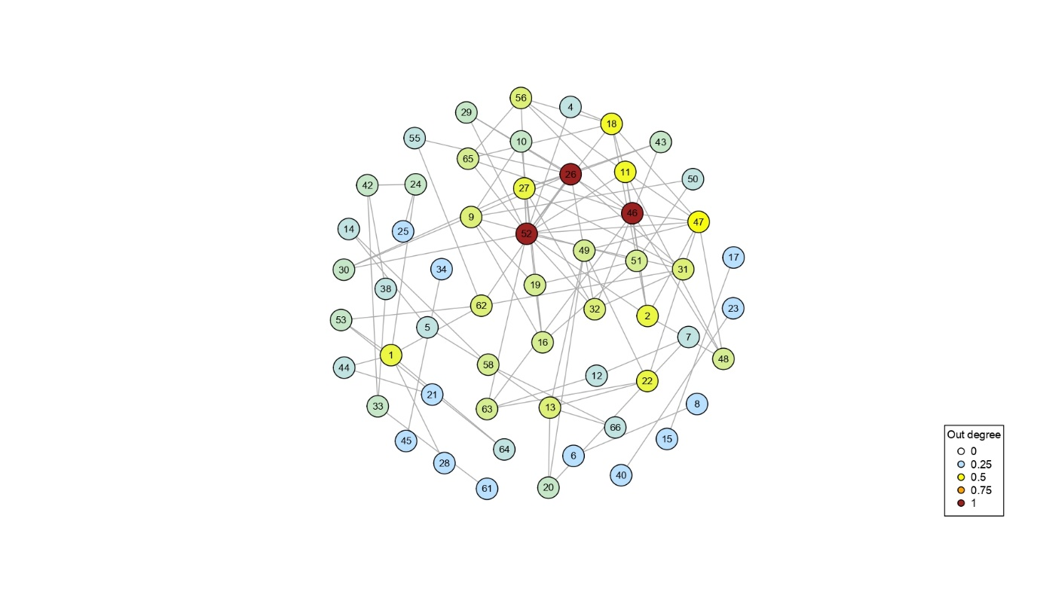Figure S7. Graph with a Fruchterman-Reingold layout representing out-strength centrality between marine reserves (nodes matching the id of Table 1) for group 3 (G3) representing Bryozoa, Mollusca and Polychaeta (mean PD of 17 days).

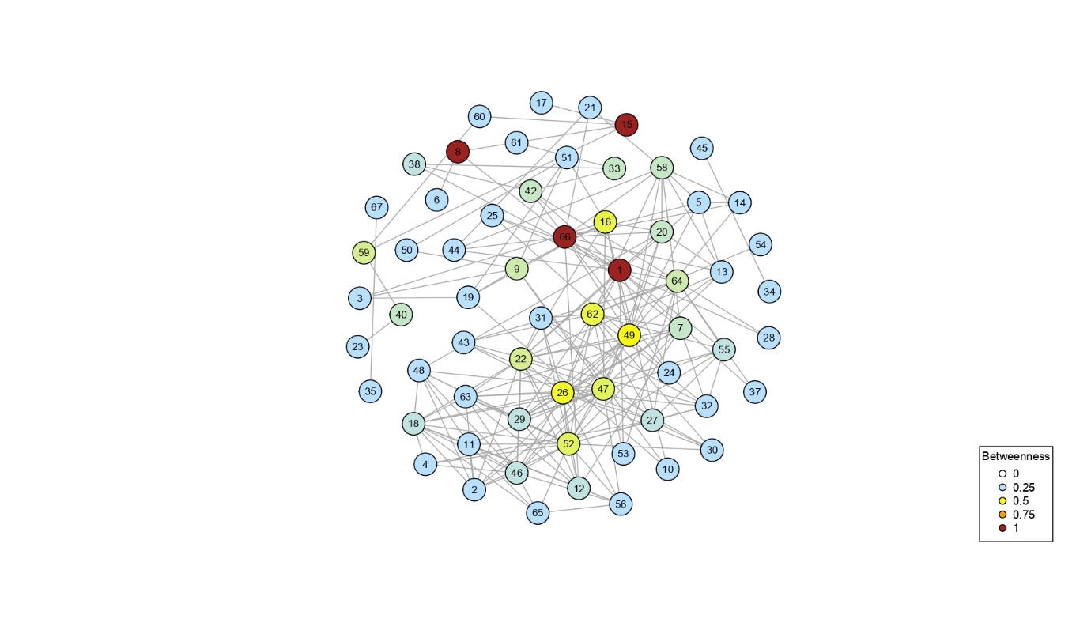

Figure S8. Graph with a Fruchterman-Reingold layout representing betweenness centrality between marine reserves (nodes matching the id of Table 1) for group 4 (G4) representing Pisces, Crustacea and Echinodermata (mean PD of 36 days).

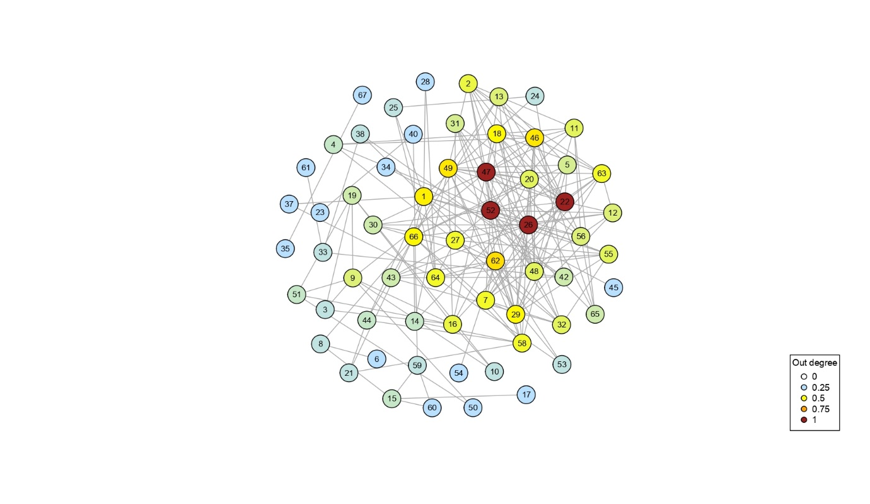

Figure S9. Graph with a Fruchterman-Reingold layout representing out-strength centrality between marine reserves (nodes matching the id of Table 1) for group 4 (G4) representing Pisces, Crustacea and Echinodermata (mean PD of 36 days).

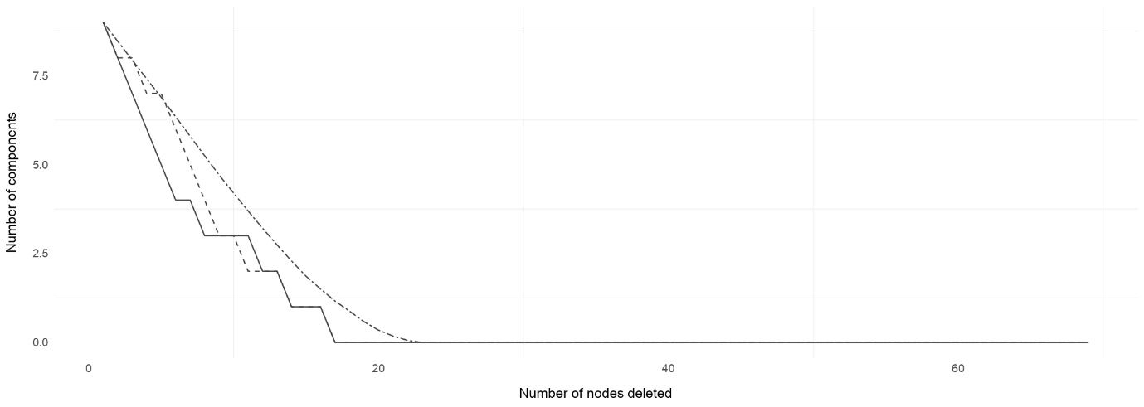

Figure S10. Effect of removing marine reserves (nodes) on the number of components of the network (i.e., number of clusters) under the 3 scenarios of sequential node deletion from the highest to the lowest betweenness centrality (highBetw.), from the highest to the lowest out-strength centrality (highOut-S.), and randomly with 999 permutations, with no replacement (Random). Network tests are related to G1 (Cnidaria, Tunicata, and Porifera).

Figure S11. Effect of removing marine reserves (nodes) on the relative size of the largest component, under the 3 scenarios of sequential node deletion from the highest to the lowest betweenness centrality (highBetw.), from the highest to the lowest out-strength centrality (highOut-S.), and randomly with 999 permutations, with no replacement (Random). Network tests are related to G1 (Cnidaria, Tunicata, and Porifera).

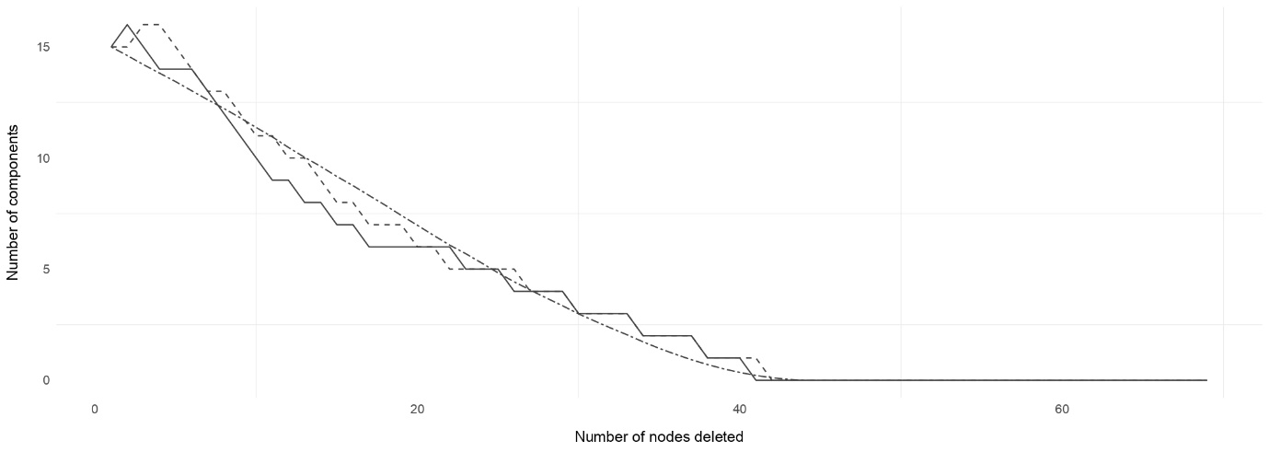

Figure S12. Effect of removing marine reserves (nodes) on the number of components of the network (i.e., number of clusters) under the 3 scenarios of sequential node deletion from the highest to the lowest betweenness centrality (highBetw.), from the highest to the lowest out-strength centrality (highOut-S.), and randomly with 999 permutations, with no replacement (Random). Network tests are related to G2 (Macroalgae and Seagrass).

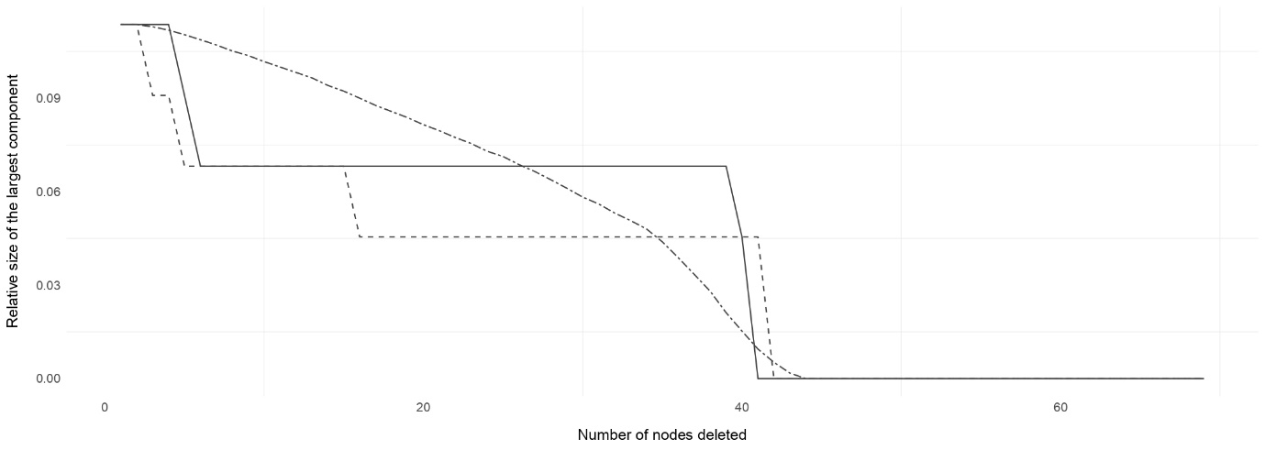

Figure S13. Effect of removing marine reserves (nodes) on the relative size of the largest component, under the 3 scenarios of sequential node deletion from the highest to the lowest betweenness centrality (highBetw.), from the highest to the lowest out-strength centrality (highOut-S.), and randomly with 999 permutations, with no replacement (Random). Network tests are related to G2 (Macroalgae and Seagrass).

Figure S14. Effect of removing marine reserves (nodes) on the number of components of the network (i.e., number of clusters) under the 3 scenarios of sequential node deletion from the highest to the lowest betweenness centrality (highBetw.), from the highest to the lowest out-strength centrality (highOut-S.), and randomly with 999 permutations, with no replacement (Random). Network tests are related to G3 (Bryozoa, Mollusca, and Polychaeta).

Figure S15. Effect of removing marine reserves (nodes) on the relative size of the largest component, under the 3 scenarios of sequential node deletion from the highest to the lowest betweenness centrality (highBetw.), from the highest to the lowest out-strength centrality (highOut-S.), and randomly with 999 permutations, with no replacement (Random). Network tests are related to G3 (Bryozoa, Mollusca, and Polychaeta).

Reference

Poulain, P.-M., Menna, M., and Mauri, E. (2012). Surface Geostrophic Circulation of the Mediterranean Sea Derived from Drifter and Satellite Altimeter Data. *Journal of Physical Oceanography* 42**,** 973-990