Supplementary Materials

RSVP Surveys
UCLA-CEE (individual meal)

Default: Meat
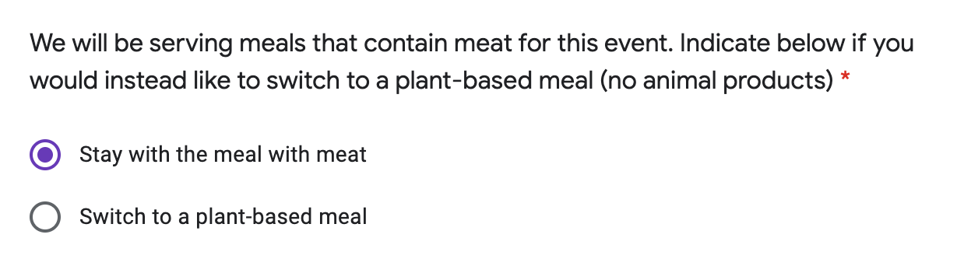

Default: Plant-based


UCLA-DG (buffet)

Default: Meat


Default: Plant-based


Harvard-BIH (individual meal)

Default: Meat 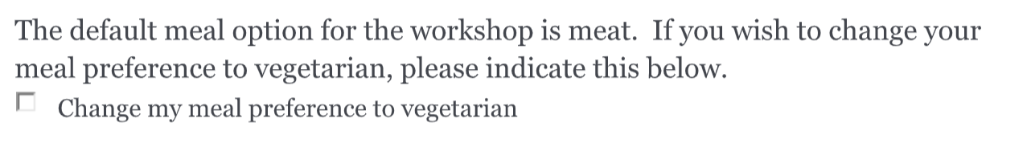

Default: Plant-based
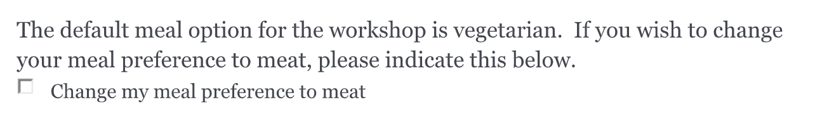

Recipe for Each Meal Option
Vegan Patty Sandwich (tofu)
Bean & Tofu Patty (1/2 cup beans)
Bean & Tofu Patty (1/4 cup tofu)
Avocado (~3/4 of one)
Tomatoes chopped (1/4 cup)
Lettuce (calculated 10 inner leaves)
Bell Peppers, tricolor (1 bell pepper = 130g) (half of one)
Mushrooms (1/4 cup cooked)
Bread (2 slices)

Vegetarian Caprese Sandwich (cheese)
Mozzarella Cheese (2.5 oz)
Bread (2 slices)
Tomato slices (1 med)
Romaine lettuce (16 inner leaves)
Olive Oil (1 T)
Basil (1/5 cup) - (no planetary boundary information)
Mushrooms (1/4 cup)
Onion (half of a small one - 35g)

Chicken-Bacon Sandwich
Chicken Breast (3.5 oz)
Onion (1/4 of a small one)
Mozzarella Cheese (1/2 oz)
Bread (2 slices)
Lettuce (half cup shredded)
Tomato (half of one)
Bacon (1.5 slices)
Olive Oil (1/4 T)

Beef Sandwich
Beef (3 oz)
Cheese (1 slice)
Bread (2 slices)
Tomato (half of one)
Onion (half of a small one - 35g)
Avocado (1/2)
Lettuce (half cup shredded)
Olive Oil (1/8 T)

Environmental Footprint and Sources for each ingredient (based on data in supplementary table of Whitener et al, 2019)
Food |  | Greenhouse Gases |  |  | Land Use |  |  | Nitrogen |  |  | Phosphorus
 |  | g CO2 eq/g | Ref. |  | m2/g | Ref. |  | mg/g | Ref |  | mg/g | Ref
Temperate fruits |  | 0.34 | H&K |  | 6.70E-04 | CFPC--NA |  | 12.7 | Spr |  | 1.91 | Spr
Tropical fruits |  | 0.86 | H&K |  | 1.05E-03 | CFPC--NA |  | 10.2 | Spr |  | 1.58 | Spr
Vegetables |  | 0.816 | H&K |  | 8.10E-04 | CFPC--NA |  | 9.55 | Spr |  | 1.67 | Spr
Legumes |  | 0.73 | H&K, Clune |  | 4.04E-03 | CFPC--NA |  | 0 | Spr |  | 0 | Spr
Corn |  | 0.66 | H&K |  | 1.74E-03 | CFPC--NA |  | 22.7 | Spr |  | 3.57 | Spr
Wheat |  | 0.53 | H&K |  | 4.89E-03 | CFPC--NA |  | 13.9 | Spr |  | 4.39 | Spr
Rice |  | 1.14 | H&K |  | 2.17E-03 | CFPC--NA |  | 9.4 | Spr |  | 5.2 | Spr
Potatoes |  | 0.21 | H&K |  | 5.20E-04 | CFPC--NA |  | 3.63 | Spr |  | 0.71 | Spr
Oil |  | 1.63 | H&K |  | 1.31E-02 | CFPC--NA |  | 31.3 | Spr |  | 5.61 | Spr
Other grains |  | 0.48 | H&K |  | 4.50E-03 | CFPC--NA |  | 16.3 | Spr |  | 2.71 | Spr
Eggs |  | 3.54 | H&K |  | 6.84E-03 | CFPC--NA |  | 51.22 | Spr |  | 8.81 | Spr
Butter |  | 11.92 | H&K |  | 1.40E-02 | CFPC--NA |  | 82.5 | M&C |  | 70 | M&C
Milk |  | 1.34 | H&K |  | 2.05E-03 | CFPC--NA |  | 20.4 | Leach |  | 1.58 | Spr
Low fat dairy yogurt |  | 2.02 | H&K |  | 2.26E-03 | CFPC--NA |  | 9.7 | M&C |  | 8.2 | M&C
Cheese |  | 9.78 | H&K |  | 1.05E-04 | CFPC--NA |  | 127.1 | Leach |  | 33.5 | M&C
Soy milk |  | 0.7 | M&C |  | 7.80E-04 | CFPC--NA |  | 0.2 | M&C |  | 1.3 | M&C
Almond milk |  | 0.7 | M&C |  | 5.00E-04 | CFPC--NA |  | 0.2 | M&C |  | 1.3 | M&C
Other vegan milk |  | 0.7 | M&C |  | 5.20E-04 | CFPC--NA |  | 0.2 | M&C |  | 1.3 | M&C
Ice Cream |  | 3.1 | H&K |  | 3.69E-03 | CFPC--NA |  | 39.4 | M&C |  | 33.5 | M&C
Frozen Yogurt |  | 3.1 | H&K |  | 2.26E-03 | CFPC--NA |  | 9.7 | M&C |  | 8.2 | M&C
Fish from aquaculture |  | 3.83 | H&K |  | 4.94E-03 | CFPC--NA |  | 80.1 | Leach |  | 4.4 | M&C
Fish from trawling |  | 3.83 | H&K |  | 0.00E+00 | CFPC--NA |  | 80.1 | Leach |  | 4.4 | M&C
Ruminant meat |  | 40.2 | Har |  | 1.35E-01 | CFPC--NA |  | 234 | Leach |  | 97.9 | M&C
Pork and bacon |  | 6.87 | Leach |  | 2.10E-02 | CFPC--NA |  | 126 | Leach |  | 22.2 | M&C
Poultry |  | 5.05 | Leach |  | 1.15E-02 | CFPC--NA |  | 89.8 | Leach |  | 16 | M&C
Soy-based meat alternative |  | 1.5 | Nij |  | 4.14E-03 | CFPC--NA |  | 2.75 | Spr |  | 3.7 | M&C
Sugar |  | 0.96 | M&C, Spr |  | 2.39E-03 | CFPC--NA |  | 1.5 | M&C |  | 3.6 | M&C
Peanuts |  | 1.94 | H&K |  | 7.28E-03 | CFPC--NA |  | 0 | Spr |  | 8 | M&C
Almonds |  | 1.17 | H&K |  | 6.92E-03 | CFPC--NA |  | 14.2 | Spr |  | 12.6 | M&C
Walnuts |  | 1.17 | H&K |  | 6.92E-03 | CFPC--NA |  | 14.2 | Spr |  | 12.6 | M&C
Seeds |  | 0.8 | H&K |  | 6.92E-03 | CFPC--NA |  | 14.2 | Spr |  | 12.6 | M&C
Quinoa |  | 0.8 | H&K |  | 6.92E-03 | CFPC--NA |  | 14.2 | Spr |  | 12.6 | M&C

References

- Clune, S., Crossin, E., Verghese, K., (2017). Systematic Review of Greenhouse Gas Emissions for Different Fresh Food Categories, Journal of Cleaner Production, 140, 766-783. doi: 10.1016/j.jclepro.2016.04.082.
- Heller, M.C., Keoleian, G.A. (2014). Greenhouse Gas Emission Estimates of U.S. Dietary Choices And Food Loss. J.Ind. Ecol, 291-401. Doi: 10.1111/jiec.12174
- Leach, A.M, Emery, K. A., Gephart, J., et al. (2016). Environmental impact food labels combining carbon, nitrogen, and water footprints. Food Policy, 61, 213–223. doi:10.1016/j.foodpol.2016.03.006.
- Meier, T., Christen, O., (2013). Environmental Impacts of Dietary Recommendations and Dietary Styles: Germany As an Example., Environ. Sci. Technol., 2013, 47, 2, 877–888. doi:10.1021/es302152v.
- Nijdam, D., Rood, T., Westhoek, H. (2012). The Price of Protein: Review of Land Use and Carbon Footprints from Life Cycle Assessments of Animal Food Products and Their Substitutes, Food Policy, 37, 760–770. doi:10.1016/j.foodpol.2012.08.002.
- Waite, R., Vennard, D., and Pozzi, G. (2019). Tracking Progress Toward the Cool Food Pledge: Setting Climate Targets, Tracking Metrics, Using the Cool Food Calculator, and Related Guidance for Pledge Signatories. Technical Food Calculator, and Related Guidance for Pledge Signatories. Technical Food Calculator, and Related Guidance for Pledge Signatories. Technical Note. Washington, DC: World Resources Institute. Retrieved from www.coolfoodpledge.org [Accessed March 1, 2022].
- Whitener, V.A., Cook, B., Spielbauer, I., et al. (2021). Impact of a College Course on the Sustainability of Student Diets in Terms of the Planetary Boundaries for Climate Change and Land, Water, Nitrogen and Phosphorus Use. Frontiers in Sustainable Food Systems, 5:,677002.. doi: 10.3389/fsufs.2021.677002

