Carmesin et al.—Frontiers in Plant Science 2022—Appendix S3

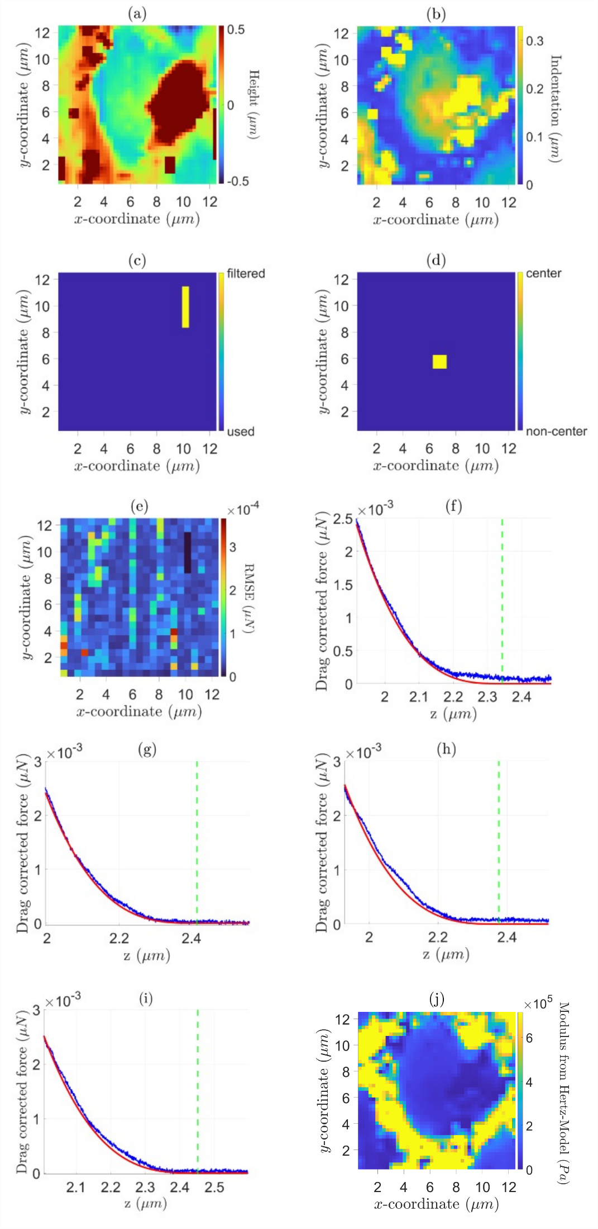

**Appendix 3.** Illustration of the procedure to model the Effective stiffness and Apparent elastic modulus of a pit membane. (a) Height profile via Hertz fit. (b) Indentation depth via Hertz fit. (c) Data filtering sorts out curves with less than 700 measurements, penetration events and no/positive slope. (d) Estimated membrane centre based on indentation depth. (e) Goodness of the fit with RMSE < 0.7e10-4. (f)-(i) Force distance curves of the centre, fitted via a non-linear model. (j) Relative stiffness via Hertz fit.