Supplementary Material

Figure 1. The schematic diagram of the mechanical impacting method. (A) Mechanical impacting devices. (B) Location of impact.

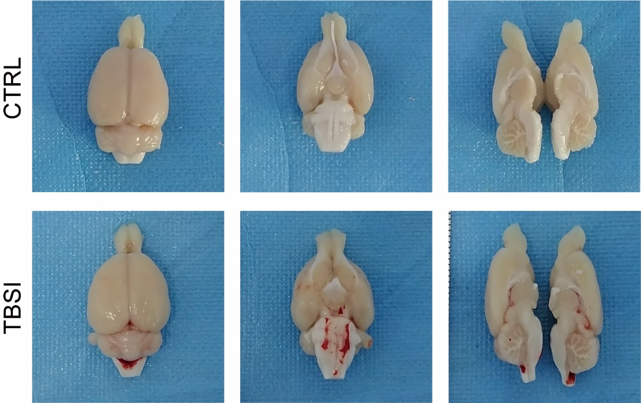
Figure 2. Anatomical view of the brain tissues of rats.

Figure 3. Distribution of metabolites.

Figure 4. Model validation of PLS-DA with the replacement test.

