Supplementary Material

Supplementary Figures
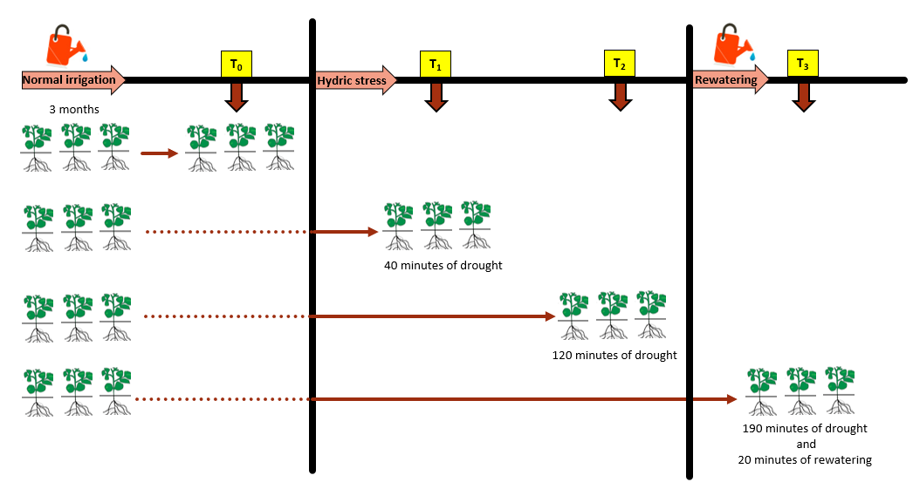
- (B)
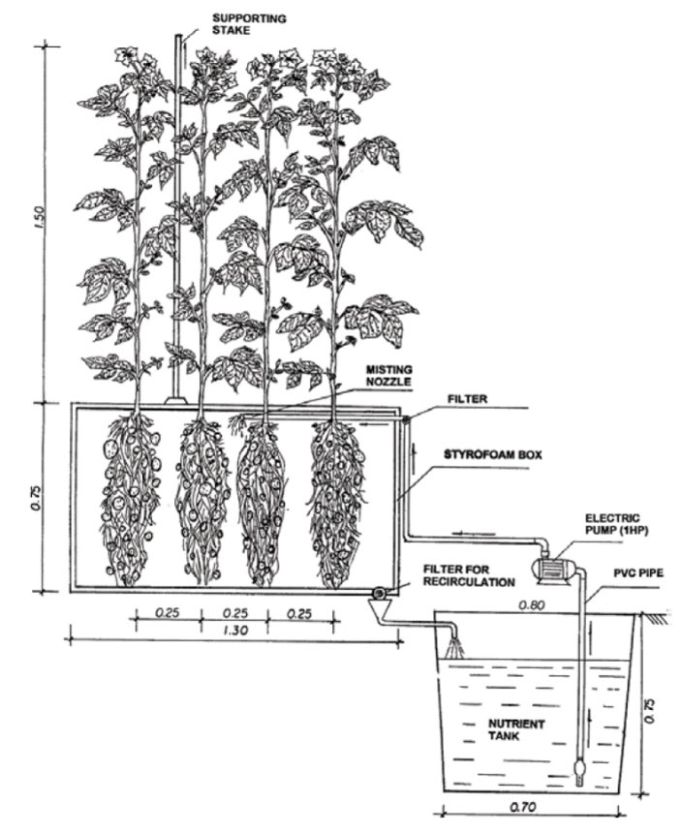
Supplementary Figure 1. Aeroponic system and experimental design. (A) An aeroponic system for quality seed and potato production (reproduced from Figure 1, Otazú, 2010) (B) After 3 months of irrigation, potato plants were exposed to drought stress until observing a decrease of 25% and 60%, and a recovery of 60% of the initial photosynthetic rate in the tolerant variety. These responses were observed at 40 (early response, T1) and 120 (late response, T2) minutes after removing the water supply, and at 20 minutes after rewatering which took place at 190 min (recovery phase, T3). At these time points, leaf and root samples were collected from three plants of each susceptible and tolerant variety. Control plant samples without drought stress were also collected (Control, T0).
(A)

Tolerant variety | Susceptible variety
Early response (T₁)  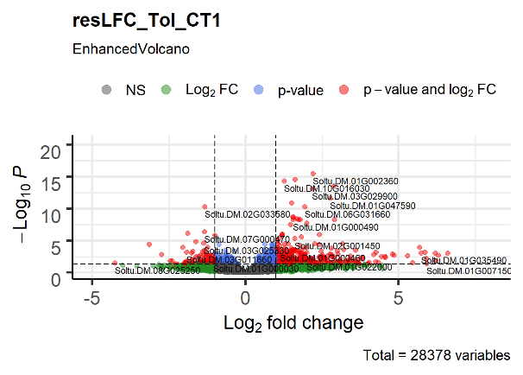  Late response (T₂)  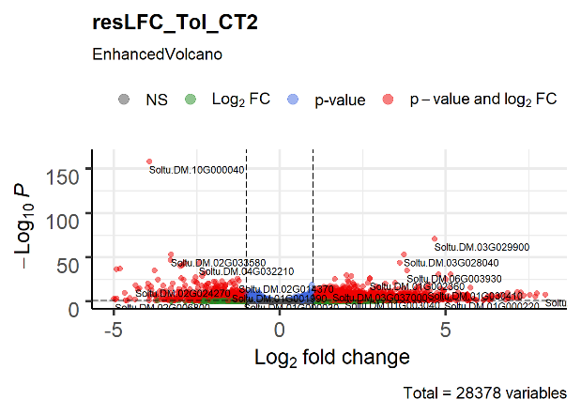  Recovery phase (T₃)  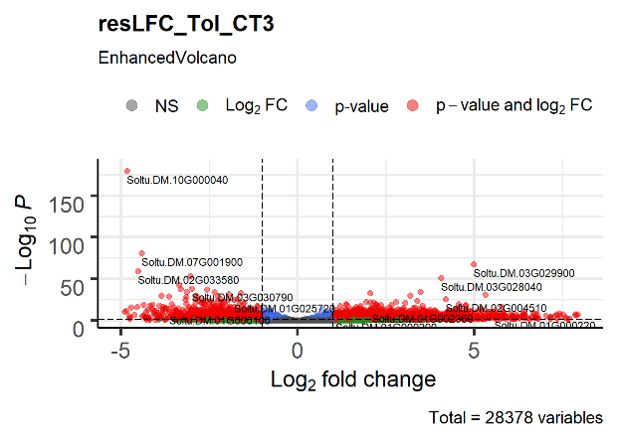 | Early response (T₁)  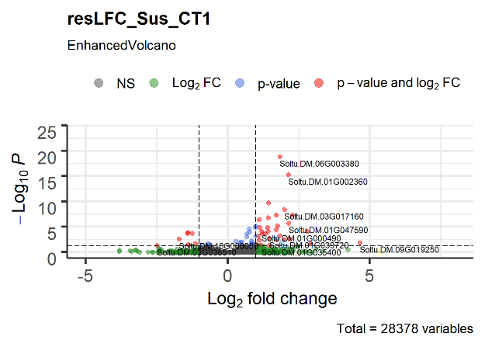  Late response (T₂)  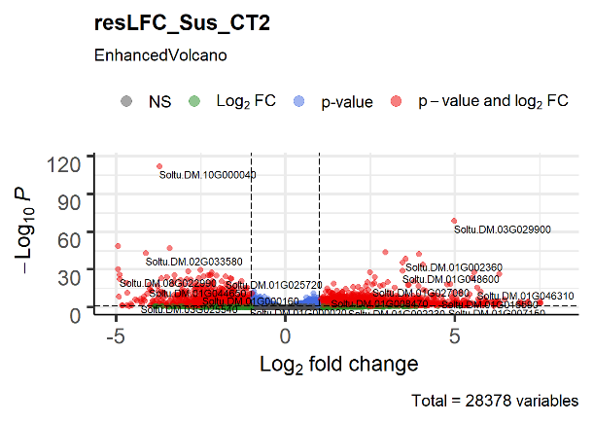  Recovery phase (T₃)  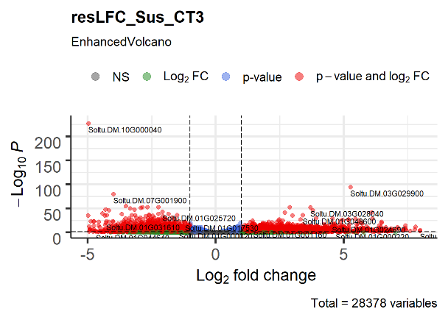

(B)
Tolerant variety | Susceptible variety
Early response (T₁)  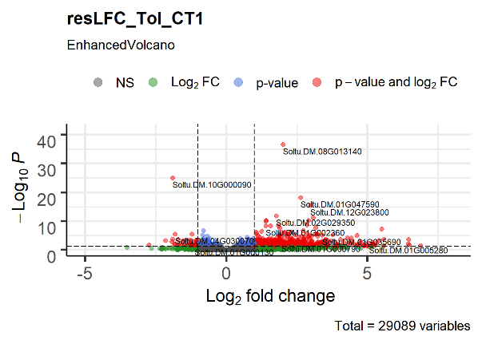  Late response (T₂)  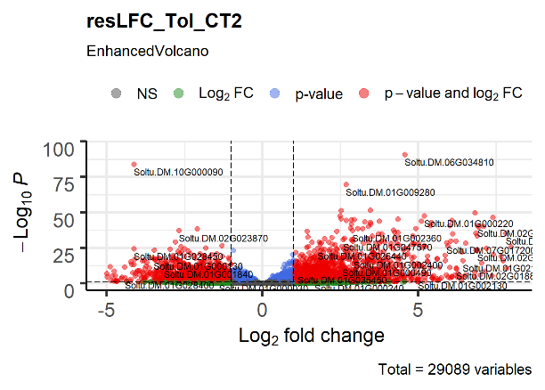  Recovery phase (T₃)  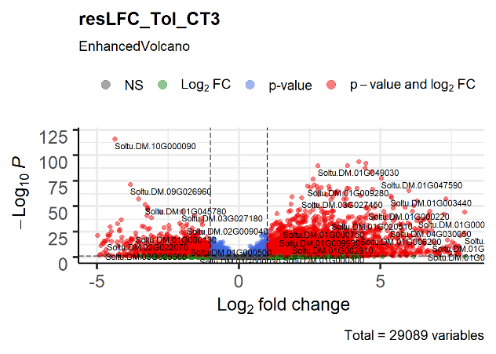 | Early response (T₁)  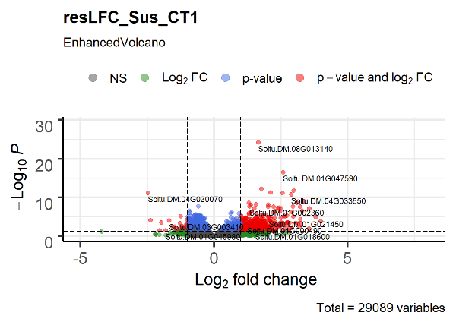  Late response (T₂)  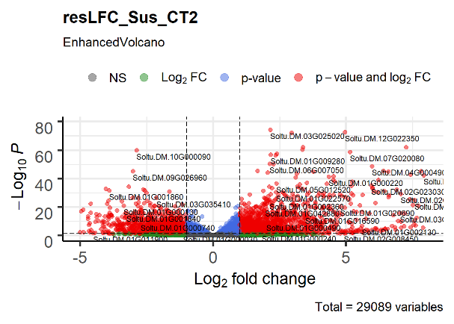  Recovery phase (T₃)  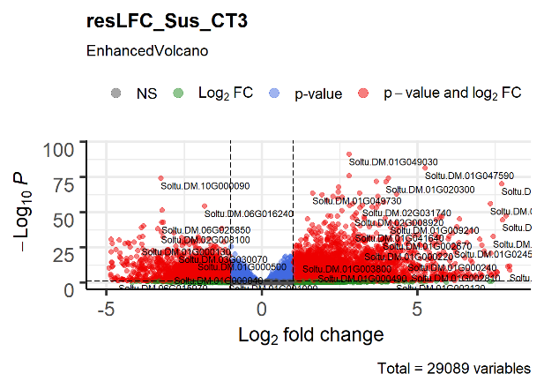
Supplementary Figure 2. Progressive drought response in two potato varieties and two tissues. DEGs are shown in each time point compared with the non-stressed control in leaf (A) and root (B) for tolerant and susceptible varieties at early (T1) and late (T2) time points and the recovery phase after rewatering (T3). Vertical dashed lines indicate absolute log2FC ≥2. Horizontal dashed lines indicate padj. equal to 5%. Genes passing neither threshold are shown in grey, while non-significant genes passing the FC threshold are shown in green. In blue are those genes with a small but significant fold change and in red are genes passing both thresholds.

(A) Early, T1
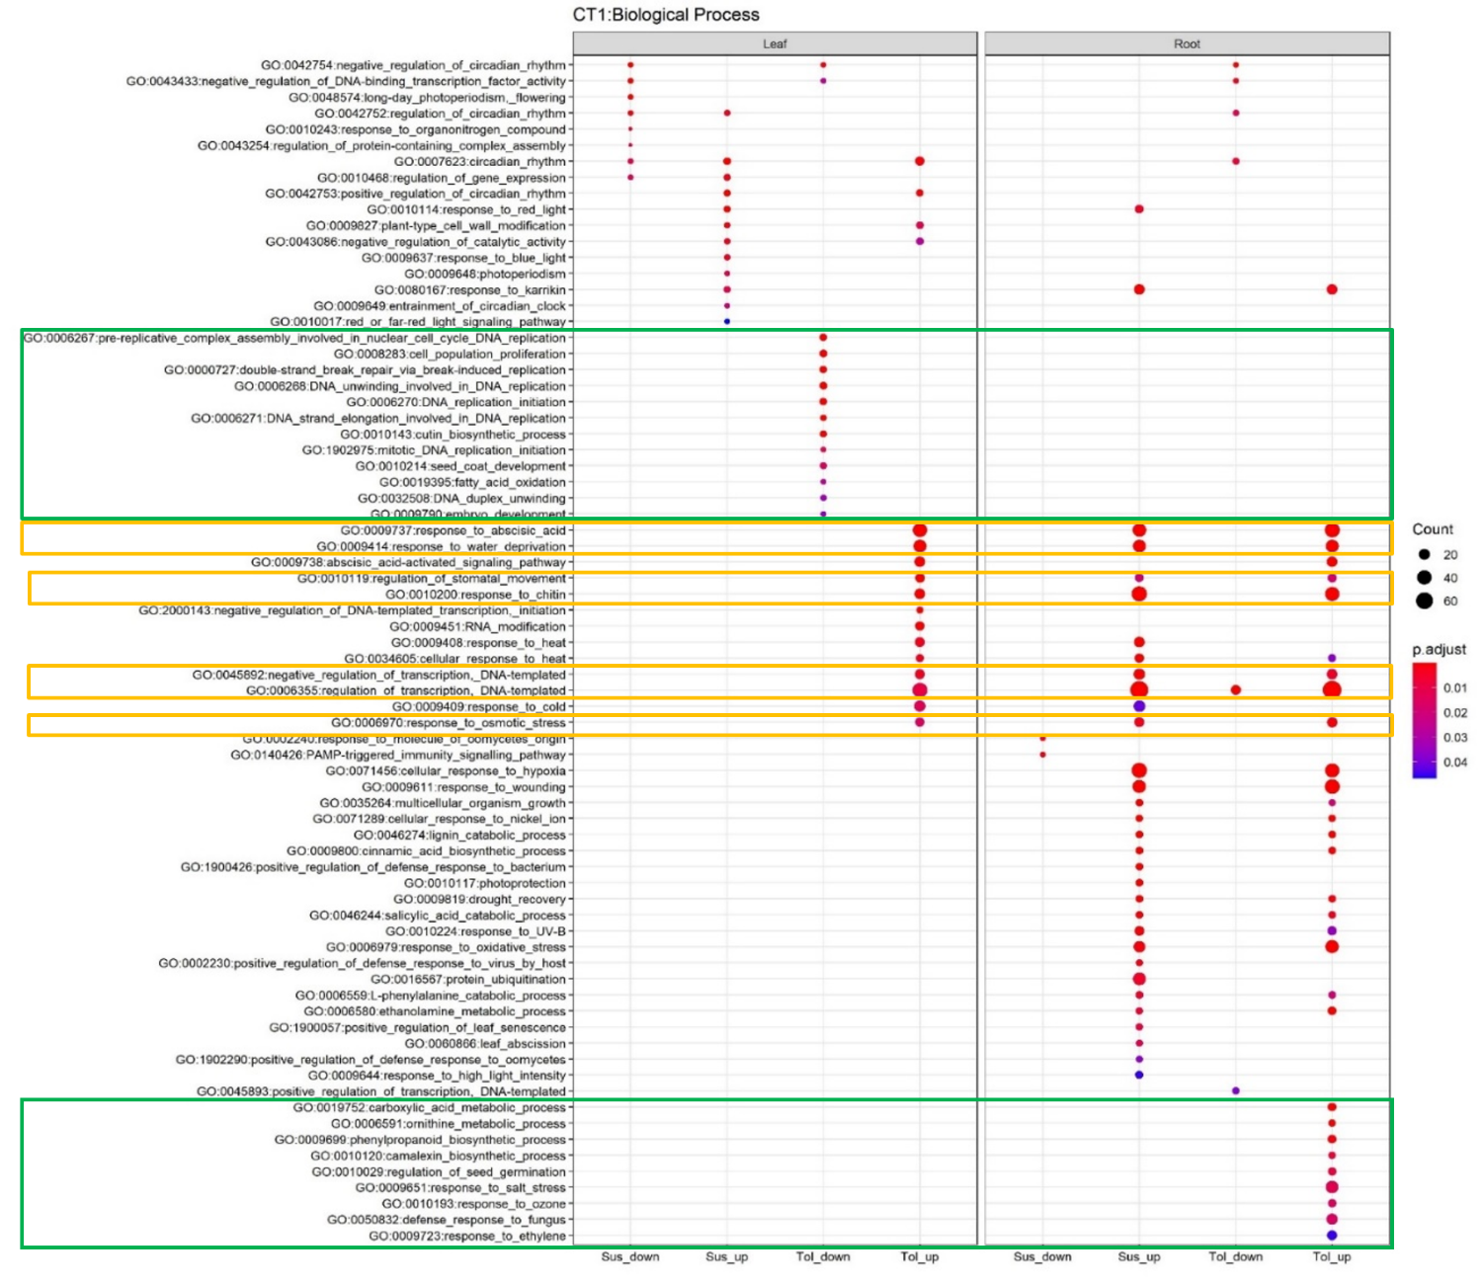

(B) Late, T2
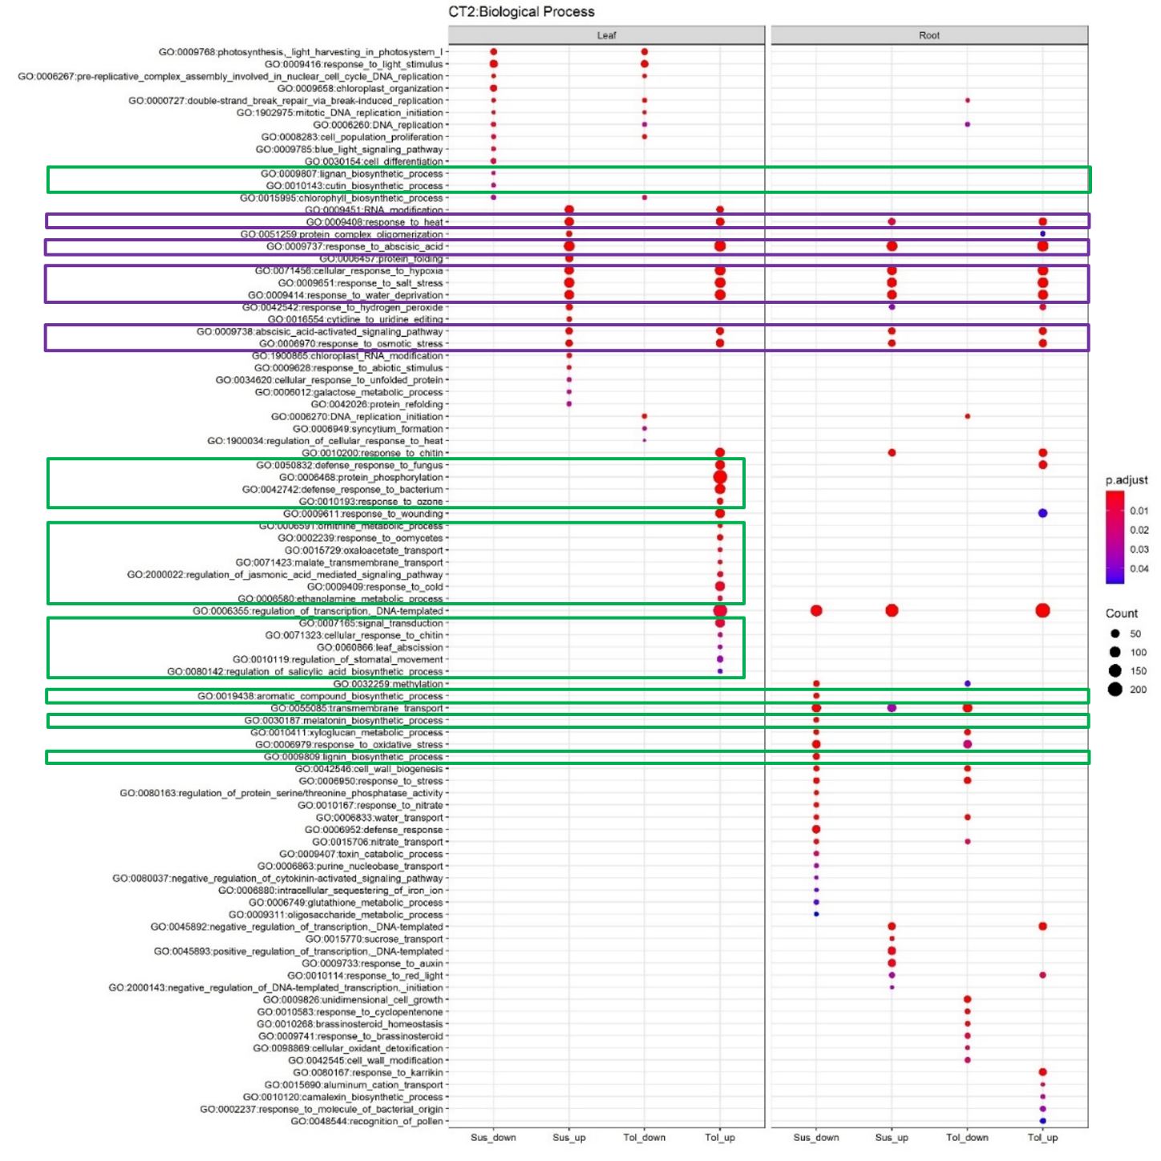

(C) Recovery, T3
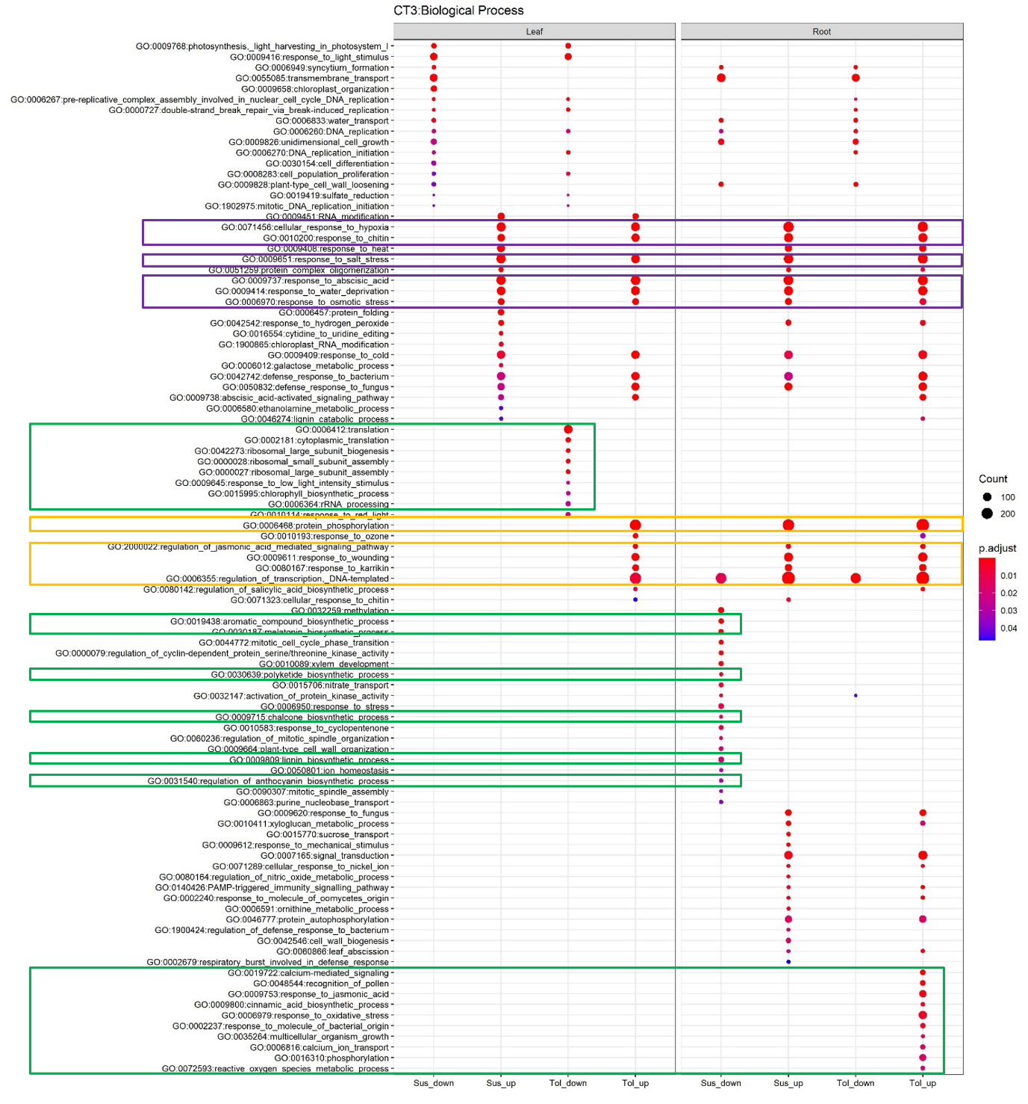
Supplementary Figure 3. Enriched Biological Processes in the Early, Late and Recovery Responses. Enriched processes are shown for early (A), late (B) and recovery (C) responses to drought. Left and right panes show results in leaf and root tissues for up- and down- regulated DEGs in susceptible (sus) and tolerant (tol) varieties. Significant enrichment is considered at Benjamini-Hochberg adjusted p < 0.05. Green boxes highlight some enriched categories specific to a particular tissue and variety. Orange boxes highlight some enriched GO terms for upregulated genes in all samples apart from susceptible leaf. Purple boxes highlight some terms enriched across both tissues and both varieties.

Supplementary Tables
Neiker Institute Code | Variety | Species | Country | Pressure (bar)
 |  |  |  | HP1 | HP2 | HP2-HP1
NKD-130 | MURO SHOCCO | S.andigena | Perú | 2 | 5 | 3
NKD-131 | PUCA HUAYRO | S. chaucha | Perú | 2 | 5 | 3
NKD-132 | CHAUCHA | S. phureja | Perú | 3 | 5 | 2
NKD-134 | PULU | S.andigena | Bolivia | 3 | 11 | 8
NKD-135 | SOCCO HUACCOTO | S. andigena | Perú | 2 | 4 | 2
NKD-137 | SIPANCACHI | S.andigena | Bolivia | 3 | 6 | 3
NKD-138 | LARAM AJAWIRI | S. ajanwiri | Bolivia | 5 | 5 | 0
NKD-139 | JANCKO AJAWIRI | S. ajanwiri | Bolivia | 3 | 5 | 2
NKD-140 | MORAR NAYRA MARI | S. stenotonum | Perú | 4 | 7 | 3
NKD-141 | UNKNOWN | S.andigena | Perú | 3 | 7 | 4
NKD-143 | WILA HUAKA LAJRA | S.andigena | Bolivia | 3.5 | 10 | 6.5
NKD-145 | PUCA QUITISH | S.andigena | Perú | 3 | 5 | 2
NKD-149 | YANA PPOCCOYA | S. stenotonum | Perú | 5 | 6.5 | 1.5
NKD-152 | MORADA TURUNA | S. stenotonum | Perú | 4 | 6 | 2
NKD-155 | KASHPADANA AMARILLA | S. goniocalix | Perú | 3 | 3 | 0
NKD-156 | HOLANDESA | S.andigena | Colombia | 4 | 7 | 3
NKD-157 | UNKNOWN | S. andigena | Colombia | 3.5 | 8 | 4.5
NKD-158 | POLUYA | S. stenotonum | Perú | 3 | 5 | 2
NKD-159 | CAMUSA | S. andigena | Venezuela | 3 | 12 | 9
NKD-160 | CHIMBINA | S.andigena | Perú | 3.5 | 5 | 1.5
NKD-161 | NEGRITA | S.andigena | Perú | 4 | 4 | 0
NKD-162 | YEMA DE HUEVO | S. phureja | Colombia | 2.5 | 4.5 | 2
NKD-163 | COLOR UNCKUNA | S. chaucha | Perú | 4.5 | 12 | 7.5
Testigo | MONALISA | S.tuberosum | España | 4.5 | 10 | 5.5

Supplementary Table 1. Hydric potential (HP) of PapaSalud potato varieties before and after water stress. Shown for each native potato variety is accession information and average hydric potential. HP1 readings were taken from “just watered” plants in an aeroponic system at 20°C with a 16h light regime. HP2 readings were taken 15 days after removal of water supply. The two varieties selected for the current study are shown in red font.

Variety |  |  | WILA HUAKA LAJRA | NEGRITA
Neiker Institute Code |  |  | NKD-143 | NKD-161
CIP Code |  |  | CIP 703248 | CIP 703671
Species |  |  | S. andigena | S. andigena
Country |  |  | Bolivia | Peru
Longitude of collecting site |  |  | -65.7166 | -78.3439
Latitude of collecting site |  |  | -17.4333 | -7.0846
Elevation of collecting site (m) |  |  | 3420 | 3097
Tuber characters |  | Pollen Viability | 100 | 50
 |  | Tuber shape | 3 | 2
 |  | Predominant Tuber Skin Color | 5 | 7
 |  | Predominant Sprout Color
 |  | Secondary Sprout Color | 0 | 0
 |  | Distribution of Secondary Sprout Color | 0 | 0
 |  | Predominant Tuber Flesh Color | 2 | 2
 |  | Depth of Tuber Eyes | 1 | 7
 |  | Tuber Skin Type | 5 | 5
Plant characters |  | Growth Habit Type | 4 | 2
 | Leaf characters | Leaf Dissection | 3 | 3
 |  | Lateral Leaflet Number | 2 | 4
 |  | Interjected Leaflets Number among Lateral Leaflets | 2 | 2
 |  | Interjected Leaflets Number on the Petiolules | 0 | 0
 |  | Stem Color | 4 | 6
 |  | Stem Wing
 |  | Degree of Flowering | 5 | 7
 |  | Corolla Shape | 7 | 5
 | Flower Color | Predominant Flower Color | 6 | 8
 |  | Intensity of Predominant Flower Color | 1 | 2
 |  | Secondary Flower Color | 1 | 0
 |  | Distribution of Secondary Flower Color | 9
 |  | Anther Pigments | 3 | 2
 |  | Pistil Pigments | 0 | 3
 |  | Calyx Color | 3 | 7

Supplementary Table 2. Accession, tuber and plant characteristics for the tolerant variety Negrita and the susceptible variety Wila Huaka Lajra. Descriptors for each trait based on usage at the International Potato Collection, Peru can be found in: International Board for Plant Genetic Resources (IBPGR) (1977) Descriptors for the cultivated potato. International Board for Plant Genetic Resources Rome, Italy, 47 pp.

Library | Sample | Initial | Trimmed | % | Mapped | %
Replicate 1
AA | TLC-1 | 26,304,956 | 26,156,706 | 99.44 | 22,777,230 | 86.59
AB | TRC-1 | 30,840,996 | 30,689,477 | 99.51 | 27,183,400 | 88.14
AC | SLC-1 | 27,976,839 | 27,813,683 | 99.42 | 23,799,346 | 85.07
AD | SRC-1 | 27,993,309 | 27,876,741 | 99.58 | 24,431,616 | 87.28
AE | TL3-1 | 25,424,875 | 25,118,280 | 98.79 | 22,160,674 | 87.16
AF | TR3-1 | 14,717,082 | 14,595,966 | 99.18 | 13,000,115 | 88.33
AG | SL3-1 | 20,067,948 | 19,863,932 | 98.98 | 17,280,268 | 86.11
AH | SR3-1 | 16,975,442 | 16,837,551 | 99.19 | 14,940,540 | 88.01
AI | TL1-1 | 17,079,619 | 16,928,170 | 99.11 | 14,987,216 | 87.75
AJ | TR1-1 | 19,780,525 | 19,622,591 | 99.20 | 17,364,649 | 87.79
AK | SL1-1 | 28,223,430 | 28,023,124 | 99.29 | 23,172,726 | 82.10
AL | SR1-1 | 27,415,791 | 27,233,457 | 99.33 | 23,998,857 | 87.54
AM | TL2-1 | 22,260,826 | 22,103,981 | 99.30 | 19,354,610 | 86.94
AN | TR2-1 | 23,292,392 | 23,065,199 | 99.02 | 20,639,123 | 88.61
AO | SL2-1 | 23,408,804 | 23,091,712 | 98.65 | 19,844,045 | 84.77
AP | SR2-1 | 24,620,110 | 24,397,771 | 99.10 | 21,557,819 | 87.56
Replicate 2
BA | TLC-2 | 46,550,628 | 46,228,457 | 99.31 | 40,877,664 | 87.81
BB | TRC-2 | 30,706,596 | 30,215,910 | 98.40 | 27,145,973 | 88.40
BC | SLC-2 | 26,077,819 | 25,330,779 | 97.14 | 22,169,365 | 85.01
BD | SRC-2 | 35,020,751 | 34,514,605 | 98.55 | 30,536,729 | 87.20
BE | TL3-2 | 36,111,457 | 35,848,611 | 99.27 | 32,055,002 | 88.77
BF | TR3-2 | 39,146,541 | 38,586,768 | 98.57 | 34,664,659 | 88.55
BG | SL3-2 | 37,473,883 | 37,111,310 | 99.03 | 32,793,862 | 87.51
BH | SR3-2 | 46,512,109 | 45,954,048 | 98.80 | 40,720,535 | 87.55
BI | TL1-2 | 50,760,622 | 49,934,704 | 98.37 | 44,185,061 | 87.05
BJ | TR1-2 | 34,893,186 | 34,409,538 | 98.61 | 30,272,810 | 86.76
BK | SL1-2 | 22,931,546 | 22,784,776 | 99.36 | 19,934,398 | 86.93
BL | SR1-2 | 26,421,383 | 26,178,495 | 99.08 | 22,932,702 | 86.80
BM | TL2-2 | 43,378,704 | 43,026,919 | 99.19 | 38,436,768 | 88.61
BN | TR2-2 | 65,443,855 | 64,864,862 | 99.12 | 57,840,610 | 88.38
BO | SL2-2 | 37,499,070 | 36,960,678 | 98.56 | 32,322,585 | 86.20
BP | SR2-2 | 33,478,561 | 33,054,710 | 98.73 | 29,114,541 | 86.96
Replicate 3
CA | TLC-3 | 23,835,480 | 23,648,008 | 99.21 | 20,944,308 | 87.87
CB | TRC-3 | 32,458,154 | 32,189,703 | 99.17 | 28,666,079 | 88.32
CC | SLC-3 | 44,146,851 | 42,459,608 | 96.18 | 36,741,837 | 83.23
CD | SRC-3 | 43,620,934 | 43,151,864 | 98.92 | 38,432,898 | 88.11
CE | TL3-3 | 51,048,669 | 50,507,050 | 98.94 | 45,143,511 | 88.43
CF | TR3-3 | 49,055,736 | 48,663,688 | 99.20 | 43,932,011 | 89.56
CG | SL3-3 | 40,740,771 | 40,235,487 | 98.76 | 33,879,880 | 83.16
CH | SR3-3 | 59,552,325 | 58,455,003 | 98.16 | 51,906,375 | 87.16
CI | TL1-3 | 46,415,103 | 44,879,577 | 96.69 | 39,301,492 | 84.67
CJ | TR1-3 | 33,341,378 | 32,625,336 | 97.85 | 29,075,254 | 87.20
CK | SL1-3 | 55,247,111 | 54,841,731 | 99.27 | 48,340,865 | 87.50
CL | SR1-3 | 54,778,319 | 54,342,632 | 99.20 | 47,851,250 | 87.35
CM | TL2-3 | 31,377,679 | 30,704,322 | 97.85 | 27,518,051 | 87.70
CN | TR2-3 | 40,295,595 | 39,361,665 | 97.68 | 35,046,577 | 86.97
CO | SL2-3 | 56,400,098 | 55,659,431 | 98.69 | 48,984,525 | 86.85
CP | SR2-3 | 37,945,230 | 37,681,160 | 99.30 | 33,724,034 | 88.88
Supplementary Table 3. Sample QC and read mapping statistics. The total number of reads is shown for each of 48 samples, together with the number and percentage of trimmed or mapped reads. Percentages are given based on the total number of reads. Samples are coded as “VarietyTissueTreatment-Replicate”. For variety, S denotes susceptible and T denotes tolerant. For tissue, L is leaf and R is root. Treatments are denoted control (C), early time point (1), late time point (2) and recovery time point (3). Biological replicates are numbered 1-3.
- Root, T1
Potato genome v6.1  Gene ID | Potato genome v6.1  Gene Annotation | Root. Tolerant |  |  |  |  |  | Root. Susceptible
 |  | T1 |  | T2 |  | T3 |  | T1 |  | T2 |  | T3
 |  | LFC | padj | LFC | padj | LFC | padj | LFC | padj | LFC | padj | LFC | padj
Upregulated genes
Cell wall modification
Soltu.DM.08G001190 | expansin-like B1 | 6.87 | 2.80E-02 | 4.09 | 1.58E-01 | 7.69 | 7.63E-04 | 2.34 | NA | 3.18 | 1.74E-01 | 4.51 | 2.23E-02
Lignin synthesis
Soltu.DM.04G028320* | Laccase | 5.14 | 4.34E-02 | 1.72 | 5.12E-01 | 5.39 | 3.17E-03 | 2.51 | NA | 5.24 | 2.02E-02 | 6.89 | 6.24E-04
Soltu.DM.06G032730 | Peroxidase superfamily protein | 4.93 | 5.92E-03 | 2.45 | 1.78E-01 | 1.88 | 2.44E-01 | 0.83 | 7.25E-01 | 1.19 | 5.46E-01 | 2.10 | 1.70E-01
Terpene biosynthesis
Soltu.DM.01G040960 | terpene synthase | 5.17 | 1.01E-02 | 2.92 | 1.37E-01 | 4.81 | 2.03E-03 | 0.53 | NA | 0.79 | 7.16E-01 | -0.68 | 7.11E-01
Soltu.DM.01G040950 | terpene synthase | 4.89 | 2.32E-02 | 3.52 | 7.27E-02 | 4.91 | 2.28E-03 | 1.51 | NA | 1.95 | 3.26E-01 | -1.27 | 5.31E-01
Soltu.DM.01G040930 | terpene synthase | 4.77 | 3.72E-03 | 3.51 | 2.51E-02 | 4.57 | 4.50E-04 | 0.55 | 7.96E-01 | -1.57 | 3.17E-01 | -2.46 | 5.51E-02
UDP-glycosyltransferases
Soltu.DM.09G031020* | UDP-Glycosyltransferase superfamily protein | 5.58 | 3.27E-02 | 5.21 | 1.61E-02 | 6.20 | 1.04E-03 | -2.43 | NA | 2.67 | 1.97E-01 | 2.10 | 2.77E-01
Soltu.DM.04G011110 | UDP-glycosyltransferase 73B4 | 4.98 | 2.76E-02 | 4.03 | 4.08E-02 | 2.85 | 1.58E-01 | -0.64 | NA | -3.60 | 5.78E-04 | 0.21 | 8.72E-01
Others
Soltu.DM.03G003070 | serine-type endopeptidase inhibitors | 6.45 | 2.50E-04 | 0.22 | 9.39E-01 | 1.86 | 2.93E-01 | 0.49 | NA | -0.15 | 9.55E-01 | -0.31 | 8.70E-01
Soltu.DM.06G018620* | serine-type endopeptidase inhibitors | 5.33 | 3.28E-03 | -1.40 | 5.67E-01 | 0.63 | 7.59E-01 | 0.26 | NA | -1.87 | 3.64E-01 | 0.40 | 8.37E-01
Soltu.DM.12G001820 | myb domain protein | 6.44 | 7.32E-03 | 4.03 | 7.46E-02 | 9.26 | 2.20E-07 | 2.67 | 1.52E-01 | 1.39 | 4.70E-01 | 6.03 | 5.71E-06
Soltu.DM.05G023310 | myb domain protein | 5.21 | 1.26E-02 | 5.68 | 8.26E-04 | 6.37 | 3.25E-05 | 1.23 | NA | 3.10 | 3.82E-03 | 4.27 | 9.49E-06
Soltu.DM.02G006200* | Dehydrin domain containing protein | 5.27 | 1.99E-02 | 8.54 | 8.88E-07 | 10.35 | 5.99E-11 | 0.64 | 8.50E-01 | 9.30 | 5.81E-10 | 9.66 | 3.98E-11
Soltu.DM.04G027470 | Cytochrome P450 superfamily protein | 5.40 | 4.92E-04 | 6.08 | 1.62E-05 | 7.59 | 4.67E-10 | 1.11 | 5.40E-01 | 7.06 | 1.80E-10 | 7.25 | 2.10E-11
Soltu.DM.01G005280 | cytochrome P450, family 71, subfamily B, polypeptide | 5.06 | 5.71E-03 | 5.96 | 4.37E-05 | 6.02 | 1.22E-05 | 0.94 | NA | 1.53 | 1.27E-03 | 1.04 | 2.97E-02
Soltu.DM.02G027440 | phytosulfokine 6 precursor | 5.17 | 2.25E-03 | 5.08 | 8.85E-04 | 4.62 | 7.35E-04 | 0.78 | 6.72E-01 | 1.47 | 3.10E-01 | 3.46 | 1.96E-03
Soltu.DM.01G047920 | Cupredoxin superfamily protein | 5.00 | 3.08E-02 | 2.92 | 1.79E-01 | 3.99 | 2.41E-02 | 1.75 | NA | 1.02 | 6.61E-01 | 3.81 | 1.63E-02
Soltu.DM.01G047870 | Cupredoxin superfamily protein | 4.87 | 3.28E-02 | 2.64 | 2.25E-01 | 2.64 | 1.53E-01 | 0.94 | 7.34E-01 | 0.68 | 7.99E-01 | 3.04 | 8.02E-02
Soltu.DM.01G039820 | Protein kinase family protein | 4.88 | 3.24E-02 | 10.42 | 9.32E-11 | 10.03 | 3.61E-11 | -0.07 | 9.82E-01 | 5.23 | 1.61E-06 | 4.73 | 9.00E-06
Soltu.DM.03G015580 | hypothetical protein | 6.49 | 1.92E-02 | 1.61 | 6.54E-01 | 7.43 | 2.89E-04 | 2.51 | NA | -0.75 | 8.09E-01 | 5.11 | 2.82E-03
Downregulated genes
Circadian Clock
Soltu.DM.10G000080* | circadian clock associated / | -1.92 | 1.24E-03 | -4.90 | 1.40E-12 | -3.96 | 3.85E-14 | -0.57 | 4.18E-01 | -2.76 | 1.90E-08 | -2.71 | 1.59E-08
 | Homeodomain-like superfamily protein
Soltu.DM.10G000090* | Homeodomain-like superfamily protein | -1.91 | 9.55E-26 | -4.13 | 8.72E-85 | -4.38 | 9.97E-117 | -0.72 | 7.17E-04 | -2.88 | 1.63E-60 | -3.25 | 3.57E-75
Soltu.DM.10G023770 | Homeodomain-like superfamily protein | -1.66 | 3.69E-03 | -1.43 | 8.04E-03 | -2.12 | 2.43E-06 | -1.12 | 5.05E-02 | -0.82 | 1.24E-01 | -1.50 | 8.27E-04
Cell wall modification
Soltu.DM.05G008140 | xyloglucan:xyloglucosyl transferase | -1.50 | 2.30E-02 | -1.46 | 1.27E-02 | 1.49 | 1.41E-03 | -0.60 | 3.89E-01 | -1.05 | 5.57E-02 | 1.77 | 1.10E-04
Others
Soltu.DM.01G049280* | conserved hypothetical protein | -2.75 | 1.60E-02 | -3.37 | 7.92E-04 | -0.76 | 4.67E-01 | -0.84 | 5.18E-01 | -1.46 | 1.58E-01 | -1.98 | 2.44E-02
Soltu.DM.11G003320 | basic helix-loop-helix (bHLH) DNA-binding superfamily protein | -1.91 | 1.46E-04 | -2.97 | 9.45E-10 | -2.65 | 1.89E-10 | -0.08 | 9.31E-01 | -0.77 | 1.51E-01 | -1.89 | 4.06E-05
Soltu.DM.02G028760 | basic helix-loop-helix (bHLH) DNA-binding superfamily protein | -1.57 | 2.51E-02 | -0.49 | 4.96E-01 | 0.68 | 2.32E-01 | -0.67 | 3.60E-01 | -0.05 | 9.62E-01 | -0.60 | 2.97E-01
Soltu.DM.02G023850 | flavanone 3-hydroxylase | -2.15 | 5.06E-04 | -2.85 | 1.23E-05 | -0.72 | 1.58E-01 | -0.92 | NA | -0.23 | 7.40E-01 | 0.68 | 1.49E-01
Soltu.DM.06G008600 | nodulin MtN21 /EamA-like transporter family protein | -1.83 | 1.37E-02 | -3.95 | 1.08E-09 | -3.67 | 4.08E-11 | -0.67 | 4.18E-01 | -3.93 | 2.94E-12 | -4.09 | 2.31E-13
Soltu.DM.03G020100 | Nodulin MtN3 family protein | -1.83 | 7.50E-03 | 2.01 | 4.11E-04 | 2.37 | 7.56E-07 | -0.65 | 3.82E-01 | 2.93 | 1.13E-09 | 3.30 | 1.29E-12
Soltu.DM.03G025460* | cytochrome P450, family 71, subfamily A, polypeptide | -1.72 | 1.96E-04 | -4.23 | 5.09E-16 | -4.13 | 6.94E-21 | 0.07 | 9.25E-01 | -3.13 | 1.69E-13 | -3.74 | 4.45E-17
Soltu.DM.09G017200 | cytochrome P450, family 82, subfamily G, polypeptide | -1.69 | 1.46E-02 | -1.58 | 1.22E-02 | -0.05 | 9.50E-01 | -0.66 | NA | -1.31 | 7.48E-02 | -1.55 | 2.10E-02
Soltu.DM.11G024560 | alpha/beta-Hydrolases superfamily protein | -1.53 | 2.87E-03 | -2.10 | 4.24E-05 | -2.15 | 6.07E-07 | -0.46 | NA | -1.53 | 2.60E-03 | -2.49 | 3.77E-06
Soltu.DM.02G030190 | Adenosylmethionine decarboxylase family protein | -1.52 | 5.19E-04 | -1.52 | 2.69E-04 | 0.78 | 4.16E-02 | -0.99 | 2.86E-02 | -0.61 | 1.65E-01 | 1.92 | 3.20E-08
Soltu.DM.03G019030* | Homeodomain-like superfamily protein | -1.42 | 3.02E-04 | -2.92 | 2.51E-16 | -4.15 | 1.05E-37 | -0.10 | 8.67E-01 | -2.67 | 1.72E-17 | -3.84 | 1.18E-33
Soltu.DM.09G001780 | NAD(P)-binding Rossmann-fold superfamily protein | -1.41 | 3.57E-02 | -2.88 | 1.07E-05 | -1.98 | 8.46E-05 | -0.85 | NA | -1.33 | 3.69E-02 | -1.96 | 1.33E-03
Soltu.DM.02G030180 | conserved peptide upstream open reading frame | -1.37 | 5.17E-03 | -1.47 | 1.02E-03 | 1.24 | 1.10E-03 | -0.58 | 2.86E-01 | -0.16 | 7.96E-01 | 2.45 | 5.67E-12
Soltu.DM.04G028940 | STAS domain / Sulfate transporter family | -1.33 | 1.37E-02 | -0.42 | 4.34E-01 | 0.25 | 6.10E-01 | -0.51 | NA | 0.49 | 3.62E-01 | 0.29 | 5.62E-01
Soltu.DM.09G029770* | terpene synthase | -1.31 | 4.78E-02 | -2.56 | 1.04E-05 | -2.50 | 3.32E-07 | -0.01 | 9.92E-01 | -1.90 | 1.91E-05 | -1.32 | 2.61E-03
Soltu.DM.04G005260 | dentin sialophosphoprotein-related | -1.29 | 2.97E-04 | -2.52 | 3.25E-15 | -3.15 | 3.73E-29 | -0.36 | 4.12E-01 | -1.51 | 2.98E-07 | -1.87 | 4.11E-11

- Leaf, T1

Potato genome v6.1  Gene ID | Potato genome v6.1  Gene Annotation | Leaf. Tolerant |  |  |  |  |  | Leaf. Susceptible
 |  | T1 |  | T2 |  | T3 |  | T1 |  | T2 |  | T3
 |  | LFC | padj | LFC | padj | LFC | padj | LFC | padj | LFC | padj | LFC | padj
Upregulated genes
Response to ABA
Soltu.DM.06G013730 | protein phosphatase 2CA | 6.20 | 8.13E-04 | 4.36 | 7.23E-03 | 5.45 | 1.53E-03 | 2.78 | 9.53E-01 | 3.65 | 4.56E-02 | 2.64 | 8.99E-02
Soltu.DM.03G012480 | protein phosphatase 2CA | 4.56 | 3.01E-03 | 6.39 | 1.36E-07 | 7.33 | 4.49E-08 | 2.10 | 1.00E+00 | 6.16 | 8.93E-06 | 6.57 | 2.28E-08
Transport
Soltu.DM.06G010580 | Transmembrane amino acid transporter family protein | 6.60 | 9.32E-04 | 9.51 | 2.52E-09 | 10.06 | 3.87E-09 | -0.03 | 1.00E+00 | 4.00 | 1.23E-02 | 5.61 | 1.11E-05
Soltu.DM.10G018680 | lipid transfer protein | 5.29 | 2.22E-03 | 5.62 | 7.31E-05 | 6.05 | 6.10E-05 | 0.16 | 1.00E+00 | 1.95 | 2.30E-01 | 2.76 | 2.47E-02
Soltu.DM.12G025220 | sugar transporter | 4.57 | 4.62E-03 | 3.61 | 8.28E-03 | 2.46 | 1.16E-01 | 0.50 | 1.00E+00 | 0.89 | 6.04E-01 | 0.72 | 5.86E-01
Soltu.DM.10G018810 | lipid transfer protein | 4.26 | 6.55E-04 | 4.41 | 2.43E-05 | 4.38 | 1.13E-04 | -0.12 | 1.00E+00 | 2.28 | 5.03E-02 | 2.93 | 1.57E-03
Heat shock proteins
Soltu.DM.06G013460 | heat shock protein 90.1 | 6.22 | 1.39E-02 | 4.46 | 3.38E-02 | 1.68 | 5.40E-01 | 1.92 | 1.00E+00 | 7.50 | 6.70E-04 | 5.75 | 2.41E-03
Soltu.DM.06G031870 | HSP20-like chaperones superfamily protein | 5.45 | 2.74E-02 | 5.90 | 2.10E-03 | 4.68 | 3.17E-02 | -0.06 | 1.00E+00 | 6.15 | 4.80E-03 | 5.51 | 2.59E-03
Stress responsive genes
Soltu.DM.07G011880 | heat shock transcription factor A2 | 4.44 | 2.79E-03 | 4.50 | 2.27E-04 | 5.71 | 1.43E-05 | 2.63 | 6.76E-01 | 4.59 | 8.88E-04 | 4.95 | 1.77E-05
Soltu.DM.10G003790 | late embryogenesis abundant domain-containing protein / LEA domain-containing protein | 4.33 | 2.37E-02 | 5.57 | 1.27E-04 | 7.28 | 3.02E-06 | 1.80 | 1.00E+00 | 3.77 | 2.81E-02 | 4.13 | 3.08E-03
Soltu.DM.03G004180 | late embryogenesis abundant domain-containing protein / LEA domain-containing protein | 4.03 | 2.39E-02 | 4.63 | 7.29E-04 | 4.94 | 9.04E-04 | 1.72 | 1.00E+00 | 3.90 | 1.36E-02 | 3.08 | 2.23E-02
Soltu.DM.02G024670 | Dehydrin domain containing protein | 5.68 | 1.11E-04 | 7.73 | 2.03E-10 | 8.61 | 1.84E-10 | 0.10 | 1.00E+00 | 3.79 | 1.24E-02 | 4.83 | 7.73E-05
Others
Soltu.DM.06G026880 | Octicosapeptide/Phox/Bem1p family protein | 6.29 | 1.86E-03 | 4.72 | 6.84E-03 | 5.61 | 2.64E-03 | 4.24 | 3.05E-01 | 2.92 | 1.68E-01 | 2.91 | 8.69E-02
Soltu.DM.01G007150 | CAP160 protein | 5.91 | 3.61E-02 | 8.95 | 1.22E-05 | 10.45 | 1.01E-06 | 0.08 | 1.00E+00 | 4.80 | 1.43E-02 | 6.30 | 7.22E-05
Soltu.DM.01G027460 | Expressed protein | 5.90 | 6.02E-03 | 7.14 | 2.74E-05 | 8.48 | 4.91E-06 | 2.98 | 1.00E+00 | 6.95 | 3.06E-04 | 7.32 | 5.88E-06
Soltu.DM.03G024470 | conserved hypothetical protein | 5.86 | 6.07E-04 | 6.56 | 3.70E-06 | 8.03 | 2.09E-07 | 2.51 | 1.00E+00 | 5.30 | 1.24E-03 | 5.56 | 4.87E-05
Soltu.DM.01G035490 | homeobox | 5.74 | 8.57E-04 | 7.34 | 1.52E-07 | 7.87 | 4.11E-07 | 2.27 | 1.00E+00 | 6.25 | 1.26E-04 | 6.40 | 2.94E-06
Soltu.DM.02G033970 | conserved hypothetical protein | 4.79 | 1.21E-03 | 6.66 | 1.94E-08 | 8.16 | 2.46E-10 | 0.48 | 1.00E+00 | 4.39 | 9.96E-04 | 4.66 | 2.80E-05
Soltu.DM.10G028300 | nuclear factor Y, subunit A9 | 4.25 | 1.87E-02 | 6.57 | 1.05E-06 | 7.92 | 5.93E-08 | -0.87 | 1.00E+00 | 5.30 | 4.19E-04 | 6.34 | 3.65E-07
Soltu.DM.08G010200* | cytochrome P450, family 71, subfamily B, polypeptide | 4.18 | 1.53E-03 | 4.52 | 3.17E-05 | 3.50 | 4.35E-03 | 1.09 | 1.00E+00 | 3.28 | 2.55E-02 | 3.19 | 1.03E-02
 | cytochrome P450, family 71, subfamily B, polypeptide
 | cytochrome P450, family 71, subfamily A, polypeptide
Downregulated genes
Soltu.DM.08G025250 | Bifunctional inhibitor/lipid-transfer protein/seed storage 2S | -4.26 | 3.20E-02 | -5.83 | 1.32E-04 | -5.47 | 1.11E-03 | 1.12 | 1.00E+00 | -3.36 | 9.62E-02 | -2.47 | 1.29E-01
 | albumin superfamily protein
Soltu.DM.06G019440 | Bifunctional inhibitor/lipid-transfer protein/seed storage 2S  albumin superfamily protein | -2.19 | 4.61E-02 | -3.58 | 6.36E-06 | -3.31 | 2.05E-04 | -0.70 | 1.00E+00 | -4.16 | 3.31E-06 | -4.20 | 3.44E-08
Soltu.DM.04G033210 | N-terminal nucleophile aminohydrolases | -3.14 | 3.82E-05 | -3.09 | 3.11E-06 | -1.91 | 1.33E-02 | -0.11 | 1.00E+00 | -0.34 | 7.69E-01 | -0.58 | 4.63E-01
 | (Ntn hydrolases) superfamily protein
Soltu.DM.05G027180 | ABC-2 type transporter family protein | -2.75 | 1.50E-03 | -1.84 | 4.84E-03 | 0.28 | 7.03E-01 | -1.18 | NA | 0.00 | 9.99E-01 | 1.96 | 7.24E-05
Soltu.DM.01G024030* | basic helix-loop-helix (bHLH) DNA-binding superfamily protein | -2.46 | 1.34E-02 | -1.43 | 7.01E-02 | -0.38 | 7.09E-01 | -0.56 | 1.00E+00 | -0.16 | 9.01E-01 | -1.51 | 4.02E-02
Soltu.DM.04G009990 | Heavy metal transport/detoxification | -2.40 | 1.70E-02 | -3.64 | 1.59E-06 | -3.53 | 3.14E-05 | -0.59 | 1.00E+00 | -3.05 | 7.15E-04 | -3.82 | 3.35E-07
 | superfamily protein
Soltu.DM.06G027540 | Kinase interacting (KIP1-like) family protein | -2.35 | 4.71E-02 | -1.75 | 6.00E-02 | -0.76 | 5.09E-01 | -0.05 | NA | 0.18 | 9.14E-01 | 0.15 | 9.06E-01
Soltu.DM.03G018250 | detoxifying efflux carrier | -2.27 | 4.14E-02 | -2.06 | 1.70E-02 | -0.87 | 4.13E-01 | -1.29 | 1.00E+00 | -1.36 | 2.06E-01 | -1.55 | 6.52E-02
Soltu.DM.07G026560 | glycosyl hydrolase 9B8 | -2.05 | 1.21E-04 | -3.98 | 1.52E-16 | -4.12 | 1.58E-14 | -1.18 | 5.17E-01 | -2.86 | 1.97E-05 | -3.10 | 3.44E-08
Soltu.DM.12G027980 | O-acyltransferase (WSD1-like) family protein | -2.00 | 2.79E-02 | -1.43 | 5.44E-02 | -1.34 | 1.07E-01 | -0.63 | 1.00E+00 | -1.42 | 1.05E-01 | -1.49 | 3.37E-02
Soltu.DM.10G024900 | growth-regulating factor | -1.99 | 4.18E-02 | -1.63 | 3.22E-02 | -1.97 | 1.60E-02 | -0.90 | 1.00E+00 | -0.59 | 6.00E-01 | -1.34 | 8.94E-02
Soltu.DM.02G025610 | conserved hypothetical protein | -1.96 | 4.95E-02 | 0.18 | 8.49E-01 | 0.54 | 5.75E-01 | -0.47 | 1.00E+00 | 0.90 | 3.70E-01 | 1.30 | 7.73E-02
Soltu.DM.10G029820 | NAD(P)-binding Rossmann-fold superfamily protein | -1.96 | 3.85E-02 | -2.51 | 4.32E-04 | -2.63 | 7.74E-04 | -0.34 | 1.00E+00 | -1.16 | 2.37E-01 | -1.56 | 3.94E-02
Soltu.DM.10G025190 | NAD(P)-binding Rossmann-fold superfamily protein | -1.79 | 4.18E-02 | -0.98 | 1.87E-01 | -1.06 | 1.89E-01 | -0.34 | 1.00E+00 | -1.18 | 1.73E-01 | -1.02 | 1.45E-01
Soltu.DM.01G033740 | cytochrome P450, family 86, subfamily A, polypeptide | -1.96 | 2.64E-02 | -1.68 | 1.68E-02 | -1.77 | 2.15E-02 | -0.79 | 1.00E+00 | -2.38 | 2.45E-03 | -1.73 | 9.86E-03
Soltu.DM.03G011660 | 3-ketoacyl-CoA synthase | -1.93 | 6.55E-04 | -1.66 | 5.56E-04 | -1.44 | 6.83E-03 | -0.70 | 1.00E+00 | -2.02 | 7.83E-03 | -1.61 | 6.22E-03
Soltu.DM.03G036380* | Glucose-methanol-choline (GMC) | -1.93 | 1.32E-02 | -2.71 | 5.11E-06 | -2.60 | 8.57E-05 | -0.29 | 1.00E+00 | -2.48 | 3.59E-04 | -2.61 | 6.70E-06
 | oxidoreductase family protein
Soltu.DM.09G012800* | Leucine-rich repeat protein kinase family protein | -1.90 | 2.24E-02 | -2.17 | 7.28E-04 | -2.60 | 1.99E-04 | 0.10 | 1.00E+00 | -2.52 | 4.93E-04 | -3.62 | 1.23E-09
Soltu.DM.10G029690 | F-box family protein | -1.89 | 7.67E-07 | -3.23 | 2.44E-21 | -2.76 | 2.07E-13 | -0.65 | 9.73E-01 | -1.72 | 2.05E-05 | -1.87 | 4.06E-08
Soltu.DM.09G028560* | Chalcone and stilbene synthase family protein | -1.78 | 3.52E-02 | -0.90 | 2.16E-01 | -0.37 | 6.85E-01 | 0.22 | 1.00E+00 | -0.81 | 3.64E-01 | -1.06 | 1.09E-01

- Root, T2

Potato genome v6.1 Gene ID | Potato genome v6.1  Gene Annotation | Root. Tolerant |  |  |  |  |  | Root. Susceptible
 |  | T1 |  | T2 |  | T3 |  | T1 |  | T2 |  | T3
 |  | LFC | padj | LFC | padj | LFC | padj | LFC | padj | LFC | padj | LFC | padj
Upregulated genes
Transcription factors
Soltu.DM.12G007400 | WRKY DNA-binding protein | 4.12 | 5.28E-02 | 4.31 | 7.60E-03 | 7.68 | 7.54E-09 | 2.19 | NA | 1.11 | 2.01E-01 | 4.41 | 7.71E-14
Soltu.DM.07G014750 | NAC domain containing protein | 3.55 | 1.87E-02 | 4.43 | 2.67E-04 | 2.64 | 3.02E-02 | -0.12 | NA | 1.04 | 3.67E-01 | -0.46 | 7.06E-01
Soltu.DM.06G010320 | DRE-binding protein 2A | 2.26 | 1.41E-01 | 5.27 | 2.18E-07 | 4.68 | 3.60E-07 | 0.01 | NA | 1.07 | 7.37E-01 | 0.11 | 9.73E-01
Terpene biosynthesis
Soltu.DM.01G040970 | terpene synthase | 3.47 | 2.54E-01 | 4.55 | 2.49E-02 | 5.01 | 4.75E-03 | 2.13 | NA | 0.68 | 7.97E-01 | -1.29 | 5.74E-01
Soltu.DM.07G004480 | terpene synthase | 1.20 | 7.08E-01 | 5.46 | 2.78E-05 | 7.64 | 3.42E-11 | 2.01 | NA | 0.55 | 8.17E-01 | 1.03 | 5.40E-01
UDP-glycosyltransferases
Soltu.DM.09G031020 | UDP-Glycosyltransferase superfamily protein | 5.58 | 3.27E-02 | 5.21 | 1.61E-02 | 6.20 | 1.04E-03 | -2.43 | NA | 2.67 | 1.97E-01 | 2.10 | 2.77E-01
Soltu.DM.12G004300 | UDP-Glycosyltransferase superfamily protein | 0.15 | NA | 6.38 | 5.72E-03 | 7.07 | 4.91E-04 | 0.00 | NA | 0.11 | 9.80E-01 | 1.04 | 7.43E-01
Soltu.DM.05G007640 | UDP-glucosyl transferase 74B1 | 2.60 | 2.00E-01 | 4.79 | 6.97E-04 | 5.02 | 2.81E-05 | 0.43 | 8.51E-01 | 2.41 | 9.11E-02 | 4.40 | 2.26E-04
Others
Soltu.DM.04G020100 | non-photochemical quenching | 5.71 | NA | 5.62 | 6.58E-03 | 2.23 | 3.41E-01 | 0.58 | NA | -2.07 | 4.40E-01 | -1.22 | 5.89E-01
Soltu.DM.09G023010 | Thioredoxin superfamily protein | 5.56 | 5.05E-02 | 4.96 | 3.48E-02 | 1.15 | 7.15E-01 | 2.08 | NA | 0.05 | 9.84E-01 | 1.69 | 3.50E-01
Soltu.DM.02G027440 | phytosulfokine 6 precursor | 5.17 | 2.25E-03 | 5.08 | 8.85E-04 | 4.62 | 7.35E-04 | 0.78 | 6.72E-01 | 1.47 | 3.10E-01 | 3.46 | 1.96E-03
Soltu.DM.01G006840 | NAD+ ADP-ribosyltransferases;NAD+ ADP-ribosyltransferases | 3.31 | NA | 4.95 | 1.87E-03 | 5.01 | 7.29E-04 | 0.57 | NA | 1.41 | 1.91E-01 | 1.44 | 1.31E-01
Soltu.DM.12G009350 | fatty acid desaturase | 3.32 | 6.99E-02 | 4.79 | 4.29E-04 | 1.23 | 4.57E-01 | -1.73 | NA | 0.34 | 8.56E-01 | -3.67 | 3.20E-02
Soltu.DM.01G005200 | beta-1,3-glucanase | 3.24 | 2.99E-01 | 4.58 | 1.85E-02 | 3.63 | 5.19E-02 | -0.54 | NA | 1.05 | 5.08E-01 | 0.49 | 7.48E-01
Soltu.DM.03G013100 | 1-cysteine peroxiredoxin | 0.15 | NA | 4.30 | 3.26E-02 | 6.18 | 2.22E-04 | 0.82 | NA | 3.56 | 7.77E-02 | 4.30 | 1.43E-02
Soltu.DM.04G019150 | cytochrome P450, family 76, subfamily C, polypeptide | 0.15 | NA | 4.99 | 4.54E-03 | 5.16 | 1.25E-03 | -0.52 | NA | 2.30 | 6.52E-02 | 1.51 | 2.25E-01
Soltu.DM.04G001920 | hypothetical protein | 3.80 | 3.17E-01 | 5.00 | 4.40E-02 | 4.39 | 5.14E-02 | 1.19 | NA | 1.94 | 5.13E-01 | 5.75 | 4.75E-03
Soltu.DM.06G019500 | hypothetical protein | 2.79 | 4.56E-02 | 4.87 | 6.90E-06 | 2.78 | 5.83E-03 | 2.09 | 8.80E-02 | 1.87 | 8.86E-02 | 1.01 | 3.58E-01
Soltu.DM.01G007060 | hypothetical protein | 0.75 | NA | 4.75 | 8.36E-03 | 4.99 | 1.95E-03 | 0.95 | NA | 0.11 | 9.78E-01 | 0.11 | 9.75E-01
Soltu.DM.08G024450 | hypothetical protein | 0.15 | 9.82E-01 | 6.26 | 2.94E-05 | 7.06 | 4.05E-07 | 0.98 | NA | 2.50 | 2.50E-01 | 1.80 | 3.95E-01
Downregulated genes
Cell wall modification
Soltu.DM.02G001870 | Plant invertase/pectin methylesterase inhibitor superfamily | -0.95 | 4.12E-01 | -4.04 | 2.07E-09 | -0.63 | 3.85E-01 | -1.10 | 1.83E-01 | -0.94 | 2.14E-01 | 0.05 | 9.56E-01
Soltu.DM.12G025120 | xyloglucan endotransglucosylase/hydrolase | -0.97 | 3.82E-01 | -3.60 | 6.53E-08 | -0.21 | 7.97E-01 | -0.99 | 2.37E-01 | -1.00 | 1.71E-01 | 0.13 | 8.72E-01
Soltu.DM.01G006590 | root hair specific | -0.86 | 7.13E-01 | -5.99 | 2.90E-03 | -1.44 | 2.29E-01 | -1.68 | NA | -1.58 | 1.86E-01 | -0.87 | 4.41E-01
Soltu.DM.04G014020 | Pectin lyase-like superfamily protein | -0.39 | NA | -3.54 | 1.74E-02 | -1.52 | 1.05E-01 | -1.00 | NA | 0.53 | 7.29E-01 | -0.87 | 5.27E-01
Others
Soltu.DM.10G029820 | NAD(P)-binding Rossmann-fold superfamily protein | -2.33 | NA | -4.72 | 1.81E-02 | -5.00 | 1.91E-03 | -1.71 | NA | -3.18 | 6.91E-02 | -4.09 | 1.41E-02
Soltu.DM.06G017710 | Serine hydrolase (FSH1) domain containing protein | -1.47 | NA | -4.37 | 2.20E-02 | -1.57 | 1.88E-01 | -0.26 | NA | -0.09 | 9.44E-01 | -0.24 | 7.89E-01
Soltu.DM.10G004610 | HXXXD-type acyl-transferase family protein | -1.59 | 2.45E-01 | -5.87 | 9.92E-04 | -1.79 | 3.81E-02 | -1.10 | NA | -0.01 | 9.94E-01 | -0.21 | 8.34E-01
Soltu.DM.01G005700 | HXXXD-type acyl-transferase family protein | -0.80 | 3.60E-01 | -3.99 | 1.01E-09 | -1.09 | 3.18E-02 | -0.64 | 3.68E-01 | -0.84 | 1.62E-01 | -0.56 | 3.19E-01
Soltu.DM.01G006560 | Peroxidase superfamily protein | -0.75 | 6.61E-01 | -3.81 | 2.02E-04 | -0.51 | 6.07E-01 | -1.18 | 2.70E-01 | -0.99 | 3.10E-01 | 0.16 | 8.75E-01
Soltu.DM.03G007520 | Protein kinase superfamily protein | -0.67 | 7.88E-01 | -4.68 | 1.89E-02 | -2.35 | 8.61E-02 | -0.36 | NA | -0.23 | 8.70E-01 | -0.69 | 4.97E-01
Soltu.DM.03G025430 | cytochrome P450, family 71, subfamily A, polypeptide | -0.43 | NA | -3.85 | 4.54E-02 | -1.40 | 2.16E-01 | -0.28 | NA | -0.91 | 5.15E-01 | -1.53 | 1.93E-01
Soltu.DM.08G026520 | Subtilase family protein | -0.30 | NA | -4.68 | 2.85E-02 | -0.17 | 9.22E-01 | -0.74 | NA | -2.69 | 9.15E-02 | -1.19 | 3.71E-01
Soltu.DM.01G000610 | S-adenosyl-L-methionine-dependent methyltransferases superfamily protein | 0.30 | NA | -3.83 | 3.90E-02 | -2.46 | 3.11E-02 | 0.08 | NA | -0.69 | 6.04E-01 | -0.59 | 6.01E-01
Soltu.DM.09G009180 | wall-associated kinase | -0.29 | NA | -4.70 | 1.59E-02 | -1.14 | 3.29E-01 | 0.53 | NA | -0.66 | 6.18E-01 | -1.90 | 9.59E-02
Soltu.DM.01G028400 | Cysteine/Histidine-rich C1 domain family protein | 0.05 | 9.81E-01 | -4.42 | 7.31E-05 | -2.97 | 1.84E-05 | -0.15 | NA | -2.62 | 9.54E-02 | -2.73 | 4.11E-02
Soltu.DM.06G001160 | Protein of unknown function, DUF547 | -0.47 | 6.91E-01 | -3.61 | 1.14E-08 | -0.75 | 1.99E-01 | -0.24 | 7.94E-01 | -0.39 | 6.00E-01 | 0.12 | 8.66E-01
Soltu.DM.10G005090 | Organ specific protein domain containing protein | -0.02 | 9.93E-01 | -4.78 | 1.35E-02 | -1.56 | 1.61E-01 | -0.28 | NA | -0.01 | 9.94E-01 | -0.83 | 4.54E-01
Soltu.DM.02G009560 | conserved hypothetical protein | -2.38 | NA | -3.74 | 1.80E-02 | -1.91 | 6.25E-02 | -2.14 | NA | -1.81 | 1.80E-01 | -2.76 | 3.60E-02
Soltu.DM.01G046840 | conserved hypothetical protein | -0.56 | NA | -5.42 | 4.74E-03 | -1.02 | 3.39E-01 | -0.45 | NA | -1.89 | 1.74E-01 | -0.87 | 4.56E-01
SoltuDM.06G003740 | hypothetical protein | 0.23 | NA | -3.99 | 2.72E-02 | -1.25 | 1.81E-01 | -0.42 | NA | -1.44 | 2.17E-01 | -1.69 | 1.03E-01

- Leaf, T2
Potato genome v6.1  Gene ID | Potato genome v6.1  Gene Annotation | Leaf.Tolerant |  |  |  |  |  | Leaf.Susceptible
 |  | T1 |  | T2 |  | T3 |  | T1 |  | T2 |  | T3
 |  | LFC | padj | LFC | padj | LFC | padj | LFC | padj | LFC | padj | LFC | padj
Upregulated genes
Transport
Soltu.DM.03G008090 | Transmembrane amino acid transporter family protein | 2.03 | NA | 6.86 | 7.53E-05 | 6.73 | 1.71E-04 | -0.02 | NA | 3.48 | 1.28E-01 | 4.83 | 6.30E-03
Soltu.DM.10G018680 | lipid transfer protein | 5.29 | 2.22E-03 | 5.62 | 7.31E-05 | 6.05 | 6.10E-05 | 0.16 | 1.00E+00 | 1.95 | 2.30E-01 | 2.76 | 2.47E-02
Heat shock proteins
Soltu.DM.04G028280 | heat shock protein 18.2 | 1.45 | 7.27E-01 | 5.92 | 1.73E-02 | 7.63 | 2.70E-03 | 0.50 | 1.00E+00 | 4.12 | 1.45E-01 | 7.97 | 1.92E-04
Others
Soltu.DM.06G018480 | Late embryogenesis abundant protein, group 1 protein | 4.16 | NA | 6.13 | 1.46E-02 | 6.56 | 1.28E-02 | -2.84 | NA | -2.88 | 4.42E-01 | -0.30 | 9.28E-01
Soltu.DM.03G030490 | late embryogenesis abundant protein-related / LEA protein-related | -0.21 | NA | 5.07 | 1.52E-02 | 6.67 | 1.25E-03 | 0.00 | NA | 4.49 | 5.95E-02 | 6.89 | 2.69E-04
Soltu.DM.03G010080 | Late Embryogenesis Abundant 4-5 | 1.50 | NA | 5.06 | 1.09E-02 | 6.10 | 2.12E-03 | -0.98 | NA | 3.60 | 1.25E-01 | 5.76 | 1.62E-03
Soltu.DM.04G002580 | Heavy metal transport/detoxification superfamily protein | 3.29 | NA | 5.70 | 8.91E-03 | 4.31 | 7.27E-02 | 0.01 | NA | 2.83 | 3.33E-01 | 4.37 | 4.45E-02
Soltu.DM.09G027510 | AWPM-19-like family protein | 1.70 | NA | 5.69 | 5.45E-03 | 5.74 | 6.86E-03 | -1.24 | NA | 2.62 | 2.12E-01 | 3.80 | 1.78E-02
Soltu.DM.06G033600 | nuclear transport factor 2 (NTF2) family protein / RNA recognition motif (RRM)-containing protein | 4.47 | 2.26E-01 | 5.66 | 4.26E-02 | 7.69 | 6.73E-03 | 2.20 | NA | 5.14 | 9.07E-02 | 6.12 | 1.27E-02
Soltu.DM.09G021850 | Pollen Ole e 1 allergen and extensin family protein | 1.49 | 7.27E-01 | 5.63 | 2.38E-02 | 7.16 | 4.71E-03 | 0.39 | 1.00E+00 | 0.53 | 8.75E-01 | -0.20 | 9.41E-01
Soltu.DM.08G017870 | Pyridoxal phosphate (PLP)-dependent transferases superfamily protein | 3.86 | 5.82E-02 | 5.55 | 1.57E-04 | 7.03 | 1.46E-06 | -0.51 | NA | -1.14 | 4.38E-01 | 1.88 | 3.84E-02
Soltu.DM.08G017880 | Pyridoxal phosphate (PLP)-dependent transferases superfamily protein | 3.84 | NA | 5.17 | 2.55E-03 | 6.63 | 8.19E-05 | 0.47 | NA | 0.18 | 9.35E-01 | 3.41 | 1.22E-03
Soltu.DM.08G028850 | WRKY family transcription factor | 3.59 | 2.99E-04 | 5.36 | 2.17E-11 | 5.17 | 6.74E-09 | 1.84 | 6.23E-01 | 0.30 | 8.34E-01 | 5.05 | 3.10E-11
Soltu.DM.10G006090 | Bifunctional inhibitor/lipid-transfer protein/seed storage 2S albumin superfamily protein | 5.01 | NA | 5.30 | 2.44E-02 | 6.82 | 4.02E-03 | -0.84 | NA | 1.27 | 7.25E-01 | 1.80 | 4.75E-01
Soltu.DM.02G014830 | Protein of unknown function (DUF1264) | 2.97 | NA | 5.37 | 1.01E-02 | 6.14 | 3.73E-03 | -1.80 | NA | 3.87 | 9.10E-02 | 5.55 | 2.49E-03
Soltu.DM.10G023160 | Protein of unknown function (DUF668) | 1.93 | 2.60E-01 | 5.20 | 1.12E-05 | 6.33 | 8.47E-07 | -0.75 | 1.00E+00 | 1.12 | 5.42E-01 | 4.82 | 2.72E-05
Soltu.DM.08G029210 | hypothetical protein | 3.91 | 1.07E-01 | 7.69 | 1.48E-06 | 7.45 | 6.28E-06 | 0.22 | NA | 2.74 | 5.67E-02 | 4.29 | 1.61E-04
Soltu.DM.01G007060 | hypothetical protein | 3.89 | NA | 6.28 | 2.04E-03 | 6.78 | 1.28E-03 | -0.98 | NA | -1.01 | 8.06E-01 | -1.07 | 7.26E-01
Soltu.DM.12G009200 | conserved hypothetical protein | 2.96 | NA | 6.80 | 3.58E-03 | 6.08 | 1.53E-02 | -2.03 | NA | 3.83 | 1.57E-01 | 5.17 | 1.55E-02
Soltu.DM.03G031190 | hypothetical protein | 4.07 | NA | 5.13 | 1.75E-03 | 5.56 | 5.98E-04 | -1.87 | NA | 1.78 | NA | 2.48 | 4.08E-02
Downregulated genes
Cell wall modification
Soltu.DM.02G024320 | Pectin lyase-like superfamily protein | -2.69 | 1.17E-01 | -3.36 | 9.67E-03 | -1.41 | 3.67E-01 | -0.01 | 1.00E+00 | -1.62 | 3.40E-01 | -1.80 | 1.67E-01
Others
Soltu.DM.08G025250 | Bifunctional inhibitor/lipid-transfer protein/seed storage 2S albumin superfamily protein | -4.26 | 3.20E-02 | -5.83 | 1.32E-04 | -5.47 | 1.11E-03 | 1.12 | 1.00E+00 | -3.36 | 9.62E-02 | -2.47 | 1.29E-01
Soltu.DM.10G020770 | myb domain protein | -3.02 | 8.13E-02 | -5.00 | 3.93E-04 | -3.13 | 3.01E-02 | 0.37 | NA | -0.96 | 6.25E-01 | -2.47 | 7.36E-02
Soltu.DM.11G019840 | cytochrome P450, family 716, subfamily A, polypeptide | -1.21 | 2.29E-01 | -4.92 | 2.35E-04 | -3.50 | 6.13E-04 | -0.36 | 1.00E+00 | -0.87 | 3.16E-01 | -2.13 | 9.00E-04
Soltu.DM.06G015970 | Plant stearoyl-acyl-carrier-protein desaturase family protein | -2.94 | NA | -4.65 | 3.03E-02 | -0.99 | 6.66E-01 | 0.15 | NA | -0.77 | NA | -0.85 | 6.47E-01
Soltu.DM.04G019810 | GDSL-like Lipase/Acylhydrolase superfamily protein | -3.66 | NA | -4.60 | 4.24E-02 | -1.05 | 7.06E-01 | 1.28 | NA | -0.52 | 8.90E-01 | -2.11 | 4.14E-01
Soltu.DM.10G015940 | SAUR-like auxin-responsive protein family | -1.07 | NA | -4.52 | 1.08E-04 | -3.95 | 2.64E-04 | -0.33 | NA | -3.65 | 6.33E-02 | -4.15 | 7.28E-03
Soltu.DM.03G011570 | HXXXD-type acyl-transferase family protein | -0.89 | NA | -4.36 | 2.13E-03 | -2.26 | 3.25E-02 | 0.12 | NA | -0.81 | 5.37E-01 | -2.40 | 1.99E-02
Soltu.DM.07G021960 | protodermal factor | -4.01 | 7.11E-02 | -3.95 | 2.11E-02 | -2.21 | 2.87E-01 | 0.37 | 1.00E+00 | -2.58 | 2.36E-01 | -2.66 | 1.22E-01
Soltu.DM.06G032220 | Undecaprenyl pyrophosphate synthetase family protein | -1.71 | NA | -3.57 | 1.17E-02 | -0.55 | 7.57E-01 | 1.28 | NA | -0.54 | 8.25E-01 | -0.03 | 9.88E-01
Soltu.DM.01G035840 | RING/U-box superfamily protein | -1.48 | NA | -3.44 | 7.24E-03 | -1.95 | 7.04E-02 | 0.19 | NA | -0.87 | 4.95E-01 | -1.94 | 4.84E-02
Soltu.DM.09G020340 | heat shock transcription factor A6B | 1.18 | 4.38E-01 | -3.38 | 1.73E-03 | -5.26 | 7.58E-06 | 1.13 | 1.00E+00 | -0.12 | 9.49E-01 | -2.90 | 5.61E-03
Soltu.DM.10G000470 | terpene synthase | -0.90 | NA | -3.35 | 4.56E-02 | -0.79 | 5.44E-01 | -0.32 | NA | -1.46 | 7.03E-02 | -3.07 | 3.26E-05
Soltu.DM.02G029200 | NAD(P)-binding Rossmann-fold superfamily protein | -2.00 | NA | -3.26 | 4.61E-03 | -2.11 | 6.92E-02 | 0.30 | NA | -2.29 | 1.80E-01 | -1.73 | 1.65E-01
Soltu.DM.01G044230 | Chloroplast-targeted copper chaperone protein | -2.55 | NA | -3.18 | 1.59E-02 | -2.33 | 9.27E-02 | -0.27 | NA | -3.82 | 9.20E-02 | -2.85 | 6.23E-02
Soltu.DM.04G028960 | sulfate transporter 1;3 | -0.78 | NA | -3.17 | 3.35E-02 | -2.02 | 1.09E-01 | 0.36 | NA | -0.08 | 9.55E-01 | -1.35 | 1.48E-01
Soltu.DM.03G035650 | Protein of unknown function (DUF1677) | -0.87 | 4.75E-01 | -3.32 | 1.64E-04 | -5.20 | 1.90E-06 | -0.63 | 1.00E+00 | -1.21 | 2.80E-01 | -3.71 | 1.16E-05
Soltu.DM.05G015980 | hypothetical protein | -0.93 | NA | -3.75 | 3.05E-02 | -1.81 | 2.94E-01 | 0.19 | NA | 0.54 | 5.97E-01 | 0.41 | 6.15E-01
Soltu.DM.07G027150 | conserved hypothetical protein | 0.63 | 6.30E-01 | -3.21 | 1.40E-02 | -1.55 | 1.79E-01 | -0.40 | 1.00E+00 | -0.19 | 8.91E-01 | 0.09 | 9.30E-01
Soltu.DM.08G020230 | hypothetical protein | -1.79 | NA | -3.16 | 9.65E-03 | -2.40 | 4.81E-02 | -0.49 | NA | 0.58 | 7.48E-01 | -0.03 | 9.87E-01
Supplementary Table 4. Top 20 most up- or down- regulated genes in the early and late responses to drought in only the tolerant variety. Differentially Expressed Genes (DEGs) are defined by log2FC >1 and padj. < 0.05 compared with the non-stressed control condition and are shown for the early response (T1) in root (A) or leaf (B) and in the late response (T2) in root (C) or leaf (D). An asterisk denotes DEGs whose expression is significantly higher (or lower) in the tolerant than in the susceptible variety for the upregulated (or downregulated) genes at T1. In grey are the padj. values > 0.05. Expression of the DEGs is also indicated for the recovery phase, T3. Genes referred to in the main text are shown in red font.

Potato genome v6.1 Gene ID | Potato genome v6.1 Gene Annotation | Leaf.Tolerant |  |  |  |  |  | Leaf.Susceptible
 |  | T1 |  | T2 |  | T3 |  | T1 |  | T2 |  | T3
 |  | log2FC | padj | log2FC | padj | log2FC | padj | log2FC | padj | log2FC | padj | log2FC | padj
Soltu.DM.01G050980 | subtilisin-like serine protease | -0.09 | 8.59E-01 | 0.08 | 8.36E-01 | 1.11 | 4.23E-04 | -0.06 | 1.00E+00 | 0.6 | 9.85E-02 | 0.99 | 3.59E-04
Soltu.DM.03G015440 | Plant invertase/pectin methylesterase inhibitor superfamily protein | 2.4 | 4.25E-05 | 5.00 | 4.61E-26 | 4.76 | 3.71E-19 | 2.16 | 2.28E-03 | 5.49 | 5.13E-24 | 5.45 | 1.53E-29
Soltu.DM.03G015460 | Plant invertase/pectin methylesterase inhibitor superfamily protein | 3.42 | 2.48E-02 | 6.86 | 1.03E-10 | 6.66 | 1.05E-09 | 3.35 | 6.82E-01 | 6.18 | 3.98E-05 | 6.75 | 1.24E-06
Soltu.DM.03G015480 | Plant invertase/pectin methylesterase inhibitor superfamily protein | 1.82 | 2.79E-03 | 3.73 | 4.64E-16 | 3.24 | 4.53E-10 | 2.8 | 8.72E-05 | 6.3 | 2.40E-27 | 6.11 | 2.16E-30
Soltu.DM.03G015490 | Plant invertase/pectin methylesterase inhibitor superfamily protein | 3.21 | 2.41E-04 | 5.74 | 1.57E-16 | 5.6 | 6.63E-13 | 2.48 | 5.33E-02 | 5.76 | 2.62E-13 | 6.46 | 5.47E-21
Soltu.DM.03G015500 | Plant invertase/pectin methylesterase inhibitor superfamily protein | 3.17 | 3.32E-05 | 4.51 | 1.20E-12 | 3.71 | 1.76E-07 | 1.78 | 4.60E-01 | 5.16 | 1.01E-12 | 5.71 | 6.09E-19
Soltu.DM.03G015510 | Plant invertase/pectin methylesterase inhibitor superfamily protein | 2.9 | 5.30E-09 | 5.13 | 8.02E-32 | 4.56 | 2.29E-20 | 1.98 | 3.29E-03 | 5.55 | 1.59E-28 | 6.08 | 2.12E-42
Soltu.DM.03G015520 | Plant invertase/pectin methylesterase inhibitor superfamily protein | 1.55 | 1.67E-01 | 2.8 | 3.39E-04 | 1.06 | 2.92E-01 | 1.26 | 1.00E+00 | 4.18 | 1.82E-06 | 4.88 | 1.27E-10
Soltu.DM.10G026840 | Plant protein of unknown function (DUF828) | -1.00 | 2.72E-02 | -1.4 | 4.19E-05 | -1.00 | 1.01E-02 | -0.29 | 1.00E+00 | -0.74 | 9.27E-02 | -1.44 | 1.94E-05
Supplementary Table 5. Genes inside the plant cell wall modification term (GO:0009827) differentially expressed in any time point (T1, T2 or T3) in the leaf of the susceptible or tolerant variety. Values in grey denote padj. > 0.05.

Potato genome v6.1  Gene ID | Potato genome v6.1  Gene Annotation | Leaf.Tolerant |  |  | Leaf.Susceptible |  |  | Root.Tolerant |  |  | Root.Susceptible |  |  | A. thaliana  GeneName
 |  | T1 | T2 | T3 | T1 | T2 | T3 | T1 | T2 | T3 | T1 | T2 | T3
Soltu.DM.11G011430 | ATP-binding cassette family G25 | 1.48 | 2.26 | 2.74 | - | 1.74 | 1.66 | - | 2.84 | 1.45 | - | 1.73 | - | ABCG25
Soltu.DM.05G023720 | pleiotropic drug resistance | 1.21 | 1.89 | 1.76 | - | - | 1.56 | - | - | 1.22 | - | 1.05 | 1.10 | ABCG40
Soltu.DM.04G000490 | ABI five binding protein | 3.42 | 4.44 | 5.17 | - | 4.07 | 4.13 | - | 6.82 | 6.16 | - | 5.98 | 5.00 | AFP1
Soltu.DM.02G030840 | ABI five binding protein | 3.65 | 3.63 | 5.10 | - | 3.99 | 4.67 | - | 2.51 | 1.96 | - | 2.43 | 1.78 | AFP3
Soltu.DM.05G000860 | ABI five binding protein | 2.98 | 4.42 | 5.54 | - | 3.81 | 3.99 | - | 4.60 | 4.43 | - | 3.40 | 3.07 | AFP3
Soltu.DM.08G001760 | 2-oxoglutarate (2OG) and Fe(II)-dependent oxygenase superfamily protein | 1.60 | 2.40 | 1.64 | - | - | 1.17 | - | - | 3.68 | - | 3.34 | 3.14 | AT2G36690
Soltu.DM.02G017790 | Aluminium induced protein with YGL and LRDR motifs | 1.77 | 2.30 | 2.27 | - | 1.63 | 2.17 | - | 2.25 | 1.77 | - | - | - | AT4G27450 / AT3G22850
Soltu.DM.01G035490 | homeobox | 5.74 | 7.34 | 7.87 | - | 6.25 | 6.40 | - | 6.01 | 4.19 | - | 3.61 | 2.18 | ATHB-12
Soltu.DM.06G014070 | homeobox | 2.68 | 3.19 | 3.07 | - | 3.26 | 2.29 | - | 1.47 | - | - | 2.58 | - | ATHB-7
Soltu.DM.11G022320 | BEL1-like homeodomain | 1.61 | 2.01 | 1.77 | - | 1.95 | 1.95 | 0.92 | 1.54 | - | - | 1.06 | - | BLH1
Soltu.DM.06G026950 | BTB and TAZ domain protein | 1.74 | - | - | - | - | - | 0.77 | 1.24 | 1.21 | 0.68 | 0.97 | 1.41 | BT2
Soltu.DM.02G032680 | Peroxidase superfamily protein | 1.41 | - | - | - | - | -1.13 | - | - | - | - | - | - | DOX1
Soltu.DM.06G010320 | DRE-binding protein 2A | 2.07 | - | - | - | - | - | - | 5.27 | 4.68 | - | - | - | DREB2C
Soltu.DM.04G031660 | MATE efflux family protein | 2.20 | 2.30 | - | - | - | 1.60 | - | 3.49 | 1.27 | 1.41 | 3.52 | 2.28 | DTX48
Soltu.DM.06G034820 | EID1-like | 2.32 | - | - | - | 2.39 | - | 3.23 | 5.07 | 2.80 | 2.75 | 4.22 | 2.19 | EDL3
Soltu.DM.10G005000 | erf domain protein | 2.80 | 2.74 | 2.98 | - | 2.19 | 2.90 | 1.73 | 2.28 | 1.89 | 1.63 | - | 1.68 | ERF4
Soltu.DM.01G050660 | GAST1 protein homolog | 1.82 | 2.03 | - | - | - | - | - | - | - | - | - | - | GASA1
Soltu.DM.05G019830 | G-box binding factor | 3.59 | 4.65 | 5.61 | - | 3.94 | 4.77 | - | 2.93 | 3.13 | - | 2.67 | 3.07 | GBF3
Soltu.DM.01G007150 | CAP160 protein | 5.91 | 8.95 | 10.45 | - | 4.80 | 6.30 | - | - | 4.98 | - | - | - | LTI65
Soltu.DM.01G045280 | nicotinamidase | 1.09 | 0.95 | - | - | 1.05 | 1.21 | - | - | - | - | - | - | NIC1
Soltu.DM.09G026670 | phosphate transporter 1;4 | 1.31 | 1.77 | 2.02 | - | 1.02 | 1.02 | - | - | - | - | -1.37 | -0.99 | PHT1-4
Soltu.DM.06G013730 | protein phosphatase 2CA | 6.20 | 4.36 | 5.45 | - | 3.65 | - | - | 7.72 | 5.90 | - | 8.33 | 6.10 | PP2CA
Soltu.DM.03G012480 | protein phosphatase 2CA | 4.56 | 6.39 | 7.33 | - | 6.16 | 6.57 | - | - | - | - | - | - | PP2CA
Soltu.DM.05G023010 | protein phosphatase 2CA | 2.64 | 2.63 | 2.99 | - | 2.80 | 2.45 | 1.51 | 3.37 | 1.22 | 1.75 | 3.08 | 1.19 | PP2CA
Soltu.DM.03G022710 | highly ABA-induced PP2C gene | 3.78 | 5.65 | 6.73 | - | 4.93 | 5.05 | - | 7.10 | 6.73 | - | 6.21 | 5.43 | AIP1 / PP2CA
Soltu.DM.07G012130 | Protein phosphatase 2C family protein | 1.47 | 2.28 | 2.54 | - | 2.00 | 2.04 | - | 2.91 | 2.41 | - | 2.21 | 1.49 | ABI2
Soltu.DM.12G029330 | NAC (No Apical Meristem) domain transcriptional regulator superfamily protein | 3.38 | 4.37 | 4.83 | - | 3.55 | 3.38 | 2.95 | 5.18 | 3.29 | 2.65 | 5.08 | 3.29 | RD26
Soltu.DM.07G024710 | NAC (No Apical Meristem) domain transcriptional regulator superfamily protein | 3.13 | 5.52 | 6.16 | - | 5.25 | 5.94 | 1.32 | 4.52 | 2.48 | 1.63 | 4.34 | 2.57 | RD26
Soltu.DM.09G024150 | Major facilitator superfamily protein | 1.09 | 2.01 | 1.60 | - | 1.44 | 1.63 | - | 2.64 | 3.09 | - | - | 2.36 | STP13
Soltu.DM.01G048750 | extra-large G-protein | 1.99 | 3.57 | 3.51 | - | 1.43 | 3.48 | - | - | 2.52 | - | - | 1.71 | XLG1
Soltu.DM.12G006170 | zinc-finger protein | 1.90 | 2.02 | 3.50 | - | - | 1.88 | 2.94 | - | 2.15 | 3.29 | -1.82 | - | ZAT10
Soltu.DM.08G015120 | carotenoid cleavage dioxygenase | 1.24 | 1.51 | 1.02 | - | - | - | - | - | - | - | - | - | NCED1 / NCED3
Soltu.DM.05G021330 | white-brown complex homolog protein | - | - | 1.96 | - | - | - | 1.46 | 1.84 | 2.25 | - | - | 1.72 | ABCG11
Soltu.DM.05G021350 | white-brown complex homolog protein | - | - | - | - | - | - | 1.39 | 1.84 | 2.15 | - | 1.03 | 1.78 | ABCG11
Soltu.DM.05G021360 | white-brown complex homolog protein | - | - | - | - | - | - | 1.71 | 1.93 | 2.45 | - | 0.98 | 1.75 | ABCG11
Soltu.DM.05G023730 | pleiotropic drug resistance | - | 1.64 | - | - | - | - | 1.27 | 1.09 | 1.25 | - | - | - | ABCG40
Soltu.DM.09G028710 | pleiotropic drug resistance | - | - | - | - | - | - | 1.18 | 0.97 | 1.60 | - | - | 1.14 | ABCG40
Soltu.DM.11G004860 | 2-oxoglutarate (2OG) and Fe(II)-dependent oxygenase superfamily protein | - | - | - | - | - | - | 2.40 | - | - | - | - | -2.89 | AT2G36690
Soltu.DM.05G023310 | myb domain protein | - | - | - | - | - | - | 5.21 | 5.68 | 6.37 | - | 3.10 | 4.27 | AtMYB78
Soltu.DM.12G001820 | myb domain protein | - | - | - | - | - | - | 6.44 | - | 9.26 | - | - | 6.03 | AtMYB78
Soltu.DM.02G019660 | cysteine-rich RLK (RECEPTOR-like protein kinase) | - | - | - | - | - | - | 4.00 | 4.05 | 4.25 | - | - | - | CRK29
Soltu.DM.12G023090 | Receptor-like protein kinase-related family protein | - | - | - | - | - | - | 2.19 | - | - | - | - | - | CRRSP38
Soltu.DM.03G001930 | ethylene responsive element binding factor | - | 2.19 | 2.85 | - | 3.83 | 4.18 | 1.86 | 3.71 | 2.57 | - | 2.57 | 1.90 | ERF4
Soltu.DM.10G020680 | GRAS family transcription factor family protein | - | - | 2.70 | - | - | 1.49 | 2.53 | 2.52 | 3.83 | - | - | - | GAI
Soltu.DM.02G006360 | galactinol synthase | - | - | 5.31 | - | 4.50 | 5.08 | 4.74 | 7.13 | 7.43 | - | 4.01 | 5.16 | GOLS1
Soltu.DM.08G010990 | lipoxygenase | - | - | - | - | - | - | 1.85 | 1.95 | 2.47 | - | 1.25 | 1.81 | LOX1
Soltu.DM.07G017180 | mitogen-activated protein kinase kinase kinase | - | 2.40 | 3.77 | - | - | 3.39 | 1.51 | 4.79 | 3.02 | - | 3.59 | 2.25 | MAPKKK17
Soltu.DM.02G008230 | PATATIN-like protein | - | - | - | - | - | - | 4.06 | - | 3.57 | - | - | - | PLP3
Soltu.DM.02G006090 | BURP domain-containing protein | - | - | - | - | - | - | 1.89 | - | - | - | - | -0.95 | RD22
Soltu.DM.02G033230 | Raffinose synthase family protein | - | 7.15 | 8.14 | - | 4.07 | 5.06 | 1.57 | 6.94 | 8.22 | - | 4.98 | 5.57 | RFS5
Soltu.DM.10G020700 | GRAS family transcription factor family protein | - | 2.38 | 3.05 | - | - | 2.36 | 1.26 | 1.05 | 3.84 | - | - | 1.90 | RGL1
Soltu.DM.08G030040 | homeobox | 3.50 | 5.61 | 6.07 | - | 5.31 | 5.93 | 2.33 | 6.03 | 4.75 | - | 5.26 | 3.73 | ATHB-7
Supplementary Table 6. DEGs inside the response to abscisic acid term (GO:0009737) unique to the early response of the tolerant variety. Shown are the log2FC values for the DEGs that are only upregulated in the tolerant leaves (green) or only in the tolerant roots (yellow), or only in both tissues (orange), but not in the susceptible during the early response to drought. (-) denotes genes that did not have a significant change from control to the respective time point. Genes referred to in the main text are shown in red font.

Potato genome v6.1  Gene ID | Potato genome v6.1  Gene Annotation | Root.Tolerant |  |  | Root.Susceptible |  |  | A. thaliana  Gene Name
 |  | T1 | T2 | T3 | T1 | T2 | T3
Soltu.DM.03G003070 | serine-type endopeptidase inhibitors | 6.45 | - | - | - | - | - | AT1G72060
Soltu.DM.06G018620 | serine-type endopeptidase inhibitors | 5.33 | - | - | - | - | - | AT1G72060
Soltu.DM.06G032730 | Peroxidase superfamily protein | 4.93 | - | - | - | - | - | PER52
Soltu.DM.02G006360 | galactinol synthase | 4.74 | 7.13 | 7.43 | - | 4.01 | 5.16 | GOLS1
Soltu.DM.06G018610 | serine-type endopeptidase inhibitors | 4.63 | - | - | - | - | - | AT1G72060
Soltu.DM.02G023240 | Rhodanese/Cell cycle control phosphatase superfamily protein | 2.53 | 1.73 | - | - | 1.80 | - | STR15
Soltu.DM.01G040810 | Peroxidase superfamily protein | 2.24 | - | 3.73 | - | - | 3.53 | PER28
Soltu.DM.01G000790 | PLANT CADMIUM RESISTANCE | 1.96 | - | 2.28 | - | - | - | PCR2
Soltu.DM.03G030760 | blue-copper-binding protein | 1.85 | 1.93 | - | - | - | 1.80 | BCB
Soltu.DM.01G011520 | Peroxidase superfamily protein | 1.62 | - | - | - | -1.78 | -1.46 | PER59
Soltu.DM.02G033230 | Raffinose synthase family protein | 1.57 | 6.94 | 8.22 | - | 4.98 | 5.57 | RFS5
Soltu.DM.06G031880 | HSP20-like chaperones superfamily protein | 1.54 | 2.56 | 4.29 | - | 1.77 | 3.73 | HSP17.6B
Soltu.DM.06G010770 | Peroxidase superfamily protein | 1.51 | 4.04 | 5.78 | - | 3.37 | 4.81 | PER52
Soltu.DM.04G027640 | Peroxidase superfamily protein | 1.26 | - | - | - | - | - | PER12
Soltu.DM.04G037090 | chloroplastic drought-induced stress protein of 32 kD | 1.22 | - | - | - | - | 1.29 | CDSP32
Soltu.DM.12G004810 | catalase | 1.11 | 1.10 | - | - | - | - | CAT2
Supplementary Table 7. 16 DEGs inside the response to oxidative stress term (GO:0006979) and only upregulated in the tolerant root in the early response to drought. (-) denotes genes that did not have a significant change from control to the respective time point. Genes referred to in the main text are shown in red font.

Potato genome v6.1  Gene ID | Potato genome v6.1  Gene Annotation | Leaf.Tolerant |  |  | Leaf.Susceptible |  |  | Root.Tolerant |  |  | Root.Susceptible |  |  | A. thaliana  GeneName
 |  | T1 | T2 | T3 | T1 | T2 | T3 | T1 | T2 | T3 | T1 | T2 | T3
Soltu.DM.05G023590 | nine-cis-epoxycarotenoid dioxygenase | - | 3.90 | - | - | 3.87 | - | - | 6.80 | 4.01 | - | 7.06 | - | NCED6
Soltu.DM.07G022620 | nine-cis-epoxycarotenoid dioxygenase | - | 3.92 | 4.64 | - | 3.03 | 3.96 | 3.16 | 6.20 | 3.50 | 3.35 | 5.12 | 2.64 | NCED3
Soltu.DM.08G003330 | nine-cis-epoxycarotenoid dioxygenase | - | - | - | - | - | - | - | -3.26 | -2.90 | - | -2.16 | -3.10 | NCED4
Soltu.DM.08G003340 | nine-cis-epoxycarotenoid dioxygenase | - | - | - | - | - | - | - | - | - | - | - | -3.79 | NCED4
Soltu.DM.08G003350 | nine-cis-epoxycarotenoid dioxygenase | - | - | - | - | - | - | - | - | - | - | - | -2.36 | NCED4
Soltu.DM.08G006990 | nine-cis-epoxycarotenoid dioxygenase | - | - | - | - | - | - | 1.86 | 3.74 | 2.53 | 2.23 | 3.79 | 3.46 | NCED5
Soltu.DM.08G015120 | carotenoid cleavage dioxygenase | 1.24 | 1.51 | 1.02 | - | - | - | - | - | - | - | - | - | NCED1 / NCED3
Soltu.DM.08G020360 | nine-cis-epoxycarotenoid dioxygenase | - | - | - | - | - | -1.59 | - | - | - | - | - | - | NCED4
Soltu.DM.08G020370 | nine-cis-epoxycarotenoid dioxygenase | - | - | - | - | -1.44 | -1.35 | - | - | - | - | - | - | NCED4
Supplementary Table 8. Expression of NCED genes annotated in the potato genome across time points, tissues, and varieties. Shown is the log2FC from control to each time point. (-) denotes genes that did not have a significant change from control to the respective time point. Genes referred to in the main text are shown in red font.

Potato genome v6.1 | Potato genome v6.1 Gene Annotation | Leaf.Tolerant |  |  | Leaf.Susceptible |  |  | Root.Tolerant |  |  | Root.Susceptible |  |  | A. thaliana  Gene Name
 |  | T1 | T2 | T3 | T1 | T2 | T3 | T1 | T2 | T3 | T1 | T2 | T3
Soltu.DM.02G022920 | Chitinase family protein | - | 2.19 | 2.84 | - | - | 2.12 | 1.90 | 2.94 | 3.76 | - | 3.53 | 4.33 | CHI-B
Soltu.DM.02G022960 | basic chitinase | - | - | - | - | - | - | 1.61 | 1.73 | - | - | - | - | CHI-B
Soltu.DM.07G005390 | basic chitinase | - | - | - | - | - | - | 3.46 | 3.50 | - | - | - | - | CHI-B
Soltu.DM.07G005400 | basic chitinase | - | - | - | - | - | - | 3.52 | 3.63 | - | - | - | - | CHI-B
Soltu.DM.10G026220 | calmodulin | - | 1.35 | 1.34 | - | 1.23 | 1.59 | - | 1.43 | 1.95 | - | - | 1.15 | CAM7
Soltu.DM.04G012040 | Calcium-binding EF-hand family protein | - | 1.39 | 2.13 | - | - | 1.76 | - | 1.91 | 2.93 | 1.13 | - | 2.30 | CML36
Soltu.DM.10G026210 | calmodulin | - | 1.14 | 1.27 | - | 1.29 | 1.65 | - | 1.21 | 1.72 | - | - | 1.23 | CAM7
Soltu.DM.10G027990 | Calcium-binding EF-hand family protein | - | 1.35 | 1.75 | - | - | 1.70 | - | 0.94 | 1.80 | - | - | 1.45 | CML36
Soltu.DM.09G009490 | WRKY DNA-binding protein | 2.26 | 4.14 | 5.45 | - | - | 4.95 | 1.71 | 1.26 | 3.16 | 1.88 | - | 2.78 | WRKY33
Soltu.DM.08G015910 | WRKY DNA-binding protein | - | 4.19 | 4.16 | - | - | - | - | 2.26 | - | - | - | 1.59 | WRKY40
Soltu.DM.03G030960 | WRKY DNA-binding protein | - | 2.24 | 2.49 | - | - | 2.17 | 2.26 | 2.30 | 6.16 | 3.24 | 2.36 | 6.52 | WRKY40
Soltu.DM.06G018840 | WRKY DNA-binding protein | - | 2.43 | 3.00 | - | - | 2.30 | 1.38 | 1.28 | 2.89 | 1.43 | - | 2.56 | WRKY33
Soltu.DM.09G011140 | WRKY DNA-binding protein | - | 2.43 | 2.68 | - | - | - | - | 2.39 | 1.41 | - | - | - | WRKY70
Soltu.DM.08G012710 | WRKY DNA-binding protein | - | 4.13 | 4.80 | - | 3.59 | 4.34 | 2.03 | 3.77 | 4.41 | - | - | 2.31 | WRKY50
Soltu.DM.06G024270 | WRKY DNA-binding protein | - | 1.62 | 1.86 | - | 1.29 | 2.69 | 1.65 | - | 4.03 | 1.75 | - | 4.18 | WRKY40
Soltu.DM.03G013350 | WRKY DNA-binding protein | - | - | 1.57 | - | - | - | - | 1.86 | 1.63 | - | - | 1.74 | WRKY70
Soltu.DM.04G023540 | WRKY DNA-binding protein | - | 3.96 | 4.53 | - | 2.31 | 1.98 | - | 3.84 | 3.88 | - | 2.55 | 2.37 | WRKY50
Soltu.DM.04G028130 | WRKY DNA-binding protein | - | 2.85 | 3.30 | - | - | 1.71 | - | 3.12 | 4.13 | - | 1.62 | 3.78 | WRKY51
Soltu.DM.08G015900 | WRKY DNA-binding protein | - | 2.23 | 3.32 | - | - | 2.78 | - | 4.71 | 3.91 | - | 2.85 | 3.82 | WRKY40
Soltu.DM.10G018560 | WRKY DNA-binding protein | - | - | - | - | - | - | - | - | - | - | -2.53 | - | WRKY70
Soltu.DM.10G021890 | WRKY DNA-binding protein | - | - | - | - | - | - | - | 3.12 | - | - | - | - | WRKY70
Soltu.DM.12G007400 | WRKY DNA-binding protein | - | - | - | - | - | - | - | 4.31 | 7.68 | - | - | 4.41 | WRKY51
Soltu.DM.12G007390 | WRKY DNA-binding protein | - | - | - | - | - | - | - | - | 6.42 | - | - | 4.10 | WRKY51
Soltu.DM.01G034410 | BCL-2-associated athanogene | 1.95 | 1.65 | - | - | - | - | - | 2.79 | 3.54 | - | 2.67 | 3.07 | BAG6
Supplementary Table 9. DEGs annotated as chitinase, calcium interacting proteins, BAG or WRKY genes inside the response to fungus term (GO:0050832). Shown are the log2FC values for genes in GO:0050832 that were DE since T1 or T2 in any tissue or variety. (-) denotes genes that did not have a significant change from control to the respective time point. Genes referred to in the main text are shown in red font.

Potato genome v6.1 | Potato genome v6.1 Gene Annotation | Root.Tolerant |  |  | Root.Susceptible
 |  | T1 | T2 | T3 | T1 | T2 | T3
Soltu.DM.02G021800 | Plant invertase/pectin methylesterase inhibitor superfamily | - | -3.70 | -1.34 | - | -2.88 | -1.58
Soltu.DM.03G015350 | Plant invertase/pectin methylesterase inhibitor superfamily | - | -3.85 | - | - | -2.73 | -
Soltu.DM.01G039670 | Plant invertase/pectin methylesterase inhibitor superfamily | - | -5.30 | - | - | -2.50 | -1.90
Soltu.DM.03G015370 | Plant invertase/pectin methylesterase inhibitor superfamily | -0.83 | -2.42 | -0.67 | - | -1.41 | -0.62
Soltu.DM.02G001870 | Plant invertase/pectin methylesterase inhibitor superfamily | - | -4.04 | - | - | - | -
Soltu.DM.03G011600 | Plant invertase/pectin methylesterase inhibitor superfamily | - | -1.85 | -1.02 | - | - | -1.16
Soltu.DM.09G023650 | Plant invertase/pectin methylesterase inhibitor superfamily | - | -1.45 | 1.49 | - | - | 1.33
Soltu.DM.06G012610 | Plant invertase/pectin methylesterase inhibitor superfamily | - | -1.71 | - | - | - | -
Soltu.DM.05G019240 | Plant invertase/pectin methylesterase inhibitor superfamily | - | -1.70 | -2.27 | - | - | -2.72
Soltu.DM.09G023660 | Plant invertase/pectin methylesterase inhibitor superfamily | - | -1.74 | - | - | - | -
Soltu.DM.06G013790 | Plant invertase/pectin methylesterase inhibitor superfamily | - | - | -0.63 | - | -0.59 | -1.06
Soltu.DM.01G031690 | Plant invertase/pectin methylesterase inhibitor superfamily | - | - | - | - | - | -1.15
Soltu.DM.11G008250 | Plant invertase/pectin methylesterase inhibitor superfamily | - | - | 1.73 | - | - | 1.27
Soltu.DM.01G025220 | Pectin lyase-like superfamily protein | - | - | -1.29 | - | -1.76 | -2.23
Soltu.DM.08G024910 | Pectin lyase-like superfamily protein | - | - | -1.54 | - | - | -1.58
Soltu.DM.12G025490 | Pectin lyase-like superfamily protein | - | - | - | - | - | -1.75
Soltu.DM.07G014040 | Pectin lyase-like superfamily protein | - | -1.74 | - | - | - | -
Soltu.DM.03G037420 | pectin methylesterase | - | - | 2.13 | - | - | 2.84
Soltu.DM.07G006430 | pectin methylesterase | - | 1.30 | 1.84 | - | 1.34 | 1.85
Soltu.DM.01G049540 | pectinesterase | - | -1.55 | - | - | -0.64 | -
Soltu.DM.07G002190 | Xyloglucan endotransglucosylase/hydrolase family protein | - | 3.78 | 4.10 | 1.16 | 4.58 | 4.84
Soltu.DM.12G020770 | Xyloglucan endotransglucosylase/hydrolase family protein | - | 1.62 | 6.65 | - | - | 5.68
Soltu.DM.12G028730 | xyloglucan endotransglucosylase/hydrolase | - | -2.89 | - | - | -2.68 | -
Soltu.DM.09G030000 | xyloglucan endotransglucosylase/hydrolase | - | -2.64 | - | - | -2.38 | -
Soltu.DM.03G018880 | xyloglucan endotransglucosylase/hydrolase | - | -1.46 | -2.53 | - | -2.27 | -3.19
Soltu.DM.07G021990 | xyloglucan endotransglucosylase/hydrolase | - | -3.09 | 0.87 | - | -1.69 | 0.92
Soltu.DM.03G002910 | xyloglucan endotransglucosylase/hydrolase | - | -2.21 | - | - | -1.63 | -
Soltu.DM.12G025130 | xyloglucan endotransglucosylase/hydrolase | - | -3.25 | - | - | -1.59 | -
Soltu.DM.10G000430 | xyloglucan endotransglucosylase/hydrolase | - | -1.87 | -2.14 | - | -1.57 | -2.04
Soltu.DM.11G020640 | xyloglucan endotransglucosylase/hydrolase | - | -1.69 | -2.38 | - | -1.56 | -3.02
Soltu.DM.07G018430 | xyloglucan endotransglucosylase/hydrolase | - | - | - | - | -1.55 | -
Soltu.DM.10G000420 | xyloglucan endotransglucosylase/hydrolase | - | -1.98 | -1.68 | - | -1.25 | -1.35
Soltu.DM.09G005280 | xyloglucan endotransglucosylase/hydrolase | - | -2.07 | -2.34 | - | -1.48 | -1.26
Soltu.DM.12G025120 | xyloglucan endotransglucosylase/hydrolase | - | -3.60 | - | - | - | -
Soltu.DM.07G022400 | xyloglucan endotransglucosylase/hydrolase | 1.59 | - | 5.96 | - | - | 5.25
Soltu.DM.12G028740 | xyloglucan endotransglucosylase/hydrolase | - | -1.88 | 1.87 | - | - | 1.50
Soltu.DM.02G019780 | xyloglucan endotransglucosylase/hydrolase | - | -2.20 | - | - | - | -
Soltu.DM.07G002180 | xyloglucan endotransglucosylase/hydrolase | - | -1.02 | 1.08 | - | - | 1.38
Soltu.DM.01G029240 | xyloglucan endotransglucosylase/hydrolase | - | 1.46 | 1.35 | - | 1.46 | 1.74
Soltu.DM.07G005220 | xyloglucan endotransglucosylase/hydrolase | - | - | - | - | 1.51 | 3.07
Soltu.DM.11G019660 | xyloglucan endotransglucosylase/hydrolase | - | 1.91 | 1.74 | - | 1.90 | 1.30
Soltu.DM.11G015160 | xyloglucan endotransglucosylase/hydrolase | - | -1.91 | -1.20 | - | -0.87 | -0.92
Soltu.DM.12G025140 | xyloglucan endotransglucosylase/hydrolase | - | -1.92 | 1.57 | - | - | 2.01
Soltu.DM.07G022000 | xyloglucan endotransglucosylase/hydrolase | - | - | 6.53 | - | - | 5.69
Soltu.DM.12G002500 | xyloglucan endotransglucosylase/hydrolase | - | - | - | - | - | 2.15
Soltu.DM.01G039330 | xyloglucan endotransglucosylase/hydrolase | - | -1.08 | - | - | - | -
Soltu.DM.08G021810 | xyloglucan endotransglucosylase/hydrolase | - | - | 1.00 | - | - | 1.63
Soltu.DM.04G003720 | xyloglucan endotransglucosylase/hydrolase | - | - | - | - | - | 1.00
Soltu.DM.05G008140 | xyloglucan:xyloglucosyl transferase | -1.50 | -1.46 | 1.49 | - | - | 1.77
Soltu.DM.03G029870 | xyloglucan xylosyltransferase | - | -0.41 | 1.78 | - | - | 1.50
Soltu.DM.03G015040 | xyloglucan endotransglycosylase | - | -1.94 | 4.00 | -1.28 | -3.31 | 3.57
Soltu.DM.03G015050 | xyloglucan endotransglycosylase | - | - | 5.36 | - | -2.59 | 4.83
Soltu.DM.03G015060 | xyloglucan endotransglycosylase | - | -2.04 | 4.77 | - | -2.52 | 4.32
Soltu.DM.03G015070 | xyloglucan endotransglycosylase | - | -1.63 | 4.61 | - | -2.41 | 3.98
Soltu.DM.05G018970 | xyloglucan endotransglycosylase | - | - | 1.99 | - | - | 1.83
Soltu.DM.09G023860 | cellulose synthase-like D5 | - | -1.00 | -0.84 | - | - | -1.93
Soltu.DM.05G000310 | Exostosin family protein | - | - | - | - | -1.48 | -1.42
Soltu.DM.04G036240 | glyoxal oxidase-related protein | - | -2.17 | -1.49 | - | -1.31 | -1.24
Soltu.DM.04G036230 | glyoxal oxidase-related protein | - | -1.48 | - | - | - | -
Soltu.DM.04G036250 | glyoxal oxidase-related protein | - | -2.09 | - | - | - | -
Soltu.DM.04G034500 | OBF binding protein | - | - | -1.29 | - | -0.85 | -1.67
Soltu.DM.02G022030 | Domain of unknown function (DUF23) | - | - | 1.07 | - | -0.76 | 0.68
Soltu.DM.08G030280 | pyrophosphorylase | - | -0.99 | 1.34 | - | - | 1.47
Soltu.DM.12G008450 | UDP-D-glucose/UDP-D-galactose 4-epimerase | -0.89 | -1.78 | 0.58 | -0.71 | - | 2.00
Soltu.DM.01G022940 | UDP-xylosyltransferase | - | - | 2.26 | - | 0.47 | 2.22
Soltu.DM.05G000160 | Galactosyl transferase GMA12/MNN10 family protein | - | -2.17 | -1.86 | - | - | -1.42
Soltu.DM.01G003570 | TRICHOME BIREFRINGENCE-LIKE | - | - | 1.19 | - | - | -
Soltu.DM.07G025630 | methylesterase PCR A | - | - | - | - | - | 1.29
Soltu.DM.08G027650 | root hair specific | - | 1.64 | 2.07 | - | 0.98 | 1.80
Soltu.DM.02G009560 | conserved hypothetical protein | - | -3.74 | - | - | - | -2.76
Supplementary Table 10. Genes inside the GO terms related to the cell wall (xyloglucan metabolic process: GO:0010411, cell wall biogenesis: GO:0042546 and cell wall modification: GO:0042545 that were enriched in the late response of the tolerant variety. Log2FC values are shown. (-) denotes genes that did not have a significant change from control to the respective time point. Genes referred to in the main text are shown in red font.

(A)
Potato genome v6.1  Gene ID | Potato genome v6.1 Gene Annotation | Leaf.Tolerant |  |  |  |  |  | Leaf.Susceptible
 |  | T1 |  | T2 |  | T3 |  | T1 |  | T2 |  | T3
 |  | LFC | padj. | LFC | padj. | LFC | padj. | LFC | padj. | LFC | padj. | LFC | padj.
Upregulated genes from control to T1
Cell wall modification
Soltu.DM.03G015500* | Plant invertase/pectin methylesterase inhibitor superfamily protein | 3.17 | 3.32E-05 | 4.51 | 1.20E-12 | 3.71 | 1.76E-07 | 1.78 | 4.60E-01 | 5.16 | 1.01E-12 | 5.71 | 6.09E-19
Soltu.DM.03G015510* | Plant invertase/pectin methylesterase inhibitor superfamily protein | 2.9 | 5.30E-09 | 5.13 | 8.02E-32 | 4.56 | 2.29E-20 | 1.98 | 3.29E-03 | 5.55 | 1.59E-28 | 6.08 | 2.12E-42
Chaperones
Soltu.DM.06G031870* | HSP20-like chaperones superfamily protein | 5.45 | 2.74E-02 | 5.9 | 2.10E-03 | 4.68 | 3.17E-02 | -0.06 | 1.00E+00 | 6.15 | 4.80E-03 | 5.51 | 2.59E-03
Transcription factor
Soltu.DM.06G015000 | heat shock transcription factor A6B | 2.42 | 3.37E-03 | 3.42 | 1.23E-07 | 2.65 | 3.19E-04 | 1.57 | 5.06E-01 | 3.38 | 3.40E-06 | 2.93 | 3.04E-06
Pathogen response
Soltu.DM.12G005300 | bifunctional nuclease in basal defense response | 2.28 | 2.54E-02 | 2.5 | 1.62E-03 | 1.39 | 1.44E-01 | 0.31 | 1.00E+00 | 1 | 3.58E-01 | 1.54 | 5.35E-02
Starch breakdown
Soltu.DM.08G023420* | chloroplast beta-amylase | 2.4 | 1.09E-06 | 2.86 | 3.65E-11 | 2.11 | 2.24E-05 | 0.39 | 1.00E+00 | 1.78 | 6.95E-04 | 1.86 | 2.24E-05
Transport
Soltu.DM.04G031660 | MATE efflux family protein | 2.2 | 7.60E-03 | 2.3 | 4.84E-04 | 1.34 | 8.62E-02 | 0.73 | 1.00E+00 | 1.38 | 8.91E-02 | 1.6 | 1.31E-02
Calcium binding
Soltu.DM.01G032110* | EF hand calcium-binding protein family | 1.3 | 3.09E-02 | 1.92 | 1.20E-05 | 1.25 | 1.26E-02 | 0.03 | 1.00E+00 | 0.74 | 2.44E-01 | 1 | 3.66E-02
Others
Soltu.DM.08G010200* | cytochrome P450, family 71, subfamily B, polypeptide | 4.18 | 1.53E-03 | 4.52 | 3.17E-05 | 3.5 | 4.35E-03 | 1.09 | 1.00E+00 | 3.28 | 2.55E-02 | 3.19 | 1.03E-02
Soltu.DM.01G028100* | beta glucosidase | 1.43 | 1.02E-02 | 1.54 | 5.25E-04 | 0.85 | 1.10E-01 | 0 | 1.00E+00 | 0.13 | 8.70E-01 | -0.18 | 7.46E-01
Soltu.DM.12G009420 | Cytochrome P450 superfamily protein | 2.47 | 3.41E-02 | 2.5 | 5.73E-03 | 1.49 | 1.65E-01 | 0.25 | 1.00E+00 | 0.69 | 6.03E-01 | 0.59 | 5.67E-01
Soltu.DM.04G034610* | cytochrome P450, family 82, subfamily C, polypeptide | 1.71 | 9.32E-04 | 1.86 | 1.32E-05 | 1.23 | 1.39E-02 | 0.5 | 1.00E+00 | 1.62 | 1.22E-03 | 1.77 | 2.12E-05
Soltu.DM.09G002950 | 2-oxoglutarate (2OG) and Fe(II)-dependent oxygenase superfamily protein | 2.22 | 1.88E-02 | 2.62 | 3.04E-04 | 1.51 | 7.76E-02 | 0.55 | 1.00E+00 | 0.8 | 3.87E-01 | 1.04 | 1.30E-01
Soltu.DM.09G002960 | 2-oxoglutarate (2OG) and Fe(II)-dependent oxygenase superfamily protein | 1.97 | 1.47E-02 | 2.41 | 1.08E-04 | 1.55 | 3.28E-02 | 0.04 | 1.00E+00 | 0.4 | 6.93E-01 | 1.09 | 9.27E-02
Soltu.DM.09G002970 | 2-oxoglutarate (2OG) and Fe(II)-dependent oxygenase superfamily protein | 1.82 | 8.93E-04 | 2.71 | 3.57E-10 | 2.13 | 1.20E-05 | -0.33 | 1.00E+00 | 0.24 | 7.19E-01 | 0.83 | 5.15E-02
Soltu.DM.04G007210* | alpha/beta-Hydrolases superfamily protein | 2 | 3.69E-02 | 3.63 | 1.06E-07 | 1.34 | 1.22E-01 | 0.56 | 1.00E+00 | 2.58 | 1.87E-03 | 3.45 | 3.28E-07
Soltu.DM.01G026800 | Subtilase family protein | 1.85 | 2.38E-03 | 2.81 | 3.08E-09 | 2.01 | 2.29E-04 | 0.35 | 1.00E+00 | 1.19 | 4.87E-02 | 0.96 | 5.81E-02
Soltu.DM.01G050660 | GAST1 protein homolog | 1.82 | 4.70E-02 | 2.03 | 3.57E-03 | 1.46 | 6.90E-02 | -0.15 | 1.00E+00 | -0.18 | 8.85E-01 | 0.75 | 3.17E-01
Soltu.DM.02G020310 | deoxyhypusine synthase | 2.39 | 4.28E-02 | 2.96 | 6.83E-04 | 2.31 | 1.67E-02 | 0.19 | NA | 0.63 | 5.91E-01 | 0.94 | 2.65E-01
Soltu.DM.03G029920 | Tetratricopeptide repeat (TPR)-like superfamily protein | 1.21 | 2.40E-02 | 1.48 | 2.53E-04 | 0.96 | 3.56E-02 | 0.16 | 1.00E+00 | 1.29 | 2.13E-03 | 1.3 | 2.62E-04
Soltu.DM.01G040460 | hypothetical protein | 1.54 | 4.29E-02 | 2.3 | 2.75E-05 | 1.56 | 1.38E-02 | 0.29 | 1.00E+00 | 2.08 | 5.94E-04 | 1.32 | 1.42E-02
Downregulated genes from control to T1
Transcription factors
Soltu.DM.09G019660 | basic helix-loop-helix (bHLH) DNA-binding superfamily protein | -1.5 | 4.60E-02 | -1.8 | 1.56E-03 | -0.39 | 6.13E-01 | -0.36 | 1.00E+00 | -0.09 | 9.31E-01 | -0.15 | 8.40E-01
Others
Soltu.DM.10G000510 | terpene synthase | -1.75 | 8.65E-03 | -2.54 | 7.95E-07 | -0.8 | 2.31E-01 | -0.29 | 1.00E+00 | -1.9 | 2.71E-03 | -3.55 | 2.97E-11
Soltu.DM.08G002160* | FAD-dependent oxidoreductase family protein | -1.48 | 1.94E-03 | -1.93 | 1.19E-06 | -1.2 | 5.58E-03 | 0.17 | 1.00E+00 | -0.58 | 2.66E-01 | -0.66 | 9.92E-02
Soltu.DM.02G024270* | B-box type zinc finger family protein | -1.47 | 1.72E-02 | -4.35 | 2.05E-19 | -3.82 | 2.88E-13 | -0.6 | 1.00E+00 | -3.96 | 1.01E-13 | -4.89 | 1.94E-24

(B)
Potato genome v6.1  Gene ID | Potato genome v6.1 Gene Annotation | Root.Tolerant |  |  |  |  |  | Root.Susceptible
 |  | T1 |  | T2 |  | T3 |  | T1 |  | T2 |  | T3
 |  | LFC | padj. | LFC | padj | LFC | padj | LFC | padj. | LFC | padj | LFC | padj
Upregulated genes from control to T1
Transcription factors
Soltu.DM.04G000840 | NAC-like, activated by AP3/PI | 3.78 | 4.64E-06 | 5.19 | 4.94E-12 | 3.96 | 1.57E-08 | 2.08 | 5.53E-03 | 3.82 | 2.15E-10 | 2.46 | 5.93E-05
Soltu.DM.07G014750 | NAC domain containing protein | 3.55 | 1.87E-02 | 4.43 | 2.67E-04 | 2.64 | 3.02E-02 | -0.12 | NA | 1.04 | 3.67E-01 | -0.46 | 7.06E-01
Soltu.DM.10G000020 | NAC domain containing protein | 2.31 | 4.74E-02 | 2.65 | 3.95E-03 | 1.38 | 1.45E-01 | 1.26 | NA | 0.9 | 3.62E-01 | -1.33 | 1.86E-01
Soltu.DM.01G044140 | xylem NAC domain | 1.44 | 4.01E-02 | 2.62 | 1.53E-06 | 1.4 | 6.23E-03 | 0.63 | 3.87E-01 | 1.61 | 1.75E-03 | 0.8 | 1.33E-01
Soltu.DM.02G018840 | MYB-like | 3.32 | 1.93E-03 | 6.22 | 2.49E-11 | 3.94 | 2.67E-06 | 1.91 | 9.09E-02 | 4.44 | 1.74E-07 | 2.72 | 1.57E-03
Soltu.DM.07G019030 | MYB-like | 2.11 | 8.09E-03 | 5.61 | 2.31E-18 | 4.31 | 7.81E-14 | 1.31 | 9.54E-02 | 3.28 | 1.90E-08 | 3.31 | 5.37E-09
Soltu.DM.01G040220 | basic region/leucine zipper motif | 1.45 | 2.46E-02 | 1.92 | 2.85E-04 | 1.19 | 1.68E-02 | -0.15 | 8.60E-01 | 1.93 | 1.06E-05 | 1.57 | 2.74E-04
Pathogen response
Soltu.DM.07G005400* | basic chitinase | 3.52 | 3.12E-04 | 3.63 | 8.11E-05 | 1.25 | 1.75E-01 | -0.17 | 9.16E-01 | 1.17 | 2.52E-01 | -0.54 | 5.97E-01
Soltu.DM.07G005390* | basic chitinase | 3.46 | 1.03E-03 | 3.5 | 4.17E-04 | 1.31 | 1.77E-01 | -0.25 | 8.82E-01 | 0.82 | 4.93E-01 | -0.73 | 4.81E-01
Soltu.DM.02G022960* | basic chitinase | 1.61 | 1.37E-04 | 1.73 | 1.61E-05 | 0.53 | 1.89E-01 | 0.24 | 6.94E-01 | -0.33 | 5.30E-01 | -0.21 | 6.50E-01
Soltu.DM.02G033060* | beta-1,3-glucanase | 3.14 | 3.43E-06 | 3.73 | 1.08E-08 | 1.21 | 6.55E-02 | -0.49 | 6.17E-01 | -0.59 | 4.95E-01 | -2.96 | 2.04E-05
Soltu.DM.03G017710 | PAR1 protein | 2.16 | 1.24E-02 | 3.03 | 3.44E-05 | 0.73 | 3.69E-01 | 0.14 | NA | 1.45 | 4.29E-02 | -0.05 | 9.60E-01
Soltu.DM.09G027690 | MLP-like protein | 2.91 | 2.20E-05 | 3.26 | 8.56E-07 | 2.21 | 1.89E-04 | 0.83 | 3.36E-01 | 1.39 | 3.82E-02 | 1.23 | 5.04E-02
Transport
Soltu.DM.06G030890 | nitrate excretion transporter1 | 1.96 | 4.89E-02 | 2.12 | 8.61E-03 | 1.13 | 1.65E-01 | 0.38 | NA | 0.47 | 6.52E-01 | 0.62 | 4.54E-01
Soltu.DM.04G001100 | nitrate transporter 1:2 | 1.52 | 2.36E-02 | 2.88 | 9.88E-08 | 1.74 | 4.19E-04 | 0.61 | 3.95E-01 | 1.52 | 3.34E-03 | 1.47 | 2.57E-03
Signalling cascade
Soltu.DM.07G017180 | mitogen-activated protein kinase kinase kinase | 1.51 | 1.18E-02 | 4.79 | 2.77E-28 | 3.02 | 3.48E-13 | 0.56 | 3.78E-01 | 3.59 | 1.95E-21 | 2.25 | 7.99E-09
Others
Soltu.DM.05G002810 | alpha/beta-Hydrolases superfamily protein | 5.59 | 1.68E-04 | 6.07 | 9.85E-06 | 5.13 | 2.81E-05 | 3.55 | 9.58E-03 | 2.78 | 2.82E-02 | 4.37 | 7.78E-05
Soltu.DM.09G019250 | EID1-like | 5.51 | 5.73E-08 | 8.07 | 3.01E-16 | 6.5 | 1.33E-13 | 3.99 | 1.44E-04 | 7.2 | 2.38E-16 | 5.62 | 1.41E-10
Soltu.DM.01G044850 | RING/U-box superfamily protein | 1.2 | 4.48E-02 | 1.35 | 6.25E-03 | 0.84 | 6.62E-02 | -0.07 | 9.32E-01 | -0.03 | 9.74E-01 | -0.45 | 3.47E-01
Soltu.DM.06G012790* | 2-oxoglutarate (2OG) and Fe(II)-dependent oxygenase superfamily protein | 2.64 | 1.38E-02 | 5.39 | 6.80E-12 | 3.84 | 5.45E-07 | 0.9 | NA | 3.59 | 6.90E-06 | 2.98 | 1.67E-04
Soltu.DM.11G010780 | 2-oxoglutarate (2OG) and Fe(II)-dependent oxygenase superfamily protein | 2.27 | 3.93E-05 | 2.74 | 7.52E-08 | 2.2 | 2.08E-06 | 0.52 | 4.18E-01 | 0.57 | 3.07E-01 | 0.38 | 4.63E-01
Soltu.DM.04G021610 | NAD(P)-binding Rossmann-fold superfamily protein | 2.59 | 3.59E-03 | 3.08 | 1.28E-04 | 2.55 | 2.93E-04 | 1.05 | 2.96E-01 | 1.36 | 9.91E-02 | 0.15 | 8.77E-01
Soltu.DM.08G030040 | homeobox | 2.33 | 1.19E-04 | 6.03 | 1.71E-30 | 4.75 | 7.95E-24 | 1.27 | 5.11E-02 | 5.26 | 5.19E-29 | 3.73 | 3.91E-15
Soltu.DM.05G006430 | homeobox | 1.6 | 2.95E-04 | 4.11 | 5.91E-27 | 2.43 | 2.72E-12 | -0.03 | 9.74E-01 | 2.38 | 1.08E-11 | 0.7 | 7.07E-02
Soltu.DM.03G030760 | blue-copper-binding protein | 1.85 | 2.60E-02 | 1.93 | 6.64E-03 | 0.73 | 3.27E-01 | 0.83 | NA | 1.34 | 5.78E-02 | 1.8 | 3.61E-03
Soltu.DM.02G018100 | serine carboxypeptidase-like | 1.8 | 1.86E-03 | 2.87 | 1.86E-08 | 1.44 | 2.35E-03 | 0.42 | 5.56E-01 | -0.57 | 3.40E-01 | -0.6 | 2.44E-01
Soltu.DM.01G026820 | Subtilase family protein | 1.69 | 4.93E-03 | 2.56 | 3.16E-07 | 0.82 | 1.32E-01 | 0.81 | NA | 0.56 | 3.85E-01 | -0.55 | 3.63E-01
Soltu.DM.01G043360 | plantacyanin | 1.16 | 1.27E-03 | 1.3 | 1.06E-04 | 0.46 | 1.60E-01 | -0.13 | 8.03E-01 | -0.4 | 2.92E-01 | -0.32 | 3.53E-01
Soltu.DM.06G015140 | Protein of unknown function (DUF1677) | 2.73 | 1.31E-03 | 4.25 | 1.74E-09 | 3.01 | 7.33E-06 | 1.81 | NA | 3.94 | 7.57E-09 | 2.59 | 2.44E-04
Soltu.DM.10G027280* | Protein of unknown function, DUF617 | 2.72 | 1.70E-07 | 6.01 | 2.09E-41 | 4.9 | 5.93E-31 | 1.71 | 2.45E-03 | 5.2 | 1.30E-35 | 3.76 | 1.04E-18
Soltu.DM.09G020460 | Protein of unknown function (DUF506) | 1.52 | 1.19E-02 | 2.69 | 1.02E-07 | 1.36 | 3.61E-03 | 0.71 | 2.74E-01 | 2.18 | 1.89E-06 | 1.62 | 3.48E-04
Soltu.DM.03G024470 | conserved hypothetical protein | 4.04 | 2.30E-04 | 8.2 | 2.01E-17 | 5.86 | 1.33E-11 | 2.3 | 4.59E-02 | 7.03 | 2.03E-16 | 4.25 | 1.03E-06
Soltu.DM.06G024460 | conserved hypothetical protein | 2.85 | 1.87E-09 | 3.9 | 8.68E-17 | 0.54 | 3.15E-01 | 1.67 | 9.59E-04 | 3.05 | 3.32E-13 | 0.14 | 8.08E-01
Soltu.DM.03G025840 | hypothetical protein | 2.6 | 2.65E-03 | 4.32 | 3.54E-09 | 3.07 | 4.76E-06 | 1.33 | 1.22E-01 | 2.13 | 1.73E-03 | 2.31 | 2.71E-04
Soltu.DM.05G002980 | hypothetical protein | 2.53 | 1.37E-02 | 3.54 | 5.99E-05 | 2.72 | 4.70E-04 | 0.76 | 5.30E-01 | 2.43 | 3.45E-03 | 2.78 | 3.04E-04
Soltu.DM.10G026720 | conserved hypothetical protein | 2.26 | 2.40E-02 | 3 | 2.02E-04 | 1.3 | 1.24E-01 | 1.33 | NA | 2.12 | 4.54E-03 | 1.5 | 4.51E-02
Soltu.DM.02G033970 | conserved hypothetical protein | 1.69 | 1.37E-02 | 4.79 | 6.81E-19 | 4.21 | 1.99E-18 | 0.76 | 2.88E-01 | 3.45 | 6.77E-13 | 2.38 | 8.91E-07
Soltu.DM.12G003800* | conserved hypothetical protein | 1.32 | 4.03E-02 | 1.46 | 7.03E-03 | 0.11 | 8.66E-01 | 0.47 | 5.17E-01 | 0.78 | 1.69E-01 | 0.9 | 7.10E-02
Downregulated genes from control to T1
Flavonoid synthesis
Soltu.DM.02G023850 | flavanone 3-hydroxylase | -2.15 | 5.06E-04 | -2.85 | 1.23E-05 | -0.72 | 1.58E-01 | -0.92 | NA | -0.23 | 7.40E-01 | 0.68 | 1.49E-01
Others
Soltu.DM.01G049280* | conserved hypothetical protein | -2.75 | 1.60E-02 | -3.37 | 7.92E-04 | -0.76 | 4.67E-01 | -0.84 | 5.18E-01 | -1.46 | 1.58E-01 | -1.98 | 2.44E-02
Soltu.DM.10G000080* | circadian clock associated | -1.92 | 1.24E-03 | -4.9 | 1.40E-12 | -3.96 | 3.85E-14 | -0.57 | 4.18E-01 | -2.76 | 1.90E-08 | -2.71 | 1.59E-08
Soltu.DM.02G027940 | Protein of unknown function (DUF1230) | -0.95 | 3.28E-02 | -1.52 | 4.12E-05 | -0.87 | 8.73E-03 | 0.16 | 7.81E-01 | -0.41 | 3.31E-01 | -0.08 | 8.60E-01
Supplementary Table 11. Genes responding rapidly to drought and rewatering in the tolerant variety. Log2FC values are shown for both varieties in leaf (A) and root (B), with values colour coded from high (red) to low (yellow). padj > 0.05 are shown in grey font. An asterisk denotes genes whose expression was significantly higher (if upregulated from control to T1) or lower (if downregulated from control to T1) in the tolerant than in the susceptible during T1. Genes referred to in the main text are shown in red font.

