Supporting Information
The r₁ relaxivity and T₁ imaging property of dendrimer-based manganese and gadolinium chelators applied for MR imaging
Kai Liu¹, Changcun Liu², Jindong Xia*¹
¹ Department of Radiology, Shanghai Songjiang District Central Hospital, Shanghai 201600, P. R. China
² Department of Nuclear Medicine, Shanghai General Hospital, Shanghai Jiao Tong University School of Medicine, Shanghai 201620, P. R. China

Table S1. The theoretical and actual number of DOTA per G5.NH₂.
G5: DOTA (mol/mol) | Theoretical value | Actual value
1:5 | 5 | 4.2
1:10 | 10 | 7.5
1:20 | 20 | 10.4
1:30 | 30 | 19.9
Table S2. The number of Gd(III) and Mn(II) per G5.NH₂.
G5 : DOTA (mol/mol) | The value of Gd(III) | The value of Mn(II)
1:5 | 4.2 | 3.8
1:10 | 11.6 | 12.7
1:20 | 20.9 | 17.9
1:30 | 31.9 | 23.3

Table S3. Zeta-Potential values of the formed G5.NH₂-DOTA(Mn) and G5.NH₂-DOTA(Gd) with different metal compositions. Data were provided with mean ± standard deviation (n = 3).
Sample | Before acetylation (mV) | After acetylation (mV)
G5.NH₂-DOTA₅(Mn) | 43.3 ± 3.1 | 21.3 ± 0.3
G5.NH₂-DOTA₁₀(Mn) | 41.3 ± 3.7 | 11.6 ± 1.9
G5.NH₂-DOTA₂₀(Mn) | 34.7 ± 3.0 | 12.6 ± 2.4
G5.NH₂-DOTA₃₀(Mn) | 35.3 ± 2.7 | 12.7 ± 1.4
G5.NH₂-DOTA₅(Gd) | 41.1 ± 6.1 | 18.7 ± 2.2
G5.NH₂-DOTA₁₀(Gd) | 46.2 ± 4.3 | 13.4 ± 4.9
G5.NH₂-DOTA₂₀(Gd) | 35.1 ± 0.7 | 16.6 ± 1.3
G5.NH₂-DOTA₃₀(Gd) | 36.9 ± 3.6 | 18.4 ± 2.3

Table S4. The Zeta-Potential of the formed (Au⁰)₅₀G5.NHAc-mPEG-DOTA₃₀(Gd), (Au⁰)₇₅ G5.NHAc-mPEG-DOTA₃₀(Gd) and (Au⁰)₁₀₀G5.NHAc-mPEG-DOTA₃₀(Gd) DENPs. Data were provided with mean ± standard deviation (n = 3).
Sample | Before acetylation (mV) | After acetylation (mV)
(Au⁰)₅₀G5.NHAc-mPEG-DOTA₃₀(Gd) | 38.6 ± 1.9 | 15.6 ± 0.6
(Au⁰)₇₅ 5.NHAc-mPEG-DOTA₃₀(Gd) | 33.5 ± 2.4 | 12.4 ± 0.4
(Au⁰)₁₀₀G5.NHAc-mPEG-DOTA₃₀(Gd) | 31.1 ± 1.8 | 10.9 ± 1.8

Table S5. The hydrodynamic size of the formed (Au⁰)₅₀G5.NHAc-mPEG-DOTA₃₀(Gd), (Au⁰)₇₅ G5.NHAc-mPEG-DOTA₃₀(Gd) and (Au⁰)₁₀₀G5.NHAc-mPEG-DOTA₃₀(Gd) DENPs. Data were provided with mean ± standard deviation (n = 3).
Sample | Before acetylation (nm) | After acetylation (nm)
(Au⁰)₅₀G5.NHAc-mPEG-DOTA₃₀(Gd) | 62.8 ± 7.9 | 64.4 ± 1.7
(Au⁰)₇₅ 5.NHAc-mPEG-DOTA₃₀(Gd) | 69.7 ± 4.3 | 71.5 ± 3.1
(Au⁰)₁₀₀G5.NHAc-mPEG-DOTA₃₀(Gd) | 70.4 ± 5.8 | 72.1 ± 1.6

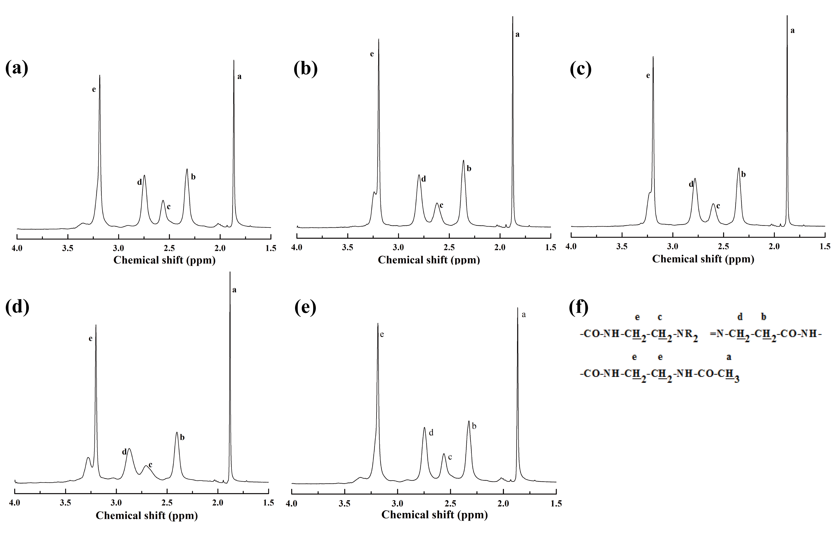
Figure S1. ¹H NMR spectra of acetylated G5.NH₂ (a), G5.NH₂-DOTA₅ (b), G5.NH₂-DOTA₁₀ (c), G5.NH₂-DOTA₂₀ (d), G5.NH₂-DOTA₃₀ (e) and the dendrimer structure used for NMR peak assignment (f)

