Supplementary Material

# Supplementary Figures and Tables

**Supplementary Table 1|** **Foreground Primers used in the study**

|  |  |  |  |
| --- | --- | --- | --- |
| **Sl. No.** | **Primer** | **Sequence** | **References** |
| 1. | **HYDB 65F-3’TE** | ACACCACATGGACAAGTTCG | (Yan et al., 2010) |
| 2. | **HYDB 62R-3’TE** | ACACTCTGGCCCATGAACAC |
| 3. | **HYDB 66R-3’TE** | ACAGAATACAGGGGACCAG |

**Supplementary Table 2|** **List of polymorphic SSR primers used in back ground selection**

|  |  |  |  |  |  |  |  |  |  |  |  |  |  |
| --- | --- | --- | --- | --- | --- | --- | --- | --- | --- | --- | --- | --- | --- |
| **SlNo** | | **Bin** | | **SSR Name** | | **Primer_F** | | **Primer_R** | | | **PIC** | | |
| 1 | | 1.00 | | **umc1353** | | AGACAGGATCATCGAAAACACACA | | ACCTCAGCCTCCTCGTCAACTACT | | |  | | |
| 2 | | 1.02 | | **bnlg1178** | | ACTACAGTTGAACGCCCCTG | | GCTCATGTGCAAATGCAAGT | | | 0.579 | | |
| 3 | | 1.01 | | **umc1948** | | TGTTGAAATAATGGAACACCTCCC | | ATCTATCTGGTTTCACGATCTCGC | | | 0.297 | | |
| 4 | | 1.01 | | **umc1160** | | CGTTTGATATGATGTGGAGATTCG | | AAGCTTGTGAATGTTCTGGATGTC | | | 0.261 | | |
| 5 | | 1.01 | | **umc1484** | | GCGTACAGAACAGAGCAGTTACGA | | ACTGAAGCTGCCTGCCTTCTATTT | | | 0.211 | | |
| 6 | | 1.03 | | **umc 1866** | | CCCAGCGCATGTCAACTCT | | CCCCGGTAATTCAGTGGATA | | | 0.087 | | |
| 7 | | 1.05 | | **umc1321** | | GATTTAAATTAGTAGCCGCCGTCC | | CCACCTGCAGATGTACAGAACAGT | | | 0.239 | | |
| 8 | | 1.05 | | **umc1611** | | TACTACCAGCAGCTTGCTTCAACA | | CTTCTTGTTCTTCACGCAGTTGTC | | | 0.28 | | |
| 9 | | 1.05 | | **umc1395** | | TGAATGAGTGGCATTCAAAATCTG | | CAGATTGCATGTGTGAGTGTGTGT | | |  | | |
| 10 | | 1.05 | | **umc1076** | | TTGGAAATCACCAATTGATATAGTTTG | | TCTATTGCAAACGCCAAAAGTAGC | | |  | | |
| 11 | | 1.06 | | **umc2235** | | GAACCCTCTAGGCTCCGGTTC | | TCGTCCCAGTACCATGCCTC | | | 0.36 | | |
| 12 | | 1.08 | | **umc1998** | | GCCTCCCAAGTGCAATATTAAATAGA | | AGAGCACAAGAACCACAACAACAA | | | 0.213 | | |
| 13 | | 1.09 | | **umc1082** | | CCGACCATGCATAAGGTCTAGG | | GCCTGCATAGAGAGGTGGTATGAT | | | 0.239 | | |
|  | **Bin** | | **SSR Name** | | **Primer_F** | | **Primer_R** | | **PIC** | | | |
| 14 | | 1.1 | | **umc2189** | | CGTAAGTACAGTACACCAATGGGC | | ACACCGACTACAAGCCTCTCAACT | | | 0.239 | | |
| 15 | | 1.12 | | **umc2100** | | AAAGGCATTATGCTCACGTTGATT | | TGACGTGCAAACAACCTTCATTAC | | | 0.340 | | |
| 16 | | 2.01 | | **phi96100** | | AGGAGGACCCCAACTCCTG | | TTGCACGAGCCATCGTAT | | | 0.245 | | |
| 17 | | 2.02 | | **umc1518** | | TAGCTCCTTTGCGCTATTCAGTCT | | GGCAGTGTTTTCTTTTGAAGTGCT | | | 0.188 | | |
| 18 | | 2.04 | | **umc1026** | | TCGTCGTCTCCAATCATACGTG | | GCTACACGATACCATGGCGTTT | | | 0.124 | | |
| 19 | | 2.04 | | **bnlg1613** | | GGGGATGATTCCGATAGGC | | GCGCTCTCTTTTCCCTCTCT | | | 0.215 | | |
| 20 | | 2.05 | | **umc1635** | | GCTGAGCAGATCTTTCCTTGTTTC | | AAGGAGCAGAACTCGGAGACG | | | 0.188 | | |
| 21 | | 2.05 | | **umc1535** | | CAAGGCACCCACACACATACATA | | GGCAGAGAGATGAAAAAGAATGGA | | |  | | |
| 22 | | 2.06 | | **bnlg1396** | | CGCATTTCTCCTGCAGTACA | | TGCTTGAGTCGTCGAATCTG | | | 0.239 | | |
| 23 | | 2.08 | | **phi127** | | ATATGCATTGCCTGGAACTGGAAGGA | | AATTCAAACACGCCTCCCGAGTGT | | | 0.239 | | |
| 24 | | 2.08 | | **umc1704** | | TTCACCGGGTAGTCCTTCTTACTG | | AGTACGCTGTACGCAGGCAG | | | 0.297 | | |
| 25 | | 2.09 | | **bnlg1520** | | TCCTCTTGCTCTCCATGTCC | | ACAGCTGCGTAGCTTCTTCC | | | 0.239 | | |
| 26 | | 3 | | **umc2101** | | CCCGGCTAGAGCTATAAAGCAAGT | | CTAGCTAGTTTGGTGCGTGGTGAT | | | 0.261 | | |
| 27 | | 3.01 | | **umc2257** | | AAAAAGGCAAACTCGACCCC | | GTCGTCATCTGCAAACCCTAGC | | | 0.188 | | |
| 28 | | 3.02 | | **umc1458** | | CCAATAAACAAATCATCTCCCCCT | | TGCTATGCTATGTACAGGGACAGG | | | 0.261 | | |
| 29 | | 3.04 | | **umc2158** | | ACACAGCACAACACAACACAACAC | | AATAATTGTACCGAGATGTTGGCG | | | 0.261 | | |
| 30 | | 3.04 | | **umc1030** | | TCCAGAGAATGAGATGACAAGACG | | CAGAATAACAGGAGATGAGACGCA | | | 0.239 | | |
| 31 | | 3.04 | | **umc2263** | | CGTGCTTATATGGGTTCTTGGGT | | GTTTGGTTGCTGCGACCTCTT | | | 0.216 | | |
| 32 | | 3.04 | | **bnlg1904** | | AGGAGCATGCACTTGGTTCT | | ACTCAACTGATGGCCGATCT | | |  | | |
| 33 | | 3.05 | | **umc1973** | | CAGGCAGAAAAGGAACGGAAC | | GTGCGAGAGAAGATGGATGATTG | | | 0.215 | | |
| 34 | | 3.06 | | **bnlg197** | | GCGAGAAGAAAGCGAGCAGA | | CGCCAAGAAGAAACACATCACA | | | 0.239 | | |
| 35 | | 3.08 | | **umc2174** | | GTACGTACGCAGCCACTTGTCAG | | ACATAAATAAAACGTGTGCCGCAG | | | 0.215 | | |
| 36 | | 3.06 | | **phi102228** | | ATTCCGACGCAATCAACA | | TTCATCTCCTCCAGGAGCCTT | | |  | | |
|  | **Bin** | | **SSR Name** | | **Primer_F** | | **Primer_R** | | | **PIC** | | |
| 37 | | 3.09 | | **umc1578** | | AAGCACTTCCAGTGGTACATGAGC | | CGAGCAGCTAAGGTAGAGCAGCTA | | | 0.239 | | |
| 38 | | 3.1 | | **umc1136** | | CTCTCGTCTCATCACCTTTCCCT | | CTGCATACAGACATCCAACCAAAG | | | 0.239 | | |
| 39 | | 4.01 | | **phi295450** | | CCTTTTCATGTTGCTTTCCC | | GCCCAATCCTTCCTTCCT | | | 0.239 | | |
| 40 | | 4.01 | | **phi213984** | | GTGACCTAAACTTGGCAGACCC | | CAAGAGGTACCTGCATGGC | | | 0.215 | | |
| 41 | | 4.04 | | **umc1963** | | CTCGTTCGAGGGGATGTACAAG | | CTTGCACTGGCACAGAGACG | | | 0.239 | | |
| 42 | | 4.05 | | **umc1511** | | CAGACAGATCCATCCAGCACATAC | | GTTTGTAGGCTTCGTTTTCCTTCA | | | 0.239 | | |
| 43 | | 4.08 | | **umc1313** | | GCTGTCTGTGACCAAGTTTCCTCT | | TGAAGAACAGGGACGTGATGATAA | | | 0.211 | | |
| 44 | | 4.08 | | **umc1476** | | CTCTGCCTCAGTCTGGTCGC | | CGAGGAAAGGAAGGAGAGCG | | | 0.239 | | |
| 45 | | 4.09 | | **umc1328** | | TACAAGGAGGAGGCCGCTGT | | ATCCAGTCTCCGGACTTCCAAC | | | 0.239 | | |
| 46 | | 4.1 | | **bnlg589** | | GGGTCGTTTAGGGAGGCACCTTTGGT | | GCGACAGACAGACAGACAAGCGCATTGT | | | 0.215 | | |
| 47 | | 4.11 | | **umc1707** | | GTCGAGAAGCGATCGATCATAGTAG | | GCACGACAGGGAGTACGGTC | | | 0.239 | | |
| 48 | | 4.11 | | **umc1649** | | GTGAAGCTCGATTTCTCCTCACAT | | GTGAAGCTCGATTTCTCCTCACAT | | | 0.157 | | |
| 49 | | 5 | | **umc1325** | | ATATTGTACAGGAGCAGCTGGGAC | | GGAGGTCATGCGTGTAAATAGGTC | | | 0.184 | | |
| 50 | | 5.01 | | **umc1523** | | TTTTAACTGTAAACCGGCCACATT | | AGAGTTAGATGACTGCAGTGGCTG | | | 0.34 | | |
| 51 | | 5.03 | | **umc2296** | | TGCAGTGACTTGAGACCATACACA | | GCTATACGCGTGCCAAGCTAAATA | | | 0.239 | | |
| 52 | | 5.03 | | **umc1564** | | AAGAAGAAAGAGAAGAAGCACGGG | | GGACAGCTCGTATTATAACCTGCG | | | 0.215 | | |
| 53 | | 5.03 | | **phi113** | | GCTCCAGGTCGGAGATGTGA | | CACAACACATCCAGTGACCAGAGT | | | 0.311 | | |
| 54 | | 5.03 | | **umc2295** | | CTGCTTCCAACTTCCGTTGC | | CACCTTGAAGACGTAGTCCACCTT | | | 0.365 | | |
| 55 | | 5.04 | | **umc2373** | | ACCCAAGTGAGGTGAAGTGAAGC | | TATGGTACAGGCACAGCAGCAGTA | | | 0.215 | | |
| 56 | | 5.04 | | **umc2300** | | ACAAGTTAACAGAACCATACGGGG | | TTTGTCTTGAGTGCCAATTTGAGA | | | 0.239 | | |
| 57 | | 5.05 | | **mmc0381** | | TGAAATAATTCACAGCACTCC | | TGATAGCACAACACAGCTATG | | |  | | |
| 58 | | 5.06 | | **phi085** | | AGCAGAACGGCAAGGGCTACT | | TTTGGCACACCACGACGA | | | 0.215 | | |
|  | **Bin** | | **SSR Name** | | **Primer_F** | | **Primer_R** | | **PIC** | | | |
| 59 | | 5.06 | | **umc2306** | | CCTTGTGCAGTGGAGTTAATGAAA | | GCTACCCATTGCTATGGTTTTCTG | | | 0.215 | | |
| 60 | | 5.08 | | **umc2143** | | ACACACAACAGAGCCTTTTGTTCA | | AAGAAAAGGACACCAAACCAAACA | | | 0.239 | | |
| 61 | | 6 | | **umc2309** | | CTGTGTTTTGTGTATTAGCGCCAG | | GTCGAAATTCCTGACACAAAAAGG | | | 0.239 | | |
| 62 | | 6.01 | | **umc2313** | | CCTCTAGTCACGGTTCAAAGGACA | | AAGGAGGATGCAGTCTCGGTTT | | | 0.239 | | |
| 63 | | 6.04 | | **umc1857** | | TTCCTTGCCAACAAATACAAGGAT | | GTTCATTGCTTCATCTTGGAACCT | | | 0.239 | | |
| 64 | | 6.04 | | **umc1014** | | GAAAGTCGATCGAGAGACCCTG | | CCCTCTCTTCACCCCTTCCTT | | | 0.184 | | |
| 65 | | 6.05 | | **nc012** | | TAATTTAAACACCACACCACCG | | ACACACGCCAAAGAAAAACC | | | 0.215 | | |
| 66 | | 6.05 | | **bnlg1154** | | GGGTGATCACATGGGTTAGG | | AAATCAATGCTCCAAATCGC | | | 0.239 | | |
| 67 | | 6.05 | | **phi025** | | GCAACATCCTGGAGAGCCACTACAAGG | | ACAGCCTGTTTTCCTGGACAGTGAACTC | | | 0.188 | | |
| 68 | | 6.07 | | **umc2059** | | GGAAAAGGAGGAACAGTGTAAGCA | | AGCGTGATCAGACGTACAATGCTA | | | 0.215 | | |
| 69 | | 6.07 | | **phi122** | | GGAGACGAGGTGCTACTTCTTCAA | | TGTGGCTGAGGCTAGGAATCTC | | | 0.215 | | |
| 70 | | 6.08 | | **umc2324** | | GATCCTCTGTCGCCAAACACTAAG | | AGATGGTGACGATGAGTGATGAAC | | | 0.185 | | |
| 71 | | 7.01 | | **umc2325** | | CCTAGGAACTCTGATGGCTATGGA | | CTACGATATCCACCTCTACCACCG | | | 0.239 | | |
| 72 | | 7.01 | | **umc1066** | | ATGGAGCACGTCATCTCAATGG | | AGCAGCAGCAACGTCTATGACACT | | | 0.215 | | |
| 73 | | 7.02 | | **bnlg1094** | | GTGAAGAACGATGACGCAGA | | CAGCAACGCTCTCACATTGT | | | 0.239 | | |
| 74 | | 7.03 | | **phi091** | | ATCTTGCTTCCATAAGATGCACTGCTCT | | CTCAGCTTCGGTTCCTACACAGT | | | 0.215 | | |
| 75 | | 7.03 | | **bnlg434** | | GTGCAAAGGGGAGAGAGGAA | | TCGCCGTTCTTCGCCTTAG | | |  | | |
| 76 | | 7.03 | | **umc1324** | | ATCCATCATCATCATCATTGCTTG | | ATGTCATCATGTACCAGGTGTTGG | | |  | | |
| 77 | | 7.03 | | **umc1408** | | GATCCGTCTCTTGCCGTGGTA | | ATGAGCTTGCGGTCCTCCTC | | | 0.184 | | |
| 78 | | 7.04 | | **umc1412** | | GCATCTGTAGCCTTTTTGTGTGTG | | CTCAGCTTGCAGGTTATCGCTT | | | 0.239 | | |
| 79 | | 7.04 | | **bnlg1666** | | GCTGGTAGCTTTCAGATGGC | | TGTCCCTCCTCCAGTTTCAC | | | 0.215 | | |
| 80 | | 7.04 | | **umc1710** | | ACTTTGCAACTACCGTACATGGGT | | TTCGACTGCACGTGAAAATCTATC | | | 0.087 | | |
| 81 | | 8.03 | | **phi125** | | ACCGCCGGTGCGAGTTGAAG | | CTTGGGATTGCCCTCATCCAC | | | 0.157 | | |
|  | **Bin** | | **SSR Name** | | **Primer_F** | | **Primer_R** | | **PIC** | | |
| 82 | | 8.05 | | **umc1130** | | TTGGGACTCATTACTTCCGGACT | | GCTAGGGGAAAGCTCGTACTATGG | | | 0.261 | | |
| 83 | | 8.05 | | **umc1777** | | GACAGCACCTGAAACTGAAACTGA | | GTCTTTCTCCACATCCCTGTTTGT | | | 0.297 | | |
| 84 | | 8.08 | | **umc2357** | | GAGCAAGAAGCAGAGCAGCAAG | | AGCTCCCTCAGGTAGTTGTCCTG | | | 0.28 | | |
| 85 | | 8.08 | | **phi080** | | CACCCGATGCAACTTGCGTAGA | | TCGTCACGTTCCACGACATCAC | | | 0.124 | | |
| 86 | | 9.03 | | **umc1743** | | TGGACTTCGAAAATTCTCTTCAGC | | GAGAGGAGGAGCTTCACGAGC | | | 0.087 | | |
| 87 | | 9.03 | | **umc1586** | | GAGGATGAGGAGGATGGTAATGGT | | TAGGAGATGAGCTCGTCGGATAAG | | | 0.124 | | |
| 88 | | 9.03 | | **umc2337** | | GAGTACCTCCGCCCACTCATC | | CTAACGTACACACATCTTGGCTGG | | | 0.157 | | |
| 89 | | 9.04 | | **bnlg1209** | | GTCCCGGGCAGAATAATACC | | TTCCTCCTTGAAGTGCTCGT | | | 0.215 | | |
| 90 | | 9.05 | | **umc1231** | | CTGTAGGGCTGAGAAAAGAGAGGG | | CGACAACTTAGGAGAACCATGGAG | | | 0.188 | | |
| 91 | | 9.05 | | **umc2134** | | TAGTCTAGCGTCGACGAAAAATGC | | CAGGCGACGAAGATGAATTGAA | | | 0.124 | | |
| 92 | | 9.05 | | **umc2133** | | TTCAGGTGTGCACTGACTCTGACT | | ATGCTCAAGCTCAACAGCACTTC | | | 0.124 | | |
| 93 | | 9.05 | | **umc1417** | | GAATCCTGGTTGGCCTTTCC | | ACAGCTGAGAACGCATTAGCAAG | | | 0.124 | | |
| 94 | | 9.06 | | **umc2346** | | GTACATGATCTCGAGAAAGCCGAT | | CTTTCTGCAGTTCTGCTAGCTGTG | | | 0.157 | | |
| 95 | | 9.07 | | **umc2099** | | AGGTCATCAAGATGCAGAGGGAG | | TCAAGGTACGAAGCCTGACGAC | | | 0.157 | | |
| 96 | | 9.08 | | **umc1137** | | ATCAGTCACTCTTCTGCCTCCACT | | GGCTGGATAATGTTGTAGCTGGTC | | | 0.212 | | |
| 97 | | 10.03 | | **bnlg1712** | | CTCAGGCTTCACGTGGGTTT | | GTTACACTCCCCTGCCAAAA | | | 0.157 | | |
| 98 | | 10.04 | | **umc1506** | | AAAAGAAACATGTTCAGTCGAGCG | | ATAAAGGTTGGCAAAACGTAGCCT | | | 0.188 | | |
| 99 | | 10.04 | | **bnlg1250** | | CCATATATTGCCGTGGAAGG | | TTCTTCATGCACACAGTTGC | | | 0.368 | | |
| 100 | | 10.04 | | **umc2163** | | AAGCGGGAATCTGAATCTTTGTTC | | GAAATTGCTGGGGTTCTCATTTCT | | | 0.157 | | |
| 101 | | 10.04 | | **umc1827** | | GCAAGTCAGGGAGTCCAAGAGAG | | CCACCTCACAGGTGTTCTACGAC | | | 0.184 | | |
| 102 | | 10.06 | | **bnlg1028** | | AGGAAACGAACACAGCAGCT | | TGCATAGACAAAACCGACGT | | | 0.366 | | |
| 103 | | 10.07 | | **umc2126** | | CAGTTCTGCACTTCTGCTTGCTC | | AGGACTGTGAAGAGCGCGAG | | | 0.184 | | |

**Note.,** Bin number is the position of the SSR marker on the chromosome. The primer name and the sequences were retrieved from the maize https://www.maizegdb.org/. **Primer_F** Forward Primer Sequence; **Primer R** Reverse Primer Sequence; **PIC** Polymorphic Information Content.

## 2. Supplementary Figures

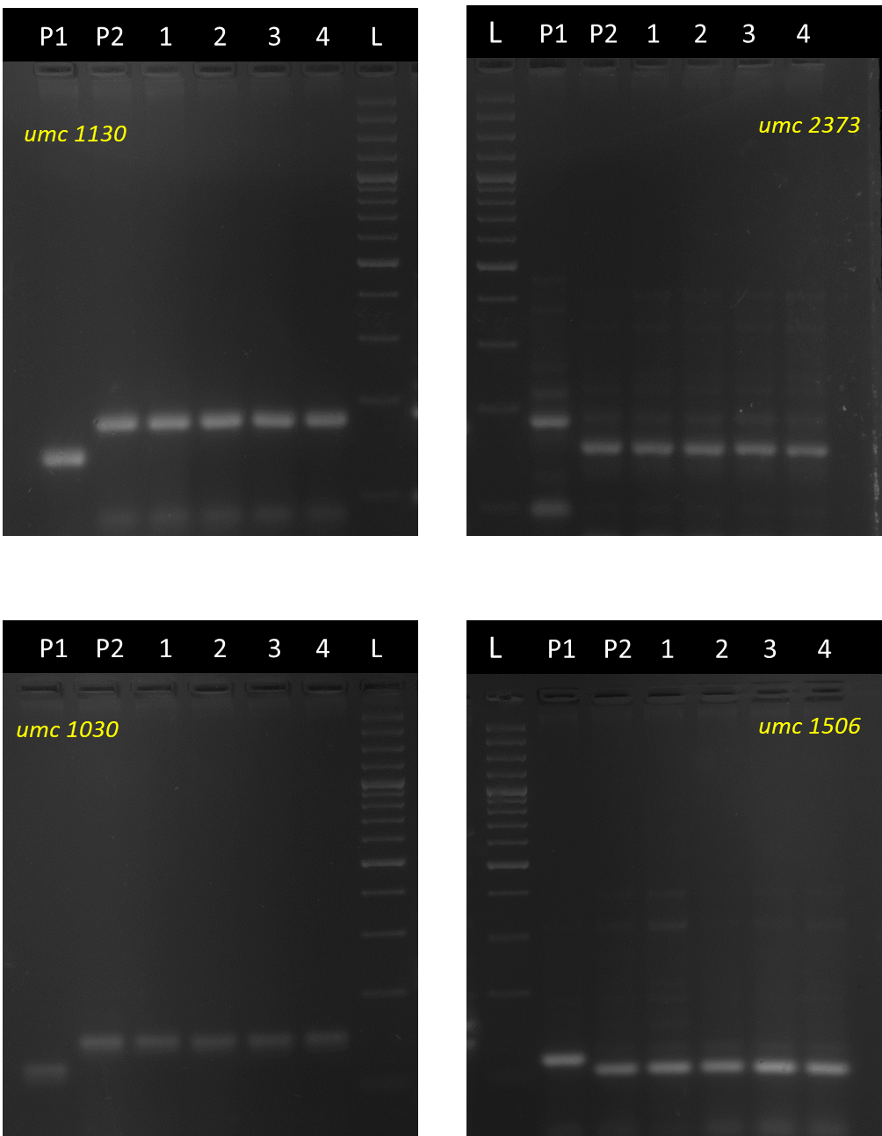

**Supplementary Figure 1a.** Background selection using SSR marker for selected improved lines from BC2F3 generation of SC11-2 × UMI 1230β1+. **Note;** (100bp), (P1) UMI 1230β1+, (P2) SC11-2, (1) DBT 17-1-1-1-35-1, (2) DBT 17-1-1-1-35-2, (3) DBT 17-1-1-1-35-3, (4) DBT 17-1-1-1-35-4 (L) Ladder