Supplementary Materials

Xylem anatomy and hydraulic traits in Vitis grafted cuttings in view of their impact on the grapevine young decline
Enrico Battiston^{1†}, Sara Falsini^{2†}, Alessio Giovannelli³, Silvia Schiff², Corrado Tani², Roberta Panaiia², Alessio Papini², Stefano Di Marco⁴ and Laura Mugnai¹

† These authors have contributed equally to this work and share first authorship

¹ Università degli Studi di Firenze, Dipartimento di Scienze e Tecnologie Agrarie, Alimentari, Ambientali e Forestali – Sezione Patologia Vegetale ed Entomologia, P.le delle Cascine 28, 50144 Firenze, Italy
² Università degli Studi di Firenze, Dipartimento di Biologia – Laboratorio di Biomorfologie, Via Micheli 3 - 50121 Firenze, Italy
³ Consiglio Nazionale delle Ricerche, Istituto di Ricerca sugli Ecosistemi Terrestri, Via Madonna del Piano 10, 50019 Sesto Fiorentino, Italy
⁴ Consiglio Nazionale delle Ricerche, Istituto per la Bioeconomia, Via P. Gobetti 101, 40129 Bologna, Italy

Anatomical study
Grafting trial 1

Glera scion onto K5BB rootstock:
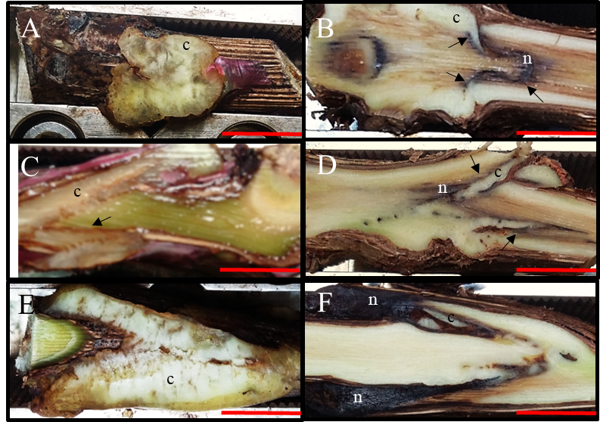
Figure S1: Photographs of graft longitudinal sections of Glera scion onto K5BB rootstock, at T1 (A, C, E) and T3 (B, D, F). Callus formation in different graft union shapes: Omega (A, B), W&T (C, D) and FC (E, F). Scale Bar: 0.8mm. c= callus; n= necrosis; black arrows= discontinuity.
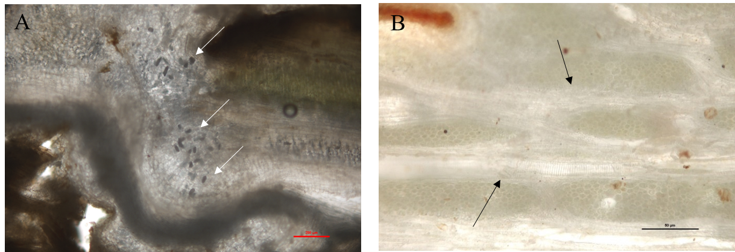
Figure S2: LM images of longitudinal sections of Glera grafting. (A) Not structured callus with Calcium Oxalate crystals (arrows) in FC grafting at T1. (B) Structured callus with xylem vessels (arrows) in W&T grafting at T3.

Cabernet Sauvignon scion onto K5BB:
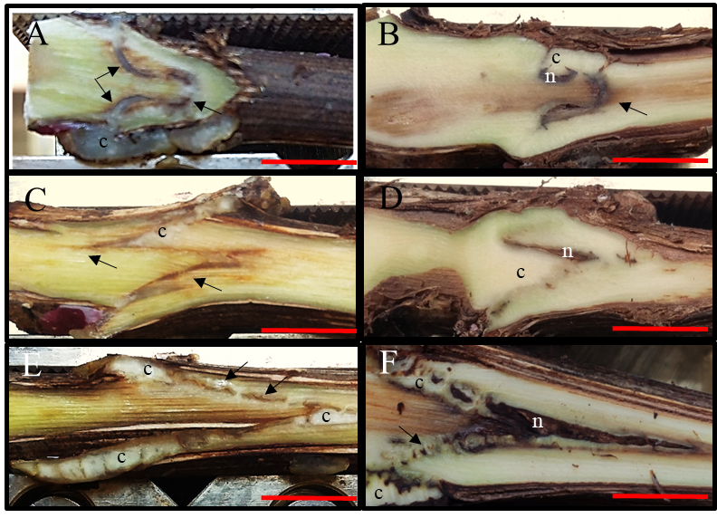
Figure S3: Photographs of graft longitudinal sections of Cabernet Sauvignon scion onto K5BB rootstock, at T1 (A, C, E) and T3 (B, D, F). Callus formation in different graft union shapes: Omega (A, B), W&T (C, D) and FC (E, F). Scale Bar: 0.8mm. c= callus; n= necrosis; black arrows= discontinuity.

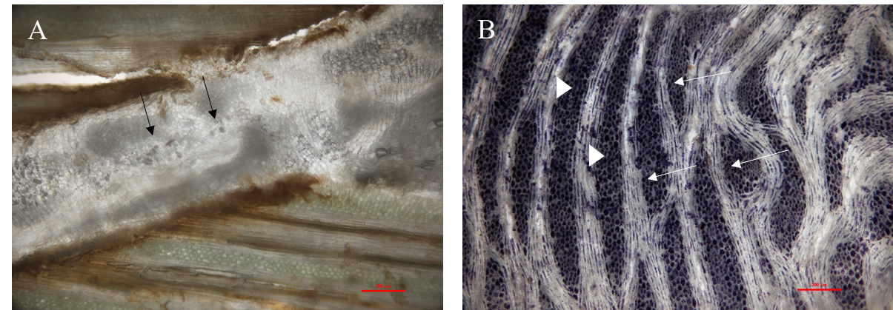
Figure S4: LM images of longitudinal sections of Cabernet Sauvignon grafting. (A) Not structured callus with Calcium Oxalate crystals in W&T grafting at T1. (B) Structured callus with xylem vessels (arrows) among parenchymatous tissue rich in starch (head arrows) at T3 (Lugol staining).

Teroldego scion onto K5BB rootstock:
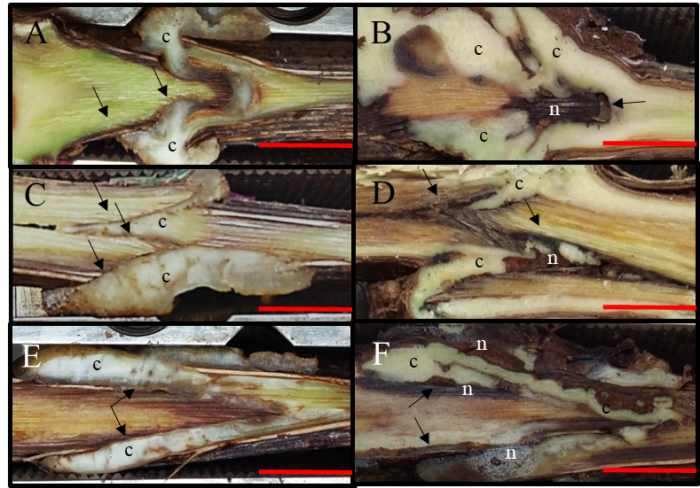
Figure S5: Photographs of graft longitudinal sections of Teroldego scion onto K5BB rootstock, at T1 (A, C, E) and T3 (B, D, F). Callus formation in different graft union shapes: Omega (A, B), W&T (C, D) and FC (E, F). Scale Bar: 0.8mm. c= callus; n= necrosis; black arrows= discontinuity.

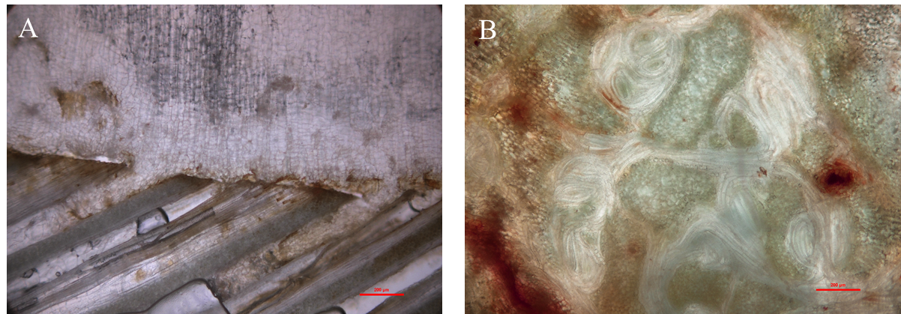
Figure S6: LM images of longitudinal sections of Teroldego cv. (A) Not structured callus in Omega grafting at T1. (B) Callus in differentiation characterized by meristemoids.

Grafting trial 2:
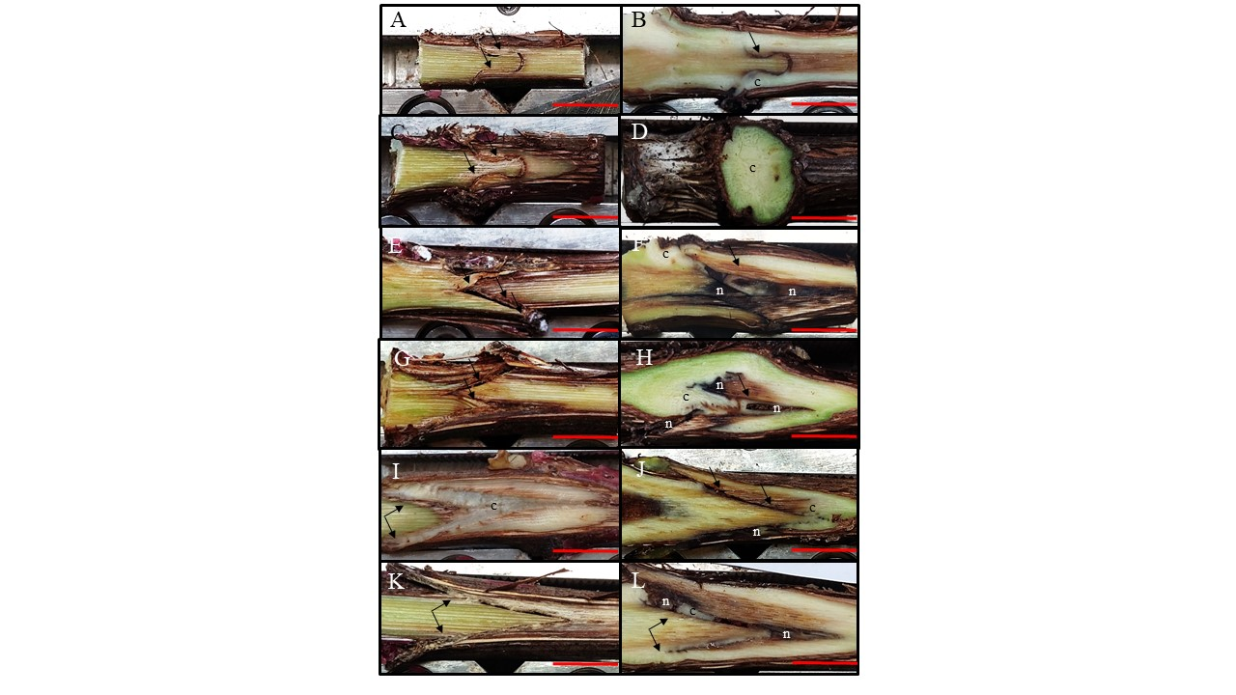

Figure S7: Photographs of graft longitudinal sections of Glera scion onto K5BB rootstock, at T1 (A, C, E, G, I, K) and T3 (B, D, F, H, J, L). Callus formation in different graft union shapes: Omega thin (A, B), Omega thick (C, D), W&T thin (E, F), W&T thick (G, H), Full Cleft thin (I, J) and Full cleft thick (K, L). Scale Bar: 0.8mm. c= callus; n= necrosis; black arrows= discontinuity.

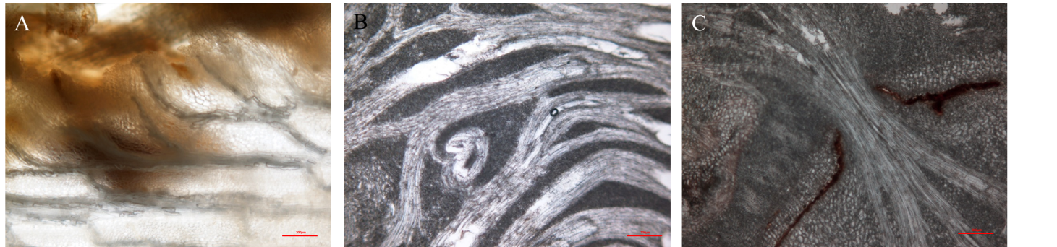
Figure S8: LM images of longitudinal sections of Glera grafting. (A) Differentiated Callus in FC thin grafting at T1. (B) Callus in differentiation characterized by meristemoids in Omega thick and (C) differentiated callus in Omega thin at T3.

Table S1: Parametrization of number of internodes by Logistic model.
Cultivar | Grafting type |  | Logistic model
 |  | K | y₀ | r
Glera | omega | 21.5±3.9d | 2.6*10⁻⁴ | 0.058±0.008
 | FC | 24±4.9cd | 4.2*10⁻⁴ | 0.057±0.008
 | W&T | 22.8±5.8cd | 1.4*10⁻³ | 0.053±0.01
Teroldego | Omega | 23.7±5.3cd | 8.5*10⁻⁵ | 0.063±0.01
 | FC | 27.0±4.8bcd | 1.4*10⁻⁴ | 0.062±0.008
 | W&T | 26.7±4.3bcd | 4.5*10⁻⁴ | 0.064±0.004
Cabernet Sauvignon | Omega | 33.0±5.0a | 5.2*10⁻⁴ | 0.061±0.009
 | FC | 30.5±4.1ab | 6.6*10⁻⁵ | 0.063±0.005
 | W&T | 27.2±4.4bc | 7.1*10⁻⁵ | 0.063±0.006
Two-way ANOVA
Factors | Df |  | F value
Cultivars | 2 | 28.128*** | 3.811* | 10.873***
Grafting type | 2 | 1.334 ^{ns} | 0.877^{ns} | 0.08^{ns}
Cultivars x Grafting type | 4 | 3.78* | 2.398^{ns} | 0.911^{ns}
*P < 0.05, ***P < 0.001, ns, non significant.

