Supplementary Material

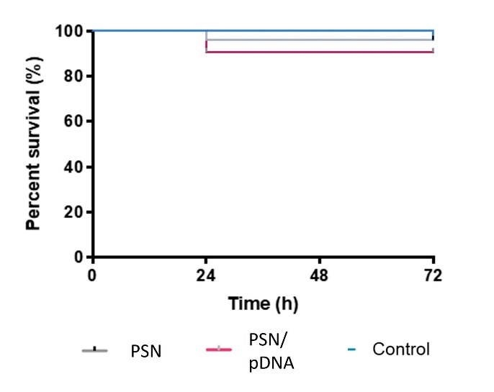

**Figure S1.** Toxicity assay of PSN and PSN/pDNA in zebrafish embryos after 24, 48 and 72 hours of incubation.

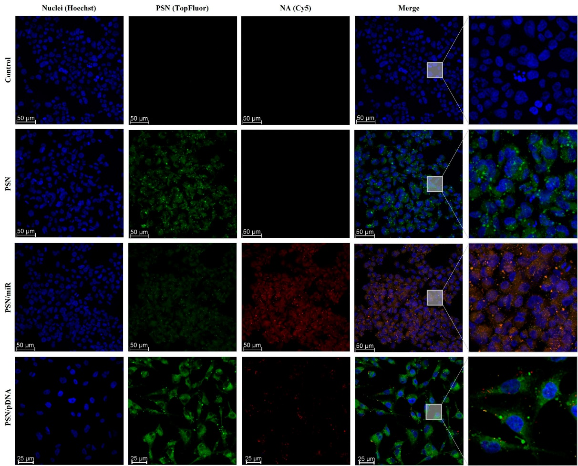

**Figure S2.** Confocal images of triple negative breast cancer cells (MDA-MB-231 cell line) after a 4h incubation with TopFluor-labelled nanosystems (green) associated and non-associated with miR/pDNA-Cy5 (red). Cell nuclei were stained with Hoescht (blue).

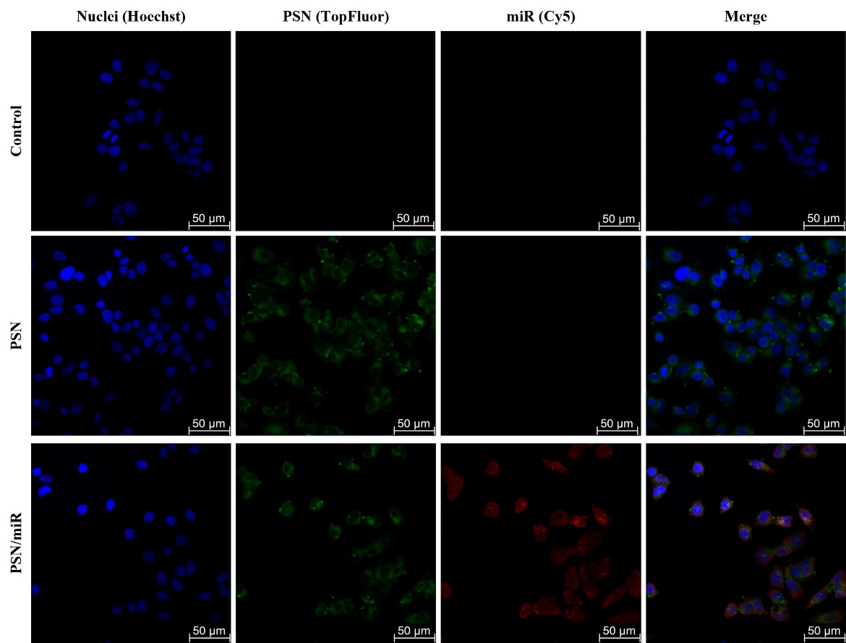**Figure S3.** Confocal images of MCF7 breast cancer cells resulting after a 4h incubation with nanocarriers labelled with TopFluor (green) associated and non-associated with miR-Cy5 (red). Cell nuclei were stained with Hoescht (blue).