Figure S1 Multiple sequence alignment of the cysteine-rich zinc finger-like motif identified in the hypothetical proteins encoded by dsRNA2 of TaPmV-1and other polymycoviruses.
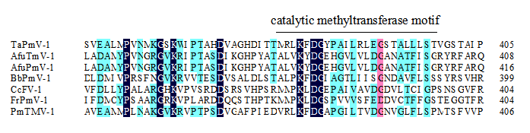
Figure S2 Multiple sequence alignment of the catalytic MTR motif identified in the proteins encoded by dsRNA3 of TaPmV-1 and other polymycoviruses.
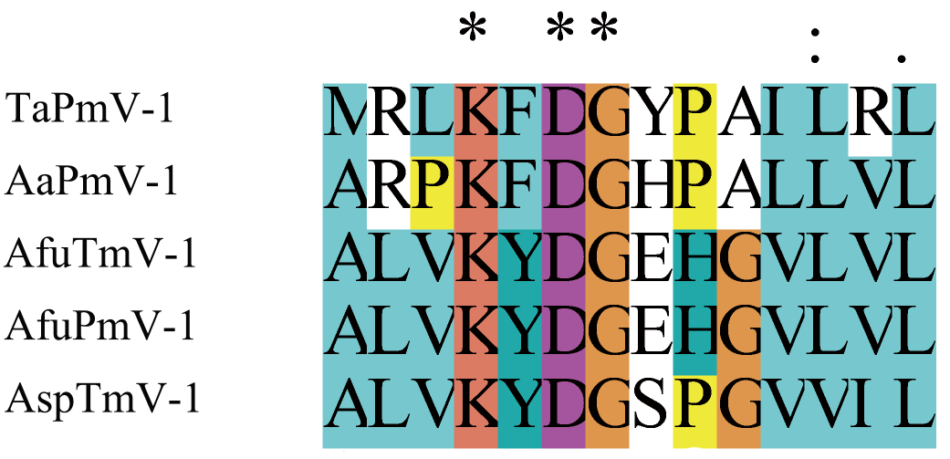
Figure S3 Multiple sequence alignment of the regions of proteins putatively encoded by TaPmV-1, AaPmV1, AfuTmV-1, AfuPmV-1 and AspTmV-1 that mediate the in 5’- capping of RNA.
Figure S4 Predicted secondary structures of 5’-UTRs and 3’-UTRs of dsRNAs 1-6 of TaPmV-1. (A) Secondary structures of the 5’-UTRs of dsRNA1-dsRNA6. (B) Secondary structures of the 3’-UTRs of dsRNA1- dsRNA6.

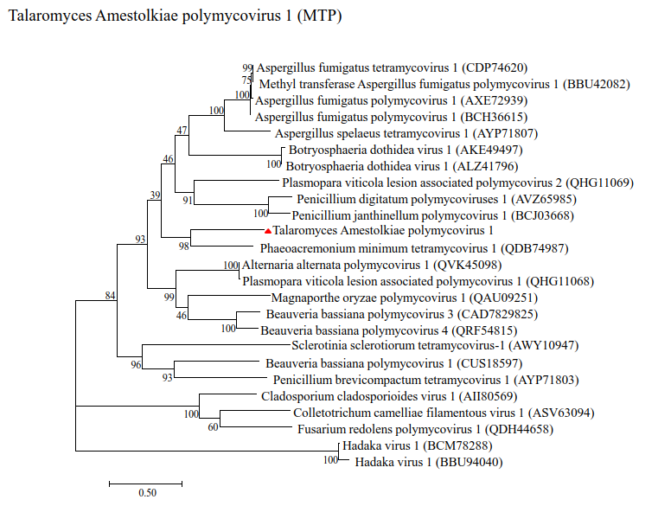
Figure S5 Phylogenetic analyses of TaPmV-1 and selected polymycoviruses. Phylogenetic analyses of TaPmV-l based on the sequences of MTP.
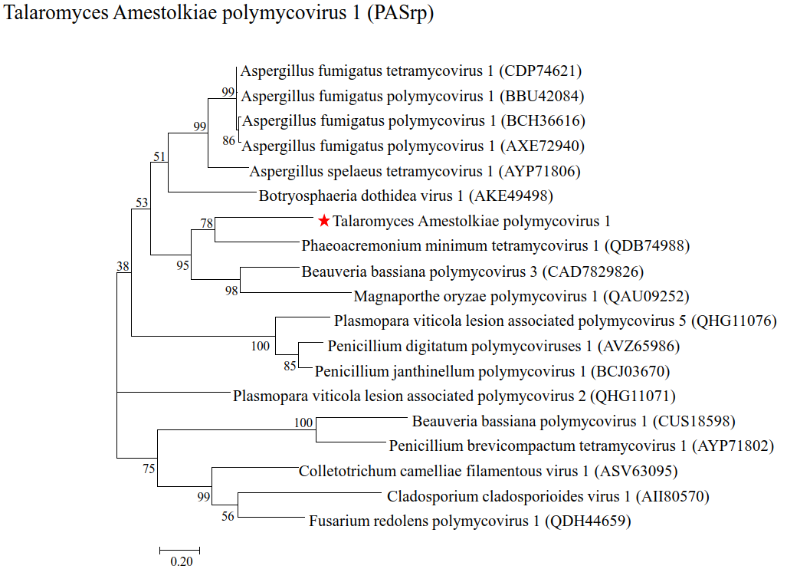
Figure S6 Phylogenetic analyses of TaPmV-1 and selected polymycoviruses. Phylogenetic analyses of TaPmV-l based on the sequences of PASrp.
Figure S7 Detection of TaPmV-1 in T. amestolkiae. (A) Detection of TaPmV-1 in T. amestolkiae following treatment with the protoplast preparation and regeneration approach, using CF11 cellulose columns for extraction followed by gel electrophoresis. (B) The presence of the TaPmV-1 genome in the strain LSH3 and the absence of the TaPmV-1 genome in the strain LSH3VF were confirmed by RT-PCR.

