**Causes of Death and Conditional Survival Estimates of Long-term Lung Cancer Survivors**

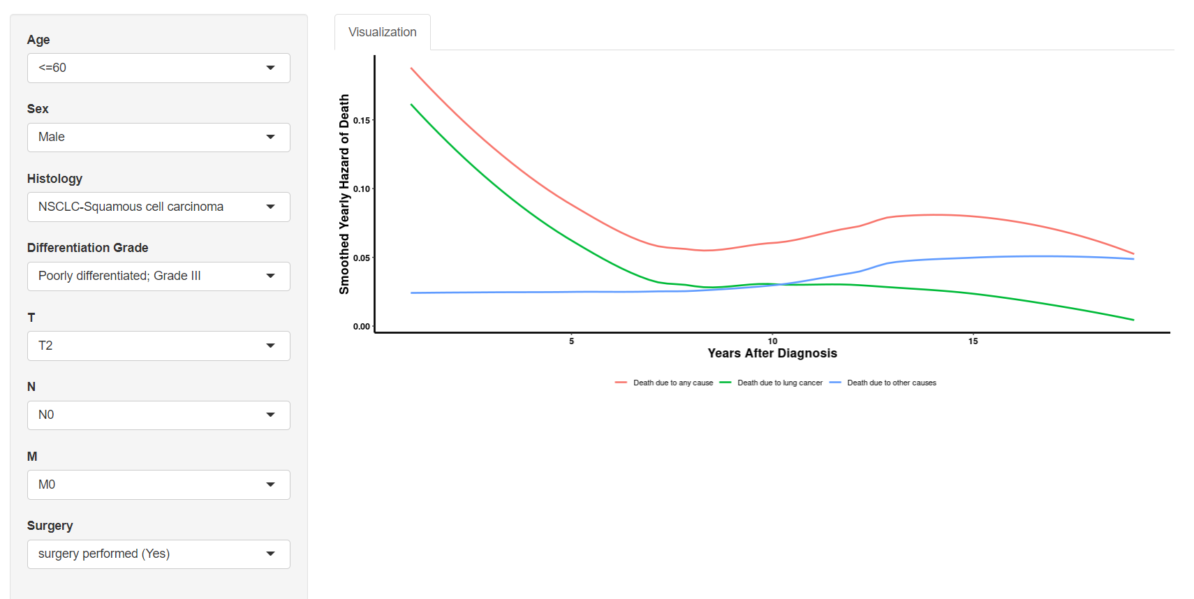

**eFigure 1. Representative Screenshot of the Web-Based Calculator to Determine Critical Time Point.**

This Figure is generated from website <https://lccs.shinyapps.io/lungcancercauses/> to help establish when the death risk from other causes will exceed that from lung cancer for different lung cancer patients. It indicates that, for male LSCC patients aged ≤ 60, with poor differentiation grade (grade III), T2N0M0, and received surgical treatment, the critical time point was 10-year, subsequent visit should more focus on other death risks since then.