Supplementary Material

Supplementary Data

The active compounds of LHQW are in the attachment file. (Active compounds of LHQW.xls)

The active compounds of QFPD are in the attachment file. (Active compounds of QFPD.xls)

Supplementary Figures and Tables

Supplementary Figures

Supplementary Figure 1

Supplementary Figure 2
Supplementary Figure 1. Chemical ingredients and putative targets of the active compounds in Lianhua Qingwen (LHQW) and Qingfei Paidu Decoction Qingfei Paidu Decoction (QFPD). (A) Venn diagram of candidate ingredients in LHQW and QFPD. (B) Venn diagram of target genes in hosts of LHQW and QFPD.
Supplementary Figure 2. Root mean square fluctuation (RMSF) and solvent-accessible surface area (SASA) of Molecular dynamics simulations. (A) The RMSF of arctiin binding to GRM1. (B) The RMSF of β-carotene binding to GRM1. (C) The RMSF of arctiin binding to GRM5. (D) The SASA of arctiin binding to GRM1. (E) The SASA of β-carotene binding to GRM1. (F) The SASA of arctiin binding to GRM5.

Supplementary Tables
Table S1. The Components, properties, and channel tropism of LHQW and QFPD.
Components | Formulas |  | Property and flavor | Channel tropism
Forsythiae Fructus  (Lian Qiao) | LHQW |  | slightly cold, bitter | lung, heart, small intestine
Glycyrrhizae Radix Et Rhizome  (Gan Cao) | LHQW | QFPD | natured, sweet | heart, lung, spleen, stomach
Lonicera Japonicae Flos  (Jin Yin Hua) | LHQW |  | cold, sweet | lung, heart, stomach
Pogostemonis Herba  (Guang Huo Xiang) | LHQW | QFPD | slightly warm, pungent | spleen, stomach, lung
Isatidis Radix  (Ban Lan Gen) | LHQW |  | cold, bitter | heart, stomach
Armeniacae Semen Amarum  (Ku Xing Ren) | LHQW | QFPD | slightly warm, bitter | lung, large intestine
Houttuyniae Herba  (Yu Xing Cao) | LHQW |  | slightly cold, pungent | lung
Ephedrae Herba  (Ma Huang) | LHQW | QFPD | warm, pungent, slightly bitter | lung, urinary bladder
Dryopteridis Crassirhizomatis Rhizoma (Mian Ma Guan Zhong) | LHQW |  | slightly cold, bitter | liver, stomach
Rhei Radix Et Rhizoma  (Da Huang) | LHQW |  | cold, bitter | spleen, stomach, large intestine, liver, cardiovascular
Menthae Haplocalycis Herba  (Bo He) | LHQW |  | cold, pungent | lung, liver
Gypsum Fibrosum  (Shi Gao) | LHQW | QFPD | sweet | lung, heart
Rhodiolae Crenulatae Radix Et Rhizoma  (Hong Jing Tian) | LHQW |  | slightly cold, bitter | lung, heart, Small intestine
Cinnamomi Ramulus  (Gui Zhi) |  | QFPD | warm, pungent and sweet | Heart, lung and bladder
Alismatis Rhizoma  (Ze Xie) |  | QFPD | light and cold, sweet | Kidney and bladder
Polyporus  (Zhu Lin) |  | QFPD | light and flat, sweet | Kidney and bladder
Atractylodis Macrocephalae Rhizoma  (Bai Zhu) |  | QFPD | warm, bitter and sweet | Spleen and stomach
Poria  (Fu Lin) |  | QFPD | light and flat, sweet | Heart, lung, spleen and kidney
Bupleuri Radix  （Chai Hu） |  | QFPD | slightly cold and bitter | Liver, gallbladder and lung
Astragali Radix  (Huang Qin) |  | QFPD | cold, bitter | Lung, gallbladder, spleen, large intestine and small intestine
Pinelliae Rhizoma Praeparatum Cum Zingibere Et Alumine  (Jiang Ban Xia) |  | QFPD | warm, pungent | Spleen, stomach and lung
Zingiberis Rhizoma Recens  (Sheng Jiang) |  | QFPD | mild temperature and pungent | Lung, spleen and stomach
Asteris Radix Et Rhizoma  (Zi Wan) |  | QFPD | warm and bitter | lung
Farfarae Flos  (Dong Hua) |  | QFPD | Warm. pungent and slightly bitter | lung
Belamcandae Rhizoma  (She Gan) |  | QFPD | cold, bitter | lung
Asari Radix Et Rhizoma  (Xi Xin) |  | QFPD | warm, pungent, | Heart, lung and kidney
Dioscoreae Rhizoma  (Shan Yao) |  | QFPD | flat, sweet | Spleen, lung and kidney
Aurantii Fructus Immaturus  (Zhi Shi) |  | QFPD | slightly cold, bitter, pungent, and sour | Spleen and stomach
Citri Reticulatae Pericarpium  (Chen Pi) |  | QFPD | warm, bitter, and pungent | Lung and spleen
Table S2. Number of active compounds and genes in LHQW and QFPD.
Formulas | Number of active compounds | Number of genes in hosts
LHQW | 196 | 249
QFPD | 310 | 261
Table S3. The chemical structures contained from LHQW participating in docking.
Target protein | Active compound | Chemical structure
GRM1 | CFMTI | 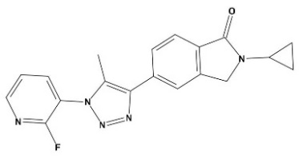
 | [11C]LY-2428703 | 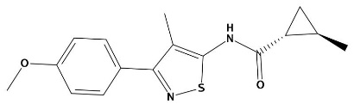
 | Arctiin | 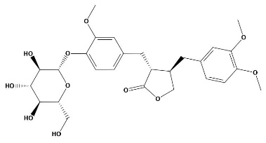
 | β-carotene | 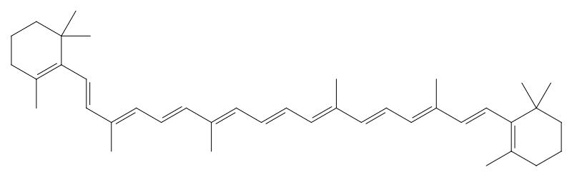
 | Aloe-emodin | 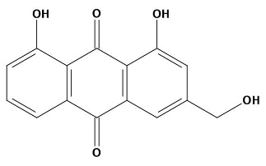
GRM5 | HTL-14242 | 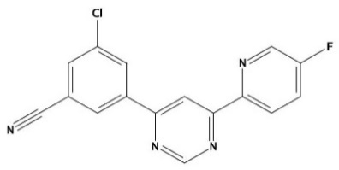
 | ADX-50938 | 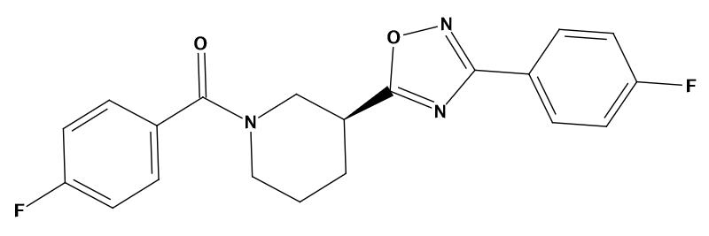
 | Arctiin | 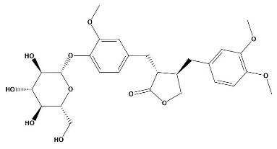
 | Corymbosin | 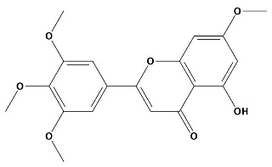
 | Aloe-emodin | 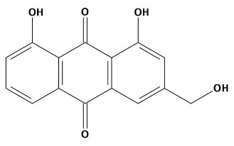
Table S4. Docking score of chemical ingredients with specific targets of LHQW.
Target protein | PDBID | Active  compound | Source | ChemPLP | ChemScore | Affinity  (kcal/mol)
GRM1 | 4OR2 | CFMTI | Control | 88.87 | 35.91 | -9.07
 |  | [11C]LY-2428703 | Control | 73.16 | 44.77 | -8.53
 |  | Arctiin | Lian Qiao | 81.58 | 18.8 | -10.51
 |  | β-carotene | Jin Yin Hua | 79.64 | 34.17 | -10.16
 |  | Aloe-emodin | Da Huang  Bo He | 72.68 | 48.57 | -6.73
GRM5 | 6FFH | HTL-14242 | Control | 103.06 | 38.50 | -6.52
 |  | ADX-50938 | Control | 89.36 | 36.82 | -6.91
 |  | Arctiin | Lian Qiao | 93.75 | 34.26 | -6.29
 |  | Corymbosin | Jin Yin Hua | 77.47 | 28.92 | -7.65
 |  | Aloe-emodin | Da Huang  Bo He | 64.58 | 21.31 | -5.39
Table S5. The chemical structures contained from QFPD participating in docking
Target protein | Active compound | Chemical structure
MTOR | Apitolisib | 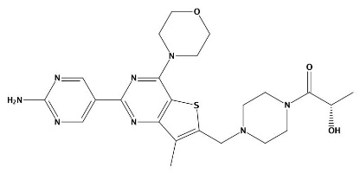
 | Gedatolisib | 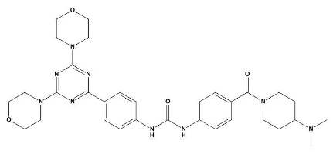
 | Isofucosterol | 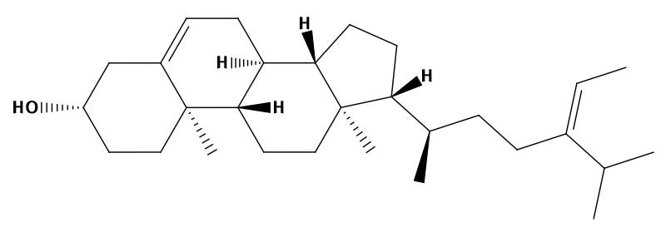
 | Baicalein | 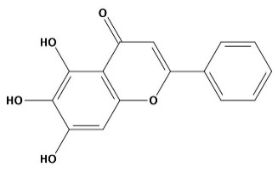
 | Nobiletin | 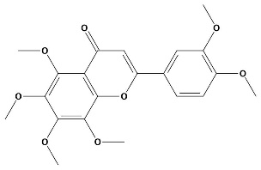
 | Oroxylin A | 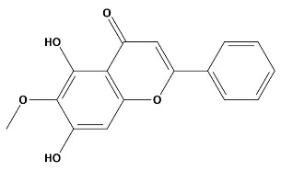
PLA2G4A | YM-26567-1 | 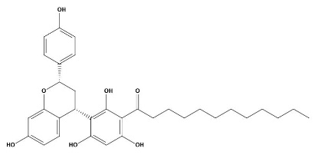
 | BMS-181162 | 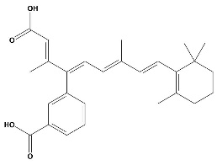
 | Epiberberine | 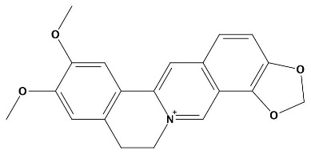
 | Piperlonguminine | 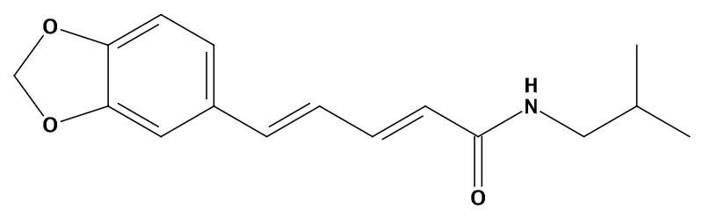
 | Baicalein | 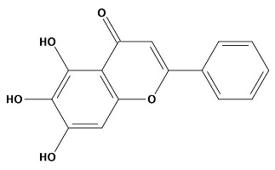
 | Isofucosterol

Table S6. Docking score of chemical ingredients with specific targets of QFPD.
Target protein | PDBID | Active  compound | Source | ChemPLP | ChemScore | Affinity  (kcal/mol)
MTOR | 4JT6 | Apitolisib | Control | 97.22 | 36.75 | -8.52
 |  | Gedatolisib | Control | 94.44 | 30.25 | -10.71
 |  | Isofucosterol | Shan Yao | 84.99 | 40.38 | -6.59
 |  | Baicalein | Huang Qin  Ban Xia | 74.05 | 34.91 | -6.60
 |  | Nobiletin | Zi Wan  Zhi Shi | 70.95 | 28.81 | -8.21
 |  | Oroxylin A | Huang Qin | 70.68 | 32.26 | -7.04
PLA2G4A | 1CJY | YM-26567-1 | Control | 92.08 | 26.14 | -9.06
 |  | BMS-181162 | Control | 73.28 | 22.10 | -8.22
 |  | Epiberberine | Huang Qin | 64.99 | 22.38 | -6.76
 |  | Piperlonguminine | Shan Yao | 63.97 | 23.86 | -6.33
 |  | Baicalein | Huang Qin | 62.14 | 24.18 | -6.64
 |  | Isofucosterol | Shan Yao | 60.12 | 24.83 | -7.87

