Supplementary Material

Supplementary Figures
Supplementary Figure 1. Methodology for grading clubroot disease investigations of B. napus.
Supplementary Figure 2. Methodology for grading clubroot disease investigations of A. thaliana.
Supplementary Figure 3. Expression levels of AtERF034 and BnERF034 in tissues and organs.
Supplementary Figure 4. Expression pattern of AtERF034 under different pathogen stresses and expression levels of root response elicitations in A. thaliana.
Supplementary Figure 5. Screening and identification of transgenic lines of BnERF034.
Supplementary Figure 6. The related functional identification about BnPUB15.
Supplementary Figure 7. The related functional identification about TCP9.
Supplementary Figure 8. Predicted interacting proteins of ERF034.
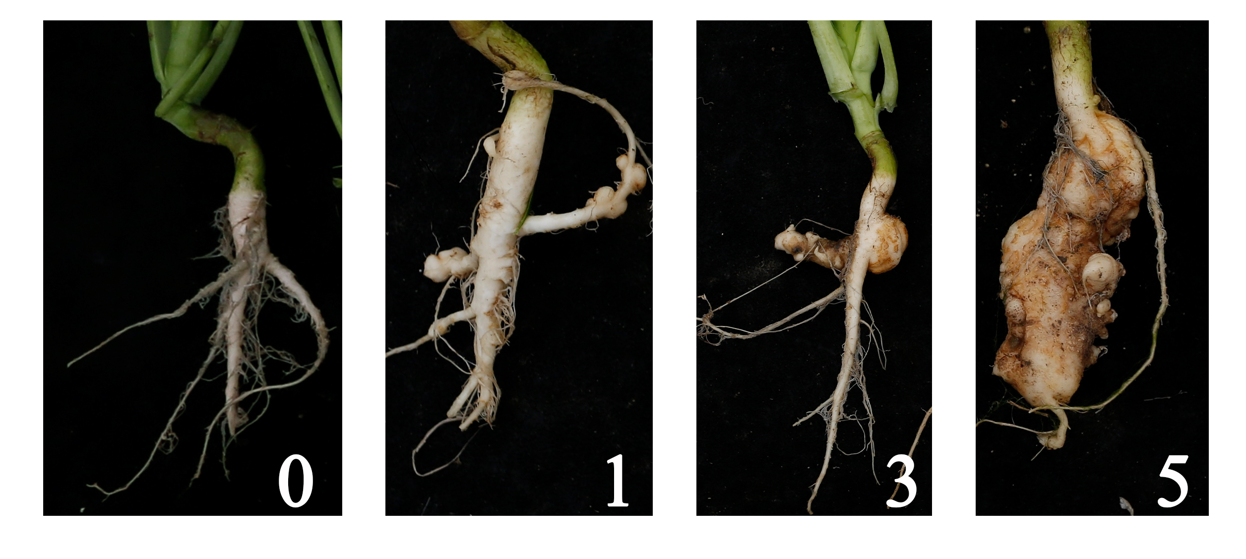Supplementary Figure 1. Methodology for grading clubroot disease investigations of B. napus. “0,” “1,” “3,” “5” mean disease symptoms scores.
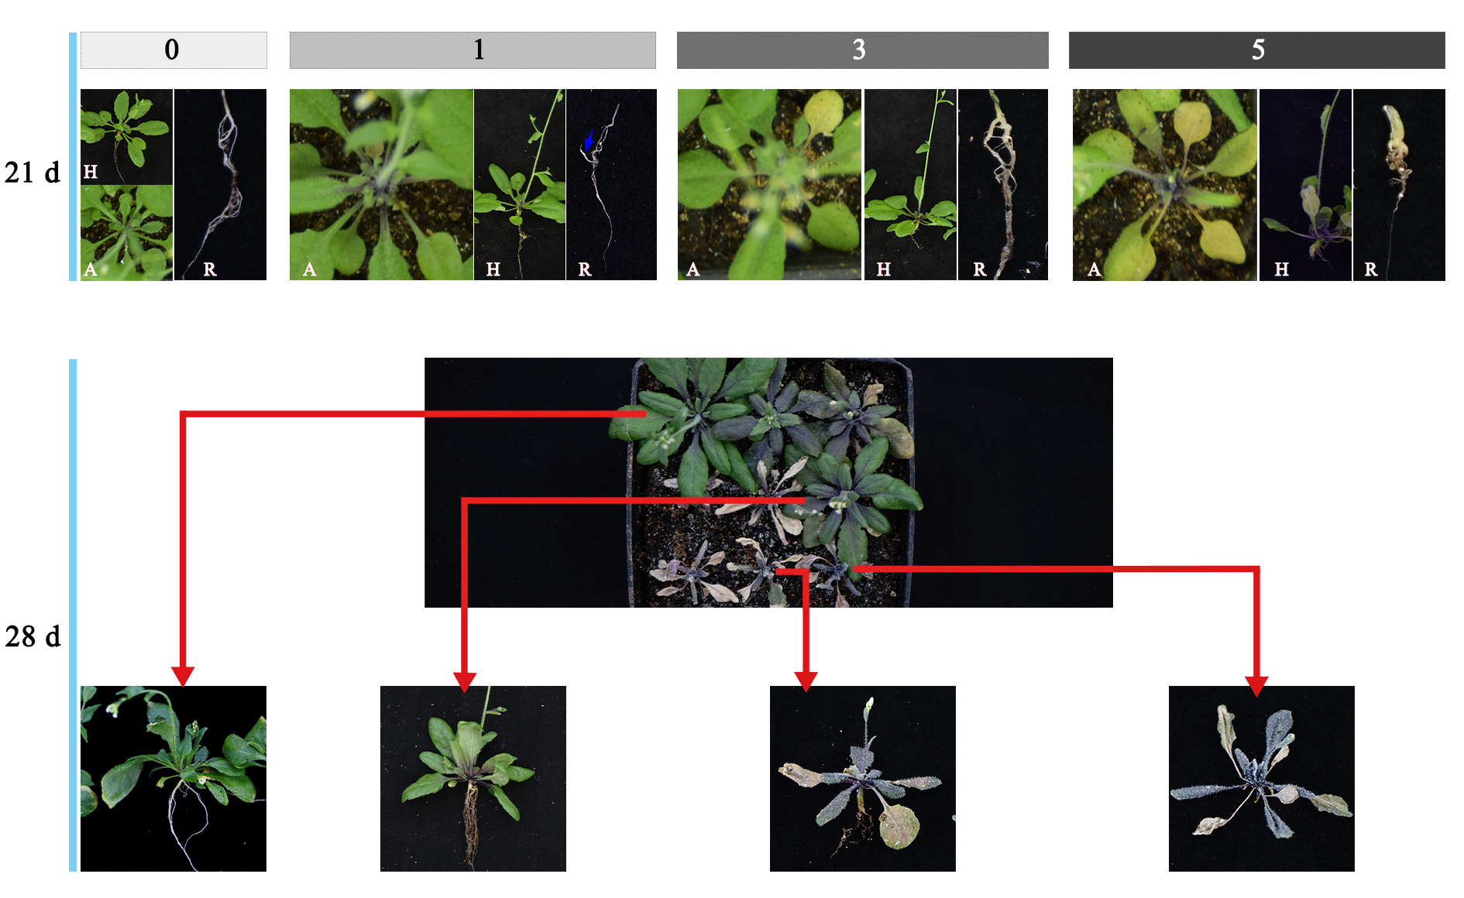Supplementary Figure 2. Methodology for grading clubroot disease investigations of A. thaliana. H indicates the phenotype of whole plants; R indicates the roots; A indicates the above-ground section of plants; blue arrow indicates the root gall of grade 1. “0,” “1,” “3,” “5” mean disease symptoms scales.
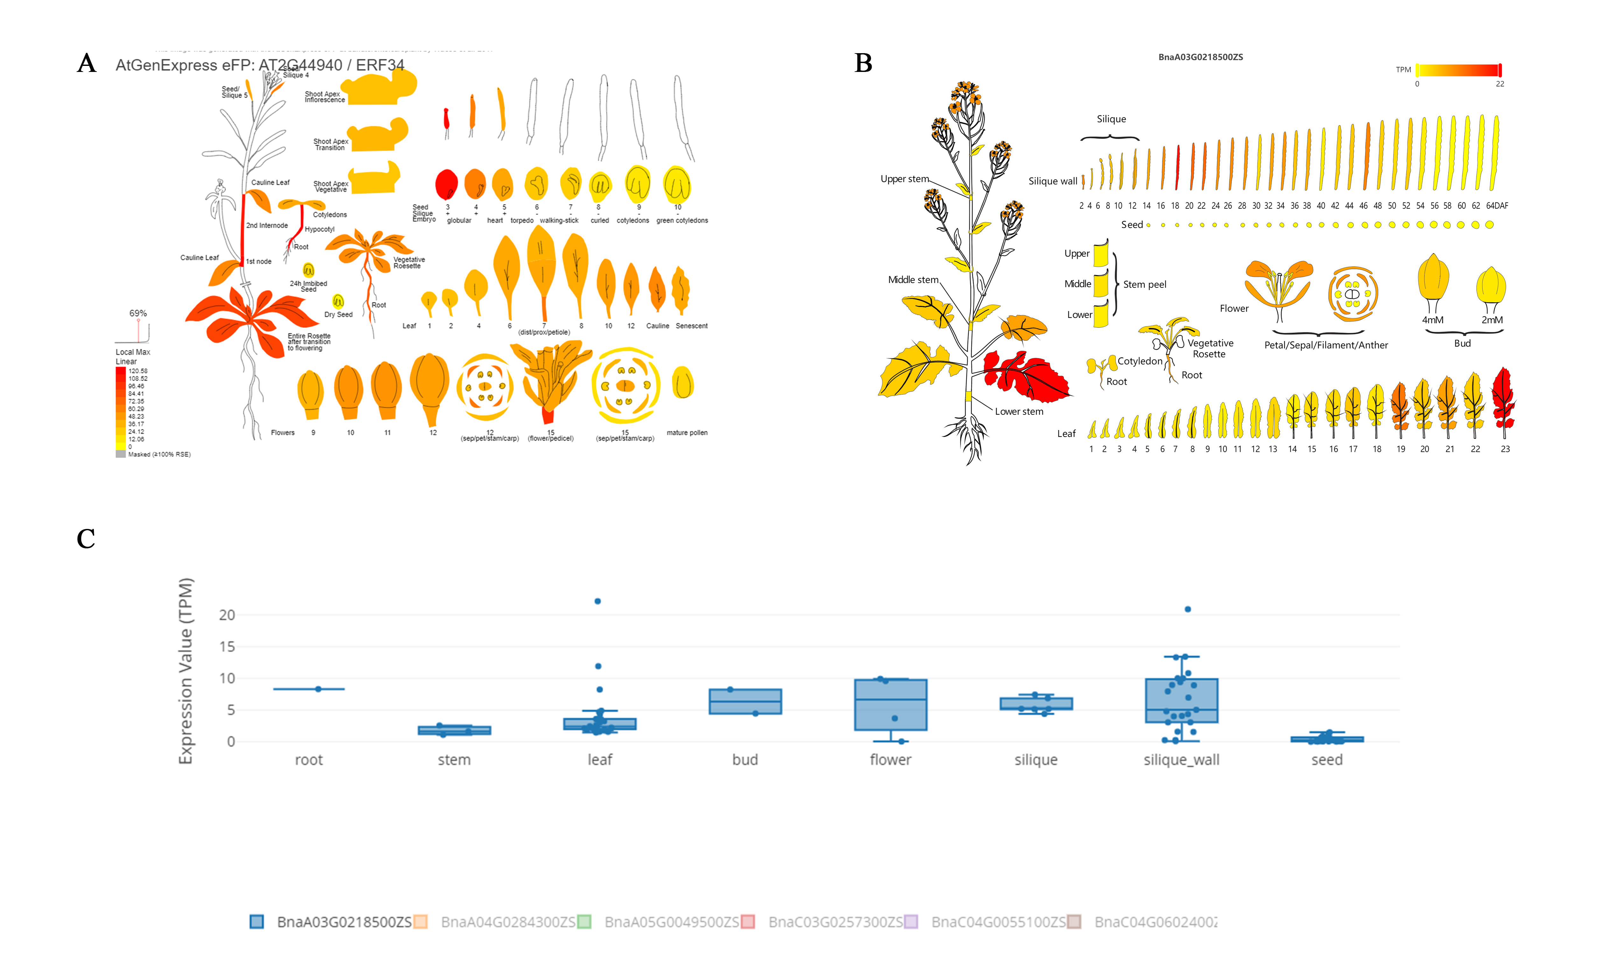
Supplementary Figure 3. Expression levels of AtERF034 and BnERF034 in tissues and organs. (A) Expression levels of AtERF034 in A. thaliana; (B) Expression levels of BnERF034 in B. nupus; (C) Expression levels of BnERF034 in different organs.
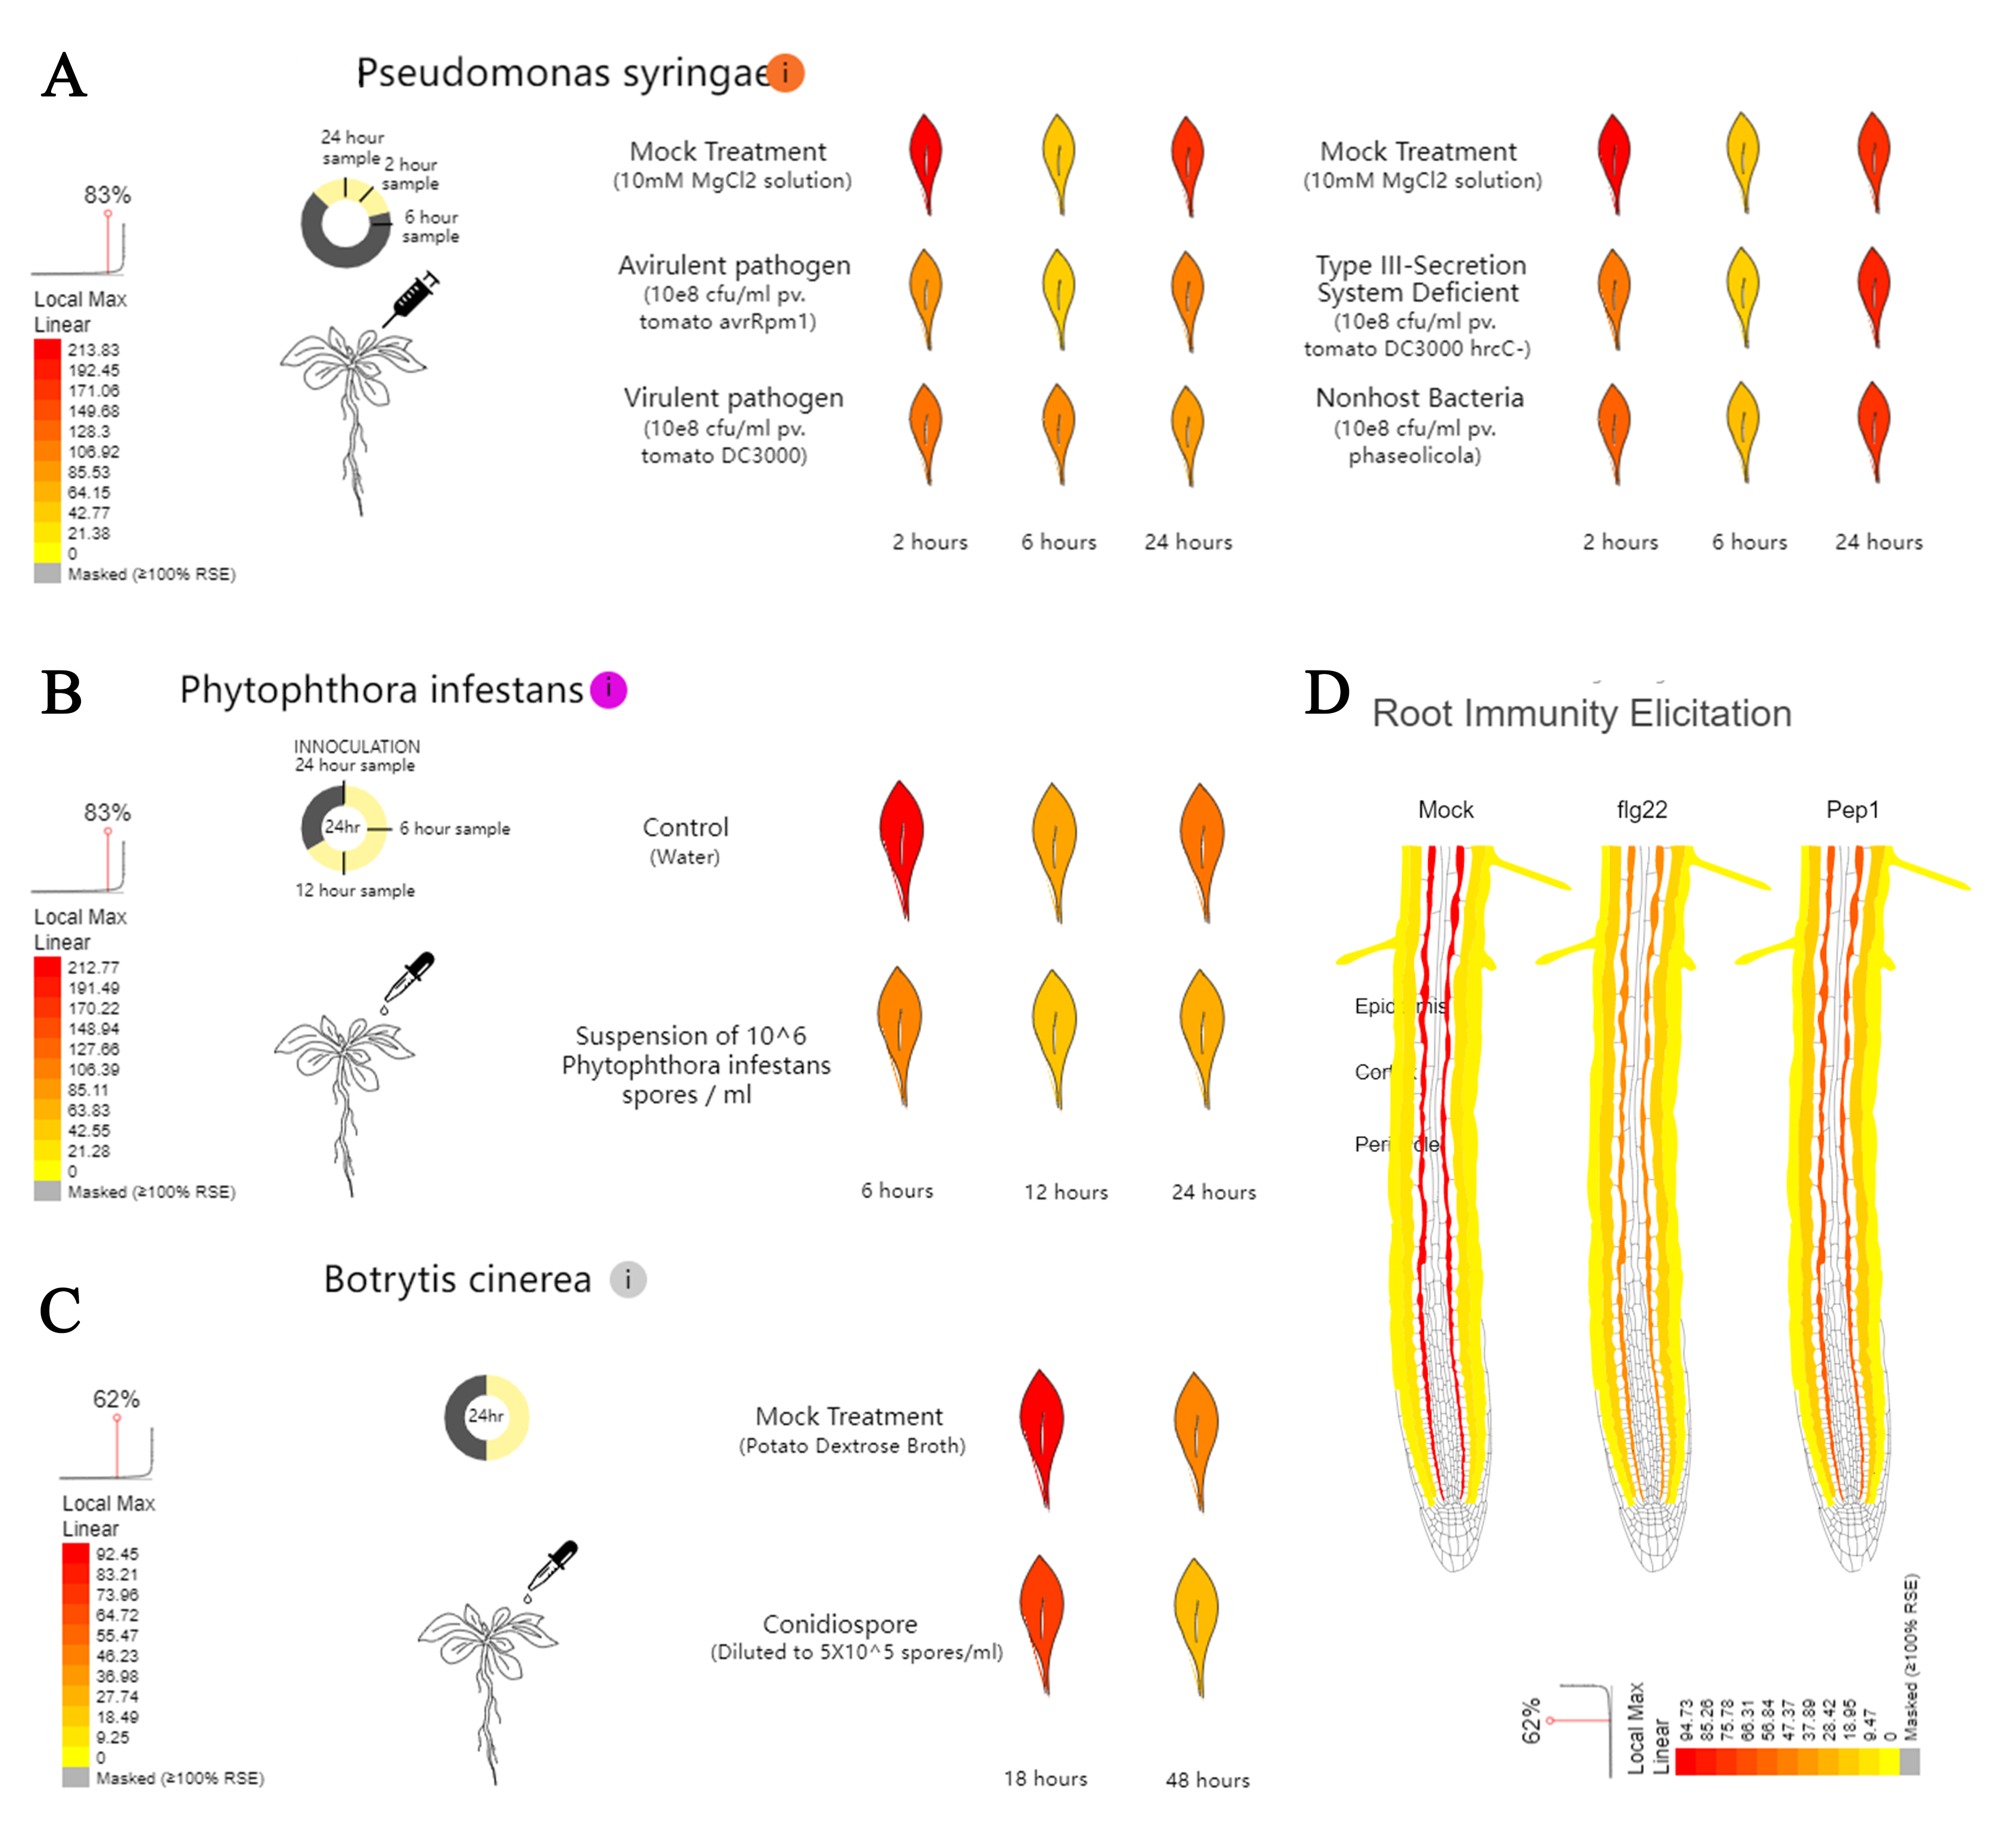
Supplementary Figure 4. Expression pattern of AtERF034 under different pathogen stresses and expression levels of root response elicitations in A. thaliana. (A) treat with P. syringae; (B) treat with P. infestans; (C) treat with B. cinerea; (D) A. thaliana roots were treated with flg22 and Pep1.
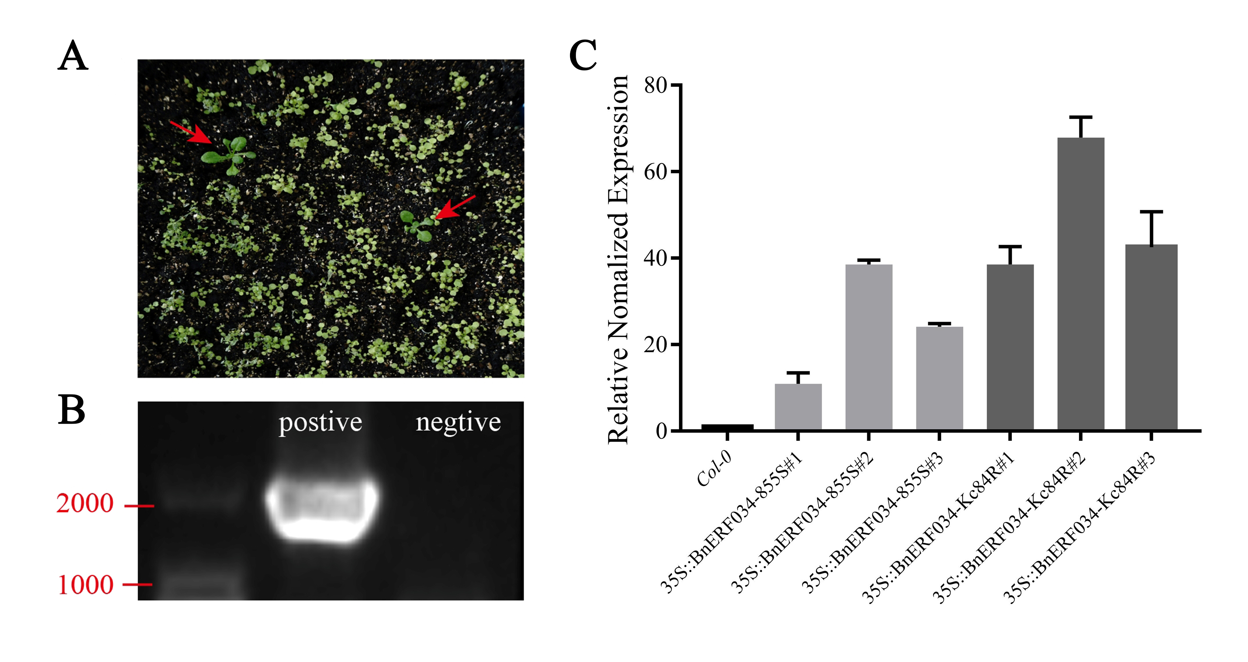
Supplementary Figure 5. Screening and identification of transgenic lines of BnERF034. (A) Basta screening of T₀ generation seeds of transgenic plants in soil culture; (B) PCR identification of positive plants; (C) Transcript level identification of T₃ generation positive plants.
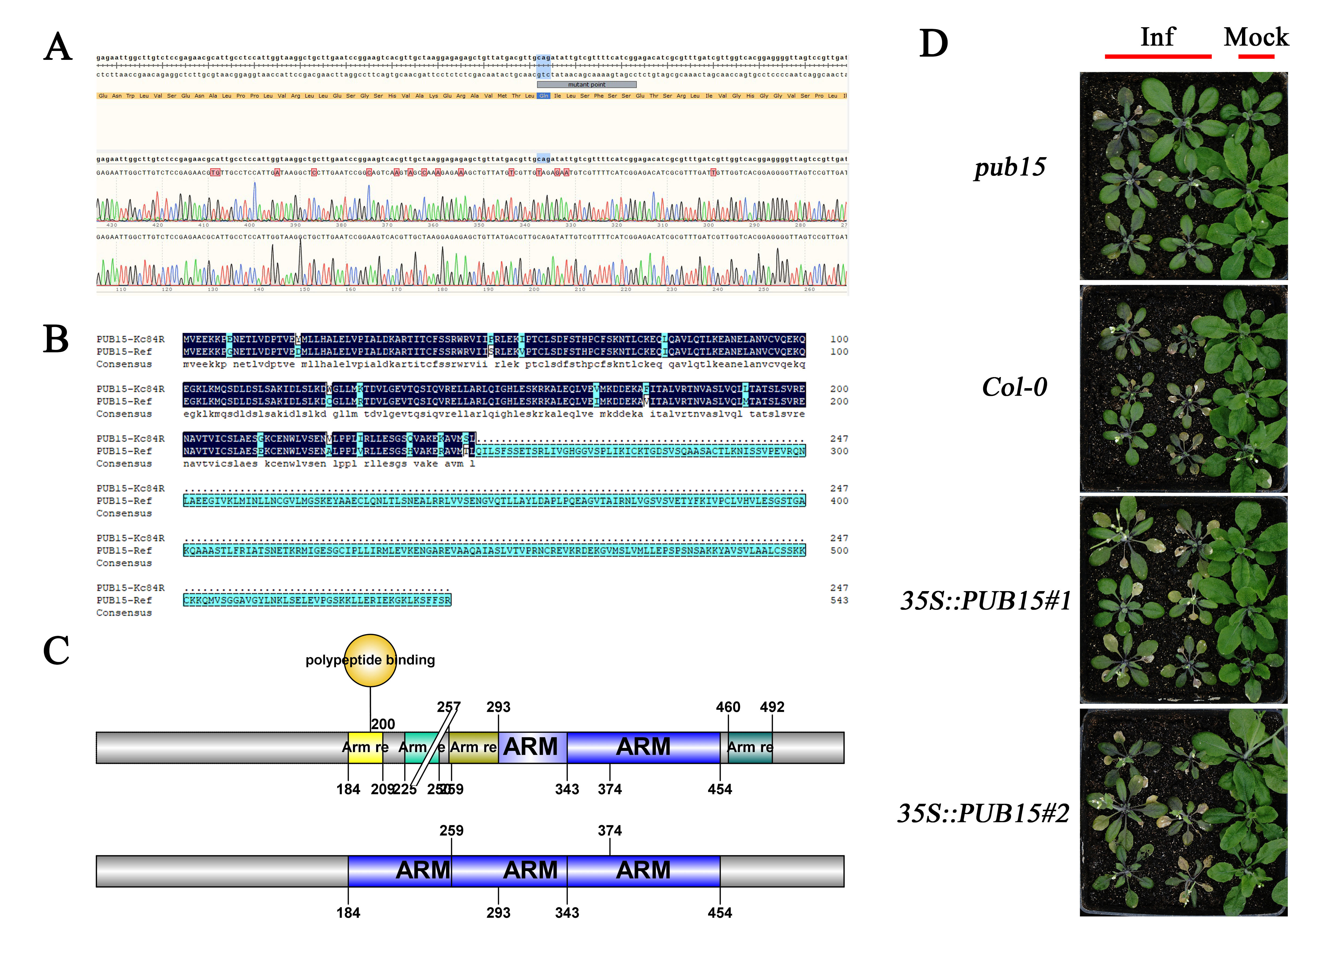
Supplementary Figure 6. The related functional identification about BnPUB15. (A) Partial sequence of BnPUB15: sequence comparison including stop loss in 855S and Kc84R. (B) Protein sequence comparison of BnPUB15 and 855S (the same as Zhongshuang11); (C) Schematic diagram of the protein structural domain of BnPUB15; (D) Above-ground partial phenotype of A. thaliana Col-0, pub15, BnPUB15 transgenic lines 21 dpi with P. brassicae.
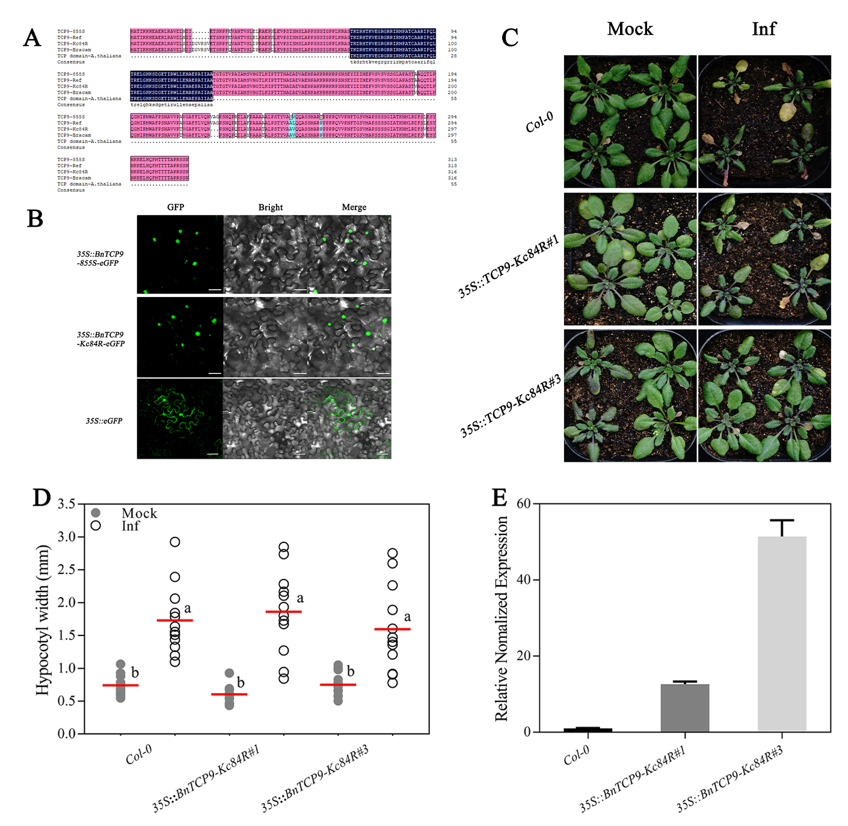
Supplementary Figure 7. The related functional identification about TCP9. (A) The protein sequences of TCP9 in 855S, Zhongshuang 11, Kc84R, B. campestris L., and the sequence alignment with TCP domain in AtTCP9. (B) The results of subcellular localization of BnTCP9-855S-eGFP and BnTCP9-Kc84R-eGFP, pBI121-eGFP as control, scale bars represent 50 μm. (C) The BnTCP9-Kc84R transgene lines’ phenotype of above-ground parts after 21 dpi with P. brassicae. (D) Hypocotyl width of the Col-0 and BnTCP9-Kc84R transgenic lines at 28 dpi in sterile water-inoculated (Mock) and P. brassicae-inoculated (Inf). Scatter plots present individual hypocotyl width measurements (10 replicates for each treatment), calculated means and SEs. Different letters indicate significant differences between means (Tamhane’s test, p< 0.05). (E) Transcript levels of AtICS1 in the Col-0 and BnTCP9-Kc84R transgenic lines at 21 dpi.
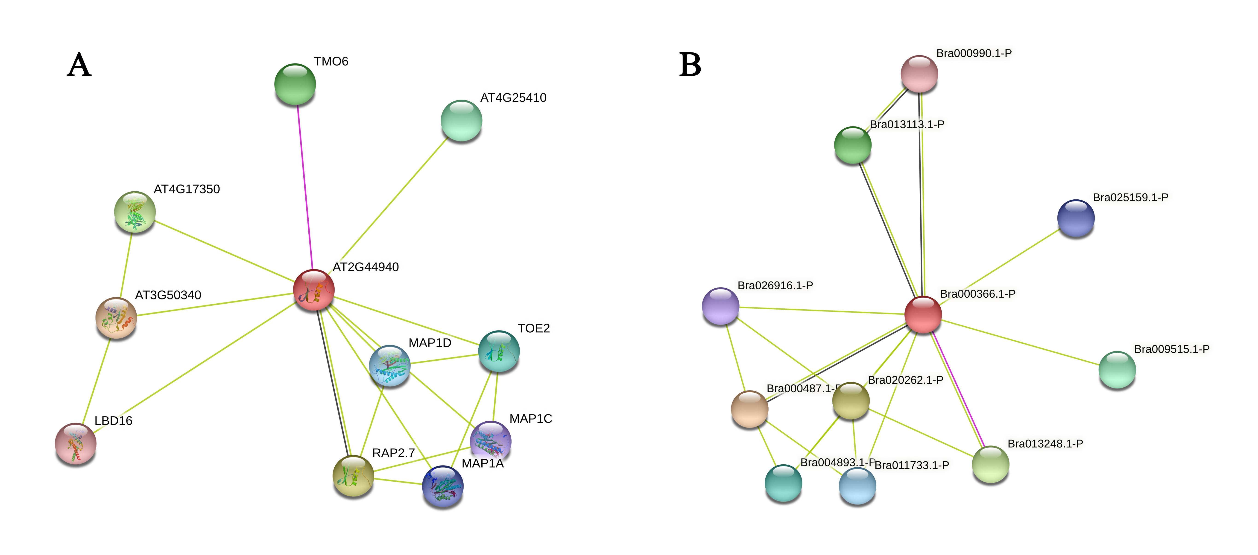
Supplementary Figure 8. Predicted interacting proteins of ERF034. (A) The predicted interacting proteins of AtERF034; (B) The predicted interacting proteins of BrERF034; Red lines indicate interactions with experimental evidence, black lines indicate predictions of co-expression, green lines indicate predictions of interactions.

