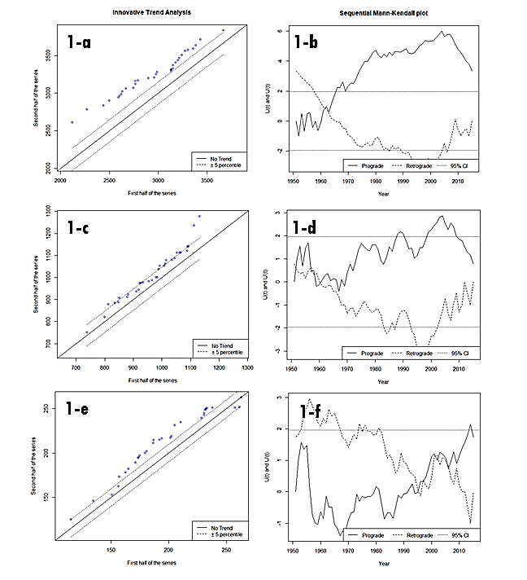

Figure :Kosi\_sub-basin\_annual\_rainfall (Mean, Minimum, Maximum) Sen's Innovative Trend Analysis & Sequential Mann-Kendall Test

**Description-**Figure 1 shows the mean, minimum and maximum annual rainfall trend from 1951 to 2015 for the entire Kosi-sub basin. The mean annual rainfall shows an increasing trend at the five percentile in Sens’ Innovative Trend analysis as shown in section 1-a. Similarly, the Sequential Mann-Kendall test suggests an increasing trend at a 95% confidence interval (Patakamuri & Das, 2022).

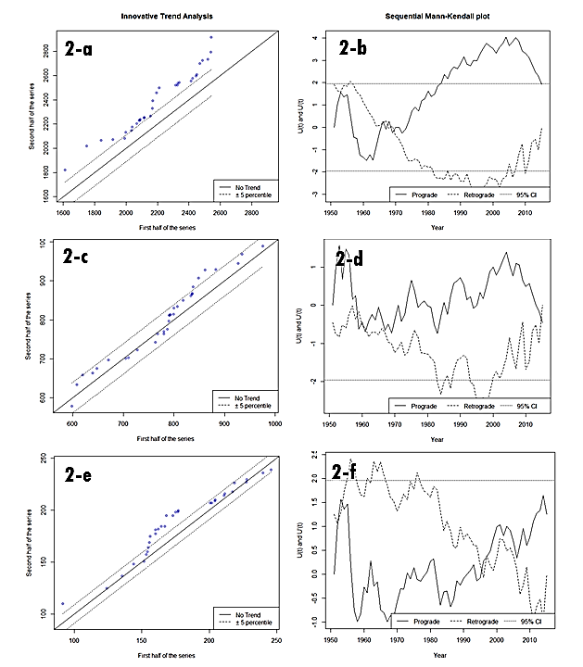

Figure : Kosi\_sub-basin\_monsoon\_ rainfall (Mean, Minimum, Maximum)\_ Sen's Innovative Trend Analysis & Sequential Mann-Kendall Test

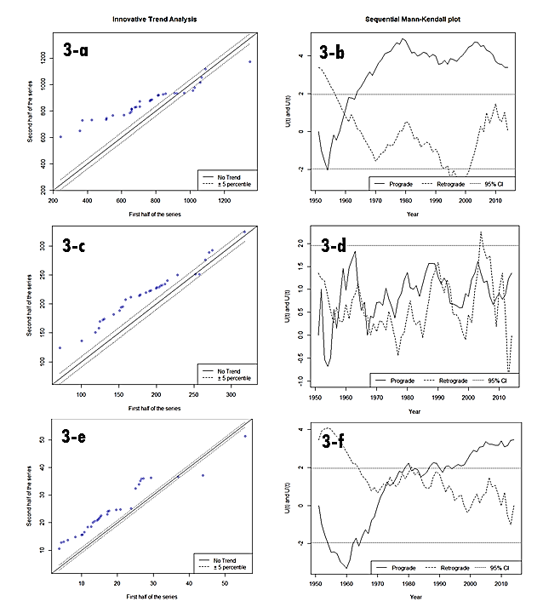

Figure : Kosi\_sub-basin\_non-monsoon\_ rainfall (Mean, Minimum, Maximum)\_ Sen's Innovative Trend Analysis & Sequential Mann-Kendall Test

**Description-Figure-3**: The non-monsoon rainfall for the Kosi-sub basin is showing an increasing trend through 3a to 3e. This means that the number of mean, minimum and maximum non-monsoon rainfall events has increased over the Kosi sub-basin.

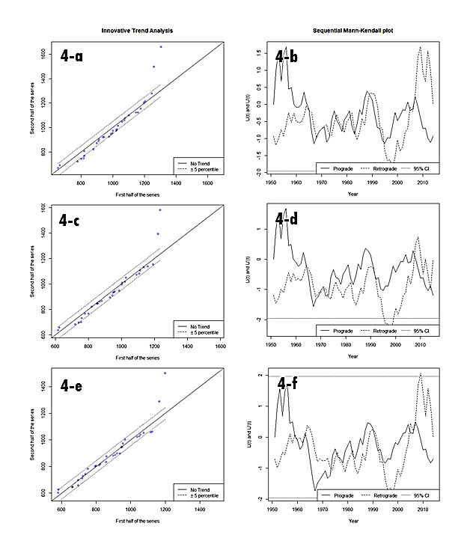

Figure : Darbhanga\_annual\_ rainfall (Mean, Minimum, Maximum)\_ Sen's Innovative Trend Analysis & Sequential Mann-Kendall Test

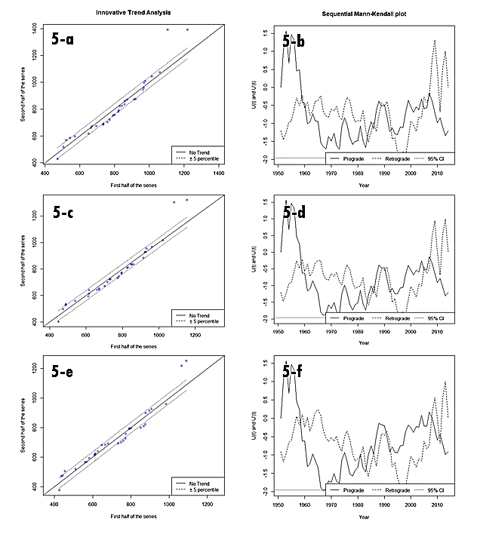

Figure : Darbhanga\_monsoon\_ rainfall (Mean, Minimum, Maximum)\_ Sen's Innovative Trend Analysis & Sequential Mann-Kendall Test

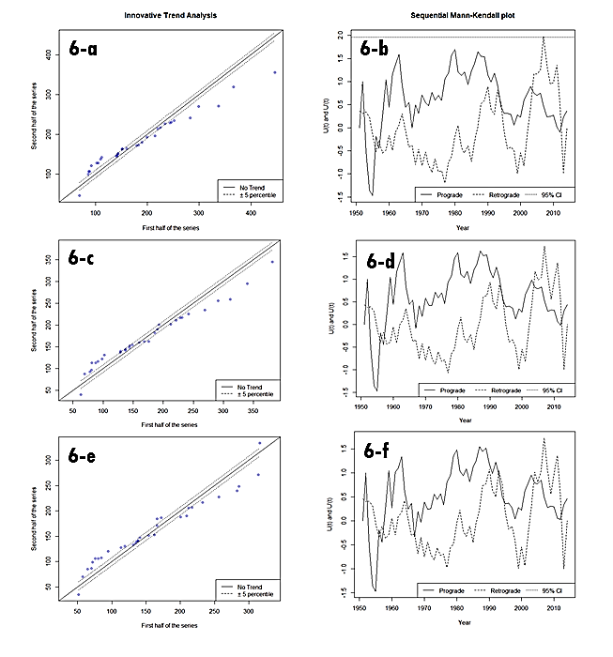

Figure : Darbhanga\_non-monsoon\_ rainfall (Mean, Minimum, Maximum)\_ Sen's Innovative Trend Analysis & Sequential Mann-Kendall Test

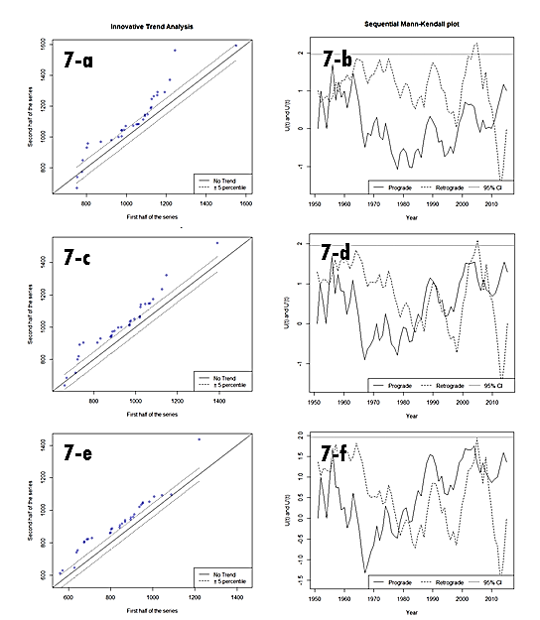

Figure : Saharsa\_annual\_ rainfall (Mean, Minimum, Maximum)\_ Sen's Innovative Trend Analysis & Sequential Mann-Kendall Test

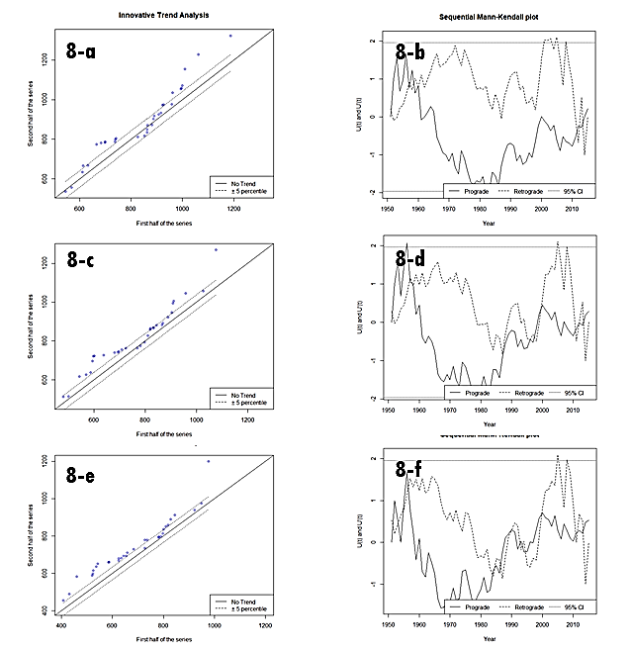

Figure :Saharsa\_monsoon\_ rainfall (Mean, Minimum, Maximum)\_ Sen's Innovative Trend Analysis & Sequential Mann-Kendall Test

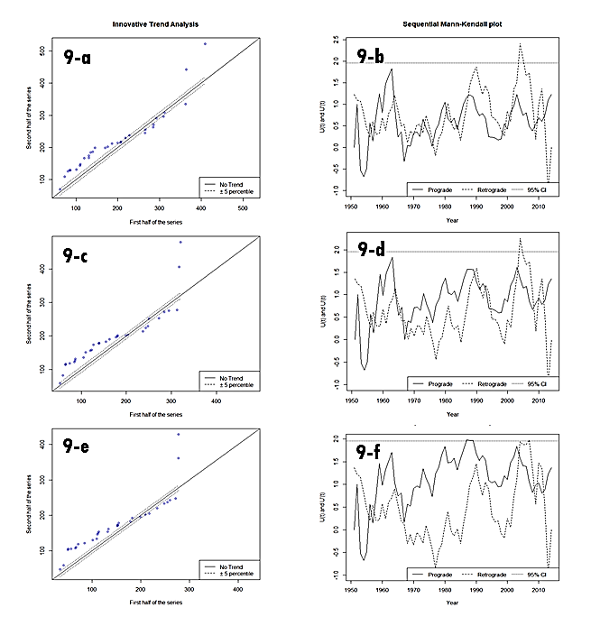

Figure : Saharsa\_non-monsoon\_ rainfall (Mean, Minimum, Maximum)\_ Sen's Innovative Trend Analysis & Sequential Mann-Kendall Test

C:\Users\ATREE\Desktop\PhD Thesis Chapters\Paper Writing-Materials\15_analysis_data\Trend\Innovative Trend Plots-Image\AMS_Kosi_DBG_SHS.tif

Figure : Kosi\_sub basin\_Darbhanga\_Saharsa\_Sen's Innovative Trend Analysis & Sequential Mann-Kendall Test.

**Description-Figure-10**: The annual Maximum Series shows no trend for all the three spatial scales-The Kosi Sub-basin, Darbhanga and Saharsa as shown in figures 10a, 10c, and 10e respectively.

Table 1: Sen's Innovative Trend Analysis values for Kosi-Sub basin\_, Darbhanga and Saharsa

|  |  |  |  |  |  |
| --- | --- | --- | --- | --- | --- |
| **Spatial-scale** | **Time-scale** | **Rainfall** | **Trend (per year)** | **p-value** | **Intercept** |
| Kosi-basin | Annual | mean | 0.99 | 0.50 | 957.50 |
| Kosi-basin | Annual | min | 0.62 | **0.05** | 185.05 |
| Kosi-basin | Annual | max | 9.80 | **0.04** | 2808.11 |
| Kosi-basin | Monsoon | mean | -0.11 | 0.63 | 797.51 |
| Kosi-basin | Monsoon | min | 0.43 | 0.23 | 164.11 |
| Kosi-basin | Monsoon | max | 3.86 | 0.11 | 2145.40 |
| Kosi-basin | Non-monsoon | mean | 1.00 | **0.01** | 166.35 |
| Kosi-basin | Non-monsoon | Min | 0.23 | **0.00** | 11.27 |
| Kosi-basin | Non-monsoon | Max | 4.56 | **0.02** | 665.70 |
| Darbhanga | Annual | Mean | -1.01 | 0.29 | 961.55 |
| Darbhanga | Annual | Min | -0.89 | 0.29 | 913.10 |
| Darbhanga | Annual | Max | -1.35 | 0.28 | 1028.39 |
| Darbhanga | Monsoon | Mean | -1.60 | 0.15 | 806.40 |
| Darbhanga | Monsoon | Min | -1.48 | 0.24 | 767.76 |
| Darbhanga | Monsoon | Max | -1.69 | 0.15 | 853.37 |
| Darbhanga | Non-monsoon | Mean | 0.22 | 0.73 | 145.43 |
| Darbhanga | Non-monsoon | Min | 0.20 | 0.61 | 136.12 |
| Darbhanga | Non-monsoon | Max | 0.19 | 0.83 | 158.87 |
| Saharsa | Annual | Mean | 1.54 | 0.35 | 919.78 |
| Saharsa | Annual | Min | 1.44 | 0.32 | 828.83 |
| Saharsa | Annual | Max | 1.36 | 0.54 | 1017.91 |
| Saharsa | Monsoon | Mean | 0.29 | 0.92 | 776.52 |
| Saharsa | Monsoon | Min | 0.47 | 0.88 | 680.07 |
| Saharsa | Monsoon | Max | 0.00 | 0.80 | 863.50 |
| Saharsa | Non-monsoon | Mean | 0.79 | 0.21 | 147.39 |
| Saharsa | Non-monsoon | Min | 0.80 | 0.23 | 124.07 |
| Saharsa | Non-monsoon | Max | 0.81 | 0.25 | 168.74 |

**Table-1-Description**: We have carried out the trend analysis of the annual rainfall change at three different spatial scales-1.Kosi-sub basin, 2. Darbhanga District and 3. Saharsa District. The mean, minimum and maximum rainfall trends were analysed on annual, monsoon and non-monsoon periods. Annual minimum and annual maximum rainfall were significant for the entire Kosi-sub basin and all non-monsoon mean, minimum and maximum rainfall was found to be significant in the Kosi-sub basin(See highlighted text in Table 1)(Bronaugh & Werner, 2019).

Table : Annual Maximum Series\_Kosi\_sub basin\_Darbhanga\_Saharsa

|  |  |  |  |  |  |
| --- | --- | --- | --- | --- | --- |
| **Spatial-scale** | **Time-scale** | **Rainfall** | **Trend (per year)** | **p-value** | **Intercept** |
| Kosi-basin | Daily Annual | Maximum | 0.0229 | 0.64 | 93.48 |
| Darbhanga | Daily Annual | Maximum | 0.0029 | 0.87 | 9.84 |
| Saharsa | Daily Annual | Maximum | 0.0004 | 0.67 | 9.96 |

Table 3: Annual Maximum Series (AMS)\_Kosi-Sub-basin\_Darbhanga\_Saharsa\_GLM values

|  |  |  |  |  |  |
| --- | --- | --- | --- | --- | --- |
| **Spatial Scale** | **Rainfall Variables** | **Estimate** | **Std. Error** | **z value** | **Pr (>|z|)** |
| Kosi\_sub-basin | Daily Annual maximum Rainfall | 0.04665 | 0.04524 | 1.031 | 0.302 |
| Darbhanga | Daily Annual maximum Rainfall | 0.44891 | 2.37252 | 0.189 | 0.850 |
| Kosi\_sub-basin | Daily Annual maximum Rainfall | 15.852 | 7378.390 | 0.002 | 0.998 |
| Saharsa | Daily Annual maximum Rainfall | -3.854 | 2090.248 | -0.002 | 0.999 |

**References**

Bronaugh, D., & Werner, A. (2019). zyp: Zhang + Yue-Pilon Trends Package. In *Pacific Climate Impacts Consortium*. https://cran.r-project.org/web/packages/zyp/index.html

Patakamuri, S. K., & Das, B. (2022). *Trendchange: Innovative Trend Analysis and Time-Series Change Point Analysis. R package version 1.1* (Issue January).