Table S1: Summary of the reference genes
Organism | Gene | Abbreviations | Accession number
 | Hemoglobin alpha adult 1 | hbaa1 | ENSDARP00000101541
Danio rerio  (Zebrafish) | Hemoglobin alpha adult 2 | hbaa2 | ENSDARP00000092484
 | Hemoglobin alpha embryonic1.1 | hbae1.1 | ENSDARP00000107930
 | Hemoglobin alpha embryonic 3 | hbae3 | ENSDARP00000112265
 | Hemoglobin alpha embryonic 5 | hbae5 | ENSDARP00000066382
 | Hemoglobin beta adult 1 | hbba1 | ENSDARP00000092488
 | Hemoglobin beta adult 2 | hbba2 | ENSDARP00000053076
 | Hemoglobin beta embryonic 1.3 | hbbe1.3 | ENSDARP00000097665
 | Hemoglobin beta embryonic 2 | hbbe2 | ENSDARP00000066383
 | Hemoglobin beta embryonic 3 | hbbe3 | ENSDARP00000055622
Homo sapiens  (Human) | Hemoglobin subunit gamma-2 | hba1 | ENSG00000130656
 | Hemoglobin subunit epsilon | hbb | ENSG00000223609
 | Hemoglobin subunit gamma-1 | hbd | ENSG00000213931
 | Hemoglobin subunit delta | hbe1 | ENSG00000086506
 | Hemoglobin subunit beta | hbg1 | ENSG00000244734
 | Hemoglobin subunit alpha | hbg2 | ENSG00000213934
 | Hemoglobin subunit zeta | hbm | ENSG00000196565
 | Hemoglobin subunit theta-1 | hbq1 | ENSG00000206172
 | Hemoglobin subunit mu | hbz | ENST00000356815.4
Lepisosteus oculatus  (Spotted gar) | Hemoglobin cathodic subunit beta-like | hbb | ENSLOCG00000007827
 | Hemoglobin embryonic subunit alpha-like | hbae | ENSLOCG00000007756
 | Hemoglobin subunit alpha-1-like | hba | ENSLOCG00000007868
 | Hemoglobin subunit alpha-like | hba | ENSLOCG00000007787
 | Hemoglobin subunit alpha-like | hba2 | ENSLOCG00000007745
 | hemoglobin subunit epsilon-like | hbe1 | ENSLOCG00000007843
 | hemoglobin subunit epsilon-like | hbe1 | ENSLOCG00000007852
 | Hemoglobin subunit zeta-like | hbz | ENSLOCG00000007770
Petromyzon marinus  (Sea lamprey) | Globin-2 | globin-2 | ENSPMAG00000007266
Danio rerio  (Zebrafish) | Mahogunin ring finger 1b | mgrn1b | ENSDARP00000072683
 | Arylalkylamine N-acetyltransferase 2 | aanat2 | ENSDARP00000002650
 | Rhomboid family member 1a | rhbdf1a | ENSDARP00000053094
 | Methylpurine-DNA glycosylase | mpg | ENSDARP00000119099
 | Nitrogen permease regulator-like 3 | nprl3 | ENSDARP00000039240
 | KN motif and ankyrin repeat domain-containing protein 2 | kank2 | ENSDARP00000128469
 | Dedicator of cytokinesis 6 | dock6 | ENSDARP00000077379
 | Mahogunin ring finger 1a | mgrn1a | ENSDARP00000140478
 | Forkhead box j1b | foxj1b | ENSDARP00000107064
 | Rhomboid 5 homolog 1b | rhbdf1b | ENSDARP00000127302
 | Aquaporin-8 | aqp8 | ENSDARP00000066381
 | Leucine carboxyl methyltransferase 1 | lcmt1 | ENSDARP00000072402
 | Rho GTPase-activating protein 17a | arhgap17a | ENSDARP00000099577

Table S2: Accession numbers of the representative fish genomes
Scientific Name | Common Name | Accession number
Gadus morhua | Atlantic cod | GCA_902167405.1
Dicentrarchus labrax | European seabass | GCA_000689215.1
Seriola dumerili | Greater amberjack | GCA_002260705.1
Larimichthys crocea | Large yellow croaker | GCF_000972845.1
Mola mola | Ocean sunfish | GCA_001698575.1
Thunnus orientalis | Pacific bluefin tuna | GCA_021601225.1
Istiophorus platypterus | Sailfish | GCA_016859345.1
Lepisosteus oculatus | Spotted gar | GCF_000242695.1
Xiphias gladius | Swordfish | GCA_016859285.1
Hippocampus comes | Tiger tail seahorse | GCA_001891065.2
Cynoglossus semilaevis | Tongue sole | GCF_000523025.1
Seriola aureovittata | Yellowtail amberjack | GCA_021018895.1
Danio rerio | Zebrafish | GCF_000002035.6

Table S3: Summary of the sequenced reads for genome assembly of the Southern bluefin tuna
Insert Size | Reads Length | Raw Data (Gb) | Clean Data (Gb)
270 bp | 150 bp | 59.05 | 52.68
500 bp | 150 bp | 25.56 | 23.74
800 bp | 125 bp | 28.79 | 26.82
2 kb | 150 bp | 24.76 | 13.83
5 kb | 150 bp | 35.03 | 18.73
Total |  | 173.19 | 135.8

Table S4: 17-mer depth distribution and estimated genome size

kmer  length | kmer num | Kmer depth | genome size | used base | used read | Coverage
17 | 44,309,018,345 | 52 | 852 | 50,496,822,825 | 386,737,780 | 63.8204
Table S5: Statistics of the genome assembly
 | scaffold | contig | gap
Total_length | 806,538,915 | 794,343,312 | 12,171,831
Total_number | 95,979 | 1,564,055 | 32,019

Table S6: Annotation of repeat sequences in the assembled genome
Type | Repeat Size (bp) | % of genome
Trf | 17,799,248 | 2.206868
Repeatmasker | 51,149,429 | 6.341843
Proteinmask | 23,721,168 | 2.941106
De novo | 194,507,419 | 24.116309
Total | 236,097,722 | 29.272949

Table S7: Detailed classification of repeat sequences in the assembled genome
 | Repbase TEs |  | TE Protiens |  | De novo |  | Combined TEs
Type | Length (bp) | Percentage | Length (bp) | Percentage | Length (bp) | Percentage | Length (bp) | Percentage
DNA | 28,220,669 | 3.50% | 3,555,207 | 0.44% | 63,952,998 | 7.93% | 79,590,796 | 9.87%
LINE | 18,751,030 | 2.32% | 17,163,997 | 2.13% | 23,603,023 | 2.93% | 40,650,413 | 5.04%
SINE | 1,251,942 | 0.16% | 0 | 0 | 2,030,127 | 0.25% | 2,256,217 | 0.28%
LTR | 7,729,188 | 0.96% | 3,010,574 | 0.37% | 4,480,184 | 0.56% | 13,320,396 | 1.65%
Other | 11,631 | 0.14% | 0 | 0 | 0 | 0 | 11,631 | 0.001%
Unknown | 0 | 0.00% | 0 | 0 | 101,839,026 | 12.63% | 101,839,026 | 12.63%

Table S8: Summary statistics of gene annotation
Method |  | Software/  gene set | number | average transcript length(bp) | average CDS length(bp) | average Exons per Gene | average exon length(bp) | average Intron length(bp)
De novo | Augustus |  | 25,717 | 14,997.76 | 1,581.49 | 9.04 | 174.90 | 1,668.26
 | Genscan |  | 35,563 | 15,308.06 | 1,490.37 | 8.25 | 180.74 | 1,906.98
Homolog | Danio rerio |  | 20,495 | 11,759.38 | 1,566.08 | 8.50 | 184.15 | 1,358.34
 | Oryzias latipes |  | 24,727 | 9,299.11 | 1,332.75 | 7.35 | 181.16 | 1,253.25
 | Oreochromis niloticus |  | 25,760 | 11,242.08 | 1,489.93 | 8.28 | 179.85 | 1,338.76
 | Takifugu rubripes |  | 21,405 | 11,670.51 | 1,533.89 | 8.57 | 178.79 | 1,337.42
 | Tetraodon nigroviridis |  | 9,773 | 11,506.38 | 1,519.96 | 8.82 | 172.37 | 1,277.40
 | Gasterosteus aculeatus |  | 25,956 | 9,670.28 | 1,317.72 | 7.42 | 177.52 | 1,300.45
 | Gadus morhua |  | 24,056 | 9,516.67 | 1,273.65 | 7.15 | 178.08 | 1,339.88
Transcriptome |  |  | 22,522 | 8,808.83 | 2,156.77 | 7.44 | 289.79 | 1,032.52
GLEAN |  |  | 23,403 | 17,660.31 | 1,800.34 | 9.82 | 183.39 | 1,798.79

Table S9: Statistics of gene functional annotation
Database/Parameter | Number | Percentage (%)
Total | 23,403
InterPro | 21,290 | 90.971243
GO | 16,458 | 70.324317
KEGG | 19,611 | 83.796949
Swissprot | 20,272 | 86.621373
TrEMBL | 22,253 | 95.0861
Annotated | 22,485 | 96.077426
Unannotated | 918 | 3.922574

Table S10: All tuna genomes available from NCBI
Scientific name | Common name | Genome Size | GC content | Complete BUSCOs | Repeats content | Sequencing technology | Accession | Reference
T. maccoyii | Southern bluefin tuna | 806 Mb | 39.0% | 95.8% | 29.27% | Illumina | GCA_025435535.1 | This study
 |  | 782 Mb | 39.7% | 98.4% | 26.07% | PacBio;10X; Hi-C | GCA_910596095.1
T. thynnus | Atlantic bluefin tuna | 944 Mb | 39.5% | 36.9% | N/A | Illumina | PRJNA843977 | Puncher et al., 2018
T. orientalis | Pacific bluefin tuna | 827 Mb | 39.7% | 97.0% | N/A | PacBio; 10X | GCA_021601225.1
 |  | 787 Mb | 39.6% | 88.2% | 25.25% | NextSeq; PacBio | GCA_009176245.1 | Suda et al., 2019
 |  | 740 Mb | 39.7% | 87.7% | N/A | 454; Illumina | GCA_000418415.1 | Nakamura et al., 2013
T. albacares | Yellowfin tuna | 792 Mb | 39.7% | 98.4% | 26.27% | PacBio; 10X; Hi-C | GCA_914725855.1
 |  | 728 Mb | 39.5% | 89.2% | 27.8% | Illumina | GCA_900302625.1 | Barth et al., 2017

Table S11: Summary of the codons at position 39 of β hemoglobin genes in twenty-seven species
 | MN cluster |  |  |  |  |  | LA cluster
 | ACT | ACC | ACG | ACA | TGC | TGT | ACT | ACC | TGT
Lepisosteus oculatus | 1 | 3
Danio rerio | 4 | 2 |  |  |  |  | 2
Gadus morhua | 1 |  | 1
Lampris incognitus | 3 | 1
Gephyroberyx darwinii
Acanthochaenus luetkenii |  | 1 |  | 1 |  |  | 3
Myripristis murdjan | 2 | 3 |  |  |  |  | 2
Lucifuga dentata | 1 |  |  |  |  |  | 1
Thalassophryne amazonica |  |  | 2 | 1 |  |  | 1
Siphamia tubifer | 4
Boleophthalmus pectinirostris |  |  |  |  |  |  | 1 |  | 1
Periophthalmus magnuspinnatus |  |  |  |  |  |  | 1
Periophthalmus modestus |  |  |  |  |  |  | 1
Thunnus maccoyii |  |  |  |  | 7 | 1 | 1
Thunnus maccoyii  (from NCBI) |  |  |  |  | 7 | 1 | 4
Thunnus albacares |  |  |  |  | 8 |  | 8
Thunnus orientalis |  |  |  |  | 5 |  | 2
Hippocampus comes |  |  |  |  |  |  |  | 1
Hippocampus abdominalis |  |  |  |  |  |  |  | 1
Seriola dumerili | 5 | 1 |  |  |  |  | 1
Seriola aureovittata | 5 | 1 |  |  |  |  | 1
Xiphias gladius | 6 | 1 |  |  |  |  | 1
Istiophorus platypterus | 5 | 1
Cynoglossus semilaevis |  |  |  |  |  |  | 2 | 1
Larimichthys crocea | 4 |  |  |  |  |  | 1
Dicentrarchus labrax | 4 |  |  |  |  |  | 3
Mola mola | 3 |  |  |  |  |  | 1

Table S12: A synteny comparison between the two assembly versions of the Southern bluefin tuna genome
Structural annotations  Variation_type | Count | Length | Length_NCBI
Syntenic regions | 1,992 | 716,589,361 | 730,445,762
Of our assembled genome |  | 98.1%
Covering the public assembly |  | 93.92%
Inversions | 21 | 4,164,315 | 4,380,385
Translocations | 1,310 | 63,747,961 | 64,774,671
Duplications | 408 | 50,847,026 | -
Duplications (NCBI) | 2,995 | - | 23,611,847
Not aligned | 2,710 | 24,696,389 | -
Not aligned (NCBI) | 3,954 | - | 7,672,231
Sequence annotations
Variation_type | Count | Length | Length_NCBI
SNPs | 5,388,969 | 5,388,969 | 5,388,969
Insertions | 864,743 | - | 7,252,508
Deletions | 466,721 | 6,198,208 | -
Copygains | 225 | - | 971,478
Copylosses | 1,990 | 3,644,742 | -
Highly diverged | 27,594 | 20,149,208 | 36,290,206
Tandem repeats | 71 | 108,876 | 144,084

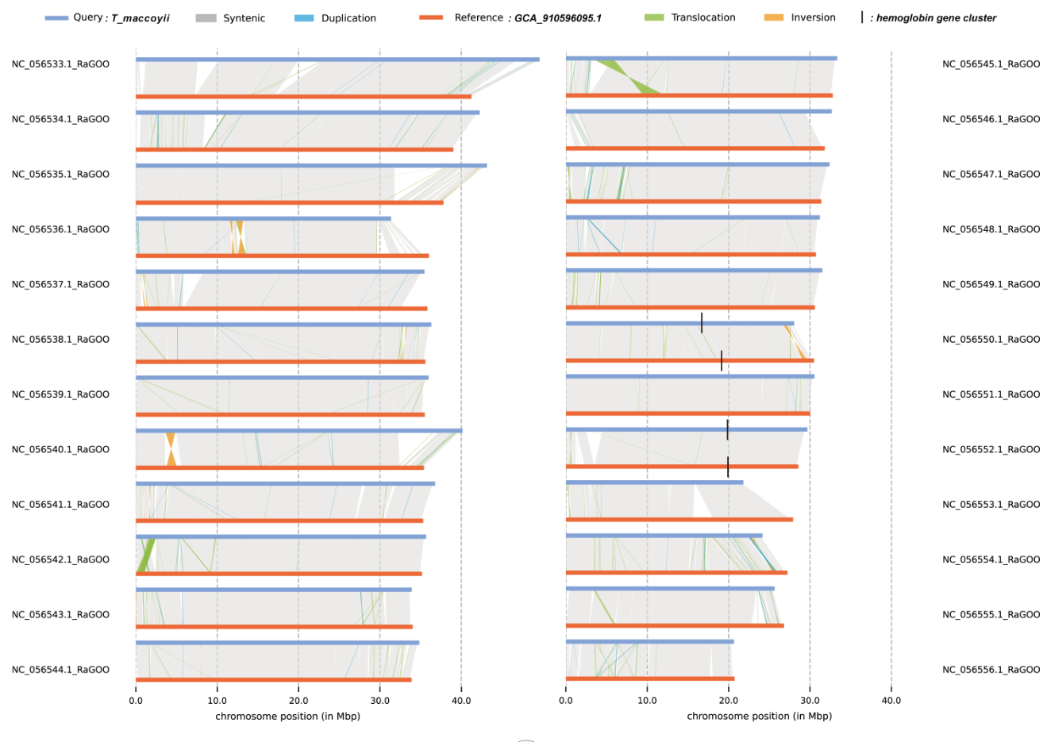
Figure S1: A synteny comparison between the two assembly versions of the Southern bluefin tuna genome.

Figure S2: Annotation comparison between the two assembly versions of the Southern bluefin tuna genome.

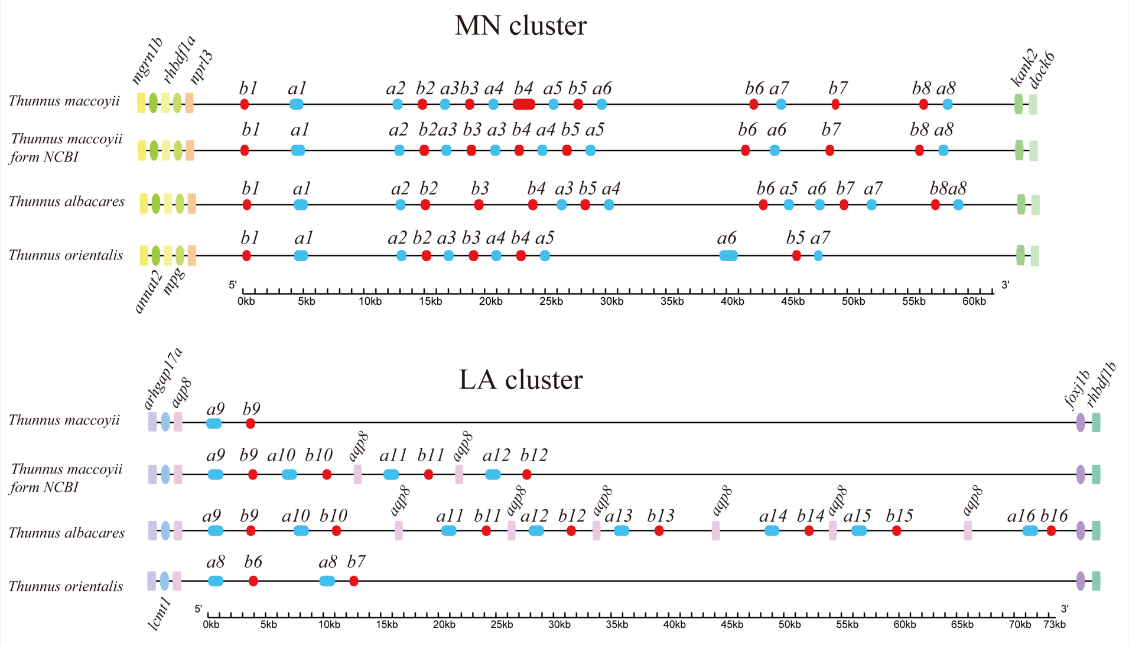
Figure S3: Collinearity of hemoglobin genes among genome assemblies of four tunas.
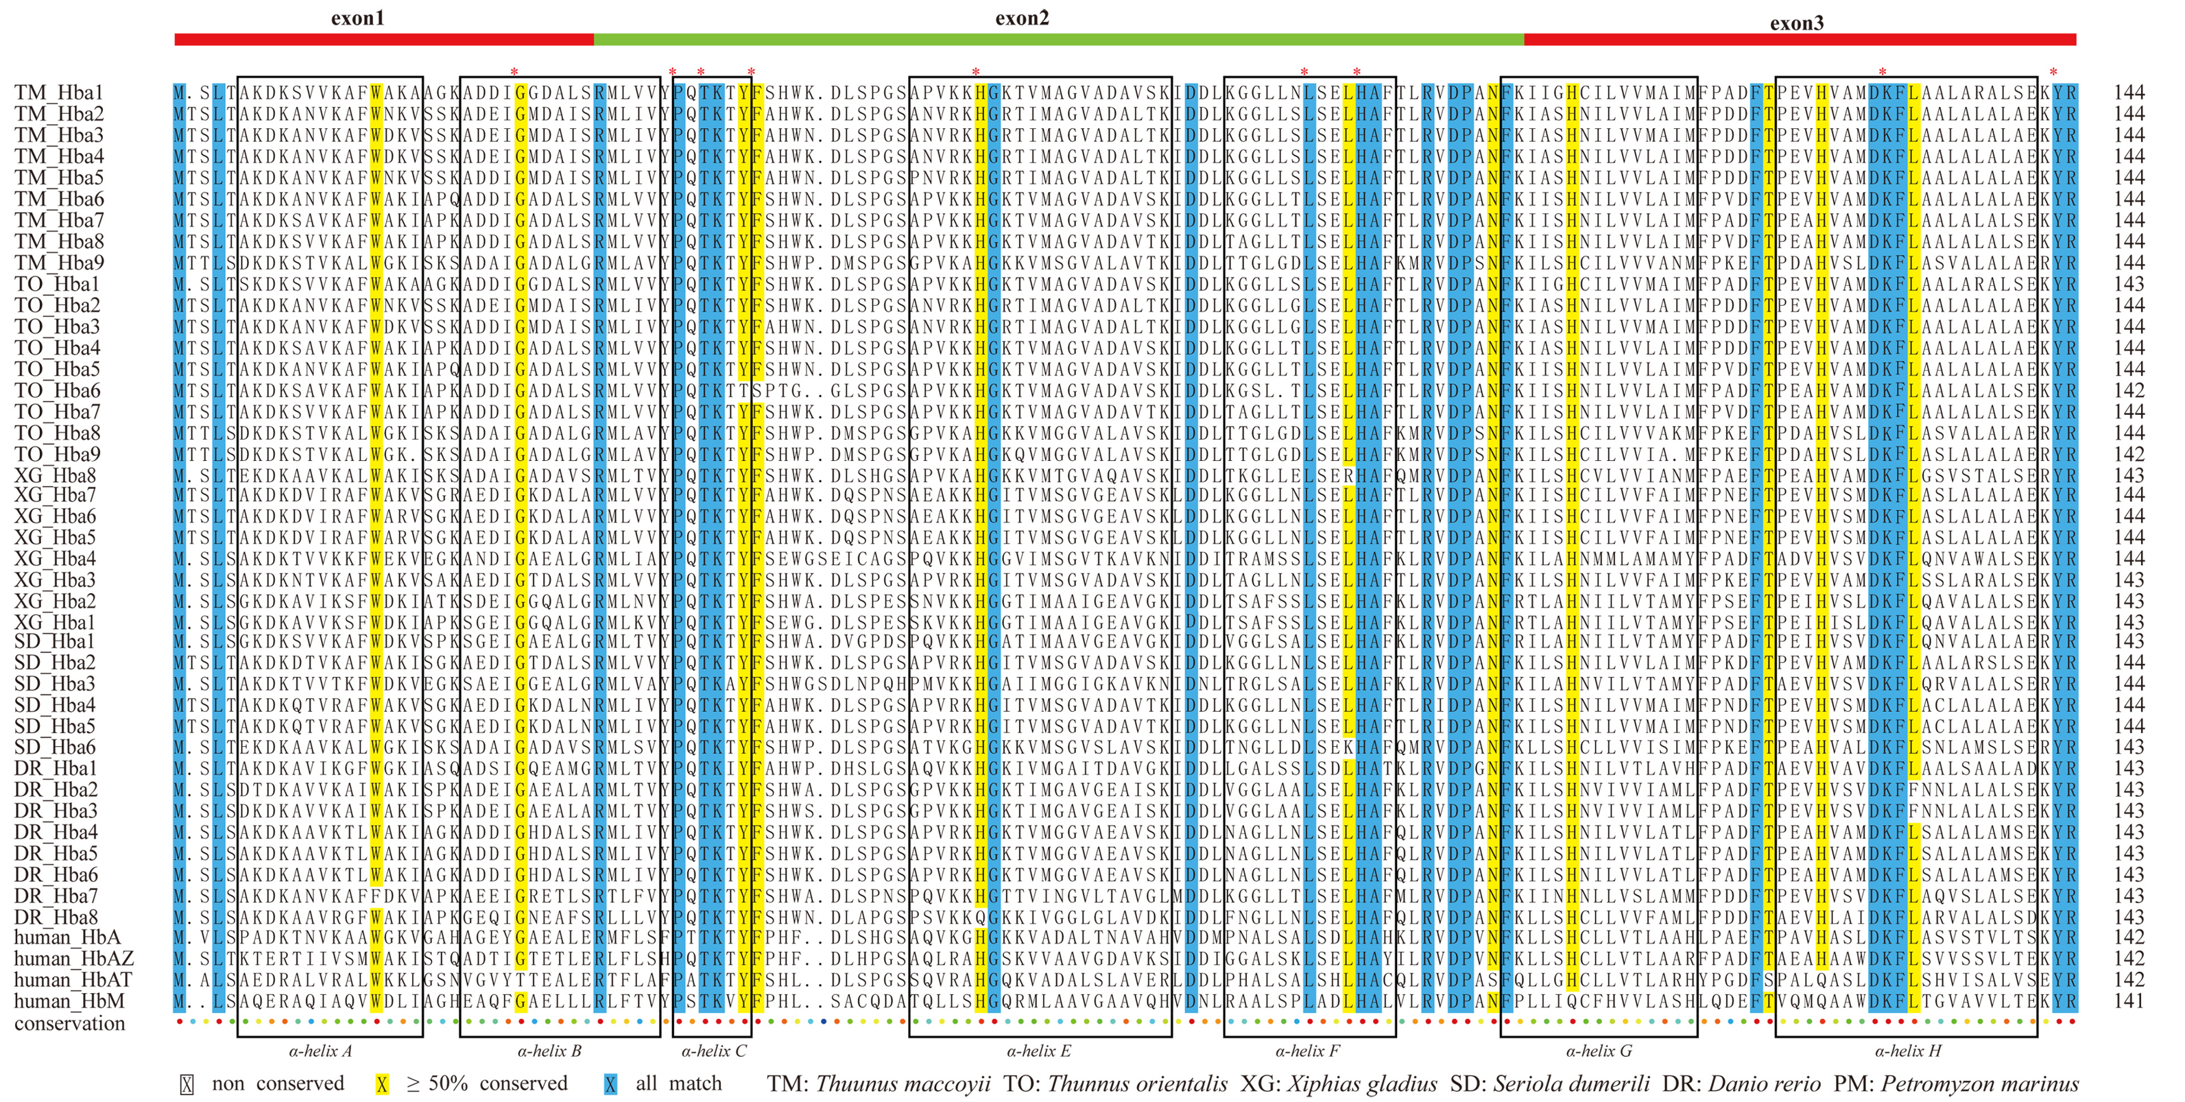
Figure S4: ClustalX alignments of α hemoglobins from seven representative species.

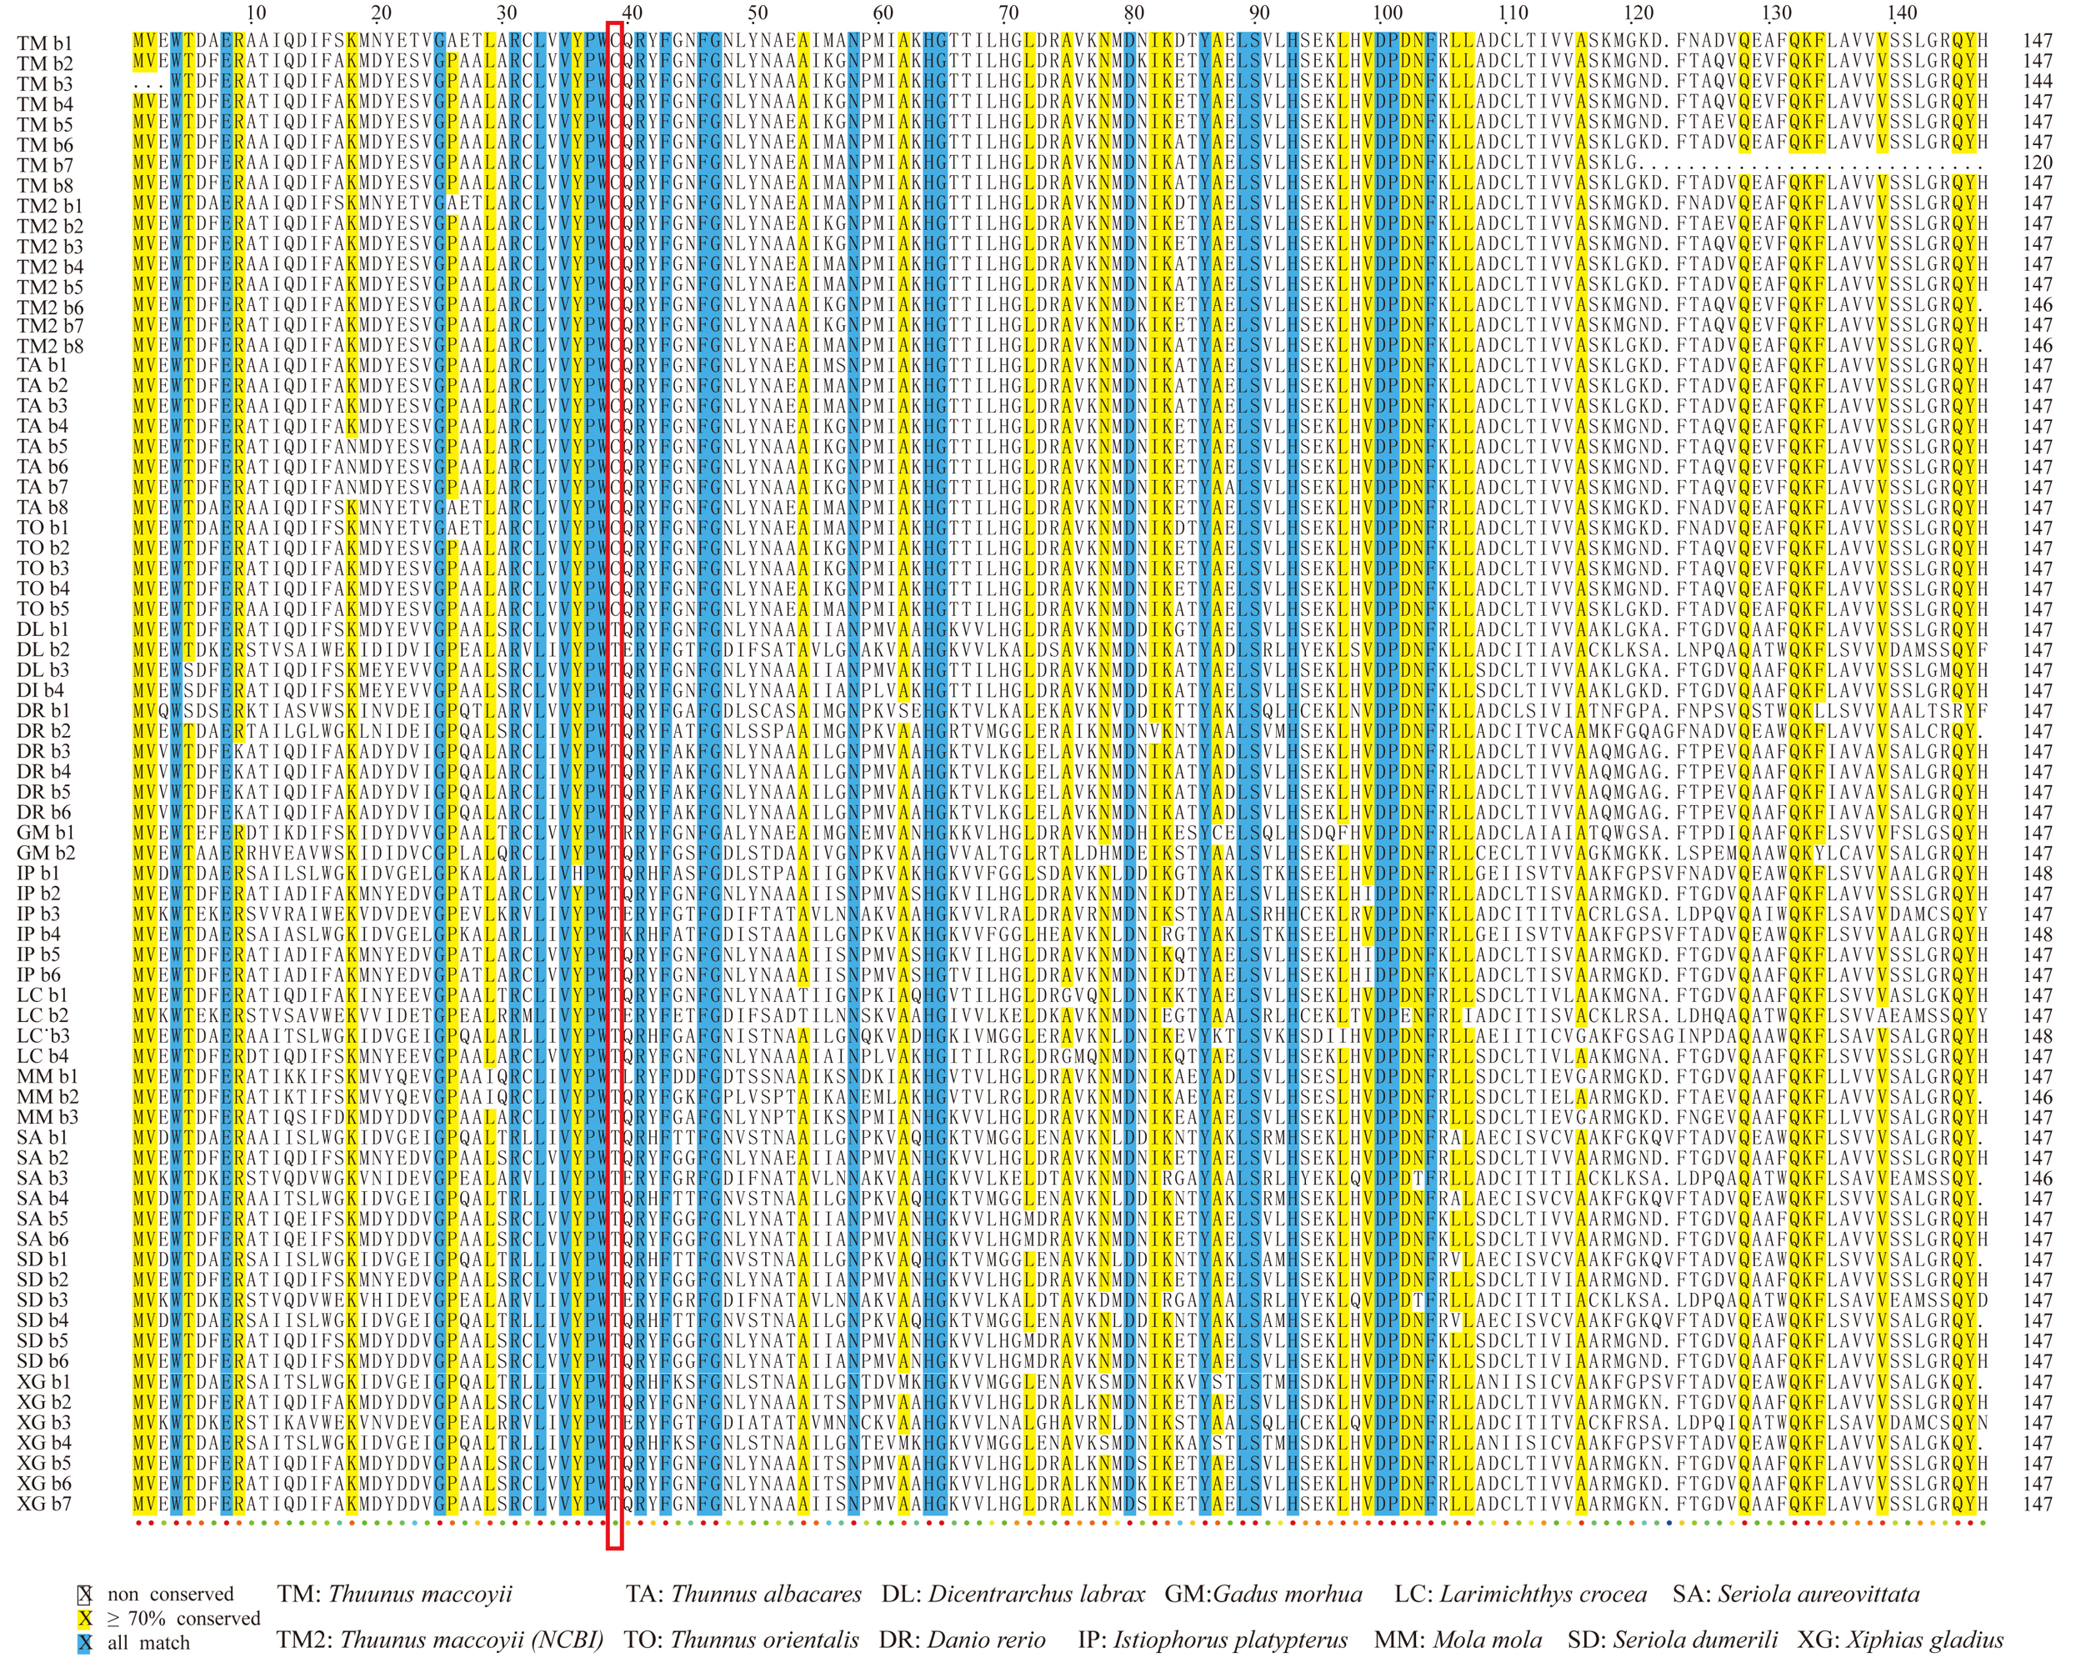
Figure S5: Alignments of β hemoglobins in the MN cluster from thirteen fishes.
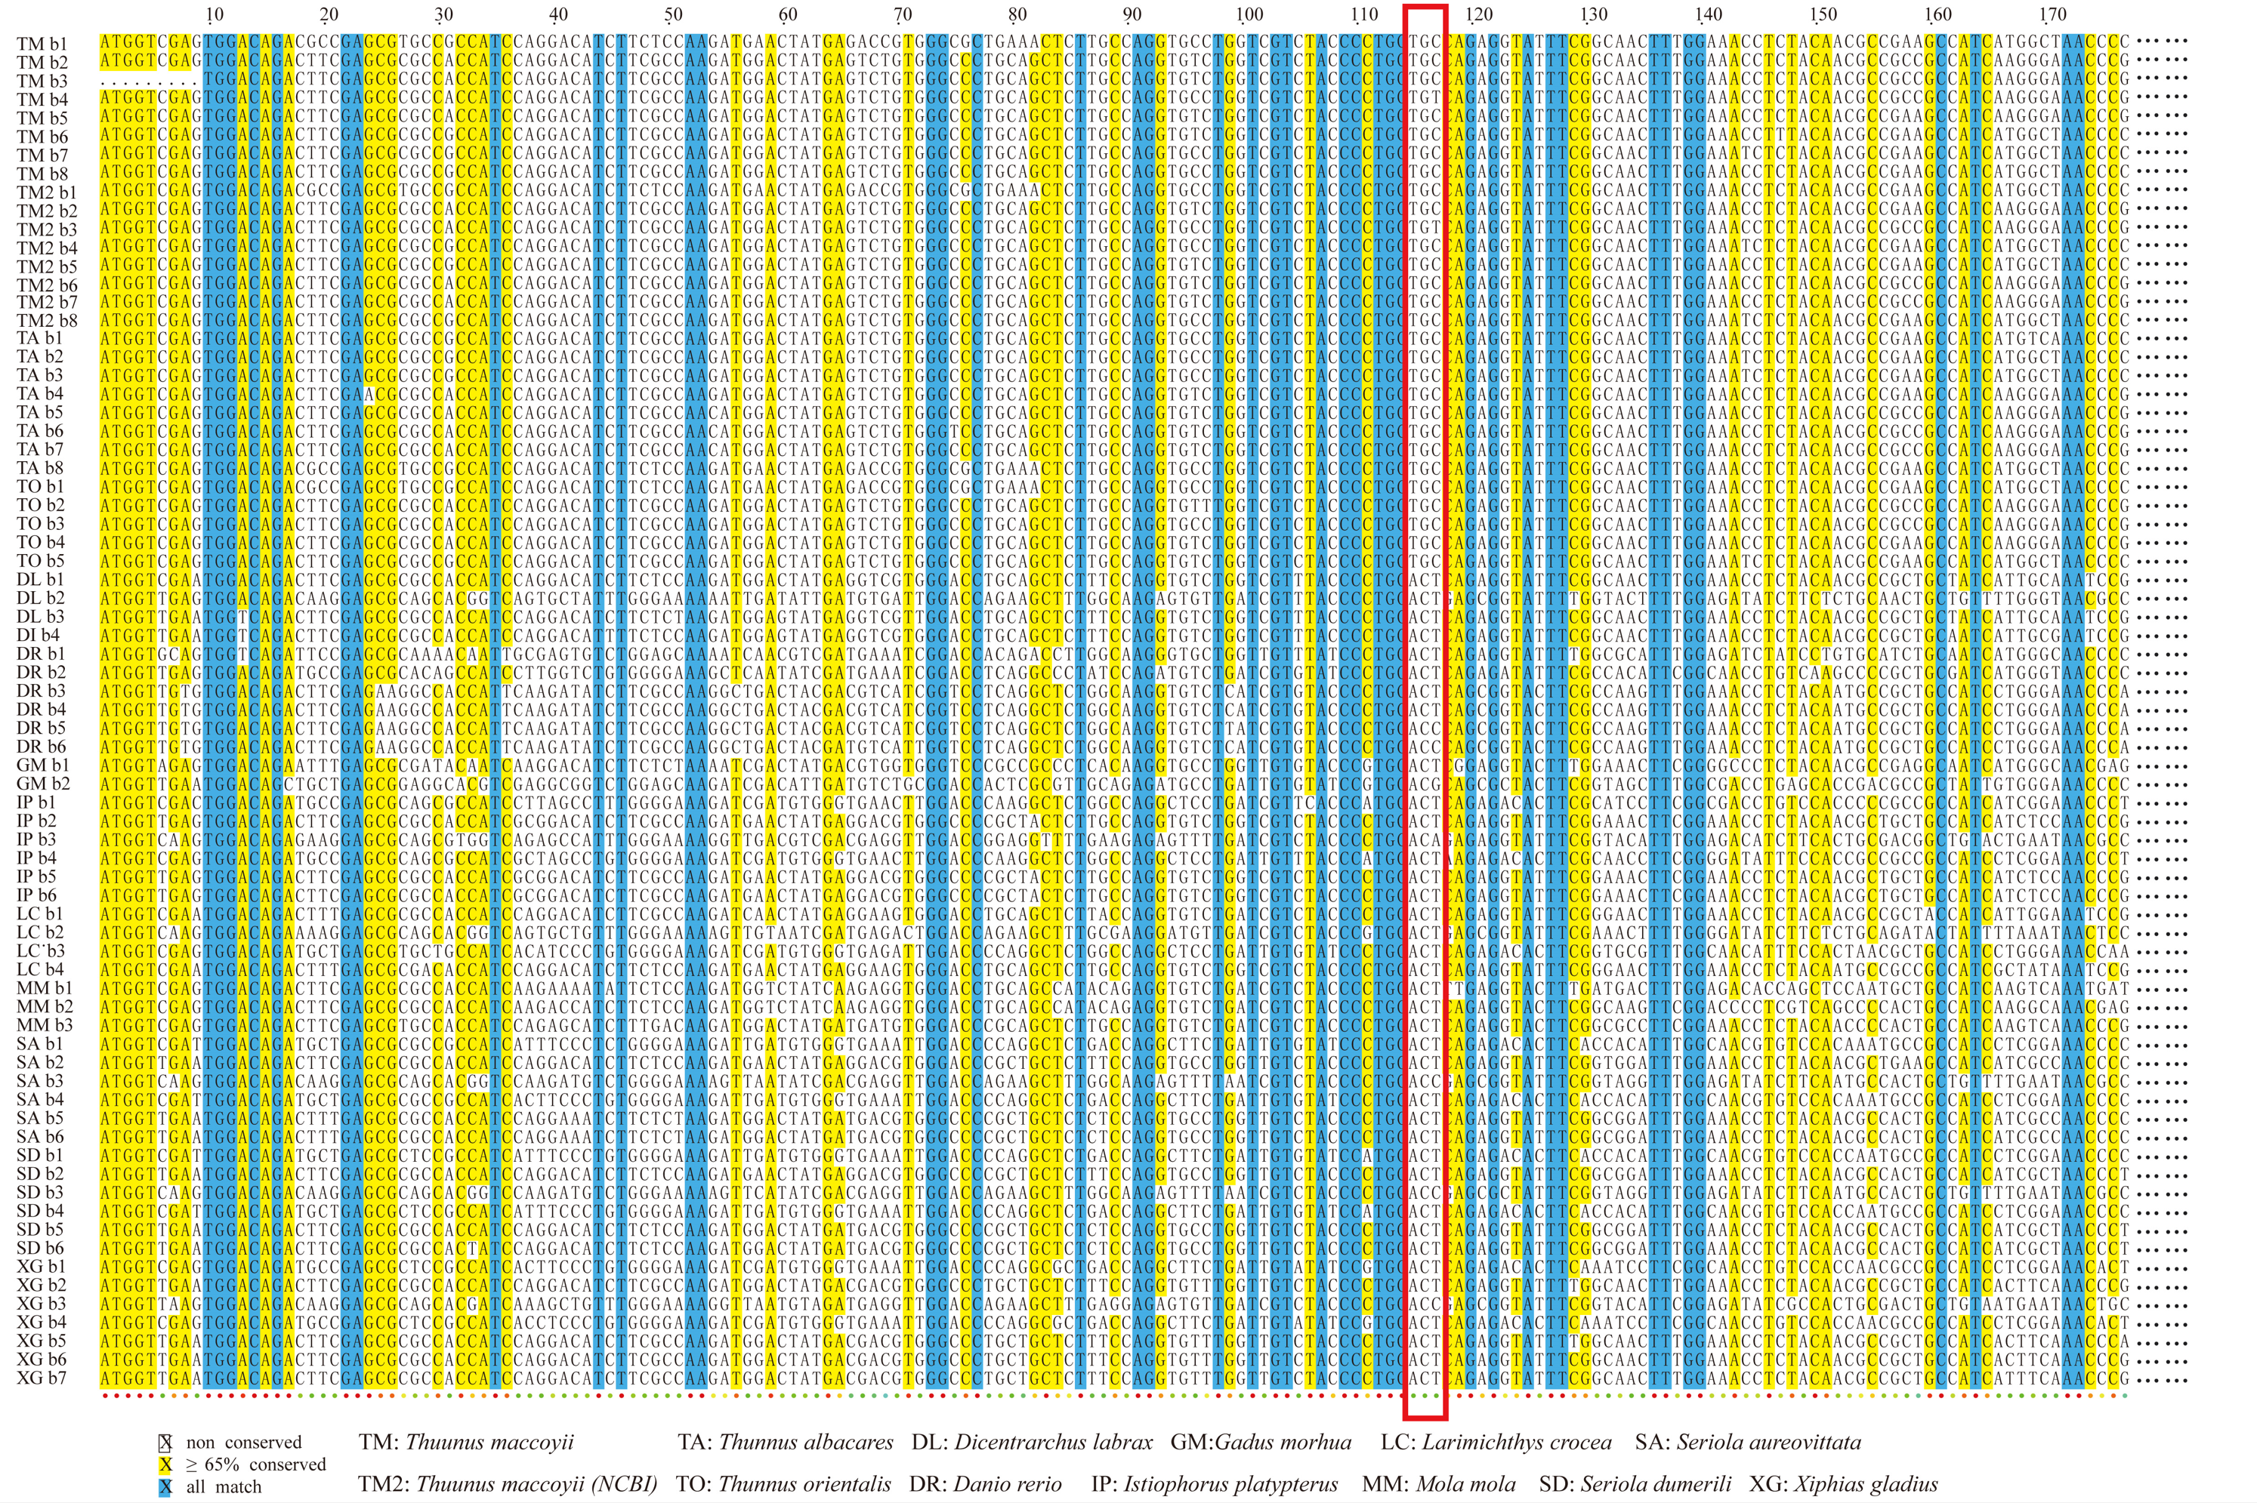
Figure S6: Alignments of β hemoglobin coding genes (1-177 nucletide) in the MN cluster from thirteen fishes.

