Supplementary Material

Engineering Elastic Bioactive Composite Hydrogels for Promoting Osteogenic Differentiation of Embryonic Mesenchymal Stem Cells

Min Wang1, #, Yi Guo2, #, Zexing Deng3, Peng Xu1,*

1Honghui Hospital, Xi'an Jiaotong University, Xi'an 710000, China

2Shaanxi Key Laboratory of Brain Disorders, Shaanxi Key Laboratory of Ischemic Cardiovascular Disease, Institute of Basic and Translational Medicine, Xi’an Medical University, Xi’an, 710021, China

3College of Materials Science and Engineering, Xi’an University of Science and Technology, Xi’an, 710054, China

# Min Wang and Yi Guo contributed equally to this paper.

**\* Correspondence:**Peng Xu  
sousou369@163.com

Supplementary Figures

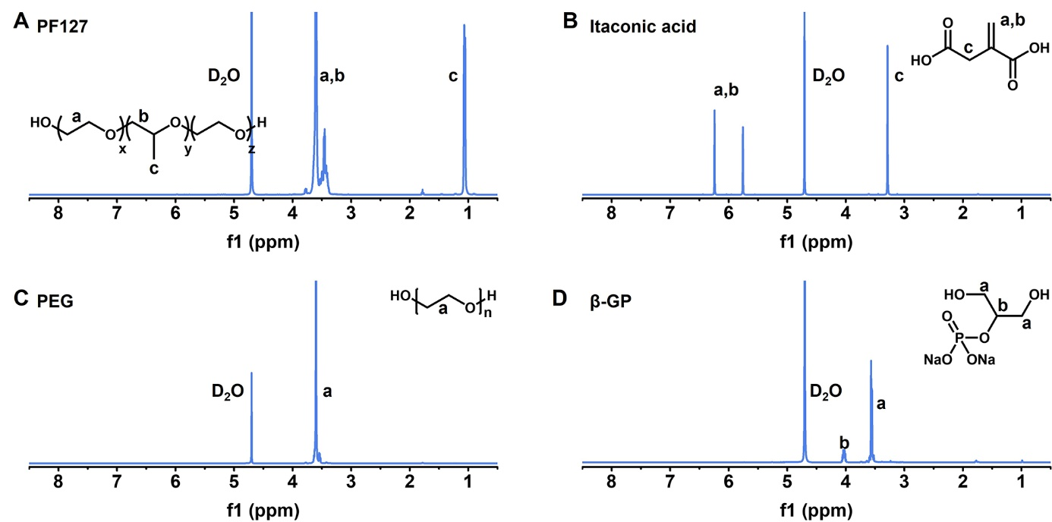

**Figure S1.** The 1H NMR spectra of **(A)** PF127, **(B)** itaconic acid, **(C)** PEG and **(D)** β-GP-Na.

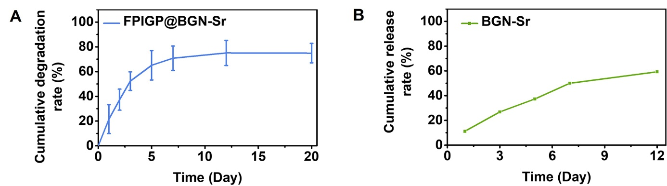

**Figure S2.** **(A)** The degradation of FPIGP@BGN-Sr hydrogel placed in PBS (pH 7.4) at 37 ℃; **(B)** The release of BGN-Sr from FPIGP@BGN-Sr hydrogel placed in PBS (pH 7.4) at 37 ℃.

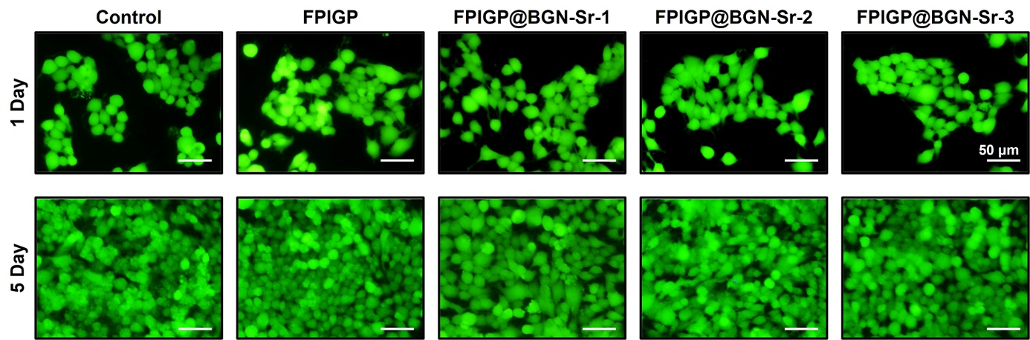

**Figure S3.** The live‒dead staining fluorescent images of C3H10T1/2 cells after incubation with hydrogels for 1 and 5 days.

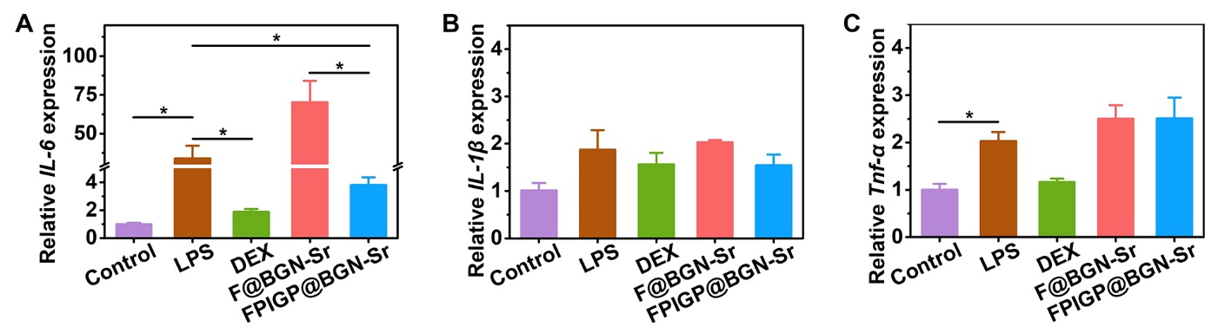

**Figure S4.** The relative (A) *IL-6*, (B) *IL-1β* and (C) *Tnf-α* expression in RAW 264.7 cells treated with LPS after incubation with hydrogels for 2 days.