Supplementary Materials
eFigure 1. Funnel plots of different endpoints.
- HR for OS, (B) HR for iPFS, (B) HR for PFS
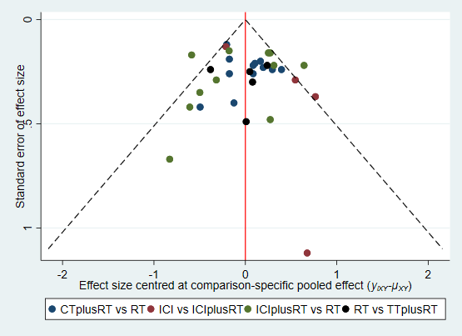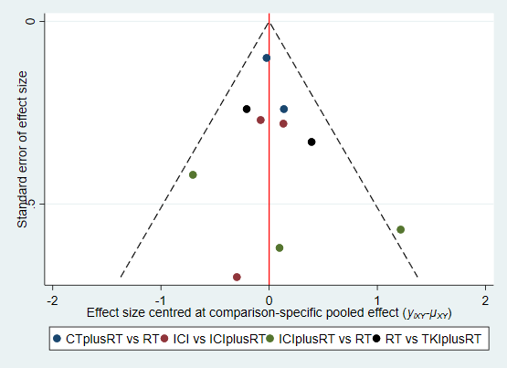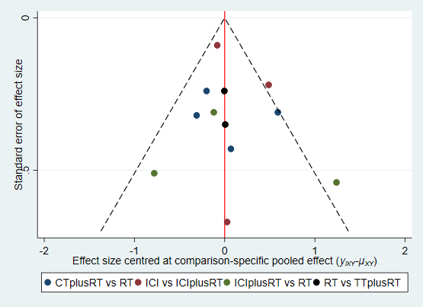
A B C

eFigure 2. Heterogeneity Analysis Charts of different endpoints.
- OS, (B)iPFS, (C)PFS
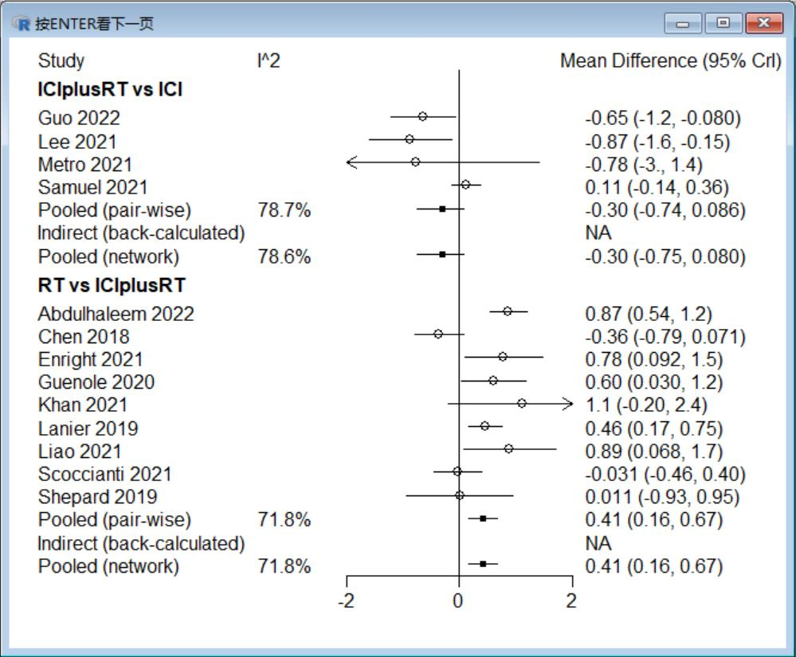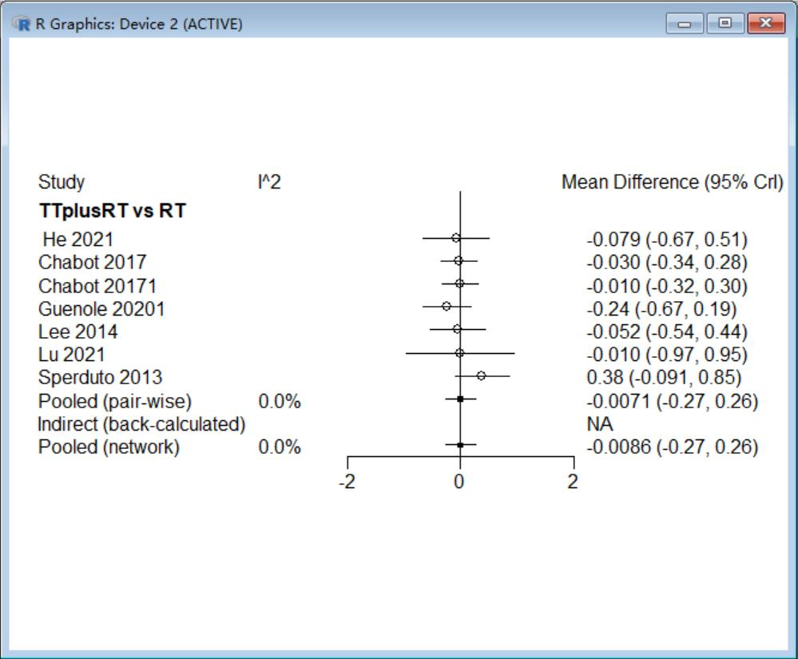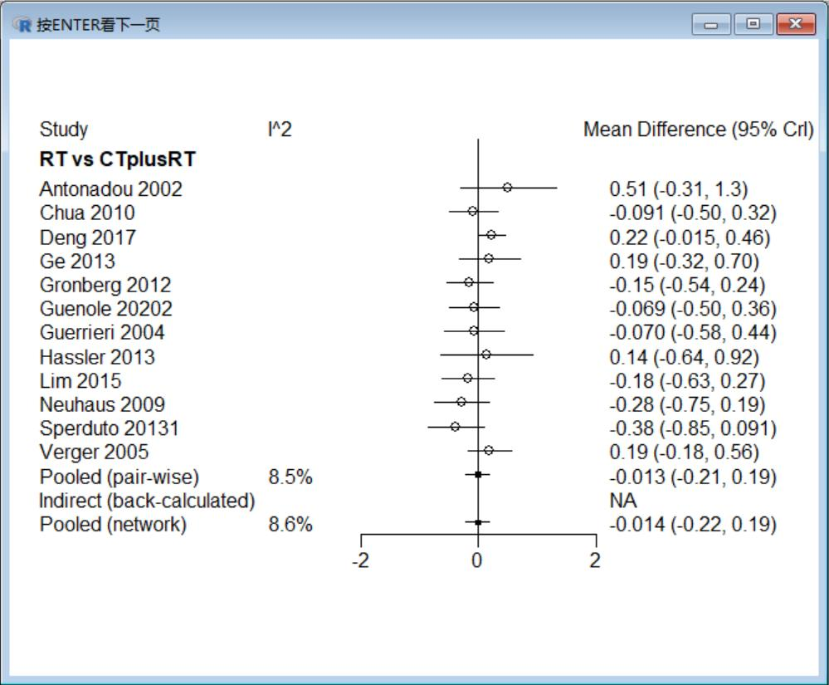
eFigure 2A

Continue with the picture
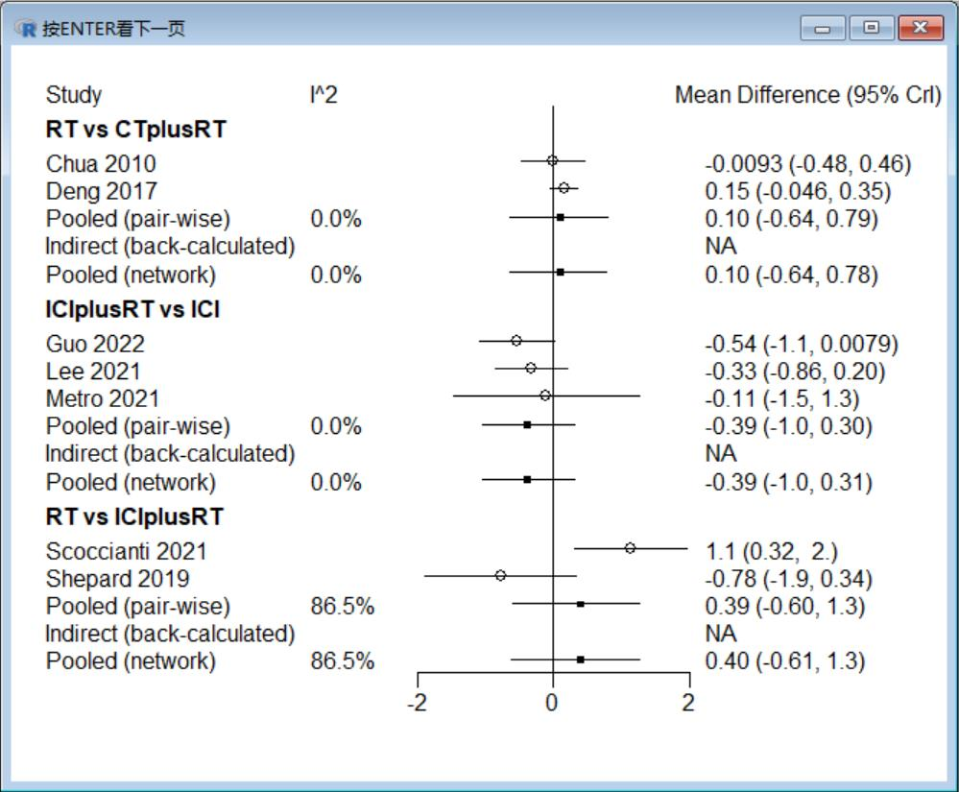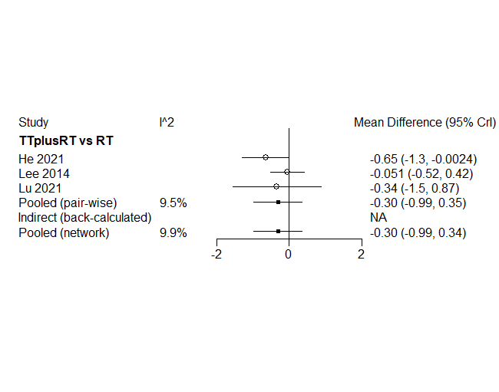
eFigure 2B

Continue with the picture
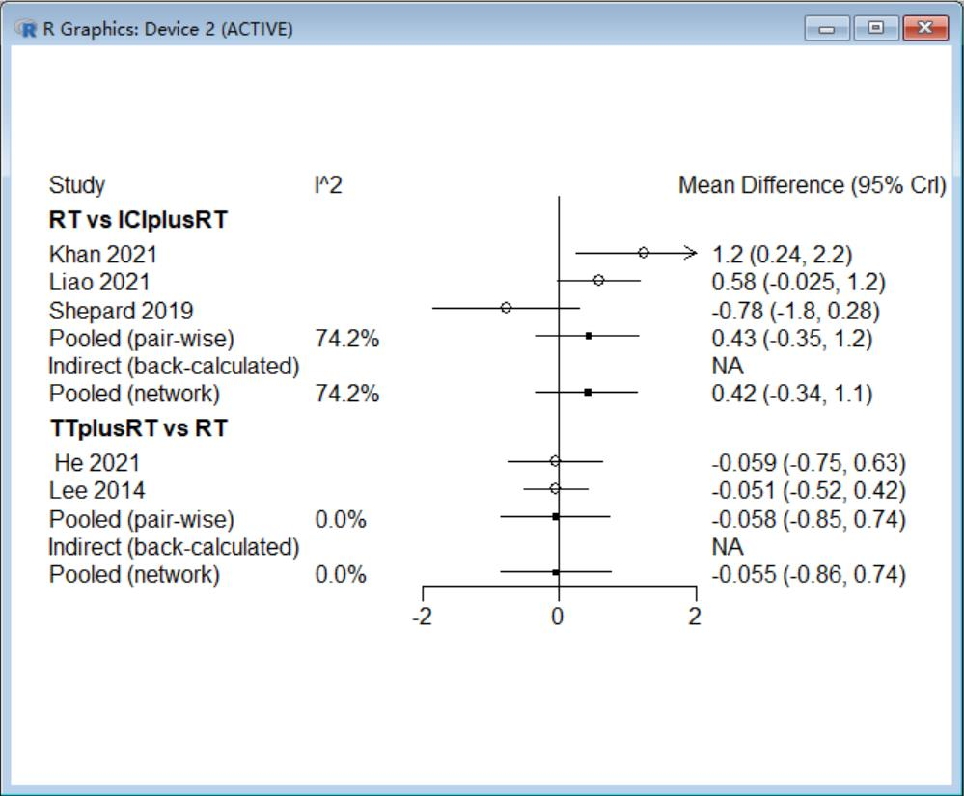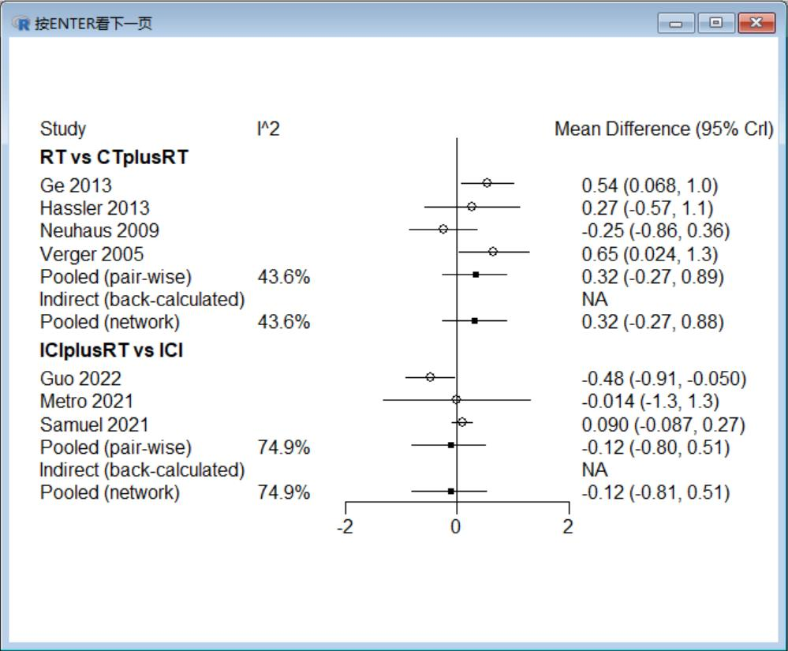
eFigure 2C

eFigure 3. Density charts of different endpoints.
- OS, (B)iPFS, (C)PFS
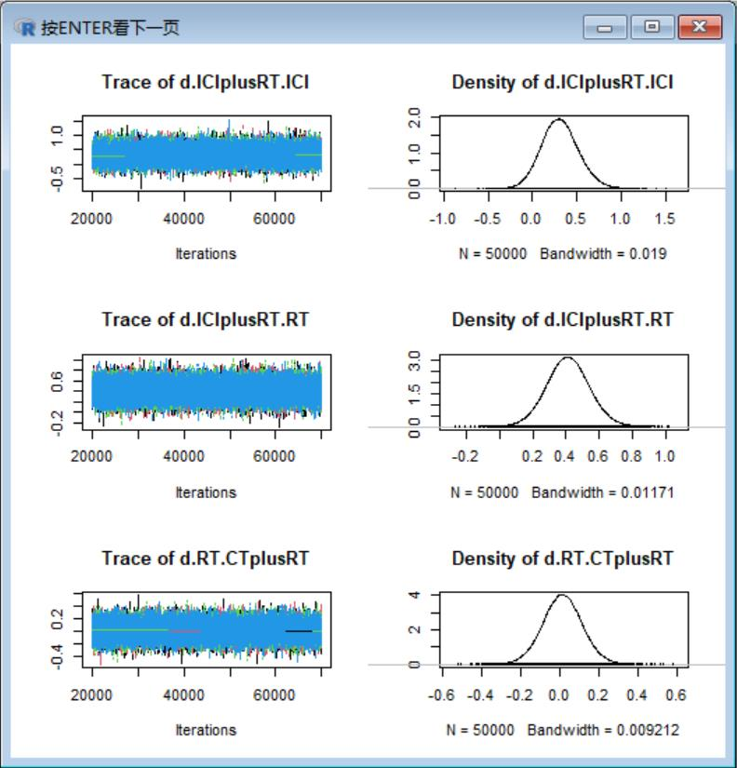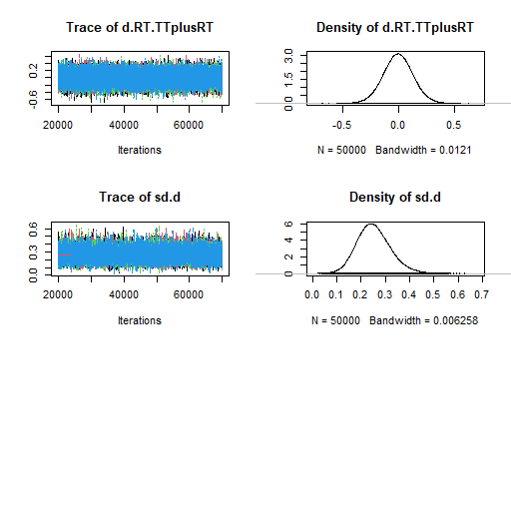
eFigure 3A

Continue with the picture
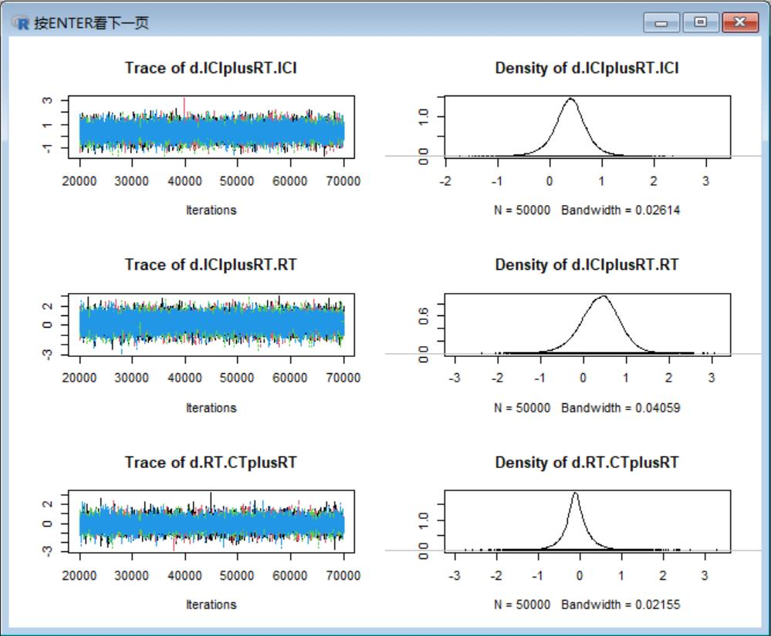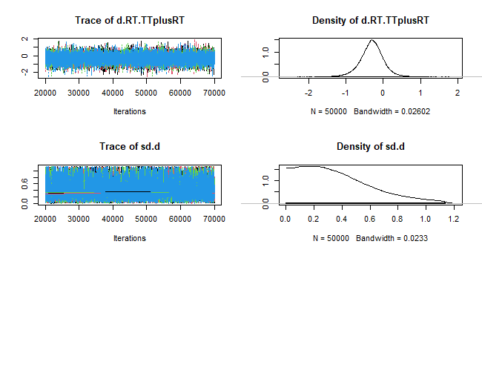
eFigure 3B

Continue with the picture
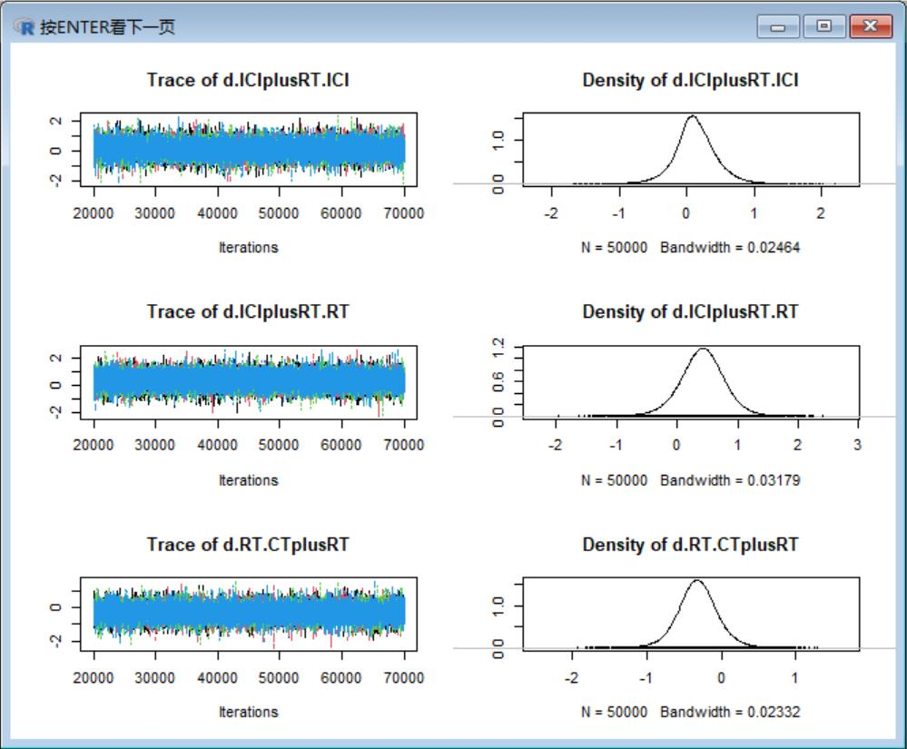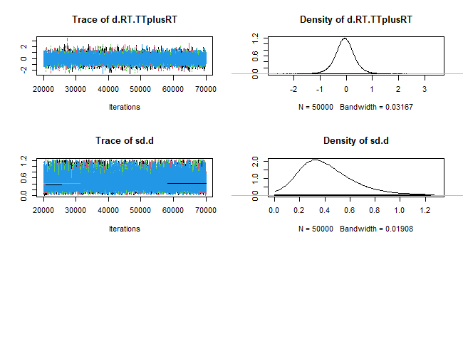
eFigure 3C

eFigure4. Convergence charts of different endpoints
- OS, (B) iPFS, (C) PFS
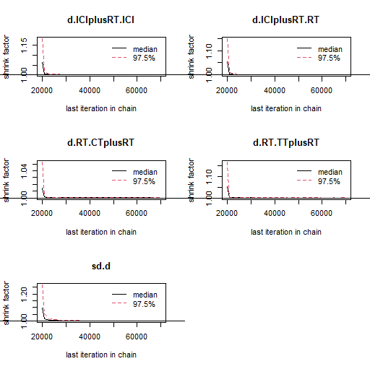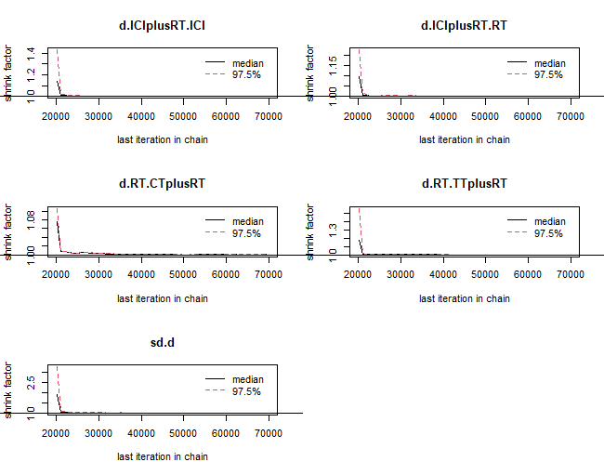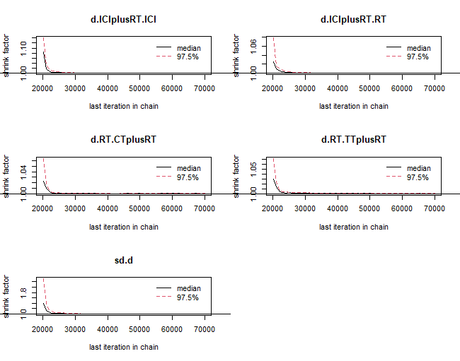
eFigure4 A eFigure4 B eFigure4 C

