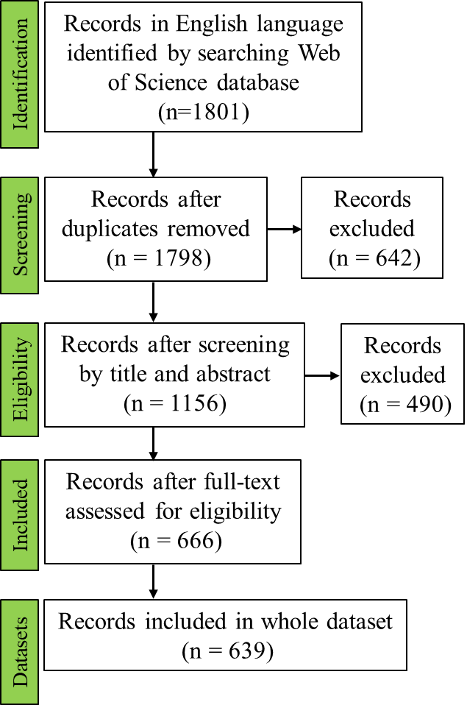

Fig. S1 PRISMA diagram showing the process of locating publications for this meta-analysis.

Fig. S2 Funnel plots for observed outcomes of plant shoot, root, and total biomass under AMF inoculation in pot experiments.

