**Islands in the Mud: The South Texas Banks Provide Crucial Mesophotic Habitat for Coral Communities.**

**Supplemental Material**

Maria Bollinger1, Keir J. Macartney1, Erin E. Easton1, David W. Hicks1

1The University of Texas Rio Grande Valley, School of Earth, Environmental and Marine Sciences, Port Isabel, TX 78958 USA

*Study Area Mesoscale Bathymetry*

Big Adam Bank was a hard-bottom area that makes up one singular component, 0.51 km2 in area, making it the smallest bank explored during this study. There was 9.48 m of vertical relief at the bank, with a maximum depth of 69.5 m and a minimum depth of 60.1 m, making it simultaneously the shallowest maximum depth and the deepest crest depth observed during this study. There was a relatively low slope across the bank (29.1 degrees), and the broad- and fine-scale BPI values reported that there are no depressions on the hard bottom area.

On the other extreme, Mysterious Bank represents the largest hard bottom area found in this study, with an irregular pattern of more than 58 small components making up approximately 3.64 km2 of hard bottom. The small components ranged in size from 200 m to over 1000 m in diameter and had different reliefs, none rising more than 12 m from the ocean floor. The components of Mysterious Bank closest to shore have a regional depth of about 69 m, but as the bank stretches further offshore, the continental shelf slopes downward to a maximum depth of 93.9 m.

Because Mysterious Bank is so large and has such a variety of components, only a small portion of the bank was included in this study. This small region, spanning 0.57 km2, encompasses the area with the maximum relief at the bank, where a peak of 69.9 m rises above the ocean floor where the regional depth is 80 m. The majority of the study area was composed of flats and low-lying crests, with only one minor depression surrounding the southern components of the study area. The bank had relatively rugged terrain (maximum VRM=0.12), with slopes measuring up to 45° on the edges of the terraces.

Hospital Bank was a 2.41 km2 hard bottom area with two large components that make up the largest contiguous hard-bottom area in this study . Depths at Hospital Bank ranged from 87.0 m at the deepest points, to 57.0 m at the crest. Hospital Bank had slopes ranging from 0 to 63 degrees, and the terrain was relatively rugged (with a maximum VRM value of 0.12). There were depressions in the benthic terrain over the hard-bottom areas, as represented as negative values in the broad- and fine-scale BPI maps.

With a maximum depth of 76.0 m and a minimum depth of 57.7 m, North Hospital Bank had the second shallowest crest depth of the five banks, second only to its nearby counterpart, Hospital Bank. North Hospital Bank was a singular component that made up 1.42 km2 of hard-bottom area with a gently sloping terrain (maximum slope of 34.4 degrees), low overall terrain ruggedness (maximum VRM value of 0.03), and slight depressions over the bank when analyzing BPI on a broad-scale.

Lastly, Southern Bank, which was found further offshore than any of the other studied South Texas Banks (75.9 km distance from shore), had a hard-bottom area of 1.02 km2. Southern Bank had a maximum depth of 92.0 m and a minimum depth of 59.0 m, and the 33 m of resulting vertical relief had a maximum rate of change (slope) of 30.6 degrees. There were two major crests on Southern Bank, and a large depression just north of the center of the bank.

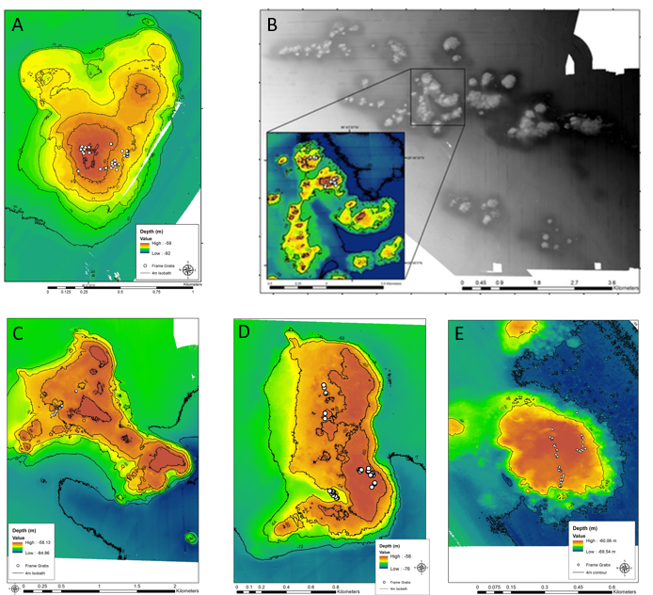**Figure S1.** Bathymetric map of the study area at (A) Big Adam Bank, (B) Mysterious Bank, (C) Hospital Bank, (D) North Hospital Bank, and (E) Southern Bank. Locations of benthic frame grabs are denoted as white dots. White areas on the maps indicate that the area was not mapped.

**Figure S2**. Stacked barplot showing the primary substrate found in each photoquadrat frame from the five banks.

**Table S1.** Benthic terrain variables on a mesoscale level at five South Texas Banks. The values for Mysterious Bank (*) reflect the bathymetry of the study area only and not the entire bank complex.

|  |  |  |  |  |  |  |  |  |  |  |
| --- | --- | --- | --- | --- | --- | --- | --- | --- | --- | --- |
| Bank | Area (km2) | Max. Depth (m) | Min. Depth (m) | Relief(m) | Max. slope (degrees) | Curvature | Aspect (degrees) | Terrain Ruggedness | Broad-scale BPI range | Fine-scale BPI range |
| Big Adam | 0.51 | 69.5 | 60.0 | 9.5 | 29.1 | -132 to 122 | 0 to 360 | 0 to 0.06 | -2 to 6 | -2 to 3 |
| Mysterious* | 3.64 | 83.0 | 69.9 | 13.1 | 44.2 | -166-169 | 0 to 360 | 0 to 0.12 | -3 to 8 | -1 to 5 |
| Hospital | 2.41 | 87.0 | 57.0 | 30.0 | 63.0 | -293 to 238 | 0 to 360 | 0 to 0.12 | -8 to 17 | -6 to 6 |
| North Hospital | 1.42 | 76.0 | 57.7 | 18.4 | 34.4 | -195 to 92 | 0 to 360 | 0 to 0.03 | -5 to 11 | -3 to 4 |
| Southern | 1.02 | 92.0 | 59.0 | 33.0 | 30.6 | -725 to 550 | 0 to 360 | 0 to 0.31 | -9 to 13 | -7 to 7 |

**Table S2.** Values used in the calculation of fine- and broad- scale bathymetric position index (BPI) values in Benthic Terrain Modeler (BTM) (Wright et al. 2012) for the mesoscale spatial analysis of five South Texas Banks.

|  |  |  |  |  |
| --- | --- | --- | --- | --- |
|  | Fine-scale BPI  inner radius | Fine-scale BPI  outer radius | Broad-scale BPI inner radius | Broad-scale BPI outer radius |
| Big Adam | 50 m | 100 m | 250 m | 500 m |
| Mysterious | 100 m | 200 m | 500 m | 1000 m |
| Hospital | 100 m | 200 m | 1000 m | 2000 m |
| North Hospital | 100 m | 200 m | 250 m | 500 m |
| Southern | 25 m | 50 m | 250 m | 500 m |

**Table S3.** ANOSIM output comparing the similarity of benthic communities between five South Texas Banks (Global R = 0.55, p=0.001).

|  |  |  |
| --- | --- | --- |
| Groups | R Statistic | P-value |
| Southern, North Hospital | 0.438 | 0.001 |
| Southern, Big Adam | 0.397 | 0.001 |
| Southern, Mysterious | 0.701 | 0.001 |
| Southern, Hospital | 0.511 | 0.001 |
| North Hospital, Big Adam | 0.618 | 0.001 |
| North Hospital, Mysterious | 0.754 | 0.001 |
| North Hospital, Hospital | 0.615 | 0.001 |
| Big Adam, Mysterious | 0.314 | 0.002 |
| Big Adam, Hospital | 0.465 | 0.001 |
| Mysterious, Hospital | 0.655 | 0.001 |

**Table S4.** Shannon diversity index, Simpson diversity index and species evenness were calculated on species abundance data for five South Texas Banks and, after samples with only one species were removed, averaged for each bank. Levels not connected by the same letter are significantly different based on Tukey’s HSD tests.

|  |  |  |  |  |
| --- | --- | --- | --- | --- |
| Bank | Species evenness (J’) | Tukey’s HSD | Shannon Diversity (H’ (log e)) | Tukey’s HSD |
| Big Adam | 0.32 ± 0.21 | A | 0.13 ± 0.48 | A |
| Mysterious | 0.34 ± 0.25 | A | 0.27 ± 0.32 | A |
| Hospital | 0.47 ± 0.24 | A | 0.58 ± 0.58 | B |
| North Hospital | 0.63 ± 0.12 | B | 1.14 ± 0.36 | C |
| Southern | 0.67 ± 0.17 | B | 1.51 ± 0.49 | D |