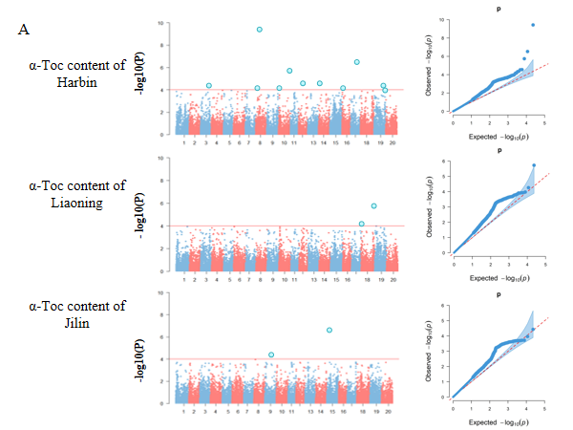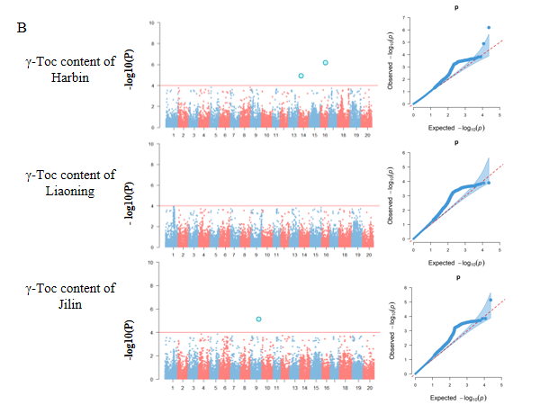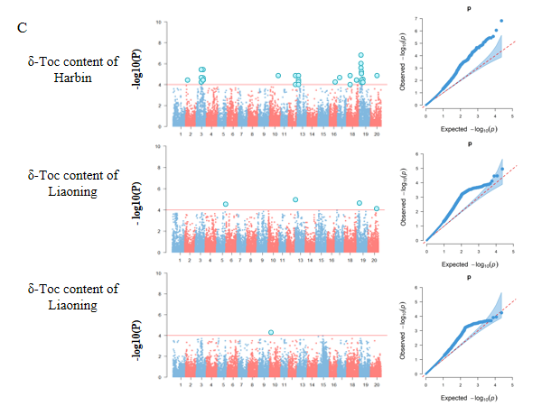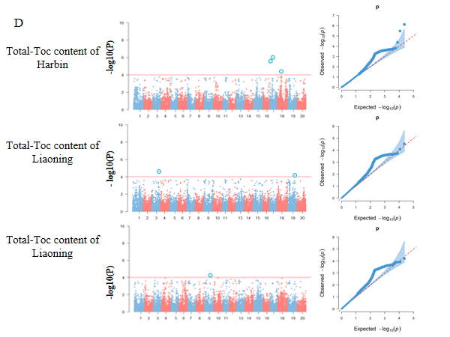

Figure S1 Manhattan plot and Q-Q plot generated from GWAS for tocopherol content in soybean seeds among 175 soybean accessions using GLM model.
Note: A–D respectively represent α-Toc, δ-Toc, γ-Toc, and Total-Toc content in three environments.

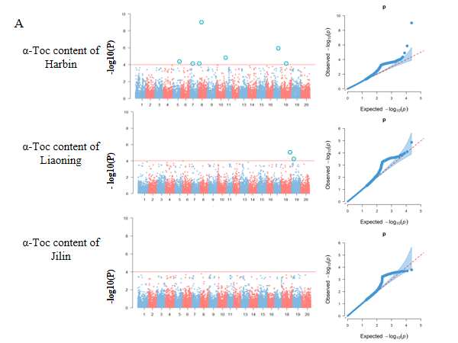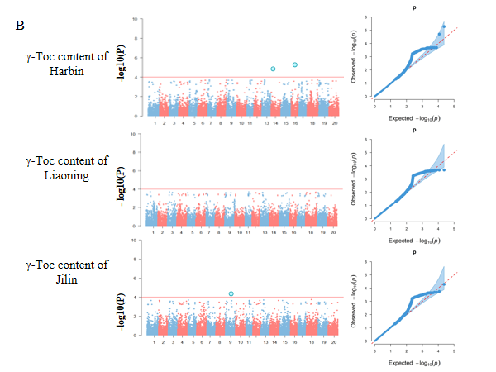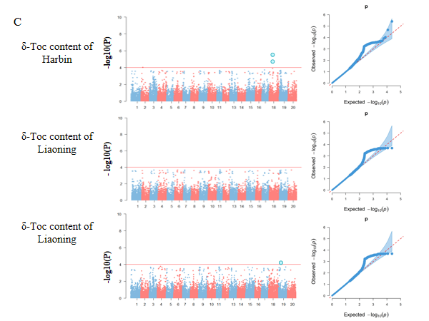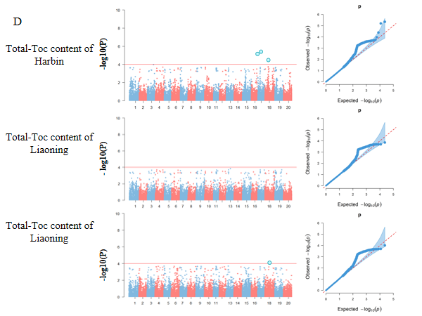
Figure S2 Manhattan plot and Q-Q plot generated from GWAS for tocopherol content in soybean seeds among 175 soybean accessions using MLM model.
Note: A–D respectively represent α-Toc, δ-Toc, γ-Toc, and Total-Toc content in three environments.
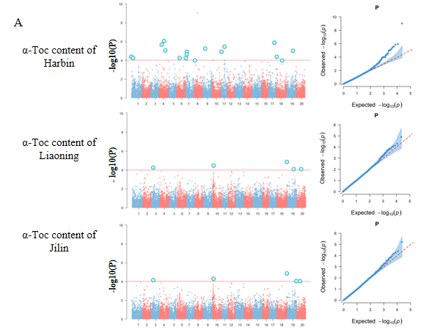
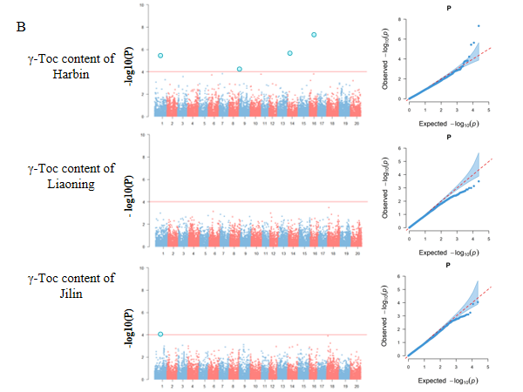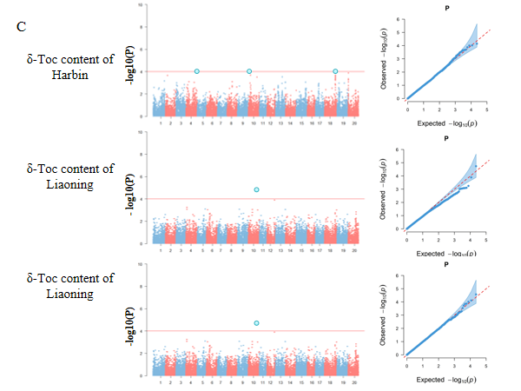
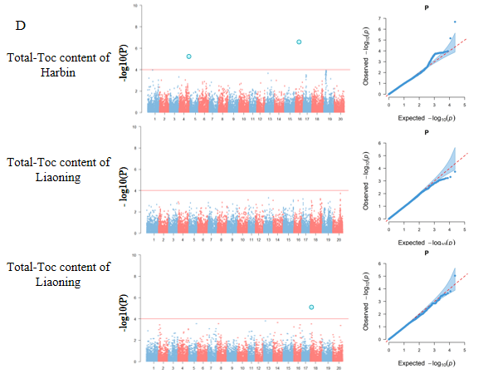
Figure S3 Manhattan plot and Q-Q plot generated from GWAS for tocopherol content in soybean seeds among 175 soybean accessions using CMLM model.
Note: A–D respectively represent α-Toc, δ-Toc, γ-Toc, and Total-Toc content in three environments.
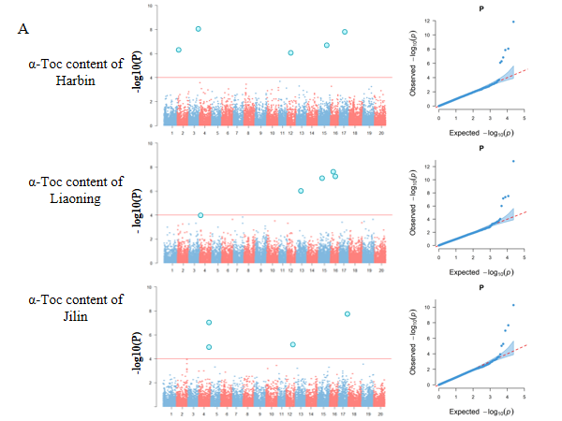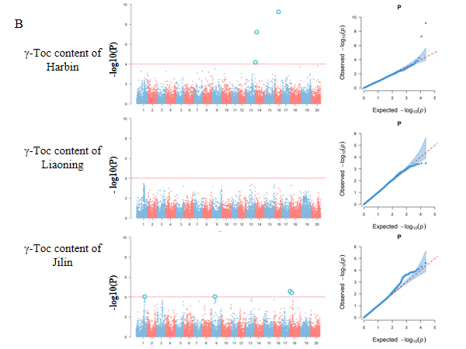
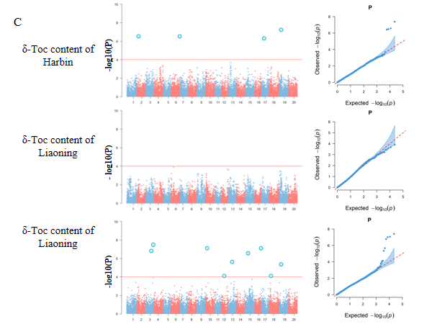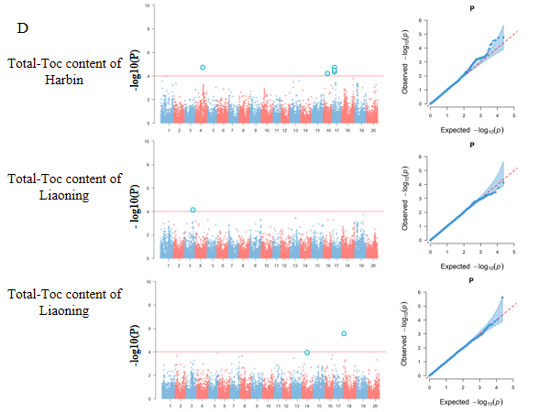
Figure S4 Manhattan plot and Q-Q plot generated from GWAS for tocopherol content in soybean seeds among 175 soybean accessions using BLINK model.
Note: A–D respectively represent α-Toc, δ-Toc, γ-Toc, and Total-Toc content in three environments.
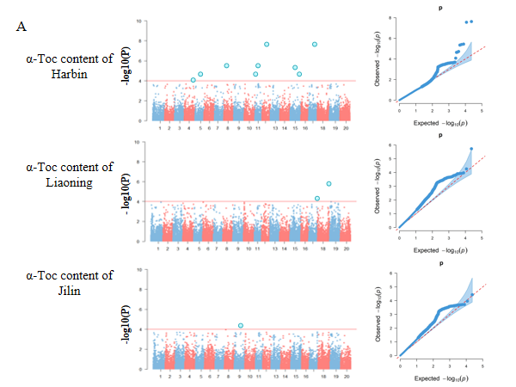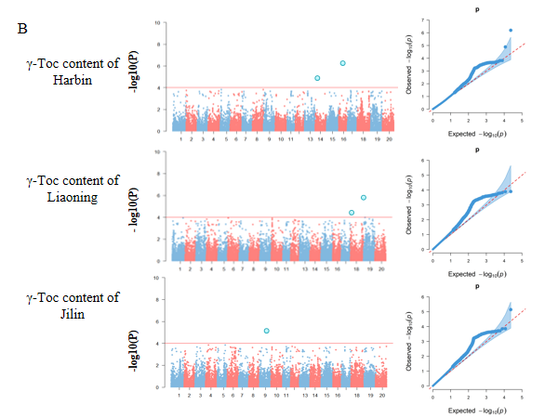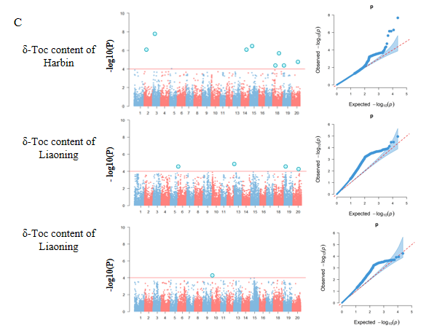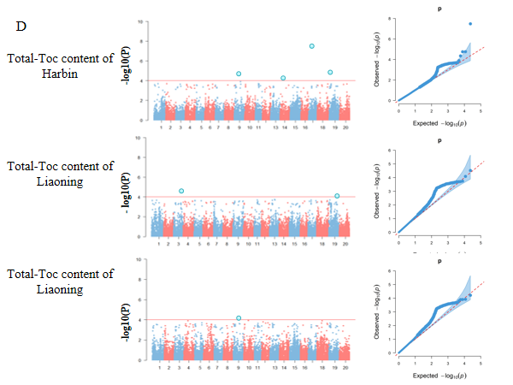
Figure S5 Manhattan plot and Q-Q plot generated from GWAS for tocopherol content in soybean seeds among 175 soybean accessions using FarmCPU model.
Note: A–D respectively represent α-Toc, δ-Toc, γ-Toc, and Total-Toc content in three environments.

Figure S6 Manhattan plot and Q-Q plot generated from GWAS for tocopherol content in soybean seeds among 175 soybean accessions using the 3VmrMLM model single-environment method.
Note: A–D respectively represent α-Toc, δ-Toc, γ-Toc, and Total-Toc content in three environments.

Figure S7 Manhattan plot and Q-Q plot generated from GWAS for tocopherol content in soybean seeds among 175 soybean accessions using QTL detection of 3VmrMLM multiple-environment method.
Note: A–D respectively represent α-Toc, δ-Toc, γ-Toc, and Total-Toc content in three environments.

Figure S8 Manhattan plot and Q-Q plot generated from GWAS for tocopherol content in soybean seeds among 175 soybean accessions using QEI detection of 3VmrMLM multiple-environment method.
Note: A–D respectively represent α-Toc, δ-Toc, γ-Toc, and Total-Toc content in three environments.

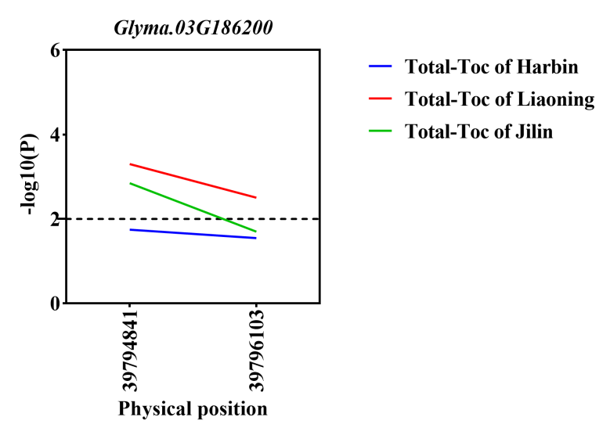
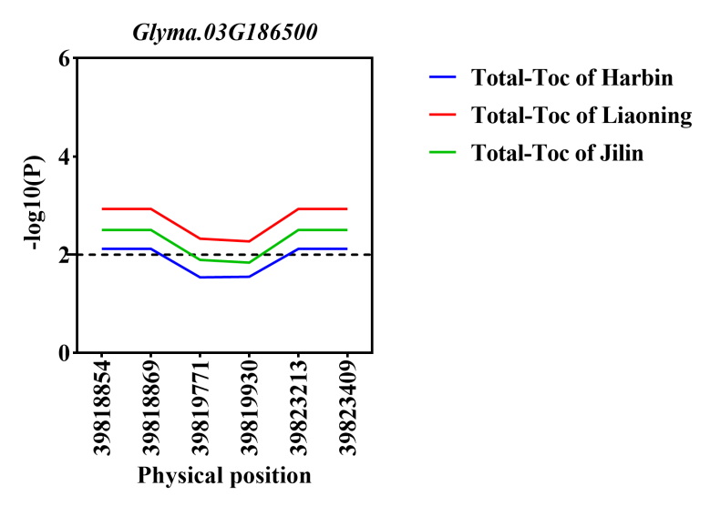

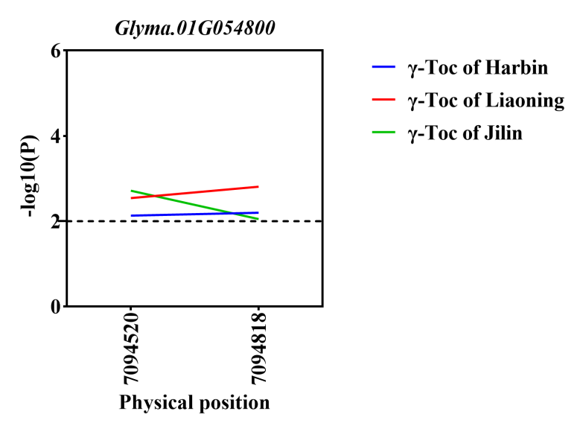
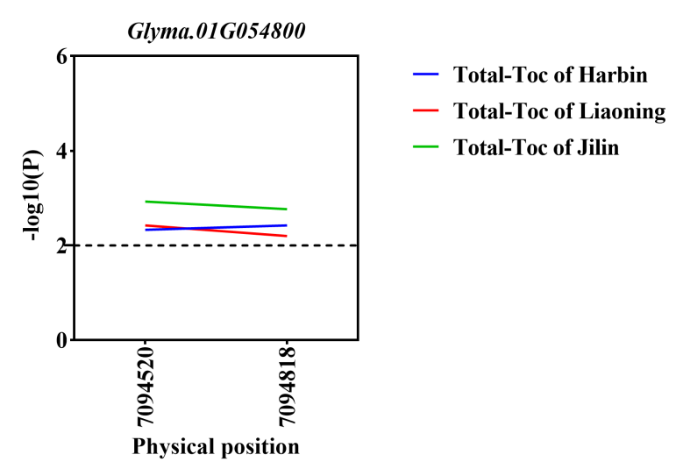
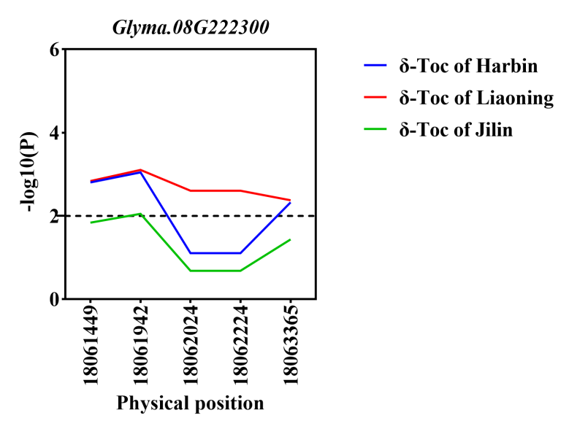

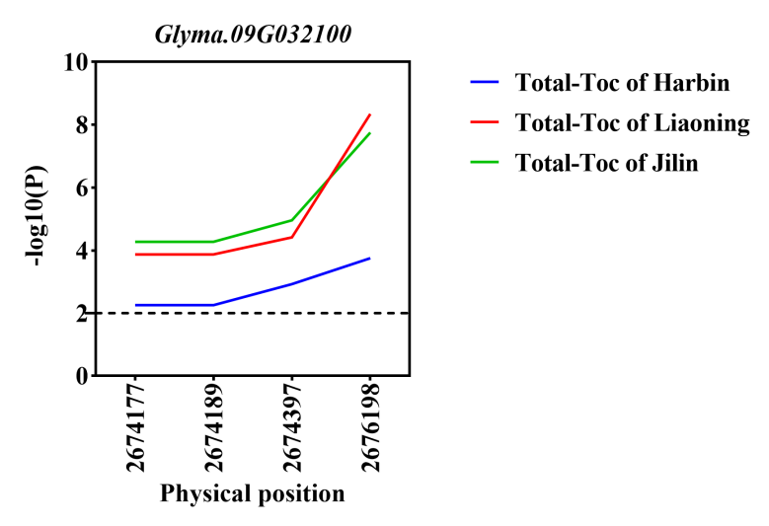
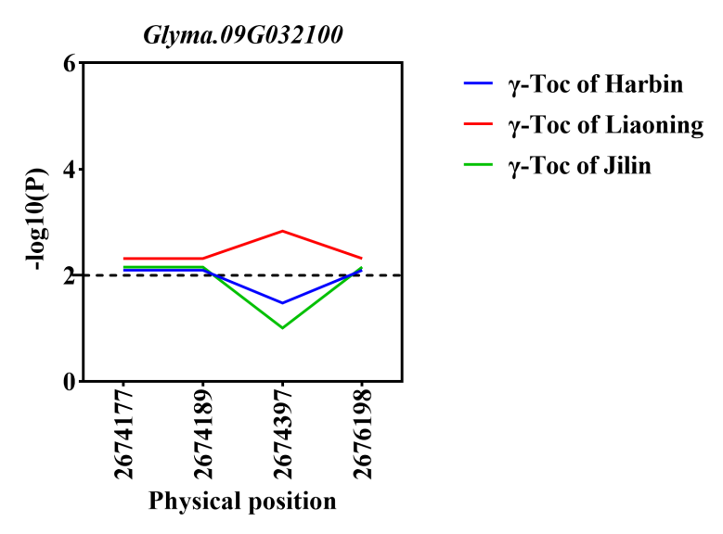
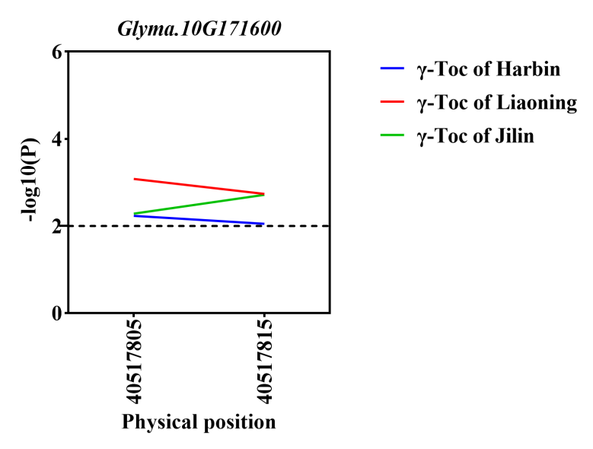
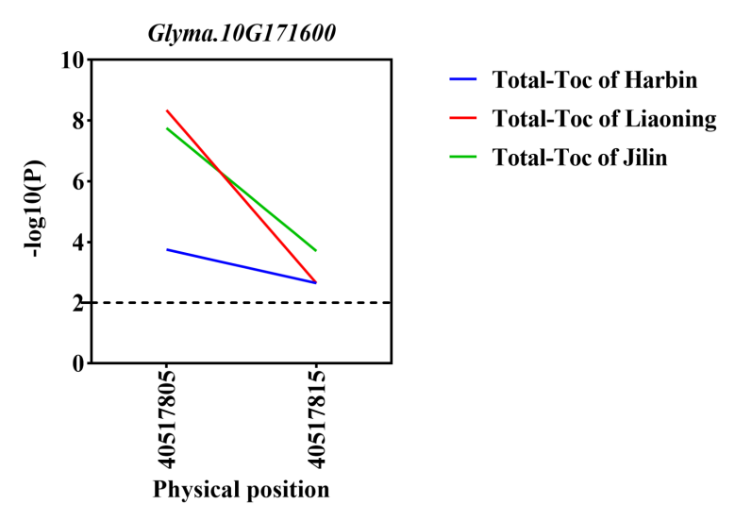
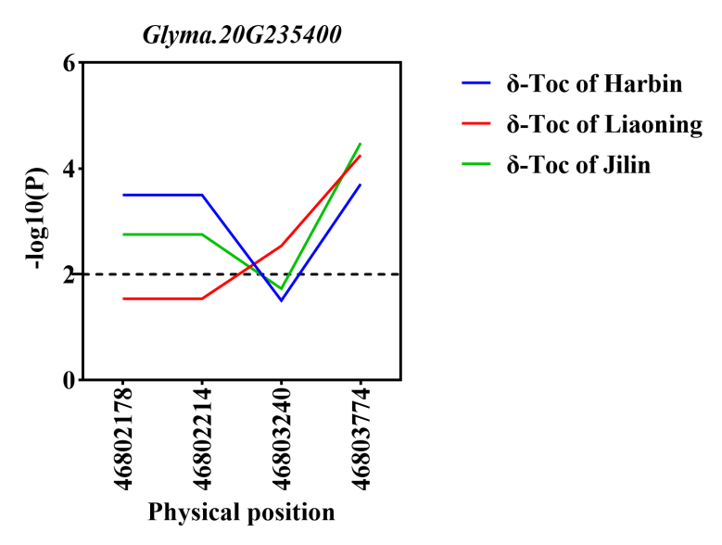
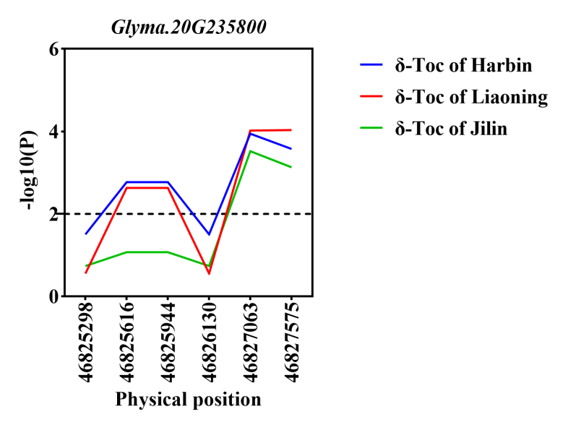
Figure S9 Gene-based association analysis of candidate genes.
Note: The horizontal line indicates that the threshold was set to 2.0.

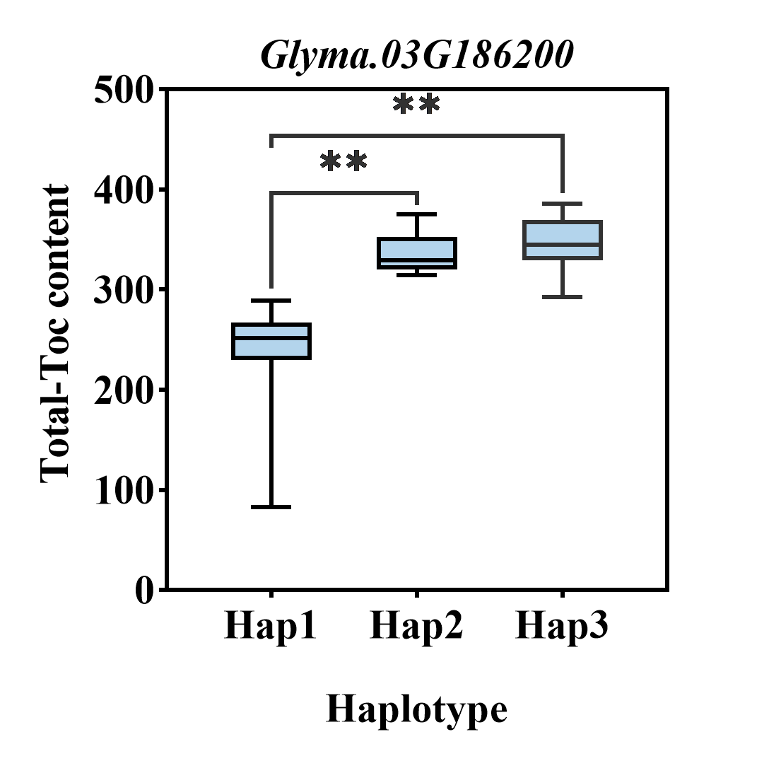
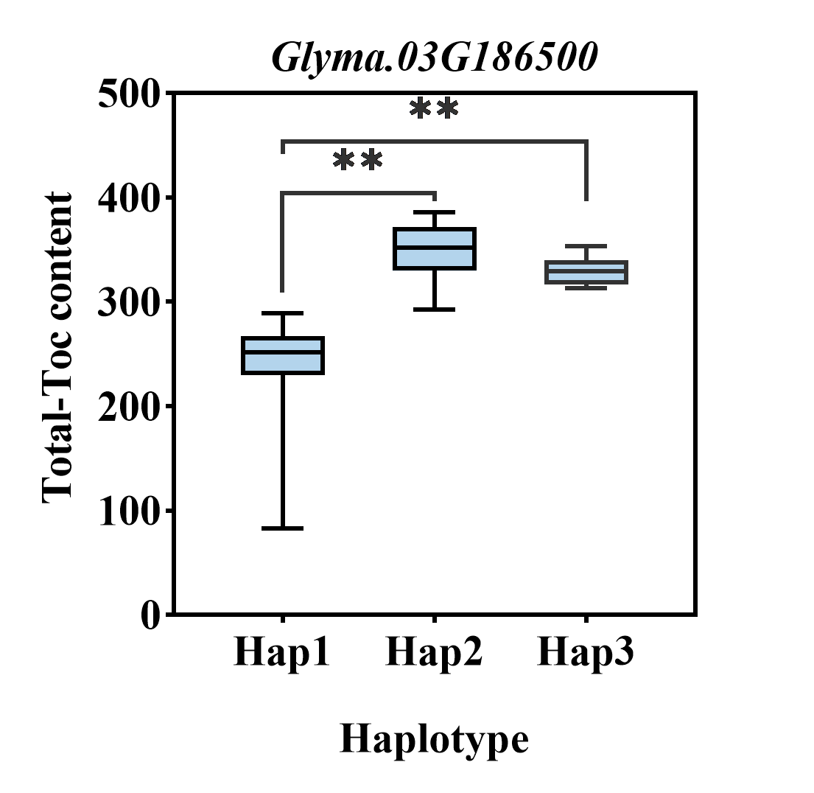

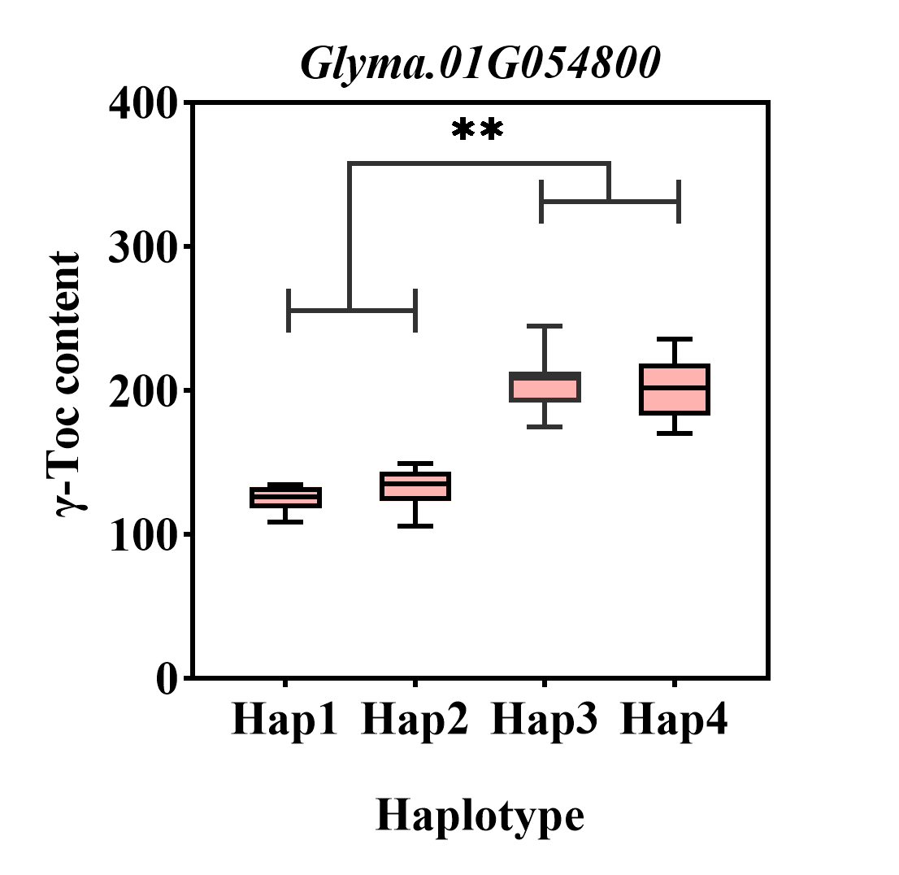
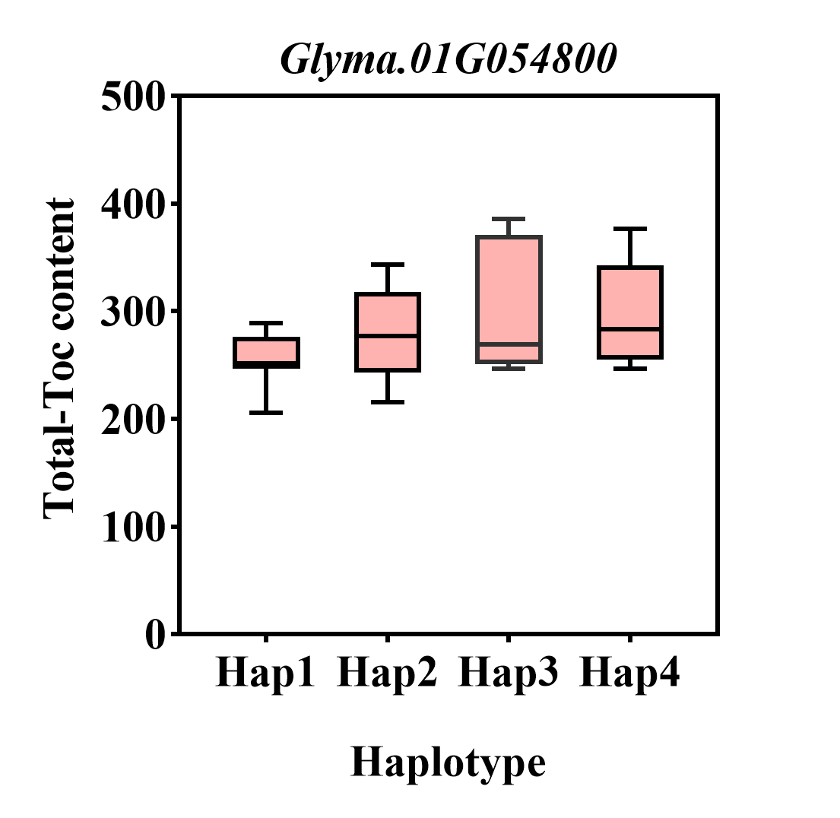
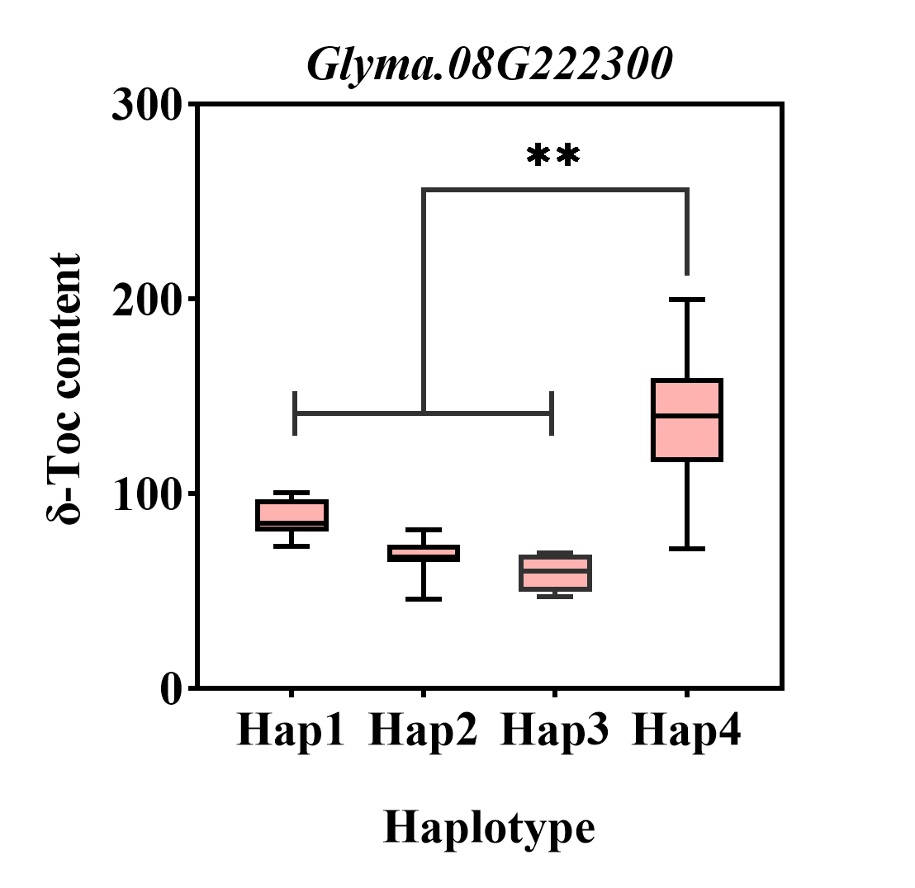
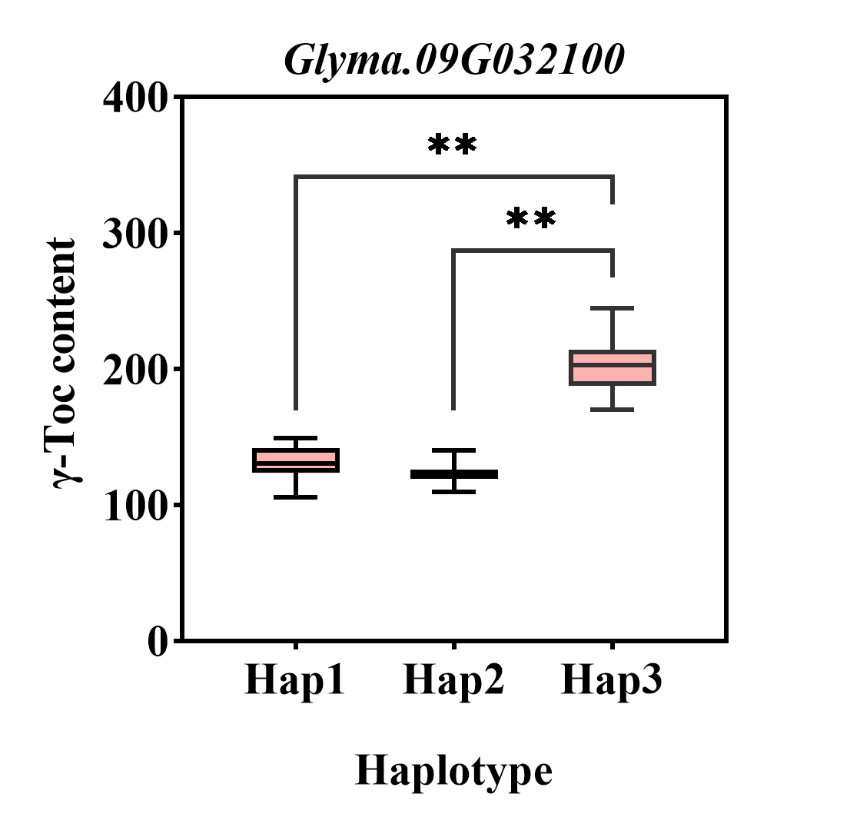
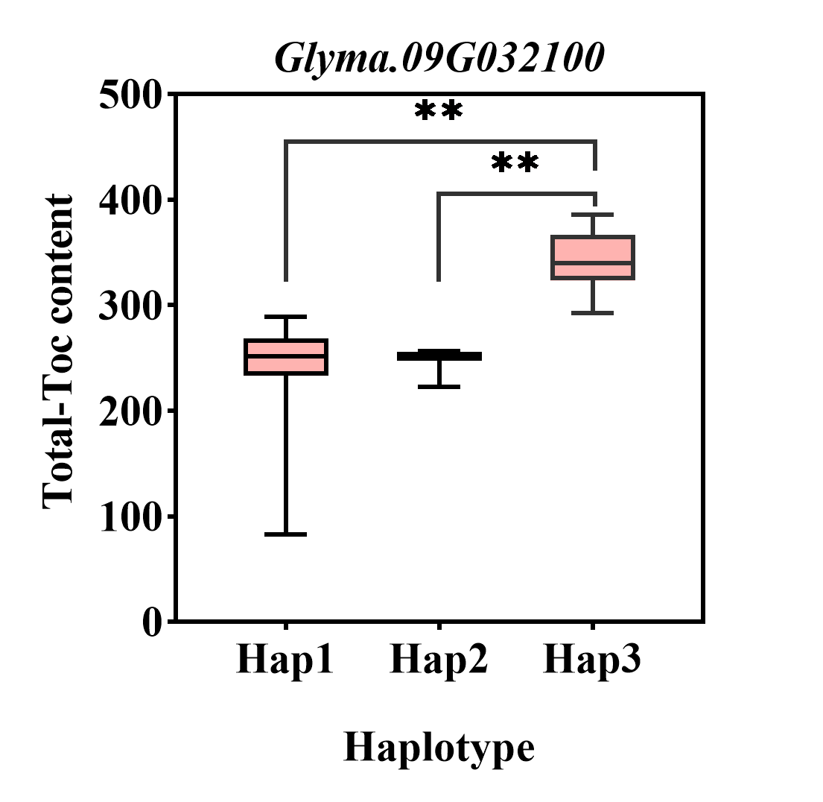
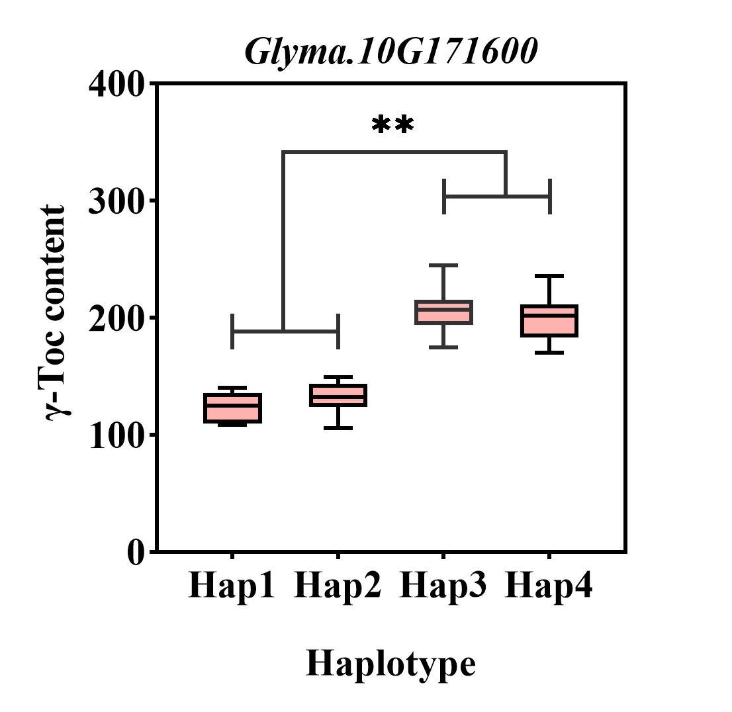
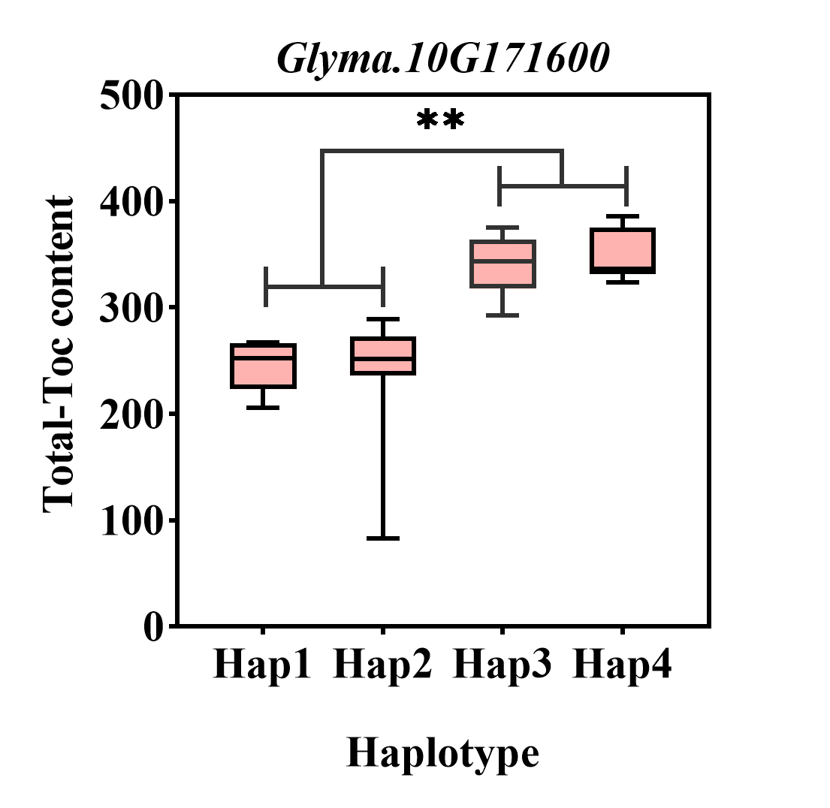
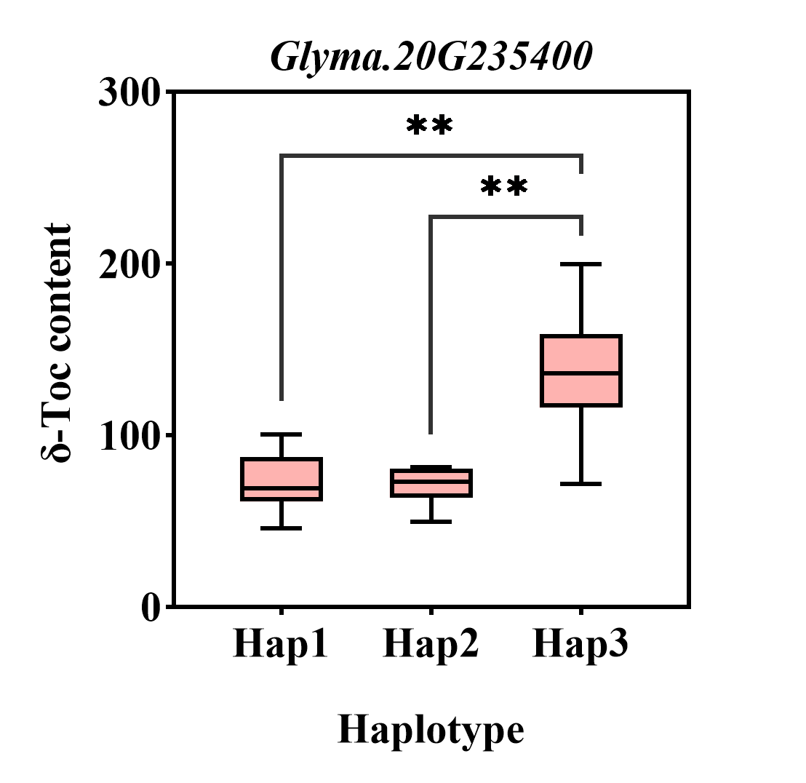
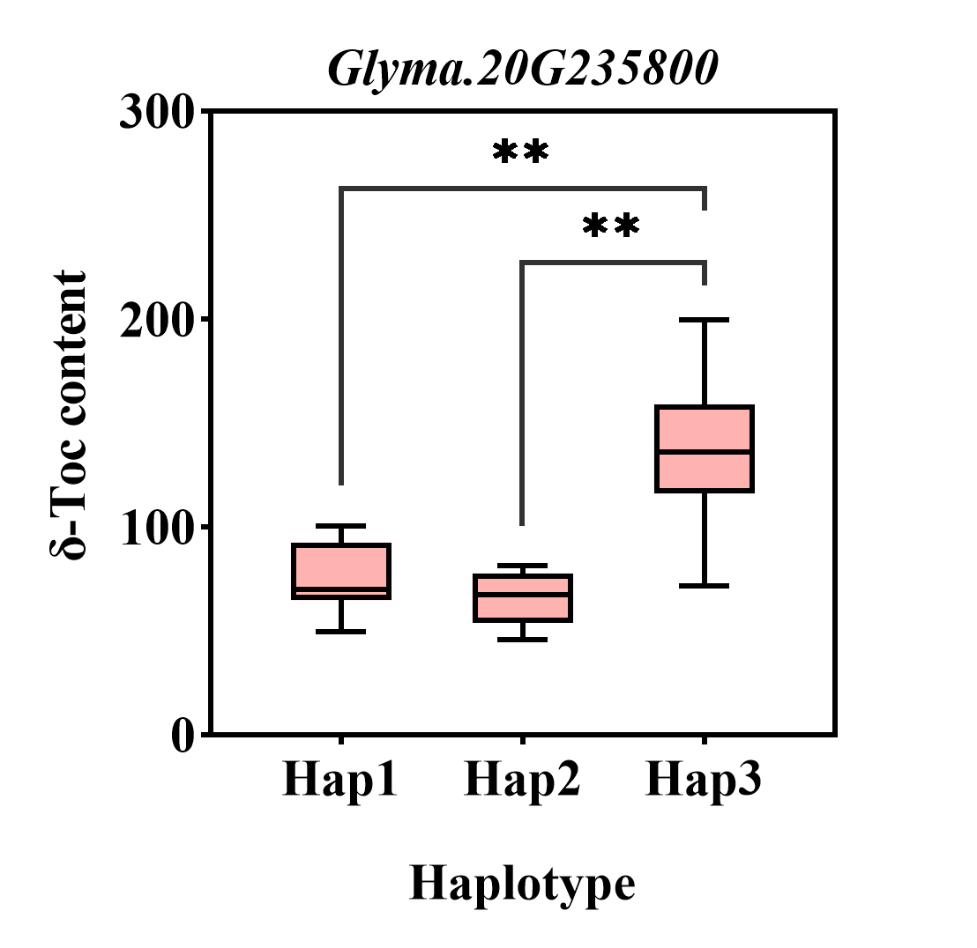
Figure S10 Haplotypes analysis of candidate genes that related to Toc content.
Note: The * and ** was significance at p < 0.05 and p < 0.01, respectively.
Figure S11 Candidate genes expression levels in each tissues.

Figure S12 Candidate genes expression analysis by qRT-PCR.

Table S1 The information of 175 soybean accessions.
Name | Country | Latitude (°N) | Longitude (°W)
Big black | China | 36.23 | 118.31
Cateye | China | 37.34 | 100.30
Cdou1 | China | 37.34 | 84.79
Small yellow | China | 37.39 | 112.24
JD17 | China | 39.19 | 116.29
Stone | China | 39.19 | 116.29
Datenhei | China | 39.19 | 116.29
JD12 | China | 39.19 | 116.29
Jin13 | China | 39.19 | 116.29
J06B7 | China | 39.19 | 116.29
HD5 | China | 39.19 | 116.29
HX446 | China | 39.19 | 116.29
ZZ00-683 | China | 40.15 | 116.28
ZD27 | China | 40.15 | 116.28
Z10 | China | 40.15 | 116.28
ZD35 | China | 40.15 | 116.28
Z20 | China | 40.15 | 116.28
Early18 | China | 40.15 | 116.28
KX3 | China | 40.15 | 116.28
Z30 | China | 40.15 | 116.28
Z03-5179 | China | 40.15 | 116.28
Zhonghuang35 | China | 40.15 | 116.28
Z95-5388 | China | 40.15 | 116.28
Z03-5334 | China | 40.15 | 116.28
ZZJ4133 | China | 40.15 | 116.28
Z03-5373 | China | 40.15 | 116.28
JZ4-1 | China | 40.85 | 122.00
L98072 | China | 40.85 | 122.00
TD54 | China | 40.85 | 122.00
LN2 | China | 40.85 | 122.00
Tejia | China | 40.85 | 122.00
LX1 | China | 40.85 | 122.00
Hangbaodou | China | 40.85 | 122.00
Baiqidou | China | 40.85 | 122.00
TD51 | China | 40.85 | 122.00
Tiefeng31 | China | 40.85 | 122.00
TF8 | China | 40.85 | 122.00
TD50 | China | 40.85 | 122.00
TD52 | China | 40.85 | 122.00
Sixty days | China | 40.85 | 122.00
TD58 | China | 40.85 | 122.00
LD3 | China | 40.85 | 122.00
LD23 | China | 40.85 | 122.00
JD33 | China | 40.85 | 122.00
Nova | Italy | 41.54 | 12.30
L-9 | USA | 41.83 | 92.91
L-57 | USA | 41.83 | 92.91
L-57 | USA | 41.83 | 92.91
L-59Peking | USA | 41.83 | 92.91
L-21 | USA | 41.83 | 92.91
L-10 | USA | 41.83 | 92.91
charleston | USA | 41.83 | 92.91
L-9 | USA | 41.83 | 92.91
Williams82 | USA | 41.83 | 92.91
Fendiyellow | China | 43.35 | 126.29
TN13 | China | 43.35 | 126.29
JN21 | China | 43.35 | 126.29
JL30 | China | 43.35 | 126.29
J89 | China | 43.35 | 126.29
JY94 | China | 43.35 | 126.29
Bmoshi | China | 43.35 | 126.29
Gonye04-141 | China | 43.35 | 126.29
J100 | China | 43.35 | 126.29
4tejia | China | 43.35 | 126.29
Douludou | China | 43.35 | 126.29
HYoutai | China | 43.35 | 126.29
JN20 | China | 43.35 | 126.29
Cse | China | 43.35 | 126.29
JL47 | China | 43.35 | 126.29
Jshanmoshi | China | 43.35 | 126.29
Jcha | China | 43.35 | 126.29
V111-4 | China | 43.35 | 126.29
Heimodou | China | 43.35 | 126.29
DY2004-5 | China | 43.35 | 126.29
Chamoshidou | China | 43.35 | 126.29
L-79 | Canada | 43.40 | 79.25
DN L-13 | Canada | 43.40 | 79.25
DN50 | Canada | 43.40 | 79.25
L-28 | Canada | 43.40 | 79.25
Aika166 | Rumania | 44.23 | 26.10
MD14 | China | 44.49 | 111.70
MD9 | China | 44.49 | 111.70
MD21 | China | 44.49 | 111.70
HJ423 | China | 44.49 | 111.70
HJ04-528 | China | 44.49 | 111.70
Domaka Tolisa-A | Yugoslavia | 46.30 | 14.30
HH38 | China | 48.29 | 128.08
BF9 | China | 48.29 | 128.08
HF35 | China | 48.29 | 128.08
Ken15 | China | 48.29 | 128.08
NF11 | China | 48.29 | 128.08
Heilongjiang41 | China | 48.29 | 128.08
SN10 | China | 48.29 | 128.08
HH18 | China | 48.29 | 128.08
B4834 | China | 48.29 | 128.08
DN48 | China | 48.29 | 128.08
HN37 | China | 48.29 | 128.08
NF15 | China | 48.29 | 128.08
Fenshou6 | China | 48.29 | 128.08
Jishanpu | China | 48.29 | 128.08
HF47 | China | 48.29 | 128.08
HF11 | China | 48.29 | 128.08
HN51 | China | 48.29 | 128.08
Suinong4 | China | 48.29 | 128.08
HF45 | China | 48.29 | 128.08
S02-339 | China | 48.29 | 128.08
K29 | China | 48.29 | 128.08
DN47 | China | 48.29 | 128.08
S28 | China | 48.29 | 128.08
DN46 | China | 48.29 | 128.08
Yanbojin | China | 48.29 | 128.08
MF1 | China | 48.29 | 128.08
Ken18 | China | 48.29 | 128.08
DN49 | China | 48.29 | 128.08
DN43 | China | 48.29 | 128.08
KJ23 | China | 48.29 | 128.08
LongX1 | China | 48.29 | 128.08
S29 | China | 48.29 | 128.08
DN594 | China | 48.29 | 128.08
S03-3952 | China | 48.29 | 128.08
Ken14 | China | 48.29 | 128.08
S04-5804 | China | 48.29 | 128.08
SN1 | China | 48.29 | 128.08
DN1068 | China | 48.29 | 128.08
K04-8579 | China | 48.29 | 128.08
DN44 | China | 48.29 | 128.08
HF25 | China | 48.29 | 128.08
SN14 | China | 48.29 | 128.08
HF52 | China | 48.29 | 128.08
S30 | China | 48.29 | 128.08
SN25 | China | 48.29 | 128.08
HF50 | China | 48.29 | 128.08
Small Moshi | China | 48.29 | 128.08
H05-31 | China | 48.29 | 128.08
DN56 | China | 48.29 | 128.08
Xian2 | China | 48.29 | 128.08
Qian black | China | 48.29 | 128.08
Xian3 | China | 48.29 | 128.08
Huajian2 | China | 48.29 | 128.08
LP03-11 | China | 48.29 | 128.08
Ken22 | China | 48.29 | 128.08
DN93046 | China | 48.29 | 128.08
S04-6018 | China | 48.29 | 128.08
S05-7304 | China | 48.29 | 128.08
HN55 | China | 48.29 | 128.08
DN42 | China | 48.29 | 128.08
B1361 | China | 48.29 | 128.08
H04-1824 | China | 48.29 | 128.08
Harvest10 | China | 48.29 | 128.08
4yellow | China | 48.29 | 128.08
Yapiche | China | 48.29 | 128.08
BD14 | China | 48.29 | 128.08
B1484 | China | 48.29 | 128.08
B1873 | China | 48.29 | 128.08
HN48 | China | 48.29 | 128.08
S03-3046 | China | 48.29 | 128.08
Hujiao03-286 | China | 48.29 | 128.08
HuaJiang4403 | China | 48.29 | 128.08
HF29 | China | 48.29 | 128.08
H05-991 | China | 48.29 | 128.08
HN44 | China | 48.29 | 128.08
K30 | China | 48.29 | 128.08
Lonqan | China | 48.29 | 128.08
FZmoshidou | China | 48.29 | 128.08
Heinong33 | China | 48.29 | 128.08
HF55 | China | 48.29 | 128.08
HH48 | China | 48.29 | 128.08
DN07-909 | China | 48.29 | 128.08
HH45 | China | 48.29 | 128.08
BD16 | China | 48.29 | 128.08
HF37 | China | 48.29 | 128.08
SN8 | China | 48.29 | 128.08
Heersong2 | Ukraine | 50.28 | 30.29
Boige du | Germany | 52.31 | 13.20
Dunajika | Russia | 61.50 | 98.00

Table S2 Primers used for quantitative real-time PCR.
Gene ID | Forward primer (5'-3') | Reverse primer (5'-3')
Glyma.01G054800 | TTGTGCTAAAACATCTGTGTCG | CAAGCACCTCAACATCTTTTGA
Glyma.09G032100 | CATCATCGGATTCGTTTGGTAC | TCAGTTGATCATGTGCTTGTTG
Glyma.10G277800 | TATTGGAGATTTGGAGCACGAA | CTCGTTGTCGTTTTTCTCAGTT
Glyma.08G222300 | CTCCTCAATTCTAATCTCGCCT | AGTTTGTACTTTCAAAGCCGAC
Glyma.20G235100 | GAAGATGCAGTAGTTAAGCAGC | GATTGTGAGTCTGTGTTGGAAC
Glyma.20G235400 | GGAAAAATTGTGTCTGGATGCT | ACAACTAATGACACTCTAGCGT
Glyma.20G235800 | TACAGCCTTGCTTTTTCTCCTA | CTTGAGGTTGAAGACATGAACG
Glyma.03G186200 | AATAAGTTGTTGGTGTGTGTGG | CTAGGGAAGGCTAAGCTGTAAG
Glyma.03G186500 | GCTCTTCGTTACAACAAGACTG | AACAAGCTTTTTCCCAGAACTC
Glyma.17G188700 | CTTATGTCAGATGTTTGTGAGG | AATGTAGCCTACAAGCTTTATG
GmActin4 | GTTTCAAGCTCTTGCTCGTAATCA | GTGTCAGCCATACTGTCCCCATTT

Table S3 Peak SNP associated with the Toc content identified by GWAS using the GLM model.
SNP | Traits | Environment | Chr. | Position | -log10（P） | MAF | Allele
rs9337368 | δ-Toc content | Harbin | 2 | 9337368 | 4.49 | 0.06 | A/T
rs19659048 | δ-Toc content | Harbin | 3 | 19659048 | 4.39 | 0.06 | A/G
rs19699991 | δ-Toc content | Harbin | 3 | 19699991 | 4.02 | 0.04 | C/T
rs19718856 | δ-Toc content | Harbin | 3 | 19718856 | 4.65 | 0.04 | T/C
rs19737458 | δ-Toc content | Harbin | 3 | 19737458 | 5.31 | 0.05 | T/A
rs20683456 | δ-Toc content | Harbin | 3 | 20683456 | 4.32 | 0.05 | C/A
rs20762556 | δ-Toc content | Harbin | 3 | 20762556 | 4.65 | 0.04 | C/A
rs20959996 | δ-Toc content | Harbin | 3 | 20959996 | 5.38 | 0.05 | A/G
rs21181591 | δ-Toc content | Harbin | 3 | 21181591 | 4.65 | 0.04 | T/C
rs21525954 | δ-Toc content | Harbin | 3 | 21525954 | 4.65 | 0.04 | C/A
rs21690828 | δ-Toc content | Harbin | 3 | 21690828 | 4.46 | 0.04 | G/A
rs22050090 | δ-Toc content | Harbin | 3 | 22050090 | 4.65 | 0.04 | C/A
rs22225963 | δ-Toc content | Harbin | 3 | 22225963 | 4.32 | 0.05 | T/C
rs22701979 | δ-Toc content | Harbin | 3 | 22701979 | 4.51 | 0.04 | G/A
rs22836247 | δ-Toc content | Harbin | 3 | 22836247 | 4.20 | 0.03 | G/T
rs22991419 | δ-Toc content | Harbin | 3 | 22991419 | 4.48 | 0.04 | G/A
rs23032537 | δ-Toc content | Harbin | 3 | 23032537 | 4.65 | 0.04 | A/G
rs23126123 | δ-Toc content | Harbin | 3 | 23126123 | 4.65 | 0.04 | C/T
rs23126538 | δ-Toc content | Harbin | 3 | 23126538 | 4.65 | 0.04 | G/T
rs23391671 | δ-Toc content | Harbin | 3 | 23391671 | 4.18 | 0.04 | T/C
rs27765335 | δ-Toc content | Harbin | 3 | 27765335 | 4.45 | 0.08 | G/T
rs27793445 | δ-Toc content | Harbin | 3 | 27793445 | 4.18 | 0.08 | G/A
rs30721039 | δ-Toc content | Harbin | 3 | 30721039 | 4.13 | 0.05 | A/G
rs39077086 | α-Toc content | Harbin | 3 | 39077086 | 4.38 | 0.43 | T/C
rs39895210 | Total-Toc content | Liaoning | 3 | 39895210 | 4.52 | 0.27 | G/A
rs2960931 | δ-Toc content | Liaoning | 6 | 2960931 | 4.47 | 0.19 | G/A
rs1834346 | α-Toc content | Harbin | 8 | 1834346 | 4.06 | 0.03 | A/T
rs19310064 | α-Toc content | Harbin | 8 | 19310064 | 9.43 | 0.01 | A/C
rs31044180 | α-Toc content | Jilin | 9 | 31044180 | 4.43 | 0.08 | G/T
 | γ-Toc content | Jilin |  |  | 5.15
 | Total-Toc content | Jilin |  |  | 4.22
rs7284532 | α-Toc content | Harbin | 10 | 7284532 | 4.19 | 0.05 | G/A
rs7543892 | δ-Toc content | Jilin | 10 | 7543892 | 4.25 | 0.06 | T/G
rs39590600 | δ-Toc content | Harbin | 10 | 39590600 | 4.78 | 0.04 | G/A
rs49928375 | α-Toc content | Harbin | 10 | 49928375 | 5.74 | 0.06 | G/T
rs17125409 | α-Toc content | Harbin | 12 | 17125409 | 4.56 | 0.07 | C/A
rs38228354 | δ-Toc content | Harbin | 12 | 38228354 | 4.07 | 0.07 | A/G
rs330000 | δ-Toc content | Harbin | 13 | 330000 | 4.76 | 0.17 | G/A
 | δ-Toc content | Liaoning |  |  | 4.96
rs10613826 | δ-Toc content | Harbin | 13 | 10613826 | 4.19 | 0.13 | C/T
rs10747461 | δ-Toc content | Harbin | 13 | 10747461 | 4.44 | 0.11 | C/T
rs11184836 | δ-Toc content | Harbin | 13 | 11184836 | 4.80 | 0.11 | G/A
rs11500692 | δ-Toc content | Harbin | 13 | 11500692 | 4.38 | 0.14 | C/T
rs12187473 | δ-Toc content | Harbin | 13 | 12187473 | 4.36 | 0.11 | C/T
rs8803536 | α-Toc content | Harbin | 14 | 8803536 | 4.54 | 0.07 | T/A
rs9782629 | γ-Toc content | Harbin | 14 | 9782629 | 4.89 | 0.07 | G/T
rs2417467 | α-Toc content | Harbin | 16 | 2417467 | 4.18 | 0.43 | A/C
rs19530677 | γ-Toc content | Harbin | 16 | 19530677 | 6.20 | 0.05 | T/A
rs31159905 | δ-Toc content | Harbin | 16 | 31159905 | 4.27 | 0.35 | T/C
rs2780598 | Total-Toc content | Harbin | 17 | 2780598 | 5.49 | 0.02 | C/G
rs14593163 | δ-Toc content | Harbin | 17 | 14593163 | 4.73 | 0.20 | T/G
 | Total-Toc content | Harbin |  |  | 6.12
rs24979561 | α-Toc content | Harbin | 17 | 24979561 | 6.53 | 0.07 | G/A
rs588498 | α-Toc content | Liaoning | 18 | 588498 | 4.26 | 0.43 | G/A
rs19903533 | δ-Toc content | Harbin | 18 | 19903533 | 4.04 | 0.03 | G/T
rs19962490 | δ-Toc content | Harbin | 18 | 19962490 | 4.84 | 0.02 | T/C
 | Total-Toc content | Harbin |  |  | 4.37
rs49413625 | δ-Toc content | Harbin | 18 | 49413625 | 4.27 | 0.45 | T/C
rs53062844 | α-Toc content | Liaoning | 18 | 53062844 | 5.73 | 0.08 | G/T
rs7528700 | δ-Toc content | Harbin | 19 | 7528700 | 4.11 | 0.39 | A/G
rs8705363 | δ-Toc content | Harbin | 19 | 8705363 | 5.56 | 0.16 | G/A
rs8705388 | δ-Toc content | Harbin | 19 | 8705388 | 5.12 | 0.15 | G/A
rs8720055 | δ-Toc content | Harbin | 19 | 8720055 | 6.06 | 0.15 | T/A
rs8720462 | δ-Toc content | Harbin | 19 | 8720462 | 6.82 | 0.17 | G/A
 |  | Liaoning |  |  | 4.48
rs8782541 | δ-Toc content | Harbin | 19 | 8782541 | 5.10 | 0.15 | G/A
rs8917233 | δ-Toc content | Harbin | 19 | 8917233 | 4.32 | 0.16 | C/A
rs8988072 | δ-Toc content | Harbin | 19 | 8988072 | 5.44 | 0.16 | C/T
rs8988491 | δ-Toc content | Harbin | 19 | 8988491 | 5.23 | 0.17 | C/T
rs9156253 | δ-Toc content | Harbin | 19 | 9156253 | 4.90 | 0.17 | G/A
rs9156264 | δ-Toc content | Harbin | 19 | 9156264 | 5.44 | 0.16 | G/A
rs9386162 | δ-Toc content | Harbin | 19 | 9386162 | 4.87 | 0.36 | A/G
rs9479779 | δ-Toc content | Harbin | 19 | 9479779 | 4.04 | 0.37 | A/G
rs9530043 | δ-Toc content | Harbin | 19 | 9530043 | 4.57 | 0.35 | A/G
rs9566892 | δ-Toc content | Harbin | 19 | 9566892 | 4.31 | 0.36 | G/A
rs9567256 | δ-Toc content | Harbin | 19 | 9567256 | 4.40 | 0.36 | T/C
rs9576679 | δ-Toc content | Harbin | 19 | 9576679 | 5.04 | 0.38 | A/G
rs9613330 | δ-Toc content | Harbin | 19 | 9613330 | 4.04 | 0.37 | A/G
rs9615952 | δ-Toc content | Harbin | 19 | 9615952 | 4.35 | 0.36 | T/A
rs10359107 | δ-Toc content | Harbin | 19 | 10359107 | 4.04 | 0.37 | A/G
rs10866180 | δ-Toc content | Harbin | 19 | 10866180 | 4.35 | 0.35 | A/G
rs10866555 | δ-Toc content | Harbin | 19 | 10866555 | 4.33 | 0.37 | T/A
rs11539773 | δ-Toc content | Harbin | 19 | 11539773 | 4.04 | 0.37 | T/C
rs11732866 | δ-Toc content | Harbin | 19 | 11732866 | 4.28 | 0.39 | A/G
rs11838628 | δ-Toc content | Harbin | 19 | 11838628 | 4.04 | 0.37 | A/C
rs12543529 | δ-Toc content | Harbin | 19 | 12543529 | 4.08 | 0.37 | C/T
rs12982938 | δ-Toc content | Harbin | 19 | 12982938 | 4.04 | 0.37 | A/T
rs37558520 | Total-Toc content | Liaoning | 19 | 37558520 | 4.09 | 0.15 | T/C
rs47221569 | α-Toc content | Harbin | 19 | 47221569 | 4.33 | 0.43 | A/T
rs34774232 | δ-Toc content | Harbin | 20 | 34774232 | 4.82 | 0.23 | A/G
rs35655050 | δ-Toc content | Liaoning | 20 | 35655050 | 4.14 | 0.21 | T/C
rs35815938 | δ-Toc content | Liaoning | 20 | 35815938 | 4.12 | 0.17 | T/C
rs2162876 | α-Toc content | Harbin | 1 | 2162876 | 4.33 | 0.05 | A/C

Table S4 Peak SNP associated with the Toc content identified by GWAS using the MLM model.
SNP | Traits | Environment | Chr. | Position | -log10（P） | MAF | Allele
rs9337368 | δ-Toc content | Harbin | 2 | 9337368 | 4.03 | 0.06 | A/T
rs33956629 | α-Toc content | Harbin | 5 | 33956629 | 4.37 | 0.02 | T/C
rs7218697 | α-Toc content | Harbin | 7 | 7218697 | 4.02 | 0.04 | C/T
rs1834346 | α-Toc content | Harbin | 8 | 1834346 | 4.16 | 0.03 | A/T
rs19310064 | α-Toc content | Harbin | 8 | 19310064 | 9.02 | 0.01 | A/C
rs31044180 | γ-Toc content | Jilin | 9 | 31044180 | 4.30 | 0.08 | G/T
rs49928375 | α-Toc content | Harbin | 10 | 49928375 | 4.91 | 0.06 | G/T
rs9782629 | γ-Toc content | Harbin | 14 | 9782629 | 4.71 | 0.07 | G/T
rs19530677 | γ-Toc content | Harbin | 16 | 19530677 | 5.28 | 0.05 | T/A
rs2780598 | Total-Toc content | Harbin | 17 | 2780598 | 5.20 | 0.02 | C/G
rs14593163 | Total-Toc content | Harbin | 17 | 14593163 | 5.35 | 0.20 | T/G
rs24979561 | α-Toc content | Harbin | 17 | 24979561 | 5.87 | 0.07 | G/A
rs19903533 | δ-Toc content | Harbin | 18 | 19903533 | 4.67 | 0.03 | G/T
rs19962490 | δ-Toc content | Harbin | 18 | 19962490 | 5.42 | 0.02 | T/C
 | Total-Toc content | Harbin |  |  | 4.39
rs24865620 | Total-Toc content | Jilin | 18 | 24865620 | 4.01 | 0.05 | C/T
rs53062844 | α-Toc content | Liaoning | 18 | 53062844 | 4.87 | 0.08 | G/T
rs6204830 | α-Toc content | Liaoning | 19 | 6204830 | 4.10 | 0.09 | T/G
rs12074736 | δ-Toc content | Jilin | 19 | 12074736 | 4.14 | 0.17 | C/A

Table S5 Peak SNP associated with the Toc content identified by GWAS using the CMLM model.
SNP | Traits | Environment | Chr. | Position | -log10（P） | MAF | Allele
rs2162876 | α-Toc content | Harbin | 1 | 2162876 | 4.33 | 0.05 | A/C
rs5437879 | α-Toc content | Harbin | 1 | 5437879 | 4.19 | 0.06 | C/A
rs23631390 | γ-Toc content | Harbin | 1 | 23631390 | 5.44 | 0.05 | G/A
rs36048309 | γ-Toc content | Jilin | 1 | 36048309 | 4.04 | 0.07 | A/G
rs9454083 | α-Toc content | Jilin | 2 | 9454083 | 4.39 | 0.05 | G/A
rs9299728 | α-Toc content | Liaoning | 3 | 9299728 | 4.13 | 0.02 | C/T
rs12579802 | α-Toc content | Harbin | 4 | 12579802 | 5.59 | 0.02 | G/A
rs24977653 | α-Toc content | Harbin | 4 | 24977653 | 5.96 | 0.07 | G/T
rs27955520 | α-Toc content | Harbin | 4 | 27955520 | 5.06 | 0.01 | T/G
rs48460348 | δ-Toc content | Harbin | 4 | 48460348 | 4.02 | 0.01 | T/G
 | Total-Toc  content | Harbin |  |  | 5.16
rs17449289 | α-Toc content | Harbin | 6 | 17449289 | 4.31 | 0.05 | T/C
rs51277551 | α-Toc content | Harbin | 6 | 51277551 | 4.29 | 0.01 | T/A
rs7089772 | α-Toc content | Harbin | 7 | 7089772 | 4.57 | 0.03 | C/A
rs7182452 | α-Toc content | Harbin | 7 | 7182452 | 4.57 | 0.03 | T/C
rs7195097 | α-Toc content | Harbin | 7 | 7195097 | 4.90 | 0.04 | G/A
rs19310064 | α-Toc content | Harbin | 8 | 19310064 | 9.02 | 0.01 | A/C
rs46769362 | γ-Toc content | Harbin | 8 | 46769362 | 4.23 | 0.05 | G/T
rs9047280 | α-Toc content | Harbin | 9 | 9047280 | 5.26 | 0.04 | G/T
rs3842394 | α-Toc content | Liaoning | 10 | 3842394 | 4.30 | 0.16 | T/A
rs8254757 | δ-Toc content | Harbin | 10 | 8254757 | 4.00 | 0.07 | C/T
rs40007289 | δ-Toc content | Liaoning | 10 | 40007289 | 4.74 | 0.03 | T/C
rs49928375 | α-Toc content | Harbin | 10 | 49928375 | 5.04 | 0.06 | G/T
rs15936090 | α-Toc content | Harbin | 11 | 15936090 | 5.49 | 0.01 | A/G
rs17125409 | α-Toc content | Jilin | 12 | 17125409 | 5.21 | 0.07 | C/A
rs29183316 | α-Toc content | Jilin | 12 | 29183316 | 4.18 | 0.48 | G/A
rs43578642 | α-Toc content | Jilin | 13 | 43578642 | 4.28 | 0.08 | C/A
rs9782629 | γ-Toc content | Harbin | 14 | 9782629 | 5.63 | 0.07 | G/T
rs19530677 | γ-Toc content | Harbin | 16 | 19530677 | 7.33 | 0.05 | T/A
 | Total-Toc content | Harbin |  |  | 6.67
rs2793608 | δ-Toc content | Jilin | 17 | 2793608 | 4.57 | 0.05 | G/T
rs24979561 | α-Toc content | Harbin | 17 | 24979561 | 5.87 | 0.07 | G/A
rs40233760 | α-Toc content | Jilin | 17 | 40233760 | 4.10 | 0.08 | G/T
rs3764631 | α-Toc content | Harbin | 18 | 3764631 | 4.40 | 0.08 | C/A
rs30693197 | α-Toc content | Harbin | 18 | 30693197 | 4.00 | 0.07 | C/A
rs49453339 | δ-Toc content | Harbin | 18 | 49453339 | 4.14 | 0.45 | A/G
rs53062844 | α-Toc content | Liaoning | 18 | 53062844 | 4.91 | 0.08 | G/T
rs31881460 | α-Toc content | Harbin | 19 | 31881460 | 5.02 | 0.09 | G/T
rs37037897 | α-Toc content | Liaoning | 19 | 37037897 | 4.03 | 0.10 | G/T
rs19168885 | α-Toc content | Liaoning | 20 | 19168885 | 4.05 | 0.05 | C/A
rs45306899 | δ-Toc content | Jilin | 20 | 45306899 | 4.01 | 0.45 | A/G
rs45306912 | δ-Toc content | Jilin | 20 | 45306912 | 4.11 | 0.46 | C/A
rs2162876 | α-Toc content | Harbin | 1 | 2162876 | 4.33 | 0.05 | A/C

Table S6 Peak SNP associated with the Toc content identified by GWAS using the BLINK model.
SNP | Traits | Environment | Chr. | Position | -log10（P） | MAF | Allele
rs43173548 | γ-Toc content | Jilin | 1 | 43173548 | 4.13 | 0.46 | C/T
rs4764653 | α-Toc content | Harbin | 2 | 4764653 | 6.29 | 0.17 | A/T
rs9337368 | δ-Toc content | Harbin | 2 | 9337368 | 6.48 | 0.06 | A/T
rs33852733 | δ-Toc content | Jilin | 3 | 33852733 | 6.77 | 0.04 | A/G
rs37890724 | δ-Toc content | Jilin | 3 | 37890724 | 7.41 | 0.22 | G/T
rs39077086 | α-Toc content | Harbin | 3 | 39077086 | 8.06 | 0.43 | C/T
rs39895210 | Total-Toc content | Liaoning | 3 | 39895210 | 4.15 | 0.27 | G/A
rs5793214 | α-Toc content | Liaoning | 4 | 5793214 | 4.03 | 0.09 | C/A
rs30444246 | Total-Toc content | Harbin | 4 | 30444246 | 4.77 | 0.05 | G/T
rs46089902 | α-Toc content | Jilin | 4 | 46089902 | 5.02 | 0.35 | T/C
rs46672009 | α-Toc content | Jilin | 4 | 46672009 | 6.98 | 0.16 | G/T
rs49628199 | δ-Toc content | Harbin | 6 | 49628199 | 6.58 | 0.20 | T/C
rs19310064 | α-Toc content | Harbin | 8 | 19310064 | 11.84 | 0.01 | A/C
rs20242356 | γ-Toc content | Jilin | 9 | 20242356 | 4.04 | 0.50 | A/C
rs7543892 | δ-Toc content | Jilin | 10 | 7543892 | 7.07 | 0.07 | T/G
rs17125409 | α-Toc content | Harbin | 12 | 17125409 | 6.09 | 0.07 | C/A
 | α-Toc content | Jilin |  |  | 10.27
rs18678328 | δ-Toc content | Jilin | 12 | 18678328 | 4.07 | 0.10 | G/T
rs33250256 | α-Toc content | Jilin | 12 | 33250256 | 5.27 | 0.32 | G/C
rs16207451 | δ-Toc content | Jilin | 13 | 16207451 | 5.67 | 0.13 | T/C
rs19241701 | α-Toc content | Liaoning | 13 | 19241701 | 6.01 | 0.10 | G/T
rs1605554 | γ-Toc content | Harbin | 14 | 1605554 | 4.23 | 0.16 | C/T
rs9782629 | γ-Toc content | Harbin | 14 | 9782629 | 7.27 | 0.07 | G/T
rs22145998 | Total-Toc content | Jilin | 14 | 22145998 | 4.01 | 0.10 | G/T
rs16976090 | α-Toc content | Liaoning | 15 | 16976090 | 7.16 | 0.22 | T/C
rs38161412 | α-Toc content | Harbin | 15 | 38161412 | 6.82 | 0.28 | A/G
rs12888642 | α-Toc content | Liaoning | 16 | 12888642 | 7.52 | 0.20 | C/A
rs19530677 | γ-Toc content | Harbin | 16 | 19530677 | 9.16 | 0.05 | T/A
 | Total-Toc content | Harbin |  |  | 4.23
rs25739207 | α-Toc content | Liaoning | 16 | 25739207 | 7.36 | 0.11 | G/A
rs2793608 | δ-Toc content | Jilin | 17 | 2793608 | 7.01 | 0.05 | G/T
rs14108110 | Total-Toc content | Harbin | 17 | 14108110 | 4.74 | 0.19 | T/C
rs14593134 | Total-Toc content | Harbin | 17 | 14593134 | 4.32 | 0.18 | A/G
rs14593163 | δ-Toc content | Harbin | 17 | 14593163 | 6.42 | 0.19 | T/G
 | Total-Toc content | Harbin |  |  | 4.56
rs14680873 | Total-Toc content | Harbin | 17 | 14680873 | 4.51 | 0.19 | A/G
rs24979561 | α-Toc content | Harbin | 17 | 24979561 | 7.86 | 0.07 | G/A
rs40233760 | α-Toc content | Jilin | 17 | 40233760 | 7.68 | 0.08 | G/T
rs5680781 | γ-Toc content | Jilin | 18 | 5680781 | 4.62 | 0.08 | G/T
 | Total-Toc content | Jilin |  |  | 5.61
rs8479815 | δ-Toc content | Jilin | 18 | 8479815 | 4.14 | 0.13 | C/T
rs17266245 | γ-Toc content | Jilin | 18 | 17266245 | 4.31 | 0.13 | T/G
rs53062844 | α-Toc content | Liaoning | 18 | 53062844 | 12.82 | 0.08 | G/T
rs8720462 | δ-Toc content | Harbin | 19 | 8720462 | 7.38 | 0.17 | G/A
rs8970462 | δ-Toc content | Jilin | 19 | 8970462 | 5.34 | 0.16 | G/A

Table S7 Peak SNP associated with the Toc content identified by GWAS using the FarmCPU model.
SNP | Traits | Environment | Chr. | Position | -log10（P） | MAF | Allele
rs9337368 | δ-Toc content | Harbin | 2 | 9337368 | 6.15 | 0.06 | A/T
rs10763457 | δ-Toc content | Harbin | 3 | 10763457 | 7.68 | 0.13 | C/A
rs39895210 | Total-Toc content | Liaoning | 3 | 39895210 | 4.53 | 0.27 | G/A
rs36602236 | α-Toc content | Harbin | 4 | 36602236 | 4.08 | 0.08 | G/T
rs11236537 | δ-Toc content | Harbin | 5 | 11236537 | 4.04 | 0.09 | G/A
rs22876354 | α-Toc content | Harbin | 5 | 22876354 | 4.64 | 0.07 | G/A
rs2960931 | δ-Toc content | Liaoning | 6 | 2960931 | 4.45 | 0.19 | G/A
rs9318903 | α-Toc content | Harbin | 8 | 9318903 | 5.44 | 0.50 | A/G
rs18596407 | Total-Toc  content | Harbin | 9 | 18596407 | 4.76 | 0.11 | C/A
rs31044180 | α-Toc content | Jilin | 9 | 31044180 | 4.43 | 0.08 | G/T
 | γ-Toc content | Jilin |  |  | 5.15
 | Total-Toc content | Jilin |  |  | 4.22
rs7543892 | δ-Toc content | Jilin | 10 | 7543892 | 4.55 | 0.06 | T/G
rs49928375 | α-Toc content | Harbin | 10 | 49928375 | 4.67 | 0.06 | G/T
rs11885640 | α-Toc content | Harbin | 11 | 11885640 | 5.41 | 0.29 | C/T
rs17125409 | α-Toc content | Harbin | 12 | 17125409 | 7.63 | 0.07 | C/A
rs330000 | δ-Toc content | Liaoning | 13 | 330000 | 4.56 | 0.17 | G/A
rs9782629 | γ-Toc content | Harbin | 14 | 9782629 | 4.89 | 0.07 | G/T
rs13678290 | Total- Toc content | Harbin | 14 | 13678290 | 4.35 | 0.39 | G/A
rs28417306 | δ-Toc content | Harbin | 14 | 28417306 | 6.15 | 0.05 | T/C
rs12265057 | δ-Toc content | Harbin | 15 | 12265057 | 6.29 | 0.21 | T/C
rs23102196 | α-Toc content | Harbin | 15 | 23102196 | 5.35 | 0.11 | C/A
rs39722884 | α-Toc content | Harbin | 15 | 39722884 | 4.73 | 0.21 | G/A
rs19530677 | γ-Toc content | Harbin | 16 | 19530677 | 6.10 | 0.05 | T/A
rs14593163 | Total-Toc content | Harbin | 17 | 14593163 | 7.49 | 0.20 | T/G
rs24979561 | α-Toc content | Harbin | 17 | 24979561 | 7.56 | 0.07 | G/A
rs588498 | α-Toc content | Liaoning | 18 | 588498 | 4.26 | 0.43 | G/A
rs13237620 | δ-Toc content | Harbin | 18 | 13237620 | 4.26 | 0.15 | A/T
rs37126946 | δ-Toc content | Harbin | 18 | 37126946 | 5.65 | 0.04 | C/A
rs53062844 | α-Toc content | Liaoning | 18 | 53062844 | 5.73 | 0.08 | G/T
rs8393139 | Total-Toc content | Harbin | 19 | 8393139 | 4.77 | 0.12 | A/G
rs8720462 | δ-Toc content | Harbin | 19 | 8720462 | 4.37 | 0.17 | G/A
 | δ-Toc content | Liaoning |  |  | 4.48
rs37558520 | Total-Toc content | Liaoning | 19 | 37558520 | 4.06 | 0.15 | T/C
rs34774232 | δ-Toc content | Harbin | 20 | 34774232 | 4.72 | 0.23 | A/G
rs35655050 | δ-Toc content | Liaoning | 20 | 35655050 | 4.14 | 0.21 | T/C
rs35815938 | δ-Toc content | Liaoning | 20 | 35815938 | 4.14 | 0.17 | T/C
rs8970462 | δ-Toc content | Jilin | 19 | 8970462 | 5.34 | 0.16 | G/A

Table S8 Peak SNP associated with the Toc content identified by GWAS using the 3VmrMLM model single-environment method.
SNP | Traits | Environment |  |  | Chr. |  | Position |  | -log10（P） |  |  | r²(%) | Allele
rs1967942 | α-Toc content | Harbin |  |  | 1 |  | 1967942 |  | 10.05 |  |  | 6.38 | C/A
rs7167202 | γ-Toc content | Jilin |  |  | 1 |  | 7167202 |  | 5.13 |  |  | 3.33 | G/T
 | Total-Toc content | Jilin |  |  |  |  |  |  | 6.43 |  |  | 6.38
rs37510038 | γ-Toc content | Liaoning |  |  | 1 |  | 37510038 |  | 7.72 |  |  | 4.79 | G/A
rs40908486 | Total-Toc content | Liaoning |  |  | 1 |  | 40908486 |  | 4.56 |  |  | 2.92 | G/T
rs41784197 | γ-Toc content | Jilin |  |  | 1 |  | 41784197 |  | 11.64 |  |  | 7.93 | T/C
rs47986763 | δ-Toc content | Harbin |  |  | 1 |  | 47986763 |  | 5.81 |  |  | 5.47 | A/C
rs54767936 | γ-Toc content | Harbin |  |  | 1 |  | 54767936 |  | 5.33 |  |  | 3.41 | T/G
rs1634861 | γ-Toc content | Jilin |  |  | 2 |  | 1634861 |  | 6.08 |  |  | 2.56 | G/A
rs3046670 | δ-Toc content | Liaoning |  |  | 2 |  | 3046670 |  | 4.99 |  |  | 4.95 | G/A
rs13744031 | γ-Toc content | Harbin |  |  | 2 |  | 13744031 |  | 7.12 |  |  | 5.45 | G/C
rs14033171 | δ-Toc content | Harbin |  |  | 2 |  | 14033171 |  | 5.52 |  |  | 6.00 | T/A
rs39535378 | α-Toc content | Harbin |  |  | 2 |  | 39535378 |  | 7.11 |  |  | 4.42 | G/A
rs47048006 | Total-Toc content | Liaoning |  |  | 2 |  | 47048006 |  | 7.04 |  |  | 5.99 | G/A
rs3804102 | δ-Toc content | Liaoning |  |  | 3 |  | 3804102 |  | 8.65 |  |  | 3.37 | T/A
rs5009043 | γ-Toc content | Harbin |  |  | 3 |  | 5009043 |  | 7.80 |  |  | 5.49 | C/A
rs5818126 | γ-Toc content | Harbin |  |  | 3 |  | 5818126 |  | 6.14 |  |  | 4.85 | A/T
rs6719191 | α-Toc content | Jilin |  |  | 3 |  | 6719191 |  | 4.52 |  |  | 2.89 | G/T
rs28985136 | γ-Toc content | Jilin |  |  | 3 |  | 28985136 |  | 6.63 |  |  | 4.78 | C/A
rs39895210 | Total-Toc content | Liaoning |  |  | 3 |  | 39895210 |  | 19.38 |  |  | 15.69 | G/A
rs3023696 | γ-Toc content | Jilin |  |  | 4 |  | 3023696 |  | 13.08 |  |  | 5.34 | T/C
rs4518367 | δ-Toc content | Liaoning |  |  | 4 |  | 4518367 |  | 7.47 |  |  | 4.99 | C/A
rs48232808 | Total-Toc content | Jilin |  |  | 4 |  | 48232808 |  | 6.36 |  |  | 8.27 | T/G
rs48514134 | δ-Toc content | Liaoning |  |  | 4 |  | 48514134 |  | 8.59 |  |  | 6.04 | A/G
rs31884576 | α-Toc content | Jilin |  |  | 5 |  | 31884576 |  | 10.60 |  |  | 5.30 | A/G
rs38068554 | Total-Toc content | Jilin |  |  | 5 |  | 38068554 |  | 11.59 |  |  | 4.99 | G/T
rs2960931 | δ-Toc content | Liaoning |  |  | 6 |  | 2960931 |  | 10.47 |  |  | 6.56 | G/A
rs6068605 | α-Toc content | Harbin |  |  | 6 |  | 6068605 |  | 23.70 |  |  | 5.68 | T/A
rs15888622 | Total-Toc content | Liaoning |  |  | 6 |  | 15888622 |  | 6.25 |  |  | 5.34 | A/G
rs16263376 | δ-Toc content | Jilin |  |  | 6 |  | 16263376 |  | 4.61 |  |  | 5.13 | G/T
rs33602349 | δ-Toc content | Harbin |  |  | 6 |  | 33602349 |  | 10.34 |  |  | 7.51 | C/A
rs9140707 | α-Toc content | Liaoning |  |  | 7 |  | 9140707 |  | 17.35 |  |  | 3.12 | G/T
rs9985352 | Total-Toc content | Harbin |  |  | 7 |  | 9985352 |  | 6.99 |  |  | 1.97 | C/A
rs31912929 | γ-Toc content | Liaoning |  |  | 7 |  | 31912929 |  | 5.46 |  |  | 5.49 | G/T
rs36481334 | Total-Toc content | Jilin |  |  | 7 |  | 36481334 |  | 4.54 |  |  | 7.03 | G/T
rs1588537 | Total-Toc content | Harbin |  |  | 8 |  | 1588537 |  | 16.79 |  |  | 6.02 | A/C
rs9319265 | α-Toc content | Harbin |  |  | 8 |  | 9319265 |  | 5.28 |  |  | 3.36 | A/G
rs13209021 | γ-Toc content | Liaoning |  |  | 8 |  | 13209021 |  | 16.46 |  |  | 7.83 | G/T
rs18105573 | δ-Toc content | Jilin |  |  | 8 |  | 18105573 |  | 6.44 |  |  | 7.64 | A/G
rs19332142 | α-Toc content | Liaoning |  |  | 8 |  | 19332142 |  | 4.45 |  |  | 3.06 | C/A
rs45007284 | γ-Toc content | Jilin |  |  | 8 |  | 45007284 |  | 8.56 |  |  | 5.59 | G/T
rs2511987 | Total-Toc content | Liaoning |  |  | 9 |  | 2511987 |  | 4.16 |  |  | 2.47 | C/T
rs2669053 | γ-Toc content | Harbin |  |  | 9 |  | 2669053 |  | 16.30 |  |  | 14.16 | T/C
 | Total-Toc content | Harbin |  |  |  |  |  |  | 12.13 |  |  | 14.09
rs31044180 | δ-Toc content | Jilin |  |  | 9 |  | 31044180 |  | 18.07 |  |  | 4.85 | G/T
rs49333152 | Total-Toc content | Liaoning |  |  | 9 |  | 49333152 |  | 12.55 |  |  | 7.53 | G/T
rs3763850 | α-Toc content | Liaoning |  |  | 10 |  | 3763850 |  | 9.56 |  |  | 4.76 | G/T
rs13737322 | Total-Toc content | Harbin |  |  | 10 |  | 13737322 |  | 6.98 |  |  | 7.64 | G/A
rs49928375 | α-Toc content | Harbin |  |  | 10 |  | 49928375 |  | 17.93 |  |  | 2.57 | G/T
rs17062257 | Total-Toc content | Harbin |  |  | 11 |  | 17062257 |  | 8.51 |  |  | 3.71 | A/C
rs1006049 | α-Toc content | Jilin |  |  | 12 |  | 1006049 |  | 7.18 |  |  | 4.83 | A/C
rs21143057 | α-Toc content | Liaoning |  |  | 12 |  | 21143057 |  | 20.64 |  |  | 4.49 | G/A
rs33250256 | α-Toc content | Jilin |  |  | 12 |  | 33250256 |  | 5.32 |  |  | 3.45 | G/C
rs33687053 | γ-Toc content | Jilin |  |  | 12 |  | 33687053 |  | 17.90 |  |  | 6.00 | G/T
rs330000 | δ-Toc content | Liaoning |  |  | 13 |  | 330000 |  | 9.65 |  |  | 6.45 | G/A
rs5318148 | α-Toc content | Harbin |  |  | 13 |  | 5318148 |  | 6.69 |  |  | 4.32 | T/C
rs14311945 | TotalToc- content | Harbin |  |  | 13 |  | 14311945 |  | 30.35 |  |  | 10.26 | G/T
rs19607617 | γ-Toc content | Liaoning |  |  | 13 |  | 19607617 |  | 10.10 |  |  | 8.36 | G/T
rs20380420 | γ-Toc content | Liaoning |  |  | 13 |  | 20380420 |  | 10.70 |  |  | 5.84 | T/A
rs29588541 | γ-Toc content | Harbin |  |  | 13 |  | 29588541 |  | 6.27 |  |  | 4.23 | A/C
rs29847711 | α-Toc content | Harbin |  |  | 13 |  | 29847711 |  | 4.63 |  |  | 2.94 | C/A
rs43578642 | α-Toc content | Jilin |  |  | 13 |  | 43578642 |  | 20.41 |  |  | 5.33 | C/A
rs29070102 | α-Toc content | Jilin |  |  | 14 |  | 29070102 |  | 32.86 |  |  | 5.73 | C/A
rs11720920 | Total-Toc content | Liaoning |  |  | 15 |  | 11720920 |  | 8.42 |  |  | 7.06 | C/A
rs13830686 | δ-Toc content | Jilin |  |  | 15 |  | 13830686 |  | 7.44 |  |  | 10.35 | A/G
rs14449662 | δ-Toc content | Liaoning |  |  | 15 |  | 14449662 |  | 4.88 |  |  | 4.83 | A/G
rs22341967 | δ-Toc content | Liaoning |  |  | 15 |  | 22341967 |  | 5.61 |  |  | 4.77 | T/G
rs37798958 | Total-Toc content | Liaoning |  |  | 15 |  | 37798958 |  | 4.77 |  |  | 3.60 | C/A
rs43000771 | γ-Toc content | Liaoning |  |  | 15 |  | 43000771 |  | 4.07 |  |  | 4.11 | C/T
rs49527604 | γ-Toc content | Liaoning |  |  | 15 |  | 49527604 |  | 8.59 |  |  | 8.07 | T/G
rs50565303 | α-Toc content | Jilin |  |  | 15 |  | 50565303 |  | 7.64 |  |  | 3.07 | C/T
rs14826149 | α-Toc content | Jilin |  |  | 16 |  | 14826149 |  | 9.95 |  |  | 4.58 | G/T
rs27969771 | Total-Toc content | Jilin |  |  | 16 |  | 27969771 |  | 4.38 |  |  | 5.66 | G/A
rs36081826 | α-Toc content | Jilin |  |  | 16 |  | 36081826 |  | 13.47 |  |  | 4.28 | G/T
rs37783217 | γ-Toc content | Liaoning |  |  | 16 |  | 37783217 |  | 6.11 |  |  | 4.68 | A/G
rs4717651 | δ-Toc content | Liaoning |  |  | 17 |  | 4717651 |  | 5.70 |  |  | 4.70 | C/T
rs12916838 | δ-Toc content | Harbin |  |  | 17 |  | 12916838 |  | 4.62 |  |  | 4.33 | C/G
rs18969794 | γ-Toc content | Harbin |  |  | 17 |  | 18969794 |  | 5.25 |  |  | 2.91 | G/T
rs24979561 | α-Toc content | Harbin |  |  | 17 |  | 24979561 |  | 18.72 |  |  | 3.45 | G/A
rs37757098 | α-Toc content | Liaoning |  |  | 17 |  | 37757098 |  | 8.58 |  |  | 5.24 | G/A
rs588498 | α-Toc content | Liaoning |  |  | 18 |  | 588498 |  | 4.53 |  |  | 3.43 | G/A
rs5680781 | γ-Toc content | Jilin |  |  | 18 |  | 5680781 |  | 9.07 |  |  | 1.99 | G/T
rs17266245 | γ-Toc content | Jilin |  |  | 18 |  | 17266245 |  | 16.18 |  |  | 7.07 | T/G
rs20511904 | α-Toc content | Harbin |  |  | 18 |  | 20511904 |  | 13.42 |  |  | 9.62 | G/T
rs20536038 | Total-Toc content | Harbin |  |  | 18 |  | 20536038 |  | 5.41 |  |  | 4.07 | A/G
rs30553268 | α-Toc content | Harbin |  |  | 18 |  | 30553268 |  | 13.30 |  |  | 1.53 | G/T
rs50030476 | Total-Toc content | Harbin |  |  | 18 |  | 50030476 |  | 13.89 |  |  | 6.24 | G/C
rs1261520 | α-Toc content | Jilin |  |  | 19 |  | 1261520 |  | 12.41 |  |  | 6.37 | G/T
rs5779917 | γ-Toc content | Harbin |  |  | 19 |  | 5779917 |  | 7.76 |  |  | 6.29 | G/T
rs6204830 | α-Toc content | Liaoning |  |  | 19 |  | 6204830 |  | 15.42 |  |  | 4.21 | T/G
 | α-Toc content | Jilin |  |  |  |  |  |  | 7.40 |  |  | 1.88
rs8720462 | δ-Toc content | Harbin |  |  | 19 |  | 8720462 |  | 5.61 |  |  | 3.75 | G/A
rs8917233 | δ-Toc content | Jilin |  |  | 19 |  | 8917233 |  | 13.78 |  |  | 11.49 | C/A
rs10866555 | δ-Toc content | Harbin |  |  | 19 |  | 10866555 |  | 6.14 |  |  | 6.75 | T/A
rs24490221 | γ-Toc content | Harbin |  |  | 19 |  | 24490221 |  | 6.35 |  |  | 5.04 | A/T
rs26086587 | α-Toc content | Liaoning |  |  | 19 |  | 26086587 |  | 12.33 |  |  | 5.57 | G/T
rs35039015 | δ-Toc content | Jilin |  |  | 19 |  | 35039015 |  | 11.00 |  |  | 4.89 | C/A
rs37558520 | α-Toc content | Liaoning |  |  | 19 |  | 37558520 |  | 9.34 |  |  | 4.07 | T/C
rs48042885 | α-Toc content | Harbin |  |  | 19 |  | 48042885 |  | 9.27 |  |  | 5.24 | A/T
rs3023398 | γ-Toc content | Jilin |  |  | 20 |  | 3023398 |  | 5.53 |  |  | 3.48 | A/G
rs8618394 | γ-Toc content | Harbin |  |  | 20 |  | 8618394 |  | 4.43 |  |  | 3.10 | C/A
rs36950954 | Total-Toc content | Liaoning |  |  | 20 |  | 36950954 |  | 7.61 |  |  | 3.96 | C/T
rs38200036 | Total-Toc content | Jilin |  |  | 20 |  | 38200036 |  | 9.20 |  |  | 7.52 | C/A
rs46814888 | δ-Toc content | Harbin |  |  | 20 |  | 46814888 |  | 8.64 |  |  | 5.43 | T/G
Table S9 Peak SNP associated with the Toc content identified by GWAS using QTL detection of 3VmrMLM multiple-environment method.
Marker | Traits |  | Chr. | Position |  | r²(%) |  | -log10（P） |  | Allele | significance
rs5957934 | δ-Toc content |  | 1 | 5957934 |  | 0.74 |  | 4.79 |  | A/G | SUG
rs7167202 | Total- content |  | 1 | 7167202 |  | 2.19 |  | 16.28 |  | G/T | SIG
rs33810082 | α-Toc content |  | 1 | 33810082 |  | 1.79 |  | 10.16 |  | A/C | SIG
rs41784197 | γ-Toc content |  | 1 | 41784197 |  | 2.77 |  | 12.32 |  | T/C | SIG
rs54988794 | γ-Toc content |  | 1 | 54988794 |  | 2.72 |  | 9.91 |  | T/A | SIG
rs9337368 | δ-Toc content |  | 2 | 9337368 |  | 1.12 |  | 6.33 |  | A/T | SIG
rs14558036 | γ-Toc content |  | 3 | 14558036 |  | 1.14 |  | 5.32 |  | G/T | SUG
rs15344256 | α-Toc content |  | 3 | 15344256 |  | 0.69 |  | 4.56 |  | C/G | SUG
rs38585708 | α-Toc content |  | 3 | 38585708 |  | 1.91 |  | 10.77 |  | C/T | SIG
rs23248953 | Total-Toc content |  | 4 | 23248953 |  | 2.59 |  | 7.10 |  | G/C | SIG
rs46089902 | α-Toc content |  | 4 | 46089902 |  | 3.11 |  | 16.84 |  | T/C | SIG
rs3776281 | Total- content |  | 5 | 3776281 |  | 1.82 |  | 4.36 |  | G/T | SUG
rs2960931 | δ-Toc content |  | 6 | 2960931 |  | 1.13 |  | 10.45 |  | G/A | SIG
rs33602349 | δ-Toc content |  | 6 | 33602349 |  | 0.83 |  | 4.45 |  | C/A | SUG
rs1125901 | γ-Toc content |  | 7 | 1125901 |  | 1.09 |  | 5.43 |  | T/C | SUG
rs9140707 | α-Toc content |  | 7 | 9140707 |  | 1.64 |  | 33.30 |  | G/T | SIG
rs1834346 | Total- content |  | 8 | 1834346 |  | 2.84 |  | 11.02 |  | A/T | SIG
rs18105573 | δ-Toc content |  | 8 | 18105573 |  | 0.91 |  | 5.58 |  | A/G | SUG
rs2623586 | δ-Toc content |  | 10 | 2623586 |  | 1.15 |  | 6.42 |  | G/T | SIG
rs7543892 | δ-Toc content |  | 10 | 7543892 |  | 0.83 |  | 11.13 |  | T/G | SIG
rs40595691 | γ-Toc content |  | 10 | 40595691 |  | 1.10 |  | 4.35 |  | C/T | SUG
 | Total-Toc content |  |  |  |  | 3.07 |  | 7.34 |  |  | SIG
rs17125409 | α-Toc content |  | 12 | 17125409 |  | 2.28 |  | 46.05 |  | C/A | SIG
rs30745948 | α-Toc content |  | 12 | 30745948 |  | 1.20 |  | 6.36 |  | G/T | SIG
rs330000 | δ-Toc content |  | 13 | 330000 |  | 0.52 |  | 4.35 |  | G/A | SUG
rs11500692 | δ-Toc content |  | 13 | 11500692 |  | 1.73 |  | 19.05 |  | C/T | SIG
rs12489028 | α-Toc content |  | 13 | 12489028 |  | 1.17 |  | 10.29 |  | G/T | SIG
rs1605554 | γ-Toc content |  | 14 | 1605554 |  | 0.93 |  | 6.44 |  | C/T | SIG
rs1729555 | γ-Toc content |  | 14 | 1729555 |  | 2.53 |  | 9.54 |  | G/A | SIG
rs7006046 | γ-Toc content |  | 14 | 7006046 |  | 1.92 |  | 10.65 |  | G/A | SIG
rs22683352 | γ-Toc content |  | 14 | 22683352 |  | 2.35 |  | 8.71 |  | T/C | SIG
rs25004545 | α-Toc content |  | 14 | 25004545 |  | 0.56 |  | 4.04 |  | G/T | SUG
rs12107100 | δ-Toc content |  | 15 | 12107100 |  | 1.42 |  | 14.48 |  | T/C | SIG
rs14340230 | δ-Toc content |  | 15 | 14340230 |  | 2.64 |  | 14.25 |  | A/G | SIG
rs17568067 | α-Toc content |  | 15 | 17568067 |  | 1.73 |  | 13.65 |  | G/A | SIG
rs35823452 | Total-Toc content |  | 15 | 35823452 |  | 2.87 |  | 7.36 |  | G/T | SIG
rs36546835 | δ-Toc content |  | 15 | 36546835 |  | 0.98 |  | 5.18 |  | C/T | SUG
rs37196130 | δ-Toc content |  | 15 | 37196130 |  | 0.51 |  | 4.08 |  | T/C | SUG
rs43000771 | Total-Toc content |  | 15 | 43000771 |  | 1.75 |  | 4.57 |  | C/T | SUG
rs9992254 | α-Toc content |  | 16 | 9992254 |  | 1.65 |  | 8.67 |  | T/A | SIG
rs28496951 | Total- content |  | 16 | 28496951 |  | 2.27 |  | 20.54 |  | G/A | SIG
rs7334748 | δ-Toc content |  | 17 | 7334748 |  | 0.36 |  | 3.63 |  | A/G | SUG
rs8202476 | γ-Toc content |  | 17 | 8202476 |  | 1.62 |  | 15.90 |  | G/T | SIG
rs13706638 | δ-Toc content |  | 17 | 13706638 |  | 2.06 |  | 12.12 |  | A/T | SIG
rs17266245 | γ-Toc content |  | 18 | 17266245 |  | 1.39 |  | 11.10 |  | T/G | SIG
rs45649502 | γ-Toc content |  | 18 | 45649502 |  | 1.17 |  | 8.22 |  | G/T | SIG
rs53062844 | α-Toc content |  | 18 | 53062844 |  | 1.57 |  | 23.60 |  | G/T | SIG
rs55570229 | Total-Toc content |  | 18 | 55570229 |  | 3.56 |  | 8.59 |  | T/C | SIG
rs55790524 | α-Toc content |  | 18 | 55790524 |  | 0.89 |  | 5.15 |  | G/T | SUG
rs7985649 | γ-Toc content |  | 19 | 7985649 |  | 3.01 |  | 11.71 |  | G/T | SIG
rs8720462 | δ-Toc content |  | 19 | 8720462 |  | 0.59 |  | 4.01 |  | G/A | SUG
rs47303195 | α-Toc content |  | 19 | 47303195 |  | 1.67 |  | 10.34 |  | T/C | SIG
rs29979841 | γ-Toc content |  | 20 | 29979841 |  | 1.85 |  | 9.68 |  | G/A | SIG
rs34774232 | δ-Toc content |  | 20 | 34774232 |  | 1.80 |  | 13.07 |  | A/G | SIG
rs35562231 | γ-Toc content |  | 20 | 35562231 |  | 1.77 |  | 9.48 |  | A/T | SIG
rs35815938 | δ-Toc content |  | 20 | 35815938 |  | 1.08 |  | 10.32 |  | T/C | SIG
rs42885365 | γ-Toc content |  | 20 | 42885365 |  | 1.68 |  | 6.70 |  | G/T | SIG
rs46814888 | δ-Toc content |  | 20 | 46814888 |  | 0.87 |  | 8.70 |  | T/G | SIG

Table S10 Peak SNP associated with the Toc content identified by GWAS using QEI detection of 3VmrMLM multiple-environment method.
Marker | Traits | Chr. | Position | r²(%) | -log10（P） | Allele | significance
rs12447869 | γ-Toc content | 1 | 12447869 | 1.50 | 4.44 | G/C | SUG
rs38321290 | α-Toc content | 1 | 38321290 | 4.92 | 22.17 | C/A | SIG
rs37739787 | α-Toc content | 2 | 37739787 | 1.56 | 6.85 | G/T | SIG
rs2799329 | α-Toc content | 6 | 2799329 | 4.16 | 19.20 | G/T | SIG
rs2669053 | γ-Toc content | 9 | 2669053 | 3.61 | 11.49 | T/C | SIG
 | Total-Toc content |  |  | 2.97 | 5.23 |  | SUG
rs50270401 | γ-Toc content | 10 | 50270401 | 7.64 | 23.87 | G/T | SIG
rs29527738 | δ-Toc content | 11 | 29527738 | 4.97 | 21.84 | T/G | SIG
rs9782629 | γ-Toc content | 14 | 9782629 | 4.56 | 15.98 | G/T | SIG
 | Total-Toc content |  |  | 9.00 | 18.12 |  | SIG
rs19530677 | γ-Toc content | 16 | 19530677 | 10.64 | 32.05 | T/A | SIG
rs36745771 | δ-Toc content | 16 | 36745771 | 1.51 | 6.44 | T/C | SIG
rs49948296 | δ-Toc content | 18 | 49948296 | 1.27 | 5.41 | C/T | SUG
rs55080151 | Total- content | 18 | 55080151 | 2.88 | 5.14 | C/T | SUG
rs5779917 | α-Toc content | 19 | 5779917 | 2.01 | 8.90 | G/T | SIG

Table S11 Candidate genes in the flanking regions of peak SNPs of two group.
Peak SNP | Chr. | Physical position (bp) |  | Gene ID | Start Position |  | Stop Position | Functional annotation
rs39895210 | 3 | 39895210 |  | Glyma.03G186200 | 39791040 |  | 39795337 | RAB GTPase homolog C2A
 |  |  |  | Glyma.03G186500 | 39817953 |  | 39826834 | Transducin family protein / WD-40 repeat family protein
 |  |  |  | Glyma.03G186600 | 39827357 |  | 39828692 | expansin A9
 |  |  |  | Glyma.03G186700 | 39832690 |  | 39839887 | Tudor/PWWP/MBT superfamily protein
 |  |  |  | Glyma.03G186800 | 39842435 |  | 39843916 | ARM repeat superfamily protein
 |  |  |  | Glyma.03G186900 | 39848060 |  | 39849803 | UDP-glucosyl transferase 73C2
 |  |  |  | Glyma.03G187000 | 39852803 |  | 39854986 | UDP-glucosyl transferase 73C1
 |  |  |  | Glyma.03G187100 | 39856018 |  | 39858175 | don-glucosyltransferase 1
 |  |  |  | Glyma.03G187200 | 39860553 |  | 39862188 | don-glucosyltransferase 1
 |  |  |  | Glyma.03G187300 | 39863823 |  | 39865741 | UDP-glucosyl transferase 73C7
 |  |  |  | Glyma.03G187400 | 39868285 |  | 39869751 | don-glucosyltransferase 1
 |  |  |  | Glyma.03G187500 | 39873967 |  | 39875695 | UDP-glucosyl transferase 73C1
 |  |  |  | Glyma.03G187700 | 39882427 |  | 39884819 | UDP-glucosyl transferase 73C2
 |  |  |  | Glyma.03G187900 | 39902224 |  | 39905432 | 2-oxoglutarate (2OG) and Fe(II)-dependent oxygenase superfamily protein
 |  |  |  | Glyma.03G188100 | 39936237 |  | 39945018 | Modifier of rudimentary (Mod(r)) protein
 |  |  |  | Glyma.03G188300 | 39945140 |  | 39946006 | Pollen Ole e 1 allergen and extensin family protein
rs2960931 | 6 | 2960931 |  | Glyma.06G037300 | 2861369 |  | 2870869 | uroporphyrinogen-III synthase family protein
 |  |  |  | Glyma.06G037800 | 2894530 |  | 2896325 | P-loop containing nucleoside triphosphate hydrolases superfamily protein
 |  |  |  | Glyma.06G037900 | 2902002 |  | 2905685 | phospholipase A 2A
 |  |  |  | Glyma.06G038000 | 2908879 |  | 2910318 | Alpha/beta-Hydrolases superfamily protein
 |  |  |  | Glyma.06G038100 | 2912312 |  | 2913301 | Plant protein of unknown function (DUF639)
 |  |  |  | Glyma.06G038200 | 2914749 |  | 2915579 | Histone superfamily protein
 |  |  |  | Glyma.06G038600 | 2930065 |  | 2934257 | Protein of unknown function DUF829, transmembrane 53
 |  |  |  | Glyma.06G038700 | 2935243 |  | 2937127 | NAD(P)-binding Rossmann-fold superfamily protein
 |  |  |  | Glyma.06G038800 | 2937412 |  | 2937772 | Ribosomal protein L14
 |  |  |  | Glyma.06G039000 | 2949704 |  | 2954653 | Protein phosphatase 2C family protein
 |  |  |  | Glyma.06G039100 | 2963434 |  | 2964779 | BRI1 kinase inhibitor 1
 |  |  |  | Glyma.06G039300 | 2981077 |  | 2981364 | calmodulin like 37
 |  |  |  | Glyma.06G039400 | 2983188 |  | 2983676 | calmodulin like 37
 |  |  |  | Glyma.06G039500 | 2986298 |  | 2990124 | Tic22-like family protein
 |  |  |  | Glyma.06G039800 | 3003277 |  | 3006341 | Vacuolar import/degradation, Vid27-related protein
 |  |  |  | Glyma.06G040000 | 3012293 |  | 3014635 | Tetratricopeptide repeat (TPR)-like superfamily protein
 |  |  |  | Glyma.06G040100 | 3015227 |  | 3020272 | Polyketide cyclase / dehydrase and lipid transport protein
 |  |  |  | Glyma.06G040300 | 3025530 |  | 3029879 | Protein of unknown function (DUF3223)
 |  |  |  | Glyma.06G040400 | 3041657 |  | 3047267 | abscisic acid responsive elements-binding factor 2
 |  |  |  | Glyma.06G040500 | 3042471 |  | 3042767 | abscisic acid responsive elements-binding factor 2
 |  |  |  | Glyma.06G040800 | 3066046 |  | 3067280 | basic helix-loop-helix (bHLH) DNA-binding superfamily protein
rs19310064 | 8 | 19310064 |  | Glyma.08G232600 | 19216622 |  | 19224146 | CTP synthase family protein
 |  |  |  | Glyma.08G232800 | 19269469 |  | 19273233 | AGC kinase 1.7
 |  |  |  | Glyma.08G232900 | 19300400 |  | 19303730 | DNA glycosylase superfamily protein
 |  |  |  | Glyma.08G233000 | 19323313 |  | 19326124 | beta glucosidase 24
 |  |  |  | Glyma.08G233100 | 19335786 |  | 19340584 | PIF1 helicase
 |  |  |  | Glyma.08G233200 | 19351700 |  | 19357626 | fatty acid reductase 5
 |  |  |  | Glyma.08G233300 | 19364232 |  | 19367220 | metacaspase 5
 |  |  |  | Glyma.08G233400 | 19368724 |  | 19369138 | RING/U-box superfamily protein
 |  |  |  | Glyma.08G233500 | 19384636 |  | 19388161 | metacaspase 4
rs31044180 | 9 | 31044180 |  | Glyma.09G125600 | 31047252 |  | 31063299 | Protein of unknown function (DUF707)
 |  |  |  | Glyma.09G125900 | 31084637 |  | 31087925 | receptor like protein 9
 |  |  |  | Glyma.09G126100 | 31089660 |  | 31091018 | Tetratricopeptide repeat (TPR)-like superfamily protein
 |  |  |  | Glyma.09G126200 | 31094159 |  | 31095607 | chitinase A
 |  |  |  | Glyma.09G126300 | 31116116 |  | 31125068 | plastidic pyruvate kinase beta subunit 1
rs49928375 | 10 | 49928375 |  | Glyma.10G275400 | 49817347 |  | 49826178 | Protein kinase superfamily protein
 |  |  |  | Glyma.10G275600 | 49830805 |  | 49832699 | cinnamate-4-hydroxylase
 |  |  |  | Glyma.10G275800 | 49838856 |  | 49844704 | protein phosphatase 2A subunit A2
 |  |  |  | Glyma.10G275900 | 49849464 |  | 49850499 | carboxyesterase 17
 |  |  |  | Glyma.10G276400 | 49881236 |  | 49885019 | P-loop containing nucleoside triphosphate hydrolases superfamily protein
 |  |  |  | Glyma.10G276600 | 49901001 |  | 49903217 | Major facilitator superfamily protein
 |  |  |  | Glyma.10G276700 | 49908169 |  | 49910491 | Major facilitator superfamily protein
 |  |  |  | Glyma.10G276800 | 49917744 |  | 49919888 | Major facilitator superfamily protein
 |  |  |  | Glyma.10G276900 | 49922223 |  | 49930810 | kow domain-containing transcription factor 1
 |  |  |  | Glyma.10G277100 | 49932961 |  | 49936949 | Protein phosphatase 2A regulatory B subunit family protein
 |  |  |  | Glyma.10G277200 | 49938040 |  | 49943119 | Pectin lyase-like superfamily protein
 |  |  |  | Glyma.10G277300 | 49950734 |  | 49951378 | ovate family protein 13
 |  |  |  | Glyma.10G277600 | 49967856 |  | 49970190 | Pentatricopeptide repeat (PPR) superfamily protein
 |  |  |  | Glyma.10G277800 | 50004232 |  | 50006000 | Duplicated homeodomain-like superfamily protein
 |  |  |  | Glyma.10G277900 | 50008091 |  | 50009714 | F1F0-ATPase inhibitor protein, putative
 |  |  |  | Glyma.10G278200 | 50022811 |  | 50029454 | clathrin adaptor complexes medium subunit family protein
rs7543892 | 10 | 7543892 |  | Glyma.10G072800 | 7468072 |  | 7471098 | PIF1 helicase
 |  |  |  | Glyma.10G073000 | 7486593 |  | 7487396 | Ubiquitin-like superfamily protein
 |  |  |  | Glyma.10G073100 | 7518531 |  | 7524700 | PIF1 helicase
 |  |  |  | Glyma.10G073200 | 7526300 |  | 7528774 | Nucleic acid-binding, OB-fold-like protein
 |  |  |  | Glyma.10G073400 | 7557716 |  | 7560013 | alpha carbonic anhydrase 7
 |  |  |  | Glyma.10G073500 | 7583618 |  | 7587863 | ARM repeat superfamily protein
 |  |  |  | Glyma.10G073800 | 7639982 |  | 7645813 | ABC2 homolog 12
rs14593163 | 17 | 14593163 |  | Glyma.17G162400 | 14412395 |  | 14414851 | TTF-type zinc finger protein with HAT dimerisation domain
 |  |  |  | Glyma.17G162600 | 14432028 |  | 14434043 | P-loop containing nucleoside triphosphate hydrolases superfamily protein
 |  |  |  | Glyma.17G162700 | 14474135 |  | 14474806 | glutathione S-transferase THETA 2
 |  |  |  | Glyma.17G162800 | 14500483 |  | 14502989 | GRAS family transcription factor
 |  |  |  | Glyma.17G163600 | 14606633 |  | 14610410 | Ribonuclease III family protein
 |  |  |  | Glyma.17G163700 | 14613303 |  | 14621128 | casein kinase alpha 1
 |  |  |  | Glyma.17G163800 | 14622846 |  | 14625505 | Uncharacterised protein family SERF
 |  |  |  | Glyma.17G164100 | 14689702 |  | 14692966 | Subtilase family protein
rs24979561 | 17 | 24979561 |  | Glyma.17G188700 | 24919859 |  | 24928912 | hAT dimerisation domain-containing protein / transposase-related
rs19962490 | 18 | 19962490 |  | Glyma.18G136400 | 19991643 |  | 19993714 | TTF-type zinc finger protein with HAT dimerisation domain
 |  |  |  | Glyma.18G136500 | 19997853 |  | 20004268 | K+ uptake permease 6
rs588498 | 18 | 588498 |  | Glyma.18G006800 | 495989 |  | 502111 | DNA-binding HORMA family protein
 |  |  |  | Glyma.18G006900 | 504226 |  | 508901 | SCP1-like small phosphatase 5
 |  |  |  | Glyma.18G007100 | 514114 |  | 514936 | nuclear factor Y, subunit C13
 |  |  |  | Glyma.18G007500 | 563494 |  | 565524 | Ribosomal protein L22p/L17e family protein
 |  |  |  | Glyma.18G007700 | 568294 |  | 572190 | Minichromosome maintenance (MCM2/3/5) family protein
 |  |  |  | Glyma.18G007900 | 574957 |  | 578056 | Galactose oxidase/kelch repeat superfamily protein
 |  |  |  | Glyma.18G008400 | 607810 |  | 610597 | Cysteine proteinases superfamily protein
 |  |  |  | Glyma.18G008700 | 624556 |  | 633668 | Protein kinase superfamily protein
 |  |  |  | Glyma.18G008900 | 645064 |  | 648182 | Acid phosphatase/vanadium-dependent haloperoxidase-related protein
 |  |  |  | Glyma.18G009200 | 667359 |  | 671598 | NAD(P)-binding Rossmann-fold superfamily protein
 |  |  |  | Glyma.18G009400 | 679092 |  | 681773 | lysine histidine transporter 1
 |  |  |  | Glyma.18G009500 | 682756 |  | 686119 | Ankyrin repeat family protein
rs37558520 | 19 | 37558520 |  | Glyma.19G118000 | 37469212 |  | 37472211 | cycling DOF factor 3
 |  |  |  | Glyma.19G118100 | 37508562 |  | 37509254 | Peroxidase superfamily protein
 |  |  |  | Glyma.19G118400 | 37574793 |  | 37577163 | WUSCHEL related homeobox 11
 |  |  |  | Glyma.19G118500 | 37592389 |  | 37594845 | myb domain protein 117
 |  |  |  | Glyma.19G118800 | 37643375 |  | 37647739 | frataxin homolog
rs6204830 | 19 | 6204830 |  | Glyma.19G041900 | 6109157 |  | 6115034 | TRICHOME BIREFRINGENCE-LIKE 19
 |  |  |  | Glyma.19G042400 | 6177407 |  | 6180442 | tryptophan synthase beta type 2
 |  |  |  | Glyma.19G042500 | 6199179 |  | 6202156 | Protein of unknown function (DUF1262)
 |  |  |  | Glyma.19G042600 | 6211567 |  | 6214311 | NB-ARC domain-containing disease resistance protein
 |  |  |  | Glyma.19G042700 | 6236487 |  | 6239735 | Integral membrane HRF1 family protein
 |  |  |  | Glyma.19G042900 | 6251912 |  | 6255738 | Methylenetetrahydrofolate reductase family protein
 |  |  |  | Glyma.19G043200 | 6293349 |  | 6295943 | glycosyl hydrolase family 81 protein
rs34774232 | 20 | 34774232 |  | Glyma.20G104500 | 34678294 |  | 34681733 | Pentatricopeptide repeat (PPR) superfamily protein
 |  |  |  | Glyma.20G104600 | 34682410 |  | 34684475 | nodulin MtN21 /EamA-like transporter family protein
 |  |  |  | Glyma.20G104700 | 34687457 |  | 34690497 | CAX interacting protein 4
 |  |  |  | Glyma.20G104900 | 34706863 |  | 34713989 | Transcription factor jumonji (jmjC) domain-containing protein
 |  |  |  | Glyma.20G105000 | 34726756 |  | 34729686 | F-box/RNI-like superfamily protein
 |  |  |  | Glyma.20G105400 | 34796301 |  | 34808587 | mechanosensitive channel of small conductance-like 6
 |  |  |  | Glyma.20G105500 | 34813357 |  | 34815998 | FAD/NAD(P)-binding oxidoreductase family protein
rs35815938 | 20 | 35815938 |  | Glyma.20G116500 | 35894331 |  | 35895981 | isopentenyltransferase 1
rs7167202 | 1 | 7167202 | Glyma.01G054700 |  | 7072113 | 7074464 |  |  | TTF-type zinc finger protein with HAT dimerisation domain
 |  |  | Glyma.01G054800 |  | 7093897 | 7097567 |  |  | Plant protein of unknown function (DUF863)
 |  |  | Glyma.01G054900 |  | 7108035 | 7110521 |  |  | Tetratricopeptide repeat (TPR)-like superfamily protein
 |  |  | Glyma.01G055000 |  | 7113117 | 7115770 |  |  | uvrB/uvrC motif-containing protein
 |  |  | Glyma.01G055100 |  | 7122525 | 7123323 |  |  | NB-ARC domain-containing disease resistance protein
 |  |  | Glyma.01G055200 |  | 7147570 | 7149067 |  |  | chitinase A
 |  |  | Glyma.01G055300 |  | 7150244 | 7159553 |  |  | appr-1-p processing enzyme family protein
 |  |  | Glyma.01G055500 |  | 7168367 | 7171683 |  |  | Ankyrin repeat family protein
 |  |  | Glyma.01G055700 |  | 7212719 | 7214922 |  |  | HCO3- transporter family
 |  |  | Glyma.01G055800 |  | 7221416 | 7222744 |  |  | Chaperone DnaJ-domain superfamily protein
 |  |  | Glyma.01G055900 |  | 7228693 | 7231351 |  |  | RING/U-box superfamily protein
 |  |  | Glyma.01G056000 |  | 7231999 | 7235244 |  |  | Remorin family protein
 |  |  | Glyma.01G056100 |  | 7235777 | 7238343 |  |  | senescence-related gene 1
 |  |  | Glyma.01G056200 |  | 7266581 | 7268146 |  |  | mitochondrial editing factor 21
 |  |  | Glyma.01G056300 |  | 7269225 | 7273861 |  |  | Leucine-rich repeat (LRR) family protein
rs9140707 | 7 | 9140707 | Glyma.07G096400 |  | 9042279 | 9047301 |  |  | Protein of unknown function (DUF789)
 |  |  | Glyma.07G096500 |  | 9048744 | 9054130 |  |  | ATP binding microtubule motor family protein
 |  |  | Glyma.07G096600 |  | 9057087 | 9064826 |  |  | phosphoglucosamine mutase-related
 |  |  | Glyma.07G096700 |  | 9066581 | 9067553 |  |  | Bifunctional inhibitor/lipid-transfer protein/seed storage 2S albumin superfamily protein
 |  |  | Glyma.07G096800 |  | 9079793 | 9081431 |  |  | chlorophyllase 2
 |  |  | Glyma.07G096900 |  | 9083837 | 9085839 |  |  | chlorophyllase 1
 |  |  | Glyma.07G097000 |  | 9118318 | 9120182 |  |  | chlorophyllase 1
 |  |  | Glyma.07G097100 |  | 9123060 | 9125558 |  |  | Reticulon family protein
 |  |  | Glyma.07G097200 |  | 9128724 | 9128960 |  |  | Putative membrane lipoprotein
 |  |  | Glyma.07G097300 |  | 9139095 | 9141147 |  |  | Tetratricopeptide repeat (TPR)-like superfamily protein
 |  |  | Glyma.07G097400 |  | 9141472 | 9143551 |  |  | Ribosomal protein S24/S35, mitochondrial
 |  |  | Glyma.07G097500 |  | 9157923 | 9159868 |  |  | Reticulon family protein
 |  |  | Glyma.07G097700 |  | 9180670 | 9186248 |  |  | RING/U-box superfamily protein
 |  |  | Glyma.07G097800 |  | 9188050 | 9193513 |  |  | Uncharacterised conserved protein UCP031088, alpha/beta hydrolase
 |  |  | Glyma.07G097900 |  | 9199620 | 9202160 |  |  | Octicosapeptide/Phox/Bem1p family protein
 |  |  | Glyma.07G098100 |  | 9213663 | 9215834 |  |  | Domain of unknown function (DUF2431)
 |  |  | Glyma.07G098200 |  | 9230897 | 9233289 |  |  | Copper transport protein family
rs18105573 | 8 | 18105573 | Glyma.08G221700 |  | 18002978 | 18006419 |  |  | RNA-binding KH domain-containing protein
 |  |  | Glyma.08G221800 |  | 18006458 | 18012023 |  |  | ZIM-LIKE 2
 |  |  | Glyma.08G221900 |  | 18013825 | 18020613 |  |  | alpha-mannosidase 1
 |  |  | Glyma.08G222000 |  | 18021880 | 18025538 |  |  | Cation efflux family protein
 |  |  | Glyma.08G222100 |  | 18026866 | 18029025 |  |  | Ribosomal protein L30/L7 family protein
 |  |  | Glyma.08G222200 |  | 18038277 | 18058503 |  |  | autoinhibited Ca(2+)-ATPase 9
 |  |  | Glyma.08G222300 |  | 18059686 | 18063561 |  |  | O-fucosyltransferase family protein
 |  |  | Glyma.08G222400 |  | 18068218 | 18073981 |  |  | Coatomer, beta subunit
 |  |  | Glyma.08G222500 |  | 18075163 | 18077665 |  |  | exocyst subunit exo70 family protein G1
 |  |  | Glyma.08G222600 |  | 18078248 | 18079952 |  |  | proton gradient regulation 7
 |  |  | Glyma.08G222800 |  | 18085127 | 18088964 |  |  | Cellulose-synthase-like C5
 |  |  | Glyma.08G222900 |  | 18090096 | 18091341 |  |  | ATP synthase epsilon chain, mitochondrial
 |  |  | Glyma.08G223000 |  | 18093196 | 18102042 |  |  | exocyst complex component 84B
 |  |  | Glyma.08G223200 |  | 18103948 | 18105613 |  |  | RNA-binding (RRM/RBD/RNP motifs) family protein
 |  |  | Glyma.08G223300 |  | 18107199 | 18109906 |  |  | D-3-phosphoglycerate dehydrogenase
 |  |  | Glyma.08G223400 |  | 18127350 | 18129276 |  |  | mitogen-activated protein kinase kinase 4
 |  |  | Glyma.08G223600 |  | 18138052 | 18142927 |  |  | Galactose mutarotase-like superfamily protein
 |  |  | Glyma.08G223700 |  | 18147188 | 18154565 |  |  | Protein kinase superfamily protein
 |  |  | Glyma.08G223800 |  | 18162779 | 18168705 |  |  | Rad23 UV excision repair protein family
 |  |  | Glyma.08G223900 |  | 18169513 | 18171372 |  |  | YGGT family protein
 |  |  | Glyma.08G224000 |  | 18175289 | 18182199 |  |  | Ubiquitin-specific protease family C19-related protein
 |  |  | Glyma.08G224200 |  | 18187905 | 18191895 |  |  | Ergosterol biosynthesis ERG4/ERG24 family
 |  |  | Glyma.08G224400 |  | 18196846 | 18202474 |  |  | vacuolar ATP synthase subunit A
 |  |  | Glyma.08G224500 |  | 18204060 | 18208035 |  |  | regulatory particle triple-A ATPase 6A
 |  |  | Glyma.08G224600 |  | 18208948 | 18211498 |  |  | Plastid-lipid associated protein PAP / fibrillin family protein
rs2669053 | 9 | 2669053 | Glyma.09G031100 |  | 2556358 | 2563473 |  |  | DEAD box RNA helicase family protein
 |  |  | Glyma.09G031200 |  | 2566174 | 2573725 |  |  | evolutionarily conserved C-terminal region 7
 |  |  | Glyma.09G031300 |  | 2568171 | 2569388 |  |  | Ubiquitin carboxyl-terminal hydrolase family protein
 |  |  | Glyma.09G031400 |  | 2581494 | 2586811 |  |  | HCO3- transporter family
 |  |  | Glyma.09G031600 |  | 2592440 | 2595781 |  |  | Pectin lyase-like superfamily protein
 |  |  | Glyma.09G031700 |  | 2609839 | 2612385 |  |  | Protein phosphatase 2C family protein
 |  |  | Glyma.09G031800 |  | 2618477 | 2623018 |  |  | ribosomal protein S1
 |  |  | Glyma.09G031900 |  | 2623854 | 2634294 |  |  | zinc knuckle (CCHC-type) family protein
 |  |  | Glyma.09G032000 |  | 2638311 | 2644265 |  |  | ubiquitin protein ligase 6
 |  |  | Glyma.09G032100 |  | 2673509 | 2675937 |  |  | myb domain protein 78
 |  |  | Glyma.09G032200 |  | 2708170 | 2715984 |  |  | gibberellin 2-oxidase 4
 |  |  | Glyma.09G032500 |  | 2751892 | 2753408 |  |  | agenet domain-containing protein
 |  |  | Glyma.09G032600 |  | 2755503 | 2757441 |  |  | F-box family protein
 |  |  | Glyma.09G032800 |  | 2762138 | 2767670 |  |  | Chaperone DnaJ-domain superfamily protein
rs40595691 | 10 | 40595691 | Glyma.10G171400 |  | 40494363 | 40498737 |  |  | Integrase-type DNA-binding superfamily protein
 |  |  | Glyma.10G171500 |  | 40502502 | 40517656 |  |  | RNA binding (RRM/RBD/RNP motifs) family protein
 |  |  | Glyma.10G171600 |  | 40519258 | 40523745 |  |  | RAB GTPase homolog A5A
 |  |  | Glyma.10G171700 |  | 40523949 | 40538605 |  |  | Endonuclease/exonuclease/phosphatase family protein
 |  |  | Glyma.10G171800 |  | 40542750 | 40545783 |  |  | Heavy metal transport/detoxification superfamily protein
 |  |  | Glyma.10G171900 |  | 40552680 | 40562442 |  |  | Transcription factor jumonji (jmj) family protein / zinc finger (C5HC2 type) family protein
 |  |  | Glyma.10G172000 |  | 40563768 | 40568736 |  |  | Nucleoporin autopeptidase
 |  |  | Glyma.10G172100 |  | 40573252 | 40577616 |  |  | Polyketide cyclase/dehydrase and lipid transport superfamily protein
 |  |  | Glyma.10G172200 |  | 40581056 | 40586186 |  |  | UDP-Glycosyltransferase superfamily protein
 |  |  | Glyma.10G172300 |  | 40588121 | 40591913 |  |  | Glycosyl hydrolase superfamily protein
 |  |  | Glyma.10G172400 |  | 40592783 | 40603954 |  |  | ubiquitin-specific protease 9
 |  |  | Glyma.10G172500 |  | 40614446 | 40624015 |  |  | RING/FYVE/PHD zinc finger superfamily protein
 |  |  | Glyma.10G172600 |  | 40628401 | 40633140 |  |  | alpha/beta-Hydrolases superfamily protein
 |  |  | Glyma.10G172700 |  | 40646539 | 40649573 |  |  | methionine gamma-lyase
 |  |  | Glyma.10G172800 |  | 40658709 | 40668066 |  |  | Tetratricopeptide repeat (TPR)-like superfamily protein
 |  |  | Glyma.10G172900 |  | 40666359 | 40670242 |  |  | YELLOW STRIPE like 1
 |  |  | Glyma.10G173000 |  | 40686435 | 40696440 |  |  | Protein kinase superfamily protein
 |  |  | Glyma.10G173100 |  | 40699391 | 40701312 |  |  | early nodulin-like protein 8
rs43000771 | 15 | 43000771 | Glyma.15G229000 |  | 42907304 | 42908462 |  |  | Duplicated homeodomain-like superfamily protein
 |  |  | Glyma.15G229100 |  | 42976994 | 42977913 |  |  | sulfotransferase 2A
 |  |  | Glyma.15G229200 |  | 42980067 | 42983136 |  |  | CCT motif family protein
 |  |  | Glyma.15G229300 |  | 42991865 | 42992644 |  |  | Protein of unknown function, DUF617
 |  |  | Glyma.15G229500 |  | 43045904 | 43050324 |  |  | Plant protein of unknown function (DUF869)
 |  |  | Glyma.15G229600 |  | 43046109 | 43063832 |  |  | Tetratricopeptide repeat (TPR)-like superfamily protein
 |  |  | Glyma.15G229700 |  | 43053298 | 43055121 |  |  | Nucleotide-diphospho-sugar transferase family protein
 |  |  | Glyma.15G229800 |  | 43054739 | 43055522 |  |  | Tim10/DDP family zinc finger protein
 |  |  | Glyma.15G229900 |  | 43055321 | 43056426 |  |  | stress-inducible protein, putative
 |  |  | Glyma.15G230000 |  | 43064967 | 43065299 |  |  | helicase in vascular tissue and tapetum
rs5779917 | 19 | 5779917 | Glyma.19G039600 |  | 5681475 | 5682707 |  |  | HXXXD-type acyl-transferase family protein
 |  |  | Glyma.19G039700 |  | 5720079 | 5721875 |  |  | HXXXD-type acyl-transferase family protein
 |  |  | Glyma.19G039800 |  | 5736959 | 5737278 |  |  | GATA type zinc finger transcription factor family protein
 |  |  | Glyma.19G040000 |  | 5770969 | 5772171 |  |  | Late embryogenesis abundant protein (LEA) family protein
 |  |  | Glyma.19G040100 |  | 5773912 | 5781906 |  |  | Ypt/Rab-GAP domain of gyp1p superfamily protein
 |  |  | Glyma.19G040200 |  | 5791073 | 5796786 |  |  | cell division protein ftsH, putative
 |  |  | Glyma.19G040300 |  | 5819045 | 5819405 |  |  | Homeodomain-like superfamily protein
 |  |  | Glyma.19G040400 |  | 5826182 | 5829696 |  |  | CBL-interacting protein kinase 8
 |  |  | Glyma.19G040500 |  | 5831176 | 5834955 |  |  | histone acetyltransferase of the CBP family 12
 |  |  | Glyma.19G040600 |  | 5840532 | 5843788 |  |  | histone acetyltransferase of the CBP family 1
 |  |  | Glyma.19G040700 |  | 5843994 | 5848776 |  |  | histone acetyltransferase of the CBP family 12
 |  |  | Glyma.19G040800 |  | 5871283 | 5882245 |  |  | Proline-rich spliceosome-associated (PSP) family protein / zinc knuckle (CCHC-type) family protein
rs46814888 | 20 | 46814888 | Glyma.20G234600 |  | 46716599 | 46733339 |  |  | homolog of yeast sucrose nonfermenting 4
 |  |  | Glyma.20G234800 |  | 46744367 | 46747550 |  |  | cyclin H;1
 |  |  | Glyma.20G234900 |  | 46751287 | 46755695 |  |  | nuclear factor Y, subunit B4
 |  |  | Glyma.20G235100 |  | 46782014 | 46785981 |  |  | indeterminate(ID)-domain 2
 |  |  | Glyma.20G235200 |  | 46788735 | 46789537 |  |  | Photosystem II reaction center PsbP family protein
 |  |  | Glyma.20G235300 |  | 46790436 | 46798140 |  |  | Zinc finger, RING-type;Transcription factor jumonji/aspartyl beta-hydroxylase
 |  |  | Glyma.20G235400 |  | 46801199 | 46803834 |  |  | P-loop containing nucleoside triphosphate hydrolases superfamily protein
 |  |  | Glyma.20G235500 |  | 46807219 | 46815704 |  |  | acyl-CoA binding protein 4
 |  |  | Glyma.20G235700 |  | 46819317 | 46823815 |  |  | Tudor/PWWP/MBT superfamily protein
 |  |  | Glyma.20G235800 |  | 46825099 | 46828197 |  |  | Transducin/WD40 repeat-like superfamily protein
 |  |  | Glyma.20G236000 |  | 46832583 | 46839603 |  |  | RECQ helicase SIM
 |  |  | Glyma.20G236100 |  | 46840729 | 46844649 |  |  | Actin-binding FH2 (formin homology 2) family protein
 |  |  | Glyma.20G236200 |  | 46855413 | 46862143 |  |  | respiratory burst oxidase homolog B
 |  |  | Glyma.20G236400 |  | 46872743 | 46878156 |  |  | rapid alkalinization factor 1
 |  |  | Glyma.20G236500 |  | 46879505 | 46883572 |  |  | regulatory particle triple-A ATPase 5A
 |  |  | Glyma.20G236600 |  | 46883985 | 46884780 |  |  | translationally controlled tumor protein
 |  |  | Glyma.20G236700 |  | 46886326 | 46894385 |  |  | RING/U-box superfamily protein
 |  |  | Glyma.20G236800 |  | 46896125 | 46902283 |  |  | SERINE-ARGININE PROTEIN 30
 |  |  | Glyma.20G236900 |  | 46905295 | 46907950 |  |  | Hypoxia-responsive family protein
 |  |  | Glyma.20G237000 |  | 46909760 | 46911144 |  |  | Ribosomal L22e protein family

Table S12 Candidate genes in the flanking regions of peak SNPs of QEIs.
Peak SNP | Chr. | Physical position (bp) | Gene ID | Gene ID | Start Position | Stop Position | Functional annotation
rs38321290 | 1 | 38321290 | Glyma.01G112600 | KRH75828 | 38353594 | 38358163 | Laccase/Diphenol oxidase family protein
 |  |  | Glyma.01G112700 | KRH75829 | 38401762 | 38404642 | Duplicated homeodomain-like superfamily protein
rs37739787 | 2 | 37739787 | Glyma.02G197800 | KRH75830 | 37686736 | 37687986 | NDR1/HIN1-like 2
 |  |  | Glyma.02G198000 | KRH75831 | 37806790 | 37811619 | Double Clp-N motif-containing P-loop nucleoside triphosphate hydrolases superfamily protein
rs2799329 | 6 | 2799329 | Glyma.06G034700 | KRH75832 | 2694644 | 2695761 | calmodulin-like 41
 |  |  | Glyma.06G035000 | KRH75833 | 2713959 | 2719986 | Protein kinase superfamily protein
 |  |  | Glyma.06G035200 | KRH75834 | 2724860 | 2727223 | cytochrome P450, family 82, subfamily C, polypeptide 4
 |  |  | Glyma.06G035300 | KRH75835 | 2729440 | 2733576 | cytochrome P450, family 82, subfamily C, polypeptide 4
 |  |  | Glyma.06G035400 | KRH75836 | 2736074 | 2739766 | cytochrome P450, family 82, subfamily C, polypeptide 4
 |  |  | Glyma.06G035600 | KRH75837 | 2741102 | 2743007 | cytochrome P450, family 82, subfamily C, polypeptide 4
 |  |  | Glyma.06G035700 | KRH75838 | 2745480 | 2748590 | Homeodomain-like superfamily protein
 |  |  | Glyma.06G035900 | KRH75839 | 2759124 | 2760027 | cytochrome b6f complex subunit (petM), putative
 |  |  | Glyma.06G036000 | KRH75840 | 2763988 | 2765469 | Leucine-rich repeat (LRR) family protein
 |  |  | Glyma.06G036100 | KRH75841 | 2772753 | 2775133 | Peptidase S24/S26A/S26B/S26C family protein
 |  |  | Glyma.06G036200 | KRH75842 | 2776996 | 2780971 | nitrate transporter 1:2
 |  |  | Glyma.06G036300 | KRH75843 | 2787223 | 2790348 | Serine protease inhibitor (SERPIN) family protein
 |  |  | Glyma.06G036400 | KRH75844 | 2793752 | 2800249 | mitogen-activated protein kinase kinase kinase 5
 |  |  | Glyma.06G036500 | KRH75845 | 2800883 | 2810069 | Spc97 / Spc98 family of spindle pole body (SBP) component
 |  |  | Glyma.06G036700 | KRH75846 | 2815452 | 2816744 | Cupredoxin superfamily protein
 |  |  | Glyma.06G036800 | KRH75847 | 2820598 | 2822127 | myb domain protein r1
 |  |  | Glyma.06G036900 | KRH75848 | 2833967 | 2834662 | Protein of unknown function (DUF617)
 |  |  | Glyma.06G037000 | KRH75849 | 2839896 | 2841514 | Protein of unknown function (DUF1645)
 |  |  | Glyma.06G037300 | KRH75850 | 2861369 | 2870869 | uroporphyrinogen-III synthase family protein
 |  |  | Glyma.06G037600 | KRH75851 | 2879848 | 2887029 | RNA-binding protein 47C
 |  |  | Glyma.06G037800 | KRH75852 | 2894530 | 2896325 | P-loop containing nucleoside triphosphate hydrolases superfamily protein
rs50270401 | 10 | 50270401 | Glyma.10G280500 | KRH75853 | 50163026 | 50173048 | GTP binding
 |  |  | Glyma.10G280600 | KRH75854 | 50174326 | 50178862 | Nucleotide-diphospho-sugar transferase family protein
 |  |  | Glyma.10G280700 | KRH75855 | 50181762 | 50199555 | Sec23/Sec24 protein transport family protein
 |  |  | Glyma.10G280800 | KRH75856 | 50201731 | 50204631 | Uncharacterised protein family (UPF0041)
 |  |  | Glyma.10G281000 | KRH75857 | 50214835 | 50221594 | Homeodomain-like superfamily protein
 |  |  | Glyma.10G281100 | KRH75858 | 50240906 | 50243956 | AP2/B3-like transcriptional factor family protein
 |  |  | Glyma.10G281200 | KRH75859 | 50246999 | 50249746 | AP2/B3-like transcriptional factor family protein
 |  |  | Glyma.10G281300 | KRH75860 | 50251157 | 50252837 | AP2/B3-like transcriptional factor family protein
 |  |  | Glyma.10G281400 | KRH75861 | 50254563 | 50258108 | hydroxypyruvate reductase
 |  |  | Glyma.10G281500 | KRH75862 | 50260657 | 50263445 | GCIP-interacting family protein
 |  |  | Glyma.10G281600 | KRH75863 | 50265922 | 50270455 | Arabidopsis phospholipase-like protein (PEARLI 4) family
 |  |  | Glyma.10G281800 | KRH75864 | 50284138 | 50287875 | basic helix-loop-helix (bHLH) DNA-binding superfamily protein
 |  |  | Glyma.10G281900 | KRH75865 | 50290469 | 50291914 | Cupredoxin superfamily protein
 |  |  | Glyma.10G282000 | KRH75866 | 50294239 | 50301335 | ubiquitin-conjugating enzyme 23
 |  |  | Glyma.10G282100 | KRH75867 | 50303921 | 50307325 | FAD/NAD(P)-binding oxidoreductase family protein
 |  |  | Glyma.10G282200 | KRH75868 | 50314887 | 50318030 | FAD/NAD(P)-binding oxidoreductase family protein
 |  |  | Glyma.10G282300 | KRH75869 | 50320024 | 50322909 | FAD/NAD(P)-binding oxidoreductase family protein
 |  |  | Glyma.10G282400 | KRH75870 | 50323152 | 50331936 | Splicing factor, CC1-like
 |  |  | Glyma.10G282700 | KRH75871 | 50332764 | 50339544 | translation initiation factor 3 (IF-3) family protein
 |  |  | Glyma.10G282900 | KRH75872 | 50358644 | 50363494 | Protein phosphatase 2C family protein
 |  |  | Glyma.10G283000 | KRH75873 | 50369012 | 50373942 | Protein of unknown function (DUF630 and DUF632)
 |  |  | Glyma.10G283100 | KRH75874 | 50376354 | 50379746 | Protein of unknown function (DUF3353)
rs29527738 | 11 | 29527738 | Glyma.11G207200 | KRH75875 | 29447370 | 29448199 | serine carboxypeptidase-like 45
 |  |  | Glyma.11G207300 | KRH75876 | 29452563 | 29461608 | cysteine-rich RLK (RECEPTOR-like protein kinase) 2
 |  |  | Glyma.11G207400 | KRH75877 | 29487026 | 29487550 | TTF-type zinc finger protein with HAT dimerisation domain
 |  |  | Glyma.11G207500 | KRH75878 | 29490841 | 29496018 | cysteine-rich RLK (RECEPTOR-like protein kinase) 2
 |  |  | Glyma.11G207600 | KRH75879 | 29503252 | 29504278 | serine carboxypeptidase-like 48
rs9782629 | 14 | 9782629 | Glyma.14G099700 | KRH75880 | 9714389 | 9719658 | Alfin-like 5
 |  |  | Glyma.14G099800 | KRH75881 | 9727169 | 9729817 | Mitochondrial substrate carrier family protein
 |  |  | Glyma.14G099900 | KRH75882 | 9736779 | 9737754 | 17.6 kDa class II heat shock protein
 |  |  | Glyma.14G100000 | KRH75883 | 9740301 | 9741067 | 17.6 kDa class II heat shock protein
 |  |  | Glyma.14G100100 | KRH75884 | 9770124 | 9770678 | WRKY DNA-binding protein 50
 |  |  | Glyma.14G100300 | KRH75885 | 9818448 | 9819839 | Concanavalin A-like lectin protein kinase family protein
 |  |  | Glyma.14G100400 | KRH75886 | 9839656 | 9841977 | Concanavalin A-like lectin protein kinase family protein
 |  |  | Glyma.14G100500 | KRH75887 | 9859595 | 9860951 | cyclic nucleotide gated channel 3
 |  |  | Glyma.14G100600 | KRH75888 | 9884437 | 9887016 | Concanavalin A-like lectin protein kinase family protein
 |  |  | Glyma.14G100700 | KRH75889 | 9887705 | 9890065 | Concanavalin A-like lectin protein kinase family protein
rs19530677 | 16 | 19530677 | Glyma.16G099800 | KRH75890 | 19456420 | 19474307 | alpha/beta-Hydrolases superfamily protein
 |  |  | Glyma.16G100000 | KRH75891 | 19639139 | 19640322 | Protein kinase superfamily protein
 |  |  | Glyma.16G205700 | KRH75892 | 36636652 | 36645502 | ATP-dependent Clp protease
 |  |  | Glyma.16G205900 | KRH75893 | 36650239 | 36655749 | DNAJ heat shock N-terminal domain-containing protein
 |  |  | Glyma.16G206000 | KRH75894 | 36656248 | 36658633 | Pentatricopeptide repeat (PPR) superfamily protein
 |  |  | Glyma.16G206200 | KRH75895 | 36663932 | 36664834 | HSP20-like chaperones superfamily protein
 |  |  | Glyma.16G206400 | KRH75896 | 36670972 | 36674446 | plastid movement impaired1
 |  |  | Glyma.16G206500 | KRH75897 | 36675871 | 36679332 | Ribosomal protein L2 family
 |  |  | Glyma.16G206600 | KRH75898 | 36680202 | 36681939 | ATP binding;nucleic acid binding;helicases
 |  |  | Glyma.16G206800 | KRH75899 | 36684395 | 36684947 | A20/AN1-like zinc finger family protein
 |  |  | Glyma.16G206900 | KRH75900 | 36686943 | 36688802 | ENTH/ANTH/VHS superfamily protein
 |  |  | Glyma.16G207000 | KRH75901 | 36692744 | 36698385 | Class I peptide chain release factor
 |  |  | Glyma.16G207100 | KRH75902 | 36701476 | 36704764 | oxidoreductases
 |  |  | Glyma.16G207200 | KRH75903 | 36705861 | 36716997 | histone-lysine N-methyltransferase ASHH3
 |  |  | Glyma.16G207300 | KRH75904 | 36718287 | 36720700 | Ribosomal protein S3 family protein
 |  |  | Glyma.16G207400 | KRH75905 | 36722555 | 36724883 | Ribosomal protein S3 family protein
 |  |  | Glyma.16G207500 | KRH75906 | 36728513 | 36732189 | Peroxidase superfamily protein
 |  |  | Glyma.16G207600 | KRH75907 | 36733685 | 36738992 | Got1/Sft2-like vescicle transport protein family
 |  |  | Glyma.16G207700 | KRH75908 | 36739878 | 36743378 | catalytic LigB subunit of aromatic ring-opening dioxygenase family
 |  |  | Glyma.16G207800 | KRH75909 | 36750028 | 36751833 | catalytic LigB subunit of aromatic ring-opening dioxygenase family
 |  |  | Glyma.16G208100 | KRH75910 | 36776806 | 36778169 | carboxyesterase 18
 |  |  | Glyma.16G208200 | KRH75911 | 36780247 | 36781946 | carboxyesterase 18
 |  |  | Glyma.16G208300 | KRH75912 | 36786114 | 36787686 | carboxyesterase 18
 |  |  | Glyma.16G208400 | KRH75913 | 36789890 | 36801967 | chloride channel C
 |  |  | Glyma.16G208500 | KRH75914 | 36806718 | 36809299 | Translation initiation factor IF6
 |  |  | Glyma.16G208600 | KRH75915 | 36810473 | 36813869 | Translation initiation factor IF6
 |  |  | Glyma.16G208700 | KRH75916 | 36814752 | 36820289 | TCP-1/cpn60 chaperonin family protein
 |  |  | Glyma.16G208800 | KRH75917 | 36826359 | 36834460 | SWIB/MDM2 domain;Plus-3;GYF
 |  |  | Glyma.16G209000 | KRH75918 | 36841786 | 36845498 | Disease resistance protein (TIR-NBS-LRR class) family
 |  |  | Glyma.16G209100 | KRH75919 | 36847918 | 36850157 | Plant protein of unknown function (DUF247)
rs49948296 | 18 | 49948296 | Glyma.18G212000 | KRH75920 | 49844858 | 49845229 | Phototropic-responsive NPH3 family protein
 |  |  | Glyma.18G212100 | KRH75921 | 49846552 | 49850610 | saposin B domain-containing protein
 |  |  | Glyma.18G212200 | KRH75922 | 49872222 | 49875889 | SOS3-interacting protein 1
 |  |  | Glyma.18G212300 | KRH75923 | 49880681 | 49885779 | TATA binding protein 2
 |  |  | Glyma.18G212500 | KRH75924 | 49917527 | 49919691 | AZA-guanine resistant1
 |  |  | Glyma.18G212600 | KRH75925 | 49924801 | 49930944 | N-acetylglucosaminyl transferase component family protein / Gpi1 family protein
 |  |  | Glyma.18G212700 | KRH75926 | 49942123 | 49944169 | SOS3-interacting protein 4
 |  |  | Glyma.18G212800 | KRH75927 | 49960776 | 49964807 | serine/threonine protein kinase 2
 |  |  | Glyma.18G213100 | KRH75928 | 49992860 | 50002425 | aminophospholipid ATPase 1
 |  |  | Glyma.18G213200 | KRH75929 | 50013378 | 50015386 | WRKY DNA-binding protein 70
 |  |  | Glyma.18G213300 | KRH75930 | 50026808 | 50028261 | Protein of unknown function, DUF599
 |  |  | Glyma.18G213400 | KRH75931 | 50037003 | 50043647 | vacuolar sorting receptor homolog 1
 |  |  | Glyma.18G213500 | KRH75932 | 50044567 | 50050213 | Transmembrane proteins 14C
rs55080151 | 18 | 55080151 | Glyma.18G264800 | KRH75933 | 54983775 | 54984648 | LYR family of Fe/S cluster biogenesis protein
 |  |  | Glyma.18G264900 | KRH75934 | 54986680 | 54988748 | calmodulin-binding protein-related
 |  |  | Glyma.18G265000 | KRH75935 | 54990671 | 54993790 | putative endonuclease or glycosyl hydrolase with C2H2-type zinc finger domain
 |  |  | Glyma.18G265100 | KRH75936 | 54995065 | 54997875 | UDP-glucose 6-dehydrogenase family protein
 |  |  | Glyma.18G265200 | KRH75937 | 55004174 | 55008145 | TPX2 (targeting protein for Xklp2) protein family
 |  |  | Glyma.18G265300 | KRH75938 | 55010646 | 55014571 | biotin carboxyl carrier protein 2
 |  |  | Glyma.18G265400 | KRH75939 | 55017312 | 55018922 | expansin A23
 |  |  | Glyma.18G265500 | KRH75940 | 55019514 | 55022070 | F-box family protein
 |  |  | Glyma.18G265600 | KRH75941 | 55024122 | 55024816 | Cytochrome P450 superfamily protein
 |  |  | Glyma.18G265700 | KRH75942 | 55026144 | 55028979 | UDP-Glycosyltransferase superfamily protein
 |  |  | Glyma.18G265800 | KRH75943 | 55035928 | 55038615 | UDP-Glycosyltransferase superfamily protein
 |  |  | Glyma.18G265900 | KRH75944 | 55040041 | 55042737 | UDP-Glycosyltransferase superfamily protein
 |  |  | Glyma.18G266000 | KRH75945 | 55045033 | 55047026 | UDP-Glycosyltransferase superfamily protein
 |  |  | Glyma.18G266100 | KRH75946 | 55052591 | 55056489 | UDP-Glycosyltransferase superfamily protein
 |  |  | Glyma.18G266200 | KRH75947 | 55065716 | 55066843 | Histone superfamily protein
 |  |  | Glyma.18G266300 | KRH75948 | 55071421 | 55074175 | dsRNA-binding domain-like superfamily protein
 |  |  | Glyma.18G266400 | KRH75949 | 55076548 | 55086297 | RS2-interacting KH protein
 |  |  | Glyma.18G266500 | KRH75950 | 55088284 | 55091427 | glycine-rich RNA-binding protein 3
 |  |  | Glyma.18G266600 | KRH75951 | 55096167 | 55099111 | exocyst subunit exo70 family protein E1
 |  |  | Glyma.18G266700 | KRH75952 | 55105365 | 55112399 | serine carboxypeptidase-like 25
 |  |  | Glyma.18G266900 | KRH75953 | 55125943 | 55128833 | glycosyl hydrolase family 81 protein
 |  |  | Glyma.18G267000 | KRH75954 | 55133437 | 55137590 | receptor-like protein kinase 2
 |  |  | Glyma.18G267100 | KRH75955 | 55151772 | 55154403 | glycosyl hydrolase family 81 protein
 |  |  | Glyma.18G267200 | KRH75956 | 55161119 | 55166101 | ABI five binding protein 3
 |  |  | Glyma.18G267200 | KRH75957 | 55161119 | 55166101 | ABI five binding protein 3
 |  |  | Glyma.18G267400 | KRH75958 | 55171420 | 55176356 | Nuclear transport factor 2 (NTF2) family protein with RNA binding (RRM-RBD-RNP motifs) domain
 |  |  | Glyma.18G267500 | KRH75959 | 55179516 | 55181798 | O-methyltransferase family protein
 |  |  | Glyma.18G267600 | KRH75960 | 55186346 | 55189874 | 3\'-5\'-exoribonuclease family protein
 |  |  | Glyma.18G267700 | KRH75961 | 55189880 | 55191241 | 3\'-5\'-exoribonuclease family protein

Table S13 Gene-based association analysis of candidate genes.
Group | Gene ID | Chr. | Physical position (bp) | Trait | Allele | Location | Region | -log₁₀^{(P)} | Functional annotation
group-Ⅰ | Glyma.03G186200 | 3 | 39794841 | Total-Toc | A/G | Harbin | exonic | 1.75 | RAB GTPase homolog C2A
 |  |  |  |  |  | Liaoning |  | 3.30
 |  |  |  |  |  | Jilin |  | 2.85
 |  |  | 39796103 | Total-Toc | G/T | Harbin | downstream | 1.55
 |  |  |  |  |  | Liaoning |  | 2.50
 |  |  |  |  |  | Jilin |  | 1.70
group-Ⅰ | Glyma.03G186500 | 3 | 39818854 | Total-Toc | T/G | Harbin | exonic | 2.12 | transducin family protein / WD-40 repeat family protein
 |  |  |  |  |  | Liaoning |  | 2.93
 |  |  |  |  |  | Jilin |  | 2.50
 |  |  | 39818869 | Total-Toc | C/T | Harbin | intronic | 2.12
 |  |  |  |  |  | Liaoning |  | 2.93
 |  |  |  |  |  | Jilin |  | 2.50
 |  |  | 39819771 | Total-Toc | A/C | Harbin | exonic | 1.54
 |  |  |  |  |  | Liaoning |  | 2.33
 |  |  |  |  |  | Jilin |  | 1.89
 |  |  | 39819930 | Total-Toc | A/C | Harbin | exonic | 1.55
 |  |  |  |  |  | Liaoning |  | 2.27
 |  |  |  |  |  | Jilin |  | 1.84
 |  |  | 39821130 | Total-Toc | C/T | Harbin | exonic | 2.12
 |  |  |  |  |  | Liaoning |  | 2.93
 |  |  |  |  |  | Jilin |  | 2.50
 |  |  | 39823409 | Total-Toc | T/C | Harbin | intronic | 2.12
 |  |  |  |  |  | Liaoning |  | 2.93
 |  |  |  |  |  | Jilin |  | 2.50
group-Ⅰ | Glyma.06G038000 | 6 | 2908711 | δ-Toc | C/T | Harbin | upstream | 7.72 | Alpha/beta-Hydrolases superfamily protein
 |  |  |  |  |  | Liaoning |  | 6.41
 |  |  |  |  |  | Jilin |  | 5.72
 |  |  | 45983026 | δ-Toc | G/T | Harbin | downstream | 8.87
 |  |  |  |  |  | Liaoning |  | 7.49
 |  |  |  |  |  | Jilin |  | 6.67
group-Ⅰ | Glyma.17G188700 | 17 | 24919348 | α-Toc | C/T | Harbin | upstream | 2.23 | hAT dimerisation domain-containing protein / transposase-related
 |  |  |  |  |  | Liaoning |  | 2.54
 |  |  |  |  |  | Jilin |  | 2.47
 |  |  | 24919381 | α-Toc | C/T | Harbin | upstream | 2.23
 |  |  |  |  |  | Liaoning |  | 2.54
 |  |  |  |  |  | Jilin |  | 2.47
 |  |  | 24919416 | α-Toc | C/T | Harbin | upstream | 2.23
 |  |  |  |  |  | Liaoning |  | 2.54
 |  |  |  |  |  | Jilin |  | 2.47
 |  |  | 24920365 | α-Toc | G/A | Harbin | exonic | 5.85
 |  |  |  |  |  | Liaoning |  | 8.55
 |  |  |  |  |  | Jilin |  | 9.15
 |  |  | 24922656 | α-Toc | A/G | Harbin | exonic | 2.26
 |  |  |  |  |  | Liaoning |  | 2.00
 |  |  |  |  |  | Jilin |  | 1.52
 |  |  | 24922901 | α-Toc | T/C | Harbin | exonic | 2.21
 |  |  |  |  |  | Liaoning |  | 2.47
 |  |  |  |  |  | Jilin |  | 1.67
group-Ⅱ | Glyma.01G054800 | 1 | 7094520 | γ-Toc | C/T | Harbin | exonic | 2.13 | Plant protein of unknown function (DUF863)
 |  |  |  |  |  | Liaoning |  | 2.54
 |  |  |  |  |  | Jilin |  | 2.72
 |  |  | 7094818 | γ-Toc | T/C | Harbin | intronic | 2.20
 |  |  |  |  |  | Liaoning |  | 2.81
 |  |  |  |  |  | Jilin |  | 2.05
 |  |  | 7094520 | Total-Toc | C/T | Harbin | exonic | 2.33
 |  |  |  |  |  | Liaoning |  | 2.43
 |  |  |  |  |  | Jilin |  | 2.93
 |  |  | 7094818 | Total-Toc | T/C | Harbin | intronic | 2.42
 |  |  |  |  |  | Liaoning |  | 2.20
 |  |  |  |  |  | Jilin |  | 2.77
group-Ⅱ | Glyma.08G222300 | 8 | 18061449 | δ-Toc | T/A | Harbin | exonic | 2.81 | O-fucosyltransferase family protein
 |  |  |  |  |  | Liaoning |  | 2.84
 |  |  |  |  |  | Jilin |  | 1.84
 |  |  | 18061942 | δ-Toc | T/A | Harbin | exonic | 3.05
 |  |  |  |  |  | Liaoning |  | 3.11
 |  |  |  |  |  | Jilin |  | 2.05
 |  |  | 18062024 | δ-Toc | A/T | Harbin | exonic | 1.11
 |  |  |  |  |  | Liaoning |  | 2.60
 |  |  |  |  |  | Jilin |  | 0.68
 |  |  | 18062224 | δ-Toc | T/C | Harbin | intronic | 1.11
 |  |  |  |  |  | Liaoning |  | 2.60
 |  |  |  |  |  | Jilin |  | 0.68
 |  |  | 18063365 | δ-Toc | A/C | Harbin | exonic | 2.33
 |  |  |  |  |  | Liaoning |  | 2.38
 |  |  |  |  |  | Jilin |  | 1.44
group-Ⅱ | Glyma.09G032100 | 9 | 2674177 | Total-Toc | T/C | Harbin | exonic | 2.26 | myb domain protein 78
 |  |  |  |  |  | Liaoning |  | 3.87
 |  |  |  |  |  | Jilin |  | 4.27
 |  |  | 2674189 | Total-Toc | T/A | Harbin | intronic | 2.26
 |  |  |  |  |  | Liaoning |  | 3.87
 |  |  |  |  |  | Jilin |  | 4.27
 |  |  | 2674397 | Total-Toc | A/T | Harbin | exonic | 2.93
 |  |  |  |  |  | Liaoning |  | 4.41
 |  |  |  |  |  | Jilin |  | 4.96
 |  |  | 2676198 | Total-Toc | C/A | Harbin | downstream | 3.75
 |  |  |  |  |  | Liaoning |  | 8.34
 |  |  |  |  |  | Jilin |  | 7.75
 |  |  | 2674177 | γ-Toc | T/C | Harbin | exonic | 2.10
 |  |  |  |  |  | Liaoning |  | 2.32
 |  |  |  |  |  | Jilin |  | 2.16
 |  |  | 2674189 | γ-Toc | T/A | Harbin | intronic | 2.10
 |  |  |  |  |  | Liaoning |  | 2.32
 |  |  |  |  |  | Jilin |  | 2.16
 |  |  | 2674397 | γ-Toc | A/T | Harbin | exonic | 1.48
 |  |  |  |  |  | Liaoning |  | 2.83
 |  |  |  |  |  | Jilin |  | 1.01
 |  |  | 2676198 | γ-Toc | C/A | Harbin | downstream | 2.10
 |  |  |  |  |  | Liaoning |  | 2.32
 |  |  |  |  |  | Jilin |  | 2.16
group-Ⅱ | Glyma.10G171600 | 10 | 40517805 | Total-Toc | T/C | Harbin | downstream | 3.75 | RAB GTPase homolog A5A
 |  |  |  |  |  | Liaoning |  | 8.34
 |  |  |  |  |  | Jilin |  | 7.75
 |  |  | 40517815 | Total-Toc | T/C | Harbin | downstream | 2.64
 |  |  |  |  |  | Liaoning |  | 2.64
 |  |  |  |  |  | Jilin |  | 3.70
 |  |  | 40517805 | γ-Toc | T/C | Harbin | downstream | 2.24
 |  |  |  |  |  | Liaoning |  | 3.08
 |  |  |  |  |  | Jilin |  | 2.29
 |  |  | 40517815 | γ-Toc | T/C | Harbin | downstream | 2.05
 |  |  |  |  |  | Liaoning |  | 2.74
 |  |  |  |  |  | Jilin |  | 2.72
group-Ⅱ | Glyma.20G235100 | 20 | 46784932 | δ-Toc | A/C | Harbin | exonic | 3.43 | indeterminate(ID)-domain 2
 |  |  |  |  |  | Liaoning |  | 4.08
 |  |  |  |  |  | Jilin |  | 3.09
 |  |  | 46786459 | δ-Toc | A/G | Harbin | downstream | 4.28
 |  |  |  |  |  | Liaoning |  | 4.88
 |  |  |  |  |  | Jilin |  | 3.90
 |  |  | 46787012 | δ-Toc | T/C | Harbin | downstream | 4.28
 |  |  |  |  |  | Liaoning |  | 4.88
 |  |  |  |  |  | Jilin |  | 3.90
group-Ⅱ | Glyma.20G235400 | 20 | 46802178 | δ-Toc | A/C | Harbin | exonic | 3.50 | P-loop containing nucleoside triphosphate hydrolases superfamily protein
 |  |  |  |  |  | Liaoning |  | 1.54
 |  |  |  |  |  | Jilin |  | 2.75
 |  |  | 46802214 | δ-Toc | A/C | Harbin | exonic | 3.50
 |  |  |  |  |  | Liaoning |  | 1.54
 |  |  |  |  |  | Jilin |  | 2.75
 |  |  | 46803240 | δ-Toc | C/G | Harbin | intronic | 1.51
 |  |  |  |  |  | Liaoning |  | 2.54
 |  |  |  |  |  | Jilin |  | 1.73
 |  |  | 46803774 | δ-Toc | C/A | Harbin | exonic | 3.71
 |  |  |  |  |  | Liaoning |  | 4.25
 |  |  |  |  |  | Jilin |  | 4.48
group-Ⅱ | Glyma.20G235800 | 20 | 46825298 | δ-Toc | C/T | Harbin | exonic | 1.51 | Transducin/WD40 repeat-like superfamily protein
 |  |  |  |  |  | Liaoning |  | 2.56
 |  |  |  |  |  | Jilin |  | 2.74
 |  |  | 46825616 | δ-Toc | G/A | Harbin | intronic | 2.77
 |  |  |  |  |  | Liaoning |  | 2.63
 |  |  |  |  |  | Jilin |  | 2.07
 |  |  | 46825944 | δ-Toc | A/T | Harbin | exonic | 2.77
 |  |  |  |  |  | Liaoning |  | 2.63
 |  |  |  |  |  | Jilin |  | 2.07
 |  |  | 46826130 | δ-Toc | T/C | Harbin | exonic | 1.51
 |  |  |  |  |  | Liaoning |  | 2.56
 |  |  |  |  |  | Jilin |  | 2.74
 |  |  | 46827063 | δ-Toc | G/A | Harbin | intronic | 3.94
 |  |  |  |  |  | Liaoning |  | 4.02
 |  |  |  |  |  | Jilin |  | 3.52
 |  |  | 46827575 | δ-Toc | G/A | Harbin | exonic | 3.57
 |  |  |  |  |  | Liaoning |  | 4.03
 |  |  |  |  |  | Jilin |  | 3.13

