Supplementary Material

## Supplementary Figures

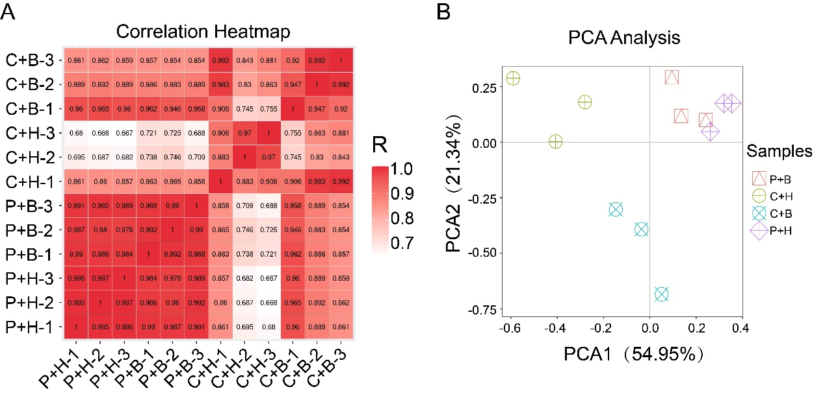

**Supplemental Figure 1.** **The correlation and PCA analyses of four treatments in *Nicotiana benthamiana***. **(A)** Correlation heatmap of four treatments with three biological replicates.The closer Pearson's Correlation Coefficient (R) is to 1, the stronger the correlation between the two duplicate samples. **(B)** Principal component analysis (PCA) of four treatments with three biological replicates. Scatter plot of PCA1 (x axis) versus PCA2 (y axis).