**Supplemental Figure S1.** the search strategy of WOS

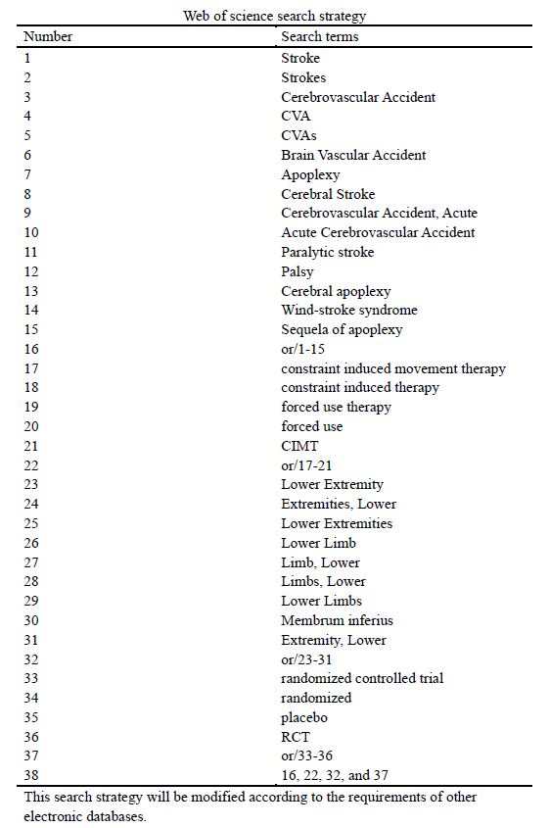

**Supplemental Figure S2.** Risk of bias in the involved studies, assessed by using the Cochrane Collaboration’s risk of bias tool: high risk of bias (+); unclear risk of bias (?); low risk of bias (-).

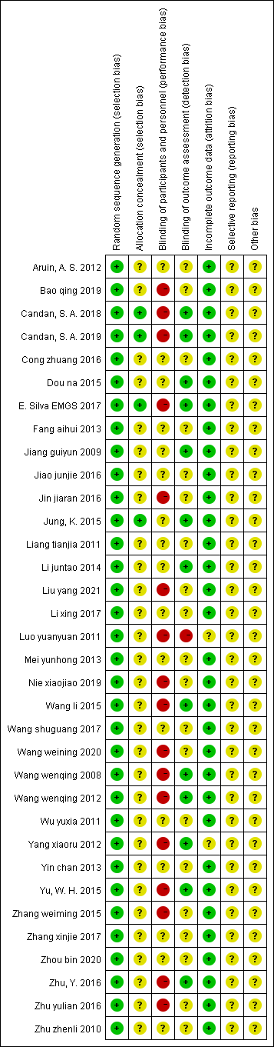

**Supplemental Figure S3.** Graph of the risk of bias: percentage of all studies included.

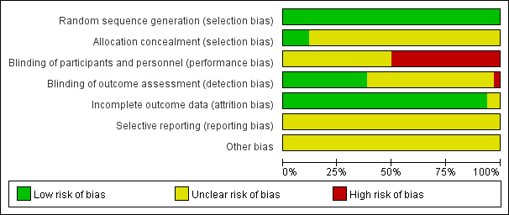

**Supplemental Figure S4.** Funnel plot. CIMT vs Conventional Physiotherapy on the Berg balance scale.

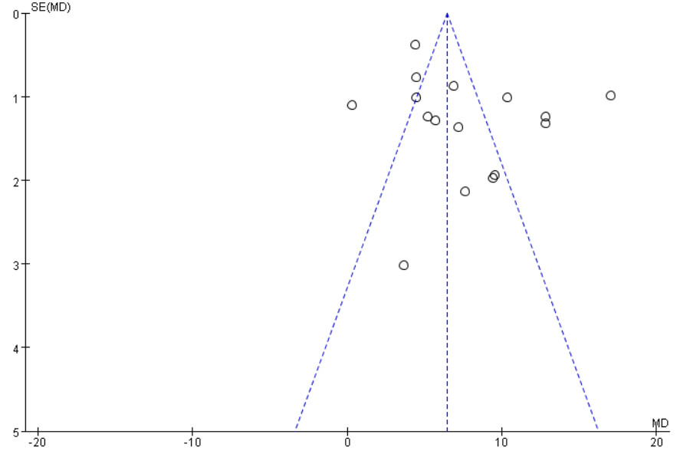

**Supplemental Figure S5.** Egger’s test. CIMT vs Conventional Physiotherapy on the Berg balance scale.

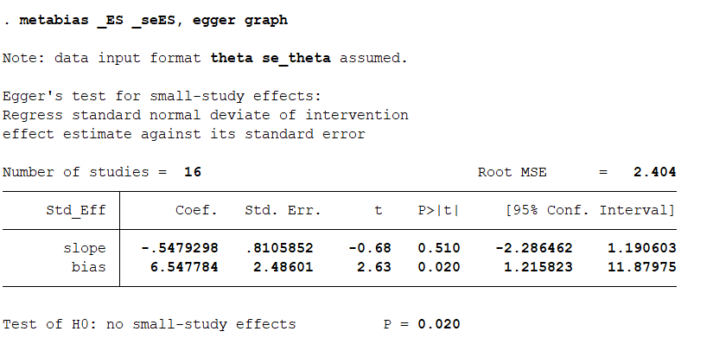

**Supplemental Figure S6.** Funnel plot. CIMT vs Conventional Physiotherapy on the 10-meter walk test.

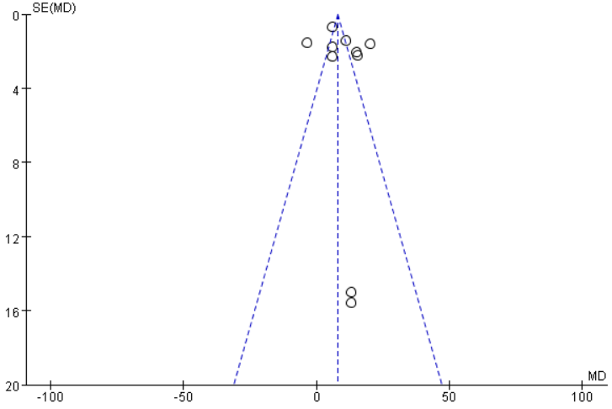

**Supplemental Figure S7.** Egger’s test. CIMT vs Conventional Physiotherapy on the 10-meter walk test.

