# Appendix 1: Distribution of the backbone natural gas pipeline network in China

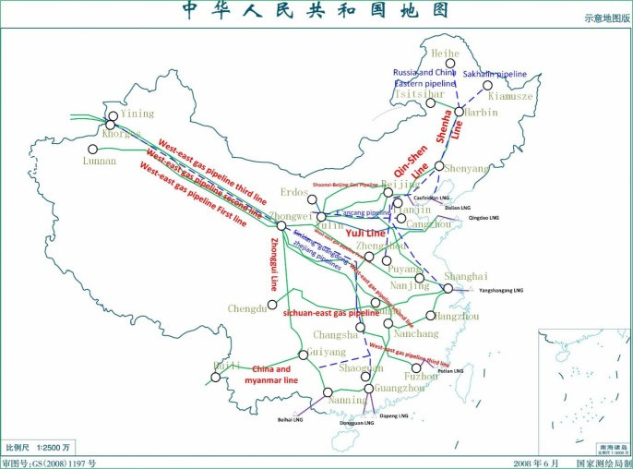

# Appendix 2. Natural Gas Supply deployment in China

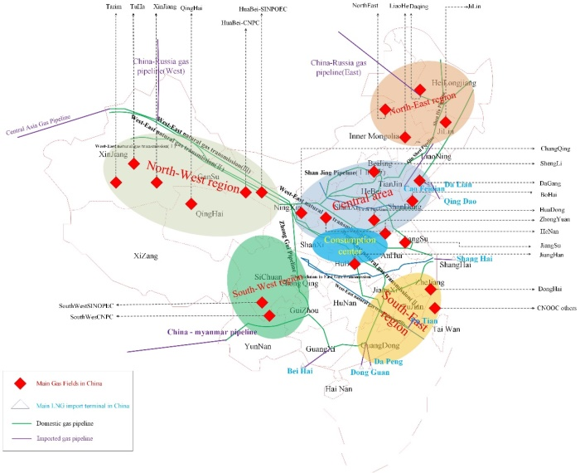

# Appendix 3: Generalized sketch of China's natural gas network

