Suppl. Table 1: Antibody clones used in IMACS
Marker | Label | Clone | Company | Cat. Nr.
CD11b | AF488 (Fitc) | icrf44 | BD | 557701
CD14 | APC-H7 | 61D3 | Invitrogen (Thermofisher) | 47-0149-42
CD16 | PE-CY7 | ebioCB16 | Ebioscience | 25-0168-42
CD45 | PO | HI30 | Invitrogen | MHCD4530
CD54 | BV711 (PerCP) | HA58 | BD | 564078
CD62L | FITC | FMC46 | BioRad  (AbD Serotec) | MCA1076F
CD64 | APC | 10.1 | BD | 561189
CD66b | PB | G10F5 | BD | 562940
CD121b (IL1) | PerCP | 34141 | Invitrogen (Thermofisher) | MA523661
CD163 | PE | GHI/61 | BD | 556018
CD206 | PerCP-Cy5.5 | 15-2 | Biolegend
HLA-DR | PE | LN3 | Invitrogen (Thermofisher) | 12-9956-42
TLR4 | PE | TF901 | BD | 564215
TLR5 | FITC | 85B152.5 | Invitrogen (Thermofisher) | MA5-16235

Suppl. Fig. 1: Flow cytometry gating strategy

Leukocyte subpopulations were identified by flowcytometry as indicated. Briefly, singlet cells were gated (1), and then granulocytes (2), monocytes (3) and lymphocytes (4) were identified based on their differential expression of granulocyte marker CD66b and monocyte marker CD64. Granulocytes were further divided into neutrophils (5) and eosinophils (6) based on CD16 expression. Monocyte subsets were divided into CD14++16- classical monocytes (CM; 7), CD14++16+ intermediate monocytes (IM; 8), and CD14+16++ non-classical monocytes (NCM; 9). Finally, dendritic cells (DC; 10) were identified as CD14-16- cells.

Suppl. Fig. 2: Monocyte subset immunophenotypic alterations after surgery
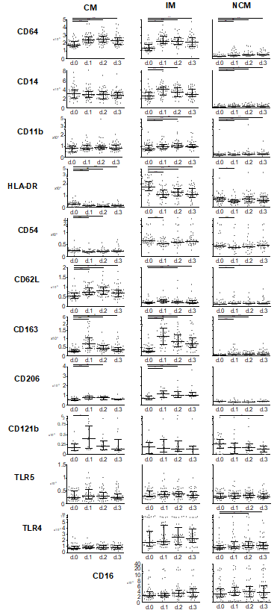

Suppl. Fig. 3: Significant correlations CM delta d.1-d.0 marker expression

Absolute lymphocyte counts in circulation in male (left, in blue) vs. female (right, in pink) patients before and during the first three days after surgery as determined by flowcytometric immunophenotyping. Individual data points as well as medians and interquartile ranges are shown. Significant differences between d.0 and d.1, d.2 or d.3 are indicated: * p ≤ 0.05; ** 0.01 > p < 0.001.

Suppl. Fig. 4: Significant correlations IM delta d.1-d.0 marker expression
