Supplementary Material
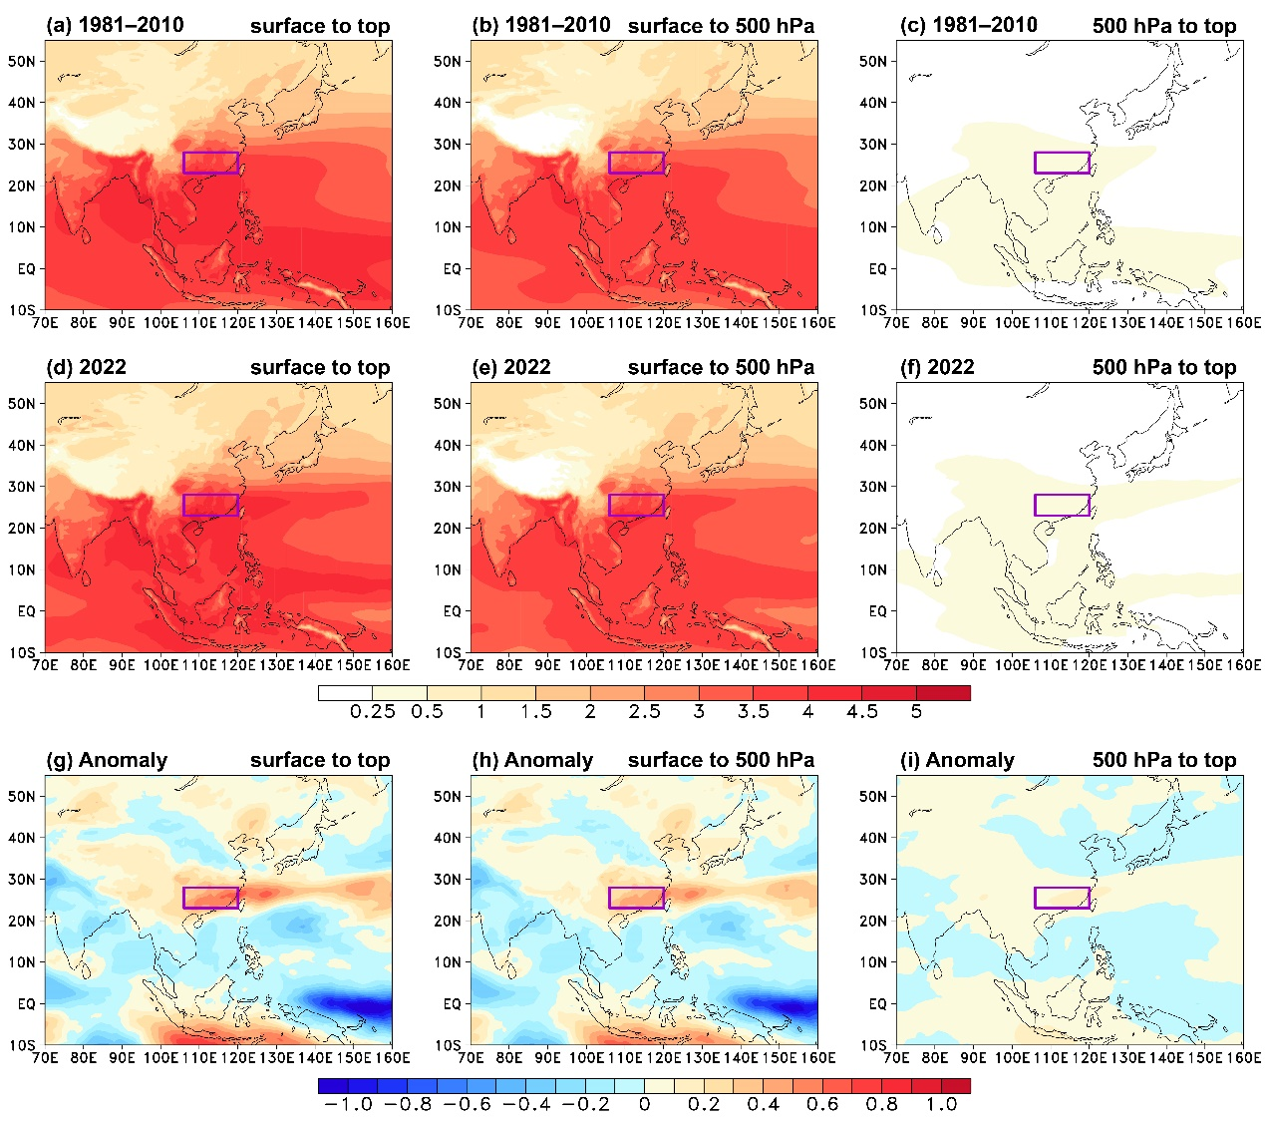
Supplementary Figure 1 (Figure S1). Distribution of the vertical integration of the climatological specific humidity from (a) surface to the top of atmosphere, (b) surface to 500 hPa, and (c) 500 hPa to the top of atmosphere in the "Dragon Boat Water" period during 1981–2010. (d)–(f) and (g)–(i) are the same as (a)–(c) but for the vertical integration of the specific humidity and specific humidity anomaly in 2022. The units are 10⁴ Pa kg kg^{–1}.

