Figure S1 The lowest and highest temperature from Oct to May in 2018, 2019, 2020, and 2021 with different generations of mutants from T1 to T4

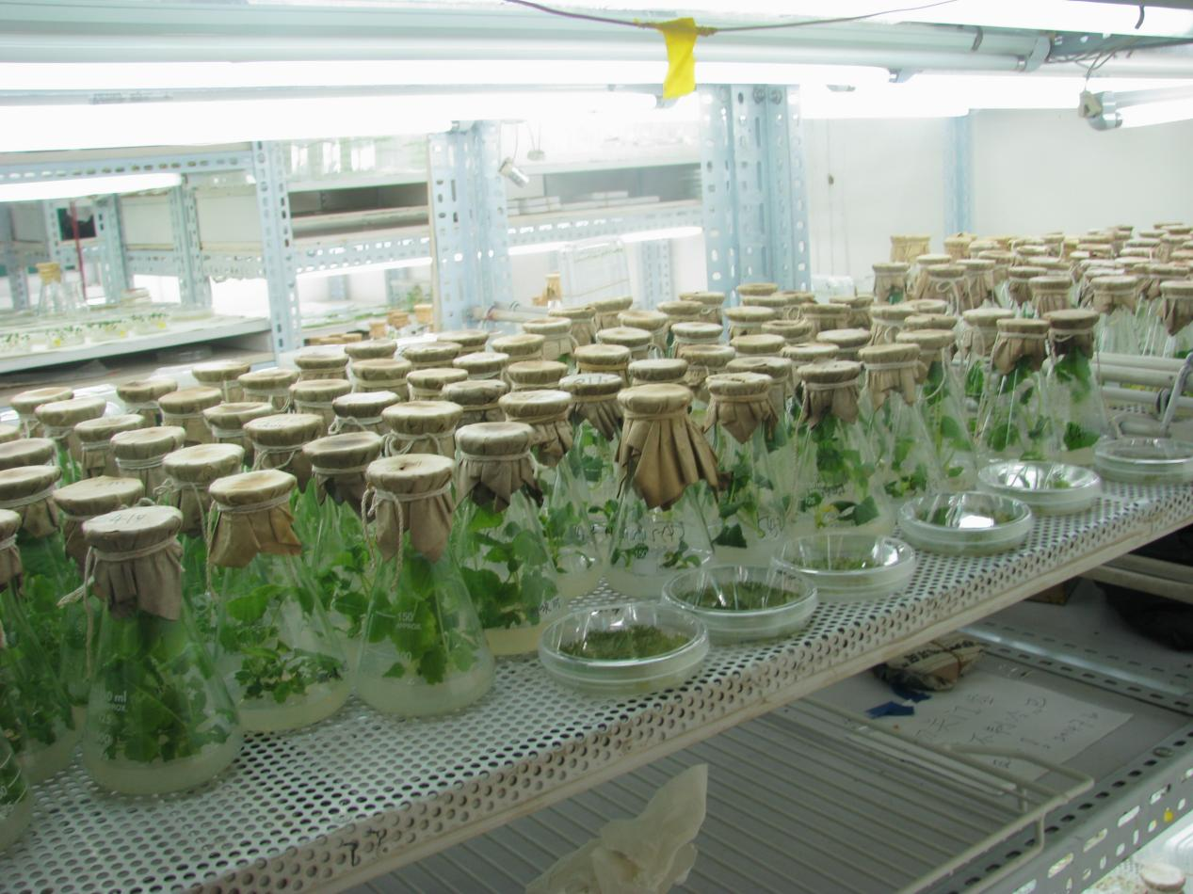

Figure S2 regeneration plants from B57-1

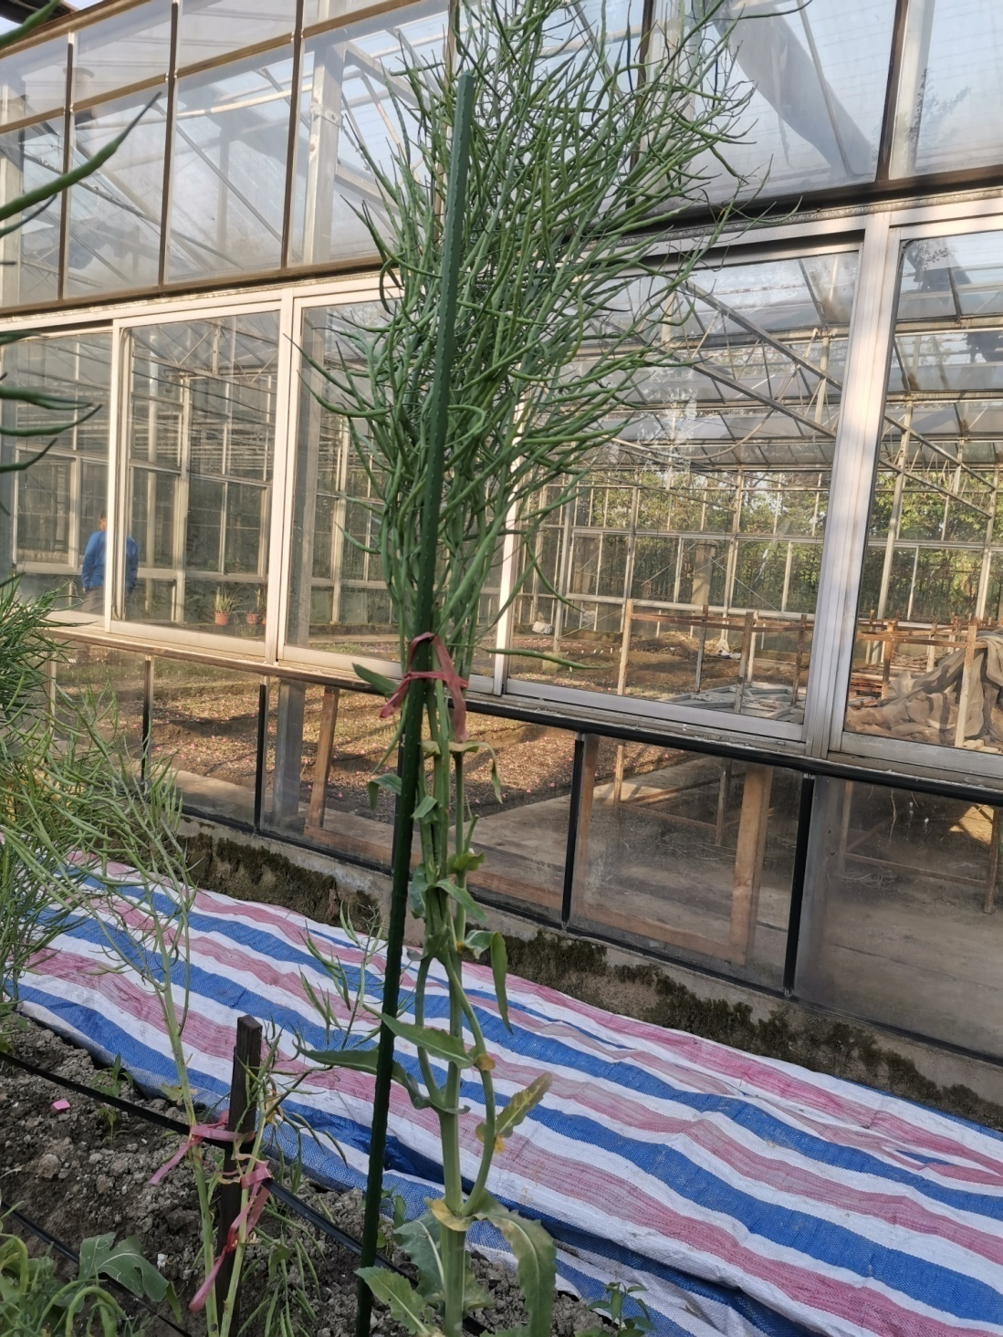

Figure S5 double loci edited plant (#289)