## Figures

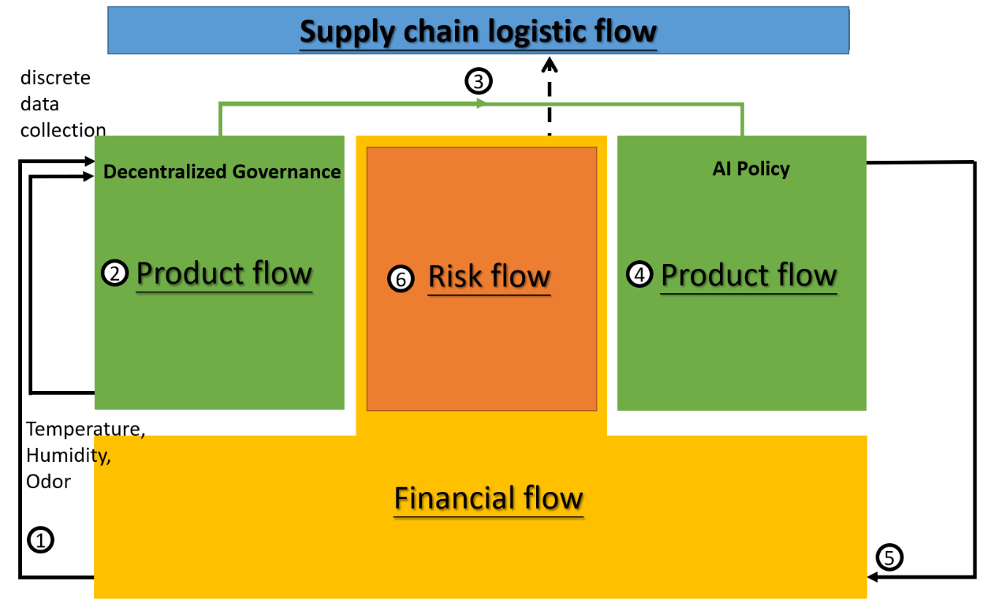

Figure 1a. Double-helix architecture based on AWF structure

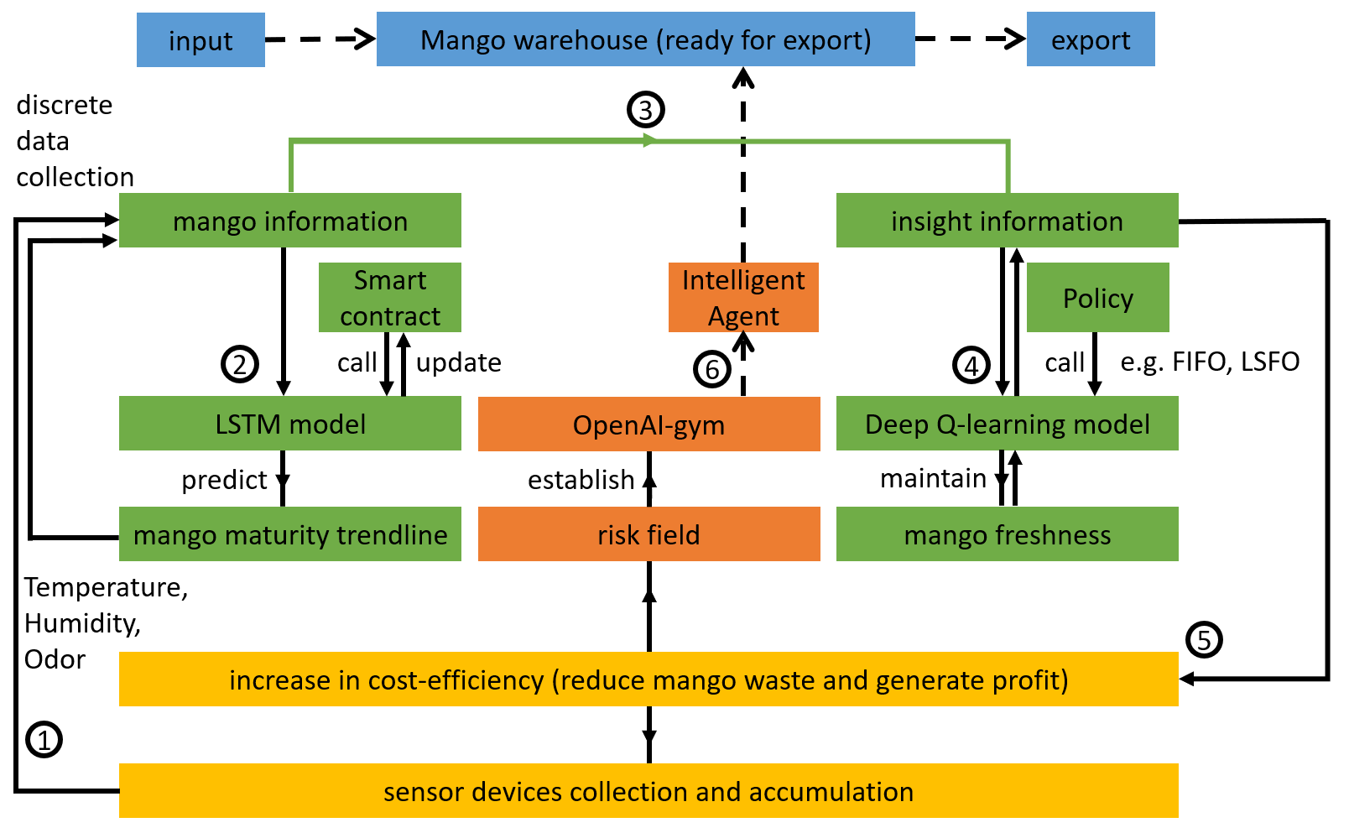

Figure 1b. Double-helix architecture based on AWF structure

Figure 2. Underripe mangoes (left), and overripe mangoes (right)

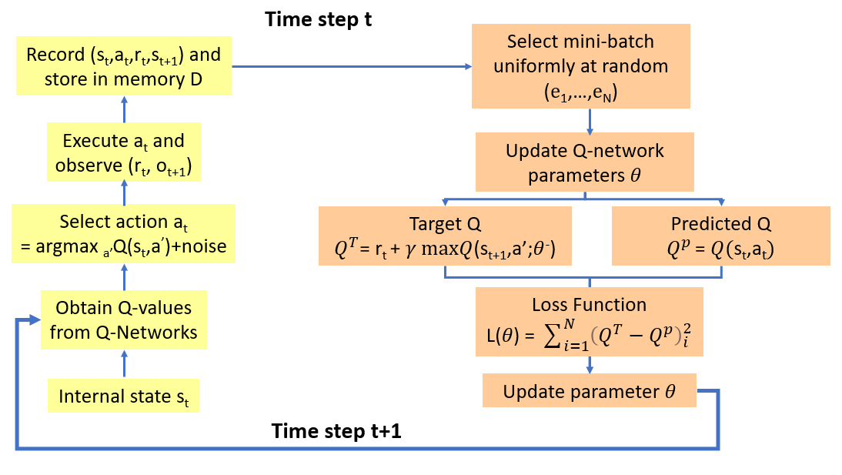

Figure 3. Deep Q learning model

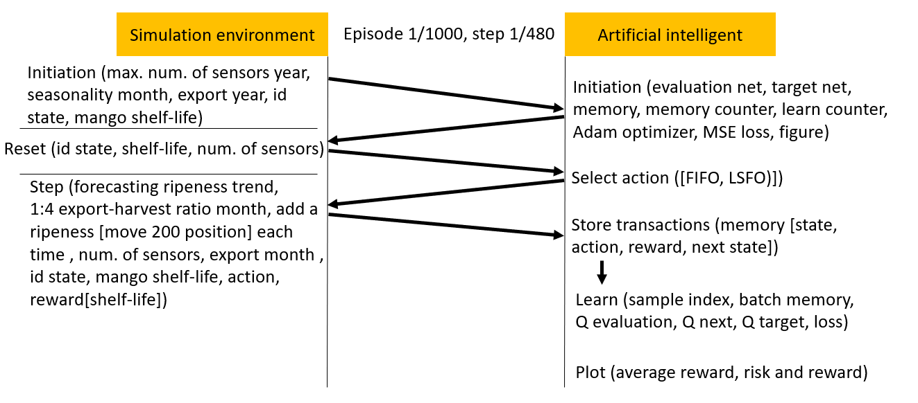

Figure 4a. Simulation flow in episode 1, step 1

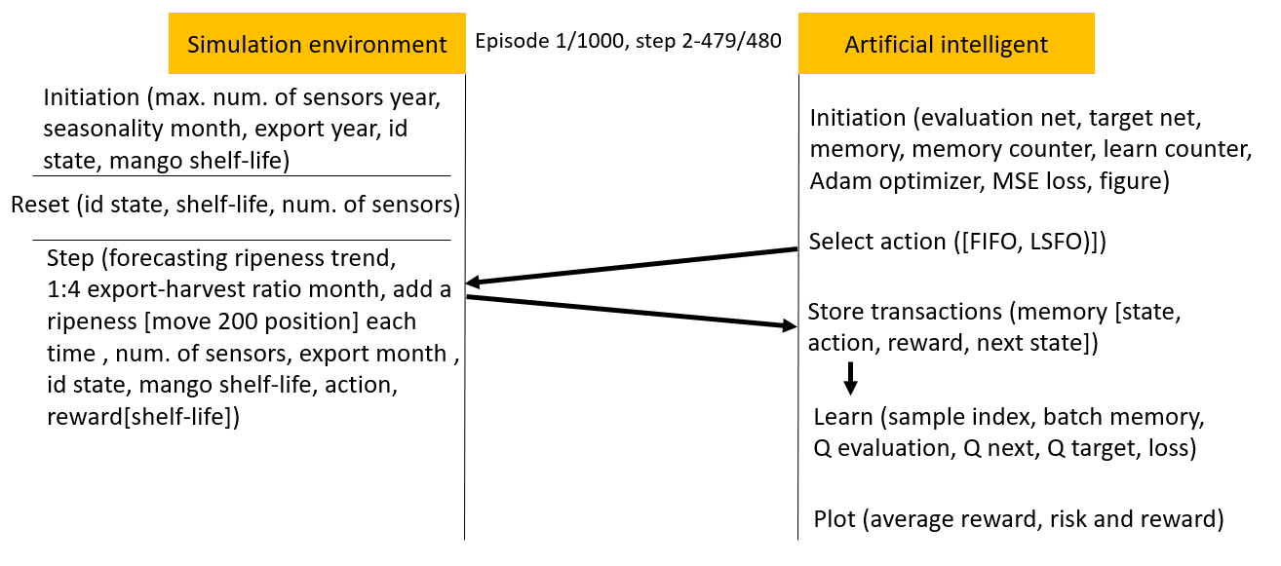

Figure 4b. Simulation flow in episode 1, steps 2–479

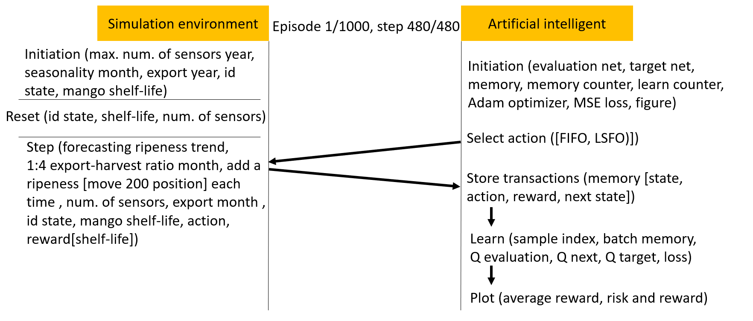

Figure 4c. Simulation flow in episode 1, step 480.

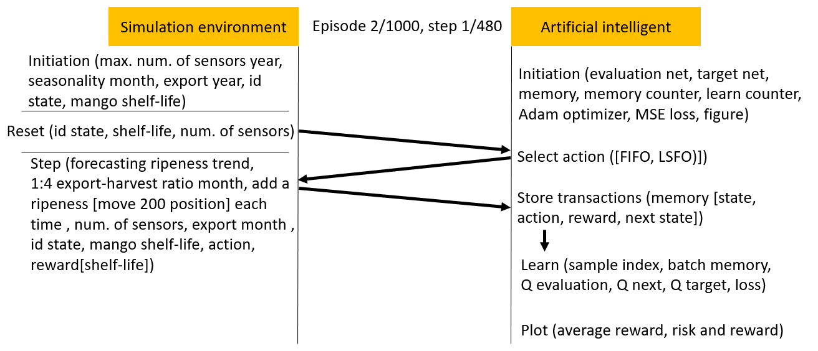

Figure 4d. Simulation flow in episode 2, step 1

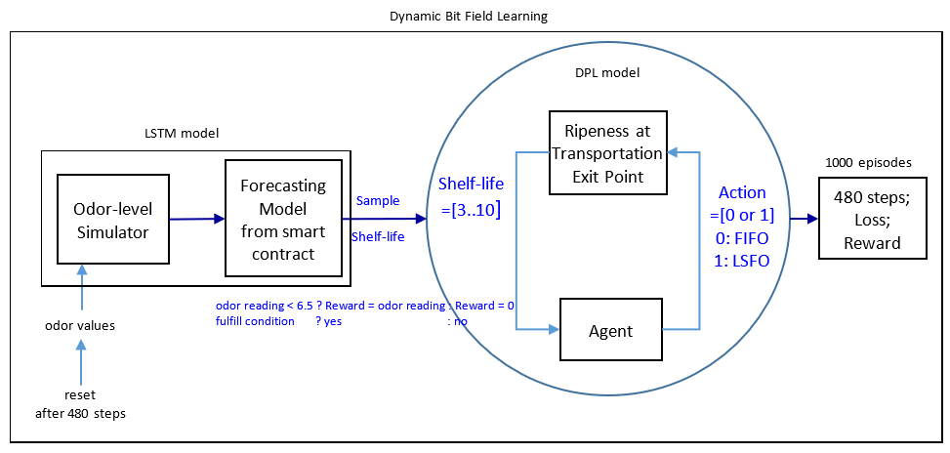

Figure 5. Deep Q-learning with simulated forecast scenarios.

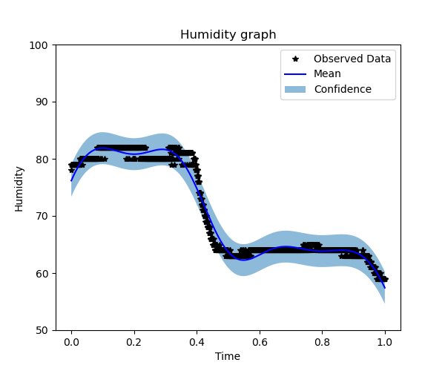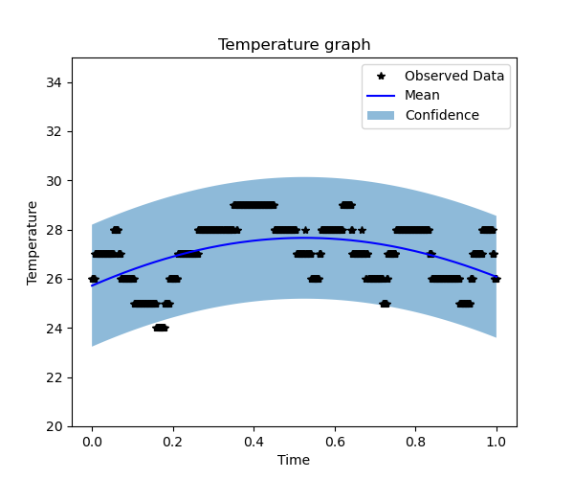

Figure 6. Temperature boundary for a forecasting model (left) and humidity boundary (right) for the forecasting model

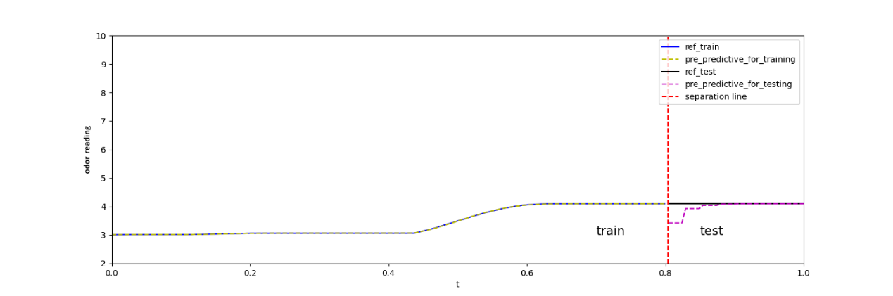

Figure 7a. Total of 200 odor-sampling points in the forecasting model.

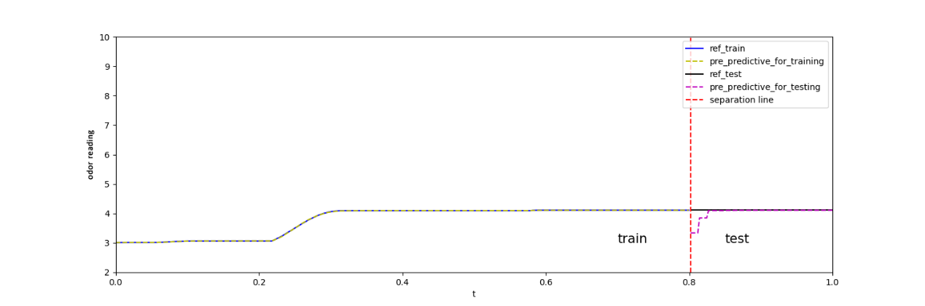

Figure 7b. Total of 400 odor-sampling points in the forecasting model.

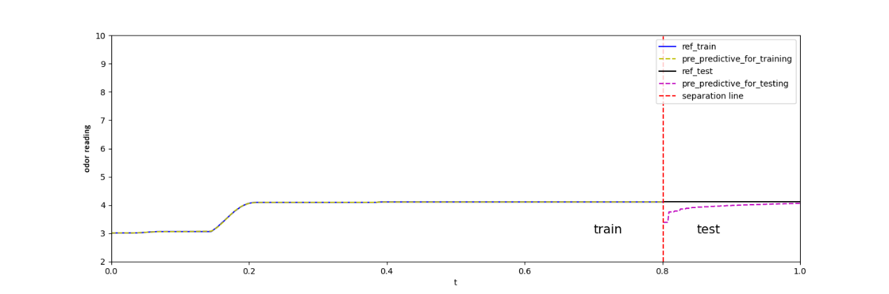

Figure 7c. Total of 600 odor-sampling points in the forecasting model.

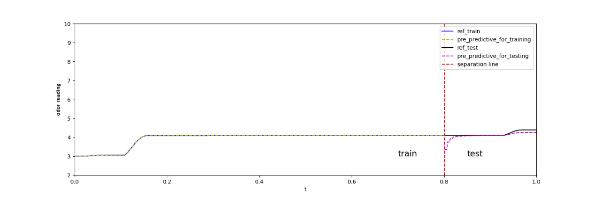

Figure 7d. Total of 800 odor-sampling points in the forecasting model.

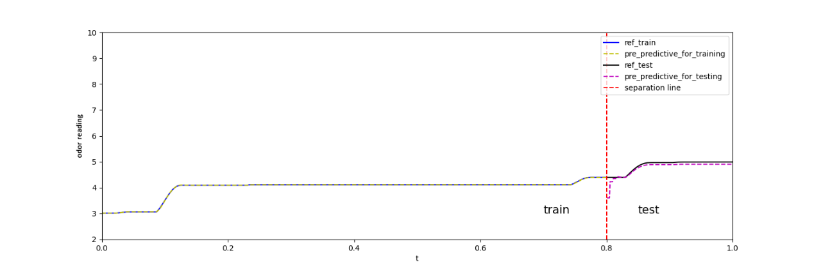

Figure 7e. Total of 1000 odor-sampling points in the forecasting model.

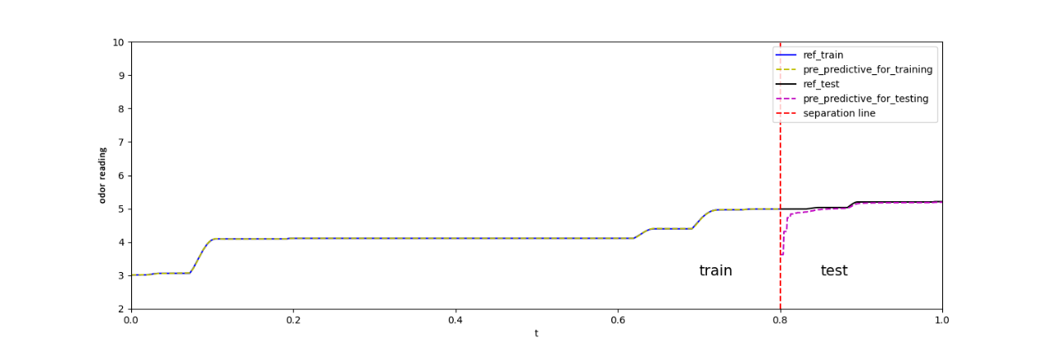

Figure 7f. Total of 1200 odor-sampling points in the forecasting model.

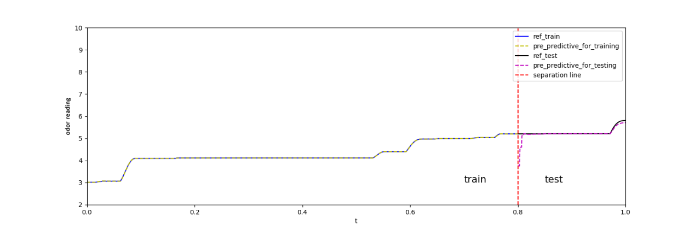

Figure 7g. Total of 1400 odor-sampling points in the forecasting model.

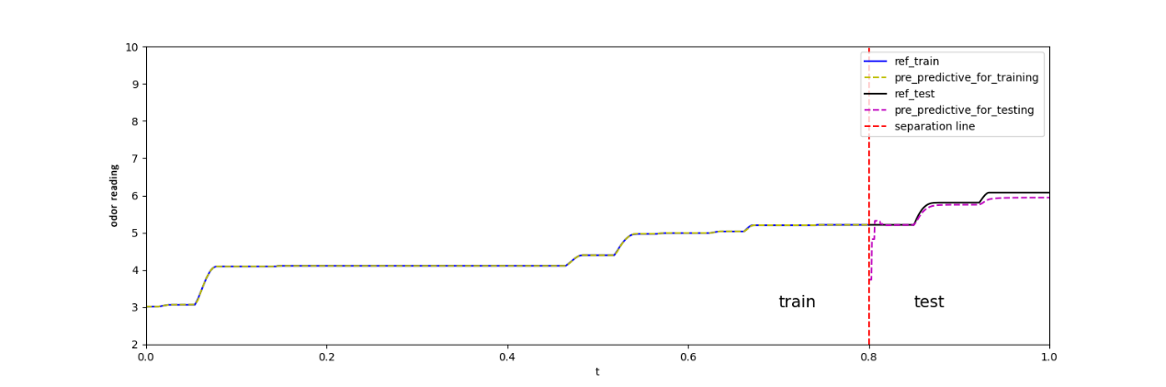

Figure 7h. Total of 1600 odor-sampling points in the forecasting model.

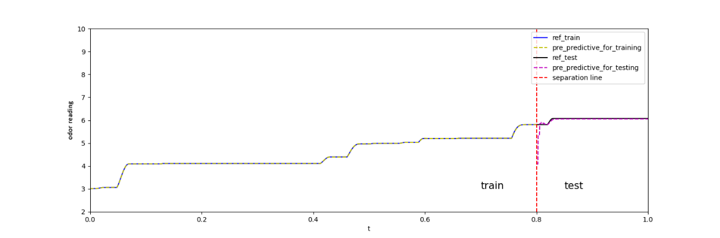

Figure 7i. Total of 1800 odor-sampling points in the forecasting model.

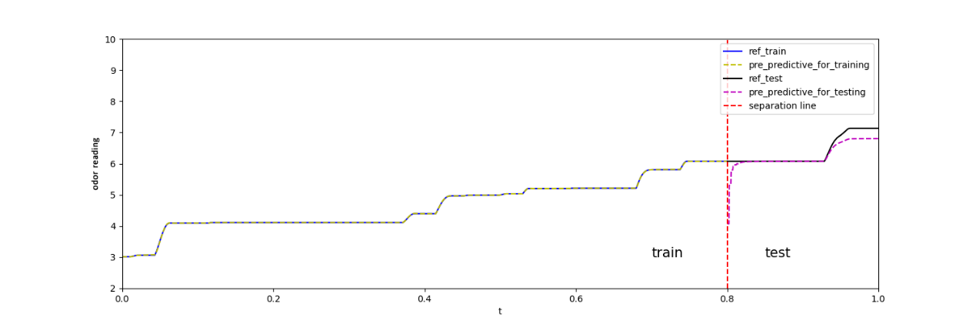

Figure 7j. Total of 2000 odor sampling points in the forecasting model

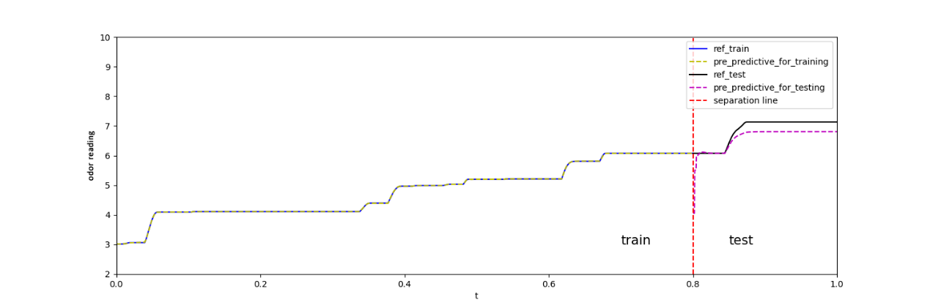

Figure 7k. Total of 2200 odor sampling points in the forecasting model

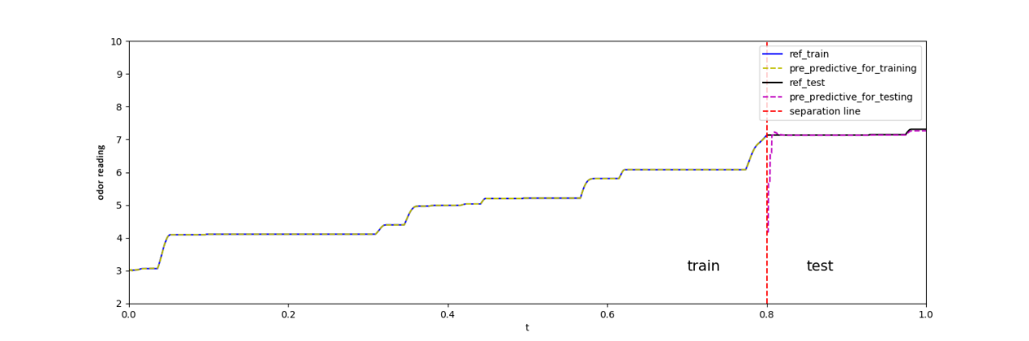

Figure 7l. Total of 2400 odor-sampling points in the forecasting model.

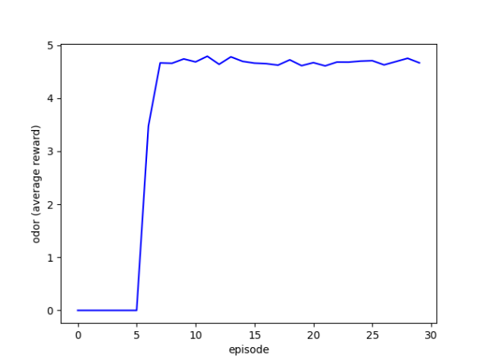 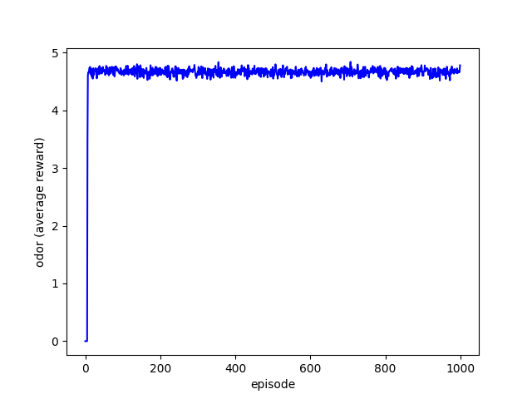

Figure 8. Agent’s average reward: 30 episodes (left) and 1000 episodes (right)