Figure S1. Maximum NDVI classes using April 2018 Sentinel-2 imagery for all cultivated pixels across our study region.
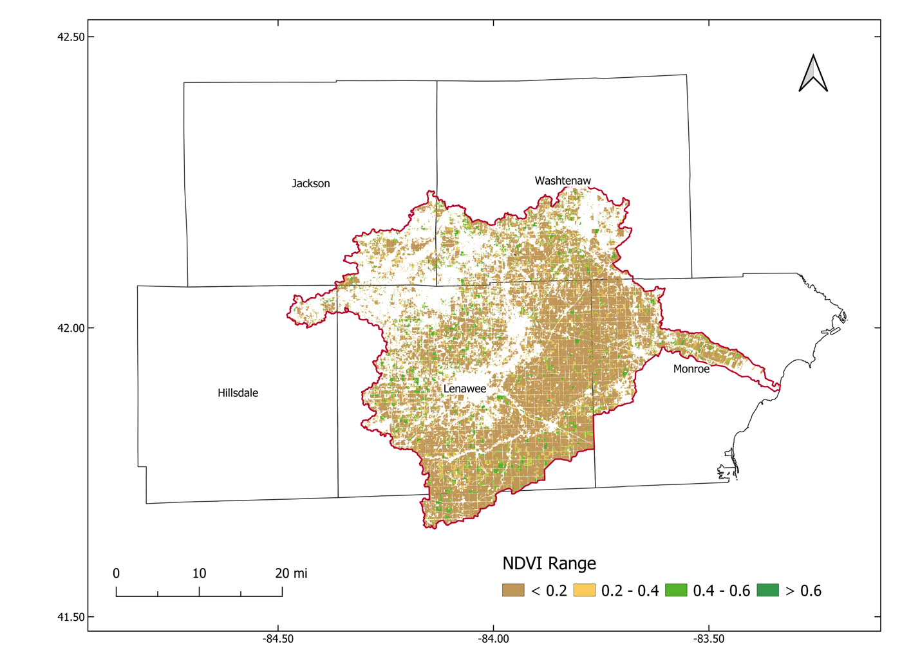
Table S1. Definitions and formulas for the four accuracy metrics used in this study.

Accuracy Metric | Definition | Formula
User’s accuracy or Recall | Probability that a feature seen on the map will actually be present on the ground | Number of correctly classified validation pixels/total number of validation pixels (calculated for each feature class)
Producer’s accuracy or Precision | Probability that true features on the ground are classified as such on the map | Number of correctly classified validation pixels/total number of classified pixels (calculated for each feature class)
Overall accuracy | Of all validation data, what proportion were mapped correctly | Number of correctly classified validation pixels/total number of validation pixels (calculated across all feature classes)
F1 Score | Harmonic mean of precision and recall | 2 x (Precision x Recall)/(Precision + Recall)

