SUPPLEMENTARY MATERIALS
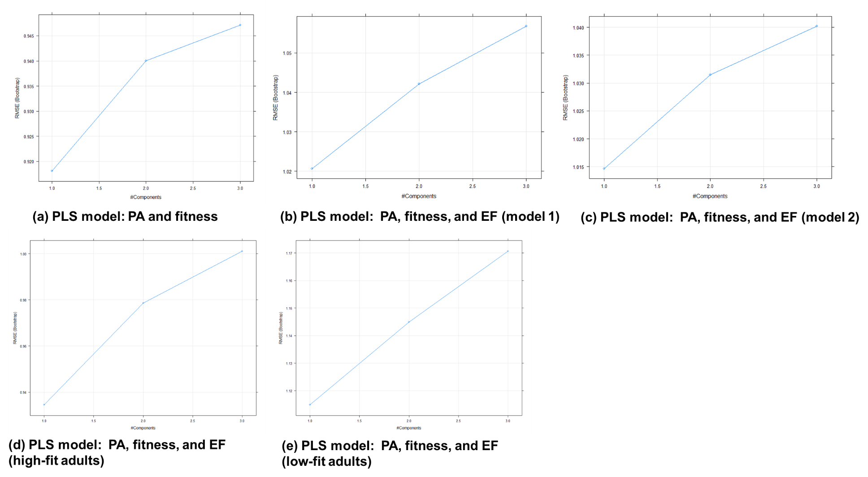
S-Figure 1. Values of Root Mean Square Error in different PLS regression models

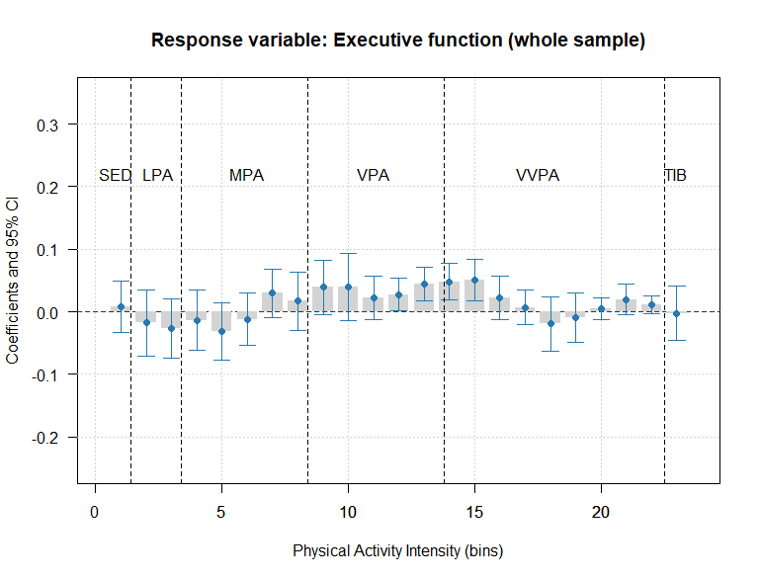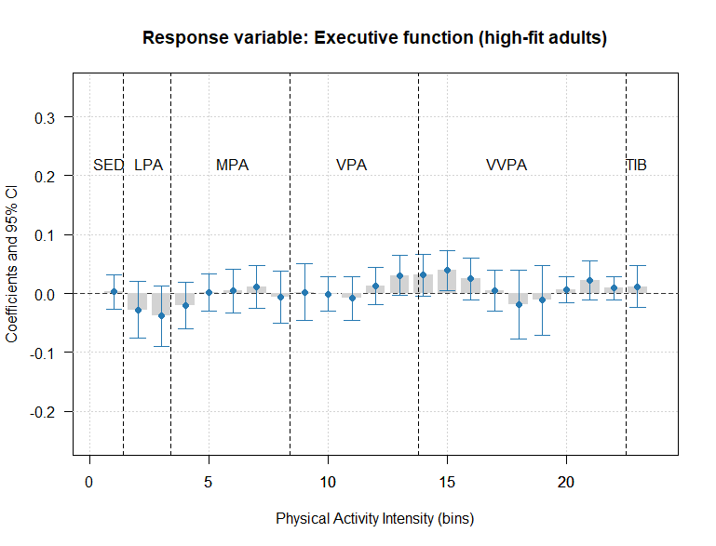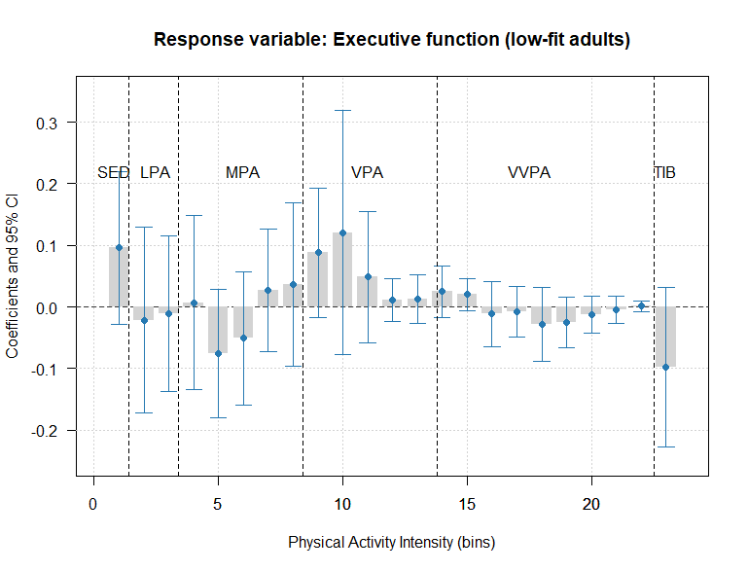
S-Figure 2. The association between physical activity intensities and executive function
SED=Sedentary; LPA=Light physical activity; MPA=Moderate physical activity; VPA=Vigorous physical activity; VVPA=Very vigorous physical activity; TIB=Time in bed/sleep time.

S-Table 1. Z-score of the physical activity intensities and sleep time.
Variable | Obs | Mean | Std. Dev. | Min | Max
Physical Activity Intensities
Bin 1 | 343 | 0.000643 | 1.003292 | -4.85286 | 2.802302
Bin 2 | 343 | 0.004856 | 1.003623 | -2.59544 | 3.342597
Bin 3 | 343 | 0.005494 | 1.005258 | -2.52889 | 3.767131
Bin 4 | 343 | 0.007142 | 1.005321 | -2.64073 | 3.801643
Bin 5 | 343 | 0.007505 | 1.003841 | -2.13014 | 5.339719
Bin 6 | 343 | 0.001998 | 1.00245 | -1.73047 | 5.21216
Bin 7 | 343 | 0.005 | 1.004057 | -1.23474 | 4.107235
Bin 8 | 343 | 0.00516 | 1.00525 | -0.69265 | 9.034923
Bin 9 | 343 | 0.006855 | 1.005559 | -0.72752 | 8.281922
Bin 10 | 343 | 0.005006 | 1.006377 | -0.51535 | 13.15636
Bin 11 | 343 | 0.0044 | 1.006592 | -0.40956 | 10.95288
Bin 12 | 343 | 0.003901 | 1.006756 | -0.28418 | 14.85627
Bin 13 | 343 | 0.005342 | 1.006293 | -0.38359 | 8.334879
Bin 14 | 343 | 0.004896 | 1.006452 | -0.34437 | 9.986707
Bin 15 | 343 | 0.004499 | 1.00658 | -0.31599 | 9.129551
Bin 16 | 343 | 0.003458 | 1.006867 | -0.24562 | 10.6411
Bin 17 | 343 | 0.003002 | 1.006964 | -0.22117 | 10.17238
Bin 18 | 343 | 0.002319 | 1.007092 | -0.17158 | 12.85216
Bin 19 | 343 | 0.001548 | 1.007108 | -0.17437 | 14.41951
Bin 20 | 343 | 0.000588 | 1.007008 | -0.13552 | 17.75108
Bin 21 | 343 | 7.56E-05 | 1.006644 | -0.15354 | 16.91877
Bin 22 | 343 | 0.001662 | 1.007188 | -0.114 | 17.57567
Sleep time | 343 | -0.00752 | 1.003201 | -3.63649 | 7.60148

