**APPENDIX**

Table A1-Descriptive Statistics

|  |  |  |  |  |  |  |  |  |  |  |  |
| --- | --- | --- | --- | --- | --- | --- | --- | --- | --- | --- | --- |
|  |  |  | Entire sample | | | Men | | | Women | | |
| Variables | Min | Max | N | Mean/Prop | SD | N | Mean/Prop | SD | N | Mean/Prop | SD |
| Probability VOX support | 0 | 10 | 1,381 | 1.78 | 3.04 | 691 | 2.18 | 3.24 | 690 | 1.39 | 2.69 |
| Woman | 0 | 1 | 1,504 | 51% |  | 735 | 100% |  | 769 | 100% |  |
| Masculinity | 0 | 10 | 1,410 | 5.72 | 2.91 | 696 | 7.63 | 1.92 | 714 | 3.87 | 2.48 |
| Age | 18 | 92 | 1,504 | 50.14 | 16.8 | 735 | 55.1 | 18.6 | 769 | 42.66 | 12.30 |
| Education | 0 | 4 | 1,504 | 1.91 | 1.25 | 735 | 1.85 | 1.27 | 769 | 1.95 | 1.22 |
| L/R Ideology | 0 | 10 | 1,337 | 4.26 | 2.78 | 677 | 4.52 | 2.72 | 660 | 4.01 | 2.80 |
| Sexism | 0 | 13 | 1,393 | 6.76 | 3.20 | 674 | 7.51 | 3.13 | 719 | 6.06 | 3.11 |

Source: Fraile, 2022. Spain December 2020

Table A2- Testing mediation conditions: Prediction of the probabilities of voting for VOX and sexist attitudes among women

|  |  |  |  |  |  |
| --- | --- | --- | --- | --- | --- |
|  | Model 1  VOX | Model 2  VOX | Model 3  Sexism | Model 4  VOX | Model 5  VOX |
| Masculinity | -0.06 | -0.02 | -0.11* | 0.00 | -0.02 |
|  | 0.05 | 0.04 | 0.05 | 0.04 | 0.08 |
| Age |  | -0.00 | 0.04*** | -0.01 | -0.01 |
|  |  | 0.01 | 0.01 | 0.01 | 0.01 |
| Education |  | -0.12 | -0.50*** | -0.04 | -0.04 |
|  |  | 0.07 | 0.09 | 0.07 | 0.07 |
| L/R Ideology |  | 0.56*** | 0.48*** | 0.49*** | 0.49*** |
|  |  | 0.03 | 0.04 | 0.03 | 0.03 |
| Sexism |  |  |  | 0.16*** | 0.15** |
|  |  |  |  | 0.03 | 0.06 |
| Masculinity*sexism | |  |  |  | 0.00 |
|  |  |  |  |  | 0.01 |
| Constant | 1.58*** | -0.47 | 3.99*** | -1.12* | -1.02 |
|  | 0.21 | 0.45 | 0.57 | 0.46 | 0.55 |
| *N* | 568 | 568 | 568 | 568 | 568 |
| R2 | 0.00 | 0.37 | 0.28 | 0.40 | 0.40 |

Source: Fraile, 2022. Spain December 2020.

Note: Unstandardized OLS coefficient estimates with their associated SE.

* *p* < 0.05, ** *p* < 0.01 *** *p* < 0.001

Table A3- Mediation analysis of the effect of masculinity on voting for VOX via sexist attitudes among women

|  |  |  |  |
| --- | --- | --- | --- |
| Effect | Mean | [95% Conf. Interval] | |
| ACME | -0.024 | -0.045 | -0.007 |
| Direct Effect | 0.000 | -0.073 | 0.074 |
| Total Effect | -0.024 | -0.096 | 0.049 |
| % of Total Effect Mediated | 0.473 | -7.439 | 8.347 |

Source: Fraile, 2022. Spain December 2020

Figure A1- Boxplot of masculinity by gender

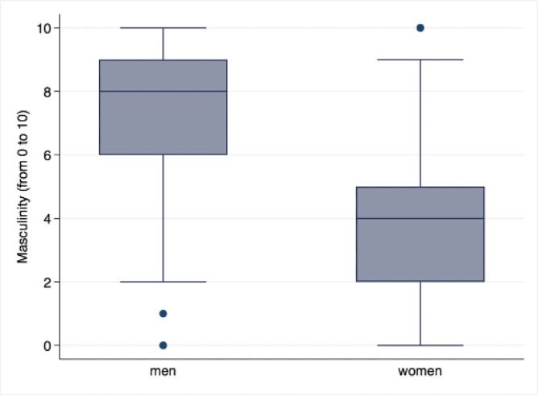

Source: Fraile, 2022. Spain December 2020.

Figure A2- Replication of Figure 2: Predicted probabilities of voting for VOX by gender and masculinity with marhis

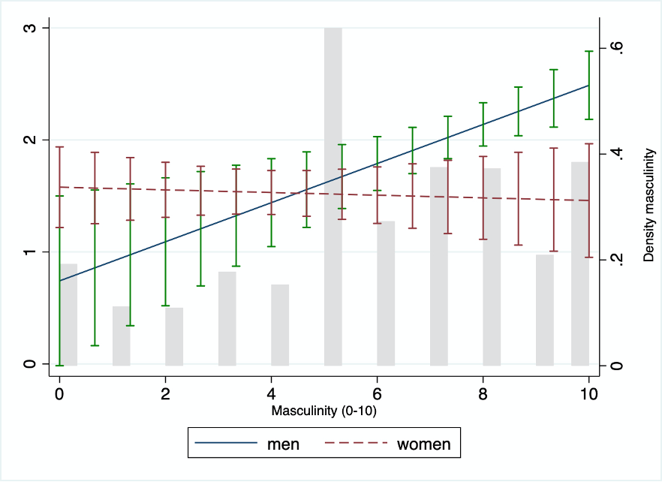

Source: Fraile, 2022. Spain December 2020. Predicted values based on Model 4 in Table 1.

Figure A3- Replication of Figure 3: Moderation test: Effects of masculinity on the probabilities of voting for VOX across values of sexism among men with marhis

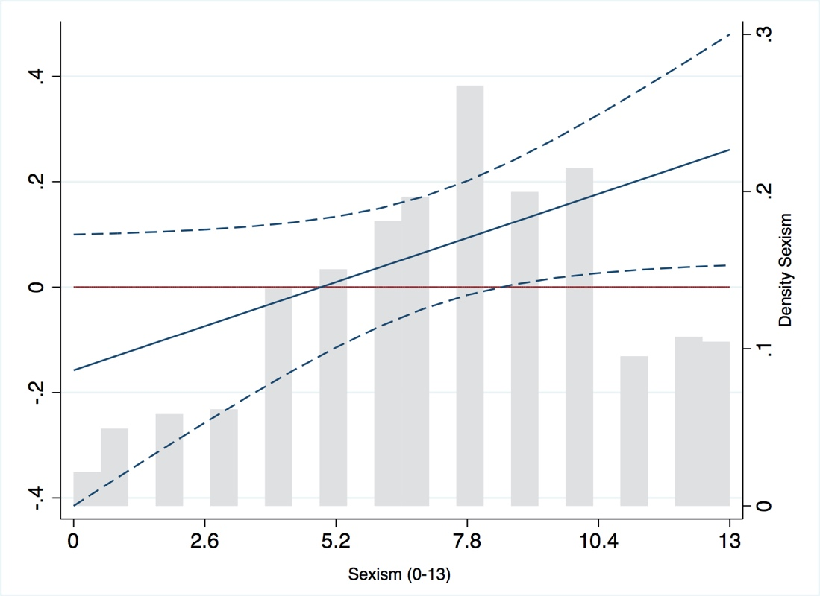

Source: Fraile, 2022. Spain December 2020. Predicted values based on Model 5 in Table 2.

Figure A4- Moderation test: Probabilities of voting for VOX by masculinity and sexism among women

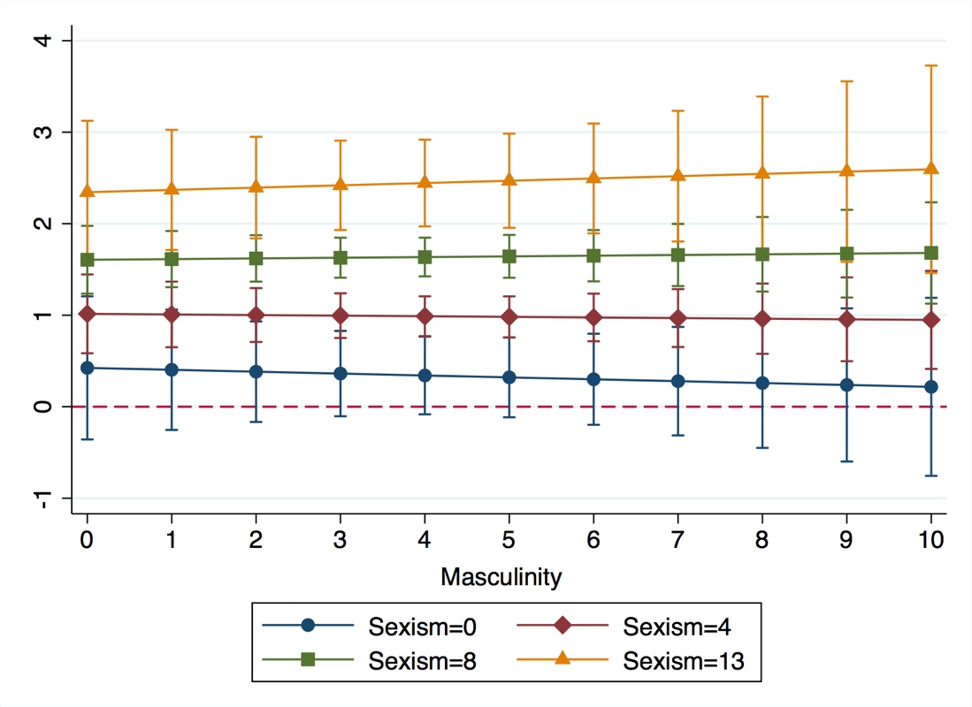

Source: Fraile, 2022. Spain December 2020. Predicted values based on Model 5 in Table A2.