Supplementary Material

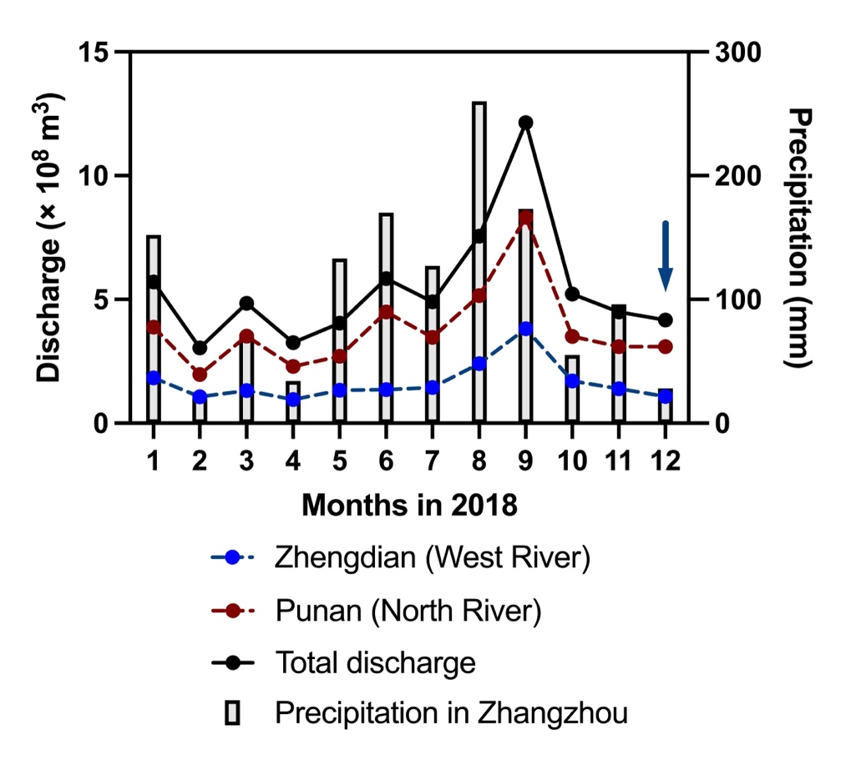

**Figure S1.** Discharge observed at two hydrological stations in the upper Jiulong River (Zhengdian and Punan), total discharge, and precipitation in Zhangzhou in 2018 (data from http://slt.fujian.gov.cn/).

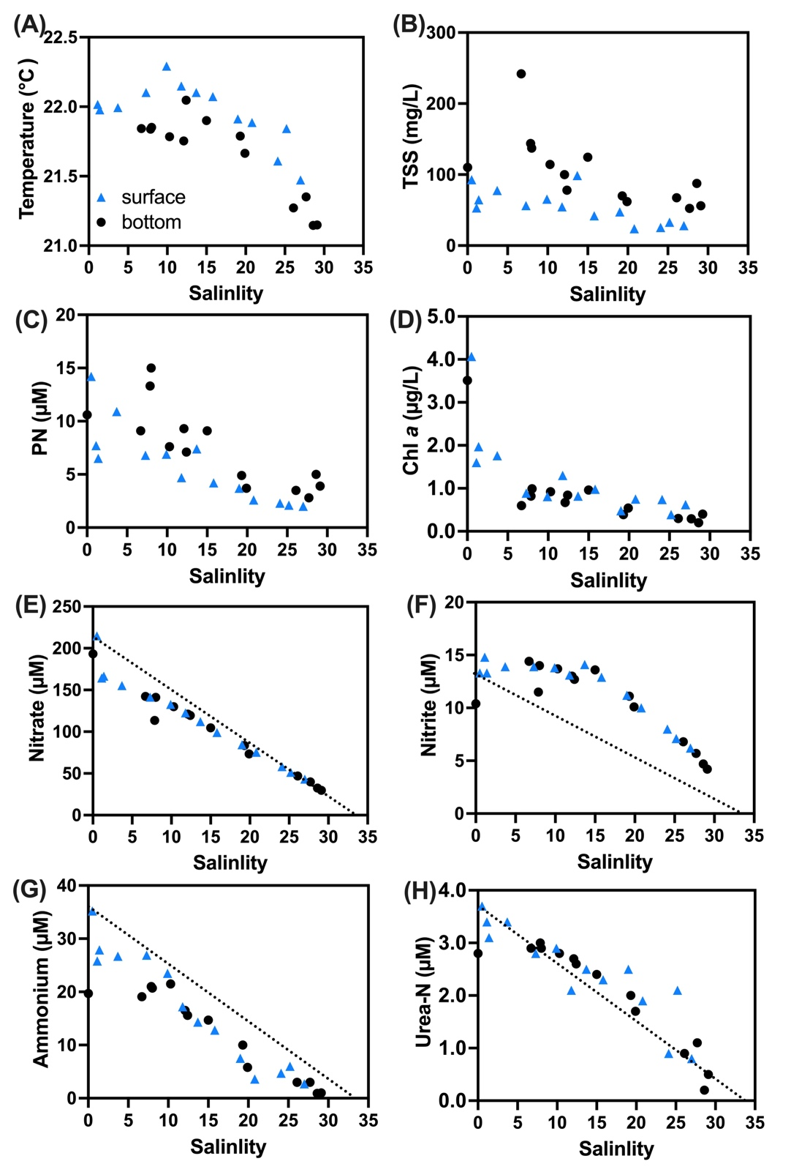

**Figure S2.** Environmental parameters against salinity: (A) temperature (◦C); (B) total suspended substances (TSS, mg/L); (C) particulate N (PN, μM); (D) Chl *a* (μg/L); (E) nitrate (μM); (F) nitrite (μM); (G) ammonium (μM); and (H) urea-N (μM). Note that the dashed line in (E)-(H) shows idealized mixing lines of these four nitrogenous nutrients, where assumed their concentrations were ~0 at salinity = 33. Blue triangles indicate surface samples and black circles indicate bottom samples.

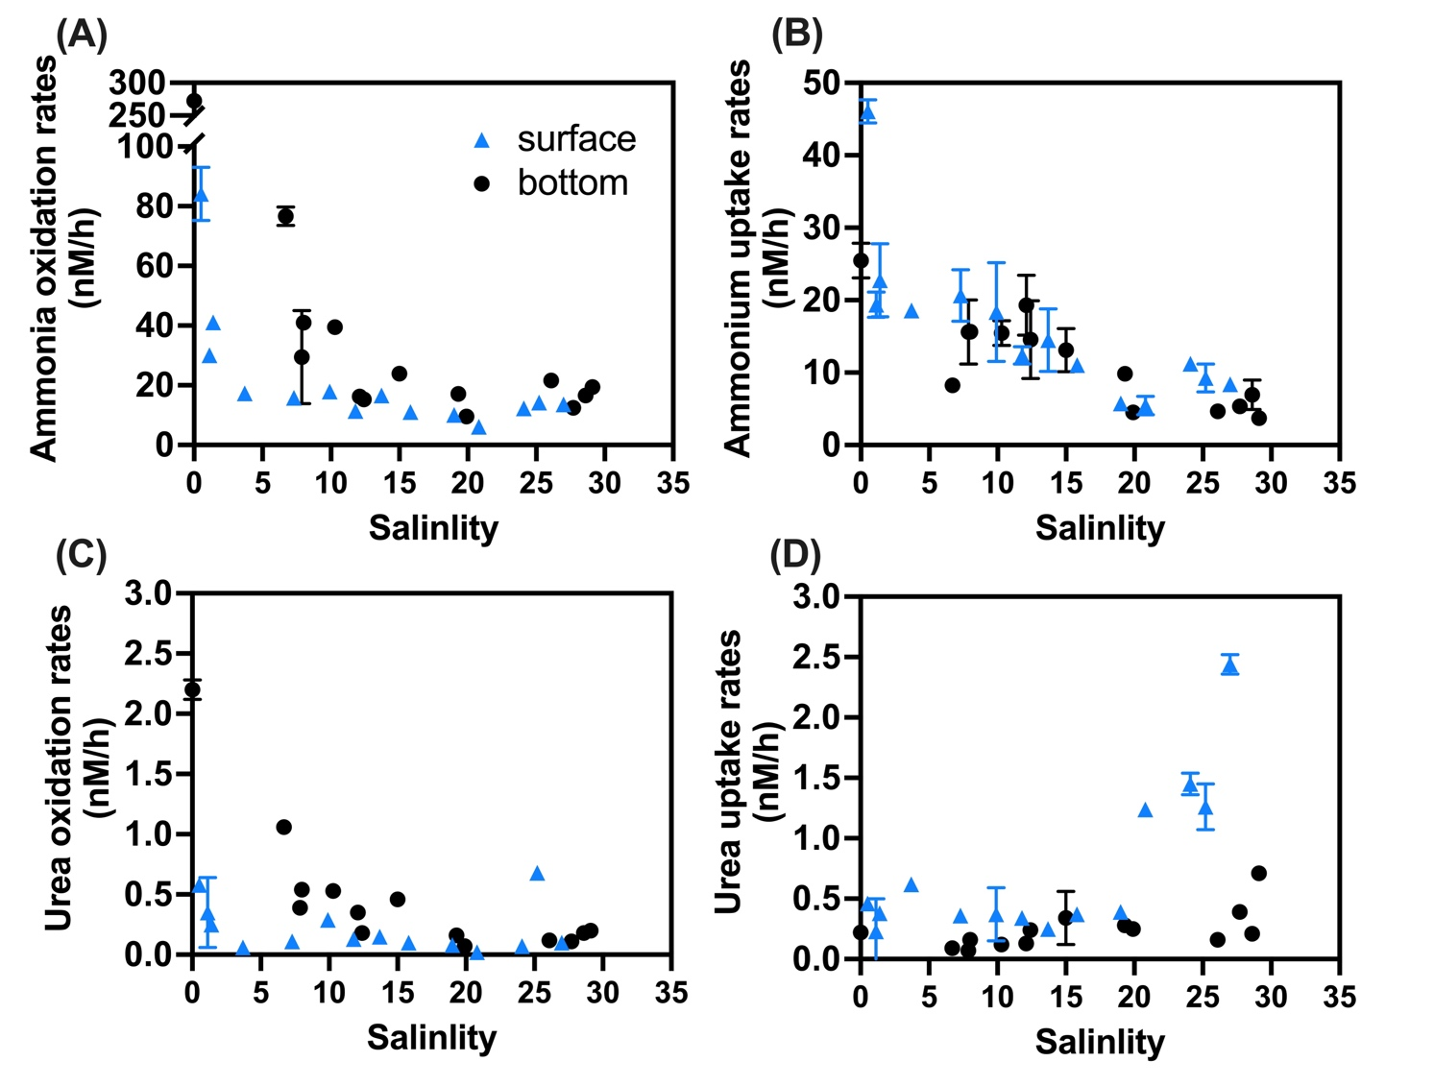

**Figure S3.** N transformation rates (nM/h) again salinity: (A) ammonia oxidation rates; (B) ammonium uptake rates; (C) urea oxidation rates; (D) urea uptake rates. Blue triangles indicate surface rates, black circles indicate bottom rates and the error bars represent the standard deviation of the two biological replicates.

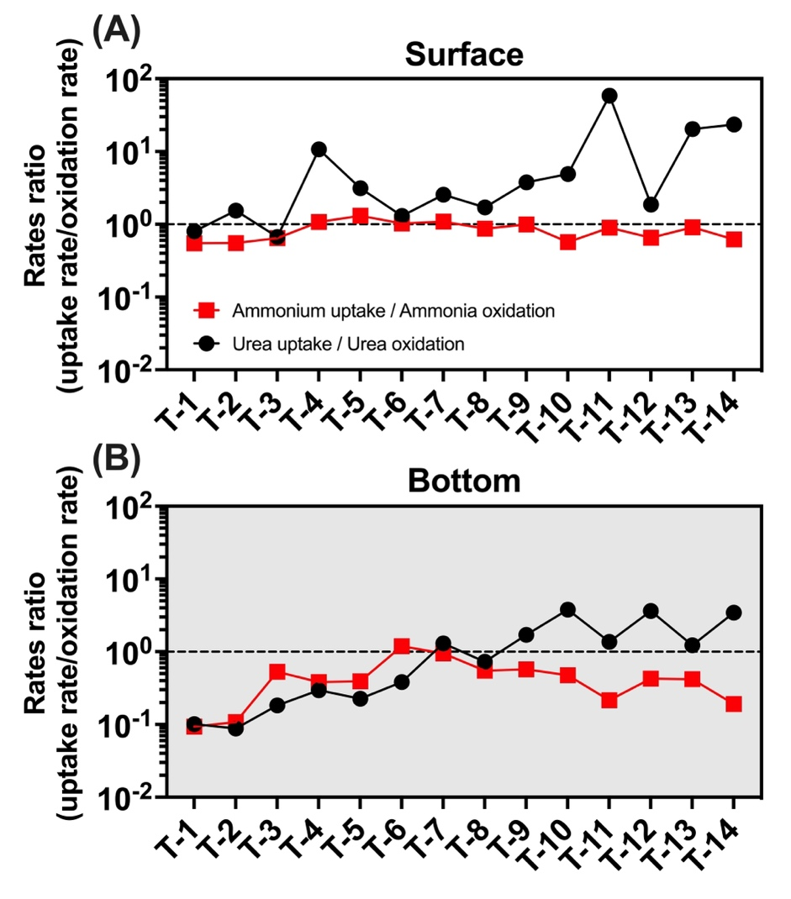

**Figure S4.** Distribution of ammonium uptake to ammonia oxidation ratio (red square) and urea uptake to urea oxidation ratio (black circle) in the surface (A) and bottom (B) layers.

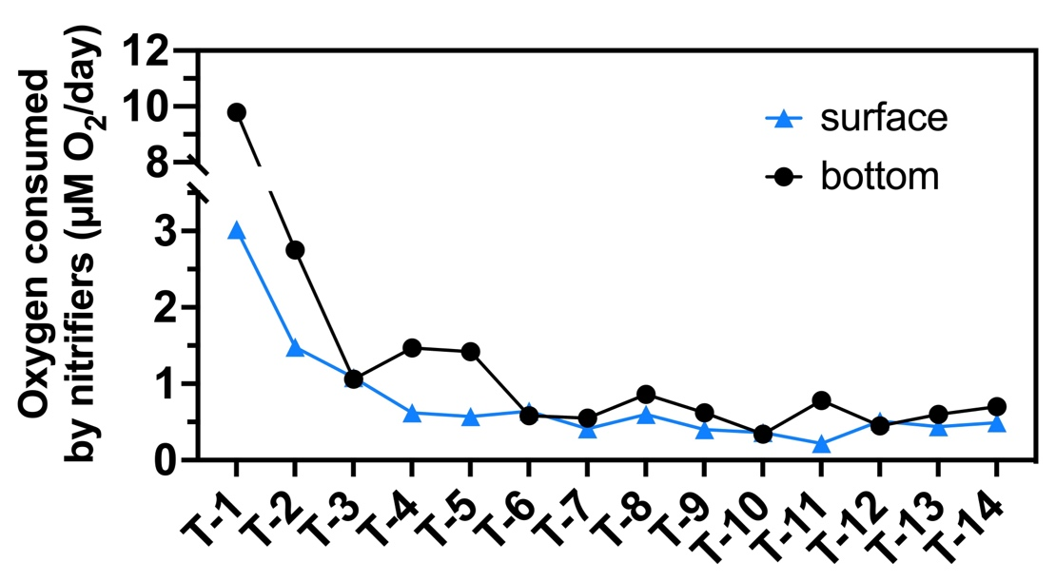

**Figure S5.** Oxygen consumed by nitrifier (μM O2/day) distribution along stations. Blue triangles indicate surface rates, black circles indicate bottom rates and the error bars represent the standard deviation of the two biological replicates.

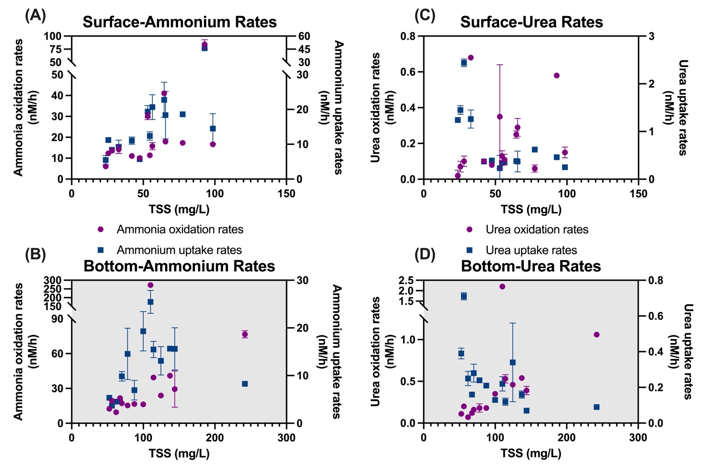

**Figure S6.** Relationship between ammonium and urea rates and total suspended substance (TSS) in the surface and bottom layers.

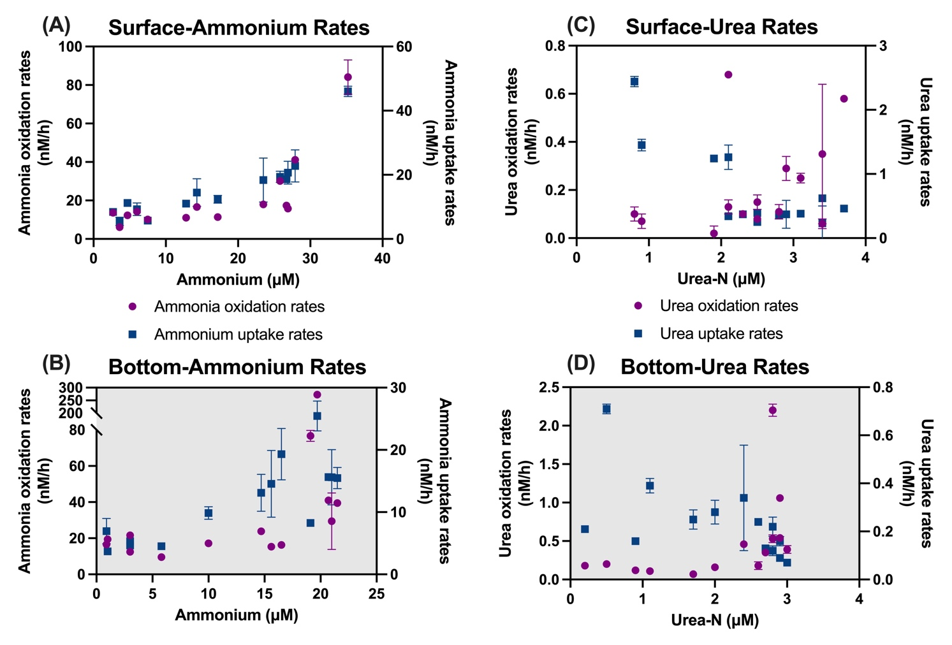

**Figure S7.** Relationship between ammonium and urea rates and their corresponding substrates in the surface and bottom layers.

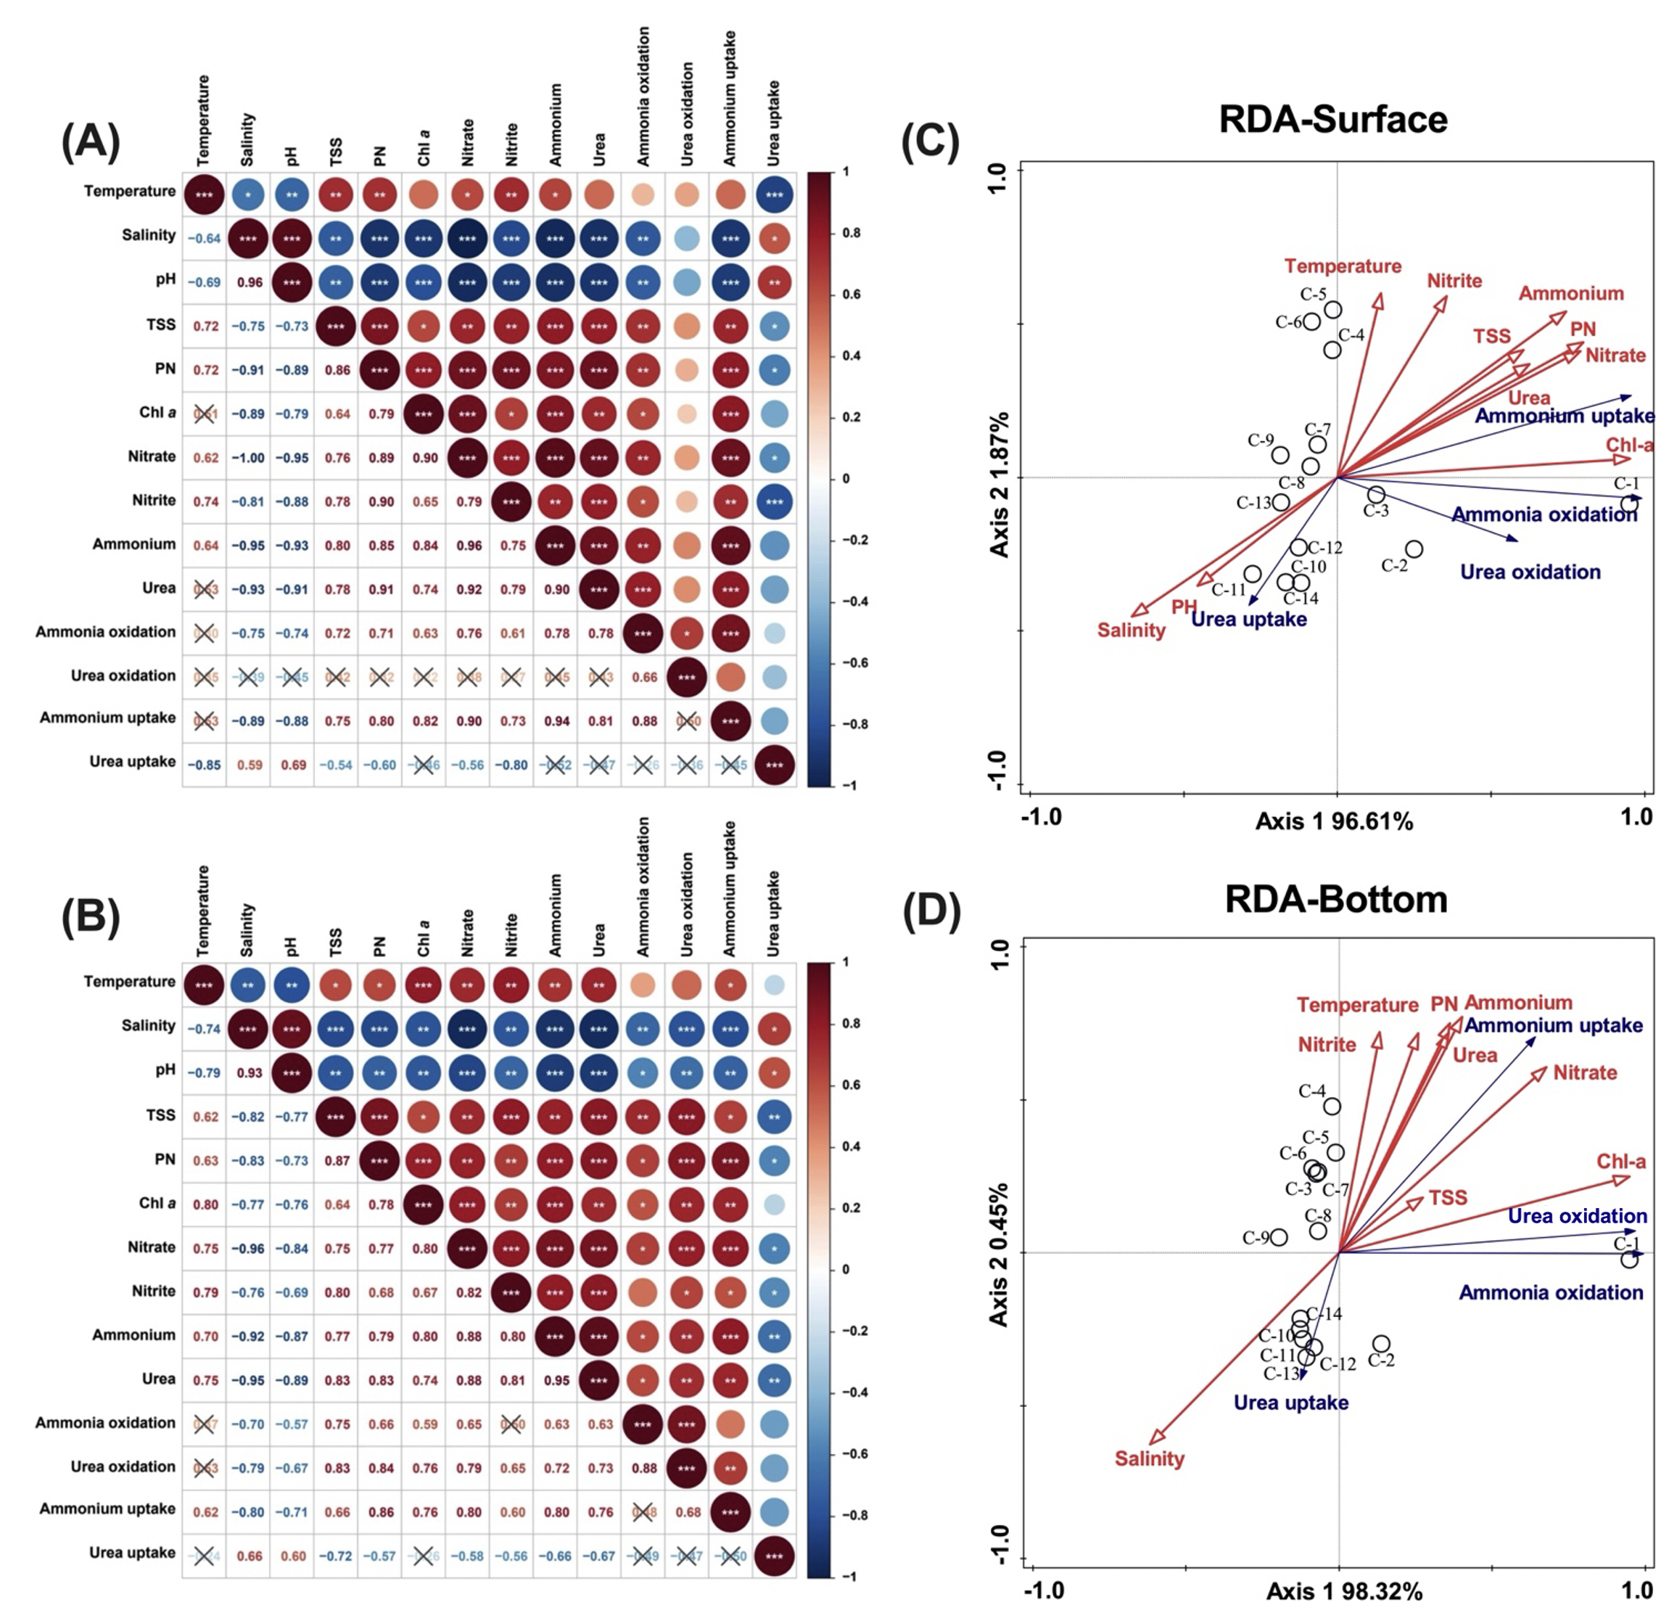

**Figure S8.** Spearman correlation analysis and redundancy analysis (RDA) (A)-(B): Spearman correlation analysis in the surface (A) and bottom (B) layers; (C)-(D): RDA in the surface (C) and bottom (D) layers. In (A)-(B), the color and size of the circles in the upper triangle and the number of the lower triangle represent the Spearman correlation coefficient r, and * represents *p* values (*, **, *** stand for a *p*-value less than 0.05, 0.01, and 0.001, respectively).

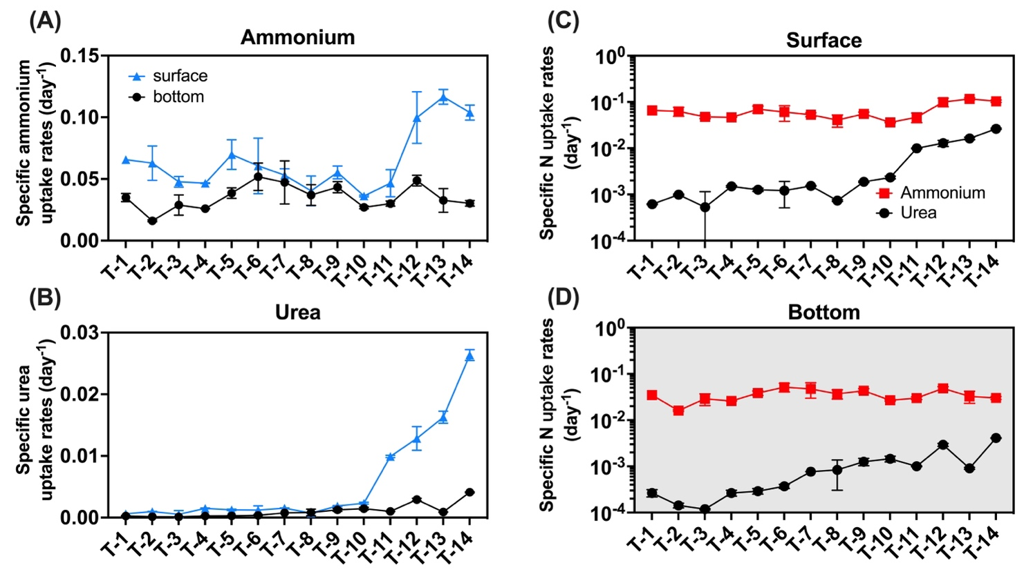

**Figure S9.** The uptake rate normalizes to PN. Subfigure (A) is plotted for the ammonium uptake rate while (B) is plotted for the urea uptake rate. Subfigures (C) and (D) are used for representing the magnitude of the rates in the surface (C) and bottom (D) layers. Blue triangles indicate surface rates, black circles indicate bottom rates, red squares represent ammonium, black circles represent urea and the error bars represent the standard deviation of the two biological replicates.

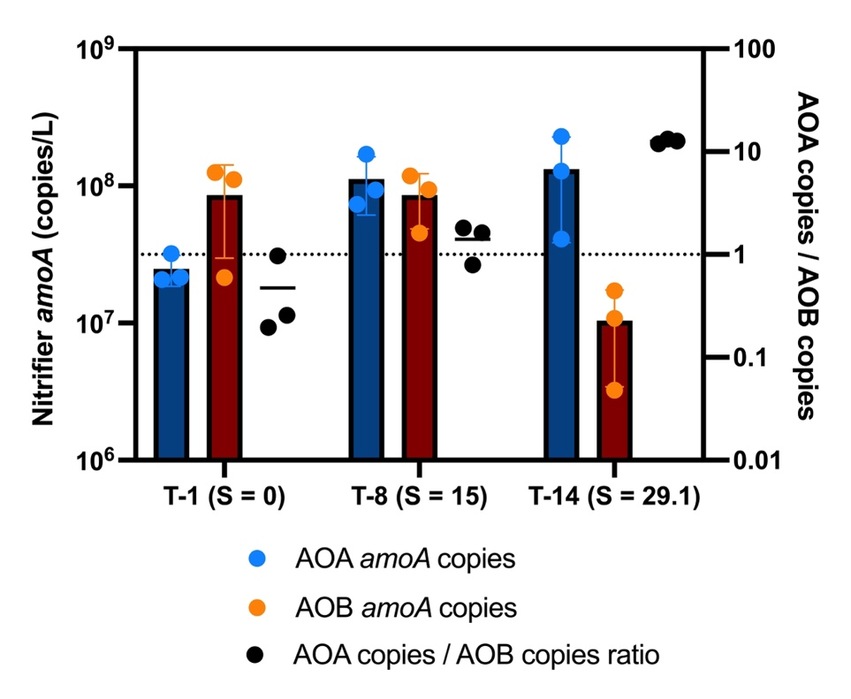

**Figure S10.** Ammonia-oxidizing archaea (AOA), ammonia-oxidizing bacteria (AOB) *amoA* gene copies and their ratios in bottom layers of three stations (T-1, T-8, and T-14).

|  |  |  |  |  |  |  |  |
| --- | --- | --- | --- | --- | --- | --- | --- |
| **Station** | **Layer** | **NH4+**  **(μM)** | **Urea-N**  **(μM)** | **15N-NH4+**  **(μM)** | **15N-Urea**  **(μM)** | **(15N/(14N+15N))Ammonium** | **(15N/(14N+15N))urea** |
| **T-1** | surface | 35.2 | 3.7 | 1.0 | 0.5 | 3% | 12% |
| **T-2** | surface | 27.9 | 3.1 | 1.0 | 0.5 | 4% | 14% |
| **T-3** | surface | 25.8 | 3.4 | 1.0 | 0.5 | 4% | 13% |
| **T-4** | surface | 26.7 | 3.4 | 1.0 | 0.5 | 4% | 13% |
| **T-5** | surface | 26.9 | 2.8 | 1.0 | 0.5 | 4% | 15% |
| **T-6** | surface | 23.5 | 2.9 | 1.0 | 0.5 | 4% | 15% |
| **T-7** | surface | 17.2 | 2.1 | 1.0 | 0.5 | 6% | 19% |
| **T-8** | surface | 14.3 | 2.5 | 1.0 | 0.5 | 7% | 16% |
| **T-9** | surface | 12.8 | 2.3 | 1.0 | 0.5 | 7% | 18% |
| **T-10** | surface | 7.5 | 2.5 | 1.0 | 0.5 | 12% | 17% |
| **T-11** | surface | 3.6 | 1.9 | 1.0 | 0.5 | 22% | 21% |
| **T-12** | surface | 6.0 | 2.1 | 1.0 | 0.5 | 14% | 19% |
| **T-13** | surface | 4.7 | 0.9 | 1.0 | 0.5 | 18% | 35% |
| **T-14** | surface | 2.7 | 0.8 | 1.0 | 0.5 | 27% | 38% |
| **T-1** | bottom | 19.7 | 2.8 | 1.0 | 0.5 | 5% | 15% |
| **T-2** | bottom | 19.1 | 2.9 | 1.0 | 0.5 | 5% | 15% |
| **T-3** | bottom | 21.0 | 3.0 | 1.0 | 0.5 | 5% | 14% |
| **T-4** | bottom | 20.7 | 2.9 | 1.0 | 0.5 | 5% | 15% |
| **T-5** | bottom | 21.5 | 2.8 | 1.0 | 0.5 | 5% | 15% |
| **T-6** | bottom | 16.5 | 2.7 | 1.0 | 0.5 | 6% | 15% |
| **T-7** | bottom | 15.6 | 2.6 | 1.0 | 0.5 | 6% | 16% |
| **T-8** | bottom | 14.7 | 2.4 | 1.0 | 0.5 | 7% | 17% |
| **T-9** | bottom | 10.0 | 2.0 | 1.0 | 0.5 | 9% | 20% |
| **T-10** | bottom | 5.8 | 1.7 | 1.0 | 0.5 | 15% | 23% |
| **T-11** | bottom | 3.0 | 0.9 | 1.0 | 0.5 | 25% | 35% |
| **T-12** | bottom | 3.0 | 1.1 | 1.0 | 0.5 | 25% | 31% |
| **T-13** | bottom | 0.9 | 0.2 | 1.0 | 0.5 | 51% | 66% |
| **T-14** | bottom | 1.0 | 0.5 | 1.0 | 0.5 | 48% | 48% |

**Table S1** The ambient substrate ammonium (NH4+) and Urea-N concentrations (μM), the final concentrations (μM) of 15N tracers, and the corresponding 15N percentage (15N/(14N+15N)) of tracers’ addition.