**Extended data and figures**

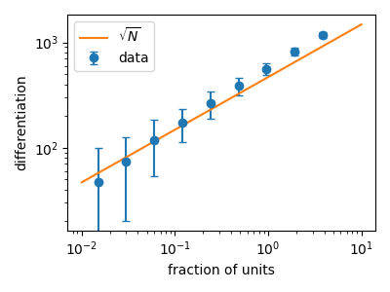

**Figure 1-1: Normalizations applied to differentiation.** Differentiation scales with the square root of number of neurons. Different fractions of neurons were subsampled or oversampled from a large population of neurons from a single experiment (entire visual cortex), and spectral differentiation was computed for each sample (blue points with SD shown as error bars). Orange line shows a sqrt(N) fit. Error bars are standard deviation of differentiation over 100 bootstrapping trials.

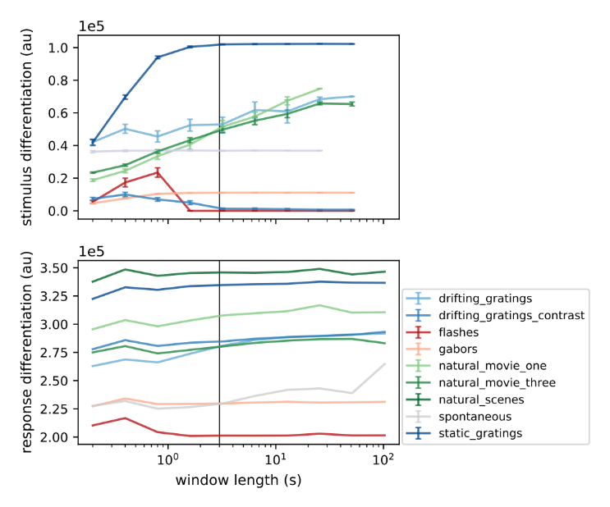

**Figure 2-1: Differentiation asymptotically approaches a constant value with respect to window length.** Both stimulus differentiation (top) and response differentiation of all visual cortical neurons for an example experiment (bottom), for all stimuli, approach an asymptotic value for very long windows. Vertical lines indicate the window length W used in our analysis.

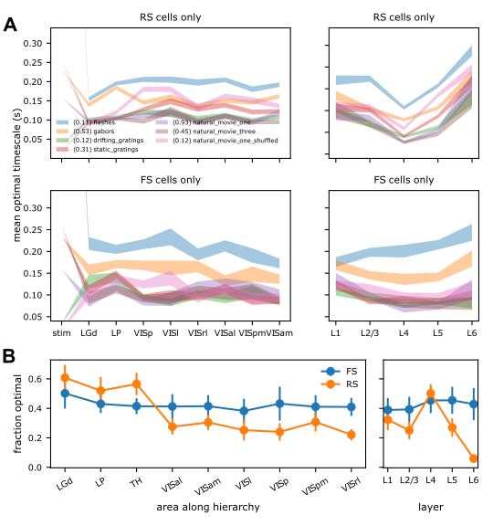

**Figure 2-2: Optimal timescale for neurons – dependence on stimuli and brain region. A.** Mean and standard deviation (shaded region) of the optimal timescale for individual regular spiking (RS) and fast spiking (FS) neurons in Neuropixels recordings from the different brain areas or cortical layers. Areas are arranged along the x-axes according to the level in the anatomical hierarchy (Harris et al., Nature, 2019). The optimal timescale increases from thalamus to the cortex, but remains constant throughout the cortex for RS cells; and decreases going up the hierarchy for FS cells. Across cortical layers, optimal timescale of RS neurons decreases with depth, with the minimum at L5; and does not vary much with layer for FS neurons. Optimal timescales for neurons are unrelated to those for stimuli (leftmost points). **B.** Fraction of neurons in each brain region that have a physiologically relevant optimal timescale (>10 ms). The fraction of FS or RS neurons with an optimal timescale is highest in the thalamic areas, and much reduced in cortical or hippocampal areas. Within the cortex, this fraction is highest in layers 4 and 5 for RS neurons. Error bars indicate SD across different stimuli.

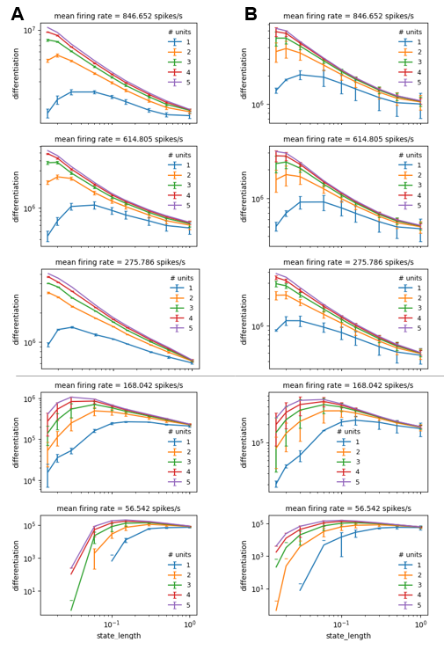

**Figure 2-3**: **Jitter or shift in firing times of high firing neurons causes loss of optimal timescale in ensembles.** Constant temporal shift or jitter was added to the spike times of 5 neurons with different average firing rates. For each neuron, 5 copies of the spike trains were generated with either a shift of between -10 and 10 ms (**A**) or jitter of up to 5 ms (**B**) introduced randomly in each case. Each of the 5 altered timeseries were treated as distinct pseudoneurons, and differentiation as a function of timescale is plotted for combinations of 1 through 5 pseudoneurons. For neurons with high firing rates (top 3 panels), the optimal timescale becomes physiologically irrelevant (<10 ms) at the ensemble level. For low firing neurons (bottom 2 panels), optimality of timescales is retained although shifted to a shorter time.

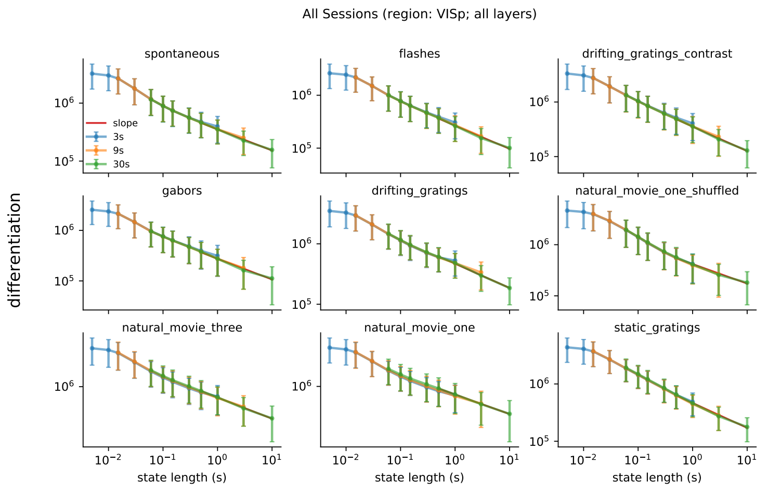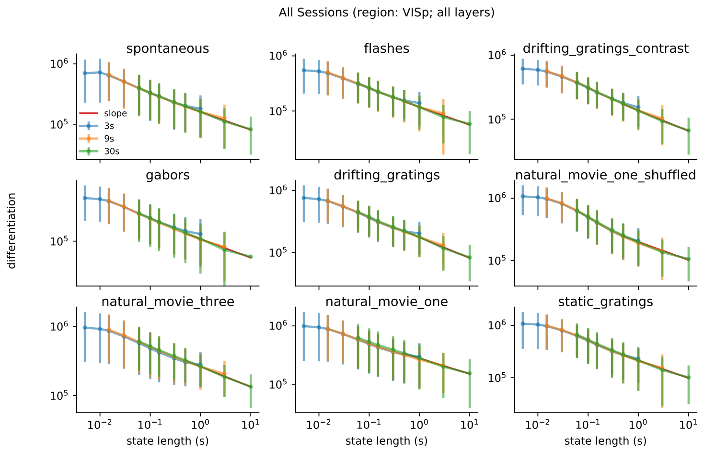

**Figure 2-4: ND does not have an optimal timescale between 5 ms to 10 s for all stimuli. Top.** Regular spiking units. **Bottom.** Fast spiking units.

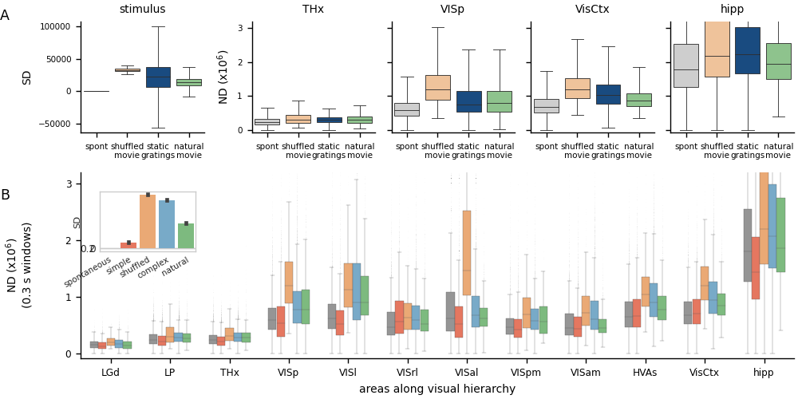

**Figure 3-1: ND for very short timescales reflects SD and not meaningfulness.** For short window length (300 ms) and state length (30 ms), ND of activity in all visual areas follows the trends of SD i.e. it is highest for shuffled movies, lower for static gratings and even lower for natural movies (**A**). This is observed for the 5 stimulus classes across the visual hierarchy (**B**).

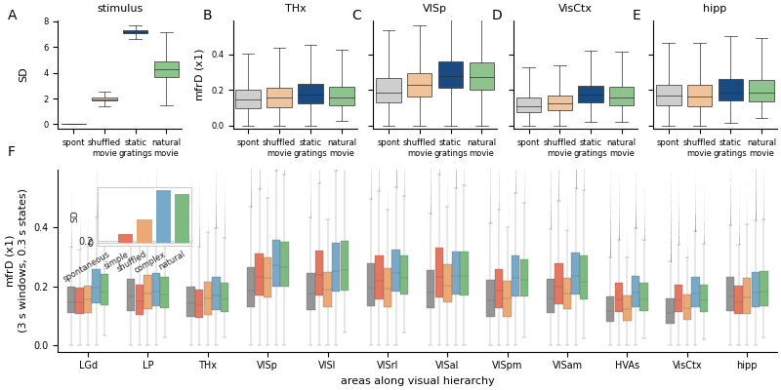

**Figure 3-2: Area-wise modulation of mfrD by stimuli for regular spiking neurons.** In contrast to spectral differentiation, the variance of ensemble mean firing rate across states (mfrD) does not follow the putative meaningfulness of stimuli in any of the visual areas, but instead follows the stimulus differentiation. mfrD is thus lower for natural movies compared to static gratings (**A**) (or complex stimuli in general, **B**) in both the thalamic and cortical ensembles.

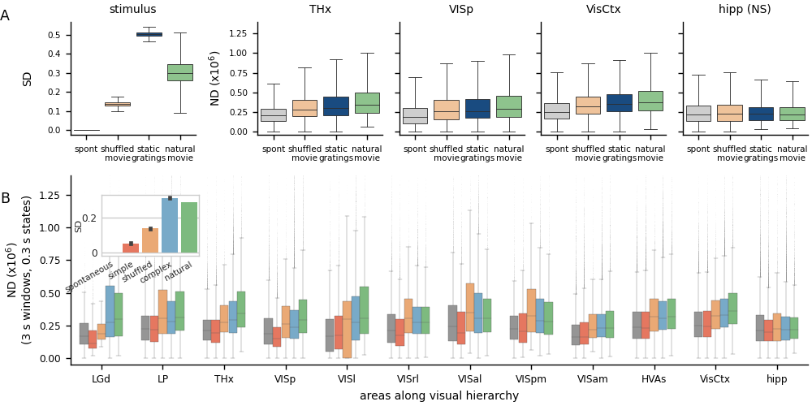

**Figure 3-3: Area-wise modulation of differentiation by stimuli for fast spiking neurons. A.** Similar to regular spiking neurons, differentiation of fast spiking neurons is also statistically significantly different (p < 0.001) between all pairs of stimuli shown in Thalamus, VISp and higher visual areas. All pairwise differences are however insignificant in the hippocampus. **B.** Note that ND for fast spiking neurons is lower than regular spiking neurons by roughly a factor of 2, but the modulation by stimuli is largely unchanged. Secondly, magnitude of ND in thalamic regions is unchanged between FS and RS neurons (see Fig. 3 for comparison).

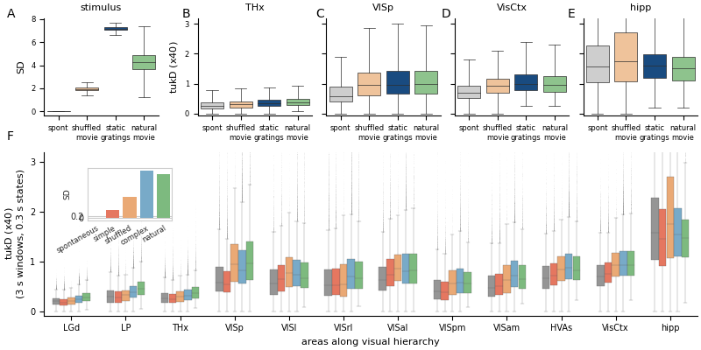

**Figure 3-4: Qualitative results do not change irrespective of the application of Tukey tapering while computing PSD. Top:** Results with Tukey window. **Bottom:** ND (x-axis) vs differentiation computed using Tukey windows (left) and box windows (right) for one experiment and neural subpopulation (VISp all layers). The strong correlation indicates that tapering (and thus edge effects) do not significantly affect our results.

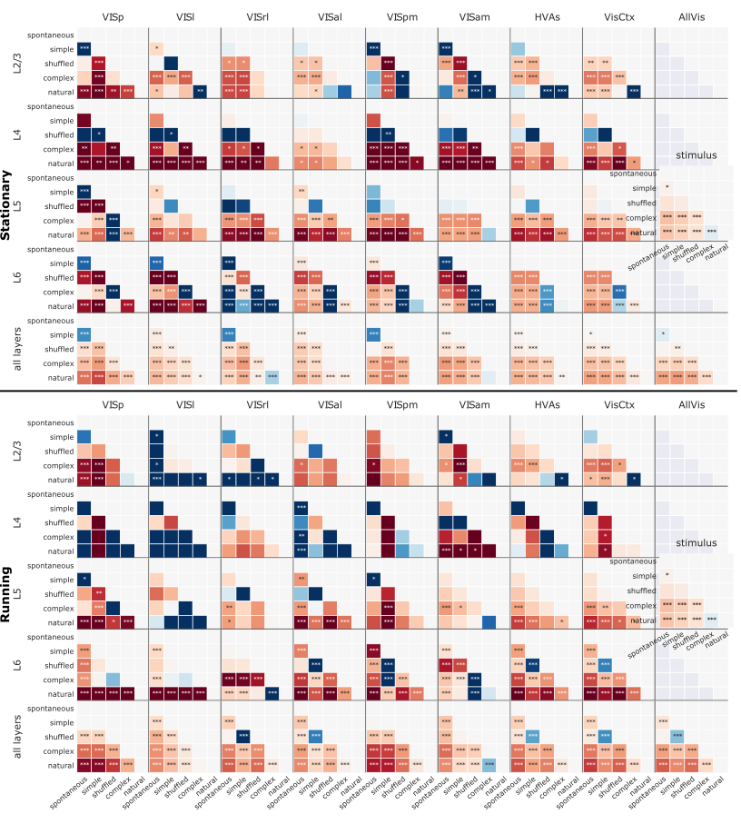

**Figure 4-1: Modulation of differentiation by stimuli across different areas and layers in running and resting states.** Running speed 1 (top) is the resting state and running speed 2 (bottom) is running state of the animal. While resting, shuffled movies evoke higher differentiation compared to natural movies in layer 6; but not while the mouse is running. Differentiation modulation by stimuli is much less significant in layers 2/3, 4 and 5 when the mouse is running compared to the resting state.

|  |  |  |  |  |  |
| --- | --- | --- | --- | --- | --- |
| **stimulus_name** | **Data structure** | **Type of test** | **Pearson r** | **p** | **95% CI** |
| drifting_gratings | normal | t (one-sided) | -0.71 | 0.12 | [-0.96, 0.25] |
| drifting_gratings_75_repeats | normal | t (one-sided) | -0.24 | 0.65 | [-0.88, 0.71] |
| drifting_gratings_contrast | normal | t (one-sided) | 0.26 | 0.62 | [-0.70, 0.89] |
| flashes | normal | t (one-sided) | -0.72 | 0.11 | [-0.97, 0.22] |
| gabors | normal | t (one-sided) | 0.33 | 0.53 | [-0.66, 0.90] |
| natural_movie_one | normal | t (one-sided) | -0.05 | 0.93 | [-0.83, 0.80] |
| natural_movie_one_more_repeats | normal | t (one-sided) | 0.76 | 0.08 | [-0.13, 0.97] |
| natural_movie_one_shuffled | normal | t (one-sided) | -0.70 | 0.12 | [-0.96, 0.25] |
| natural_movie_three | normal | t (one-sided) | -0.39 | 0.45 | [-0.91, 0.62] |
| spontaneous | normal | t (one-sided) | -0.11 | 0.83 | [-0.85, 0.77] |
| static_gratings | normal | t (one-sided) | -0.50 | 0.31 | [-0.93, 0.52] |

**Table 2-1**: Pearson’s correlation coefficient along with statistical test parameters for correlation between hierarchy level and optimal timescale for RS neurons for all stimuli

|  |  |  |  |  |  |
| --- | --- | --- | --- | --- | --- |
| **stimulus_name** | **Data structure** | **Type of test** | **Pearson r** | **p** | **95% CI** |
| drifting_gratings | normal | t (one-sided) | 0.07 | 0.90 | [-0.79, 0.83] |
| drifting_gratings_75_repeats | normal | t (one-sided) | 0.62 | 0.19 | [-0.38, 0.95] |
| drifting_gratings_contrast | normal | t (one-sided) | -0.80 | 0.05 | [-0.98, 0.02] |
| flashes | normal | t (one-sided) | -0.81 | 0.05 | [-0.98, 0.02] |
| gabors | normal | t (one-sided) | -0.82 | 0.04 | [-0.98, -0.04] |
| natural_movie_one | normal | t (one-sided) | 0.54 | 0.27 | [-0.48, 0.94] |
| natural_movie_one_more_repeats | normal | t (one-sided) | -0.10 | 0.85 | [-0.84, 0.77] |
| natural_movie_one_shuffled | normal | t (one-sided) | -0.74 | 0.09 | [-0.97, 0.17] |
| natural_movie_three | normal | t (one-sided) | 0.09 | 0.87 | [-0.78, 0.84] |
| spontaneous | normal | t (one-sided) | -0.27 | 0.60 | [-0.89, 0.69] |
| static_gratings | normal | t (one-sided) | -0.30 | 0.56 | [-0.89, 0.67] |

**Table 2-2**: Pearson’s correlation coefficient along with statistical test parameters for correlation between hierarchy level and optimal timescale for RS neurons for all stimuli

| **stimulus_categories** | **Data structure** | **Type of test** | **Pearson r** | **p** | **95% CI** |
| --- | --- | --- | --- | --- | --- |
| complex | normal | t (one-sided) | -0.67 | 0.15 | [-0.96, 0.31] |
| natural | normal | t (one-sided) | -0.87 | 0.03 | [-0.99, -0.19] |
| shuffled | normal | t (one-sided) | -0.52 | 0.29 | [-0.94, 0.5] |
| simple | normal | t (one-sided) | -0.37 | 0.48 | [-0.91, 0.63] |
| spontaneous | normal | t (one-sided) | -0.71 | 0.12 | [-0.96, 0.25] |

**Table 3-1**: Pearson’s correlation coefficient along with statistical test parameters for correlation between cortical hierarchy level and Neurophysiological Differentiation (ND) for RS neurons