*[Frontiers in Marine Science]*

Supporting Information for

**[Assessing the sources and dynamics of organic matter in a high human impact bay in the northern Beibu Gulf: insights from stable isotopes and optical properties]**

[Xuan Lu1, 2, 3, Qibin Lao1, 2, 3, Fajin Chen1, 2, 3*, Xin Zhou1, 2, 3, Chunqing Chen1, 2, 3, Qingmei Zhu1, 2, 3]

[1 College of Ocean and Meteorology, Guangdong Ocean University, Zhanjiang 524088, China; 2 Key Laboratory for Coastal Ocean Variation and Disaster Prediction, Guangdong Ocean University, Zhanjiang 524088, China; 3Key Laboratory of Climate, Resources and Environment in Continental Shelf Sea and Deep Sea of Department of Education of Guangdong Province, Guangdong Ocean University, Zhanjiang 524088, China]

**Contents of this file**

Figures S1

**Introduction**

The supporting information include one figures. Figure S1 was PARAFAC model results for EEMs data interpretation.

C:\Users\1\Desktop\防城港\FDOM.tif

**Figure S1**. EEM contours of fluorescent components C1 – C3 identified using PARAFAC



Fig. S2. Spatial distributions of DO in Xi Bay. Black dots represent sampling sites.



Fig. S3. Mixing plots of the δ13C and δ15N values of the three potential POM sources for the different areas in Xi Bay. The potential POM sources were marine and terrestrial organic matter sources (Meyers,1994, 1997) and freshwater phytoplankton (Ye et al., 2017).

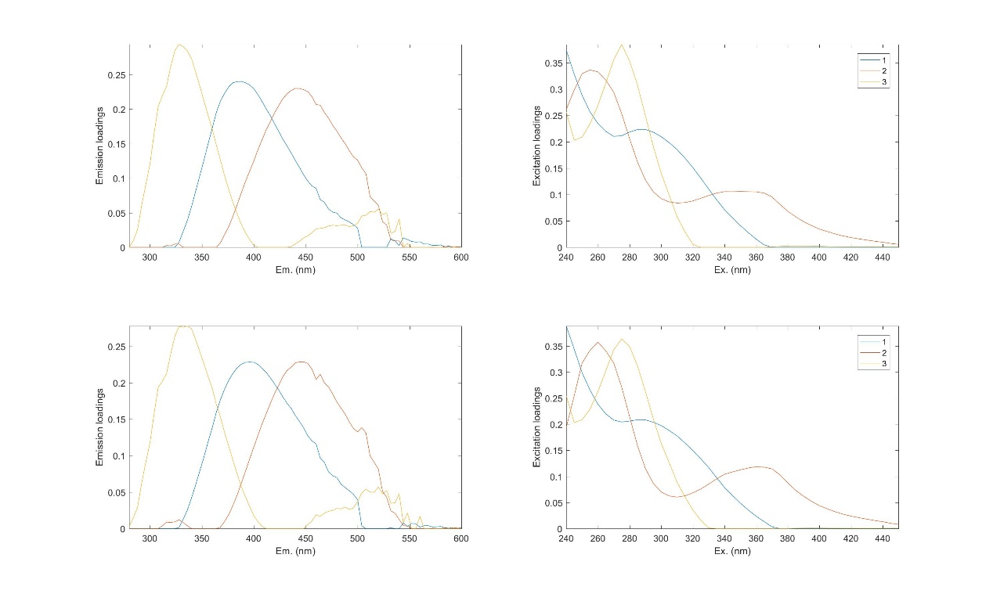

Fig. S4 Results of split-half validation

**Table S1**. δ13C and δ15N values for the potential POM sources in the water in Xi Bay

|  |  |  |  |
| --- | --- | --- | --- |
| Source | δ13C  (‰) | δ15N  (‰) | Reference |
| C3 plants | -25.9±1.2 | 5.1±2.1 | (Sarma et al., 2014) |
| C4 plants | -13.1±1.2 | 4.4±2.1 | (Sarma et al., 2014) |
| Terrestrial soil organic matter | -19.2±2.4 | 10.3±2.7 | (Sarma et al., 2014) |
| Sewage | -24.8±3.2 | 14±4.0 | (Andrews et al., 1998; Sarma et al., 2020) |
| Marine organic matter | -20.0±2.0 | 6.0±2.0 | (Ye et al., 2017) |
| Freshwater phytoplankton | -30.0±2.0 | 12.0±2.0 | (Ye et al., 2017) |