**Supplementary Material**

**Captions**

Figure S1. Colony morphology, cell morphology and Gram staining results of the isolated strain on PYG medium in 3 days

Table S1 Microelements

Table S2 α-diversity index

Figure S1.

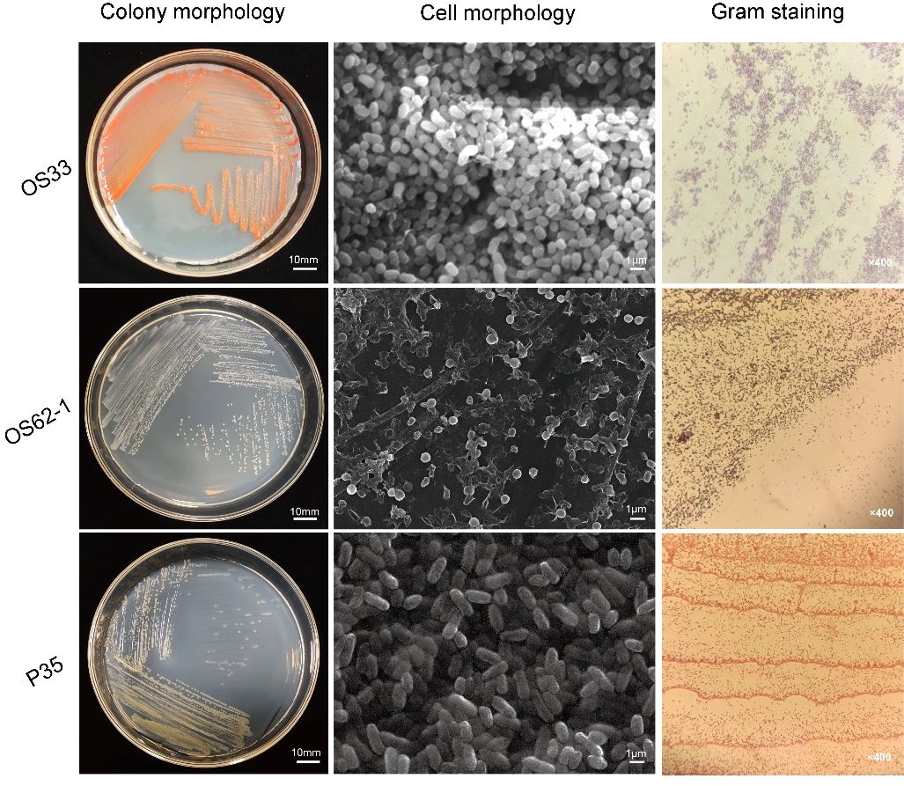

|  |  |
| --- | --- |
| Table S1 Microelements | |
| Chemicals | Content |
| ZnSO4·7H2O | 0.150 g |
| FeSO4·7H2O | 0.540 g |
| MnSO4·H2O | 0.020 g |
| CuSO4·5H2O | 0.035 g |
| CaCl2 | 0.015 g |
| H3BO3 | 0.005 g |
| Na2MoO4·2H2O | 0.010 g |
| ddH2O | 1000 mL |

#The solution was sterilized at 121°C for 15 min and stored in dark at 4 °C.

|  |  |  |  |  |  |
| --- | --- | --- | --- | --- | --- |
| Table S2 α-diversity index | | | | | |
| **Sample name** | **Chao1** | **Faith_pd** | **Observed_OTUs** | **Shannon** | **Simpson** |
| Soil | 1554.752 ± 182.871a | 88.179 ± 1.668a | 1548 ± 185a | 7.902 ± 0.551a | 0.983 ± 0.010a |
| ERC1 | 153.108 ± 1.885c | 19.195 ± 1.701c | 153 ± 2c | 2.788 ± 0.169b | 0.786 ± 0.063b |
| ERC2 | 294.813 ± 118.560c | 32.418 ± 5.078c | 294 ± 118c | 1.888 ± 0.710cd | 0.509 ± 0.113c |
| ERC3 | 217.218 ± 70.277c | 32.192 ± 4.032c | 217 ± 70c | 1.298 ± 0.306d | 0.423 ± 0.178c |
| ERC4 | 630.454 ± 232.997b | 54.740 ± 17.037b | 630 ± 232b | 2.663 ± 0.641bc | 0.611 ± 0.073bc |
| ERC5 | 179.866 ± 57.960c | 22.911 ± 11.060c | 179 ± 58c | 1.658 ± 0.154d | 0.494 ± 0.093c |

#Groups sharing different letters (a, b, c) indicate significant differences between two treatments by one-way ANOVA test (*P < 0.05*).