Supplementary material S2
Figure 1 Flowchart for profiling SLC2As of LUAD
Figure 2 GO annotations and Kyoto Encyclopedia of Genes and Genomes (KEGG) pathway analyses of SLC2As. (A) biological process. (B)Cellular components. (C) Molecular functions. (D) Pathway analyses using the KEGG database. (E) diseases associated with SLC2As.

Figure 3 Prognostic value of mRNA expression of distinct SLC2As in LUAD (Kaplan-Meier Plotter). Lower mRNA expressions of SLC2A1, SLC2A2,
S LC2A3, SLC2A4, SLC2A5, SLC2A9, SLC2A14 and higher mRNA level of SLC2A10, SLC2A12, SLC2A13 were significantly associated with favorable Overall Survial (OS) of LUAD (A-J).
Figure 4 SLC2As expression has significant correlations with infiltration of immune cells and macrophage polarization in LUAD. (A-D, J-K) SLC2A3, SLC2A5, SLC2A14 expressions were all in significantly positive correlation with infiltration of monocytes and M2 macrophages in LUAD. (E-F) SLC2A6 expression was in significantly positive correlation with infiltration of monocytes and T cells in LUAD. (G-I) SLC2A9 expression was in significantly positive correlation with infiltration of monocytes, Tregs and M2 macrophages in LUAD.

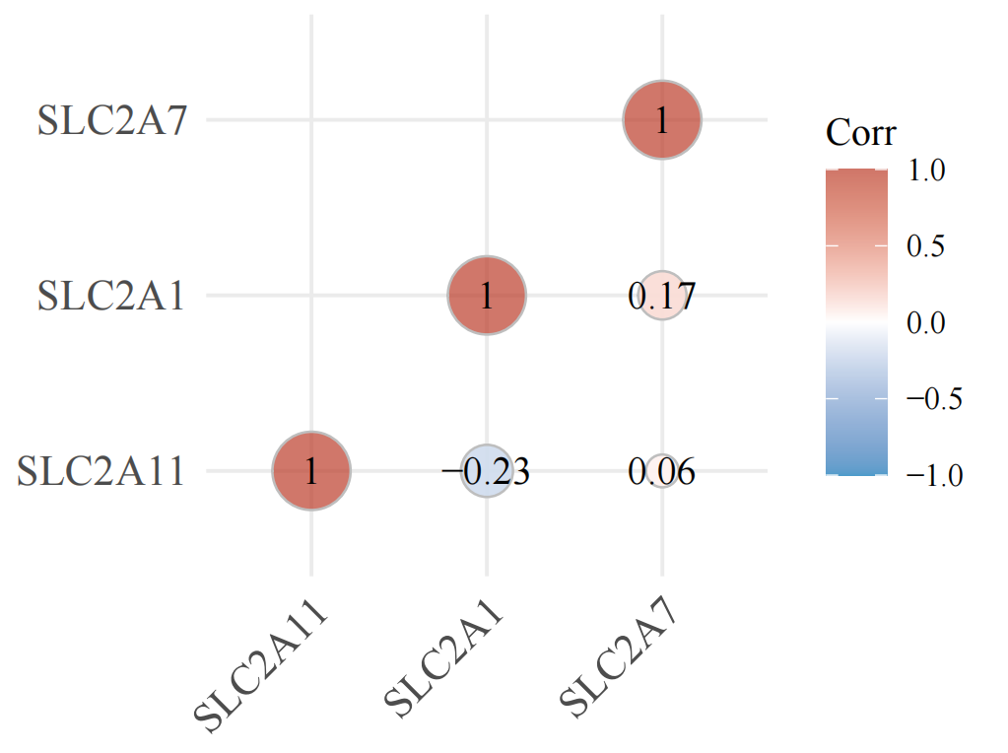
Figure 5 A heatmap of the correlation among SLC2A1, SLC2A7, and SLC2A11.The abscissa and ordinate represent genes, different colors represent different correlation coefficients (blue represents positive correlation whereas red represents negative correlation), the darker the color, the stronger the relation. Asterisks (*) stand for significance levels, ** p < 0.01, * p < 0.05.

