Appendices
Appendix A
Background Text
In an acid-base titration, a chemical reaction occurs between an acid and a base, one of which has an unknown concentration, called the analyte, whereas the other has a known concentration, called the standard. In your case, the analyte is your water sample that contains HCl, and the standard you will use is a solution of sodium hydroxide (NaOH). Your laboratory has already prepared the solution and determined its concentration.

Acids such as HCl produce hydrogen ions (H⁺) when dissolved in water, and bases such as NaOH produce hydroxide ions (OH⁻) when dissolved in water. When these acids or bases dissolve in water, we say that the solutions they form are aqueous solutions, and we use the (aq) symbol next to each acid and base in an equation. Aqueous HCl and NaOH are considered a strong acid and base. This means that in an aqueous solution of HCl, all of the HCl molecules have broken up into H ions and Cl ions. Similarly, in an aqueous solution of NaOH, all of the NaOH molecules have broken up into Na ions and OH ions. In fact, for any aqueous solution of strong acid or base, the solution consists only of ions and water molecules.

Let’s use these ideas to think about the reaction between HCl (aq) and NaOH (aq) that happens in this experiment. For any acid-base reaction, the H ions from the acid will combine with the OH ions from the base to form H₂O, water! The other ions that are in the solutions, like the Cl and the OH in this case, do not react. As a result, these other ions are on both sides of the equation of an acid-base reaction. Equation 1 below shows the reaction equation between HCl (aq) and NaOH (aq).

Equation 1
Na⁺(aq)+ OH⁻(aq)+ H⁺(aq) + Cl⁻ (aq) → H₂O(l)+ Na(aq) + Cl⁻(aq)

Since the Na and Cl ions are not involved in the reaction, we can leave them out of the equation. The new equation we get is called a net ionic equation. Equation 2 shows the net ionic equation for the reaction between HCl (aq) and NaOH (aq).

Equation 2
OH(aq) + H⁺(aq)→ H₂O(l)

The reaction between HCl (aq) and NaOH (aq) can also be written as if the acid and base did not break up into their ions. This equation looks like Equation 3:

Equation 3
NaOH(aq) + HCl(aq)→ H₂O(l)+ NaCl(aq)

Keep in mind that because they are strong acids and bases, they have broken up into their ions. This equation helps us recognize what the mole ratio is between the acid and acid and base. Notice that all of the above equations state that NaOH and HCl react in a 1:1 mole ratio. This means every mole of NaOH standard that you add to the water sample will react with one mole of HCl in the sample. Because of this, when performing the acid-base titration with HCl and NaOH, you want to add enough NaOH to your water sample to react with all of the HCl. This way you can use the 1:1 mole ratio to relate the number of moles of NaOH that you added to the number of moles of acid that were originally in the water sample. You can then use this to find the concentration of acid. This logic applies to acid-base titrations where the mole ratio is not 1:1. As long as you add enough standard to react with all of your analyte, you can use the mole ratio to figure out the concentration of your analyte.

But how will you know when you have added enough NaOH to react all of the acid in the water sample?

You’ll use an indicator! An indicator is a solid or liquid substance that changes color in response to an acidic or basic environment. One common indicator in an acid-base titration is phenolphthalein. If phenolphthalein is in an acidic solution, the solution will be colorless. If the solution containing phenolphthalein is basic, the solution will turn pink. This means that adding phenolphthalein to your water sample will initially not affect the color of the sample, but as you add your basic standard to the water sample, the solution will turn pink in response to the presence of the base.

Once the NaOH reacts with some of the acid in the water sample according to Equations 1-3, the solution will return to clear, as the base has now become NaCl and water, making the solution acidic again. Addition of more base will cause the color of the sample to turn pink, but the solution will stay pink for a longer amount of time before returning to clear. When you have added enough base to react with all of the acid in the sample, the solution will turn pink for the longest amount of time before returning to clear, but once you add a single drop of the standard past the point at which the reaction is complete, the solution will become pink permanently. This means that all of the acid in the sample has been converted to the products of Equations 1-3. When the color of the solution remains pink after a single droplet has been added, that is called the endpoint.

Ensuring that one reaches the endpoint by adding only a single drop of base is crucial to obtaining accurate data and calculating an accurate concentration. The more one overshoots this point, the less accurate your calculations will be and the more uncertain you will be as to the safety of the water for the animals.

Now click the “Procedures” button located to the right of the “Background” to read the procedures for the experiment.

Appendix B
Control Condition Procedures

Equipment
This experiment uses a virtual 50-mL burette and a virtual 250-mL beaker.

A burette is a long, thin tube with an open end that allows the burette to be filled with liquid and another end with a stopcock that you can turn to dispense liquid. Markers along the burette indicate the volume of liquid it is currently holding.

Task Overview
Your task is to examine your water sample in the beaker by (1) mixing it with the NaOH standard you will dispense from the burette (2) use the minimum amount of NaOH standard until the water sample remains pink, and (3) read and document the required volume of NaOH that you have dispensed to reach the endpoint.

Procedure
You will perform exactly two trials to examine 2 water samples from the same water source. Your virtual burette has been filled with 0.01 M NaOH, and your virtual 250-mL beaker has been filled with 25 mL of water sample at the beginning of each trial. The color indicator has also already been added to the water sample so that it will turn pink when the water turns basic from acidic.

Follow these 4 steps to complete a trial:
- Turn on the stir bar by pressing the Stir button at the top-right corner of your screen.
- Dispense the NaOH standard from the burette using the stopcock. Use the left and right arrows to turn the stopcock. When the stopcock is perpendicular to the burette, no liquid is released. When the stopcock is parallel to the burette, the liquid is released at the maximum flow rate.
- Repeat steps (1) and (2) until your water sample remains pink. It is important that you use the least amount of NaOH standard possible.
- Read the meniscus (view with the “m” key on your keyboard) and click “Data” in the top-left to document how many mL of NaOH standard you had to dispense for the water sample to remain pink.
- Click “submit” to submit your answer, or click “new trial” if you want to redo the current trial.

Experimental Condition Procedures
Equipment
This experiment uses a virtual 50-mL burette and a virtual 250-mL beaker.

A burette is a long, thin tube containing two ends: there is an open end that allows the burette to be filled with liquid, and another end with a stopcock that you can turn to dispense liquid. Markers along the burette indicate the volume of liquid it is currently holding.

Task Overview
Your task is to examine your water sample in the beaker by (1) mixing it with the NaOH standard you will dispense from the burette (2) use the minimum amount of NaOH standard until the water sample remains pink, and (3) read and document the required volume of NaOH that you have dispensed to reach the endpoint.

Procedure
You will perform exactly two trials to examine 2 water samples from the same water source. Your virtual burette has been filled with 0.01 M NaOH, and your virtual 250-mL beaker has been filled with 25 mL of water sample at the beginning of each trial. The color indicator has also already been added to the water sample so that it will turn pink when the water turns basic from acidic.

Follow these 4 steps to complete a trial:
- Turn on the stir bar by pressing the Stir button at the top-right corner of your screen.
- Dispense the NaOH standard from the burette using the stopcock. When the stopcock is perpendicular to the burette, no liquid is released. When the stopcock is parallel to the burette, the liquid is released at the maximum flow rate.
- Repeat steps (1) and (2) until your water sample remains pink. It is important that you use the least amount of NaOH standard possible.
- Read the meniscus (view with the “m” key on your keyboard) and click “Data” in the top-left to document how many mL of NaOH standard you had to dispense for the water sample to remain pink.
- Click “submit” to submit your answer, or click “new trial” if you want to redo the current trial.

Appendix C
Pre-test
Demographics
- How many semesters of chemistry have you had - including high school?
0
1
2
3
4
more than 5
- How old are you?
_____
- What is your ethnicity?
Hispanic NonHispanic-Caucasion African American Native American Asian Prefer not to say
- Which is your dominant hand?
Left Right Neither
- What is your gender?
M F Other Prefer not to say
- Have you learned about titration?
no yes
- When was the last time you observed a titration experiment?

- When was the last time you physically performed a titration? (pick one)
Never
Within this month
within this year
within last 3 years
More than 3 years ago
Science Identity
- I have come to think of myself as a chemist.
1 = strongly disagree; 2 = disagree; 3 = somewhat disagree; 4 = Neither disagree nor agree; 5 = somewhat agree; 6 = agree; 7 = strongly agree
- In general, being a chemist is an important part of my self-image.
1 = strongly disagree; 2 = disagree; 3 = somewhat disagree; 4 = Neither disagree nor agree; 5 = somewhat agree; 6 = agree; 7 = strongly agree
- Being a chemist is an important reflection of who I am.
1 = strongly disagree; 2 = disagree; 3 = somewhat disagree; 4 = Neither disagree nor agree; 5 = somewhat agree; 6 = agree; 7 = strongly agree
Science Efficacy
I am confident that I can…
- Use technical science skills and tools.
1 = strongly disagree; 2 = disagree; 3 = somewhat disagree; 4 = Neither disagree nor agree; 5 = somewhat agree; 6 = agree; 7 = strongly agree
- Use a burette.
1 = strongly disagree; 2 = disagree; 3 = somewhat disagree; 4 = Neither disagree nor agree; 5 = somewhat agree; 6 = agree; 7 = strongly agree
- Figure out what data/observations to collect and how to collect them.
1 = strongly disagree; 2 = disagree; 3 = somewhat disagree; 4 = Neither disagree nor agree; 5 = somewhat agree; 6 = agree; 7 = strongly agree
- Learn the full range of science skills with appropriate training.
1 = strongly disagree; 2 = disagree; 3 = somewhat disagree; 4 = Neither disagree nor agree; 5 = somewhat agree; 6 = agree; 7 = strongly agree

Chemistry Knowledge
- [General] (4 points) Order the following substances from most acidic to most basic on the pH scale by dragging and dropping each item to the appropriate box on the scale.
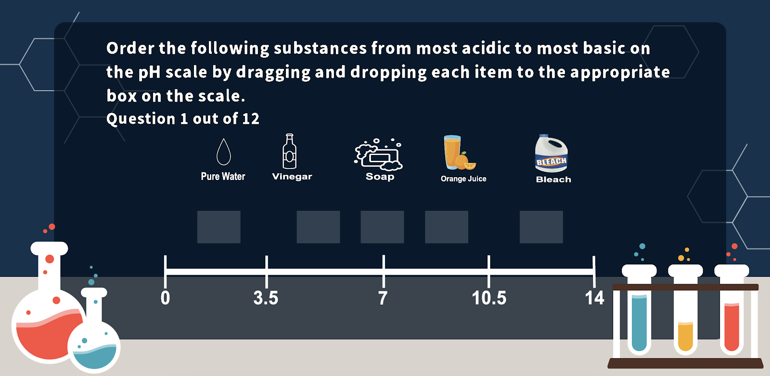

- [General] (2 points) Which of the following is TRUE about an aqueous solution of strong acid or strong base?
- The solution does not contain ions
- The solution contains water molecules and ions
- The solution contains non-ionic molecules of acid and base
- The solution contains only ions

- [General] (2 points) Which of the following is the net ionic equation for the reaction between aqueous HCl and aqueous NaOH?
- NaOH (aq)+HCl (aq)H2O (l)+NaCl (aq)
- Na+ (aq)+Cl-(aq)NaCl (aq)
- OH-(aq)+H+(aq)H2O (l)
- NaOH (l)+HCl (l)H2O (l)+NaCl (s)

- [General] (2 points) Consider the following particle diagram of an aqueous solution of HCl. Suppose you have added enough aqueous solution of NaOH to your solution of HCl to react with all of the HCl. Assume that this aqueous solution contains exactly one of each kind of particle that is in aqueous NaOH. Which of the following pictures most accurately shows what your particle diagram of HCl would look like now after having reacted with the aqueous NaOH?
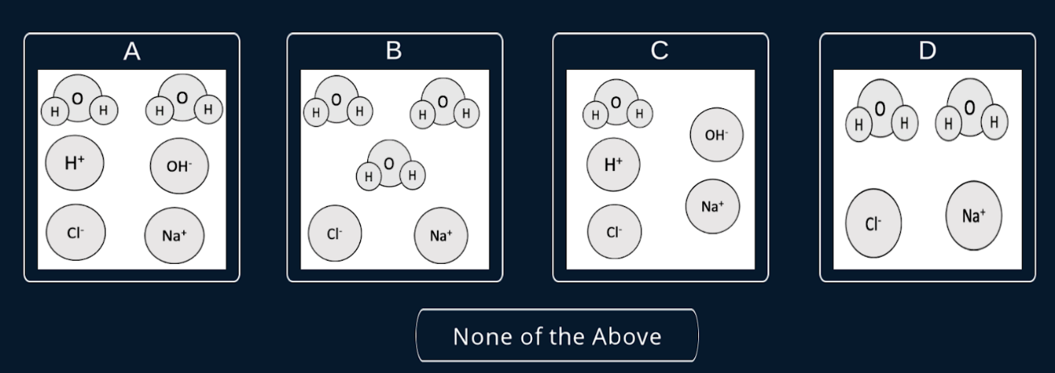
- [General] (2 points) Consider the following particle diagram of an aqueous solution of HCl. Suppose you have added enough aqueous solution of NaOH to your original solution of HCl to react with all of the HCl. Now you add one more droplet of an aqueous solution of NaOH. Assume that this droplet contains exactly 1 of each kind of particle in aqueous NaOH. Which of the following pictures most accurately shows what your particle diagram of HCl would look like now after having added this much NaOH solution?
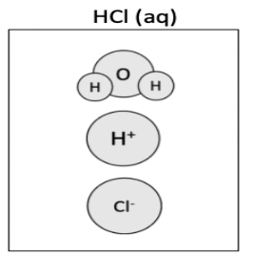
- [Titration] (3 points) Thinking back to titration experiments, if you saw the water sample turn from clear to pink when you added base, why did this happen?

- [Titration] (3 points) Thinking back to titration experiments, if you saw the water sample turn from pink to colorless, why did this happen?

- [General] (1 point) The following reaction equation is between the strong acid HNO₃ (nitric acid) and the strong base Ba(OH)₂ (barium hydroxide). Balance the reaction equation by typing the coefficient for each molecule. If the coefficient is 1, type 1.

__HNO₃ + __Ba(OH)₂ → __Ba(NO₃)₂ + __H₂O

- [General] (2 points) Suppose you add 10 molecules of Ba(OH)₂ to a solution of HNO₃. Based on your balanced equation, how many molecules of HNO₃ will react with the added Ba(OH)₂? Type the number of HNO₃ molecules in the following box.

- [Titration] (3 points) Suppose you have a 1 liter of an NaOH solution. The concentration of this solution is 0.10 moles per liter. Describe how you would calculate the number of moles of OH⁻ ions in the solution? Whenever you mention a number, include its units.

- [Titration] (3 points) Suppose you have 1 liter of an NaOH solution. The concentration of this solution is 0.10 moles per liter. If this entire solution was added to a 1-liter solution of HCl, describe how you would calculate the number of moles of H⁺ that reacted with the added OH⁻? Whenever you mention a number, include its units.

- [Titration] (3 points) Suppose you know that there are 0.01 moles of H+ ions in your solution of HCl, and the volume of your solution of HCl is 1 liter. How would you calculate the concentration of HCl in moles per liter? Specify units in your answer.
Learning Phase
[Text for Scenario for Titration Simulation Module]
“You have just begun your new job as a member of a water quality control team for a local government agency. In addition to ensuring that drinking water is clean, you are also responsible for monitoring the acidity of residential lakes. Lakes that are too acidic can be harmful for wildlife.
On your first day on the job, you have collected a water sample from the lake. Through other chemical analyses, you have identified that the sample contains hydrochloric acid (HCl). Now you need to determine the concentration of HCl in the water sample using a technique called an acid-base titration.
Then you will be able to save the animals!”

Posttest

- [Verbal Free response] (9.5 Idea unit points) Inform experimenter that you will need to stand 6 feet away from the camera. Pretend you are a teacher. How would you describe a titration experiment to a new student? Respond verbally.
Self-reported Learning Outcome
- I feel like I’ve learned something new about titration.
1 = strongly disagree; 2 = disagree; 3 = somewhat disagree; 4 = Neither disagree nor agree; 5 = somewhat agree; 6 = agree; 7 = strongly agree
- (open) What are some of the new concepts you have learned?

- I think that the success of a titration experiment is dependent on the learner’s sensitivity to the speed/ flow of chemicals from the burette
1 = strongly disagree; 2 = disagree; 3 = somewhat disagree; 4 = Neither disagree nor agree; 5 = somewhat agree; 6 = agree; 7 = strongly agree
- Would you recommend that your teacher use this module in your class and why?
User Experience
- [Enjoyment] I found using the virtual titration program to be enjoyable
1 = strongly disagree; 2 = disagree; 3 = somewhat disagree; 4 = Neither disagree nor agree; 5 = somewhat agree; 6 = agree; 7 = strongly agree
- [Engagement] Time flew when I was using the virtual titration program.
1 = strongly disagree; 2 = disagree; 3 = somewhat disagree; 4 = Neither disagree nor agree; 5 = somewhat agree; 6 = agree; 7 = strongly agree
- [Engagement] I was immersed in this experience
1 = strongly disagree; 2 = disagree; 3 = somewhat disagree; 4 = Neither disagree nor agree; 5 = somewhat agree; 6 = agree; 7 = strongly agree
- [Engagement] When I was using the virtual titration program, I forgot everything else around me.
1 = strongly disagree; 2 = disagree; 3 = somewhat disagree; 4 = Neither disagree nor agree; 5 = somewhat agree; 6 = agree; 7 = strongly agree
- [Ease of Use] My interaction with the burette was easy for me to understand
1 = strongly disagree; 2 = disagree; 3 = somewhat disagree; 4 = Neither disagree nor agree; 5 = somewhat agree; 6 = agree; 7 = strongly agree
- [Ease of Use] I found it easy to get the burette to do what I wanted it to do.
1 = strongly disagree; 2 = disagree; 3 = somewhat disagree; 4 = Neither disagree nor agree; 5 = somewhat agree; 6 = agree; 7 = strongly agree
- [Device Preference] Place a checkmark along the scale to indicate how much you prefer a device. The further towards an end you place the checkmark, the stronger you feel that you prefer the device on that end.

- [Device Preference] Why did you prefer this device over the other?
Science Identity
- I have come to think of myself as a chemist.
1 = strongly disagree; 2 = disagree; 3 = somewhat disagree; 4 = Neither disagree nor agree; 5 = somewhat agree; 6 = agree; 7 = strongly agree
- In general, being a chemist is an important part of my self-image.
1 = strongly disagree; 2 = disagree; 3 = somewhat disagree; 4 = Neither disagree nor agree; 5 = somewhat agree; 6 = agree; 7 = strongly agree
- Being a chemist is an important reflection of who I am.
1 = strongly disagree; 2 = disagree; 3 = somewhat disagree; 4 = Neither disagree nor agree; 5 = somewhat agree; 6 = agree; 7 = strongly agree
Science Efficacy
I am confident that I can…
- Use technical science skills and tools.
1 = strongly disagree; 2 = disagree; 3 = somewhat disagree; 4 = Neither disagree nor agree; 5 = somewhat agree; 6 = agree; 7 = strongly agree
- Use a burette.
1 = strongly disagree; 2 = disagree; 3 = somewhat disagree; 4 = Neither disagree nor agree; 5 = somewhat agree; 6 = agree; 7 = strongly agree
- Figure out what data/observations to collect and how to collect them.
1 = strongly disagree; 2 = disagree; 3 = somewhat disagree; 4 = Neither disagree nor agree; 5 = somewhat agree; 6 = agree; 7 = strongly agree
- Learn the full range of science skills with appropriate training.
1 = strongly disagree; 2 = disagree; 3 = somewhat disagree; 4 = Neither disagree nor agree; 5 = somewhat agree; 6 = agree; 7 = strongly agree
Feedback
- If you had problems with the burette what were they?
_________________________________________________________
- If you had problems with other aspects of the experience, what were they?
____________________________________________________
- Is there anything we could change to make this a better learning activity?
_____________________________

PreINtervention Chemistry Questions repeated…

- [General] (4 points) Order the following substances from most acidic to most basic on the pH scale by dragging and dropping each item to the appropriate box on the scale.
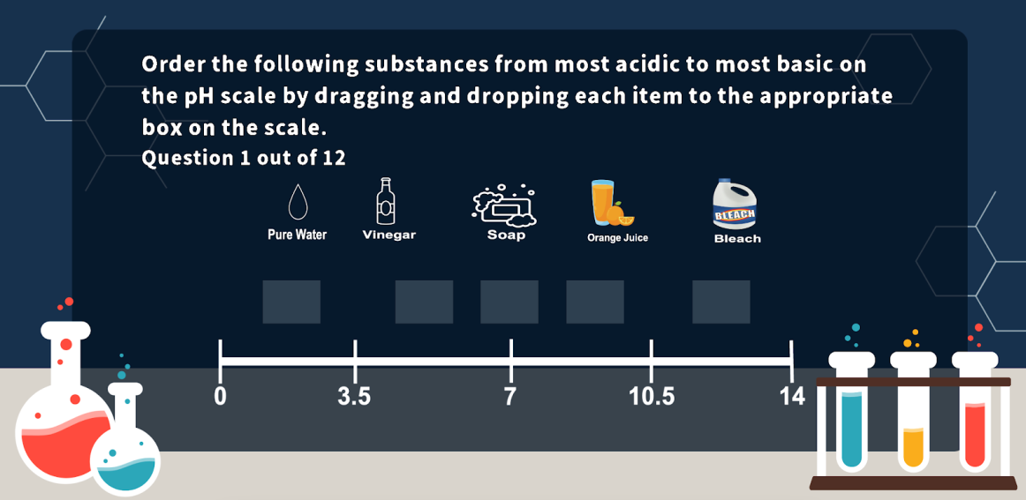
- [General] (2 points) Which of the following is TRUE about an aqueous solution of strong acid or strong base?
  - The solution does not contain ions
  - The solution contains water molecules and ions
  - The solution contains non-ionic molecules of acid and base
  - The solution contains only ions

- [General] (2 points) Which of the following is the net ionic equation for the reaction between aqueous HCl and aqueous NaOH?
  - NaOH (aq)+HCl (aq)H2O (l)+NaCl (aq)
  - Na+(aq)+Cl-(aq)NaCl(aq)
  - OH-(aq)+H+(aq)H2O (l)
  - NaOH (l)+HCl (l)H2O (l)+NaCl (s)

- [General] (2 points) Consider the following particle diagram of an aqueous solution of HCl. Suppose you have added enough aqueous solution of NaOH to your solution of HCl to react with all of the HCl. Assume that this aqueous solution contains exactly one of each kind of particle that is in aqueous NaOH. Which of the following pictures most accurately shows what your particle diagram of HCl would look like now after having reacted with the aqueous NaOH?
- [General] (2 points) Consider the following particle diagram of an aqueous solution of HCl. Suppose you have added enough aqueous solution of NaOH to your original solution of HCl to react with all of the HCl. Now you add one more droplet of an aqueous solution of NaOH. Assume that this droplet contains exactly 1 of each kind of particle in aqueous NaOH. Which of the following pictures most accurately shows what your particle diagram of HCl would look like now after having added this much NaOH solution?
- [Titration] (3 points) Thinking back to titration experiments, if you saw the water sample turn from clear to pink when you added base, why did this happen?

- [Titration] (3 points) Thinking back to titration experiments, if you saw the water sample turn from pink to colorless, why did this happen?

New posttest questions:

- [Titration] (2 points) Eventually, you added just enough NaOH to turn the water sample permanently pink. When this happened, this meant that...
  - The water sample contained only half of the original amount of HCl
  - There were more H⁺ ions than OH⁻ ions in the water sample
  - All of the HCl in the water sample had been consumed by the reaction with NaOH
  - The total amount of added NaOH was double the original amount of HCl in the water sample

- [Titration] (3 points) In your experiment, you used a 25-mL water sample for every trial. The concentration of NaOH that you used was 1 mol per liter. Using the volume measurement from one of your trials, describe how you would calculate the concentration of HCl in the water sample for that trial. Whenever you mention a number, include its units. Note that 1000 mL = 1 L.
- Data table would be accessible on-screen

- [General] (1 point) The following reaction equation is between the strong acid HNO₃ (nitric acid) and the strong base Ba(OH)₂ (barium hydroxide). Balance the reaction equation by typing the coefficient for each molecule. If the coefficient is 1, type 1.

__HNO₃ + __Ba(OH)₂ → __Ba(NO₃)₂ + __H₂O
- [General] (2 points) Suppose you add 10 molecules of Ba(OH)₂ to a solution of HNO₃. Based on your balanced equation, how many molecules of HNO₃ will react with the added Ba(OH)₂? Type the number of HNO₃ molecules in the following box.

[Text for Scenario for Titration Simulation Module]
“You have collected a water sample from a second lake. An analysis of the sample revealed that it contained hydroiodic acid (HI), but no other acid was found. To determine the concentration of hydroiodic acid in the lake, you will now perform another titration using the same sodium hydroxide (NaOH) standard from your first titration. Record data for two repeated trials, and click submit when you are finished. ”

- [General] (1 point) The following reaction equation is between the strong acid HI (hydroiodic acid) and the strong base NaOH (sodium hydroxide). Balance the reaction equation by typing the coefficient for each molecule. If the coefficient is 1, type 1.

__HI + __NaOH → __NaI + __H₂O

- [Titration] (3 points) In your experiment, you used a 25-mL water sample for every trial. The concentration of NaOH that you used was 1 mole per liter. Using the volume measurement from one of your trials, describe how you would calculate the concentration of HI in the water sample for that trial. Whenever you mention a number, include its units. Note that 1000 mL = 1L.
- Data table would be accessible on-screen

[Text for Scenario for Titration Simulation Module]
“You have collected a water sample from a third lake. An analysis of the sample revealed that it contained sulfuric acid(H2SO4), but no other acid was found. To determine the concentration of sulfuric acid in the lake, you will now perform another titration using the same sodium hydroxide standard from your first titration. Record data for two repeated trials, and click submit when you are finished. ”

- [General] (1 point) The following reaction equation is between the strong acid H₂SO₄ (sulfuric acid) and the strong base Ba(OH)₂ (barium hydroxide). Balance the reaction equation by typing the coefficient for each molecule. If the coefficient is 1, type 1.

__NaOH + __H₂SO₄ → __Na₂SO₄ + __H₂O
- [Titration] (3 points) In your experiment, you used a 25-mL water sample for every trial. The concentration of NaOH that you used was 1 mol per liter. Using the volume measurement from one of your trials, describe how you would calculate the concentration of H₂SO₄ in the water sample for that trial. Whenever you mention a number, include its units. Note that 1000 mL = 1L.
- Data table would be accessible on-screen

C.1. Science Identity and Efficacy Change Scores Control vs. Experimental
Two paired samples t-tests show that the learning phase led to positive changes in both identity and efficacy ratings across conditions. Overall the increase in science identity ratings (M = 1.10, SD = 4.08), was significant, t(135) = 5.33, p < .001, 95%CI[0.69, 1.51]. Overall the increase in science efficacy ratings (M = 3.09, SD = 4.24), was significant, t(135) = 12.13, p < .001, 95%CI[2.58, 3.59].
The following analyses address whether identity and efficacy changes from pretest to posttest differ between the control and experimental conditions. A change score was created for science identity and science efficacy ratings (Post - Pre), and an independent samples t-test assessed whether the two conditions differed. Science identity ratings increased significantly from pretest to posttest for both the control condition (ΔM = 1.00, SD = 2.36) and the experimental condition (ΔM = 1.21, SD = 2.48), but the two conditional change scores did not differ from each other significantly, t (134) = 0.50, N.S.

Correlations
Correlations on several pretest items and all posttest items of interest were conducted, see Table C1.
Table C1. Correlations between several pretest/posttest variables.
Pearson  Correlation | Pre Repeated | Pre General Chem | Pre Titration Specific | Pre Science Identity | Pret Science Efficacy | Post Repeated | Post General Chem | Post Titration Specific | Post Science Identity | Post Science Efficacy
Pre Repeated |  | 0.8*** | 0.43*** | 0.26** | 0.33*** | 0.46*** | 0.44*** | 0.34*** | 0.16 | 0.21*
Pre General Chem | 0.8*** |  | 0.34*** | 0.28*** | 0.34*** | 0.54*** | 0.67*** | 0.36*** | 0.15 | 0.26**
Pre Titration Specific | 0.43*** | 0.34*** |  | 0.31*** | 0.38*** | 0.34*** | 0.38*** | 0.60*** | 0.22** | 0.34***
Pre Science Identity | 0.26** | 0.28*** | 0.31*** |  | 0.42*** | 0.23** | 0.33*** | 0.14 | 0.83*** | 0.23**
Pre Science Efficacy | 0.33*** | 0.34*** | 0.38*** | 0.42*** |  | 0.23** | 0.38*** | 0.29*** | 0.39*** | 0.72***
Post Repeated | 0.46*** | 0.54*** | 0.34*** | 0.23** | 0.23** |  | 0.82*** | 0.55*** | 0.14 | 0.20*
Post General Chem | 0.44*** | 0.67*** | 0.38*** | 0.33*** | 0.38*** | 0.82*** |  | 0.44*** | 0.18* | 0.25**
Post Titration Specific | 0.34*** | 0.36*** | 0.60*** | 0.14 | 0.29*** | 0.55*** | 0.44*** |  | 0.11 | 0.3***
Post Science Identity | 0.16 | 0.15 | 0.22** | 0.83*** | 0.39*** | 0.14 | 0.18* | 0.11 |  | 0.30***
Post Science Efficacy | 0.21* | 0.26** | 0.34*** | 0.23** | 0.72*** | 0.2* | 0.25** | 0.30*** | 0.30***
Significance levels denoted, “*” for p $≤$ .05, “**” for p $≤$ .01, “***” for p $≤$ .001.
Focus on Science Efficacy
Science efficacy is tapping into variance that differs from that in science identity, so a regression was run with condition, the covariate of pretest science efficacy ratings (grand mean centered), and their interaction. The overall regression was statistically significant, R² = 0.55, F(3, 132) = 52.83, p < .001. Table D2 lists the results. The fitted regression model was:
Posttest science efficacy = 23.92 - 0.24Condition + 0.64Pretest science efficacy + 0.12ConditionXPretest science efficacy.
Table C2. Statistics for multiple regression coefficients predicting posttest science efficacy ratings.
Coefficients:
 | Estimate | Std. Error | t value
(Intercept) | 23.92 | 0.22 | 110.45***
Pretest Science Efficacy | -0.24 | 0.22 | -1.11
Condition | 0.64 | 0.05 | 12.37***
Pretest Science EfficacyXCondition | 0.12 | 0.05 | 2.25*
Signif. codes: If p is less than ‘*’ 0.05 ‘**’ 0.01 ‘***’ 0.001
Condition did not significantly predict ratings for posttest science efficacy items. Ratings for pretest science efficacy items significantly predicted ratings for posttest science efficacy items. The significant interaction appears to be driven by the differences seen at lower pretest efficacy ratings. The participants in the control group who reported lower efficacy rating, were by posttest reporting comparatively higher efficacy rating, i.e., compared to the experimental group. See Figure below for interaction.

