Supplementary Material for
Broadband Low-Frequency Sound Absorption In Open Tunnels With Deep Sub-Wavelength Mie Resonators

Note 1 Eigenmodes of unit cell without outer frame.....................................................2
Note 2 Eigenmodes of the unit cell with two cavities....................................................2
Note 3 Acoustic equivalent circuit of open tunnel ........................................................3
Note 4 Absorption performance of open tunnel for right incidence of sound..............................................................................................................................5
Note 5 Absorption performance of open tunnel with a symmetric system of Mie resonators ......................................................................................................................6
Note 6 Absorption performance of open tunnel with 13 unit cells................................7
Note 7 Experimental set-up............................................................................................8
Note 8 Error analysis of experimental measurement.....................................................9

Note 1 Eigenmodes of unit cell without outer frame
Figures S1A-D show the simulated pressure and phase eigenfunctions of the unit cell without outer frame, in which the other parameters are the same as those in Figure 1B. Note that there also exist two types of eigenmodes (denoted as MMR I′&II′), and the real eigenfrequency of MMR I′ (257 Hz) is close to that of MMR I with the outer frame in Figure 1B (249 Hz), while the real eigenfrequency of MMR II′ (436 Hz) is much larger than that of MMR II (282 Hz). Moreover, we simulate the real eigenfrequencies of MMR I′ and II′ with different values of R, which is shown in Figure 1E. We can also find that the real eigenfrequencies of MMR II′ are much larger than those of MMR II, and those of MMR I′ and I are very close. Therefore, we demonstrate that MMR II are determined by the coupling between the multiple-cavity structure and outer frame, and the coupling of MMR I is much weaker than that of MMR II.
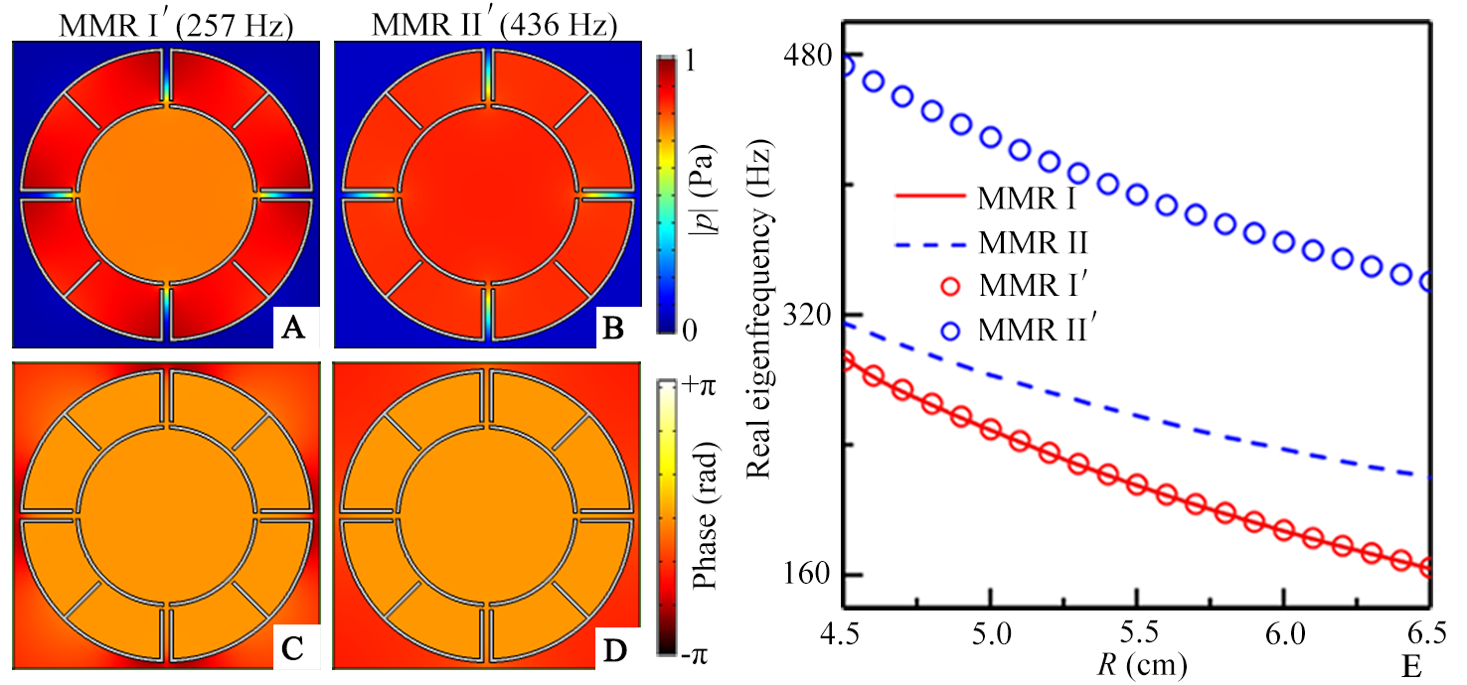
FIGURE S1 | Simulated pressure (A), (B) and phase (C), (D) eigenfunctions of the unit cell (R=5.0 cm) without outer frame. Eigenmodes of MMR I′ and II′ can be observed at 257 and 436 Hz. (E) Real eigenfrequencies of MMR I′ and II′ with different values of R.
Note 2 Eigenmodes of unit cell with two cavities
We simulate the eigenmodes of the unit cell composed of an outer frame and two cavities around 250 Hz, and the other parameters of are the same as those in Figure 1B. As shown in Figure S2A, for the unit cell composed of two cavities, it only has a single eigenmode at 251 Hz, and its eigenfrequency is very close to that of MMR I (249 Hz). The pressure distribution of the eigenmode shows typical characteristic of Helmholtz resonance. Beyond that, we simulate the eigenfrequencies of the unit cells with different values of R, which are very close to those of MMR I. Thus, we deduce that MMR I and I′ are created by Helmholtz resonances of each cavity, which is not related to the outer frames.
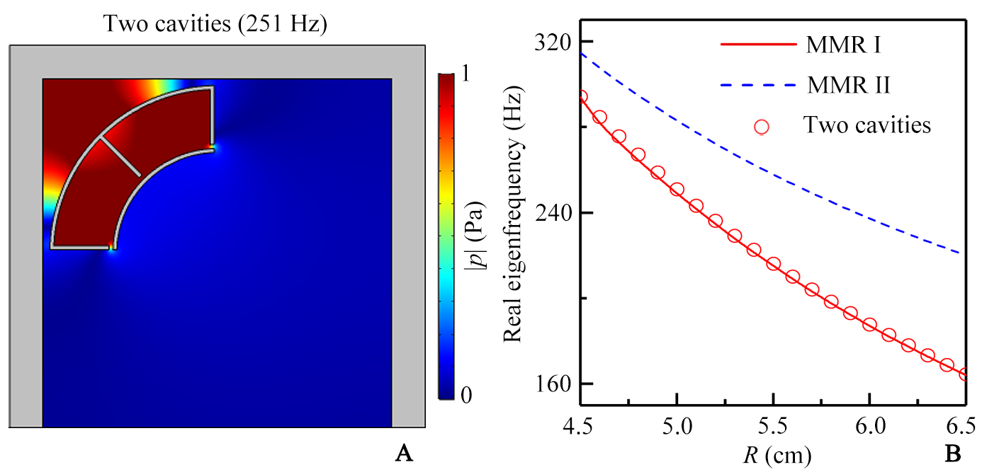
FIGURE S2 | (A) Simulated pressure eigenfunction of the unit cell composed of two cavities with R=5.0 cm. Eigenmode is observed at 251 Hz. (B) Real eigenfrequencies of MMR I and MMR II, and those of the unit cell composed of two cavities with different values of R.

Note 3 Acoustic equivalent circuit of open tunnel
To further demonstrate the performance of sound absorption for the open tunnel, we calculate acoustic impedances of the tunnel by using an acoustic equivalent circuit. Here, the unit cell is composed of 8 Helmholtz resonators, and thus the acoustic impedance of each unit cell can be written as, whereand represent the acoustic resistance and reactance, respectively. As shown in Figure S3A, P_{s} represents the incident source at the left side, Z₀ is the specific impedance of air in the left or right side of the tunnel, Z₁ and Z₂ represent the acoustic impedances of the unit cells I and II, Z_{L} is the specific impedance of air between both unit cells in the tunnel, and Z is the total impedance of the tunnel. The acoustic impedance between the points C and D is given as
. (S1)
Here, by using the impedance transfer formula, we can obtain the acoustic impedance between the points A and B
, (S2)
where k is the wave number of air, d is the distance between the unit cells I and II. Based on Eq.(S2), we can obtain . The reflection (r) and transmission (t) coefficients can be expressed as
, (S3)
. (S4)
Based on Eqs. (S3) and (S4), we realize the near-perfect sound absorption when Z/Z₀ is close to 1(r≈0), andis close to 0 (t≈0). By modulating the distance between the two unit cells and the sound impedances of both unit cells, we can realize near-perfect sound absorption. Here, by using the simulated reflection coefficients in Figure 2D, we theoretically calculate the sound impedance Z based on Eq. (S3), which is shown in Figure S3B. We can see that, at the absorption peak (283 Hz), the real part of Z/Z₀ is close to 1.0, and the imaginary part of Z/Z₀ is close to 0, showing the typical characteristics of near-perfect sound absorption.
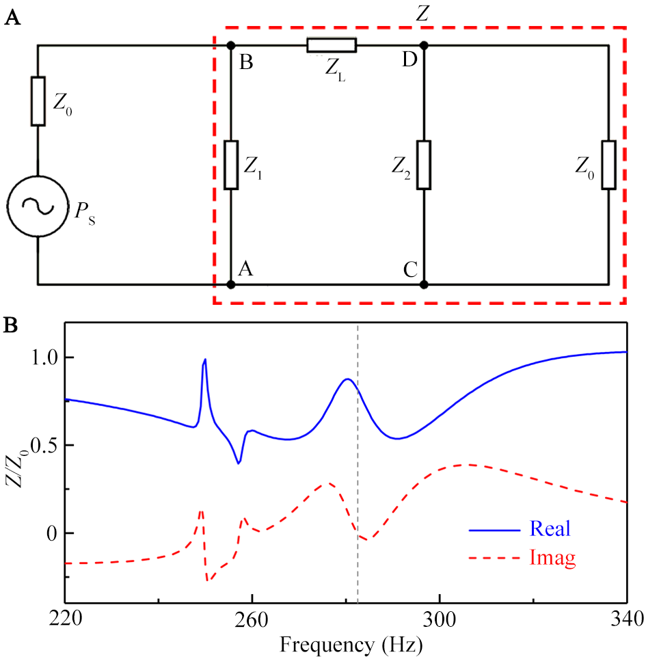
FIGURE S3 | (A) Acoustic equivalent circuit of the open tunnel. (B) Theoretically calculated acoustic impedances of the open tunnel based on the acoustic equivalent circuit.
Note 4 Absorption performance of open tunnel for right incidence of sound
As shown in Figure S4A, we also discuss the absorption performances through the open tunnel for the right incidence of sound, in which the parameters of the open tunnel remain constant. Figure S4B shows the corresponding absorption spectrum through the open tunnel, in which the maximum absorption coefficient is only about 0.66. Such a phenomenon arises from the increase of sound reflections created by the asymmetric design of both Mie resonators, and the proposed open tunnel of asymmetric sound absorption can be applied to exhaust pipes of cars with the need of unidirectional noise reduction.
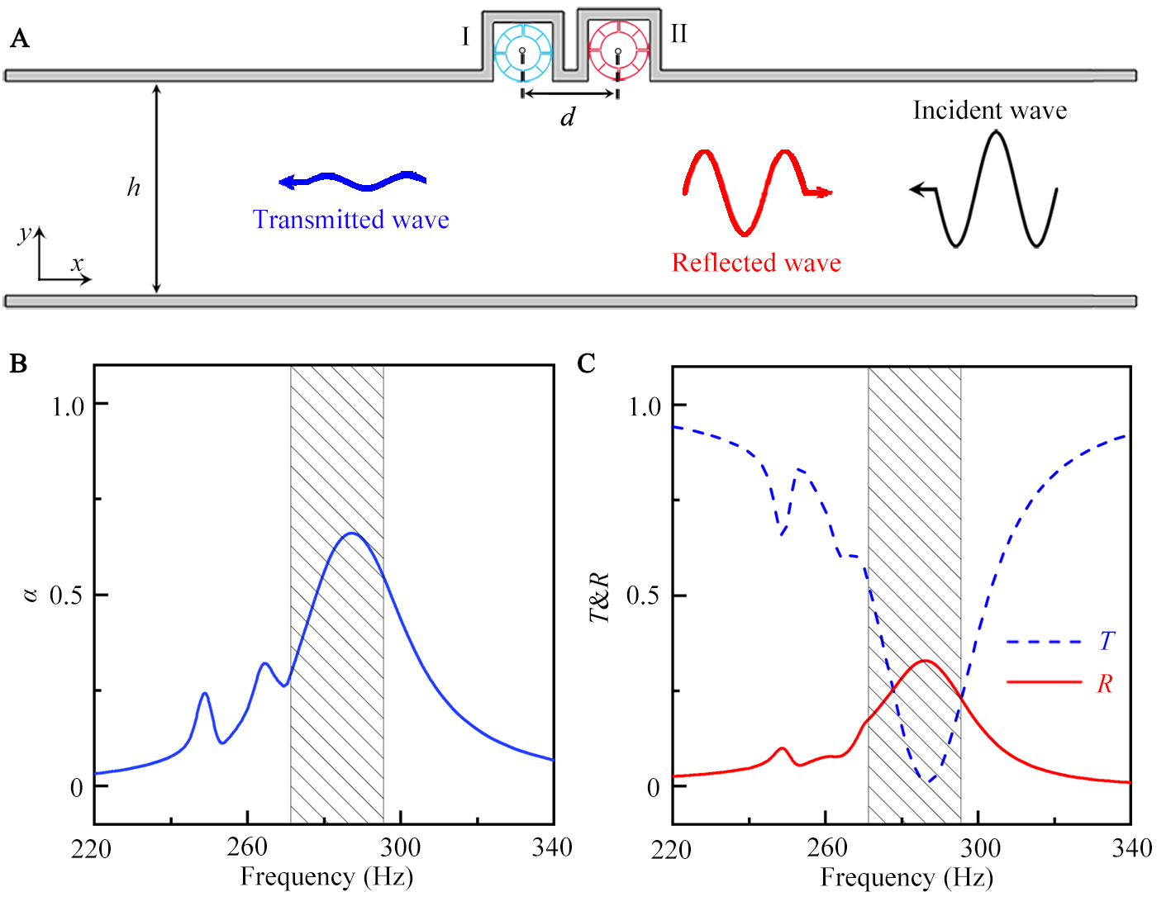
FIGURE S4 | (A) Schematic of the open tunnel with the unit cells II and I for the right incidence of sound. Simulated (B) absorption, and (C) transmittance and reflectance spectra through the open tunnel for the right incidence of sound.
Note 5 Absorption performance of open tunnel with a symmetric system of Mie resonators
As shown in Figure S5A, we also simulate the sound absorption through the open tunnel with a symmetric system of Mie resonators which is composed of a unit cell I and two unit cells II on both sides. The simulated absorption, transmittance and reflectance spectra through the designed open tunnel are shown in Figures S4B, C. We can see that the maximum absorption coefficient is about 0.88, which is still lower than that in Figure 2C.

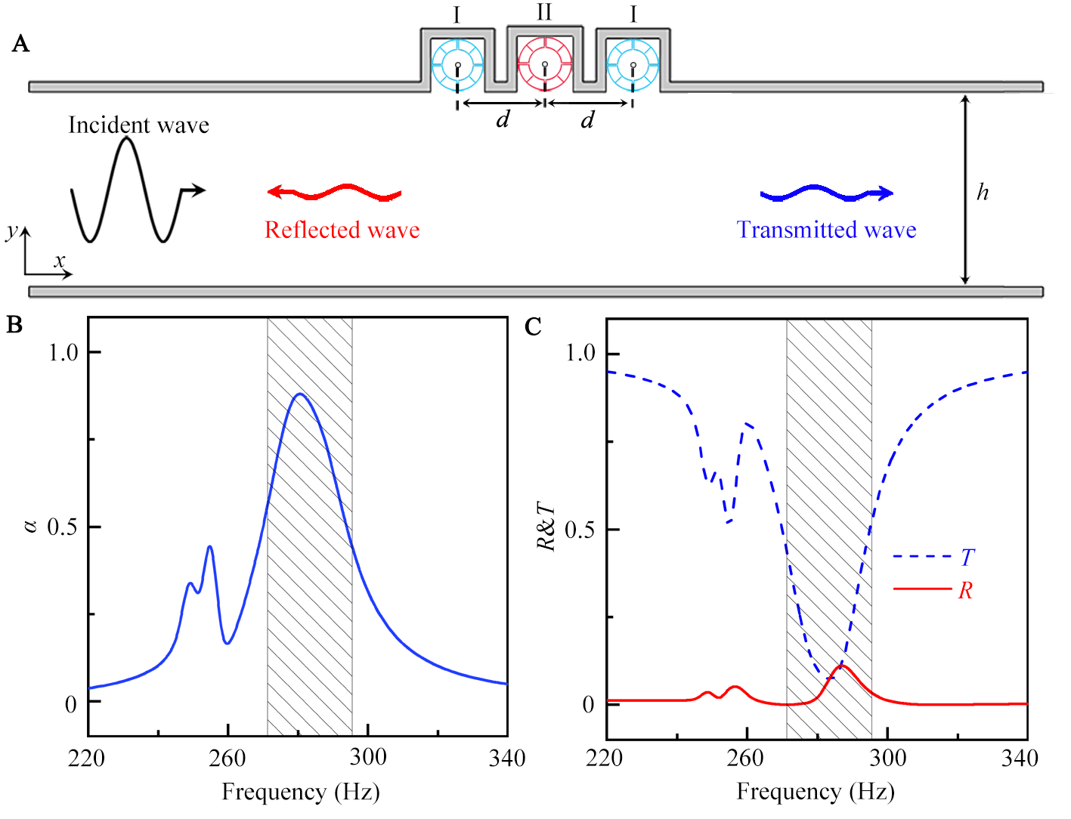
FIGURE S5 | (A) Schematic of the open tunnel with a symmetric system of Mie resonators composed of a unit cell I and two unit cells II. Simulated (B) absorption, (C) transmittance and reflectance spectra through the open tunnel.
Note 6 Absorption performance of open tunnel with 13 unit cells
By increasing the number of the unit cells, we can further broad the bandwidth of the proposed open tunnel. Figure S6A shows the schematic of the open tunnel with 13 unit cells for the left incidence of sound. The size of the waveguide and the distance between adjacent unit cells are the same as those in Figure 2A. Figure S6B shows the absorption spectrum through the open tunnel around the peak C. It is found that, in the range 204-326 Hz (shaded region), the absorption coefficient is larger than 0.5, and thus the fractional bandwidth can reach about 0.46. Beyond that, in the range 215-310 Hz, the absorption coefficient can exceed 0.9, and both coefficients R and T are close zero [Figure S6C], showing the characteristic of broadband near-perfect sound absorption.
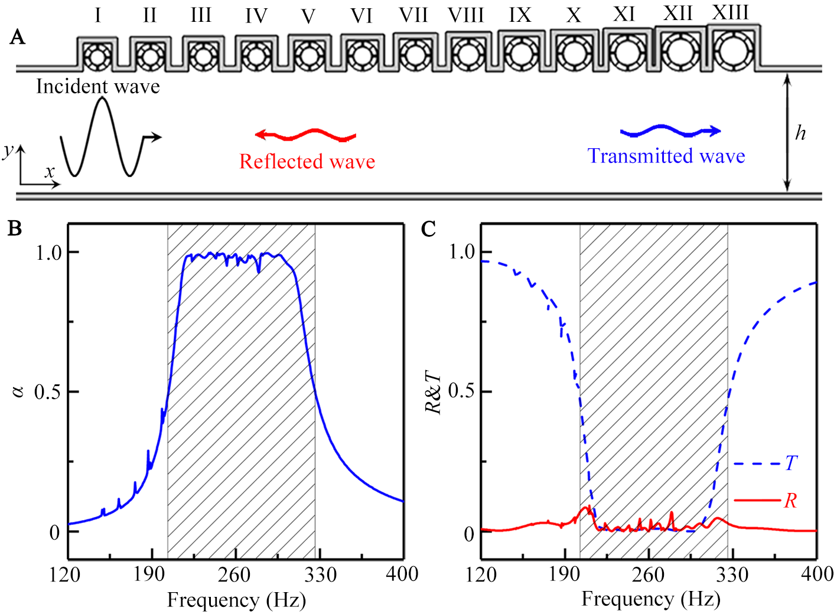
FIGURE S6 | (A) Schematic of the open tunnel with 13 unit cells for the left incidence of sound. The parameters t and w of each unit cell are fixed at 1.2 and 2.0 mm, R_{I}=4.5 cm, R_{II}=4.6 cm, R_{III}=4.7 cm, R_{IV}=4.8 cm, R_{V}=4.9 cm, R_{VI}=5.0 cm, R_{VII}=5.1 cm, R_{VIII}=5.2 cm, R_{IX}=5.3 cm, R_{X}=5.4 cm, R_{XI}=5.5 cm, R_{XII}=5.6 cm and R_{XIII}=5.7 cm. Simulated (B) absorption, (C) transmittance and reflectance spectra through the open tunnel with 13 unit cells.
Note 7 Experimental setup
The experimental setup is shown in Figure S7. In the experiment, a loudspeaker array is located at the left side of the tunnel to generate incident acoustic waves. There exist 4 detecting holes with the diameter of 0.25 inch on the top surface of the tunnel, which is marked as 1, 2, 3 and 4, respectively. The sound absorbing foams placed at the right side of the tunnel are used to avoid reflected acoustic energy. We adopt two 0.25-in-diameter microphones (Brüel&Kjær type-4961) to detect pressure amplitudes and phases in the holes 1 and 2 (or 3 and 4) simultaneously. Thus, we can measure the sound pressures in the holes 1, 2, 3 and 4, which is denoted as p₁, p₂, p₃ and p₄. Based on the measured pressures p₁, p₂, p₃ and p₄, we can calculate the transmission and reflection coefficients as and , respectively, in which D₁ is the distance between the holes 1 and 2, and D₂ is that between the holes 3 and 4. By using the transmission and reflection coefficients t and r, we can calculate the absorption coefficient α=1-t²-r².
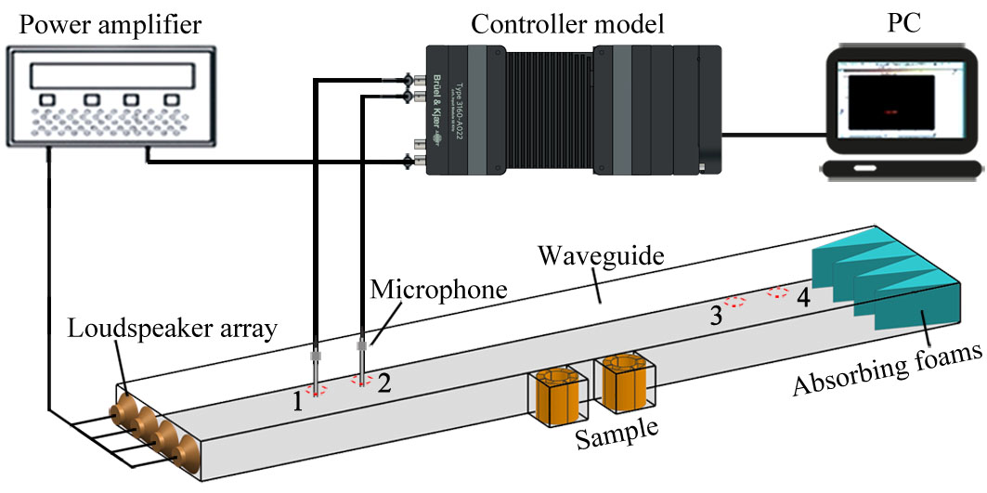
FIGURE S7 | Experimental setup
Note 8 Error analysis of experimental measurement
To analyze the errors in the experiment, we carefully measure the parameters of each unit cell in the sample. By using the measuring parameters of the sample, we simulate the absorption, transmittance and reflectance spectra through the two types of tunnels, which are shown in Figure S8. Additionally, the corresponding experimental results are also displayed for comparison. Note that the working bands of sound absorption for both tunnels are close to those of the measured results. Therefore, we demonstrate that the bands of sound absorption are very sensitive to the parameters of the unit cells, and the errors in the measured working bands of sound absorption mainly arise from the structure errors of the sample.
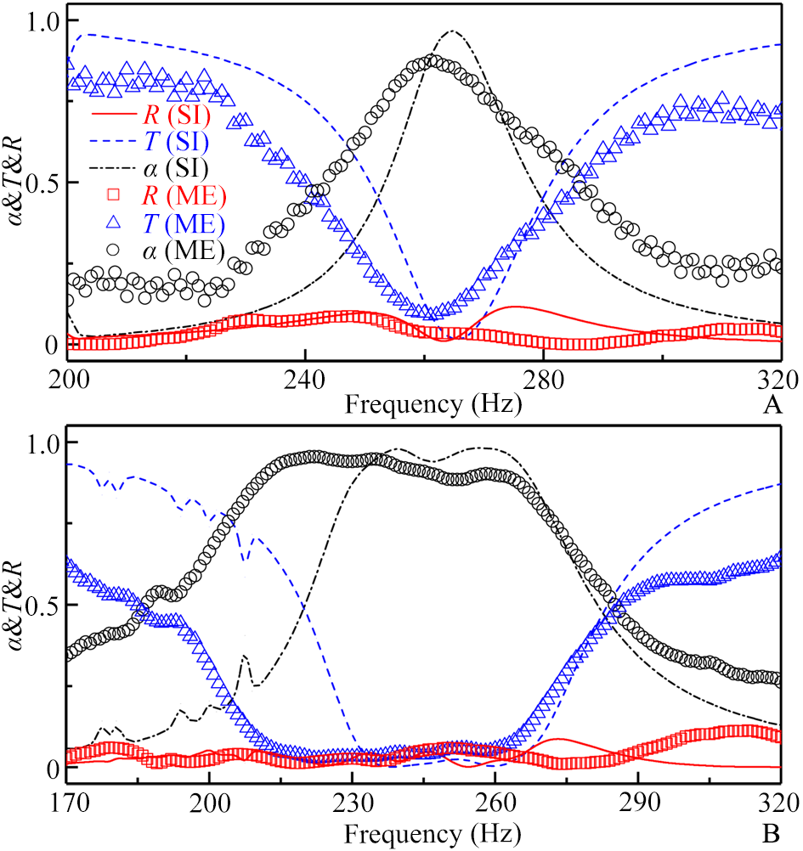
FIGURE S8 | Measured and simulated absorption, transmittance and reflectance spectra through the open tunnels with (A) 2 and (B) 6 unit cells for the left incidence of sound. The structure parameters in the simulations are t_{I}=1.6 mm, w_{I}=1.0 mm, R_{I}=49.5 mm; t_{II}=1.5 mm, w_{II}=1.0 mm, R_{II}=50.3 mm for the two unit cells in (A), t_{I}=1.6 mm, w_{I}=1.0 mm, R_{I}=49.5 mm; t_{II}=1.5 mm, w_{II}=1.0 mm, R_{II}=50.3 mm; t_{III}=1.8 mm, w_{III}=1.1 mm, R_{III}=52.2 mm; t_{IV}=1.5 mm, w_{IV}=1.0 mm, R_{IV}=53.9 mm; t_{V}=1.6 mm, w_{V}=1.0 mm, R_{V}=56.2 mm; t_{VI}=1.7 mm, w_{VI}=1.1 mm, R_{VI}=58.3 mm for 6 unit cells in (B).

