Supplementary Material

# Supplementary Figures and Tables

This supporting information provides the event list of space hurricane in this study and related information shown in Table S1 (file uploaded separately). The solar elevation angle and Earth’s dipole tilt angle distribution of 329 space hurricane events as shown in Figure S1, and an overview of the number of SSUSI images in 147 individual space hurricane event (second column of Table S1) as shown in Figure S2. Figure S2 reveals the minimum duration for each individual space hurricane event.

## Supplementary Figures

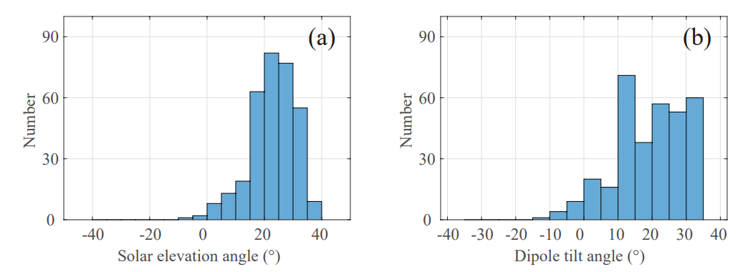

**Figure S1.** (a) solar elevation angle distribution of 329 space hurricane events. (b) Earth’s dipole tilt angle distribution of 329 space hurricane events.

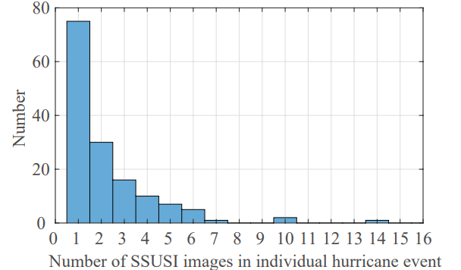

**Figure S2.** Statistics on the number of SSUSI images in 147 individual space hurricane event (Second column of Supplementary list 1). When SSUSI images is greater than 1, the minimum duration for each individual space hurricane event is equal to the number of SSUSI images multiplied by the orbital period (~101min). When SSUSI images is equal to 1, it means individual space hurricane events can only be observed by one orbital period and the space hurricane last no longer than ~202min.

## Supplementary Tables

Table S1. An overview of the event list of space hurricane in this study and related information. The columns from left to right in the table are Event number, Individual event number, Date of event, DMSP satellite number, Orbit number, Day of year, Event start time, MLT (°), MLAT (°), Solar elevation angle, Dipole tilt angle.