Supplementary Material

# Supplementary Figures and Tables

## Supplementary Figures

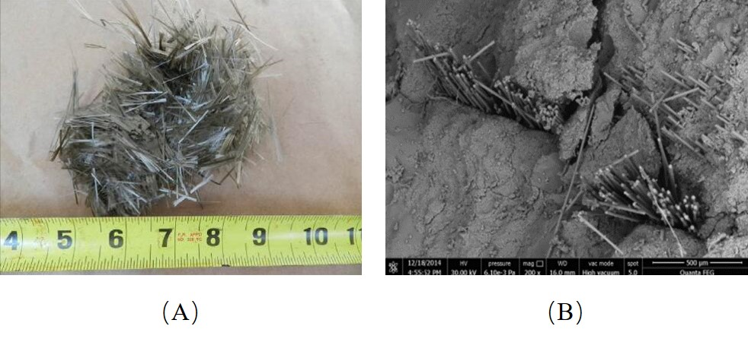

**Supplementary Figure 1. Morphology of basalt fiber and SEM [5-6]**

**（A） Macroscopic morphology （B） SEM morphology**



**Supplementary Figure 2. Influence of basalt fiber length and volume content on concrete slump [10]**



**Supplementary Figure 3. The effect of fly ash on the fluidity of BFRC [44]**



**Supplementary Figure 4. Effect of fiber length and WFT on cohesiveness of mixtures [51]**

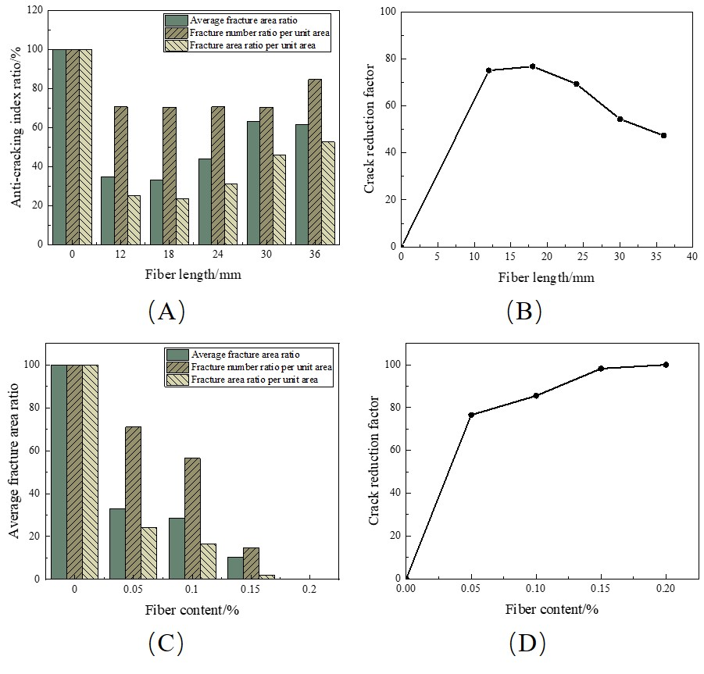**Supplementary Figure 5. Comparison of crack parameters of basalt fiber reinforced concrete with concrete of different length and different volume content of BF [58]**

**（A） Anti-cracking index ratio influenced by fiber length （B） Crack reduction factor influenced by fiber length （C）Anti-cracking index ratio influenced by fiber content （D）Crack reduction factor influenced by fiber content**



**Supplementary Figure 6. Effect of BF length and content on impact resistance of concrete [14]**

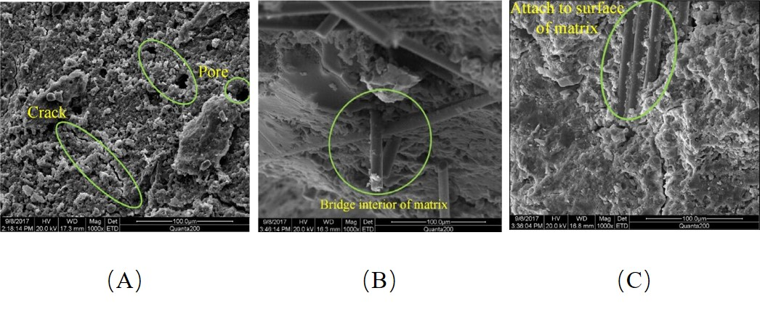

**Supplementary Figure 7. Microstructure of BFRC with BF content of 0%, 0.2% and 0.5% [67]**

**（A） BF content of 0% （B）BF content of 0.2% （B）BF content of 0.5%**

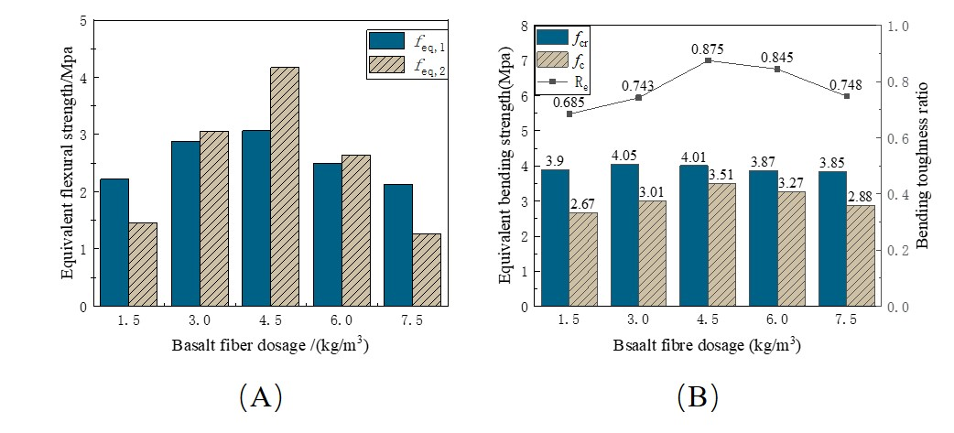

**Supplementary Figure 8. Equivalent bending strength measured by DBV-1998 and JSCE SF-4 [76]**

**（A） The results measured by DBV-1998 （B） The results measured by JSCE SF-4**



**Supplementary Figure 9. Distribution of different pore contents in BFSC measured by NMR [76]**



**Supplementary Figure 10. Effect of fiber content and length on compressive strength of concrete at 7d, 28d and 90d [49]**

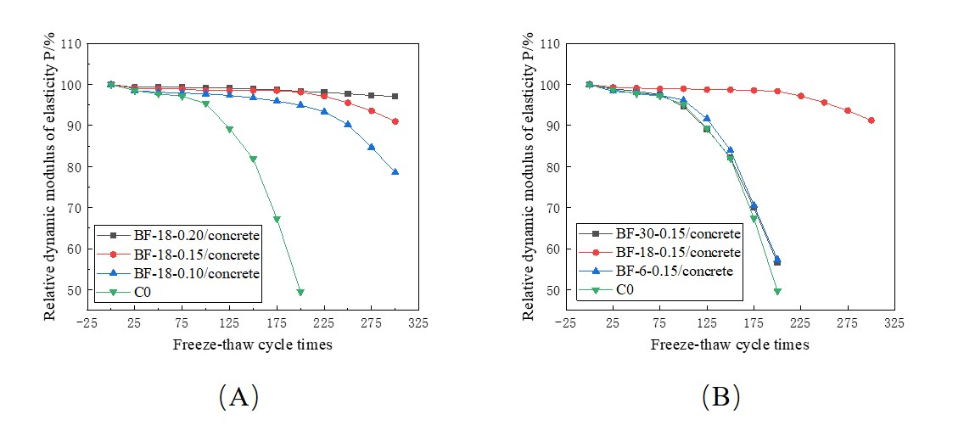

**Supplementary Figure 11. The relative dynamic modulus of BFRC varies with the number of freeze-thaw cycles under different basalt fiber volume content and fiber length [88]**

**（A） Different volume content of basalt fiber （B） Different fiber length**

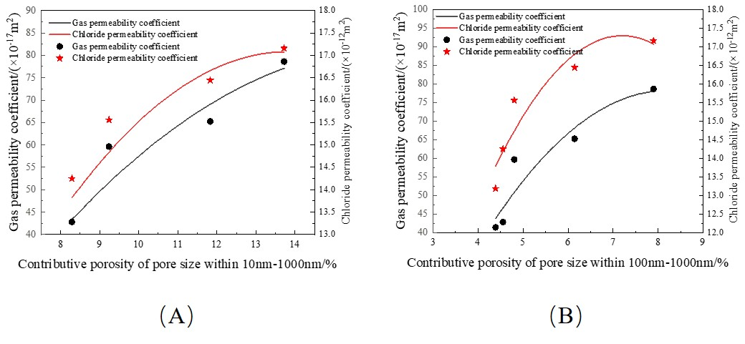

**Supplementary Figure 12. Relationship between permeability and the contributive porosity of pore size in concrete [97]**

**（A） Pore size within 10nm-1000nm （B） Pore size within 100nm-1000nm**

## Supplementary Table

**Table 1 Fiber types of shotcrete and its material parameter** **[18]**

|  |  |  |  |  |  |  |
| --- | --- | --- | --- | --- | --- | --- |
| Fiber types | Length/  mm | Diameter/  μm | Density/  (g/cm3) | Tensile  strength/MPa | Elasticity  modulus/MPa | Elongation  at break/% |
| Basalt fiber | 15-30 | 9-25 | 2.60-2.80 | 3000-4800 | 80-100x103 | 2.7-3.4 |
| Steel fiber [19] | 20-36 | 250-550 | 7.80 | 600-2000 | 200-210 x103 | — |
| Polypropylene fiber [20] | 3-29 | 30-40 | 0.93 | ≥500 | ＞3850 | — |
| PET fiber [9] | 6-30 | 2-15 | 0.90-1.35 | 108 | 3830±47 | 16-35 |
| Polypropylene fiber | 4-19 | 18-65 | 0.91 | 276-650 | 3.79 | 15-18 |
| Polyacrylonitrile | 6-25 | 13 | 1.18 | 500-910 | 7.5-21 | 11-20 |

**Table 2 Pore size distribution of BFRC with different fiber content [60]**

|  |  |  |  |  |  |
| --- | --- | --- | --- | --- | --- |
| Fiber content/% | Cumulative pore specific surface area/(m2/g) | Cumulative pore volume/(cm3/g) | The average pore diameter/nm | The median pore diameter/nm | The most aperture available/nm |
| 0 | 6.4 | 252.1×10-3 | 24.9 | 26.6 | 13.7 |
| 0.05 | 7.3 | 24.0×10-3 | 13.8 | 18.2 | 6.1 |
| 0.10 | 7.1 | 23.3×10-3 | 13.1 | 19.4 | 4.8 |
| 0.20 | 7.9 | 30.0×10-3 | 22.2 | 20.2 | 6.5 |
| 0.30 | 6.9 | 31.4×10-3 | 26.3 | 36.1 | 6.8 |

**Table 3 Summary of performance comparison between SC and BFSC**

|  |  |  |  |  |  |
| --- | --- | --- | --- | --- | --- |
| Evaluation index | BF content /% | BF length /mm | BF diameter/μm | Change in performance compared to PC/% | Postscript （Performance characterization method） |
| Compressive  strength（7d/28d）[78] | 0.20 | 6 | 17.4 | 18.8/11.9 | The performance change is represented by the strength change of BFSC and PC |
| 0.30 | 20.3/24.6 |
| 0.20 | 12 | 17.4 | 2.8/8.4 |
| 0.30 | 6.2/12.2 |
| Flexural  strength（7d/28d）[74] | 0.06 | 13 | 18 | 7.6/4.8 |
| 0.12 | 16.9/13.4 |
| 0.18 | 15.5/12.4 |
| 0.24 | 14.8/11.2 |
| 0.3 | 8.2/7.8 |
| Workability [43] | 0.05 | 12/22 | —— | -7.0/-8.1 | The change of slump measured by slump test is expressed |
| 0.10 | -15.1/-16.2 |
| 0.30 | -53.0/-56.2 |
| 0.50 | -64.9/-67.6 |
| Early cracking resistance (Fracture length improvement/Crack width improvement) [46] | 0.05 | 18 | 17 | 37.0/47.8 | The improvement of crack length/width between BFRC and PC was compared. |
| 0.10 | 57.4/47.8 |
| 0.15 | 48.5/73.9 |
| 0.05 | 12 | 17 | 35.8/48.2 |
| 18 | 37.0/54.6 |
| 24 | 47.8/5.9 |
| 30 | 36.3/35.0 |
| 36 | 51.0/43.9 |
| Permeability  Resistance [59，60] | 0.05 | 18 | 18 | -4.9 | The change of seepage height is used to show the change in performance. Among them, positive value means that the impermeability of BFSC is improved compared with PC, while negative value means that it is decreased. |
| 0.10 | -18.0 |
| 0.15 | 7.3 |
| 0.20 | 27.9 |
| 0.25 | 18.0 |
| 0.30 | 69.2 |
| 0.35 | 87.8 |
| Chloride penetration resistance [100] | 0.05 | 12 | 13 | 33.1 | The variation of the electric flux between BFSC and PC under the electric flux method represents the performance variation. The positive value indicates that the anti-ion permeability of BFSC is improved compared with PC, while the negative value indicates a decrease。 |
| 0.10 | 56.5 |
| 0.15 | 25.6 |
| Frost and thawing resistance (water/NaCl solution） [88] | 0.10 | 18 | 15 | 37.4/35.0 | The quality loss rate under freeze-thaw cycle (65 times) is used to represent the performance change. The positive value indicates that the anti-ion permeability of BFSC is improved compared with PC, while the negative value indicates a decrease. |