**Table S1 Sampling information of wild *K. punctatus***

|  |  |  |  |  |  |  |
| --- | --- | --- | --- | --- | --- | --- |
| Category | Sampling locality | Code | Sampling size | Time | Longitude | Latitude |
| China | Dandong | DG | 17 | 2014.05 | 124.15E | 39.87N |
| Qinhuangdao | QHD | 15 | 2014.09 | 119.60E | 39.93N |
| Dongying | DY | 24 | 2018.11 | 118.67E | 37.43N |
| Laizhou | LZ | 24 | 2020.08 | 119.94E | 37.18N |
| Rizhao | SRZ | 24 | 2018.04 | 119.33E | 35.10N |
| Lvsi | LS | 20 | 2018.04 | 119.22E | 34.60N |
| Zhoushan | ZS | 24 | 2018.04 | 122.20E | 30.00N |
| Wenzhou | WZ | 21 | 2019.01 | 120.95E | 28.13N |
| Sanwei | SW | 15 | 2018.04 | 115.37E | 22.78N |
| Zhongshan | GS | 23 | 2018.04 | 113.38E | 22.52N |
| Japan | Saga | RZ | 21 | 2019.11 | 131.53E | 33.15N |
| Korea | Jeolla-Do | HQ | 19 | 2019.12 | 127.54E | 34.24N |

**Table S2 Characterization of twenty *K. punctatus* microsatellite primers**

|  |  |  |  |  |
| --- | --- | --- | --- | --- |
| Locus  name | Primer sequences  (5′–3′) | Repeat  motif | Temperature  (°C) | Fragment  (bp) |
| Kunp01 | F: TGACATGCTGCTGGCCAAA | (TG)14 | 56 | 126~160 |
| R: GTCTGTCAGAGATGTGGCCC |
| Kunp02 | F: AAAGGCACTGTTGAAGGCAC | (AG)12 | 56 | 121~185 |
| R: GGAAGGTCAGTGTTGGAGTGT |
| Kunp03 | F: AGATGACAGAGGGCAGAGGT | (AG)14 | 55.5 | 142~196 |
| R: CCCTACTGTCTGCCTCATCC |
| Kunp04 | F: GAACACTGAAGGAGTTTGCCT | (CA)13 | 56 | 161~215 |
| R: ACATGGCCTGCATTTCACAG |
| Kunp05 | F: CTGTTCACTGGGTAGCTGCT | (GT)10 | 56 | 224~276 |
| R: AGACCCTTTGACTGATGGGC |
| Kunp06 | F: CTGGGTGACTGCAGTTCACA | (GT)12 | 56 | 129~149 |
| R: AAGCAATGTCCCTCTCCTGC |
| Kunp07 | F: ACTCGCTCTTTCATCGCTGT | (CT)9 | 56 | 144~180 |
| R: CGAGTGGGAGGGAATTGCAA |
| Kunp08 | F: GAGTGACACAGTGCTCTGCT | (GA)11 | 56 | 159~179 |
| R: GTGCCTGTGCTGAGTGGTTA |
| Kunp09 | F: CTGCGTCTCCAACTGACTGT | (CT)14 | 56 | 192~226 |
| R: AAACTTGTAGTTCTGCACTTGTT |
| Kunp10 | F: CACCCTAAACCTGCATGGCT | (CA)12 | 56 | 208~260 |
| R: CAGTAGAAGGACGGCTGCAA |
| Kunp11 | F: TGCAAACCGTTCTTCACAGA | (AC)11 | 56 | 239~281 |
| R: TGCAATGGTGTGAAATGGAAAC |
| Kunp12 | F: CGACCACTTGTGTTCAGCAG | (CA)9 | 56 | 120~186 |
| R: ATGGCGTTCAGTCTTGGAGT |
| Kunp13 | F: GGGAGTTTGCCCTGGTAAGG | (AG)12 | 56 | 138~230 |
| R: ACTCATCCTTGGAGGCGAGT |
| Kunp14 | F: GGTCTAAGGTGAGCTGAGCC | (AG)14 | 56 | 135~223 |
| R: CCAGGTGAGGACGAGAAAGG |
| Kunp15 | F: TGCCTCTTATCTCCCTGCCT | (GT)13 | 56 | 186~228 |
| R: TGTCTAAGCCCTGCTCTTGC |
| Kunp16 | F: CTCCTAGCAAGCCAGCATCA | (AC)13 | 56 | 118~186 |
| R: AAGTTCCTTCCAGGACTCGG |
| Kunp17 | F: CGCTCCACTCTGTCTGGTTA | (TG)12 | 56 | 135~186 |
| R: GTCTTCAGGTCTGCCAGCAA |
| Kunp18 | F: AACAGCAAGGCAGGCAGAAA | (TG)12 | 56 | 138~250 |
| R: ACCGCTGCCATTCTGCTATA |
| Kunp19 | F: TCAGTCAGATTCAGTCGCCG | (TG)9 | 56 | 198~238 |
| R: TAGCATGAACACAGGCAGCA |
| Kunp20 | F: AGCATGCACAGTAACATATGACA | (AC)10 | 56 | 188~226 |
| R: GCACAGCTTTCAACCTCCAG |

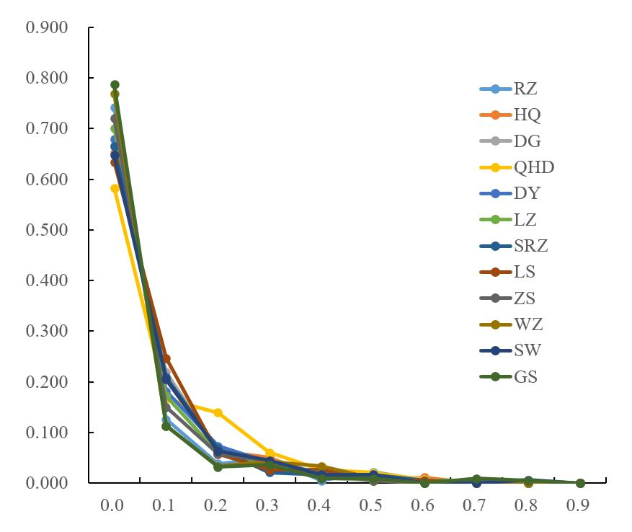 **Figure S1 Mode Shift Test for Bottleneck of *K. punctatus* populations.** Dandong: DG; Qinhuangdao: QHD; Dongying: DY; Laizhou: LZ; Rizhao: SRZ; Lvsi: LS; Zhoushan: ZS; Wenzhou: WZ; Sanwei: SW; Zhongshan: GS; Jeolla: HQ; Saga: RZ.

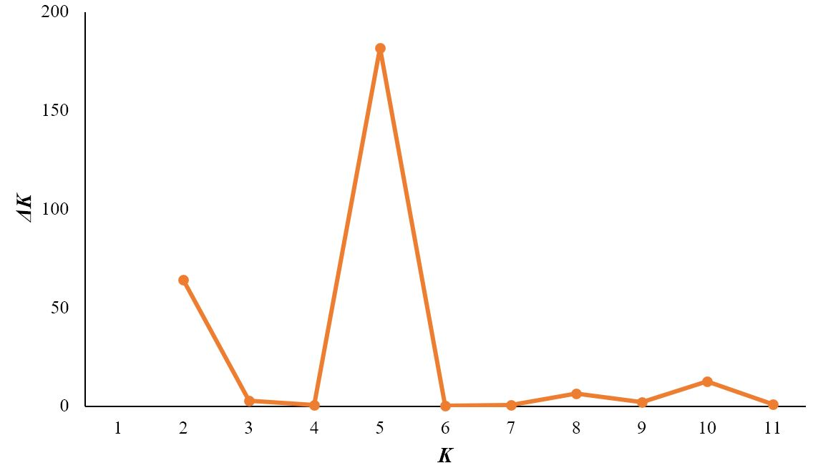

**Figure S2 Evanno *K* statistics of STRUCTURE analysis of *K. punctatus* populations.** A prevailing signal for *K* = 5 and a comparatively weak signal for *K* = 2 were obtained based on the *ΔK* values.



**Figure S3 Mantel test using neutral microsatellite markers.** (A) The Mantel test was performed to test the occurrence of a positive correlation between Nei’s genetic distances and geographic distances. The genetic and geographic distance were significantly correlated (R2 = 0.5311, *p* < 0.001). (B) The Mantel test was performed to test the occurrence of a positive correlation between Nei’s genetic distances and environmental distances. The genetic and environmental distances were significantly correlated (R2 = 0.3017, *p* = 0.007).



**Figure S4 Population genetic structure of 12 wild *K. punctatus* using neutral microsatellite markers.** Dandong: DG; Qinhuangdao: QHD; Dongying: DY; Laizhou: LZ; Rizhao: SRZ; Lvsi: LS; Zhoushan: ZS; Wenzhou: WZ; Sanwei: SW; Zhongshan: GS; Jeolla: HQ; Saga: RZ.

(A) The unweighted pair group method with arithmetic mean (UPGMA) tree inferred from Nei’s genetic distance. (B) Principal coordinate analysis (PCoA) based on genetic distance. Percentage values represent variation justified by each axis. (C) Population structure obtained from STRUCTURE analysis. Individuals are represented by vertical bars. Different colors in the same individual indicate the percentage of the genome shared with each cluster according to the admixture proportions. The y-axis represents the probability to belong to a certain cluster, while the x-axis represents each population delimited by a black solid vertical line.

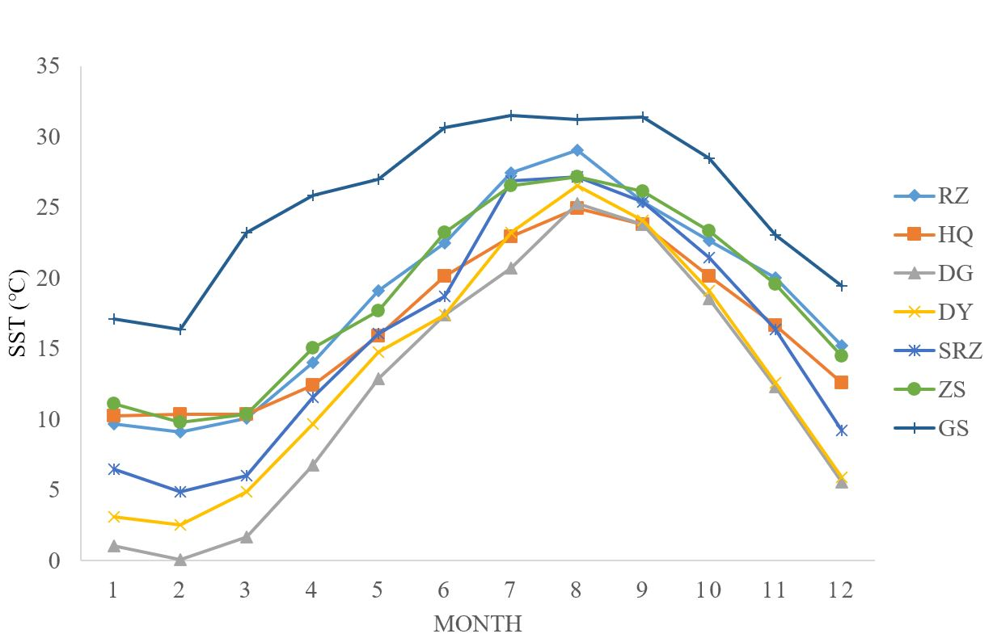

**Figure S5 Monthly average sea surface temperature (SST) from satellite remote sensing data of seven sampling sites from each of seven populations during 2010 to 2020.** Dandong: DG; Dongying: DY; Rizhao: SRZ; Zhoushan: ZS; Zhongshan: GS; Jeolla: HQ; Saga: RZ.