Supplementary Material

# Supplementary Figures and Tables

## Supplementary Figures

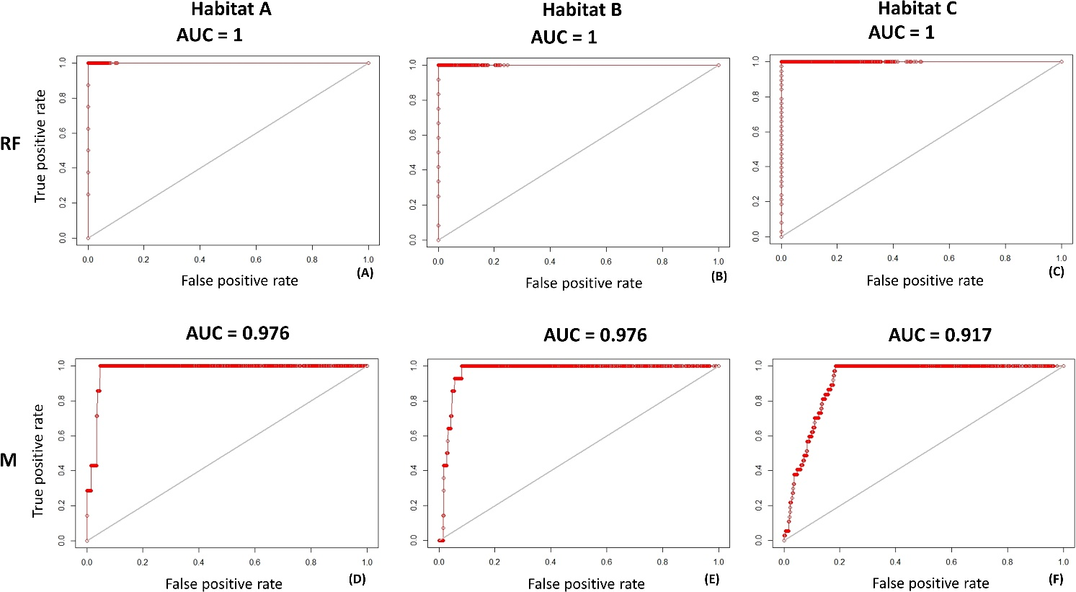

Supplementary Figure - AUC graphics on training dataset permitted to evaluate the Random Forest (RF) and Maxent (M). Training AUC is helpful to understand the success rate of the model. (A) Random Forest AUC on test dataset of habitat A; (B) Random Forest AUC on test dataset of habitat B; (C) Random Forest AUC on test dataset of habitat C; (D) Maxent AUC on test dataset of habitat A; (E) Maxent AUC on test dataset of habitat B; (F) Maxent AUC on test dataset of habitat C.

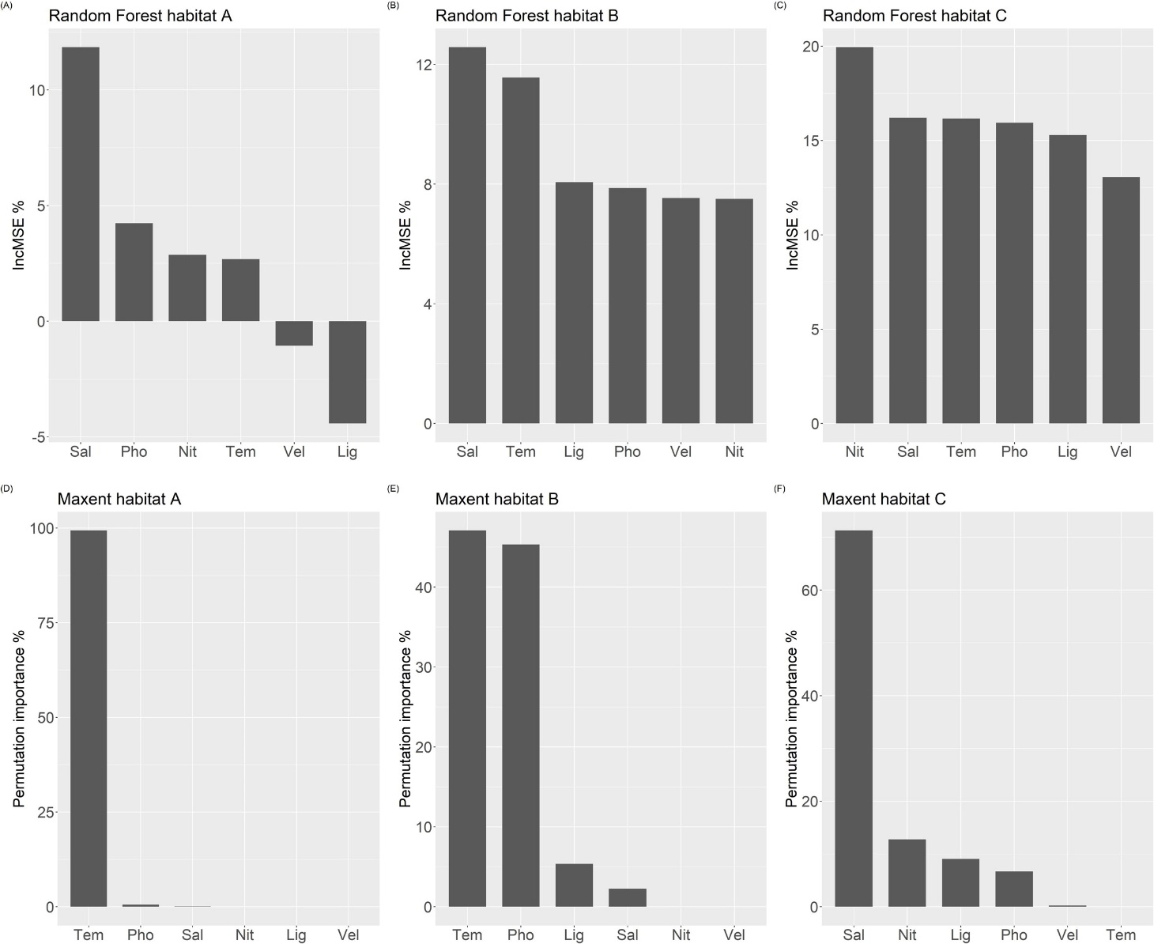

Supplementary Figure - Variable importance and contribution derived from Random Forest (RF) and MaxEnt (M) models: (A) Random Forest Mean Decrease Accuracy (%IncMSE) of habitat A; (B) Random Forest Mean Decrease Accuracy (%IncMSE) of habitat B; (C) Random Forest Mean Decrease Accuracy (%IncMSE) of habitat C; (D) MaxEnt permutation importance of habitat A; (E) MaxEnt permutation importance of habitat B; (F) MaxEnt AUC permutation importance of habitat C.

## Supplementary Tables

Supplementary Table - Random Forest number of habitat typologies under the historical scenario

|  |  |
| --- | --- |
| **Random Forest** | |
| **Habitat** | **Number of habitat typologies** |
| A | 12 |
| B | 18 |
| C | 55 |

Supplementary Table - Maxent number of habitat typologies under the historical period

|  |  |
| --- | --- |
| **Maxent** | |
| **Habitat** | **Historical period** |
| A | 10 |
| B | 21 |
| C | 54 |

Supplementary Table - Random Forest variable importance for Habitat A was calculated as the mean square error (%IncMSE). Higher values meant a higher decrease in the predictive skill of the model.

|  |  |
| --- | --- |
| **Variable** | **%IncMSE** |
| **Salinity** | 11.847068 |
| **Phosphates** | 4.241109 |
| **Nitrates** | 2.873579 |
| **Temperature** | 2.683864 |
| **Current Vel.** | -1.054819 |
| **Light** | -4.422093 |

Supplementary Table - Random Forest variable importance for Habitat B was calculated as the mean square error (%IncMSE). Higher values meant a higher decrease in the predictive skill of the model.

|  |  |
| --- | --- |
| **Variable** | **%IncMSE** |
| **Salinity** | 12.577664 |
| **Temperature** | 11.560574 |
| **Light** | 8.067698 |
| **Phosphates** | 7.870354 |
| **Current Vel.** | 7.535477 |
| **Nitrates** | 7.508628 |

Supplementary Table - Random Forest variable importance for Habitat C was calculated as the mean square error (%IncMSE). Higher values meant a higher decrease in the predictive skill of the model*.*

|  |  |
| --- | --- |
| **Variable** | **%IncMSE** |
| **Nitrates** | 19.94306 |
| **Salinity** | 16.21013 |
| **Temperature** | 16.15900 |
| **Phosphates** | 15.94153 |
| **Light** | 15.28271 |
| **Current Vel.** | 13.05514 |

Supplementary Table - MaxEnt variable contribution for Habitat A was calculated as Decrease of AUC. Higher values mean higher dependence of the model from that particular variable

|  |  |
| --- | --- |
| **Variable** | **Decrease of AUC (%)** |
| **Temperature** | 99.3 |
| **Phosphates** | 0.6 |
| **Salinity** | 0.1 |
| **Nitrates** | 0 |
| **Light** | 0 |
| **Current Vel.** | 0 |

Supplementary Table - MaxEnt variable contribution for Habitat B was calculated as Decrease of AUC. Higher values mean higher dependence of the model from that particular variable

|  |  |
| --- | --- |
| **Variable** | **Decrease of AUC (%)** |
| **Temperature** | 47.1 |
| **Phosphates** | 45.3 |
| **Light** | 5.4 |
| **Salinity** | 2.2 |
| **Nitrate** | 0 |
| **Velocity** | 0 |

Supplementary Table 8 - MaxEnt variable contribution for Habitat C calculated as Decrease of AUC. Higher values mean higher dependence of the model from that particular variable

|  |  |
| --- | --- |
| **Variable** | **Decrease of AUC (%)** |
| **Salinity** | 71.3 |
| **Nitrates** | 12.8 |
| **Light** | 9.1 |
| **Phosphates** | 6.7 |
| **Velocity** | 0.2 |
| **Temperature** | 0 |