Enhanced ultraviolet-B radiation reduces methane emission in one of the oldest and largest rice terraces in China but triggers new challenges

Supplementary Material

**Section 1. Experimental design and measurement of greenhouse gas emissions**

**1.1 Experimental design**

The winter fallow period is from October to April of the next year (2016–2017 in the present study). Six plots (2.25 m × 3.9 m) were established after rice harvesting. A total of 8.8 kg of rice straws were returned to each plot. For the entire winter fallow period, the plots were flooded, with a layer of water 10–15 cm in thickness. During winter, the returned rice straws floated on the water in the rice paddy.

The rice-growing period is from May to September (2017 in the present study). A variety of rice local to the Yuanyang Terraces, Baijiaolaojing, was cultivated in the paddy fields. The rice was sown in late March, and seedlings were transplanted into the experimental plots in early May. Rice was planted in 14 rows × 16 columns, and 6 rows and 4 columns of rice was set around each plot as guard rows. No pesticides or chemical fertilizers were used, and there was constant flooding during the rice-growing period.

Enhanced UV-B radiation of 5.0 kJ.m−2 was applied in both the winter fallow and rice-growing periods. Three plots received rice straw incorporation under natural light, and the other three plots received rice straw incorporation under enhanced UV-B radiation of 5.0 kJ.m−2, and a UV radiation tester (Photoelectric Instrument Plant of Beijing Normal University) was used to determine the radiation intensity at a wavelength of 297 nm. UV-B radiation was supplied for 7 h at 10:00–17:00 every day (except for rainy days), starting from rice harvesting (October 2016) and lasting until the next rice transplantation (April 2017). During the rice-growing period, natural light and enhanced UV-B radiation (5 kJ.m−2) treatments were repeated thrice. Enhanced UV-B radiation was applied to the central 10 rows of rice in the test plots. One 40 W UV-B tube (Beijing, UV308, 280–320 nm) was suspended right above the central rice (in the 9th column) in each of the 10 rows. The height of the tube’s placement was constantly regulated according to the growth of the rice plants, to maintain a radiation intensity of 5.0 kJ.m−2 (measured from the top of the plant).

**1.2 Measurement of greenhouse gas emissions**

Gas in the rice field was collected using the static chamber-gas chromatographic method (He et al. 2016). The static chamber was made of a light-proof polyvinyl chloride material and had a cylinder with a radius of 30 cm and height that could be regulated according to rice growth. This chamber was connected using hoops and covered with a lid onto which a thermometer and gas collection valve were installed. Vaseline was coated at the joints to ensure air tightness of the chamber body. Trestles were constructed around sampling points to reduce the disturbance caused by the sampling process.

In the middle of each month during the rice-growing and winter fallow periods, the sealed static chamber was used to collect gas samples from the rice field. The sampling time was between 9:00 and 11:00 am. The chamber body was placed on the field with three rice plants inside, and the air tightness of the static chamber was guaranteed by the liquid seal due to the inundation of the rice field. Immediately after the lid covering, a double-connecting bulb was used to manually pump gas in the chamber into a 500 mL aluminum foil vacuum gas bag. Sampling was performed at 0, 10, 20, and 30 min after the chamber was covered.

According to the Nayak method (Nayak et al. 2006), gas samples were analyzed using an Agilent 7890B gas chromatograph. The parameters of the flame ionization detector (FID) were set as follows: the heater was set to a temperature of 210 °C, the H2 flow quantity was at 40 mL.min−1, the airflow rate was at 400 mL.min−1, the make-up gas flow quantity (N2) was 20.871 mL.min−1, the column compartment temperature was at 50 °C, and the flow quantity of the chromatographic column was 2.500 mL.min−1. CH4 signals were detected through the FID.

Calculation formula: F = dC / dtt=0 × h × ρ × 273 / (273 + T) (1)

In equation 1, F is the gas emission flux, h is the height of the sampling chamber, T is the chamber temperature, ρ is the gas density under standard conditions, and dC/dtt=0 is the linear change rate of gas concentration per unit time. Standard curves were obtained by injecting various volumes of pure CO2 (99.999%), CH4 (99.992%), and N2O (99.5%) in high purity N2 (99.999%, Yunnan Messer Gas Products Co., Ltd.).

**Reference:**

He, Y., F. Zhan, L. Yuan, W. Xu, and Y. Ming. 2016. "Effect of enhanced UV-B radiation on methane emission in a paddy field and rice root exudation of low-molecular-weight organic acids." Photochemical and Photobiological Sciences 15 (6):735-743.

Nayak, D. R., T. K. Adhya, Y. J. Babu, A. Datta, B. Ramakrishnan, and V. R. Rao. 2006. "Methane emission from a flooded field of Eastern India as influenced by planting date and age of rice (Oryza sativa L.) seedlings." Agriculture Ecosystems & Environment.

**Section 2. Greenhouse gas emission dynamics in the Yuanyang Terraces**

Regarding greenhouse gas emissions, CH4, CO2 and N2O were all tested from May 2016 to October 2017 (during one winter fallow period, and two rice growing periods in both 2016 and 2017). In total, during the rice growing period, there were similar monthly greenhouse gas emission patterns and similar responses to enhanced UV-B in both 2016 and 2017. Emissions of all the tested greenhouse gases peaked in October (during the winter fallow period) and sharply declined after October. Compared with the effects of natural light treatment (Control), enhanced UV-B radiation decreased CH4 emissions, but increased CO2 and N2O emissions in the rice field (Supplementary Figure 1).

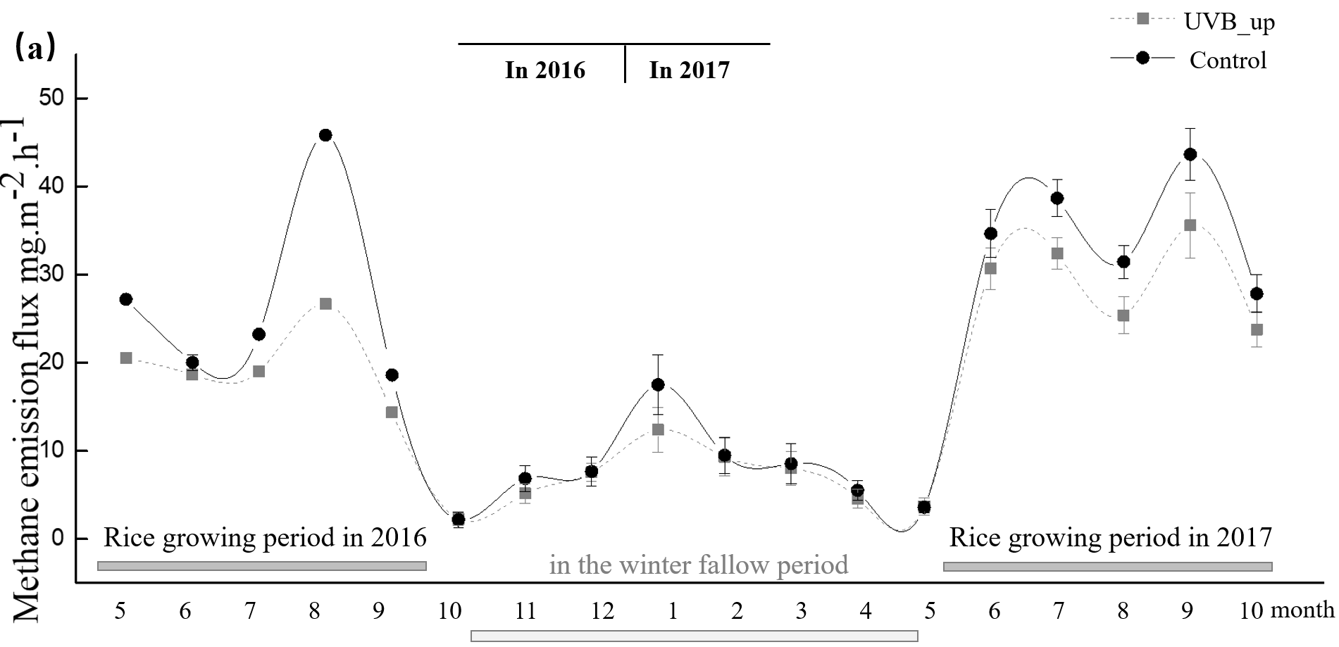

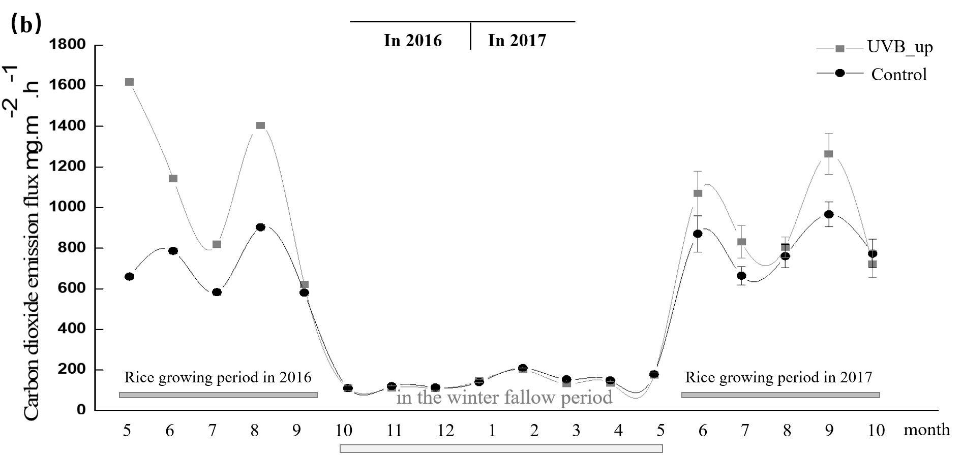

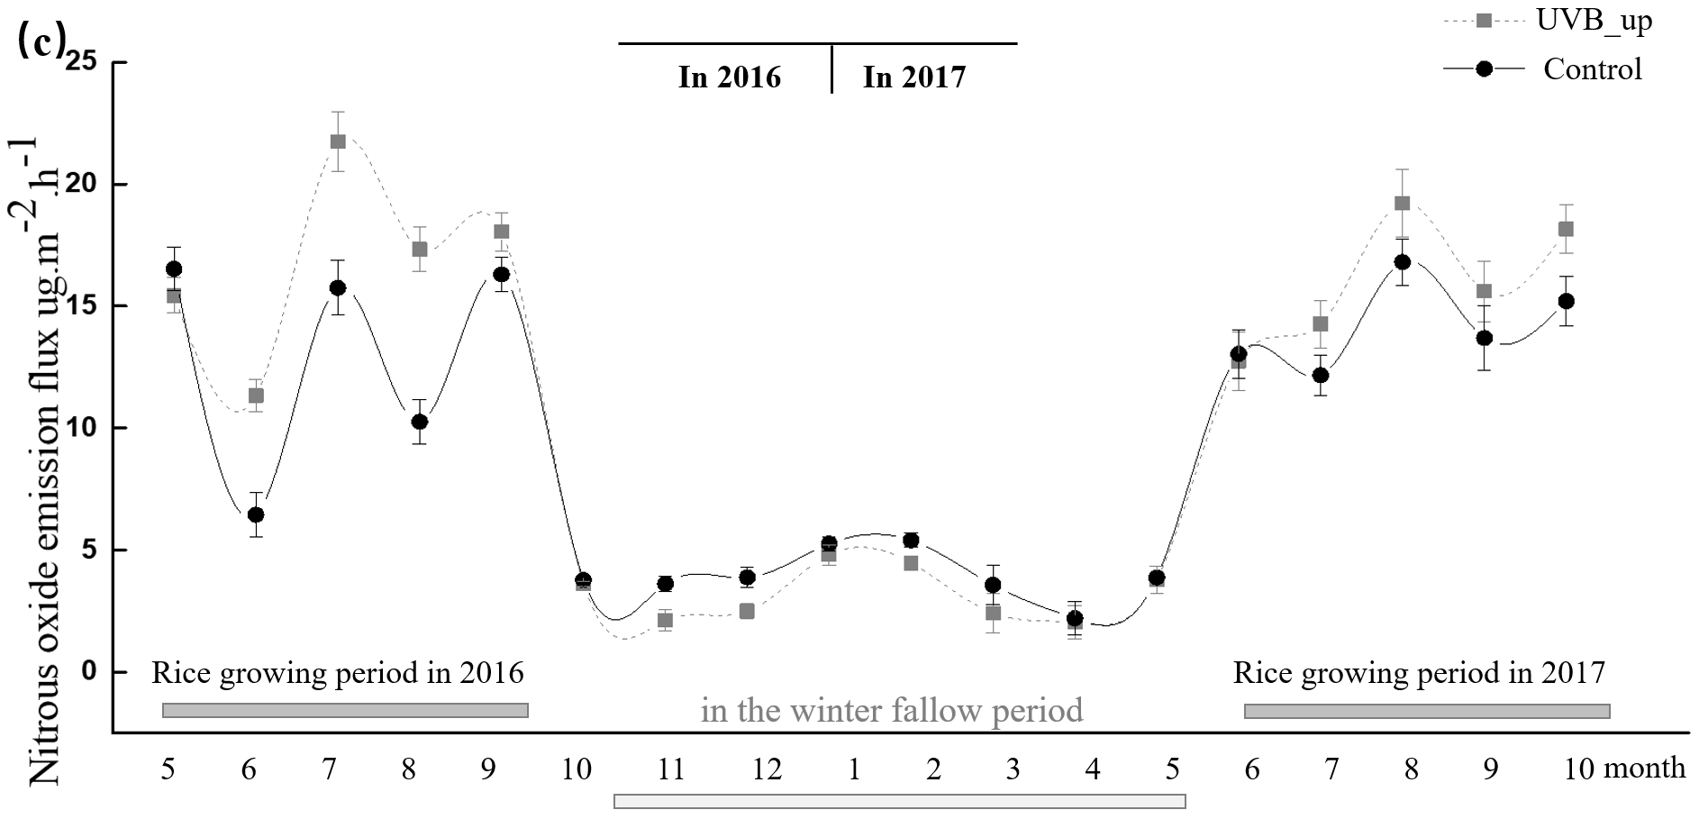

**Supplementary Figure 1.** CH4 (a), CO2 (b) and N2O (c) emissions and flux in the rice paddy under natural light (Control) and enhanced UV-B radiation (UVB_up) from May 2016 to October 2017.

**Section 3. Response ratios of enhanced UV-B treatment and the relationships between such treatment and weather and natural UV-B conditions**

Response ratios of enhanced UV-B treatment were less the results of shifts in precipitation, mean temperature, evaporation, and changes in natural UV-B conditions. All of the aforementioned variables are not significant (Supplementary Figure 2).

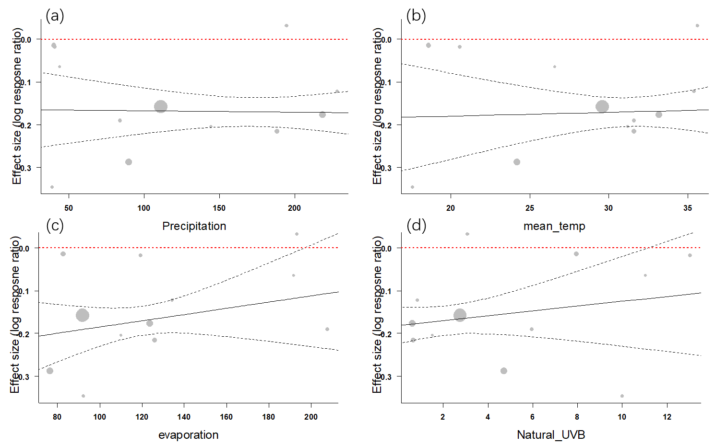

**Supplementary Figure 2.** Effect sizes of CH4 emissions under enhanced UV-B, and the relationships between the effect size and 4 environmental variables: (a) mean precipitation, mm; (b) mean temperature (℃); (c) mean evaporation, mm; (d) UV-B radiation under natural conditions, KJ/m2. Mean values < 0 (below the red dotted lines) indicate that, as compared to the effects under natural conditions, enhanced UV-B reduces the corresponding variables; all 4 environmental variables do not significantly affect effect size.

**Section 4. Dynamics of carbon transformation enzymes in the Yuanyang Terraces**

Compared with natural light treatment, enhanced UV-B radiation significantly reduced the activity of β-glucosidase (in June, July, and September) and invertase (in June, August, and September) during the rice-growing period, and polyphenol oxidase activities (in November, January, February, March, July, August, and September) over the course of the whole year. By contrast, enhanced UV-B radiation increased the activities of β-glucosidase (in February and March) and invertase (November, December, and May) in the winter fallow period and cellulase activities (in January, February, May, June, July, and August) over the course of the whole year (Supplementary Figure 3). These results indicate that UV-B radiation changes the activities of carbon transformation enzymes in the rice field and that its effects vary among enzyme types and the time of year.

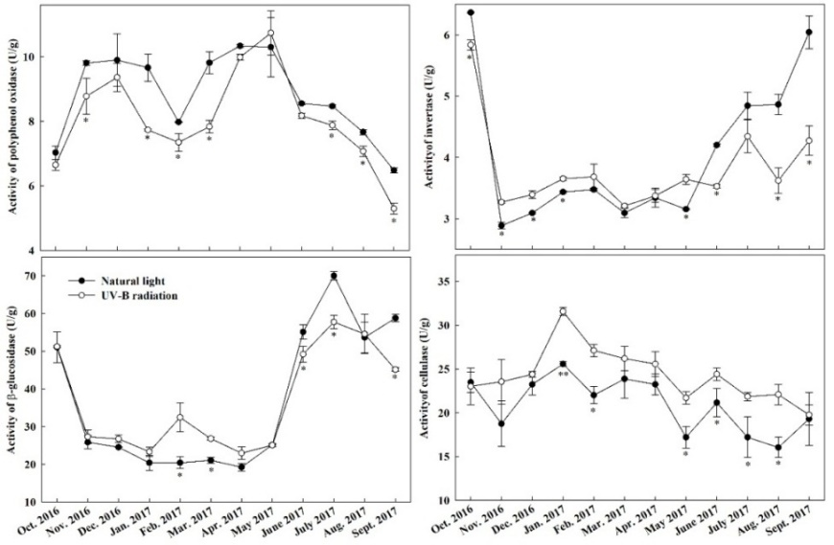

**Supplementary Figure 3.** Activities of carbon transformation enzymes in the rice paddy under natural light and enhanced UV-B radiation. Note: single asterisk for p-value < 0.05, double asterisks for p-value < 0.01.

**Section 5. Dynamics of soil labile organic carbon in the Yuanyang Terraces**

Compared with natural light treatment, enhanced UV-B radiation significantly reduced the contents of EOC (in November, December, January, March, April, May, and July) and MBC (in May, July, September, and October) over the course of the entire year, and the DOC content (in January) in the soils. By contrast, it increased soil DOC contents in July, September, and October (Supplementary Figure 4). These results indicate that UV-B radiation changes the LOC contents in the rice field and that its effects vary among LOC types and the time of year.

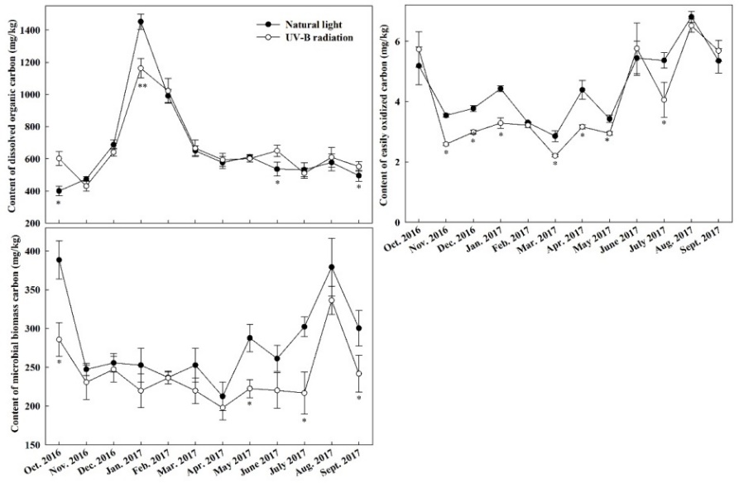

**Supplementary Figure 4.** Contents of labile organic carbon in the rice paddy under natural light and enhanced UV-B radiation. Note: single asterisk for p-value < 0.05, double asterisks for p-value < 0.01.

**Section 6. Effects of enhanced UV-B radiation on rice yield and rice straw composition**

Enhanced UV-B can significantly reduce rice biomass, rice seed weight, and rice yield. Meanwhile, it can also affect rice straw composition, by reducing for instance lignin and total phenols contents, which would further affect rice straw decomposition (Supplementary Table 1 and 2).

**Supplementary** **Table 1.** Effects of enhanced UV-B radiation on plant biomass and rice yield

|  |  |  |
| --- | --- | --- |
|  | Control | Enhanced UV-B treatment |
| Rice plant biomass (g) | 198.12±33.35 * | 159.93±34.55 |
| Rice height (cm) | 157.14±7.69 | 169.57±4.73 |
| Rice yield (g·m-2) | 683.03 ±32.19 * | 619.74±29.20 |
| Rice seed weight (g/1000 seed) | 25.705±1.62 * | 24.91±0.89 |
| Note: * Significant differences P <0.05. | | |

**Supplementary** **Table 2.**  Effect of UV-B Radiation on Rice Straw Composition

|  |  |  |
| --- | --- | --- |
|  | Control | Enhanced UV-B treatment |
| **L**ignin % | 21.35±2.56 * | 33.51±2.30 |
| **S**oluble sugarmg/g | 7.30±1.32 | 9.15±1.44 |
| **A**mylummg/g | 61.93±11.79 | 88.54±15.33 |
| **T**otal phenols mg/g | 25.35±1.13 * | 28.21±1.02 |
| **C**ellulose% | 15.57±2.34 | 15.77±2.12 |
| **F**lavonoidA305·g-1FW | 0.54±0.028 | 0.72±0.01* |
| Note: * Significant differences P <0.05. | | |