Supplementary Material

# Supplementary Figures and Tables

1

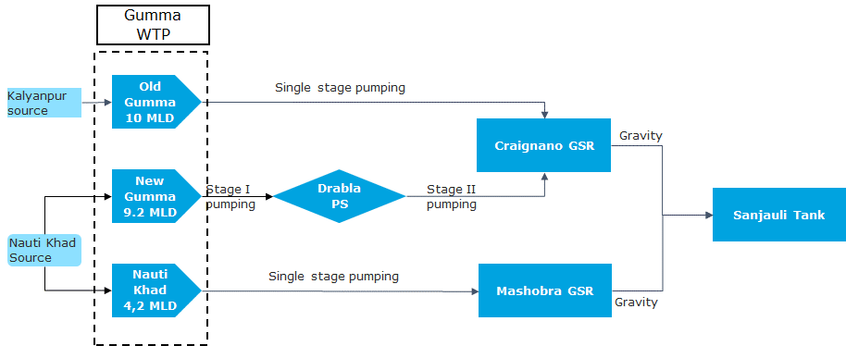

Figure : Gumma - Source to Tank

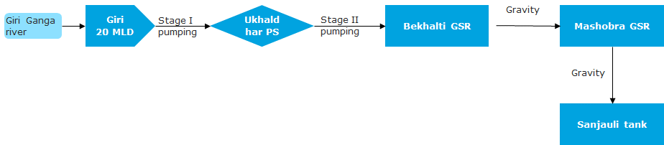Source: Situation Analysis Report, 2018. GSWSSC

2

Figure : Giri - Source to Tank

Source: Situation Analysis Report, 2018. GSWSSC.

3

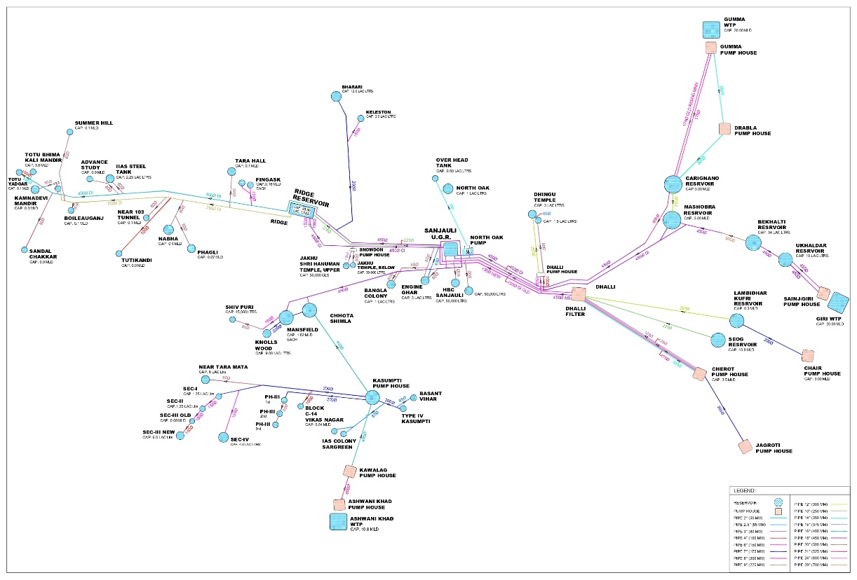

Figure : Water distribution network of Shimla. Source: SJPNL

4

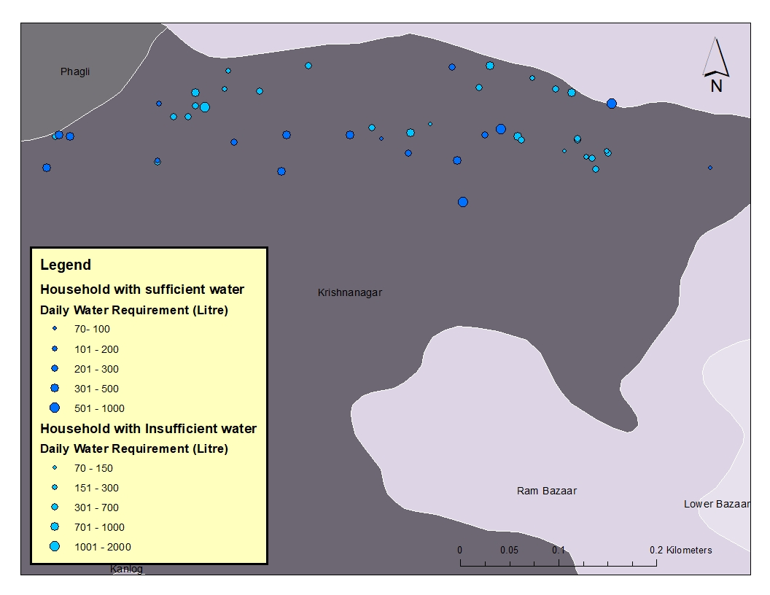

Figure : Map showing the daily water requirements of residents.