Fig. S1 Plots of relative abundance at each sampling site at the genus level.

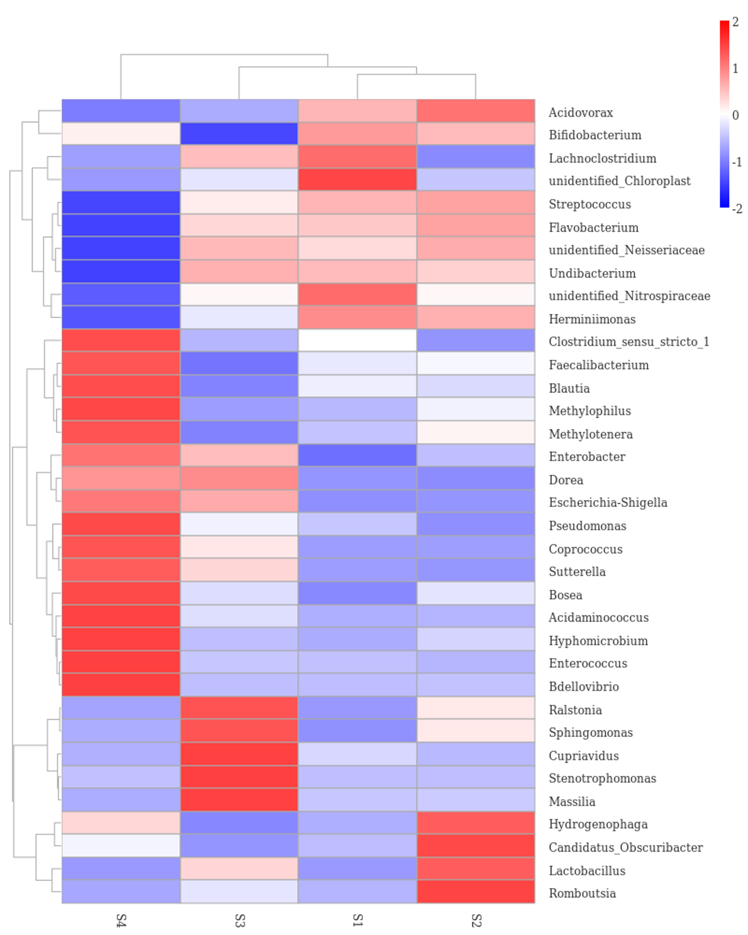

Fig. S2 Genus clustering heatmap (The dominant bacterial TAXA at the genus level)

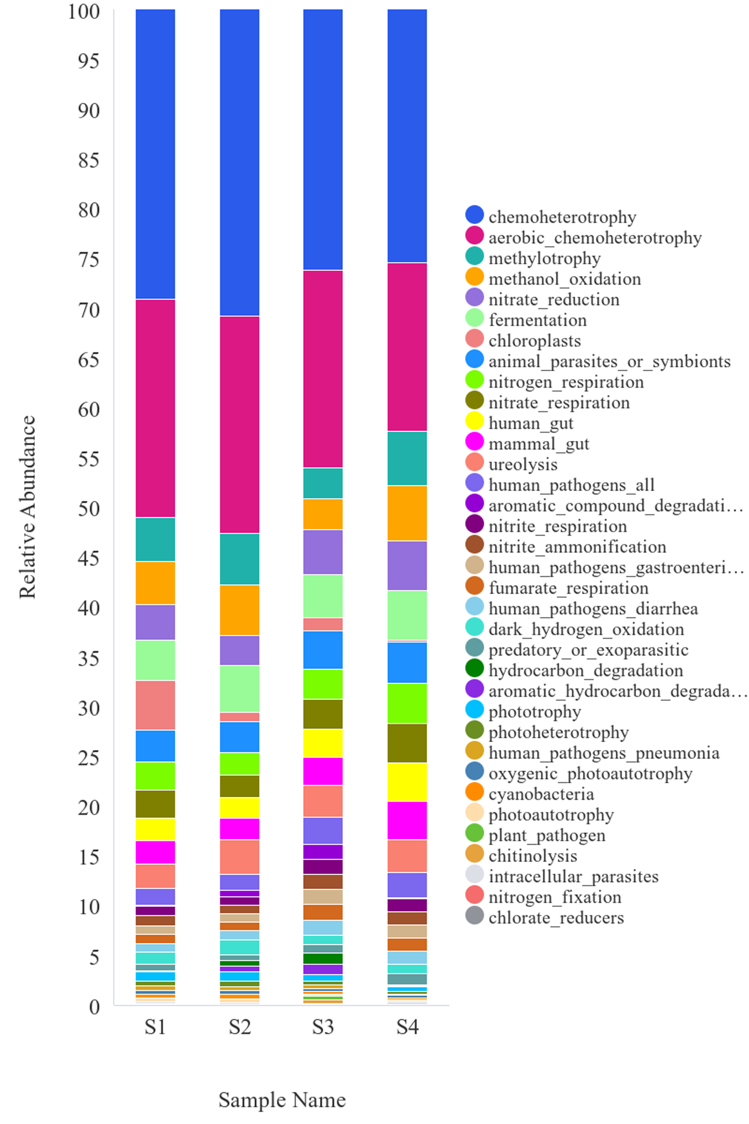Fig. S3 FAPROTAX - Relative abundance column chart

