Supplementary Material

# Supplementary Data

**1.1 Details of the apparatus used in this study**

Twenty-seven steel soil tanks of size 0.4 m × 0.2 m × 0.2 m were prefabricated to simulate soil erosion. The indoor rainfall simulation used handmade needle-and-tube rainfall equipment, which comprised a water supply device, pressure pump, raindrop generator, flowmeter, and syringe needles (Figure S1). This rainfall device was made of a perforated iron water tank with a medical syringe and an industrial dispensing dropper of the same diameter. The dropper has a variety of diameter models to adjust the size of the raindrops. Runoff devices (i.e., runoff boxes and beakers) were used to collect runoff samples. An ultra-low temperature refrigerator (Meiling DW-HL82) was used to simulate the freezing events.

**1.2 Calculations of runoff parameters**

The runoff rate (L m-2 min-1) was calculated as the ratio of runoff volume (L) to rainfall duration (min) and runoff area (m2) using Equation (1) according to Cheng et al. (2021). In addition, the soil loss rate (g m-2 min-1) was estimated as the ratio of sediment yield (g) to rainfall duration and runoff area (2). The total runoff (m3 hm-2) at the end of rainfall was calculated according to Equation (3). The total soil loss (t hm-2) at the end of rainfall was determined using Equation (4). The rate of runoff loss (mg m-2 min-1) of ammonia nitrogen (AN), nitrate nitrogen (NN), total phosphorus (TP), and dissolved phosphorus (DP) at the end of the rainfall was calculated using Equation (5). The total nutrient runoff loss per hectare (kg hm-2) at the end of the rainfall was calculated using Equation (6).

$$Runoff rate=\frac{Runoff volume}{Slope area×rainfall duration} (1)$$

$$Soil loss rate=\frac{Sediment yield}{Slope area×rainfall duration} (2)$$

$$Total runoff=\frac{Total runoff volume×10}{Slope area} (3)$$

$$Total soil loss=\frac{Total sediment yield}{Slope area×100} (4)$$

$$Runoff loss rate=Nutrients concentration×The runoff rate (5)$$

$$Total runoff loss=\frac{\sum{(Runoff volume × nutrients concentration)}}{Slope area×100} (6)$$

Where, the runoff volume is the total rainfall measured at the end of each rainfall duration time (*t*), and the nutrient concentration is the sum of the AN, NN, TP, and DP (mg L-1) concentrations at the end of each rainfall duration.

# Supplementary Figures and Tables

## Supplementary Figures

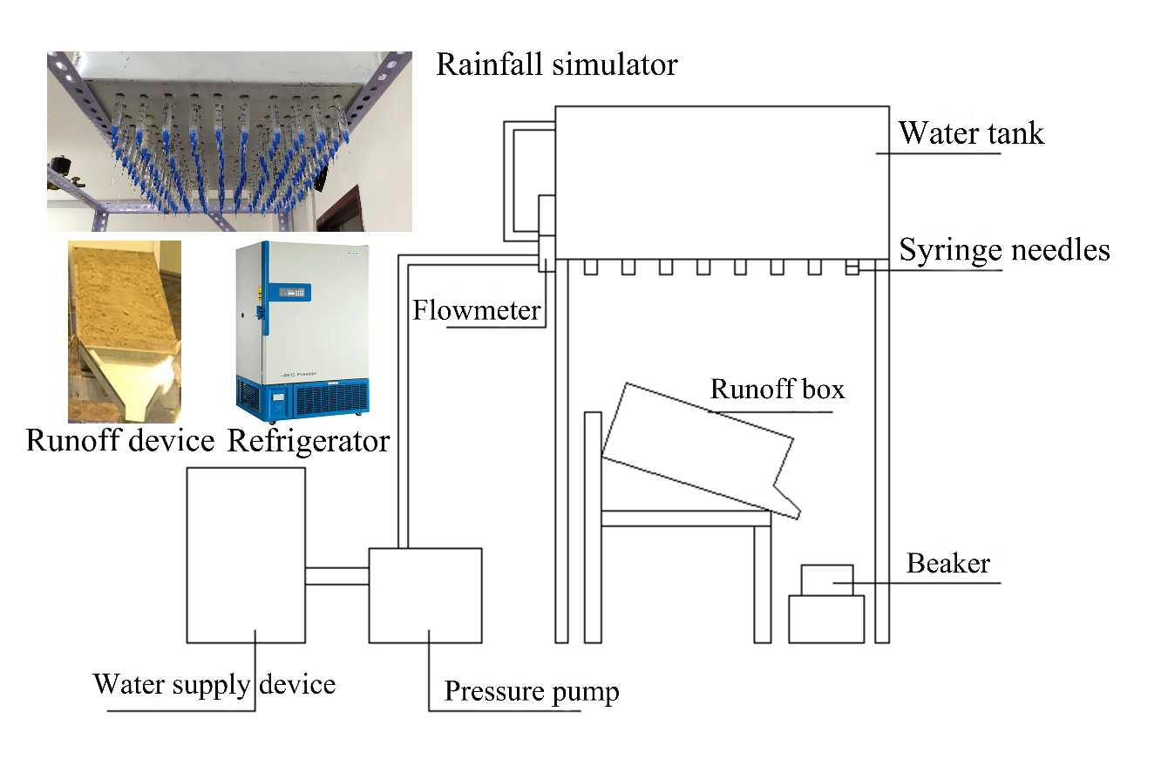

**Supplementary** **Figure 1**. Schematic diagram of the indoor rainfall simulation device.



**Supplementary** **Figure 2**. Influence of biochar application rates, i.e. (B0: 0 kg hm-2, B1: 500 kg hm-2, and B2: 1000 kg hm-2), on the concentrations of ammonia nitrogen (AN, A–C) and () nitrate nitrogen (NN, D–F) under the freeze-thaw conditions (F0: 0 cycles, F3: 3 cycles, and F5: 5 cycles).



**Supplementary** **Figure 3**. Influence of biochar application rates, i.e. (B0: 0 kg hm-2, B1: 500 kg hm-2, and B2: 1000 kg hm-2), on the concentrations of total phosphorus (TP, A–C) and dissolved phosphorus (DP, D–F) under the freeze-thaw conditions (F0: 0 cycles, F3: 3 cycles, and F5: 5 cycles).

## Supplementary Tables

**Supplementary Table 1**. Analysis of the effects of different freeze-thaw and biochar treatments on the runoff volume and soil loss.

|  |  |  |  |  |  |  |  |  |  |  |  |
| --- | --- | --- | --- | --- | --- | --- | --- | --- | --- | --- | --- |
|  | Runoff volume | | | | | | Soil loss | | | | |
|  | Sum of Squares | df | Mean Square | F value | *p* value | Sum of Squares | | df | Mean Square | F value | *p* value |
| Biochar application rate (BAR) | 518859.3418 | 2 | 259429.6709 | 90.6010 | 0.0001 | 782.4530 | | 2 | 391.2265 | 26.1350 | 0.0002 |
| Freeze-thaw cycles (FTCs) | 2901475.9378 | 2 | 1450737.9689 | 506.6420 | 0.0001 | 899.4835 | | 2 | 449.7417 | 30.0440 | 0.0001 |
| BARs × FTCs | 4112.7110 | 4 | 1028.1778 | 0.3590 | 0.8317 | 9.8518 | | 4 | 2.4630 | 0.1650 | 0.9511 |
| Error | 25770.9608 | 9 | 2863.4401 |  |  | 134.7250 | | 9 | 14.9694 |  |  |
| Total | 3450218.9514 | 17 |  |  |  | 1826.5132 | | 17 |  |  |  |

Note: *p* indicates statistical significance; *p <* 0.05, significant difference; *p <* 0.01, extremely significant difference.

**Supplementary Table 2**. Analysis of the effects of different freeze-thaw and biochar application treatments on the loss of ammonium and nitrate nitrogen in slope soil.

|  |  |  |  |  |  |  |  |  |  |  |  |
| --- | --- | --- | --- | --- | --- | --- | --- | --- | --- | --- | --- |
|  | Ammonium nitrogen (AN) | | | | | | Nitrate nitrogen (NN) | | | | |
|  | Sum of Squares | df | Mean Square | F value | *p* value | Sum of Squares | | df | Mean Square | F value | *p* value |
| Biochar application rates (BARs) | 0.1982 | 2 | 0.0991 | 113.7120 | 0.0001 | 0.1632 | | 2 | 0.0816 | 5.8380 | 0.0237 |
| Freeze-thaw cycles (FTCs) | 0.2106 | 2 | 0.1053 | 120.8380 | 0.0001 | 0.5599 | | 2 | 0.2800 | 20.0290 | 0.0005 |
| BARs × FTCs | 0.0150 | 4 | 0.0038 | 4.3120 | 0.0320 | 0.0045 | | 4 | 0.0011 | 0.0800 | 0.9866 |
| Error | 0.0078 | 9 | 0.0009 |  |  | 0.1258 | | 9 | 0.0140 |  |  |
| Total | 0.4317 | 17 |  |  |  | 0.8534 | | 17 |  |  |  |

Note: *p* indicates statistical significance; *p <* 0.05, significant difference; *p <* 0.01, extremely significant difference.

**Supplementary Table 3**. Analysis of total phosphorus and dissolved P in soil under a different number of freeze-thaw (FT) cycles and biochar application rates.

|  |  |  |  |  |  |  |  |  |  |  |  |
| --- | --- | --- | --- | --- | --- | --- | --- | --- | --- | --- | --- |
|  | Total phosphorus (TP) | | | | | | Dissolved P (DP) | | | | |
|  | Sum of Squares | df | Mean Square | F value | *p* value | Sum of Squares | | df | Mean Square | F value | *p* value |
| Biochar application rates (BARs) | 0.1015 | 2 | 0.0507 | 29.9800 | 0.0001 | 0.0461 | | 2 | 0.0230 | 111.4020 | 0.0001 |
| Freeze-thaw cycles (FTCs) | 0.1172 | 2 | 0.0586 | 34.6260 | 0.0001 | 0.0494 | | 2 | 0.0247 | 119.3700 | 0.0001 |
| BARs × FTCs | 0.0164 | 4 | 0.0041 | 2.4260 | 0.1240 | 0.0015 | | 4 | 0.0004 | 1.8570 | 0.2023 |
| Error | 0.0152 | 9 | 0.0017 |  |  | 0.0019 | | 9 | 0.0002 |  |  |
| Total | 0.2503 | 17 |  |  |  | 0.0988 | | 17 |  |  |  |

Note: *p* indicates statistical significance; *p <* 0.05, significant difference; *p <* 0.01, extremely significant difference.

**Reference**

Cheng Y., Li P., Xu G., Wang X., Li Z., Cheng S., Huang M，2021. Effects of dynamic factors of erosion on soil nitrogen and phosphorus loss under freeze-thaw conditions. Geoderma, 390: 114972. https://doi:10.1016/j.geoderma.2021.114972