# Appendix B

**Appendix B1**

The Eu/Eu* (i.e., EuN/(SmN0.5*GdN0.5 ) as all values are chondrite normalized) are mainly between 0.88-1.3 and 93% data are between 0.9-1.2 (Fig. B 1 A, B). This confirms very limited plagioclase crystallization discussed in section 2.1. No correlation between Sr/Nd and EuN/Eu* (Fig. B 1 C) demonstrates trace element ratios such as Sr/Nd are not affected by crystallization and represent the composition of primitive magmas.



Fig. B 1 (A) Histogram for Eu/Eu*. (B) Pareto diagram for Eu/Eu*. (C) Sr/Nd vs Eu/Eu*. 36 values from Eastern Lau spreading centre which are bigger than 2 are excluded.

**Appendix B2**

The indices of aqueous fluid such as Ba/Nb and Sr/Nd is not correlated with Ba in subducting sediments and Sr in subducting sediments respectively (Fig. B 2). Similarly, Th/Nb has no correlation with Th in sediments. The ratio Ba/La is positively correlated with the Ba content in subducting sediments. All these trace element ratios are not correlated with sediment thickness. These indicate trace element ratios especially Ba/Nb, Sr/Nd, and Th/Nb are not controlled by the composition and amount of sediment subducted and they can be used to find the relationship between physical parameters of subduction and the volume of slab component in mantle source.

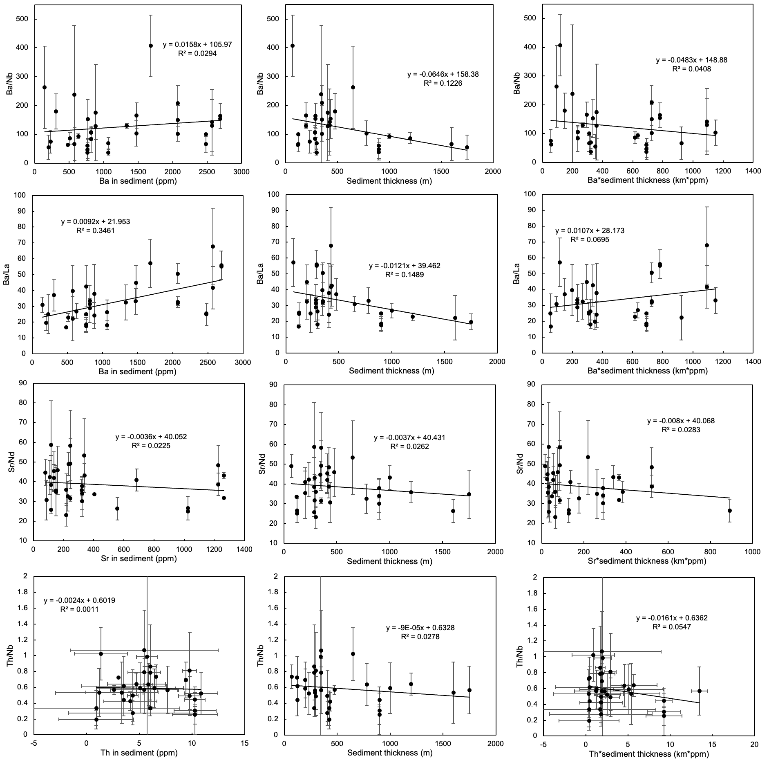

Fig. B 2 Indices of slab components in frontal arcs vs trace elements in subducting sediments or sediment thickness. The sediments are from Plank, 2013.

**Appendix B3**

Slab dip negatively correlates with crustal thickness, especially for frontal arcs (Fig. B3).

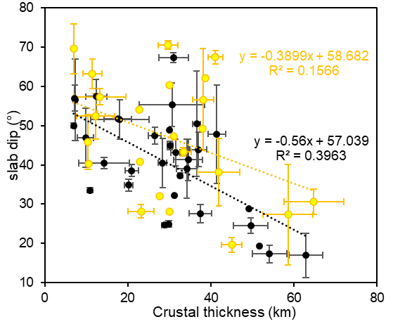

*Fig. B3 The correlation between crustal thickness and slab dip.*

Reference:

Plank, T., 2013. The Chemical Composition of Subducting Sediments, 2nd ed, Treatise on Geochemistry: Second Edition. Elsevier Ltd. https://doi.org/10.1016/B978-0-08-095975-7.00319-3