Supplementary Material

Supplementary Table
Table S1. gene expression data for 60 OSCC and 112 normal tissues from GEO database
GSE | Total differentially  expressed genes | Up-regulated | Down-regulated | Technology/Platform | Sample size for each group
GSE138206 | 1756 | 972 | 784 | [HG-U133_Plus_2]  Affymetrix  Human Genome U133  Plus 2.0 Array | 6 cancer tissues  6 contralateral normal tissues  6 tissues adjacant to cancer
GSE13601 | 4230 | 1437 | 2793 | [HG_U95Av2] Affymetrix  Human Genome  U95 Version 2 Array | 31 cancer tissues  27 normal tissues
GSE31056 | 2459 | 1180 | 1279 | [HG-U133_Plus_2] Affymetrix  GeneChip Human Genome  HG-U133 Plus 2 Array  [Brainarray Version 12] | 23 cancer tissues  73 margin normal tissues
Intersection | 416 | 238 | 178

Table S2. Expression results of the final screened five differential genes in different data sets
Gene |  | Log2FC |  |  | adj.P.Val
 | GSE138206 | GSE13601 | GSE78060 | GSE138206 | GSE13601 | GSE78060
CFD | -2.788600111 | -2.055809071 | -2.201918982 | 0.000187085 | 2.14E-09 | 0.009358046
CLU | -2.260752461 | -1.727585949 | -3.768587542 | 0.000275858 | 0.000407028 | 0.011503766
ABCA8 | -2.516874171 | -2.710794019 | -2.552601713 | 0.000571622 | 2.41E-07 | 0.04431405
ADH1B | -2.844443838 | -3.16653475 | -3.702646599 | 0.002304717 | 3.82E-08 | 0.000672318
CRISP3 | -4.87188203 | -2.625730345 | -5.767466592 | 0.006802578 | 9.80E-06 | 0.030553507

Supplementary Figures

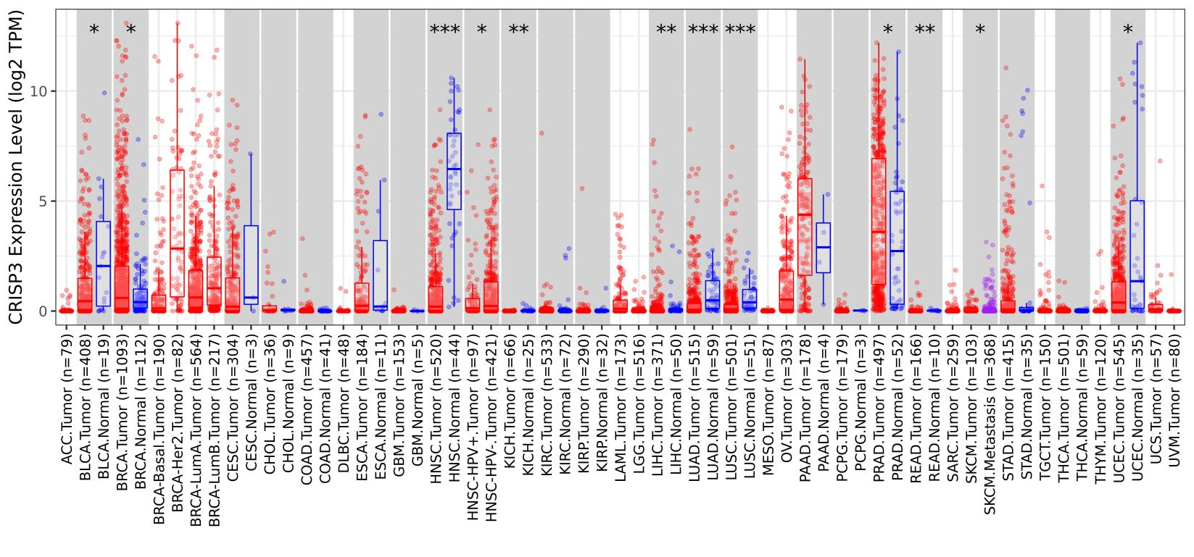
Fig. S1. CRISP3 expression levels in various tumor tissues and stages. TIMER2 was utilized to examine CRISP3 gene expression differences in different malignancies or tumor subtype tissues and nearby non-tumor tissues in the TCGA experiment. (*P < 0.05; **P < 0.01; ***P < 0.001)

Fig. S2. CLU expression levels in human tissues were obtained by analysis of HUMAN PROTEIN ATLAS tool (A) CLU protein expression in various human tissues; (B) RNA expression of CLU in numerous human tissues.

Fig. S3. CLU gene expression levels in several types of cancers and pathological stages (A) GTEx database's equivalent normal tissues were employed as controls, and GEPIA2 was utilized to examine the CLU gene expression status in ACC and SARC; (B) CLU expression levels by numerous pathological staging of BLCA, BRCA, CESC, CHOL, COAD, DLBC, ESCA, HNSC, KIRP, LUSC, OV, PAAD, READ, STAD, TGCT, and UCEC

Fig. S4. The link between CLU gene expression and cancer prognosis was investigated utilizing the Kaplan-Meier plotter. We carried out a series of survival analyses utilizing Kaplan-Meier plotter depending on CLU expression level in ovarian cancer (A) lung cancer; (B) gastric cancer; (C) liver cancer (D); and BC; (E) cases, including OS, DMFS (Distant metastasis-free survival), RFS, PFS, PPS, and FP.

Fig. S5. Correlation investigation of CLU gene expression with CD8+ T-cell immunological infiltration (A) For all TCGA tumors, several algorithms (TIMER, EPIC, MCPCOUNTER, CIBERSORT, CIBERSORT-ABS, QUANTISEQ, and XCELL) were used to assess the connection between CLU expression and the amount of immunological infiltration of CD8+ T-cells; (B) scatterplot data of the selected tumor was provided, which was created using one of the methods.

Fig. S6. GO-biological process/molecular function/cellular component analysis of CLU-related genes. (A) Dot plot for the biological process data in GO enrichment analysis is based on CLU-correlated genes and CLU-bound proteins; (B) dot plot for the molecular function data in GO enrichment analysis depends on CLU-correlated genes and CLU-bound protein; (C) dot plot for the cellular component data in GO analysis depending on CLU-correlated genes and CLU-bound protein.

