# Large scale genetic transformation of mature seed embryo explants in maize

Xudong Yeꝉ1, Ashok Shrawatꝉ1, Edward Williams2, Anatoly Rivlin2, Zarir Vaghchhipawala1, Lorena Moeller1, Jennifer Kumpf3, Shubha Subbarao1, Brian Martinell1, Charles Armstrong1, M. Annie Saltarikos1, David Somers3, Yurong Chenꝉ1, 4

ꝉThese authors contributed equally to this work

1Plant Biotechnology, Bayer Crop Science,700 Chesterfield Pkwy, W. St. Louis, MO, 63017, USA

2 Agracetus Campus, Monsanto Company, 8520 University Green, P.O. Box 620999, Middleton, WI, 53562

3 Mystic Research, Monsanto Company, 62 Maritime Drive, Mystic, CT 06355, USA

4 To whom correspondence should be addressed

Address correspondence to

Dr. Yurong Chen

Plant Biotechnology

Bayer Crop Science,

700 Chesterfield Pkwy, W. St. Louis, MO 63017

[yurong.chen@bayer.com](mailto:yurong.chen@bayer.com)

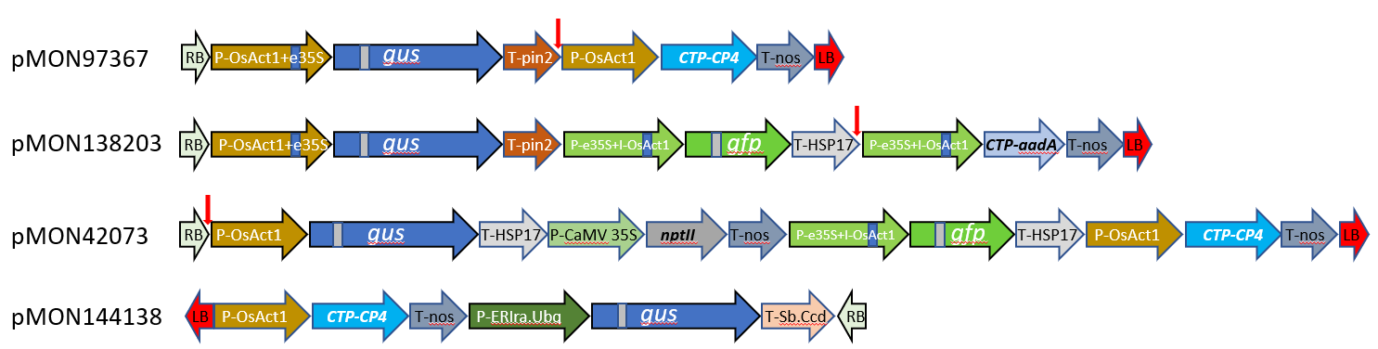

**Supplemental Figure S1:** Constructs used for maize SEEs transformation development.Vertical arrows indicate *HindIII* cut for Southern blot. Note: pMON138210 is identical to pMON138203 except that the *aadA* coding sequence is codon optimized for monocot expression. pMON138210 is identical to pMON138203, except for the codon optimization of *aadA*. **P-OsAct1+e35S**: rice actin 1 promoter with CaMV enhancer sequence; ***gus****: gusA gene with intron (*Vancanneyt et al., 1990);***T-pin2:*** Potato proteinase inhibitor II terminator (GenBank accession X04118)***;*** ***CP4****: cp4 epsps gene from Agrobacterium* CP4 strain encoding for 5-enolpyruvulshikimate-3-phosphate synthase; ***T-nos****: Agrobacterium nos* transcription terminator (Depicker et al. 1982); **P-ERIra.Ubq**: *Tripidium ravennae* ubiquitin promoter (GenBank MH026095); **P-eCaMV35S**: enhanced CaMV 35S promoter; ***aadA***: aminoglycoside (3'') (9) adenylyltransferase gene confers resistance to the aminoglycosides spectinomycin; **T-HSP17**: wheat heat shock protein terminator (GenBank accession X13431); ***gfp****:* green fluorescent protein gene (Pang et al., 1996); ***nptII***: neomycin phosphotransferase gene; **T-Sb.Ccd**: *Sorghum bicolor* cortical cell-delineating protein terminator (GenBank accession XM_002450283.2)

**References:**

1.Depicker A, Stachel S, Dhaese P, Zambryski P, Goodman HM. (1982) Nopaline synthase: transcript mapping and DNA sequence. J Mol Appl Genet. 1:561-73. (no DOI #)

2.Pang SZ, DeBoer DL, Wan Y, Ye G, Layton JG, Neher MK, Armstrong CL, Fry JE, Hinchee MA, Fromm ME. (1996) An improved green fluorescent protein gene as a vital marker in plants. Plant Physiol. 112: 893–900. https://doi:10.1104/pp.112.3.893

3.Vancanneyt G, Schmidt R, O’Connor-Sanchez A, Willmitzer L, Rocha-Sosa M (1990) Construction of an intron-containing marker gene: splicing of the intron in transgenic plants and its use in monitoring early events in *Agrobacterium*-mediated plant transformation. Mol Genet Genomics. 220:245–2503. <https://doi.org/10.1007/BF00260489>

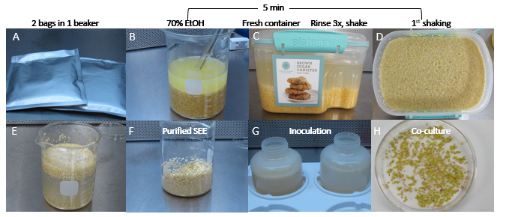

**Supplemental Figure S2:** Purification of maize SEE by water floatation. **A**) Ground maize seed particles sealed in a Mylar bag and stored at -20 or -80 oC; **B**) Pour two bags (20,000 SEEs each) into 1 liter beaker, add 70% ethanol to cover the crushed corn particles for about 4 min, pour off the ethanol and rinsed with 500 ml sterilized water 3 times; **C**) Transfer into the canister, add 1 liter water, close the lid with snap lock, shake 1 to 3 times to float SEEs; D) SEE float on surface; E) Scoop the SEE into a 500 ml beaker with 500 ml water, rinse with water 3 times; **F**) Rinsed SEEs ready for inoculation; **G**) Transfer SEEs into 500 ml conical centrifuge tube with 300 to 500 ml *Agrobacterium* suspension; centrifuge at 291 xg for 30 mins, remove *Agrobacterium* suspension completely after centrifuging and pouring into a Plantcon lid; **H**) Spread 1 layer of inoculated *Agrobacterium* SEEs on a filter paper for co-culture.

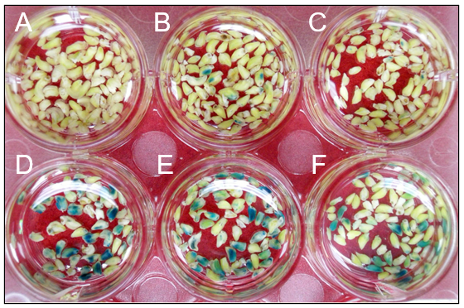

**Supplemental Figure S3.**  T-DNA delivery into relevant tissues of maize SEEs by KOH pre-treatment and sonication during inoculation. 2 mM KOH pretreatment of SEE before *Agrobacterium* inoculation, followed by vacuum and/or sonication. **A**) control, no *Agrobacterium*, vacuum twice, sonication 1 min; **B**) with *Agrobacterium*, vacuum 1x; **C**) with *Agrobacterium*, vacuum 2x; **D**) with *Agrobacterium*, sonication 1 min; **E**) with *Agrobacterium*, vacuum 1x, and followed by sonication 1 min; **F**) with *Agrobacterium*, vacuum 2x, and followed by sonication 1 min. pMON42073 (Figure S1) was used for these experiments.



**Supplemental Figure S4.** The effect of centrifugation, sonication, and temperature on T-DNA delivery to maize SEEs during inoculation with *Agrobacterium*. The negative control treatment (center) was not inoculated. Four treatments (on the left) were sonicated for 1 minute at 45 kHz, whereas four treatments (on the left) were not. Additional treatments (as labeled) were centrifugation at 291 xg, or no centrifugation and temperatures of 4⁰C or 23⁰C. Expression of gusA was measured as an activity in a MUG fluorometric assay for quantitative analysis of beta-glucuronidase (GUS) activity.



**Supplemental Figure S5.** *Agrobacterium* infection of SEEs of multiple germplasms under different inoculation conditions. (**A**) to (**C)** Infection of inbred line BPL1, BPL2 and LH244inoculated with AB32 / pMON138203 without centrifugation; (**D**) to (**F**) Infection of inbred lines BPL1, BPL2 and LH244inoculated with AB32 / pMON138203 with centrifugation at 291 g.



**Supplemental Figure S6**. The effect of co-culture medium on transient expression. (**A**) Co-culture medium 1595; (**B**) Co-culture medium 1595 with 5 mg/l 2,4-D; (**C**) Co-culture medium 1484; (**D**) Co-culture medium 1273.

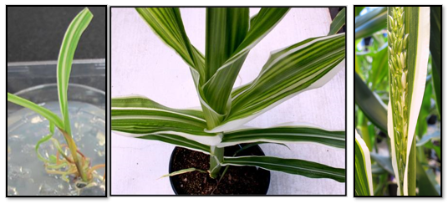

**Supplemental Figure S7.** Examples of phenotypic chimerism of primary transformed plants selected on glyphosate. **From left to right**: striped plantlet from tissue culture, striped leaves from plant in soil, striped leaf and tassel from plant in greenhouse.

**Supplemental Table S1**. Transmission of transgenes into the next generation in maize SEE transformation

|  |  |  |  |  |  |  |  |  |
| --- | --- | --- | --- | --- | --- | --- | --- | --- |
| Event | Vector | Selectable marker | Estimated GUS copy | Estimated CP4 copy | Pollen staining | GUS+ : GUS in F1 progeny | Exp. ratio | Chi-square value |
| 2 | pMON 42073 | npt II | 1 | 1 | ND | 21:19 | 1:1 | 0.03 |
| 3 | pMON 97367 | cp4 | 2 | 2 | ND | 17:19 | 1:1 | 0.03 |
| 4 | pMON 97367 | cp4 | 4 | 2 | ND | 8:11 | 1:1 | 0.21 |
| 5 | pMON 97367 | cp4 | 5 | 2 | segregation | 8:15 | 1:1 | 1.57 |
| 6 | pMON 97367 | cp4 | >4 | 4 | segregation | 25:23 | 1:1 | 0.02 |
| 7 | pMON 97367 | cp4 | 8 | >4 | negative | 1:47 | 1:1 | 42.2* |
| 8 | pMON 97367 | cp4 | 4 | 2 | ND | 15:22 | 1:1 | 0.97 |
| 9 | pMON 97367 | cp4 | 3 | 1 | segregation | 23:19 | 1:1 | 0.21 |
| 10 | pMON 97367 | cp4 | >8 | >6 | ND | 10:1 | 3:1 | 0.76 |
| 12 | pMON 97367 | cp4 | 1 | 1 | segregation | 28:46 | 1:1 | 3.90* |
| 13 | pMON 97367 | cp4 | 2 | 1 | segregation | 23:12 | 1:1 | 2.86 |
| 15 | pMON  138210 | aadA | 1 | 0 | segregation | 19:20 | 1:1 | 0.00 |