Supplementary information
Appendix. Supplementary data
Table S1. Components identified in SLPN by LC-MS.
Figure S1. Photograph of Panax notoginseng plants.
Figure S2. Base peak ion chromatogram (BPI) of SLPN analyzed by UPLC - MS (A), principal components of instant beverage identified by HPLC-ELSD (B).

Table S1. Components identified in SLPN by LC-MS.
No. | Component | Retention time (min) | Formula | Observed (m/z) | Mass error  (m Da) | Mass error  (ppm) | Adducts
1 | Dencichine | 0.66 | C₅H₈N₂O₅ | 175.0357 | -0.3 | -1.7 | -H
2 | Quercetin-3-O-β-D-galactose (21) glucoside | 2.84 | C₂₇H₃₀O₁₇ | 625.1461 | -1.4 | -0.8 | -H
3 | Kaempferol-3-O-β-D-galactose (21) glucoside | 3.18 | C₂₇H₃₀O₁₆ | 609.1522 | -1.3 | -1.1 | -H
4 | Ginsenoside-La | 7.2 | C₄₂H₇₂O₁₄ | 845.4891 | -1.3 | -1.5 | +HCOO
5 | Floralginsenoside P | 9.63 | C₅₃H₉₀O₂₃ | 1139.5840 | -1.6 | -1.4 | +HCOO, -H
6 | Notoginsenoside D | 10.66 | C₆₄H₁₀₈O₃₁ | 1417.6830 | -3 | -2.1 | +HCOO, -H
7 | Ginsenoside I (24S or 24R) | 11.06 | C₄₈H₈₂O₂₀ | 977.5307 | -1.9 | -2 | -H
8 | Chikusetsusaponin L₅ | 11.72 | C₄₆H₇₈O₁₇ | 947.5195 | -2.6 | -2.8 | +HCOO
9 | Notoginsenoside R₄ | 12.16 | C₅₉H₁₀₀O₂₇ | 1285.6410 | -2.8 | -2.2 | +HCOO, -H
10 | Notoginsenoside R₁ | 12.54 | C₄₇H₈₀O₁₈ | 977.5298 | -2.9 | -2.9 | +HCOO
11 | Floralquinquenoside B | 12.55 | C₄₂H₇₂O₁₅ | 815.4780 | -1.8 | -2.2 | -H
12 | Ginsenoside F₃ | 12.81 | C₄₁H₇₀O₁₃ | 815.4786 | -1.3 | -1.5 | +HCOO
13 | Ginsenoside Ra₁ | 13.35 | C₅₈H₉₈O₂₆ | 1255.6290 | -3.4 | -2.7 | +HCOO, -H
14 | Malonylginsenoside Ra₃ | 13.7 | C₆₂H₁₀₂O₃₀ | 1325.6350 | -3.0 | -2.3 | -H
15 | M-notoginsenoside R₄ | 13.9 | C₆₂H₁₀₂O₃₀ | 1325.6350 | -3.3 | -2.5 | -H
16 | Yesanchinoside J | 14.15 | C₆₁H₁₀₂O₂₈ | 1281.6450 | -3.4 | -2.6 | -H
17 | Quinquefoloside-Lc | 14.28 | C₅₄H₉₂O₂₃ | 1153.5980 | -3 | -2.6 | +HCOO, -H
18 | Quinquenoside R₁ | 14.57 | C₅₆H₉₄O₂₄ | 1195.6080 | -4.2 | -3.5 | +HCOO, -H
19 | Notoginsenoside FP₂ | 14.89 | C₅₈H₉₈O₂₆ | 1255.6300 | -2.7 | -2.2 | +HCOO, -H
20 | Malnoylfloralginsenosides Rb₁ | 15.26 | C₅₇H₉₄O₂₆ | 1193.5940 | -2.5 | -2.1 | -H
21 | Notoginsenoside Q | 15.71 | C₆₃H₁₀₆O₃₀ | 1387.6730 | -2.1 | -1.5 | +HCOO, -H
22 | Vinaginsenoside R₂₀ | 15.92 | C₄₈H₈₀O₂₀ | 975.5150 | -2 | -2.1 | -H
23 | Notoginsenoside A | 16.09 | C₅₄H₉₂O₂₄ | 1123.5890 | -1.7 | -1.5 | -H
24 | Ginsenoside F₁ | 16.41 | C₃₆H₆₂O₉ | 683.4376 | 0.0 | 0.0 | +HCOO
25 | Chikusetsusaponin FK₆ | 16.62 | C₅₃H₉₀O₂₂ | 1123.5900 | -1.0 | -0.9 | +HCOO, -H
26 | Ginsenoside Rs₁ | 17.3 | C₅₅H₉₂O₂₃ | 1119.5930 | -2.2 | -2.0 | -H
27 | Malnoylfloralginsenosides Rc₁ | 17.3 | C₅₆H₉₂O₂₅ | 1163.5840 | -1.7 | -1.5 | -H
28 | Malonylginsenoside Rb₂ | 17.4 | C₅₆H₉₂O₂₅ | 1163.5840 | -1.8 | -1.5 | -H
29 | Pseudoginsenoside F₈ | 17.68 | C₅₅H₉₂O₂₃ | 1119.5950 | -0.6 | -0.5 | -H
30 | Notoginsenoside K | 18.35 | C₄₈H₈₂O₁₈ | 991.5471 | -1.2 | -1.2 | +HCOO, -H
31 | Malnoylfloralginsenosides Rd₁ | 18.44 | C₅₁H₈₄O₂₁ | 1031.5410 | -2.3 | -2.2 | -H
32 | Malnoylfloralginsenosides Re₃ | 18.44 | C₅₁H₈₄O₂₁ | 1031.5420 | -1.6 | -1.5 | -H
33 | Notoginsenoside P | 19.03 | C₅₂H₈₈O₂₁ | 1093.5780 | -2.3 | -2.1 | +HCOO, -H
34 | Floralginsenoside O | 19.42 | C₅₃H₉₀O₂₄ | 1155.5720 | -8.9 | -7.7 | +HCOO
35 | Malnoylfloralginsenosides Rd₆ | 19.57 | C₅₄H₈₆O₂₄ | 1117.5420 | -1.3 | -1.1 | -H
36 | Quinquefoloside Lb | 19.85 | C₅₃H₈₈O₂₂ | 1075.5680 | -1.9 | -1.8 | -H
37 | Notoginsenoside R₆ | 19.95 | C₄₈H₈₂O₁₉ | 961.5350 | -2.8 | -2.9 | -H
38 | Notoginsenoside Fe | 20.71 | C₄₇H₈₀O₁₇ | 961.5363 | -1.5 | -1.5 | +HCOO, -H
39 | Ginsenoside Rb₁ | 20.71 | C₅₄H₉₂O₂₃ | 1107.5940 | -1.7 | -1.5 | -H
40 | Ginsenoside F₂ | 22.4 | C₄₂H₇₂O₁₃ | 829.4947 | -0.7 | -0.9 | +HCOO
41 | Notoginsenoside ST - ₂ | 22.5 | C₄₃H₇₄O₁₅ | 829.4949 | -0.6 | -0.8 | -H
42 | Ginsenoside Rs₃ | 22.72 | C₄₄H₇₄O₁₄ | 871.5049 | -1.2 | -1.4 | +HCOO, -H
43 | Ginsenoside Rs₄ | 23.32 | C₄₄H₇₂O₁₄ | 869.4895 | -0.9 | -1.0 | +HCOO
44 | 24(R) - Pseudoginsenoside F₁₁ | 23.72 | C₄₂H₇₂O₁₄ | 799.4845 | -0.4 | -0.5 | -H
45 | Gypenoside XIII | 24.61 | C₄₁H₇₀O₁₂ | 799.4847 | -0.3 | -0.3 | +HCOO, -H
46 | 24(R) - Vinaginsenoside R₁ | 25 | C₄₄H₇₄O₁₅ | 841.4942 | -1.3 | -1.5 | -H

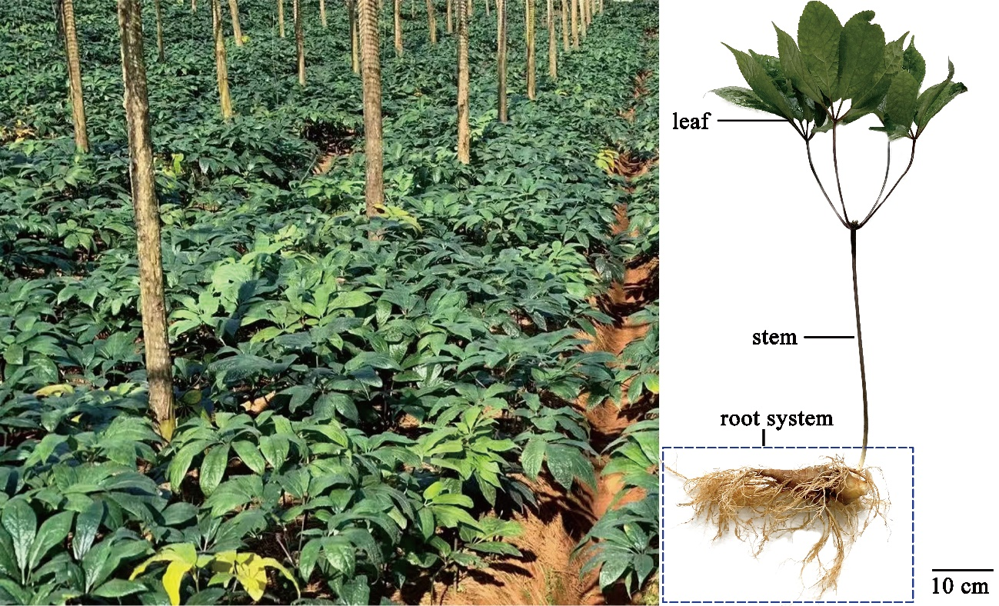
Figure S1. Photograph of Panax notoginseng plants

Figure S2. Base peak ion chromatogram (BPI) of SLPN analyzed by UPLC - MS (A), principal components of SLPN-instant beverage identified by HPLC-ELSD (B).

