**Supplementary Information**

# Supplementary Data & Figures

**Supplementary Information Section S1.1: Examples Time-Series Voltaiq Data Files**

Time-series data collected in Voltaiq Data Format files have two main sections, a header and a body. The header consists of a metadata header and the body consists of the time-series data. An example file is shown below which shows the metadata header and the body, separated by the [DATA START] line. The termination of the header is indicated by a line containing only the string "[DATA START]". This file can be downloaded and accessed at <https://github.com/vq-clininger/VoltaiqDataFormat>.

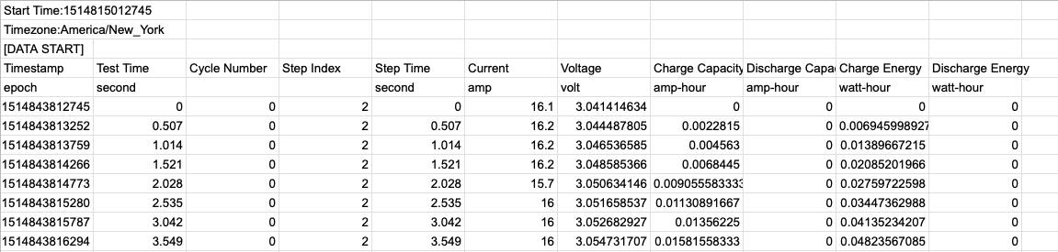

**Figure S1.1: Image of time-series datafile in Voltaiq Data Format.**

For any additional time-series trace names that are not explicitly included in Table 2 in the main body, the columns should be included in the file as auxiliary traces, named “Aux. {Trace Name}”, where {Trace Name} is replaced with a descriptive name for the time-series data. Below is an example of a Voltaiq Data File with displacement measurements included as an auxiliary trace. BMS traces are another example of data that can be included as auxiliary traces.

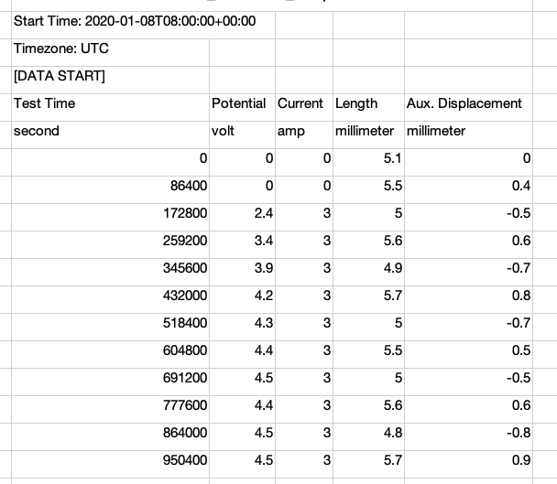

**Figure S1.2: Image of time-series datafile in Voltaiq Data Format with an auxiliary measurement.**

**Supplementary Information Section S1.2: Example Voltaiq Metadata Files**

Metadata that is outside the scope of the time-series datafile header should be included in a separate metadata file in Voltaiq Metadata Format. Each row is a distinct electrochemical device, each column is named according to the Voltaiq standard naming schema, and each value column has an associated units column subsequently. This file can be downloaded and accessed at <https://github.com/vq-clininger/VoltaiqDataFormat>.

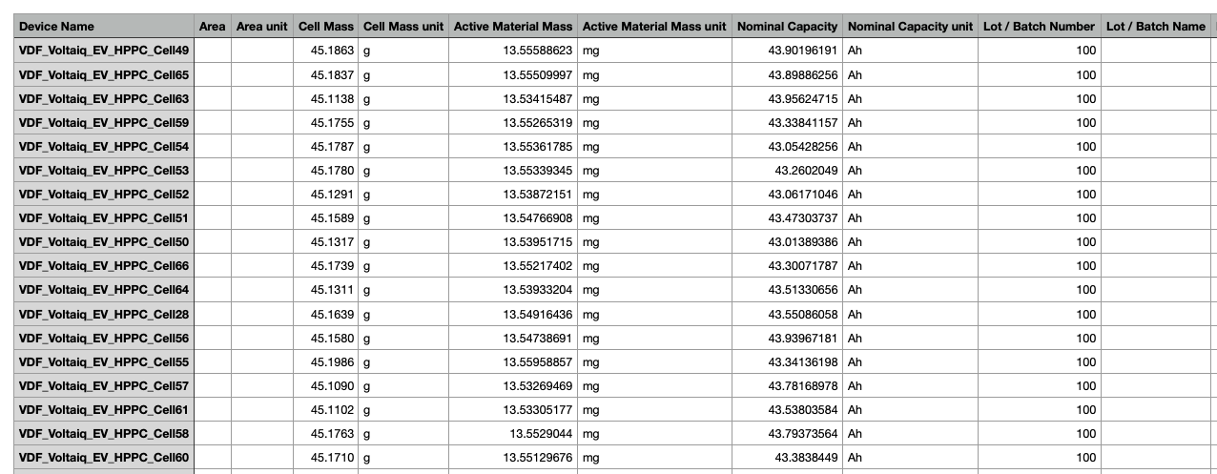

**Figure S2.1: Image of Voltaiq Data Format Metadata file.**

# Supplementary Tables

**Supplementary Information Section S2.1: Supported Units**

For each dimension of measurement, we have listed the accepted units for all Voltaiq Data File traces.

## Supported Units

| **Dimension** | **Unit** | **Key for Datafile** |
| --- | --- | --- |
| Angle | Degrees | degree |
| Angle | Radians | radian |
| Area | Square Centimeters | square-cm |
| Area | Square Meters | square-m |
| Area | Square Inches | square-in |
| Area | Square Millimeters | square-mm |
| Areal Density | Milligrams per Square Centimeters | milligram-per-square-cm |
| Areal Density | Grams per Square Centimeters | gram-per-square-cm |
| Areal Density | Kilograms per Square Meters | kilogram-per-square-m |
| Boolean | Boolean | boolean |
| Capacity | Ampere-Hours | amp-hour |
| Capacity | Milliampere-Hours | milliamp-hour |
| Capacity | Kiloampere-Hours | kiloamp-hour |
| Capacity | Coulombs | coulomb |
| Current | Amperes | amp |
| Current | Milliamperes | milliamp |
| Current | Microamperes | microamp |
| Current | Kiloamperes | kiloamp |
| Current | Megaamperes | megaamp |
| Date | Date and Time | datetime |
| Date | Milliseconds since 1970 | epoch |
| Density | Grams per Cubic Centimeters | gram-per-cubic-cm |
| Density | Kilograms per Cubic Meters | kilogram-per-cubic-m |
| dI/dt | Amps per second | amp-per-second |
| dI/dt | Amps per minute | amp-per-minute |
| dI/dt | Amps per hour | amp-per-hour |
| dQ/dV | Ampere-hours per Volt | amp-hour-volt |
| dQ/dV | Milliampere-hours per Volt | milliamp-hour-volt |
| dT/dt | Degrees Celsius per Second | celsius-per-second |
| dT/dt | Degrees Celsius per Minute | celsius-per-minute |
| dT/dt | Degrees Celsius per Hour | celsius-per-hour |
| dV/dt | Volts per Second | volt-second |
| dV/dt | Millivolts per Second | millivolt-second |
| dV/dt | Volts per Minute | volt-per-minute |
| dV/dt | Volts per Hour | volt-per-hour |
| Energy | Watt-Hours | watt-hour |
| Energy | Milliwatt-Hours | milliwatt-hour |
| Energy | Kilowatt-Hours | kilowatt-hour |
| Energy | Megawatt-Hours | megawatt-hour |
| Energy | Joules | joule |
| Energy | Millijoules | millijoule |
| Energy | Kilojoules | kilojoule |
| Energy | Megajoules | megajoule |
| Flow | Standard Liters per Minute | slpm |
| Force | Newtons | newton |
| Force | Pounds-Force | pound-force |
| Force | Dynes | dyne |
| Force | Poundals | poundal |
| Impedance | Ohms Imaginary | ohm-imaginary |
| Impedance | Microohms Imaginary | microohm-imaginary |
| Impedance | Milliohms Imaginary | milliohm-imaginary |
| Impedance | Megaohms Imaginary | megaohm-imaginary |
| Impedance | KiloohmsKilliohms Imaginary | kiloohm-imaginarykilliohm-imaginary |
| Length | Meters | meter |
| Length | Centimeters | centimeter |
| Length | Millimeteres | millimeter |
| Length | Microns | micron |
| Length | Nanometers | nanometer |
| Length | Angstroms | angstrom |
| Length | Feet | foot |
| Length | Inches | inch |
| Mass | Micrograms | microgram |
| Mass | Milligrams | milligram |
| Mass | Grams | gram |
| Mass | Kilograms | kilogram |
| Mass | Pounds | pound |
| Mass | Slugs | slug |
| None | None | none (or empty string) |
| Percent | Percent | percent |
| Percent | Decimal Fraction | decimal |
| pH | pH | ph |
| Power | Watts | watt |
| Power | Milliwatts | milliwatt |
| Power | Kilowatts | kilowatt |
| Power | Megawatts | megawatt |
| Power | Horsepower | horsepower |
| Pressure | Pascals | pascal |
| Pressure | Kilopascals | kilopascal |
| Pressure | Pounds per Square Inch | psi |
| Pressure | Bars | bar |
| Pressure | Atmospheres | atmosphere |
| Resistance | Ohms | ohm |
| Resistance | Microohms | microohm |
| Resistance | Milliohms | milliohm |
| Resistance | Megaohms | megaohm |
| Resistance | kiloohms | kiloohm |
| Specific Energy | Watt-Hours Per Gram | watt-hour-per-gram |
| Specific Energy | Watt-Hours Per Kilogram | watt-hour-per-kilogram |
| Temperature | Degrees Celsius | celsius |
| Temperature | Degrees Fahrenheit | fahrenheit |
| Temperature | Kelvins | kelvin |
| Time | Seconds | second |
| Time | Deciseconds | decisecond |
| Time | Milliseconds | millisecond |
| Time | Minutes | minute |
| Time | Hours | hour |
| Time | Hours Decimal | hour-dec |
| Time | Days | day |
| Voltage | Volts | volt |
| Voltage | Millivolts | millivolt |
| Voltage | Kilovolts | kilovolt |
| Volume | Cubic Millimeters | cubic-mm |
| Volume | Cubic Centimeters | cubic-cm |
| Volume | Cubic Meters | cubic-m |
| Volume | Liters | liter |
| Volume | Cubic Inches | cubic-in |